React Files & Folders

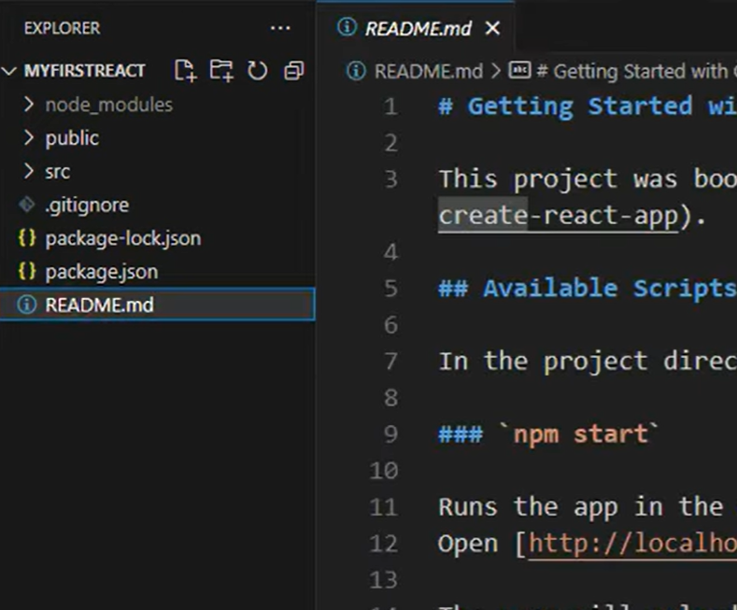

//these files are created by react, and these README.md files contains the how to handle the react project documentation, i.e how to run or start the project.

//package.json has react application details.

//package-lock.json also contains react information

//we should not touch the package.json,package-lock.json,node_modules

//we work on src folder section mostly,

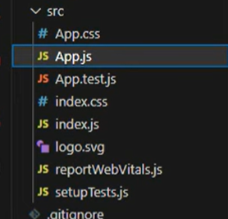

//In App.css we work on styling of our application.

//App.js, whatever we write the output code in App.js, we will get on the output screen

//index.css also we can use for styling.

//index.js is backbone of our project

//After SRC folder, we work on Public folder, in that public folder, we

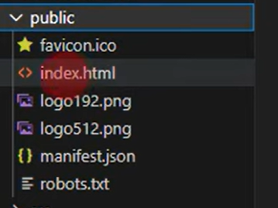

//index.html which forms the layout for our project.

//we store the icons,images, videos, other sources which are required for our project in ‘Public’ folder.

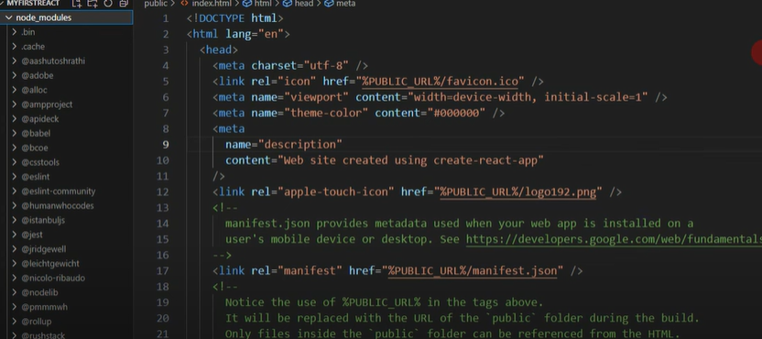

//node_modules folder contains dependencies of our React project.