//Components

//group of elements we can create by using components, then we can apply styling on it.Then after creating components based on the device screen we can re-arrange the components (portability or responsive).

//Components:

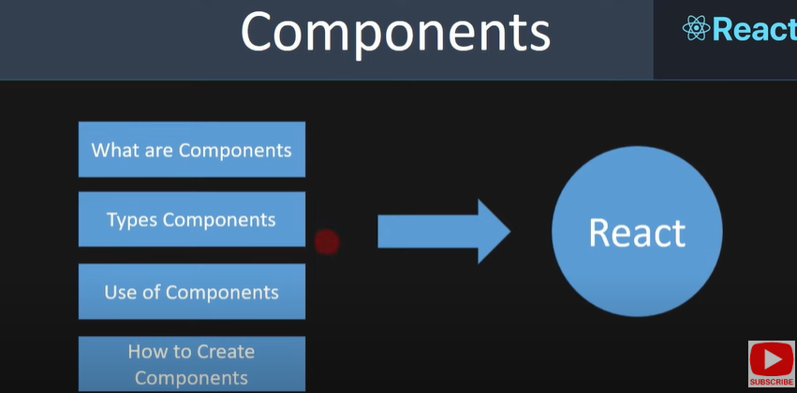

1.What are components?

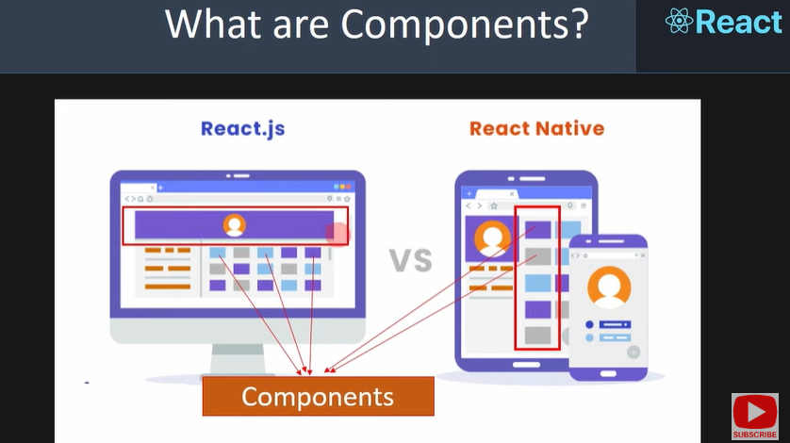

//components are like building blocks, we can create how many we want and we can apply the styling and make responsive that components.

//2.Types of Components.

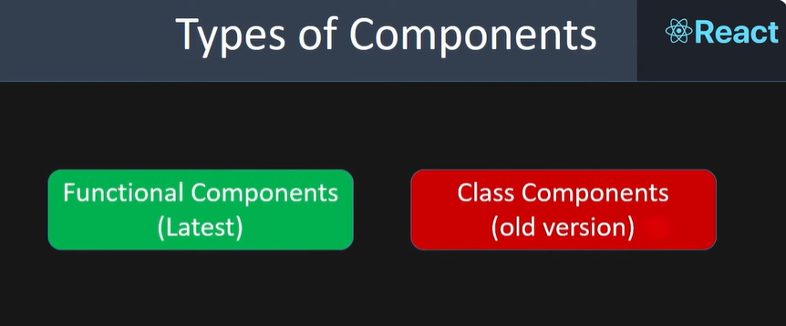

4.How to create Components?

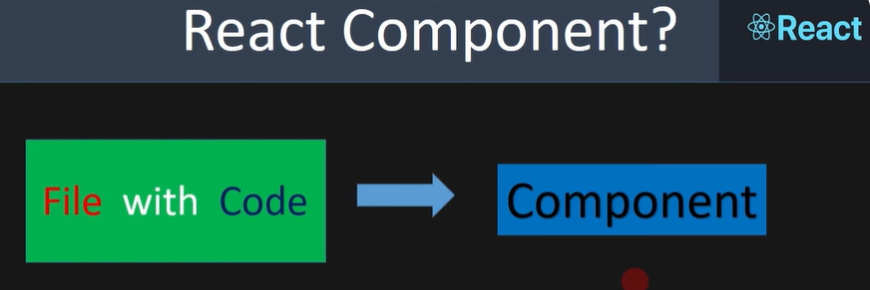

//if a file has one code then that is one component.



//if a file has multiple components(header,body,footer) regarding multiple codes which represents multiple components

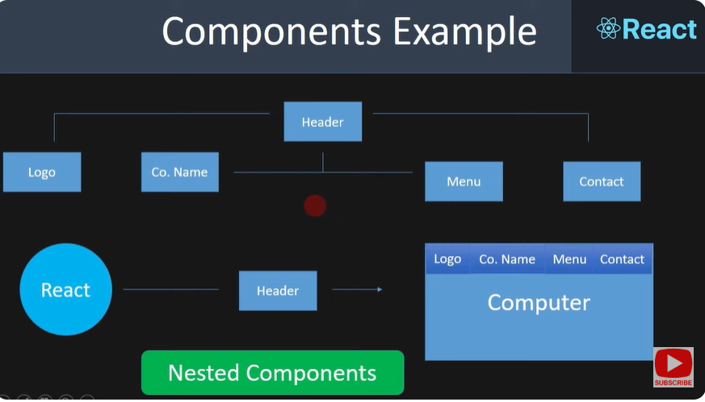

//if a component has multiple component codes then that is called nested components.

//Create Components:

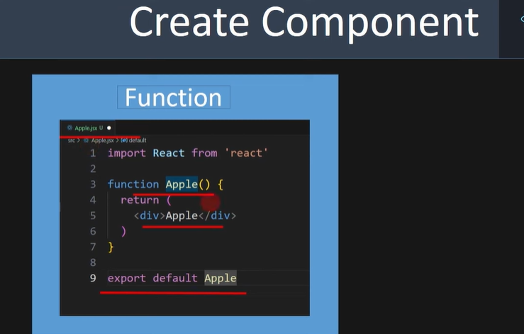

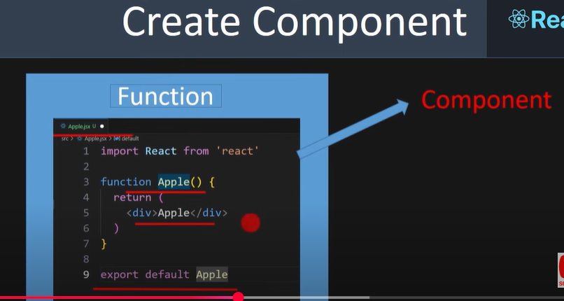

//Let see how we created a component with files

//1.we created a Apple.jsx file

//2.Inside the file we created a function Apple(), and that function returns a container “Apple”.

//3.export the created function

//Entire these thing is called Component we named it “Apple”, and we created these component by using function, so it is called functional component.

//we can also create the components by using “Simplify Extensions”

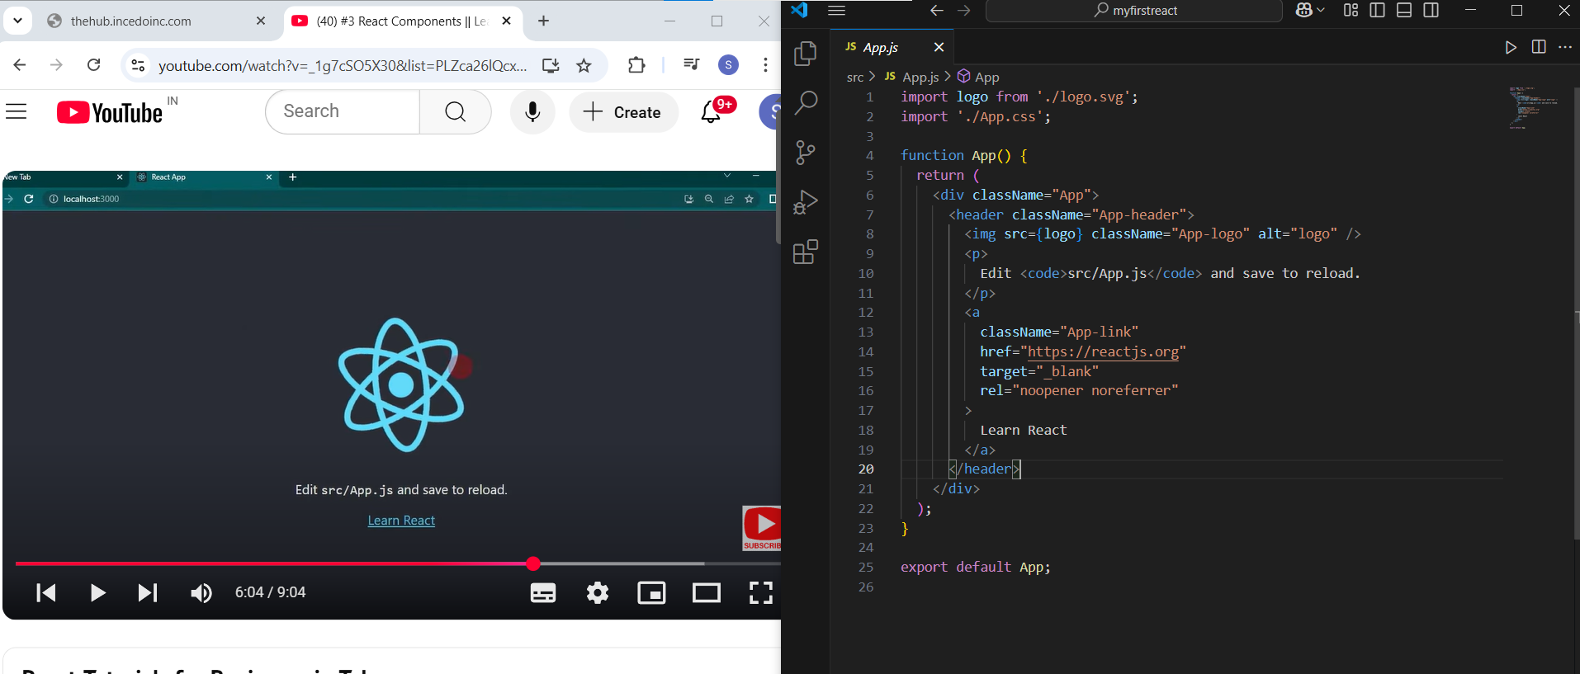

//the web page content is displayed due to the component developed in App.js

//we have created a Apple.jsx component , these component returns <h1>Hello World</h1> tag text execution on screen, these component is imported in main component App.js, and called with tag <Apple/> inside the App component in App.js

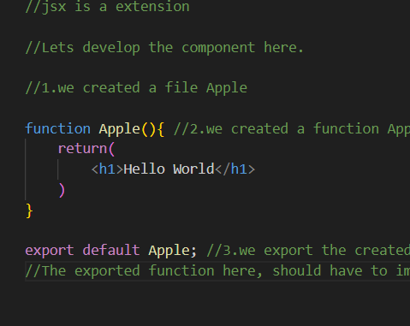

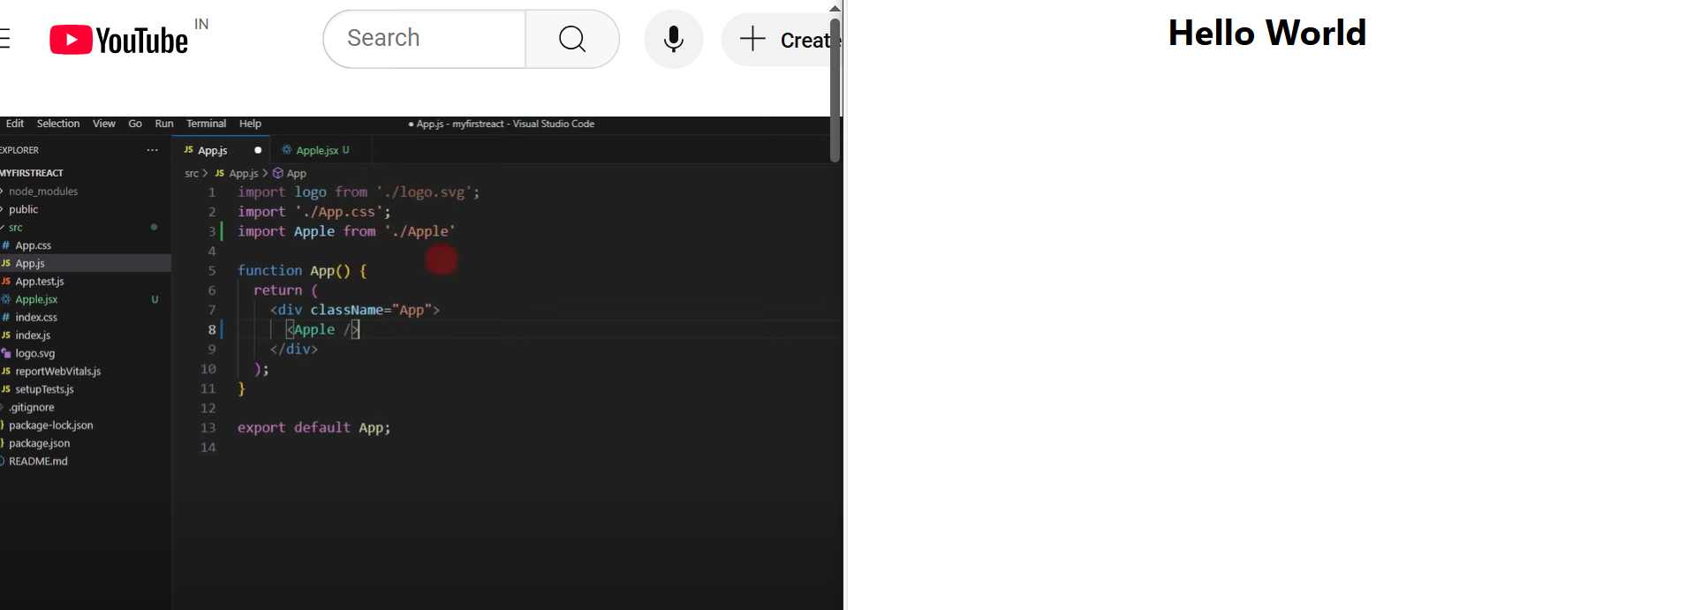

//By continuing these process we can create the nested component in next class, (one component has multiple components code)