Just To-Do It User Guide

<https://just-to-do-it-website.netlify.app/>

Table of Contents

Loading Page 2

Login 2

Register 3

Home View 3

Adding To-dos 4

More about Individual To-dos 4

To-do Action Buttons 4

Due Today View 4

Due This Week View 5

Completed View 5

Recently Deleted View 6

Respective Tag Views 7

My Account View 8

Edit To-do View 9

Title Section 9

Description Section 9

Deadline and Tags Section 9

Subtodo Section 10

Edit View action buttons 10

Navigation Drawer 10

Search Function 11

By title: 11

By tags: 11

By deadline: 11

Dark Mode 11

Just To-Do Views when dark mode is enabled 11

Mobile Views 12

Logging Out 12

# Loading Page

When users first visit Just To-Do it, they will see a loading page. This is necessary as the backend Heroku dyno needs to wake up before it can serve users. I am too broke to buy a hobby dyno and there is a motivational quote for users to read while waiting for the webpage to load. This usually takes a while (around 20 seconds) when users visit the page after a long time.

# Login

Users can log into Just To-Do it if they already have an account.

If you entered your email or password wrongly, an error message will pop up informing you that you have to try again.

# Register

Do not have an account? Click the link in the login page and you can register for one. After successfully creating an account, you will be redirected to the login page to login.

If you entered an invalid email or password is less then 6 characters or your password and password confirmation does not match, you will get an error message shown to you and you can try again.

# Home View

This is your main page where you can add to-dos and view them all at once.

## Adding To-dos

There is a add button in the bottom right corner of the home view where you can add a to-do. Wait a second and you will see a to-do slide in from the right. You can then proceed to edit your to-do.

## More about Individual To-dos

This is where you can quickly edit to-dos. The to-do’s title and completion status can be changed quickly.

### To-do Action Buttons

The 4 icon buttons are Save, Edit, Delete and More Info. Clicking the Save button will save your changes. However, most of the time the to-do will save automatically when there are changes detected. The edit button will bring up a comprehensive edit view which will be introduced later in this guide. The delete icon will delete your to-do. Your to-do will now only appear in the Recently Deleted view.

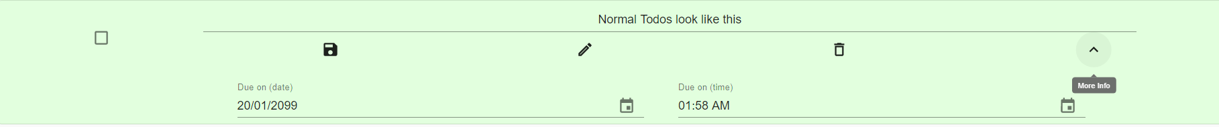

The more info icon will bring up your due date and time for the to-do which you can view or edit quickly on the fly. This is an example of a to-do with the more info tab expanded.

# Due Today View

To-dos that are due on the current day will appear in this view.

# Due This Week View

To-dos that are due in the current week will appear in this view.

# Completed View

Completed to-dos will appear in this view.

If you look closely there is a button in the bottom right corner of this view. You can click the button to delete all your completed to-dos. This will move the to-dos that are completed to the Recently Deleted View.

# Recently Deleted View

This view contains all your Recently Deleted To-dos.

You can restore these deleted to-dos by clicking the RESTORE TODO button if you wish.

If you look closely there is another button in the bottom right corner of this view. You can click the button to **permanently** delete all your completed to-dos. Do not worry, a dialog will pop up to confirm your decision should you press this button accidentally.

Here you can confirm your decision or cancel it if you wish.

# Respective Tag Views

This view will only appear if you have at least one to-do with a tag. Each view will contain all to-dos with the respective tags associated with it.

# 

# My Account View

This view will allow you to change your password should you wish to do so.

This view will also allow you to permanently delete your account if you choose to do so. Do not worry, if you accidentally clicked the button, a confirmation dialog will appear to confirm your decision.

# Edit To-do View

This is your comprehensive edit dialog that is brought into focus by clicking the edit icon in the respective to-dos.

## Title Section

You can edit the title of your to-do here.

## Description Section

You can edit the description of the to-do here.

## Deadline and Tags Section

Here you can change the deadline of the to-do or add tags to the to-do.

## Subtodo Section

Here you can add subtodos or edit them or you can also **permanently** delete them.

## Edit View action buttons



These are the action buttons of the edit dialog. MARK AS COMPLETED will mark the main to-do as completed and exit without saving. DISCARD CHANGES will exit without saving any changes and SAVE will save all changes and exit.

# Navigation Drawer

This is the main navigation drawer which is used to navigate between views on the website.

The first one shows the unexpanded navigational drawer. The second shows the expanded navigational drawer.

# Search Function

In most views, you might have noticed that there is a search bar. It is used to search through the to-dos that are currently in the view.

## By title:



## By tags:



## By deadline:

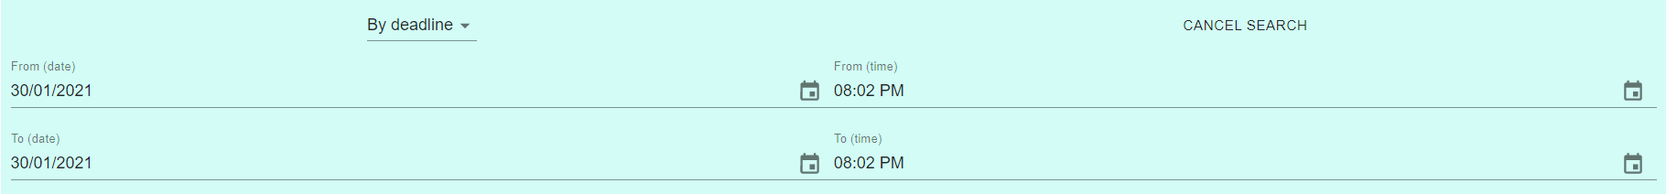

# Dark Mode

Do your eyes feel tired? No worries because Just To-Do it supports dark mode. You can enable it by clicking the toggle in the app header.

## A screenshot of a computer Description automatically generatedGraphical user interface Description automatically generatedJust To-Do Views when dark mode is enabled

# Mobile Views

Just To-do It is fully mobile, and tablet optimised.

# Logging Out

You can log out by clicking the log out button the app header. Your data will be saved safely in our backend servers.

