1. Download vechile sales data ->

https://github.com/shashank-mishra219/Hive-Class/blob/main/sales_order_data.csv

2. Store raw data into hdfs location

| hdfs dfs -copyFromLocal '/config/workspace/sales_order_data.csv' '/tmp/hive/' |
| --- |

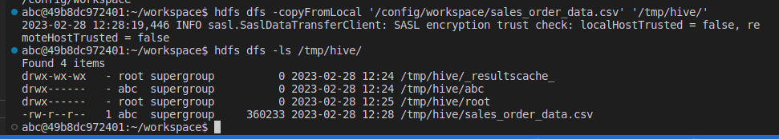

3. Create a internal hive table "sales_order_csv" which will store csv data sales_order_csv .. make sure to skip header row while creating table

| Create table sales_order_data (ORDERNUMBER int, QUANTITYORDERED int, PRICEEACH int, ORDERLINENUMBER int, SALES int, STATUS string, QTR_ID int, MONTH_ID int, YEAR_ID int, PRODUCTLINE string, MSRP int, PRODUCTCODE string, PHONE string, CITY string, STATE string, POSTALCODE string, COUNTRY string, TERRITORY string, CONTACTLASTNAME string, CONTACTFIRSTNAME string, DEALSIZE string) row format delimited fields terminated by ',' tblproperties("skip.header.line.count"="1"); |
| --- |

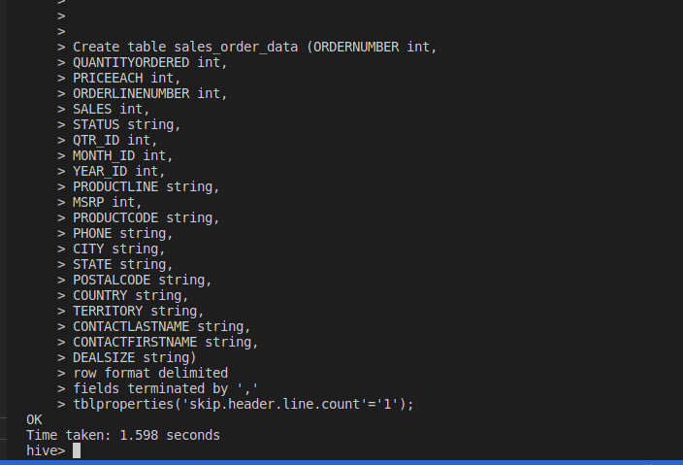

4. Load data from hdfs path into "sales_order_csv"

| load data inpath '/tmp/hive/sales_order_data.csv' into table sales_order_data; |
| --- |

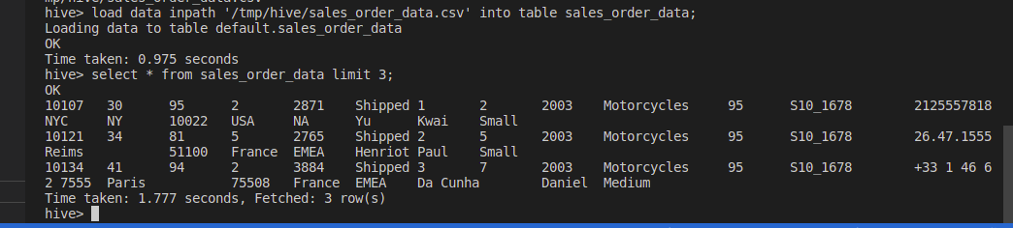

5. Create an internal hive table which will store data in ORC format "sales_order_orc"

| CREATE TABLE `sales_order_orc`(  `ordernumber` int,   `quantityordered` int,   `priceeach` int,   `orderlinenumber` int,   `sales` int,   `status` string,   `qtr_id` int,   `month_id` int,   `year_id` int,   `productline` string,   `msrp` int,   `productcode` string,   `phone` string,   `city` string,   `state` string,   `postalcode` string,   `country` string,   `territory` string,   `contactlastname` string,   `contactfirstname` string,   `dealsize` string) ROW FORMAT SERDE   'org.apache.hadoop.hive.ql.io.orc.OrcSerde'  STORED AS INPUTFORMAT   'org.apache.hadoop.hive.ql.io.orc.OrcInputFormat'  OUTPUTFORMAT   'org.apache.hadoop.hive.ql.io.orc.OrcOutputFormat' TBLPROPERTIES (  'bucketing_version'='2') |
| --- |

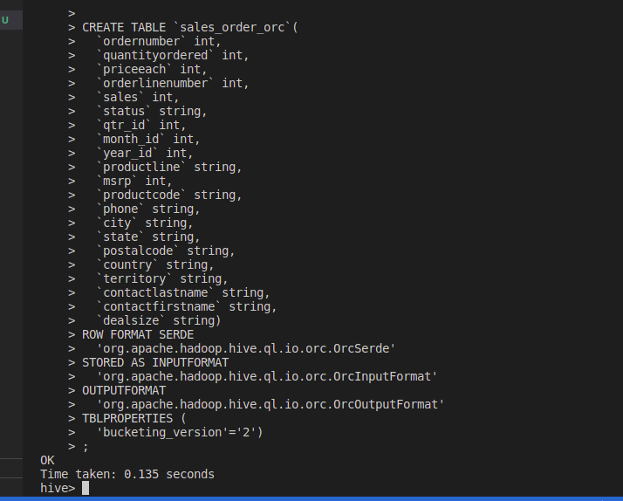

6. Load data from "sales_order_csv" into "sales_order_orc"

| insert overwrite table sales_order_orc select * from sales_order_data; |
| --- |

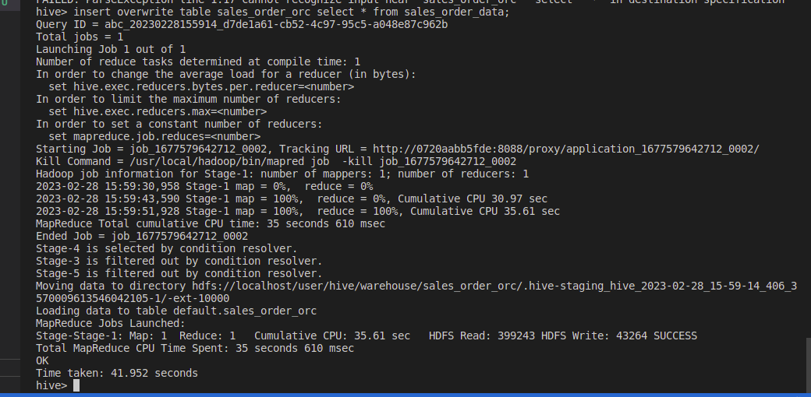

Perform below menioned queries on "sales_order_orc" table :

a. Calculatye total sales per year

| select year_id, count(sales) from sales_order_orc group by year_id; |
| --- |

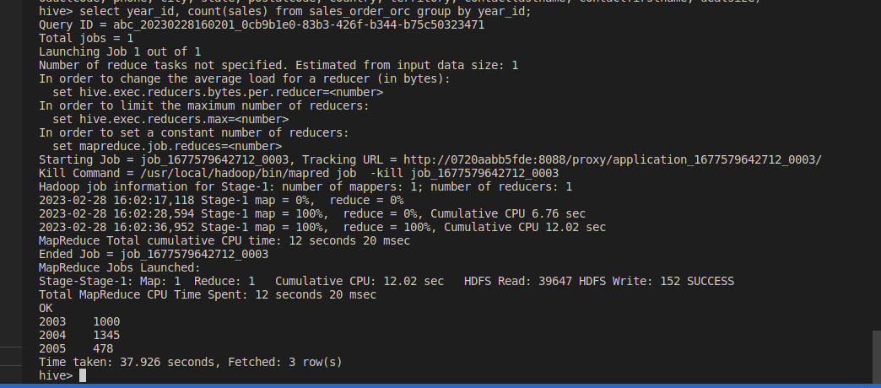

b. Find a product for which maximum orders were placed

| select PRODUCTLINE, sum(QUANTITYORDERED) from sales_order_orc group by PRODUCTLINE order by 2 desc; |
| --- |

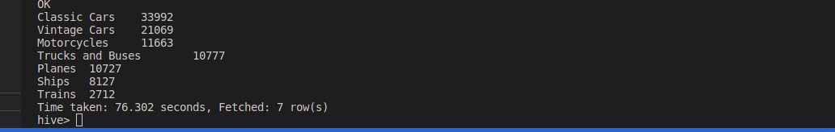

c. Calculate the total sales for each quarter

| select year_id,month_id, qtr_id, sum(sales) from sales_order_orc group by year_id, month_id, qtr_id order by 4 desc; |
| --- |

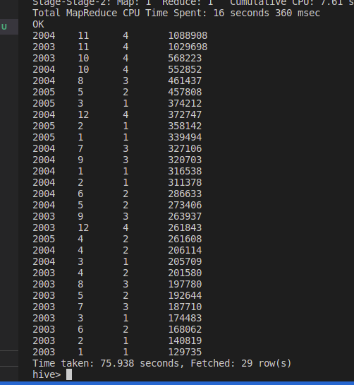

d. In which quarter sales was minimum

| Select year_id, month_id, qtr_id, sales from sales_order_orc where sales = (select min(sales) from sales_order_orc); |
| --- |

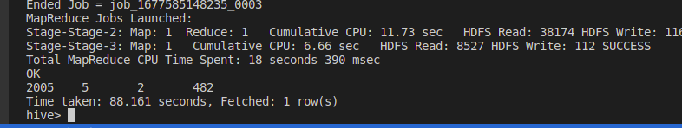

e. In which country sales was maximum and in which country sales was minimum

| Select country, sales from sales_order_orc where sales = (select max(sales) from sales_order_orc) union all Select country, sales from sales_order_orc where sales = (select min(sales) from sales_order_orc) |
| --- |

f. Calculate quartelry sales for each city

| select city,year_id,month_id, qtr_id, sum(sales) from sales_order_orc group by city,year_id, month_id, qtr_id order by 1,2,3,4 desc; |
| --- |

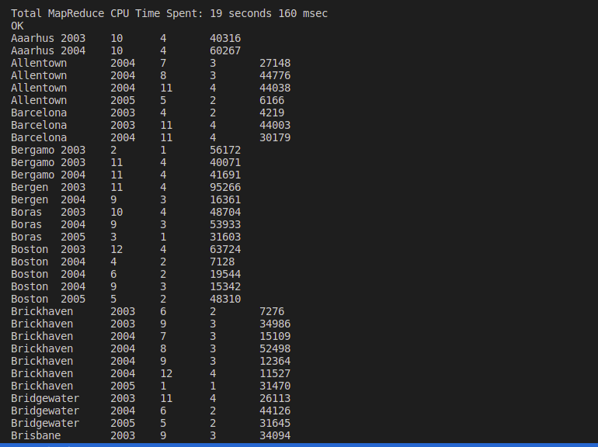

h. Find a month for each year in which maximum number of quantities were sold

| Select year_id, month_id, max(month_sale) from (Select year_id, month_id, sum(QUANTITYORDERED) as month_sale from sales_order_orc Group by year_id, month_id) a; |
| --- |