Subroutine Rotate2D:
This subroutine rotates variables from primed system aligned with the overall wind into the regular grid system:
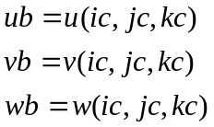
The coordinate rotation is done in the following manner:

y
y’
x
x’
y’
L
M
In the above figure,
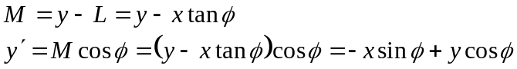
Similarly,
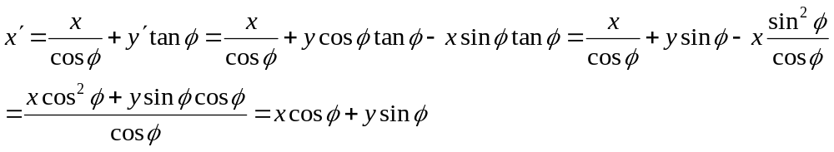
The above approach can be extended to the velocity vector,

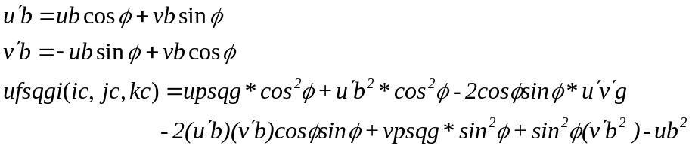

ufsqgi(ic,jc,kc)=upsqg*cosphi**2+upb**2*cosphi**2-2.*cosphi*sinphi*upvpg &
-2.*cosphi*sinphi*upb*vpb+vpsqg*sinphi**2+sinphi**2*vpb**2-ub**2
vfsqgi(ic,jc,kc)=upsqg*sinphi**2+upb**2*sinphi**2+2.*upvpg*sinphi*cosphi &
+2.*upb*vpb*sinphi*cosphi+vpsqg*cosphi**2+vpb**2*cosphi**2-vb**2
wfsqgi(ic,jc,kc)=wpsqg
ufvfgi(ic,jc,kc)=upsqg*cosphi*sinphi+upb**2*cosphi*sinphi+upvpg*(cosphi**2 &
-sinphi**2)+upb*vpb*(cosphi**2-sinphi**2)-vpsqg*sinphi*cosphi-vpb**2*sinphi*cosphi-ub*vb
ufwfgi(ic,jc,kc)=upwpg*cosphi+upb*wb*cosphi-vpwpg*sinphi-vpb*wb*sinphi-ub*wb
vfwfgi(ic,jc,kc)=upwpg*sinphi+upb*wb*sinphi+vpwpg*cosphi+vpb*wb*cosphi-vb*wb

