BIRLA INSTITUTE OF TECHNOLOGY AND SCIENCE, PILANI
Work Integrated Learning Programmes Division
SEZG583 SCALABLE SERVICES
Assignment: Microservices Development and Deployment
Application: Library Management Microservices System
Student Name | Student ID
Sivesh Kumar | 2025MT03074

Contents
- Student Details
- Abstract
- Application Description
- Business Capabilities
- Functional and Non-Functional Requirements
- System Operations (Commands and Queries)
- Service Identification and Responsibility Matrix
- Architecture and Service Collaboration
- Technology Stack
- Implementation Details
- Project Structure
- GitHub Repositories
- Docker Deployment
- Kubernetes Deployment (Docker Desktop)
- Execution Instructions
- Postman Test Results
- Optional: CI Pipeline
- Limitations and Future Work
- Conclusion
- References

1. Student Details
Item | Details
Name | Sivesh Kumar
Student ID | 2025MT03074
Course | SEZG583 Scalable Services
Assignment | Microservices Development and Deployment
Application | Library Management Microservices System
Submission mode | Individual, LMS file upload

2. Abstract
This assignment designs and implements a small microservices application for a library: members borrow and return books. I split the problem into business capabilities (member management, book catalogue, lending) and mapped them to services. Two services are implemented: a Member Service that manages member records, and a Book Service that manages the book catalogue and the loans. When a book is borrowed, the Book Service calls the Member Service over REST to check that the member exists and to read the membership type, because a STANDARD member may hold 3 books and a PREMIUM member 5.
Both services are written in Java 17 with Spring Boot 3, Spring Data JPA and an H2 database. Each service lives in its own Git repository, is packaged into its own Docker image and is deployed to the local Kubernetes cluster that comes with Docker Desktop, in its own namespace using Deployments, Services and a ConfigMap. The APIs were tested with Postman. The document also records the design decisions, the limitations of the current version (for example, the in-memory database) and what I would do to make the system more scalable.

3. Application Description

3.1 Problem description
A college library keeps its member list and its book stock in registers and spreadsheets. It is hard to know how many copies of a book are on the shelf, which member holds which book, when it is due, and whether a member has crossed the limit of books allowed. If the whole library system is one large application, a change to the lending rules needs the member data module to be tested and released again, and the lending part, which is the busiest, cannot be scaled without scaling everything else.
I therefore chose a Library Management System and designed it as microservices, so that members, books and lending can be developed, deployed and scaled on their own.

3.2 Scope
In scope: maintaining members, maintaining books with a number of copies, borrowing a book, returning a book, and viewing loans. Out of scope for this assignment (but considered in the design): login and roles, fines for late return, reservations of books, search by author, and e-mail reminders.

3.3 Assumptions
- Member ids are generated by the Member Service. The Book Service never creates members.
- A book can have several copies. A member can hold one copy of a given book at a time.
- The loan period is 14 days. The loan limit is 3 active loans for STANDARD members and 5 for PREMIUM members. Both are configuration values.
- The databases are in-memory H2 as required, so data is lost when a pod or container restarts.
- Authentication is not part of this assignment, so the APIs are open.

4. Business Capabilities
A business capability is something the business does, independent of how the software is built. I identified the following and mapped each to a service.
Business capability | What it covers | Mapped to service
Member management | Keeping member records and membership type (create, view, update, delete) | Member Service
Book catalogue management | Keeping books, authors, ISBN and the number of copies | Book Service
Lending management | Borrowing, returning, due dates, loan limits, copy availability, listing loans | Book Service
Overdue notification (future) | Reminding members about due books | Notification Service (designed, not implemented)
Access control (future) | Login, roles, routing, rate limiting | API Gateway (designed, not implemented)
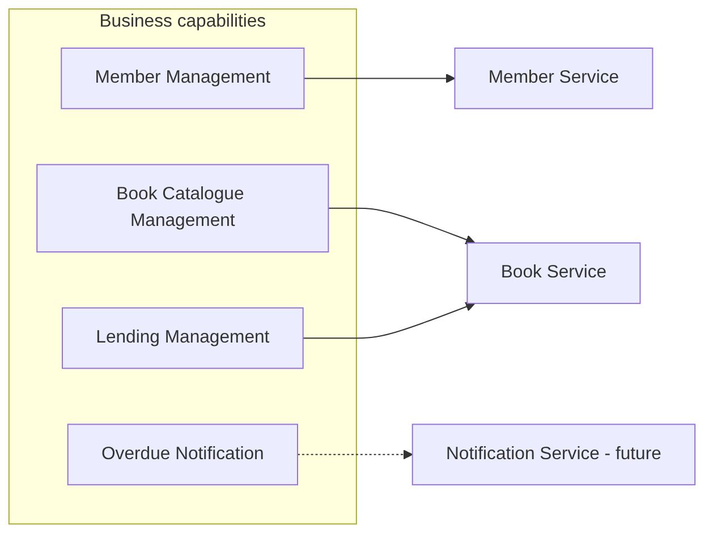
Figure 1: Business capabilities mapped to services
Lending and the book catalogue are in the same service because a lending decision depends on how many copies are free, and the copy count must change in the same transaction that creates or closes the loan. If they were separate services, a failure between the two calls could leave the copy count wrong.

5. Functional and Non-Functional Requirements

5.1 Functional requirements
ID | Requirement | Service
FR1 | The system shall allow a member to be created with name, email, phone and membership type | Member
FR2 | The system shall return one member by id and the list of all members | Member
FR3 | The system shall allow a member's details to be updated | Member
FR4 | The system shall allow a member to be deleted | Member
FR5 | The system shall not allow two members with the same email | Member
FR6 | The system shall allow a book to be added with ISBN, title, author and number of copies | Book
FR7 | The system shall return one book and the list of all books, with the number of copies available | Book
FR8 | The system shall allow a book to be borrowed only if the member exists | Book (calls Member)
FR9 | The system shall reject a borrow request if no copy is available, if the member already holds the same book, or if the member has reached the loan limit of the membership type | Book
FR10 | The system shall set a due date on every loan and reduce the available copies by one | Book
FR11 | The system shall allow a book to be returned, which closes the loan and increases the available copies by one | Book
FR12 | The system shall list loans: all, one loan, and by member | Book
FR13 | The system shall return clear error messages and proper HTTP status codes for invalid input | Both

5.2 Non-functional requirements
ID | Quality | Requirement and how it is addressed
NFR1 | Scalability | Services are stateless apart from the database, so more pods can be added with kubectl scale or an HPA. Each service scales on its own.
NFR2 | Independent deployability | Two Git repositories, two Docker images, two Kubernetes Deployments.
NFR3 | Loose coupling | The only dependency is one REST call from Book to Member. Each service has its own database, and no one reads another service's tables.
NFR4 | Availability / resilience | Kubernetes restarts failed pods (liveness probe) and sends traffic only to ready pods (readiness probe). The Book Service returns 503 instead of crashing when the Member Service is down, and uses connect and read timeouts.
NFR5 | Performance | Simple indexed lookups, response expected in well under a second on a laptop. Timeouts of 3 s (connect) and 5 s (read) on the REST call.
NFR6 | Consistency | Borrow and return change the loan and the copy count in one database transaction.
NFR7 | Portability | Runs the same way locally, in Docker and in Kubernetes. The Member Service URL and the loan rules are configurable.
NFR8 | Observability | Spring Actuator health endpoint, logs to stdout so docker logs and kubectl logs work.
NFR9 | Maintainability | Layered code (controller, service, repository), DTOs separate from entities, one global exception handler per service.
NFR10 | Security (basic) | Input validation, container runs as a non-root user. Authentication is left for future work.

6. System Operations (Commands and Queries)
System operations are the requests the system must handle. A command changes data. A query only reads data. The core use case is borrowing a book.

6.1 Commands
No. | Command | Description | Owning service | REST endpoint
C1 | createMember | Add a new member | Member | POST /api/members
C2 | updateMember | Change name, email, phone or membership type | Member | PUT /api/members/{id}
C3 | deleteMember | Remove a member | Member | DELETE /api/members/{id}
C4 | addBook | Add a book with a number of copies | Book | POST /api/books
C5 | borrowBook | Borrow a book (checks member, copy, duplicate and loan limit) | Book | POST /api/loans
C6 | returnBook | Close a loan and put the copy back | Book | PUT /api/loans/{loanId}/return

6.2 Queries
No. | Query | Description | Owning service | REST endpoint
Q1 | getMember | One member by id | Member | GET /api/members/{id}
Q2 | getAllMembers | All members | Member | GET /api/members
Q3 | getBook | One book by id, with copies available | Book | GET /api/books/{id}
Q4 | getAllBooks | All books | Book | GET /api/books
Q5 | getLoan | One loan by id | Book | GET /api/loans/{loanId}
Q6 | viewAllLoans | All loans, active and returned | Book | GET /api/loans
Q7 | viewLoansOfMember | Loans of one member | Book | GET /api/loans/member/{memberId}
C5 is the only operation that needs two services. To complete it, the Book Service issues query Q1 on the Member Service. C6 is local to the Book Service.

7. Service Identification and Responsibility Matrix

7.1 How I identified the services
I used the business capabilities as the starting point (decomposition by business capability). Each service should own one capability and its data, and should change for one kind of reason. Member data changes when the library changes what it keeps about a member. The catalogue and lending rules change when library policy changes. These are different reasons, so they are different services.
Why the services are separate:
- Different data owners. Member data can be reused by other systems later (fees, events, hostel). Keeping it in its own service makes that possible.
- Independent scaling. Most traffic is borrowing and returning, which is in the Book Service. The Member Service does not need the same number of instances.
- Independent deployment. The loan limit or the loan period can be changed and only the Book Service is redeployed.
- Fault isolation. If the Member Service is down, the catalogue and returns still work. Only the borrow command fails, with a clear 503 message.
- Clear ownership. Each repository can be built, tested and released without waiting for the other.
I did not split lending into a third service. The copy count and the loan have to change together, and with only two entities a third service would add network calls and deployment work without a real benefit.

7.2 Service responsibility matrix
Responsibility | Member Service | Book Service | Notes
Own member data and member database | Yes | No | H2 memberdb
Own book data and book database | No | Yes | H2 bookdb
Own loan data | No | Yes | H2 bookdb
Create / update / delete member | Yes | No | C1, C2, C3
Add book | No | Yes | C4
Borrow and return book | No | Yes | C5, C6 (C5 calls Member Service)
Validate that a member exists, give membership type | Provides the answer (Q1) | Asks for the answer | REST GET
Copy availability, duplicate loan and loan limit rules | No | Yes | 409 Conflict
Query members | Yes | No | Q1, Q2
Query books and loans | No | Yes | Q3 to Q7
Expose health endpoint | Yes | Yes | /actuator/health
Port | 8081 | 8082
Kubernetes Service name | member-service | book-service | DNS names in the cluster

8. Architecture and Service Collaboration

8.1 Service collaboration
The Book Service depends on the Member Service. The Member Service does not depend on anything. This keeps the dependency one way and avoids circular calls.
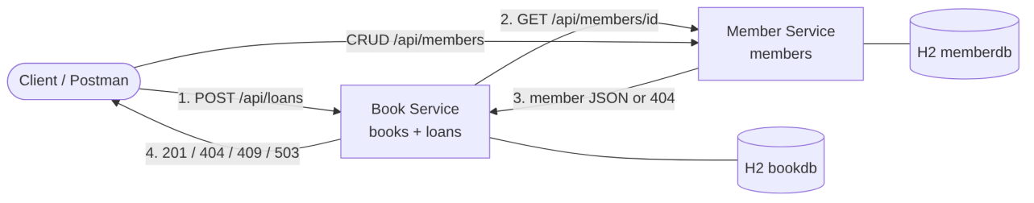
Figure 2: Service collaboration diagram

8.2 Overall microservice architecture
Each service has its own H2 database (database per service pattern). Clients call the services over REST with JSON. The dashed boxes (API Gateway and Notification Service) are part of the design for a larger system but are not implemented in this assignment.
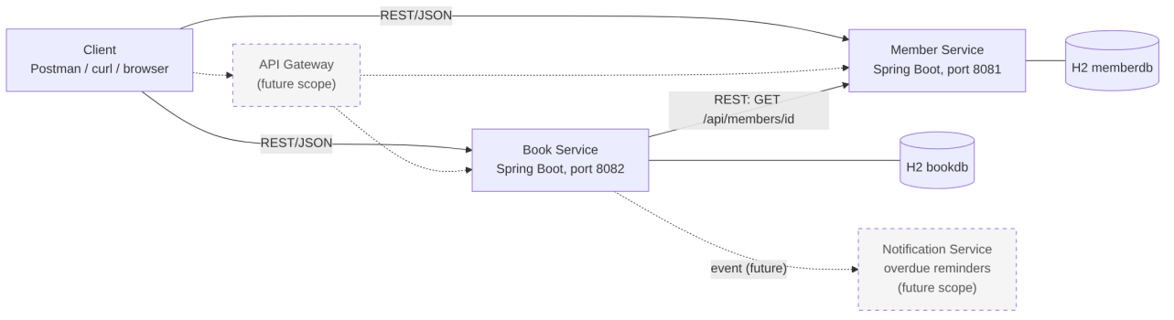
Figure 3: Overall microservice architecture

8.3 Sequence diagram: Borrow Book
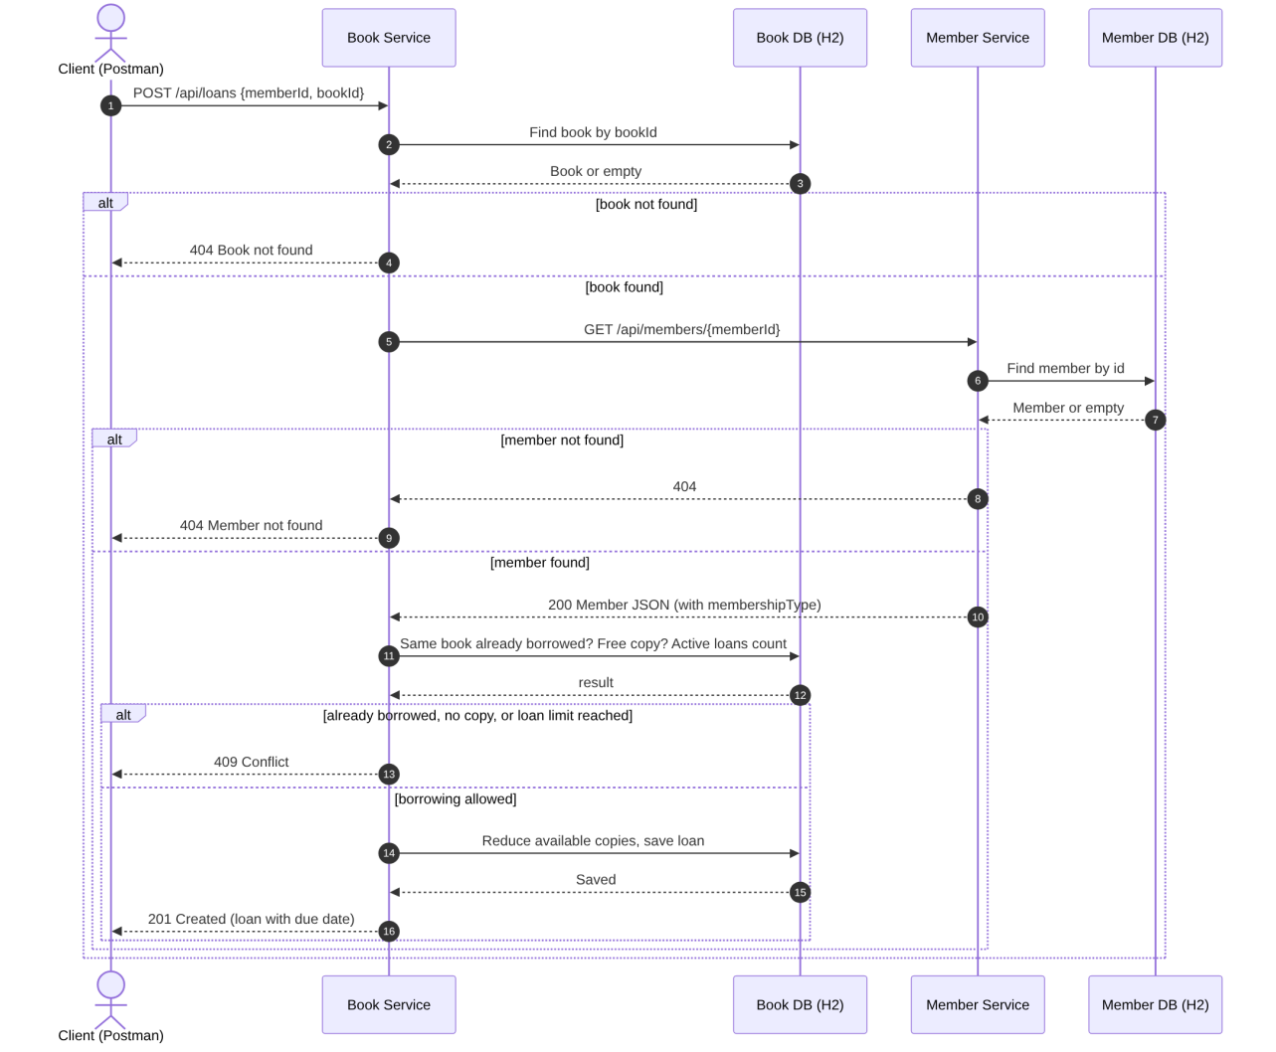
Figure 4: Sequence diagram for borrowing a book

8.4 Service interaction, step by step
- The client sends POST /api/loans with {"memberId": 1, "bookId": 1} to the Book Service.
- The controller validates the body. If a field is missing, it returns 400.
- LoanService looks up the book in the Book database. If it is not found, the response is 404.
- The service calls MemberClient, which sends GET http://member-service:8081/api/members/1 to the Member Service. In Kubernetes member-service is resolved by the cluster DNS to the Service of the same name. The URL comes from the MEMBER_SERVICE_URL environment variable.
- The Member Service reads the member from its own database and returns the JSON (including the membership type), or 404 if the member does not exist.
- If the Member Service answers 404, the Book Service returns 404 "Member not found". If it cannot be reached or times out, the Book Service returns 503.
- The Book Service checks three rules: the member does not already hold this book, at least one copy is available, and the number of active loans of the member is below the limit for the membership type (3 or 5). If any rule fails it returns 409 with a message that says which one.
- Otherwise it reduces the available copies by one, saves the loan with a due date 14 days ahead (both changes in one transaction) and returns 201.
To return a book the client calls PUT /api/loans/{loanId}/return. The Book Service closes the loan, sets the return time and increases the available copies. No call to the Member Service is needed.

8.5 Scalability considerations in the design
- Services are stateless, so Kubernetes can run several replicas behind the same Service. This is limited in this implementation because H2 is in memory and not shared (see Section 18). With a shared database such as PostgreSQL the replicas can be increased without any code change.
- Member and Book services can be scaled independently, and an optional HPA manifest is included.
- A gateway would give one entry point, authentication and rate limiting. An event such as BookBorrowed published to a message broker would let a Notification Service send due-date reminders without slowing the borrow call.
- A circuit breaker (for example Resilience4j) could be added around MemberClient so that repeated failures do not keep hitting a service that is down.
- The membership type is read from the Member Service at the time of borrowing, so a change of membership applies from the next borrow without any data copy.

9. Technology Stack
Area | Choice | Why I chose it
Language | Java 17 | LTS version, required by Spring Boot 3, records make DTOs short
Framework | Spring Boot 3.2.5 | Quick to set up REST services with embedded Tomcat
Persistence | Spring Data JPA (Hibernate) | Repositories without boilerplate SQL
Database | H2 (in-memory), one per service | Required by the assignment, no installation, easy to demo
Validation | Jakarta Bean Validation | Declarative checks on request DTOs
Service communication | Synchronous REST over HTTP/JSON using Spring's RestClient | Borrowing needs the member check (and the membership type) before it can answer, so a request/response call fits. Easy to test with Postman.
Health | Spring Boot Actuator | Used by Kubernetes liveness and readiness probes
Build | Maven | Standard for Spring Boot
Containers | Docker, base image eclipse-temurin:17-jre-alpine | Small image, JRE only
Orchestration | Kubernetes (Docker Desktop) | Deployments, Services, ConfigMap, HPA
Testing | Postman, curl | Manual API tests
Source control | Git and GitHub, one repo per service | Independent development
CI (optional) | GitHub Actions | Builds and tests on every push
About the communication choice: I considered asynchronous messaging, but the borrow request cannot complete without knowing that the member exists and which membership type applies, and the assignment asks for a suitable and simple approach, so I used synchronous REST. Messaging is listed under future work for notifications.

10. Implementation Details
I implemented the two services that carry the main use case: Member Service (port 8081) and Book Service (port 8082). Both use the same layering: controller, service, repository, model (JPA entities), DTO and exception packages.

10.1 Member Service
Layer | Class | Purpose
Main | MemberServiceApplication | Spring Boot entry point
Controller | MemberController | REST endpoints under /api/members
Service | MemberService | Business logic, duplicate email check, transactions
Repository | MemberRepository | JpaRepository with existsByEmailIgnoreCase and findByEmailIgnoreCase
Model | Member, MembershipType | JPA entity (id, fullName, unique email, phone, membershipType, joinedOn) and the enum STANDARD / PREMIUM
DTO | MemberRequest, MemberResponse | Request with validation, response that does not expose the entity
Exception | NotFoundException, ConflictException, ApiError, GlobalExceptionHandler | Maps errors to 404, 409, 400 and 500

Method | Endpoint | Success | Errors
POST | /api/members | 201 | 400, 409
GET | /api/members | 200
GET | /api/members/{id} | 200 | 404
PUT | /api/members/{id} | 200 | 400, 404, 409
DELETE | /api/members/{id} | 204 | 404

10.2 Book Service
Layer | Class | Purpose
Main | BookServiceApplication | Spring Boot entry point
Controller | BookController, LoanController | Endpoints under /api/books and /api/loans
Service | BookService, LoanService | Catalogue logic, borrow and return rules
Client | MemberClient | REST call to the Member Service using RestClient
Config | RestClientConfig, LibraryRules | RestClient with timeouts, loan period and limits read from properties
Repository | BookRepository, LoanRepository | JPA repositories, with counts of active loans
Model | Book, Loan | Book keeps total and available copies. Loan keeps member id, book id, due date and return time
DTO | BookRequest, BookResponse, BorrowRequest, LoanResponse, MemberDto | MemberDto is the part of the Member Service reply that is needed
Exception | NotFoundException, ConflictException, MemberServiceUnavailableException, ApiError, GlobalExceptionHandler | 404, 409, 503, 400, 500

Method | Endpoint | Success | Errors
POST | /api/books | 201 | 400, 409
GET | /api/books | 200
GET | /api/books/{id} | 200 | 404
POST | /api/loans | 201 | 400, 404, 409, 503
PUT | /api/loans/{loanId}/return | 200 | 404, 409
GET | /api/loans | 200
GET | /api/loans/{loanId} | 200 | 404
GET | /api/loans/member/{memberId} | 200

10.3 Key code: the REST call between services
@Component
public class MemberClient {
private final RestClient restClient;
public MemberClient(RestClient memberRestClient) {
this.restClient = memberRestClient;
}
public MemberDto fetchMember(Long memberId) {
try {
MemberDto member = restClient.get()
.uri("/api/members/{id}", memberId)
.retrieve()
.onStatus(status -> status.value() == 404, (request, response) -> {
throw new NotFoundException("Member not found with id " + memberId);
})
.body(MemberDto.class);
if (member == null) {
throw new NotFoundException("Member not found with id " + memberId);
}
return member;
} catch (RestClientException ex) {
throw new MemberServiceUnavailableException("Member Service is not reachable, please try again later");
}
}
}

10.4 Key code: the borrow command
public LoanResponse borrow(BorrowRequest req) {
Book book = findBookOrThrow(req.bookId());
MemberDto member = memberClient.fetchMember(req.memberId());
if (loans.existsByMemberIdAndBookIdAndReturnedOnIsNull(member.id(), book.getId())) {
throw new ConflictException("Member " + member.id() + " has already borrowed '"
+ book.getTitle() + "' and not returned it");
}
if (!book.hasFreeCopy()) {
throw new ConflictException("No copies of '" + book.getTitle() + "' are available right now");
}
long activeLoans = loans.countByMemberIdAndReturnedOnIsNull(member.id());
int limit = rules.maxLoansFor(member.membershipType());
if (activeLoans >= limit) {
throw new ConflictException("Loan limit reached: " + member.membershipType()
+ " members can hold " + limit + " books at a time");
}
book.checkOut();
Loan loan = loans.save(new Loan(member.id(), member.fullName(), book.getId(), rules.loanDays()));
return LoanResponse.of(loan, book);
}
The method is transactional, so the reduced copy count and the new loan are saved together or not at all.

10.5 Configuration
The Book Service reads the address of the Member Service and the loan rules from properties. The address can be overridden by an environment variable, which is the only change needed between local run, Docker and Kubernetes.
member.service.url=${MEMBER_SERVICE_URL:http://localhost:8081}
library.loan-days=14
library.max-loans.standard=3
library.max-loans.premium=5
Where it runs | Value of MEMBER_SERVICE_URL
Local (java -jar) | not set, default http://localhost:8081
Docker (user-defined network) | http://member-service:8081
Kubernetes | http://member-service:8081, from the ConfigMap

10.6 Design decisions
- Records for DTOs. Java 17 records keep request and response classes short and immutable.
- Entities are never returned directly. The API contract does not change when the table changes.
- Domain behaviour inside the entity. Book.checkOut() and Book.checkIn() change the copy count, so the rule that copies never go below zero or above the total is in one place.
- Loan stores the member name. Loans can be listed without calling the Member Service for each row. The trade-off is that the copy of the name can become old if the member is renamed.
- No foreign key across services. memberId in the loan table is only a number. The check that the member exists is done with the REST call.
- Membership type decides the limit. This is the reason the Book Service needs the member data and not only a yes or no answer.
- Errors in one format. Every error returns timestamp, status, error, message, path.

11. Project Structure
Each service is in its own repository. The Kubernetes manifests that belong to a service are kept in its k8s folder.

11.1 member-service repository
member-service/
├── .github/workflows/ci.yml
├── .gitignore
├── .dockerignore
├── Dockerfile
├── pom.xml
├── README.md
├── k8s/
│ ├── namespace.yaml
│ ├── member-service-deployment.yaml
│ ├── member-service-service.yaml
│ └── member-service-hpa.yaml
└── src/
├── main/
│ ├── java/com/bits/library/member/
│ │ ├── MemberServiceApplication.java
│ │ ├── controller/MemberController.java
│ │ ├── service/MemberService.java
│ │ ├── repository/MemberRepository.java
│ │ ├── model/Member.java
│ │ ├── model/MembershipType.java
│ │ ├── dto/MemberRequest.java
│ │ ├── dto/MemberResponse.java
│ │ └── exception/
│ │ ├── ApiError.java
│ │ ├── ConflictException.java
│ │ ├── GlobalExceptionHandler.java
│ │ └── NotFoundException.java
│ └── resources/application.properties
└── test/java/com/bits/library/member/MemberServiceApplicationTests.java

11.2 book-service repository
book-service/
├── .github/workflows/ci.yml
├── .gitignore
├── .dockerignore
├── Dockerfile
├── pom.xml
├── README.md
├── k8s/
│ ├── namespace.yaml
│ ├── book-service-configmap.yaml
│ ├── book-service-deployment.yaml
│ ├── book-service-service.yaml
│ └── book-service-hpa.yaml
└── src/
├── main/
│ ├── java/com/bits/library/book/
│ │ ├── BookServiceApplication.java
│ │ ├── client/MemberClient.java
│ │ ├── config/LibraryRules.java
│ │ ├── config/RestClientConfig.java
│ │ ├── controller/BookController.java
│ │ ├── controller/LoanController.java
│ │ ├── service/BookService.java
│ │ ├── service/LoanService.java
│ │ ├── repository/BookRepository.java
│ │ ├── repository/LoanRepository.java
│ │ ├── model/Book.java
│ │ ├── model/Loan.java
│ │ ├── dto/BookRequest.java
│ │ ├── dto/BookResponse.java
│ │ ├── dto/BorrowRequest.java
│ │ ├── dto/LoanResponse.java
│ │ ├── dto/MemberDto.java
│ │ └── exception/
│ │ ├── ApiError.java
│ │ ├── ConflictException.java
│ │ ├── GlobalExceptionHandler.java
│ │ ├── MemberServiceUnavailableException.java
│ │ └── NotFoundException.java
│ └── resources/application.properties
└── test/java/com/bits/library/book/BookServiceApplicationTests.java
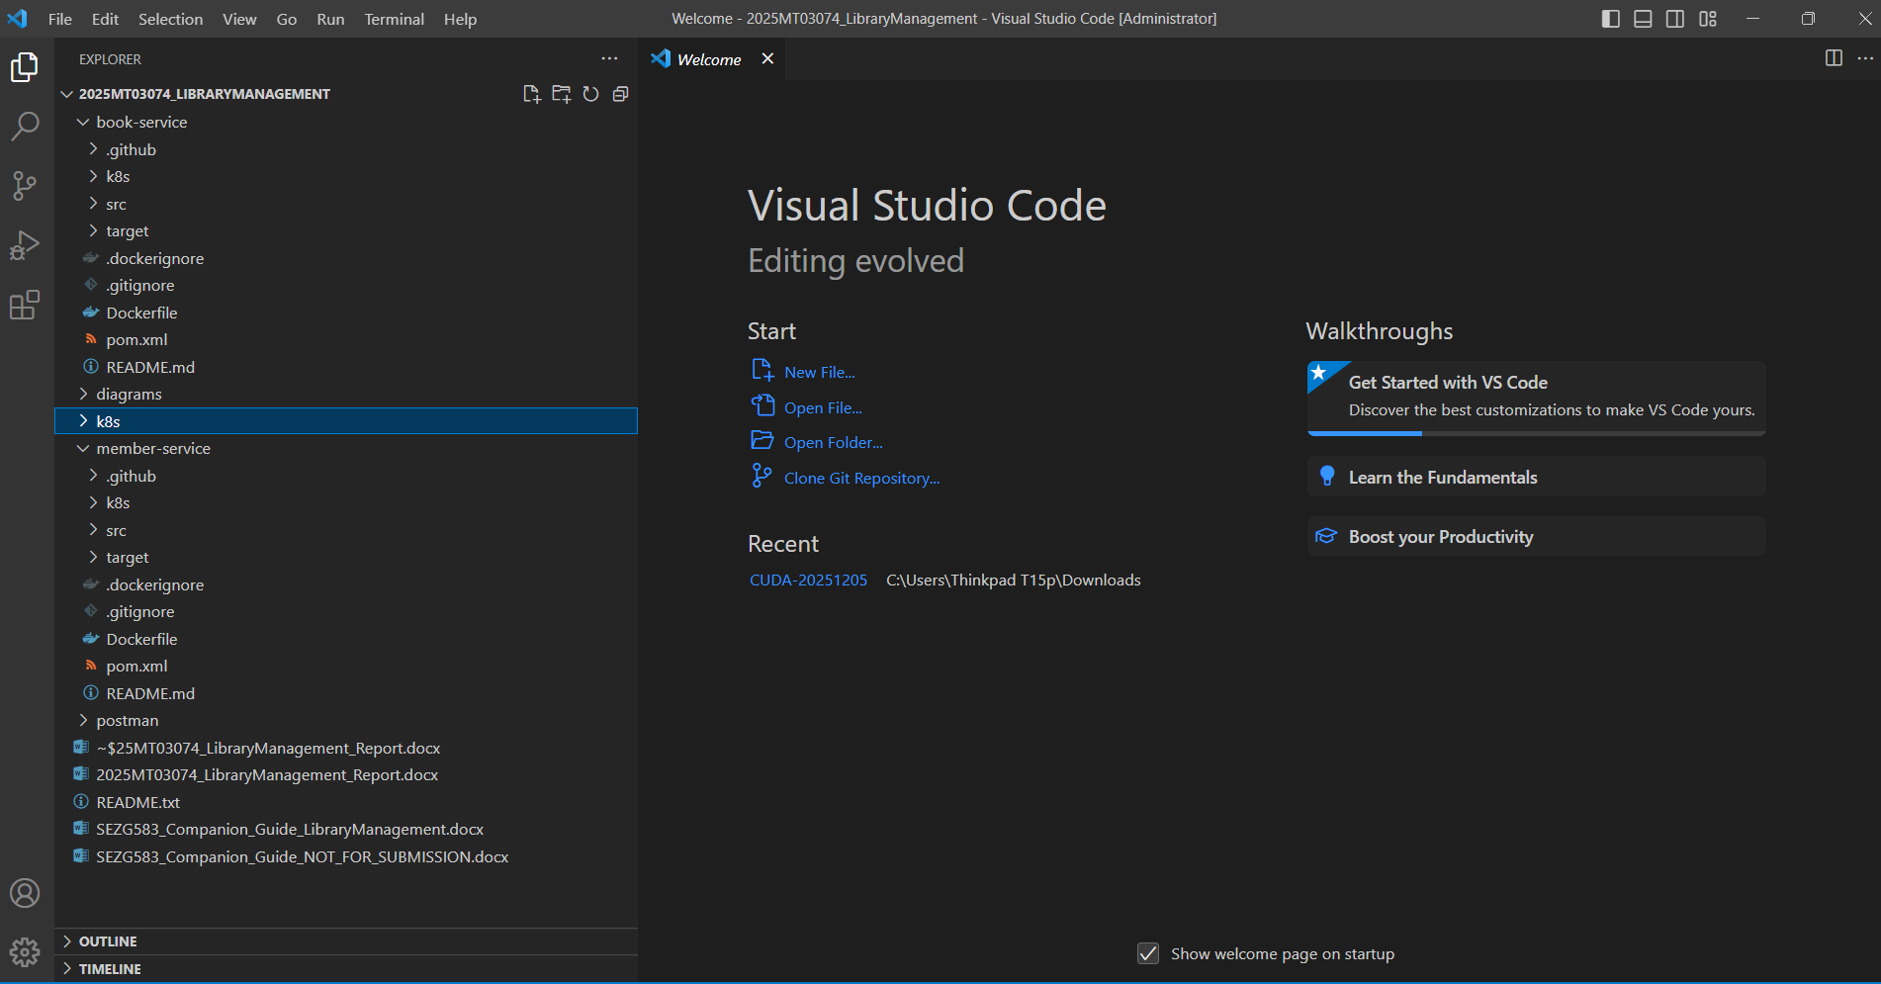

Figure 6: VS Code Explorer showing the member-service and book-service project structure

12. GitHub Repositories
Repository | URL
Member Service | https://github.com/YOUR-GITHUB-USERNAME/member-service
Book Service | https://github.com/YOUR-GITHUB-USERNAME/book-service
Commands used to publish each repository (shown for member-service, the same steps are used for book-service):
cd member-service
git init
git add .
git commit -m "Initial commit: Member Service with Docker and Kubernetes files"
git branch -M main
git remote add origin https://github.com/YOUR-GITHUB-USERNAME/member-service.git
git push -u origin main
[ Paste screenshot here ]
Figure 7: GitHub page of the member-service repository showing files and latest commit
[ Paste screenshot here ]
Figure 8: GitHub page of the book-service repository showing files and latest commit

13. Docker Deployment
Each service is deployed in its own container. The jar is built with Maven on the host and copied into a small JRE image.

13.1 Dockerfile (member-service)
FROM eclipse-temurin:17-jre-alpine
WORKDIR /app
RUN addgroup -S spring && adduser -S spring -G spring
USER spring
COPY target/member-service.jar app.jar
EXPOSE 8081
ENTRYPOINT ["java", "-XX:MaxRAMPercentage=75.0", "-jar", "/app/app.jar"]
The Dockerfile of the Book Service is the same except for the jar name and the port 8082.

13.2 Build and run
# build the jars
cd member-service && mvn clean package && cd ..
cd book-service && mvn clean package && cd ..
# build the images
docker build -t member-service:1.0 ./member-service
docker build -t book-service:1.0 ./book-service
# optional: tag for Docker Hub
docker tag member-service:1.0 YOUR-DOCKERHUB-USER/member-service:1.0
docker tag book-service:1.0 YOUR-DOCKERHUB-USER/book-service:1.0
# a user-defined network lets the containers find each other by name
docker network create lib-net
docker run -d --name member-service --network lib-net -p 8081:8081 member-service:1.0
docker run -d --name book-service --network lib-net -p 8082:8082 \
-e MEMBER_SERVICE_URL=http://member-service:8081 book-service:1.0

13.3 Verification
docker images
docker ps
docker logs member-service
docker logs book-service
curl http://localhost:8081/actuator/health
curl http://localhost:8082/actuator/health
Expected: both containers are shown as Up, the logs end with Started MemberServiceApplication and Started BookServiceApplication, and the health endpoints return {"status":"UP"}.
[ Paste screenshot here ]
Figure 9: Output of mvn clean package showing BUILD SUCCESS for both services
[ Paste screenshot here ]
Figure 10: Output of docker images showing member-service:1.0 and book-service:1.0
[ Paste screenshot here ]
Figure 11: Output of docker ps showing both containers running
[ Paste screenshot here ]
Figure 12: Output of docker logs for both containers
Before moving to Kubernetes the containers are stopped and removed so that ports 8081 and 8082 are free:
docker rm -f member-service book-service
docker network rm lib-net

14. Kubernetes Deployment (Docker Desktop)

14.1 Deployment plan
The application is deployed to the single-node Kubernetes cluster that is built into Docker Desktop on Windows 11. The assignment text mentions Minikube. Docker Desktop's cluster is also a local single-node Kubernetes cluster, so the same manifests and kubectl commands apply. It is enabled once from Docker Desktop, Settings, Kubernetes. The cluster type is kubeadm, so the cluster can use the images built with docker build directly, without pushing them to a registry or loading them separately.
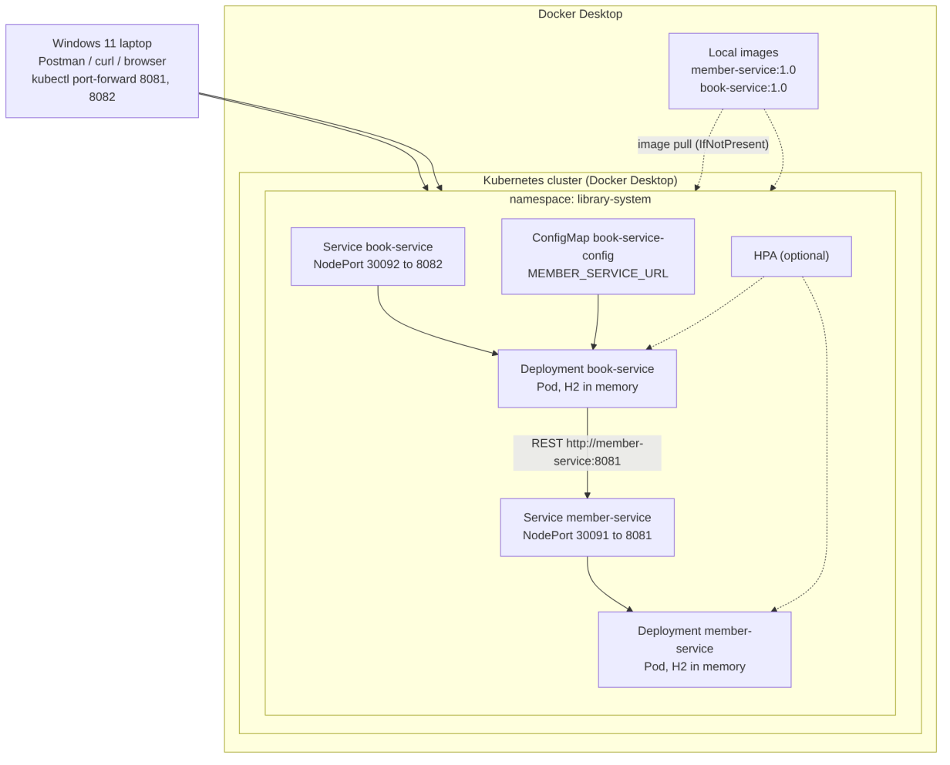
Figure 5: Deployment architecture
Object | Name | Purpose
Namespace | library-system | Keeps all resources of the application together
ConfigMap | book-service-config | Holds MEMBER_SERVICE_URL for the Book Service
Deployment | member-service | One pod of member-service:1.0, with readiness and liveness probes, CPU and memory limits
Service | member-service (NodePort 30091) | Stable name and port 8081 inside the cluster, also reachable from outside
Deployment | book-service | One pod of book-service:1.0, reads the ConfigMap
Service | book-service (NodePort 30092) | Stable name and port 8082
HPA (optional) | member-service-hpa, book-service-hpa | Scales 1 to 3 pods at 70% CPU. Needs metrics-server
Pods reach each other through the Service name. The Book Service calls http://member-service:8081, which the cluster DNS resolves to the Member Service.

14.2 Manifests
The complete manifests are in the k8s folders of the repositories. The Member Service Deployment is shown here as an example:
apiVersion: apps/v1
kind: Deployment
metadata:
name: member-service
namespace: library-system
labels:
app: member-service
spec:
replicas: 1
selector:
matchLabels:
app: member-service
template:
metadata:
labels:
app: member-service
spec:
containers:
- name: member-service
image: member-service:1.0
imagePullPolicy: IfNotPresent
ports:
- containerPort: 8081
resources:
requests: { cpu: "100m", memory: "256Mi" }
limits: { cpu: "500m", memory: "512Mi" }
readinessProbe:
httpGet: { path: /actuator/health/readiness, port: 8081 }
initialDelaySeconds: 30
periodSeconds: 10
livenessProbe:
httpGet: { path: /actuator/health/liveness, port: 8081 }
initialDelaySeconds: 60
periodSeconds: 15
imagePullPolicy: IfNotPresent is important because the images only exist locally and are not in a registry.

14.3 Commands, in order
Kubernetes is enabled in Docker Desktop (Settings, Kubernetes, Enable Kubernetes, cluster type kubeadm) and the status at the bottom left of Docker Desktop shows it as running. After that:
kubectl config use-context docker-desktop
kubectl config current-context
kubectl get nodes
docker images
kubectl apply -f k8s/namespace.yaml
kubectl apply -f k8s/book-service-configmap.yaml
kubectl apply -f k8s/member-service-deployment.yaml
kubectl apply -f k8s/member-service-service.yaml
kubectl apply -f k8s/book-service-deployment.yaml
kubectl apply -f k8s/book-service-service.yaml
kubectl get pods -n library-system
kubectl get svc -n library-system
kubectl get all -n library-system
kubectl describe pod -l app=member-service -n library-system
kubectl logs deployment/member-service -n library-system
kubectl logs deployment/book-service -n library-system
kubectl port-forward svc/member-service 8081:8081 -n library-system
kubectl port-forward svc/book-service 8082:8082 -n library-system
docker images is run to confirm that member-service:1.0 and book-service:1.0 exist, because the pods use them. The two port-forward commands are run in two separate terminals, and the Postman URLs are localhost:8081 and localhost:8082. The NodePorts (30091 and 30092) can also be used directly on localhost.
Optional scaling demo. Docker Desktop does not include metrics-server, so it is installed first (the patch command is run in Git Bash, because PowerShell changes the quotes):
kubectl apply -f https://github.com/kubernetes-sigs/metrics-server/releases/latest/download/components.yaml
kubectl patch deployment metrics-server -n kube-system --type=json -p '[{"op":"add","path":"/spec/template/spec/containers/0/args/-","value":"--kubelet-insecure-tls"}]'
kubectl top nodes
kubectl apply -f k8s/hpa.yaml
kubectl get hpa -n library-system
kubectl scale deployment member-service --replicas=2 -n library-system
[ Paste screenshot here ]
Figure 13: Output of kubectl get nodes and kubectl config current-context
[ Paste screenshot here ]
Figure 14: Output of kubectl get pods -n library-system showing both pods Running 1/1
[ Paste screenshot here ]
Figure 15: Output of kubectl get svc -n library-system
[ Paste screenshot here ]
Figure 16: Output of kubectl describe pod for member-service
[ Paste screenshot here ]
Figure 17: Output of kubectl logs for book-service after a borrow call

14.4 Kubernetes dashboard
The assignment asks to open the Kubernetes dashboard and analyse the deployments. The official Kubernetes Dashboard project was archived in January 2026 and the Kubernetes project now points to Headlamp as the replacement. I therefore used the following options, in this order:
- Headlamp. It can be installed on Windows with winget install headlamp. It reads the same kubeconfig as kubectl, so it shows the docker-desktop cluster directly.
- The Kubernetes Dashboard from its Helm chart, if it is needed (it still works, but it is not maintained).
In the dashboard I selected the namespace library-system and checked the following.
What I checked | Where | What I looked at
Deployments | Workloads, Deployments | Both deployments show 1/1 available, image names, strategy RollingUpdate
Pods | Workloads, Pods | Both pods Running, restart count 0, node, IP, CPU and memory
Services | Network, Services | member-service and book-service, type NodePort, ports 8081 and 8082, endpoints
ConfigMap | Config, ConfigMaps | book-service-config with MEMBER_SERVICE_URL
Logs | Pod, Logs | Startup logs and the borrow call from the Book Service to the Member Service
Events | Pod, Events | Image pulled or already present, container started, probes passing
[ Paste screenshot here ]
Figure 18: Kubernetes dashboard (Headlamp) overview of namespace library-system
[ Paste screenshot here ]
Figure 19: Dashboard Deployments page showing member-service and book-service
[ Paste screenshot here ]
Figure 20: Dashboard Pods page showing both pods Running
[ Paste screenshot here ]
Figure 21: Dashboard Services page showing the two NodePort services
[ Paste screenshot here ]
Figure 22: Dashboard ConfigMap page showing book-service-config
[ Paste screenshot here ]
Figure 23: Dashboard pod logs of book-service

15. Execution Instructions
Short version. The detailed beginner guide with checks after each step is given in my companion execution guide.
Prerequisites: Java 17 (java -version), Maven 3.8 or higher (mvn -v), Git (git --version), Docker Desktop running (docker version), kubectl (kubectl version --client), Kubernetes enabled in Docker Desktop, Postman.
- Clone the two repositories into one folder.
- Run each service locally to check it works: mvn clean package and then java -jar target/<service>.jar. Start the Member Service first.
- Build the Docker images and run the containers (Section 13).
- Stop the containers, switch kubectl to the docker-desktop context, and apply the manifests in the order of Section 14.3.
- Wait until kubectl get pods -n library-system shows both pods 1/1 Running.
- Start the two port-forwards and run the Postman collection (Section 16).
- Open the dashboard and capture the screenshots.

16. Postman Test Results
The Postman collection LibraryManagement.postman_collection.json has two folders (Member Service and Book Service). It uses the variables memberBase = http://localhost:8081 and bookBase = http://localhost:8082. The ids returned by the create calls are saved in variables, so the requests can be run one after another.
The request and response bodies below are the expected ones for a fresh start of both services. Timestamps and dates will be different in each run.

16.1 Member APIs
Create member: POST {{memberBase}}/api/members
{
"fullName": "Anitha Raman",
"email": "anitha.raman@example.com",
"phone": "9876543210",
"membershipType": "STANDARD"
}
Response: 201 Created
{
"id": 1,
"fullName": "Anitha Raman",
"email": "anitha.raman@example.com",
"phone": "9876543210",
"membershipType": "STANDARD",
"joinedOn": "2026-11-11"
}
[ Paste screenshot here ]
Figure 24: Postman: Create Member request and 201 response
A second member (Karthik Subramanian, PREMIUM, id 2) is created in the same way.
Get all members: GET {{memberBase}}/api/members returns 200 with an array of the members created so far.
[ Paste screenshot here ]
Figure 25: Postman: Get All Members response
Get member by id: GET {{memberBase}}/api/members/1 returns 200 with the member. For an id that does not exist (for example 9999) the response is 404:
{
"timestamp": "2026-11-11T10:20:11.512Z",
"status": 404,
"error": "Not Found",
"message": "Member not found with id 9999",
"path": "/api/members/9999"
}
[ Paste screenshot here ]
Figure 26: Postman: Get Member by id, and the 404 for an unknown id
Update member: PUT {{memberBase}}/api/members/1 with the same body and a changed phone number returns 200 with the updated member.
[ Paste screenshot here ]
Figure 27: Postman: Update Member request and response
Validation error: POST with an empty name, an invalid email and a wrong phone returns 400:
{
"timestamp": "2026-11-11T10:22:40.101Z",
"status": 400,
"error": "Bad Request",
"message": "email: email is not valid; fullName: fullName is required; phone: phone must have 7 to 15 digits",
"path": "/api/members"
}
A duplicate email returns 409 Email anitha.raman@example.com is already registered.
Delete member: DELETE {{memberBase}}/api/members/2 returns 204 No Content. This is run at the end, after the loan tests.
[ Paste screenshot here ]
Figure 28: Postman: Validation error 400, duplicate email 409 and Delete Member 204

16.2 Book and loan APIs
Add book: POST {{bookBase}}/api/books
{
"isbn": "9781617294549",
"title": "Microservices Patterns",
"author": "Chris Richardson",
"copies": 1
}
Response: 201 Created
{
"id": 1,
"isbn": "9781617294549",
"title": "Microservices Patterns",
"author": "Chris Richardson",
"totalCopies": 1,
"availableCopies": 1
}
[ Paste screenshot here ]
Figure 29: Postman: Add Book request and 201 response
A second book (Building Microservices, 3 copies, id 2) is added the same way. GET {{bookBase}}/api/books and GET {{bookBase}}/api/books/1 return 200.
[ Paste screenshot here ]
Figure 30: Postman: Get All Books and Get Book by id
Borrow book: POST {{bookBase}}/api/loans
{
"memberId": 1,
"bookId": 1
}
Response: 201 Created
{
"loanId": 1,
"memberId": 1,
"memberName": "Anitha Raman",
"bookId": 1,
"isbn": "9781617294549",
"title": "Microservices Patterns",
"borrowedOn": "2026-11-11T10:30:05.654321",
"dueDate": "2026-11-25",
"returnedOn": null,
"status": "ACTIVE"
}
[ Paste screenshot here ]
Figure 31: Postman: Borrow Book request and 201 response (this shows the call between the two services)
Rules in action. The same request again returns 409 because the member already holds the book. The book has only one copy, so a request from member 2 for book 1 returns 409:
{
"timestamp": "2026-11-11T10:31:02.337Z",
"status": 409,
"error": "Conflict",
"message": "No copies of 'Microservices Patterns' are available right now",
"path": "/api/loans"
}
An unknown member ("memberId": 9999) returns 404 Member not found with id 9999, which is produced by the Member Service and passed on by the Book Service. An unknown book returns 404 Book not found with id 9999. Getting the book again shows availableCopies as 0.
[ Paste screenshot here ]
Figure 32: Postman: 409 duplicate loan, 409 no copies, and 404 for unknown member
Return book: PUT {{bookBase}}/api/loans/1/return returns 200 with status RETURNED and the returnedOn time filled in. A second return of the same loan returns 409 Loan 1 was already returned. The book then shows availableCopies 1 again, and member 2 can borrow it.
[ Paste screenshot here ]
Figure 33: Postman: Return Book 200, second return 409, and the book showing availableCopies 1 again
View loans: GET {{bookBase}}/api/loans, GET {{bookBase}}/api/loans/1 and GET {{bookBase}}/api/loans/member/1 return 200 with the loan records in the format shown above.
[ Paste screenshot here ]
Figure 34: Postman: View Loans (all, by id, by member)
Loan limit check (optional). A STANDARD member who already holds 3 books gets 409 Loan limit reached: STANDARD members can hold 3 books at a time on the fourth borrow. For this test 4 different books are needed.
Resilience check. To show the 503 case, the member pod is scaled to zero with kubectl scale deployment member-service --replicas=0 -n library-system. A borrow request then returns 503 Member Service is not reachable, please try again later, while GET /api/books and the return call still work. The pod is scaled back to 1 afterwards (member data is lost because H2 is in memory, so the members are created again).
[ Paste screenshot here ]
Figure 35: Postman: 503 response when the Member Service is scaled down (optional)

16.3 Collection runner
[ Paste screenshot here ]
Figure 36: Postman Collection Runner result showing all requests passed

17. Optional: CI Pipeline
Each repository contains a GitHub Actions workflow in .github/workflows/ci.yml. On every push or pull request to main it sets up JDK 17, runs mvn -B clean package (which also runs the tests) and builds the Docker image. I did not set up an automatic deployment to the cluster because the cluster is on a local laptop. For a real setup the next steps would be to push the image to a registry and apply the manifests from the pipeline.
[ Paste screenshot here ]
Figure 37: GitHub Actions run for one of the repositories (optional, if the workflow passes)

18. Limitations and Future Work
- In-memory H2. Data is lost when a pod restarts, and if more than one replica is started each pod has its own separate data. For real scaling a shared database (PostgreSQL) per service with a persistent volume is needed. I kept H2 because the assignment asked for it, and the HPA manifest is only included as an optional demonstration.
- No distributed transaction. Borrowing depends on a read from another service. If a member is deleted while holding books, the loans stay. A real system would publish a MemberDeleted event, or block the delete while loans are active.
- Two requests for the last copy. The copy check and the update are not locked, so two simultaneous requests for the last copy could both succeed. Optimistic locking (a version column on the book) would fix this.
- No fines or reservations. The due date is stored but nothing checks it. Overdue handling and fines are future work.
- No authentication. APIs are open. A gateway with JWT validation would be added.
- Synchronous coupling. Borrowing fails if the Member Service is down. A circuit breaker, retry and caching of the membership type could reduce this.
- No API gateway or notification service. They are in the design but not implemented.
- Single node cluster. Docker Desktop's cluster has one node, so node failure could not be tested.

19. Conclusion
I designed a library system as a set of services based on business capabilities, listed its commands and queries, and assigned them to services. I implemented the Member Service and the Book Service with Spring Boot, packaged them as separate Docker images and deployed them to a local Kubernetes cluster. The Book Service uses REST to read members from the Member Service, and the service address is passed in through a ConfigMap, so the same code runs locally, in Docker and in Kubernetes.
The assignment helped me see how a service boundary affects the code: there can be no database foreign key between loans and members, the copy count and the loan have to stay in the same service to be changed in one transaction, and I had to decide what to do when the other service is down. It also showed how much of the work in a microservice project is packaging and configuration (Dockerfile, probes, service names, ConfigMap) and not only Java code. The main things I would improve next are a shared database, locking for the last copy, an API gateway and asynchronous events for overdue reminders.

20. References
- BITS Pilani WILP, SEZG583 Scalable Services, course handout and assignment statement, 2026.
- C. Richardson, Microservices Patterns, Manning Publications, 2018 (decomposition by business capability, database per service, system operations).
- Spring Boot Reference Documentation, https://docs.spring.io/spring-boot/
- Spring Data JPA Reference, https://docs.spring.io/spring-data/jpa/reference/
- Docker Documentation, https://docs.docker.com/
- Kubernetes Documentation, https://kubernetes.io/docs/
- Docker Desktop Documentation, https://docs.docker.com/desktop/
- Headlamp, Kubernetes web UI, https://headlamp.dev/
- Kubernetes blog, "From Kubernetes Dashboard to Headlamp: Understanding the Transition", 2026.
- H2 Database Engine, https://www.h2database.com/
- Postman Learning Center, https://learning.postman.com/

