SPAR Enterprise
BAU Incident Management
Business Requirements Document
& Business Process Reengineering

Kanban-to-Sprint Transformation
Jira Service Management | Confluence | SEOP Platform

Prepared by: Scrums.com | Software Engineering. Sorted.
Date: August 2026
Version: 2.0
CONFIDENTIAL

Document Control
Field | Details
Document Title | SPAR Enterprise BAU Incident Management — BRD & Business Process Reengineering
Version | 2.0
Date | August 2026
Author | Siveshin Reddy, Enterprise Business Analyst — Scrums.com
Client | SPAR Enterprise — IT Services
Classification | Confidential
Status | Draft for Review

Revision History
Version | Date | Author | Changes
0.1 | July 2026 | S. Reddy | Initial As-Is / To-Be ideation (combined with Project & Demand workstreams)
0.5 | August 2026 | S. Reddy | Incident Management extracted as standalone focus; process flows drafted
1.0 | August 2026 | S. Reddy | Full BRD with Kanban-to-Sprint reengineering, JSM integration, SEOP reporting layer

Distribution List
Name | Role | Organisation
Mary Oelsen | CIO / Executive Sponsor | SPAR Enterprise
Kogilan Coopasamy | IT Programme Manager | SPAR Enterprise
Ashkelon Packery | Enterprise Architect | SPAR Enterprise
Andrew Ehrich | IT Operations Manager | SPAR Enterprise
Anton Seocharan | 2nd Level Support Lead | SPAR Enterprise
Solly Khoza | 2nd Level Support | SPAR Enterprise
Yusuf Abdullatief | Business Stakeholder | SPAR Enterprise
Siveshin Reddy | Enterprise Business Analyst | Scrums.com

Table of Contents

1. Executive Summary
This Business Requirements Document (BRD) and Business Process Reengineering (BPR) plan focuses exclusively on the BAU Incident Management workstream within SPAR Enterprise IT Services. It defines the current-state (As-Is) process, identifies inefficiencies, and prescribes a structured transformation from the existing ad-hoc Kanban workflow to a disciplined, sprint-based delivery model powered by Jira Service Management (JSM).
The Incident Management function — owned by Anton Seocharan and Solly Khoza as 2nd Level Support — currently operates on a reactive Kanban board within the Jira Logistics Portfolio. Tickets flow from the SPAR CRM (1st Level) to a flat backlog with no formal sprint cadence, no automated SLA tracking, and no structured code-review process for development work. Severity 1 incidents are escalated via WhatsApp and Microsoft Teams, bypassing formal channels.
The proposed To-Be state introduces:
- Jira Service Management (JSM) as the front-door for incident intake, with automated SLA assignment based on the existing P1–P5 priority model (governed by Andrew Murch’s team).
- Weekly sprint cadence for 2nd Level Support, replacing the open-ended Kanban pull model with planned capacity, formal ceremonies (Planning, Daily Standup, Review, Retrospective), and measurable velocity.
- Formal GitHub PR workflow with branch-per-ticket, mandatory code review, and CI/CD integration — replacing the current direct-commit approach.
- Confluence knowledge base with Rovo AI agents that auto-link related tickets and surface resolution articles during triage.
- SEOP platform (Scrums.com) as the unified reporting layer on top of Confluence and Jira, providing sprint dashboards, SLA compliance views, burndown charts, and stakeholder governance reports.
This transformation preserves the existing triage structure and priority model — the people and decision points remain the same. What changes is the cadence, tooling, and visibility around those decisions.

2. Scope & Objectives

2.1 In Scope
- BAU Incident Management process (1st Level triage through 2nd Level resolution and development handoff)
- Kanban-to-Sprint transformation for the 2nd Level Support team
- Jira Service Management (JSM) implementation for incident intake and SLA automation
- Sprint ceremony framework (Planning, Standup, Review, Retrospective)
- GitHub PR workflow standardisation (branching strategy, code review, CI/CD)
- Confluence knowledge base and Rovo agent integration
- SEOP reporting layer configuration (dashboards, metrics, governance views)
- Process flow documentation (As-Is and To-Be, high-level and detailed)

2.2 Out of Scope
- SPAR Enterprise DC Deployment — Project workstream (covered in a separate BRD)
- Demand Management workstream (separate backlog and governance)
- 1st Level Support tooling changes (SPAR CRM remains as-is for initial phase)
- Infrastructure changes, server provisioning, or network modifications
- Commercial terms, licensing, or procurement

2.3 Objectives
Objective | Success Measure
Reduce mean time to resolution (MTTR) for P1/P2 incidents | MTTR reduction of 25% within 3 sprints of go-live
Introduce measurable sprint velocity for 2nd Level Support | Velocity tracked and reported per sprint via SEOP
Achieve 95% SLA compliance for P1–P3 incidents | JSM SLA dashboard shows ≥95% within 6 sprints
Eliminate direct-commit deployments | 100% of code changes go through PR review within 2 sprints
Establish a self-service knowledge base | ≥20 runbook articles in Confluence within 3 months
Provide executive visibility into incident trends | Weekly SEOP governance report delivered to stakeholders

3. Current State (As-Is)

3.1 Process Overview
The current BAU Incident Management process follows a reactive, queue-based model. Incidents are reported by end users through phone, email, or walk-in contact and are logged by the SPAR CRM team (1st Level Support). After initial diagnosis, unresolved tickets are escalated to the Jira Logistics Portfolio Kanban board, where Anton Seocharan and Solly Khoza (2nd Level Support) pick up and work items in an ad-hoc fashion.
There is no formal sprint cadence, no automated SLA enforcement, and no structured reporting beyond Jira board column movements. Development work (when required) follows a direct-commit model on GitHub with no pull-request review gate.

3.2 High-Level As-Is Process Flow
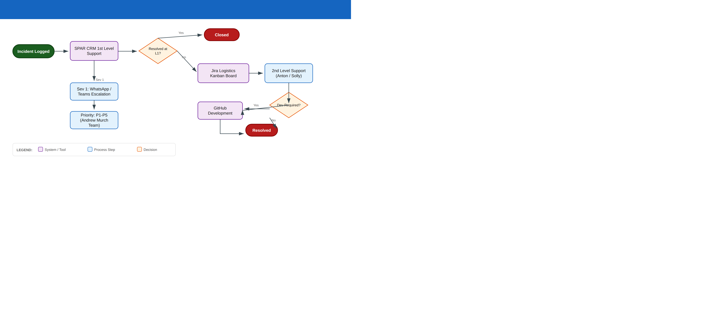
Figure 1: High-Level As-Is — Incident Management Process Flow

3.3 Detailed As-Is Process Flow
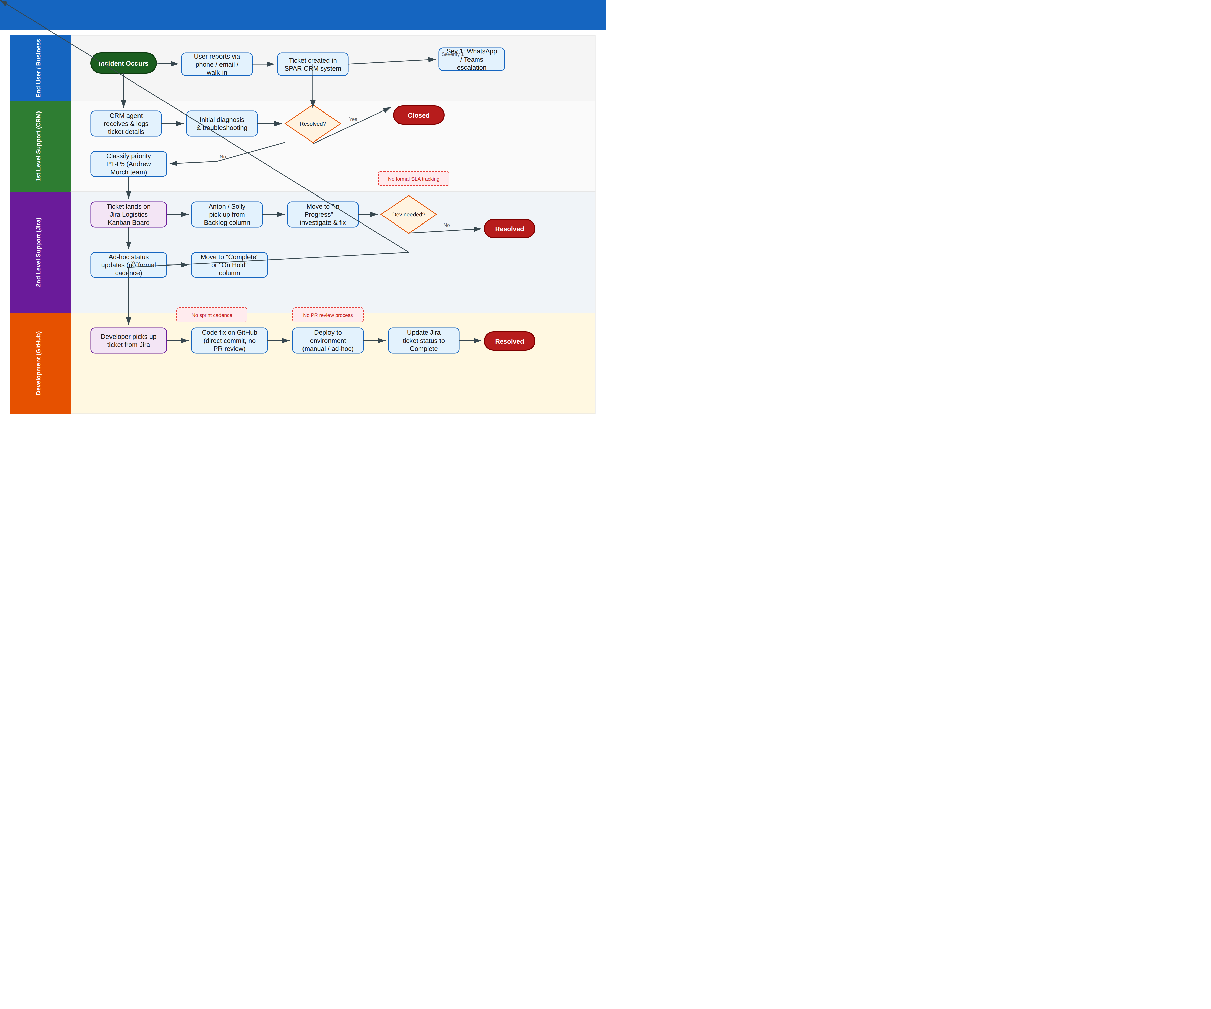
Figure 2: Detailed As-Is — Swimlane Process Flow (Current State)

3.4 Current Tooling & Platforms
Platform | Usage | Pain Points
SPAR CRM | 1st Level ticket logging and initial triage | No integration with Jira; manual handoff to 2nd Level
Jira Logistics Portfolio (Kanban) | 2nd Level backlog; columns: Backlog, Next Priorities, In Progress, On Hold, Complete, Rejected | No sprint cadence; no SLA tracking; no automated notifications
GitHub | Source code for development fixes | Direct commits to main; no PR review; no branch strategy
WhatsApp / Microsoft Teams | Severity 1 escalation path | Informal; no audit trail; bypasses ticketing system
Email / Phone | Incident reporting by end users | No self-service portal; high manual effort for 1st Level

3.5 Current Priority Model
The P1–P5 priority model is governed by Andrew Murch’s team and applies specifically to Incident Management / Helpdesk. This is distinct from the business-determined priority (High/Medium/Low) used by the Project and Demand workstreams.
Priority | Definition
P1 — Critical | Complete service outage affecting multiple business units; immediate escalation via WhatsApp/Teams
P2 — High | Significant degradation of a business-critical system; 2nd Level engagement within 2 hours
P3 — Medium | Partial loss of non-critical functionality; resolution within business SLA window
P4 — Low | Minor issue with workaround available; scheduled for next available capacity
P5 — Informational | Enhancement request or cosmetic issue; backlogged for future consideration

3.6 Current Pain Points
Pain Point | Business Impact
No formal SLA enforcement | Tickets can sit in backlog indefinitely with no escalation trigger; no accountability metrics
Ad-hoc Kanban without sprint cadence | No planned capacity; no velocity measurement; impossible to forecast resolution timelines
Direct commits to GitHub | No peer review; higher risk of introducing bugs; no traceability from ticket to code change
Manual status reporting | Stakeholders rely on ad-hoc updates; no single dashboard for incident health
Sev 1 escalation via WhatsApp | No formal audit trail; critical incident response depends on individual availability
No knowledge base | Repeat incidents require re-investigation; tribal knowledge locked in individuals
Disconnected tooling | CRM, Jira, GitHub, and communication tools operate in silos; context lost at each handoff

4. Future State (To-Be)

4.1 Transformation Summary
The To-Be state preserves the existing people structure and priority model while introducing process discipline, automation, and visibility. The core transformation is moving from an open-ended Kanban pull model to a weekly sprint cadence with formal ceremonies, automated SLA management via JSM, and a structured GitHub PR workflow.
The SEOP platform (Scrums.com) serves as the reporting and governance layer on top of Confluence and Jira. It does not replace these tools — it aggregates their data into executive dashboards, sprint performance views, and compliance reports. Think of SEOP as the lens through which stakeholders observe and govern the process, while Jira and Confluence remain the systems of record.

4.2 High-Level To-Be Process Flow
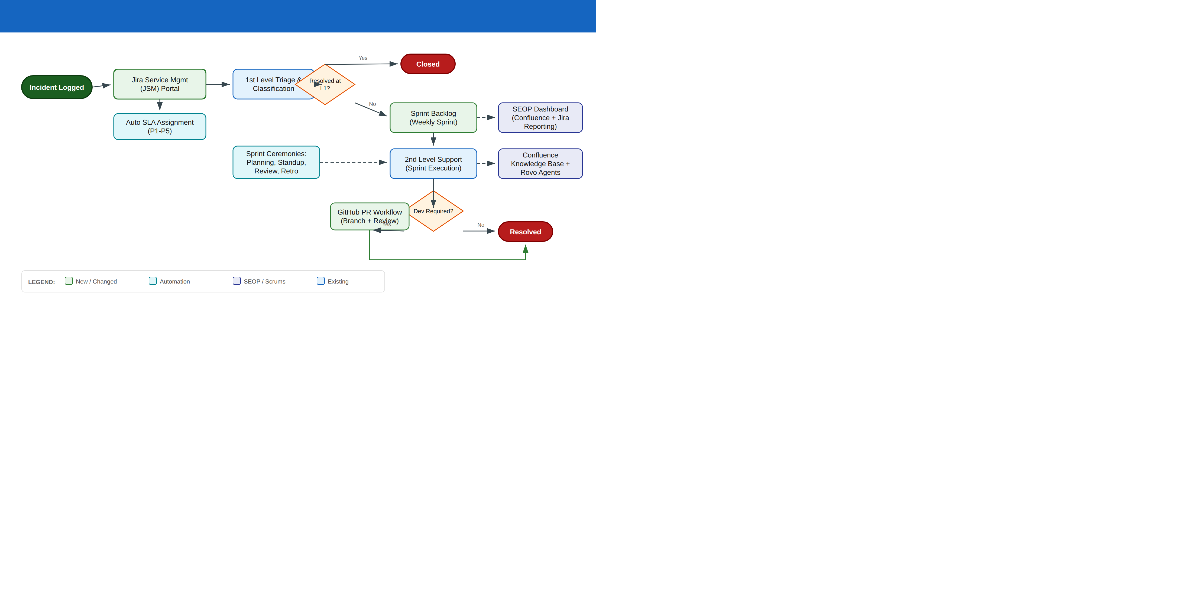
Figure 3: High-Level To-Be — Sprint-Based Incident Management

4.3 Detailed To-Be Process Flow
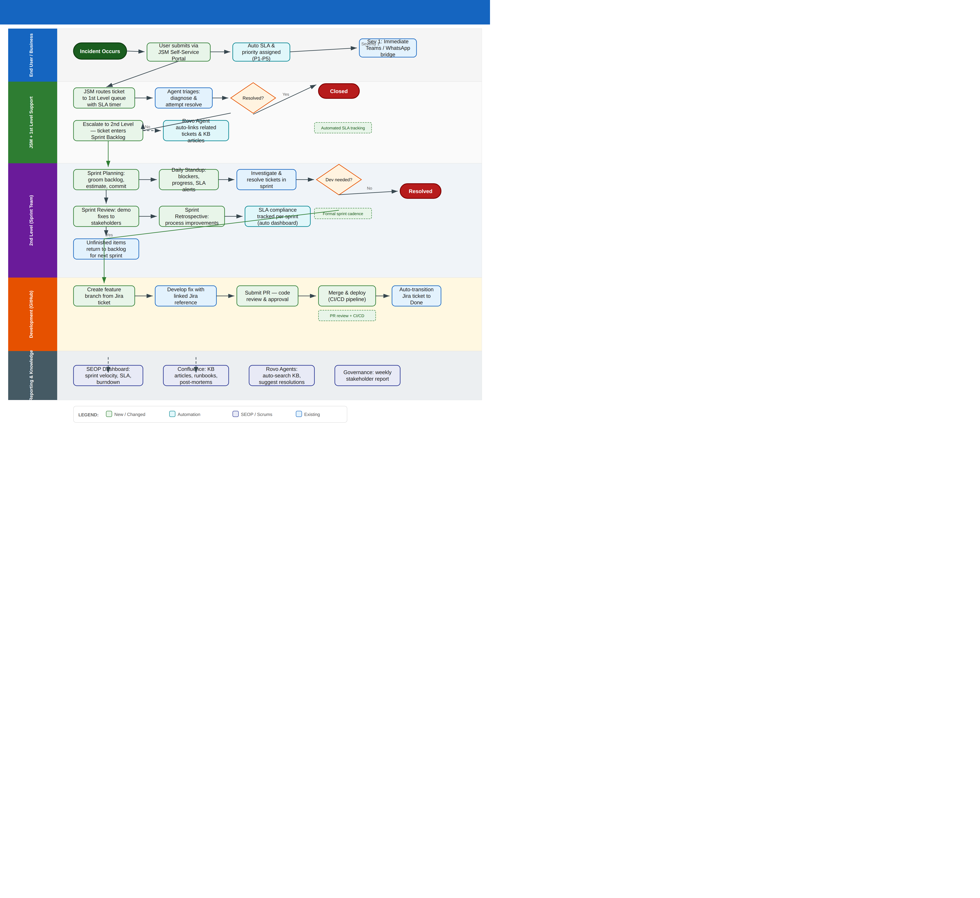
Figure 4: Detailed To-Be — Swimlane Process Flow (Sprint-Based with JSM)

4.4 Key Changes Summary
Area | As-Is (Current) | To-Be (Proposed)
Incident Intake | Phone/email to SPAR CRM; manual logging | JSM Self-Service Portal with auto-categorisation
SLA Management | No formal SLA tracking | Automated P1–P5 SLA timers in JSM; escalation triggers
Work Management | Open Kanban board; ad-hoc pull | Weekly sprints with planning, standup, review, retro
Priority Assignment | Manual classification by 1st Level | Auto-assigned by JSM rules; manual override available
Development Workflow | Direct commit to main branch | Branch-per-ticket; PR with code review; CI/CD pipeline
Knowledge Management | No formal knowledge base | Confluence KB with Rovo AI agents for auto-search
Reporting & Governance | Ad-hoc Jira board views | SEOP dashboards: velocity, SLA, burndown, governance
Sev 1 Escalation | WhatsApp/Teams (informal) | JSM escalation rules + Teams/WhatsApp bridge (audited)
Triage Process | 1st Level diagnosis in CRM | Unchanged — 1st Level triage preserved as-is
Success Measurement | No formal metrics | Sprint velocity, SLA compliance, MTTR, burndown

5. Kanban-to-Sprint Transformation

5.1 Why Sprints?
The current Kanban model provides flexibility but lacks the cadence and predictability needed for a mature incident management function. Without time-boxed iterations, there is no natural forcing function for prioritisation, no regular retrospective to drive process improvement, and no way to measure whether the team’s capacity is being used effectively.
Sprints introduce:
- Predictable delivery windows — stakeholders know that committed work will be reviewed within one week
- Measurable velocity — the team can track story points or ticket counts per sprint, enabling capacity planning
- Regular feedback loops — Sprint Review surfaces completed work to stakeholders; Retrospective drives continuous improvement
- SLA accountability — sprint planning forces explicit prioritisation of SLA-breaching tickets

5.2 Sprint Structure — High Level
The proposed sprint cadence is a one-week (5 business day) cycle, aligned with the existing incident flow rhythm. This short cycle ensures that no incident waits more than one planning session to enter active work.
Sprint Element | Details
Sprint Duration | 1 week (Monday to Friday)
Sprint Goal | Resolve committed backlog items within SLA; zero P1/P2 breaches
Team | Anton Seocharan (Lead), Solly Khoza, + development resources as needed
Backlog Source | JSM escalations from 1st Level; items carried over from previous sprint
Capacity Buffer | 20% of sprint capacity reserved for unplanned P1/P2 incidents mid-sprint

5.3 Sprint Ceremonies — Detailed Breakdown

5.3.1 Sprint Planning (Monday, 09:00–10:00)
The team reviews the prioritised backlog, selects items for the sprint based on capacity, and commits to a sprint goal. Items are ordered by SLA urgency (P1/P2 first), then business value.
- Attendees: Anton Seocharan, Solly Khoza, Scrum Master (Scrums.com), Product Owner representative
- Inputs: Prioritised JSM backlog, previous sprint velocity, SLA compliance report
- Outputs: Sprint backlog (committed items), sprint goal, capacity allocation
- Tool: Jira Sprint Board — move items from Backlog to Sprint; SEOP sprint planning view

5.3.2 Daily Standup (Daily, 09:00–09:15)
A 15-minute time-boxed synchronisation meeting. Each team member answers three questions: What did I complete yesterday? What am I working on today? Are there any blockers?
- Attendees: Sprint team (mandatory), stakeholders (optional observe)
- Focus: SLA alerts, blocked tickets, mid-sprint P1/P2 arrivals
- Tool: Jira board filtered to current sprint; SEOP daily view

5.3.3 Sprint Review (Friday, 14:00–15:00)
The team demonstrates completed work to stakeholders. This is not a sign-off meeting — it is a feedback session where stakeholders see resolved incidents, deployed fixes, and knowledge articles created during the sprint.
- Attendees: Sprint team, Product Owner, key stakeholders (Kogilan, Andrew)
- Outputs: Accepted/rejected items, stakeholder feedback, updated backlog priorities
- Tool: SEOP Sprint Review dashboard — showing velocity, SLA compliance, and burndown for the sprint

5.3.4 Sprint Retrospective (Friday, 15:00–15:30)
The team reflects on what went well, what didn’t, and what to improve. Action items are tracked and reviewed at the next retrospective.
- Attendees: Sprint team only (safe space for candid discussion)
- Outputs: 2–3 actionable improvement items for the next sprint
- Tool: Confluence retrospective page (template provided); actions tracked in Jira

5.4 Sprint Board Configuration
The existing Jira Logistics Kanban board will be reconfigured as a Sprint Board with the following columns:
Column | Purpose | Automation
Backlog | All escalated tickets not yet committed to a sprint | Auto-populated from JSM escalations
Sprint Backlog | Items committed for the current sprint | Populated during Sprint Planning
In Progress | Actively being worked by 2nd Level | SLA timer continues; daily standup focus
In Review | Awaiting code review (for dev items) or stakeholder validation | PR linked; review reminders via Jira automation
Done | Resolved and validated within the sprint | Auto-transition when PR merged or resolution confirmed
Carry Over | Not completed in sprint; returns to backlog with priority boost | Flagged in Sprint Review; SLA impact noted

5.5 Handling Unplanned Work (Mid-Sprint P1/P2)
Critical incidents (P1/P2) that arrive mid-sprint cannot wait for the next planning session. The sprint model accommodates this with a 20% capacity buffer and a defined escalation protocol:
- P1/P2 ticket arrives in JSM with automated SLA assignment.
- Scrum Master assesses impact on current sprint commitments.
- If the team can absorb it within the buffer, it enters the current sprint immediately.
- If it exceeds buffer capacity, the lowest-priority committed item is moved to Carry Over.
- The displaced item is flagged in the daily standup and Sprint Review for transparency.
This preserves sprint discipline while ensuring critical incidents are never delayed by process.

6. Jira Service Management (JSM) Integration

6.1 JSM Portal Configuration
Jira Service Management will serve as the single entry point for all incident submissions, replacing the current phone/email-to-CRM-to-Jira handoff chain. The JSM portal provides:
- Self-service portal for end users to log incidents with guided categorisation
- Automated priority and SLA assignment based on impact/urgency matrix
- Transparent status tracking for reporters (real-time updates without chasing agents)
- Integration with Confluence KB — suggested articles before ticket creation (deflection)

6.2 SLA Configuration
Priority | First Response | Resolution Target | Escalation Trigger
P1 — Critical | 15 minutes | 4 hours | Auto-escalate to management after 2 hours
P2 — High | 30 minutes | 8 hours | Auto-escalate after 4 hours
P3 — Medium | 2 hours | 3 business days | Auto-escalate after 2 business days
P4 — Low | 4 hours | 5 business days | Flagged if open > 4 business days
P5 — Informational | 1 business day | 10 business days | No auto-escalation; reviewed in Sprint Planning

6.3 JSM-to-Jira Sprint Board Flow
When a ticket is escalated from 1st Level to 2nd Level, JSM automatically:
- Creates a linked Jira issue in the Logistics project with the original ticket’s context.
- Applies the SLA timer that carries forward from the JSM ticket.
- Places the issue in the Sprint Backlog for the next Sprint Planning session.
- Triggers a Rovo agent to search Confluence KB for related articles and auto-link them.
- Notifies the 2nd Level team via Jira notification and Teams channel.
For P1/P2 tickets, step 3 is bypassed — the ticket enters the current sprint immediately per the mid-sprint protocol defined in Section 5.5.

7. GitHub Development Workflow

7.1 Current vs. Proposed
Aspect | Current (As-Is)
Branching | Direct commits to main/master branch
Code Review | None — individual developer pushes directly
CI/CD | Manual or ad-hoc deployment
Traceability | No link between Jira ticket and code change

Aspect | Proposed (To-Be)
Branching | Feature branch per Jira ticket (e.g., LOGISTICS-273-fix-login-timeout)
Code Review | Mandatory PR with at least one reviewer approval
CI/CD | Automated build/test on PR; deploy on merge to main
Traceability | Jira ticket ID in branch name and PR title; auto-link via Smart Commits

7.2 PR Workflow Steps
- Developer creates a branch from main: LOGISTICS-{id}-{description}
- Code changes are committed with Jira Smart Commit messages (e.g., LOGISTICS-273 #comment Fixed timeout)
- Developer opens a Pull Request; Jira auto-transitions the ticket to "In Review"
- At least one team member reviews the PR; automated tests run in CI
- On approval and passing tests, PR is merged to main
- CI/CD pipeline deploys to the target environment
- Jira ticket auto-transitions to "Done"

7.3 Repository Structure
Two GitHub repositories support the SPAR Enterprise incident management development:
- SPAR-side (ReddySive_sza/spar-enterprise-flows): Client-facing repository for SPAR-owned code and configuration
- Scrums.com-side (siveshin-scrumsdotcom/spar-enterprise-flows): Scrums.com internal repository for platform integration, SEOP connectors, and reporting templates
Both repositories follow the same branching and PR conventions. Cross-repo dependencies are documented in Confluence.

8. Confluence Knowledge Base & Rovo Agents

8.1 Knowledge Base Structure
A dedicated Confluence space (within the existing Enterprise space) will house all incident management knowledge:
Section | Content
Runbooks | Step-by-step resolution guides for recurring incidents (e.g., "Login timeout on ERP portal")
Post-Mortems | Root cause analysis for P1/P2 incidents; lessons learned and prevention measures
Architecture Diagrams | System topology, integration maps, and dependency charts for reference during triage
Sprint Reports | Archived sprint review summaries, velocity trends, and SLA compliance history
Onboarding | New team member onboarding guide: tools, access, processes, contacts
FAQ | Common questions from 1st Level and end users; linked to runbooks

8.2 Rovo AI Agent Configuration
Atlassian Rovo agents will be configured to provide intelligent automation across the incident management workflow:

8.2.1 Triage Assistant Agent
- Trigger: New ticket escalated from 1st Level to 2nd Level
- Action: Search Confluence KB for related runbooks and past incidents; auto-link top 3 matches to the Jira ticket
- Benefit: Reduces investigation time; surfaces institutional knowledge that might otherwise be missed

8.2.2 SLA Monitor Agent
- Trigger: Ticket approaching SLA breach threshold (80% of time elapsed)
- Action: Post a warning in the team’s Teams channel; update Jira ticket with SLA risk flag
- Benefit: Proactive alerting prevents SLA breaches before they happen

8.2.3 Sprint Health Agent
- Trigger: Daily at 08:45 (before standup)
- Action: Compile sprint progress summary — tickets done, in progress, blocked; SLA status; carry-over risk
- Benefit: Team arrives at standup with context already prepared; meeting stays under 15 minutes

9. SEOP Platform — Reporting & Governance Layer

9.1 What is SEOP?
The Scrums.com SEOP (Software Engineering Operations Platform) is a reporting and governance layer that sits on top of Confluence and Jira. It does not replace these tools or add a new system of record — it aggregates data from the existing Atlassian stack and presents it in purpose-built dashboards for different audiences.
Think of SEOP as a window into the process: Jira is where the work happens; Confluence is where knowledge lives; SEOP is where stakeholders observe, govern, and make decisions.

9.2 SEOP Dashboard Views
Dashboard | Audience | Key Metrics
Sprint Velocity | Sprint Team, Scrum Master | Story points completed vs. committed; trend over last 6 sprints
SLA Compliance | IT Operations Manager, Stakeholders | SLA adherence by priority; breach count and root causes
Burndown Chart | Sprint Team | Remaining work vs. ideal burndown line; carry-over forecast
Incident Trends | CIO, Programme Manager | Incident volume by category, priority, and resolution time; month-over-month trends
Team Utilisation | Scrum Master, Management | Capacity allocation; planned vs. unplanned work ratio
Governance Report | Executive Stakeholders | Weekly summary: sprint outcome, SLA health, blockers, escalations, and action items

9.3 SEOP Integration Architecture
SEOP connects to the SPAR Atlassian instance via standard Jira and Confluence REST APIs. No additional plugins or marketplace apps are required on the SPAR side. The integration flow is:
- Jira provides ticket data: status transitions, SLA timers, sprint assignments, story points
- Confluence provides KB article metadata: article views, linked tickets, search patterns
- SEOP aggregates and visualises this data in role-appropriate dashboards
- Governance reports are auto-generated weekly and published to the Confluence Enterprise space
SEOP does not write back to Jira or Confluence — it is a read-only reporting layer. All ticket management and content creation continues in the native Atlassian tools.

9.4 SEOP Screenshots & Visual Reference
The SEOP platform interface follows the Scrums.com design language. A prototype has been developed (ClickUp task reference: 869ejj41y) demonstrating the dashboard layout and data visualisation approach. The final configuration will mirror the Jira Logistics board structure (https://spar-za.atlassian.net/jira/software/c/projects/LOGISTICS/boards/2411) to ensure a familiar data model for stakeholders.

12. Governance Framework

12.1 Weekly Governance Cycle
Governance for the BAU Incident Management workstream follows a weekly rhythm aligned with the sprint cycle:
Day | Governance Activity
Monday | Sprint Planning sets the week’s priorities; SLA compliance from previous week reviewed
Tuesday–Thursday | Daily standups ensure continuous alignment; SLA Monitor Agent provides proactive alerts
Friday AM | Sprint Review: stakeholders observe completed work and provide feedback
Friday PM | Retrospective: team-internal process improvement; governance report published via SEOP

12.2 Escalation Matrix
Trigger | Escalation Path | Response Time
P1 incident logged | Immediate: Anton + management notification via Teams/WhatsApp | < 15 minutes
P2 approaching SLA breach | Rovo Agent alert → Scrum Master → Andrew Ehrich | < 30 minutes from alert
Sprint goal at risk (>30% carry-over) | Scrum Master → Kogilan Coopasamy for resource support | Same business day
Repeated SLA breaches (3+ in one sprint) | Governance escalation to Mary Oelsen with root cause analysis | Next governance report

12.3 Metrics & KPIs
Metric | Target | Measurement
Sprint Velocity | Stable or improving trend | Story points completed per sprint (SEOP dashboard)
SLA Compliance (P1–P3) | ≥ 95% | JSM SLA report; SEOP compliance view
Mean Time to Resolution (MTTR) | 25% reduction within 3 months | JSM ticket lifecycle data; SEOP trend analysis
First-Call Resolution Rate | ≥ 40% | 1st Level resolution count / total incidents (SEOP)
PR Review Turnaround | < 4 hours | GitHub PR metrics; linked to Jira ticket cycle time
KB Article Coverage | ≥ 20 articles in 3 months | Confluence article count; SEOP KB dashboard
Carry-Over Rate | < 15% per sprint | Sprint board data; SEOP sprint health view

11. Implementation Roadmap

11.1 Phased Approach
Phase | Timeline | Key Activities
Phase 1: Foundation | Weeks 1–2 | JSM portal setup; SLA configuration; Jira sprint board reconfiguration; Confluence KB space creation
Phase 2: Sprint Launch | Weeks 3–4 | First sprint cycle; ceremony facilitation; daily standup cadence; SEOP dashboard configuration
Phase 3: GitHub Workflow | Weeks 3–6 | Branch strategy implementation; PR workflow rollout; CI/CD pipeline setup; team training
Phase 4: Knowledge & AI | Weeks 5–8 | Rovo agent configuration; initial KB article creation (top 20 incidents); triage assistant go-live
Phase 5: Optimisation | Weeks 9–12 | Process tuning based on retrospective feedback; SEOP governance reports fully operational; SLA target review

11.2 Success Criteria & Milestones
Milestone | Target
JSM portal live with SLA automation | End of Week 2
First sprint completed with formal ceremonies | End of Week 4
100% of dev work via PR workflow | End of Week 6
20+ KB articles published | End of Week 8
SEOP governance report delivered to stakeholders | End of Week 4 (ongoing weekly)
MTTR reduction of 15% (initial target) | End of Week 8
SLA compliance > 90% | End of Week 8

11.3 Risk Register
Risk | Likelihood | Mitigation
Team resistance to sprint ceremonies | Medium | Start with lightweight ceremonies; demonstrate value through first 2 sprints; retrospective feedback loop
Mid-sprint P1 incidents disrupting sprint goals | High | 20% capacity buffer; defined escalation protocol (Section 5.5); carry-over transparency
JSM configuration delays | Low | Phased rollout; CRM continues as parallel intake channel during transition
Insufficient KB content at launch | Medium | Prioritise top 20 recurring incidents; mandate one KB article per sprint per team member
SEOP integration complexity | Low | SEOP uses standard Jira/Confluence APIs; no custom plugins required; Scrums.com provides integration support

10. Roles & Responsibilities

10.1 RACI Matrix
Activity | Anton (Lead) | Solly | Scrum Master | Product Owner
Sprint Planning | A / R | R | R / C | A / R
Daily Standup | R | R | R | I
Ticket Investigation | R | R | I | I
Code Development | R | R | I | I
PR Review | R | R | I | I
Sprint Review | R | R | R | A / R
Retrospective | R | R | R / A | I
SLA Monitoring | R | R | R | C
KB Article Creation | R | R | C | I
SEOP Reporting | I | I | R | C / I
Governance Report | C | I | R | A
R = Responsible, A = Accountable, C = Consulted, I = Informed

10.2 Stakeholder Directory
Name | Role | Involvement
Mary Oelsen | CIO / Executive Sponsor | Strategic oversight; governance report recipient; escalation point for P1 incidents
Kogilan Coopasamy | IT Programme Manager | Cross-workstream alignment; resource allocation; sprint-level governance
Ashkelon Packery | Enterprise Architect | Technical guidance; architecture decisions; integration design review
Andrew Ehrich | IT Operations Manager | Operational oversight of incident process; SLA governance; team performance
Anton Seocharan | 2nd Level Support Lead | Sprint execution lead; ticket resolution; code development; KB contributions
Solly Khoza | 2nd Level Support | Ticket resolution; code development; knowledge base contributions
Andrew Murch (team) | Priority Governance | P1–P5 priority framework owner; escalation policy
Yusuf Abdullatief | Business Stakeholder | Business requirements input; sprint review participant; acceptance criteria

13. Appendices

Appendix A: Jira Logistics Board — Current State Reference
The Jira Logistics Portfolio board (https://spar-za.atlassian.net/jira/software/c/projects/LOGISTICS/boards/2411) currently operates as a Kanban board with the following columns: Backlog, Next Priorities, In Progress, On Hold, Complete, Rejected.
Sample active tickets at time of analysis:
Ticket | Summary | Status
LOGISTICS-273 | Login timeout on ERP portal — intermittent 504 errors | In Progress
LOGISTICS-42 | Report generation failure for monthly reconciliation | On Hold
LOGISTICS-277 | New user provisioning — AD sync delay | Backlog
LOGISTICS-155 | POS integration error — transaction mismatch | Next Priorities

Appendix B: Decision Options at Process Fork Points
Two key decision points exist in the incident flow, each with two options:

Fork 1: Ticketing Platform
Option | Description
Option A: Jira Service Management (JSM) | Full JSM implementation with self-service portal, automated SLA, and Confluence integration. Recommended.
Option B: Enhanced Jira + Manual SLA | Keep current Jira project; add manual SLA tracking via custom fields and Jira Automation rules. Lower cost but limited scalability.

Fork 2: Sprint Duration
Option | Description
Option A: 1-Week Sprint (Recommended) | Fast feedback cycle; aligns with incident urgency; lower carry-over risk. Recommended for incident management.
Option B: 2-Week Sprint | More planning time per cycle; suits larger development items. May introduce delay for P3/P4 incidents waiting for next planning.

Appendix C: Platform & Tool Summary
Platform | Role in To-Be State
Jira Service Management (JSM) | Incident intake, SLA automation, 1st Level queue management
Jira Software (Logistics Project) | Sprint board for 2nd Level; ticket lifecycle; story points
Confluence | Knowledge base, runbooks, post-mortems, sprint reports, retrospective notes
Rovo Agents | AI-powered automation: triage assistant, SLA monitor, sprint health
GitHub (2 repos) | Source code management; PR workflow; CI/CD pipeline
SEOP (Scrums.com) | Reporting layer: sprint dashboards, SLA views, governance reports (read-only over Jira/Confluence)
Microsoft Teams | Sev 1 escalation bridge; daily standup reminders; sprint notifications

Appendix D: Glossary
Term | Definition
BAU | Business As Usual — ongoing operational activities (as opposed to project-based work)
JSM | Jira Service Management — Atlassian’s ITSM platform
SLA | Service Level Agreement — contractual response/resolution time targets
MTTR | Mean Time to Resolution — average time from incident report to resolution
SEOP | Software Engineering Operations Platform — Scrums.com reporting layer
Rovo | Atlassian’s AI agent platform built into Confluence and Jira
PR | Pull Request — code review mechanism in GitHub
CI/CD | Continuous Integration / Continuous Deployment
Kanban | A pull-based workflow model with no fixed time-boxes
Sprint | A fixed-duration iteration (here: 1 week) in Scrum methodology

