SPAR Enterprise
Jira As-Is to To-Be Transition & Ideation
Prepared by Scrums.com · 6 August 2026
This document sets out the current (As-Is) way SPAR Enterprise runs Projects, Demand Management and Incident Management on Jira, the target (To-Be) architecture for moving from Kanban to Sprints, detailed requirements for each component, and a high-level ideation framework for kicking the transition off (Task 2).
SPAR Enterprise today runs all three process areas on Jira Kanban boards, documents requirements in Sharefolders and MS Teams (not Confluence), keeps developer code in Github, and does not use Atlassian's AI features (Confluence Rovo agents, Jira AI agents). The intent of this transition is to move to Sprints, adopt Confluence with Rovo agents, formalise the Github workflow, adopt AI-assisted ways of working, and operate under the Scrums.com delivery platform for governance and reporting.

Task 1 — As-Is to To-Be

1. As-Is Process Flow
The diagram below shows how work currently flows through Jira for each of the three Enterprise process areas — Projects, Demand Management and Incident Management — from input, through assessment on a Jira Kanban board, to output.
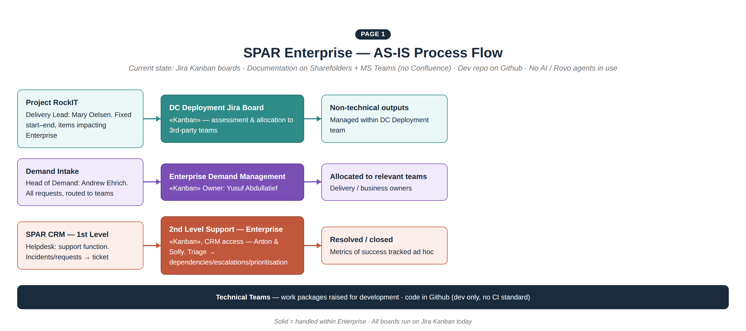
Figure 1 — SPAR Enterprise current-state (As-Is) process flow
Key points from the current state:
- Projects: fixed start and end dates, with items that impact Enterprise assessed and allocated to 3rd-party teams on the DC Deployment Jira board.
- Helpdesk (Incident Management): a support function running on Kanban, with Anton Seocharan and Solly Khoza triaging tickets and holding CRM access; incidents move from ticket → team → dependencies / escalations / prioritisation.
- Integrations: technical work — including integration items — is tracked on the same Kanban boards as regular delivery work; there is no separate integrations process today.
- Metrics of success: Helpdesk currently has no formal SLA; success is tracked informally rather than through a metrics dashboard.
- Tooling gaps: documents and requirements live in Sharefolders and MS Teams, not Confluence; developer code sits in Github; no Rovo or Jira AI agents are in use anywhere in the flow.

2. To-Be Transition — High Level
At a high level, each of the three components moves from its current Kanban board onto Sprints, while a shared foundation layer — Confluence with Rovo agents, Github, Jira AI agents, and the Scrums.com platform — is introduced underneath all three.
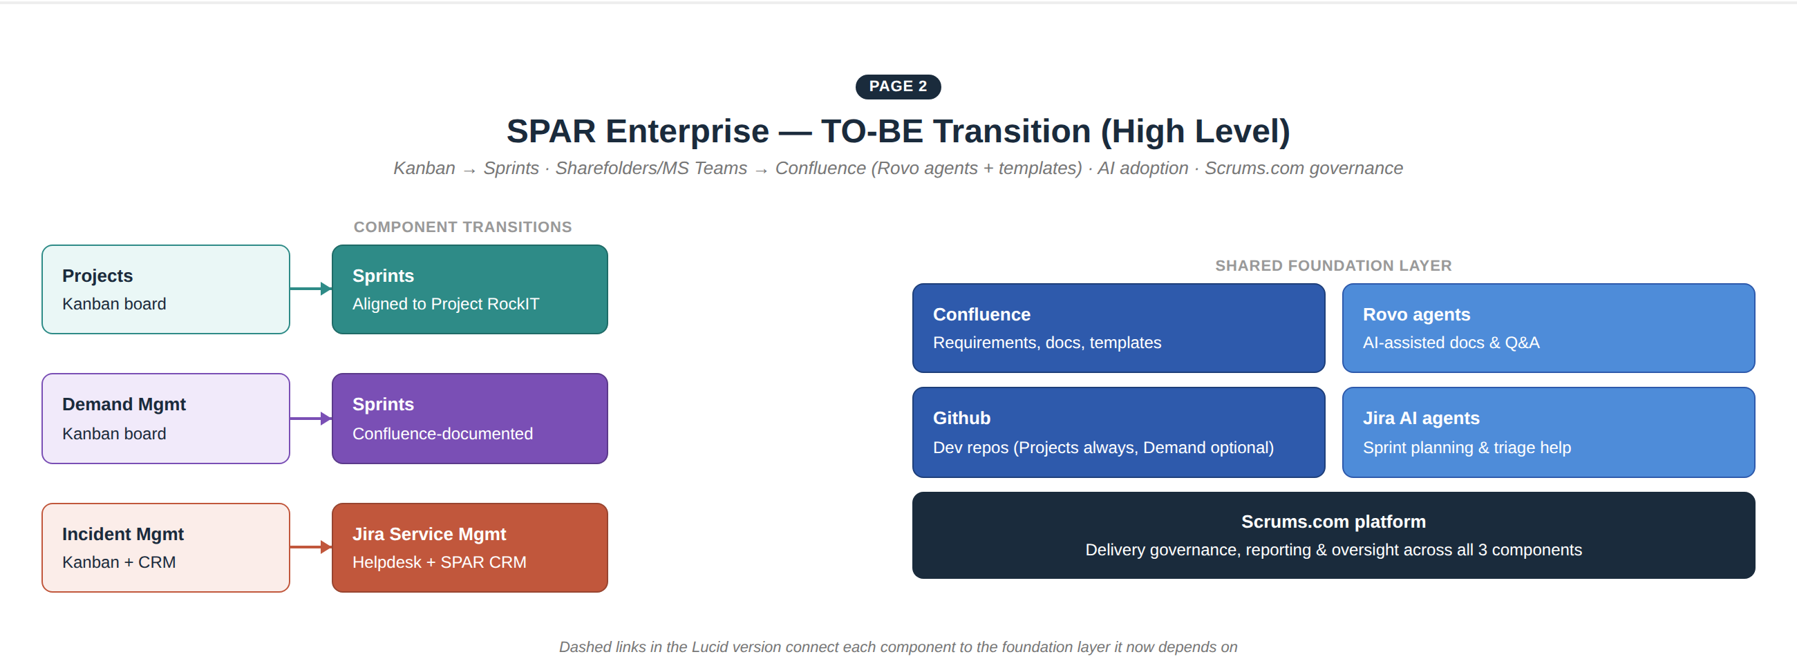
Figure 2 — To-Be transition, high-level architecture and infrastructure
- Sprints: Kanban boards are retired in favour of Sprints, each aligned to the cadence appropriate to that component (Project RockIT milestones for Projects; a rolling Enterprise sprint for Demand; a service-management model for Incidents).
- Confluence + Rovo: becomes the system of record for requirements, decisions and documentation, replacing Sharefolders and MS Teams for this purpose; Rovo agents are configured on top to draft documents from templates and answer questions.
- Github: remains the developer code repository, now formally linked to Jira tickets (branch and PR per story/work package).
- Jira Service Management: Incident Management specifically moves from a Kanban Helpdesk to Jira Service Management (Helpdesk), while keeping its existing connection to SPAR CRM.
- Scrums.com platform: sits across all three components for delivery governance, reporting and oversight of the transition and, subsequently, of steady-state delivery.

3. Detailed Requirements & End-to-End Flow by Component
Each component below is broken down into its detailed end-to-end flow under the To-Be model, together with an As-Is / To-Be requirements comparison.

3a. Projects
Owner: Kogilan Coopasamy (Head of Enterprise) / Ashkelon Packery (Enterprise Portfolio Manager). Projects will transition from Kanban to Sprints to align with the overall Project RockIT cadence; documents and requirements move to Confluence with templates and Rovo-agent skills; code stays in Github.
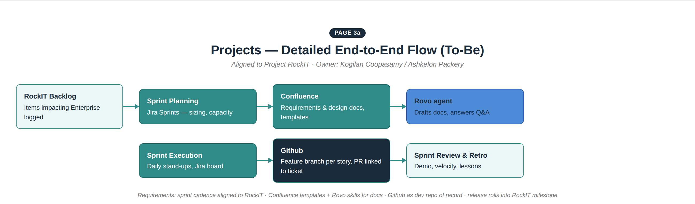
Figure 3a — Projects, detailed end-to-end flow (To-Be)
Area | As-Is (current) | To-Be (target)
Board type | Kanban board (DC Deployment) | Sprints, aligned to Project RockIT milestones
Documentation | Sharefolders / MS Teams | Confluence — dedicated Projects space with templates
AI assistance | None | Rovo agent drafts docs from templates, answers project Q&A
Code repository | Github (informal use) | Github — feature branch per story, PR linked to Jira ticket
Governance / reporting | Ad hoc | Scrums.com platform oversight and reporting

3b. Demand Management
Owner: Yusuf Abdullatief (Enterprise Demand Management), reporting into Andrew Ehrich's overall Demand function. Demand Management will transition to Sprints, with documents and requirements stored in Confluence, and Github connected as an option where a demand item requires a code change.
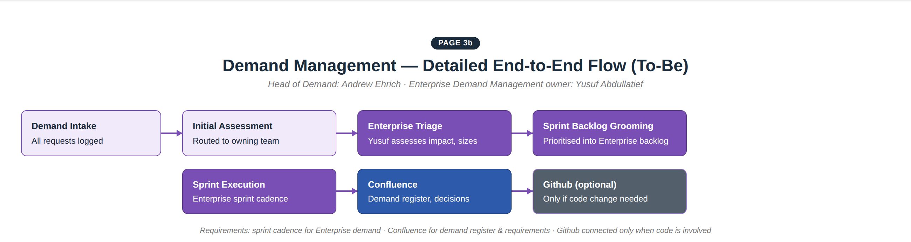
Figure 3b — Demand Management, detailed end-to-end flow (To-Be)
Area | As-Is (current) | To-Be (target)
Board type | Kanban board (Enterprise Demand) | Sprints — Enterprise demand backlog, groomed each sprint
Documentation | Sharefolders / MS Teams | Confluence — demand register, decisions, requirements
Code repository | Not formally connected | Github — connected as an option, only when a code change is required
Impact assessment | Yusuf Abdullatief assesses impact ad hoc | Same assessment, now performed as part of sprint backlog grooming

3c. Incident Management
Owners: Anton Seocharan & Solly Khoza (2nd Level Support). Incident Management transforms into Jira Helpdesk (Jira Service Management), remaining connected to SPAR CRM as 1st Level Support, with incident templates and documentation such as SLAs and success metrics.
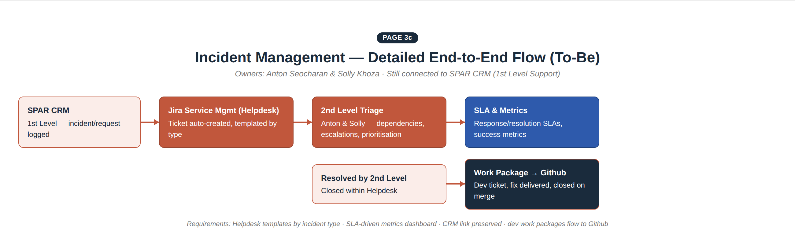
Figure 3c — Incident Management, detailed end-to-end flow (To-Be)
Area | As-Is (current) | To-Be (target)
Board type | Kanban board (2nd Level Support) | Jira Service Management — Helpdesk
1st line link | SPAR CRM | SPAR CRM — unchanged, remains the 1st Level Support entry point
Templates | None formal | Incident / request templates by type
SLAs & metrics | Tracked ad hoc | Formal SLA tracking (response / resolution) and a success-metrics dashboard
Escalation | Manual, informal | Structured escalation path with dependency and prioritisation rules
Dev handoff | Ad hoc work packages | Structured work package, linked to Github, closed automatically on merge

Task 2 — Ideation

1. High-Level Ideation Framework
Before the As-Is → To-Be transition begins, a short ideation phase confirms scope, dependencies and communication lines. This directly answers each point raised on the whiteboard, including the open question on strategic outline.
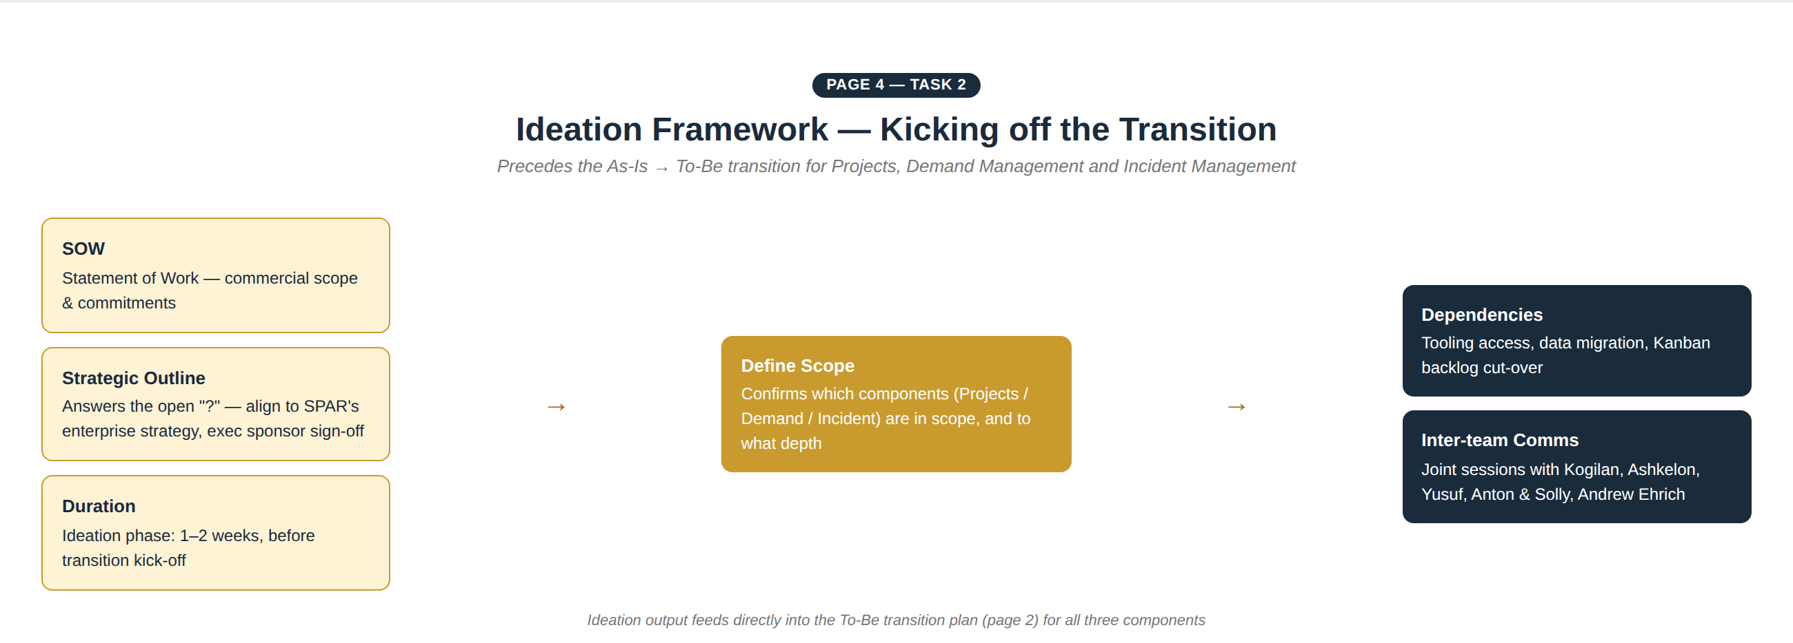
Figure 4 — Ideation framework, feeding into the transition plan
- SOW: the commercial Statement of Work, covering scope and commitments for the transition engagement.
- Strategic outline: this was left as an open question on the whiteboard. Our recommendation: it means aligning the transition to SPAR's broader enterprise strategy, with executive sponsor sign-off before work begins — not a separate workstream, but a gate within ideation.
- Duration: the ideation phase itself is estimated at 1–2 weeks, ahead of transition kick-off.
- Define scope: SOW, strategic outline and duration together confirm which components — Projects, Demand Management, Incident Management — are in scope and to what depth.
- Dependencies: tooling access (Confluence, Rovo, Jira Service Management), data migration from existing Kanban boards, and backlog cut-over planning.
- Inter-team comms: joint sessions across Kogilan Coopasamy, Ashkelon Packery, Yusuf Abdullatief, Anton Seocharan, Solly Khoza and Andrew Ehrich to align on the plan before transition starts.

2. Detailed End-to-End Flow by Component
The in-depth, end-to-end flow for each component is detailed in Task 1, Section 3, and referenced again here for completeness:
- Projects: Sprint planning → Confluence + Rovo documentation → Sprint execution → Github (branch/PR per story) → Sprint review/retro → release into Project RockIT. See Figure 3a.
- Demand Management: Demand intake → initial assessment/routing → Enterprise triage (Yusuf) → sprint backlog grooming → sprint execution → Confluence documentation → Github (optional). See Figure 3b.
- Incident Management: SPAR CRM (1st level) → Jira Service Management ticket → 2nd level triage (Anton & Solly) → SLA/metrics tracking → resolved in Helpdesk, or work package raised → Github → closed on merge. See Figure 3c.

Appendix — files provided alongside this document:
- SPAR_Enterprise_AsIs_ToBe_Ideation.xml — draw.io format, importable into Lucidchart as a six-page editable diagram (As-Is, To-Be, and the three detailed component flows, plus the Ideation framework).
- SPAR_Enterprise_AsIs_ToBe_Ideation_preview.html — a single-page HTML preview of all six views.

