
SPAR ENTERPRISE — PROJECT (ROCKIT)
DC Deployment — BRD & Business Process Reengineering
Converting Kanban to Weekly Sprints, Integrated with the Scrums.com Platform

Document Name | DC Deployment (Project) — BRD & Business Process Reengineering: Kanban to Sprints
Prepared for | SPAR Enterprise — Project (RockIT): Mary Oelsen, Kogilan Coopasamy, Ashkelon Packery
Prepared by | S. Reddy — Scrums.com
Date | 16 August 2026
Version | 1.0 — Project (RockIT) component only, derived from the SPAR Enterprise As-Is/To-Be Ideation
Status | Draft — pending validation with Mary Oelsen, Kogilan Coopasamy and Ashkelon Packery
Classification | Confidential — SPAR Enterprise / Scrums.com

1. Purpose & Scope
This document is a focused Business Requirements Document (BRD) and Business Process Reengineering (BPR) plan for a single component of the broader SPAR Enterprise As-Is and To-Be Ideation: the Project (RockIT) workstream, delivered through the Enterprise — DC Deployment function. Demand Management and Incident/Helpdesk Management are separate workstreams within that broader ideation and are documented independently — they are out of scope here.
Scope note: this document narrows the Project (RockIT) component of the SPAR Enterprise As-Is/To-Be Ideation into a standalone, execution-ready package — covering not just the process redesign but the full business process reengineering approach, sprint cadence, people/resourcing model, governance and delivery playbook needed to actually move DC Deployment (Project) from a Kanban board to weekly Sprints.
The objective is to reengineer how Project (RockIT) work is delivered — moving from a flat, 3-status Kanban board to a weekly Sprint cadence run under Scrum, with delivery governance and reporting integrated into the Scrums.com platform (platform.scrums.com). This document, together with its companion Process & Flow diagram pack and Delivery Playbook & Templates pack, is intended to take the Project workstream from an approved To-Be concept through to a working, governed sprint operation.
- A high-level and a detailed view of the process, shown as both As-Is (current Kanban state) and To-Be (proposed Sprint state).
- A Business Process Reengineering approach: pain points, target operating model, phased migration plan, change management and risk register.
- The Sprint cadence and Scrum framework this workstream will run under, including ceremonies, Definition of Ready/Done, and capacity planning.
- The people and resourcing model, including how delivery-pod capacity can flex without disrupting sprint commitments.
- Governance: the priority model, RACI, escalation path, and how this workstream reports into the Scrums.com platform.

2. Executive Summary — High-Level Overview
At a high level, a Project RockIT item is logged, Demand sets its priority and urgency, and the ticket is assigned to Enterprise (DC Deployment), where Yusuf Abdullatief's team performs the BA Assessment — the single fork point in the process today.
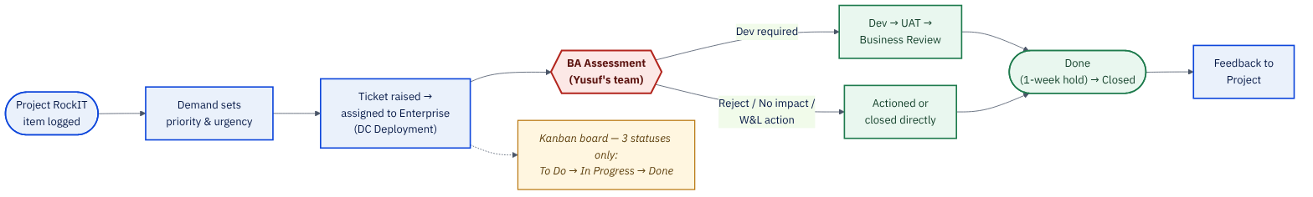
Figure 1 — Project (RockIT): As-Is high-level flow.
The proposed To-Be flow keeps the same underlying fork-point logic, but replaces the flat Kanban board with a weekly Sprint backlog, and combines the BA Assessment with a Rovo-assisted Priority Triage that routes each item by business-determined priority (High / Medium / Low).
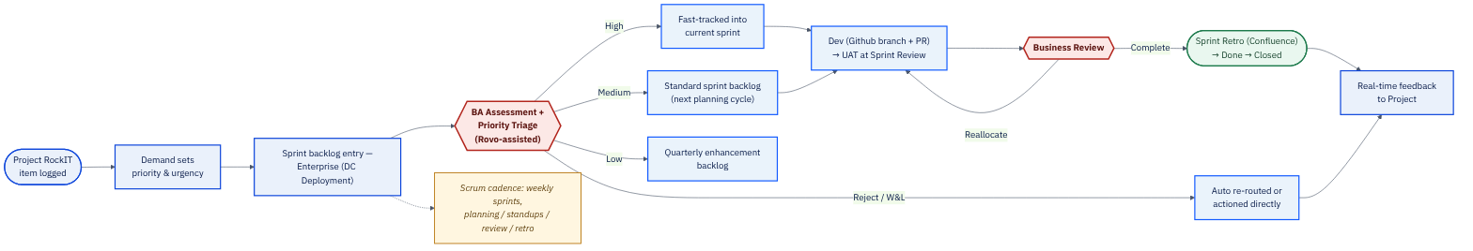
Figure 2 — Project (RockIT): To-Be high-level flow — Sprint cadence.

3. As-Is Process — Detailed View & Fork Points
A Project RockIT item is logged, and Demand sets its priority and urgency before a ticket is raised and assigned to Enterprise (DC Deployment). From there it reaches the single fork point in the process: Yusuf Abdullatief's team performs the BA Assessment and forks the ticket to one of four options — Reject (not in Enterprise's area, closed), No impact (kept on the board for awareness only), a Warehouse & Logistics (W&L) team action (an admin/config update, done directly), or Dev required (sent to the Dev team).
Where development is required, the Dev team builds, the item is assigned for UAT, and a UAT signoff is required before Business Review. Business Review can Complete (business satisfied → Done), Reallocate (not satisfied → back to the Dev team), or Reject (close the ticket, no further action). Completed items are held for one week before formally closing, and feedback is then sent back to Project for implementation.
The Jira board underlying this process today has only three statuses: To Do → In Progress → Done. Incidents affecting Project RockIT are handled within this same board — not the Enterprise Helpdesk — with critical incidents targeted for resolution in 2–4 hours and change requests applied within 24 hours. Every fork on this page can also Reject, Complete or Reallocate a ticket — not just proceed to the next step.
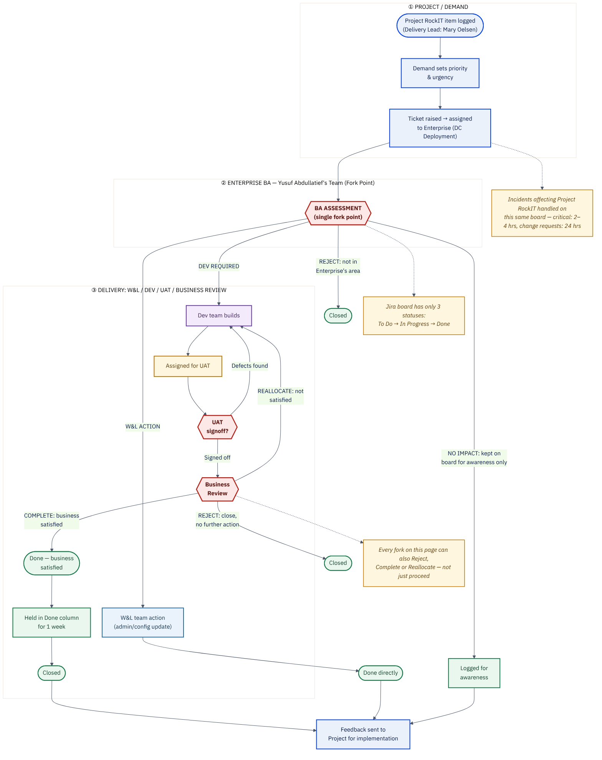
Figure 3 — Project (RockIT): As-Is detailed flow.
Decision options available at each fork:
Option | Definition | Where it occurs | Continues or diverges?
Reject | Declined — not in Enterprise's area. | BA Assessment. | DIVERGES — closed (To-Be: Rovo-assisted re-route).
No impact | Kept on the board for awareness only. | BA Assessment. | DIVERGES — logged, no further routing.
W&L team action | Admin/config update, actioned directly. | BA Assessment. | DIVERGES — done directly, skips Dev/UAT.
Dev required | Sent to the Dev team for development. | BA Assessment. | CONTINUES to Dev → UAT → Business Review.
Complete | Business satisfied — ticket moves toward closure. | Business Review. | CONTINUES to the 1-week Done hold, then Closed.
Reallocate | Business not satisfied — sent back to Dev. | Business Review. | DIVERGES — returns to Dev (To-Be: back into sprint).
Reject (Business Review) | Ticket closed, no further action. | Business Review. | DIVERGES — closed.

4. To-Be Process — Proposed Improvements
The proposed To-Be process keeps the same underlying decision logic but replaces the flat 3-status Kanban board with a Sprint backlog run under a Scrum process. Priority is no longer assessed only for scope/fit — the BA Assessment becomes a combined BA Assessment + Priority Triage, Rovo-assisted, and business-determined priority (High / Medium / Low, not the P1–P5 scale used by Incident/Helpdesk) drives routing.
A Reject is now Rovo-assisted — the agent suggests the correct owning team before closing. Confluence requirements and design docs are attached before Dev picks up the story, and Dev work moves through a formal Github feature-branch-per-story workflow with PRs linked to the Jira ticket, replacing today's ad hoc handoff. UAT signoff now happens at Sprint Review. Business Review still allows Complete, Reallocate (back into the sprint) or Reject, and closure is logged via a Sprint Retro in Confluence, with feedback sent back to Project in real time.
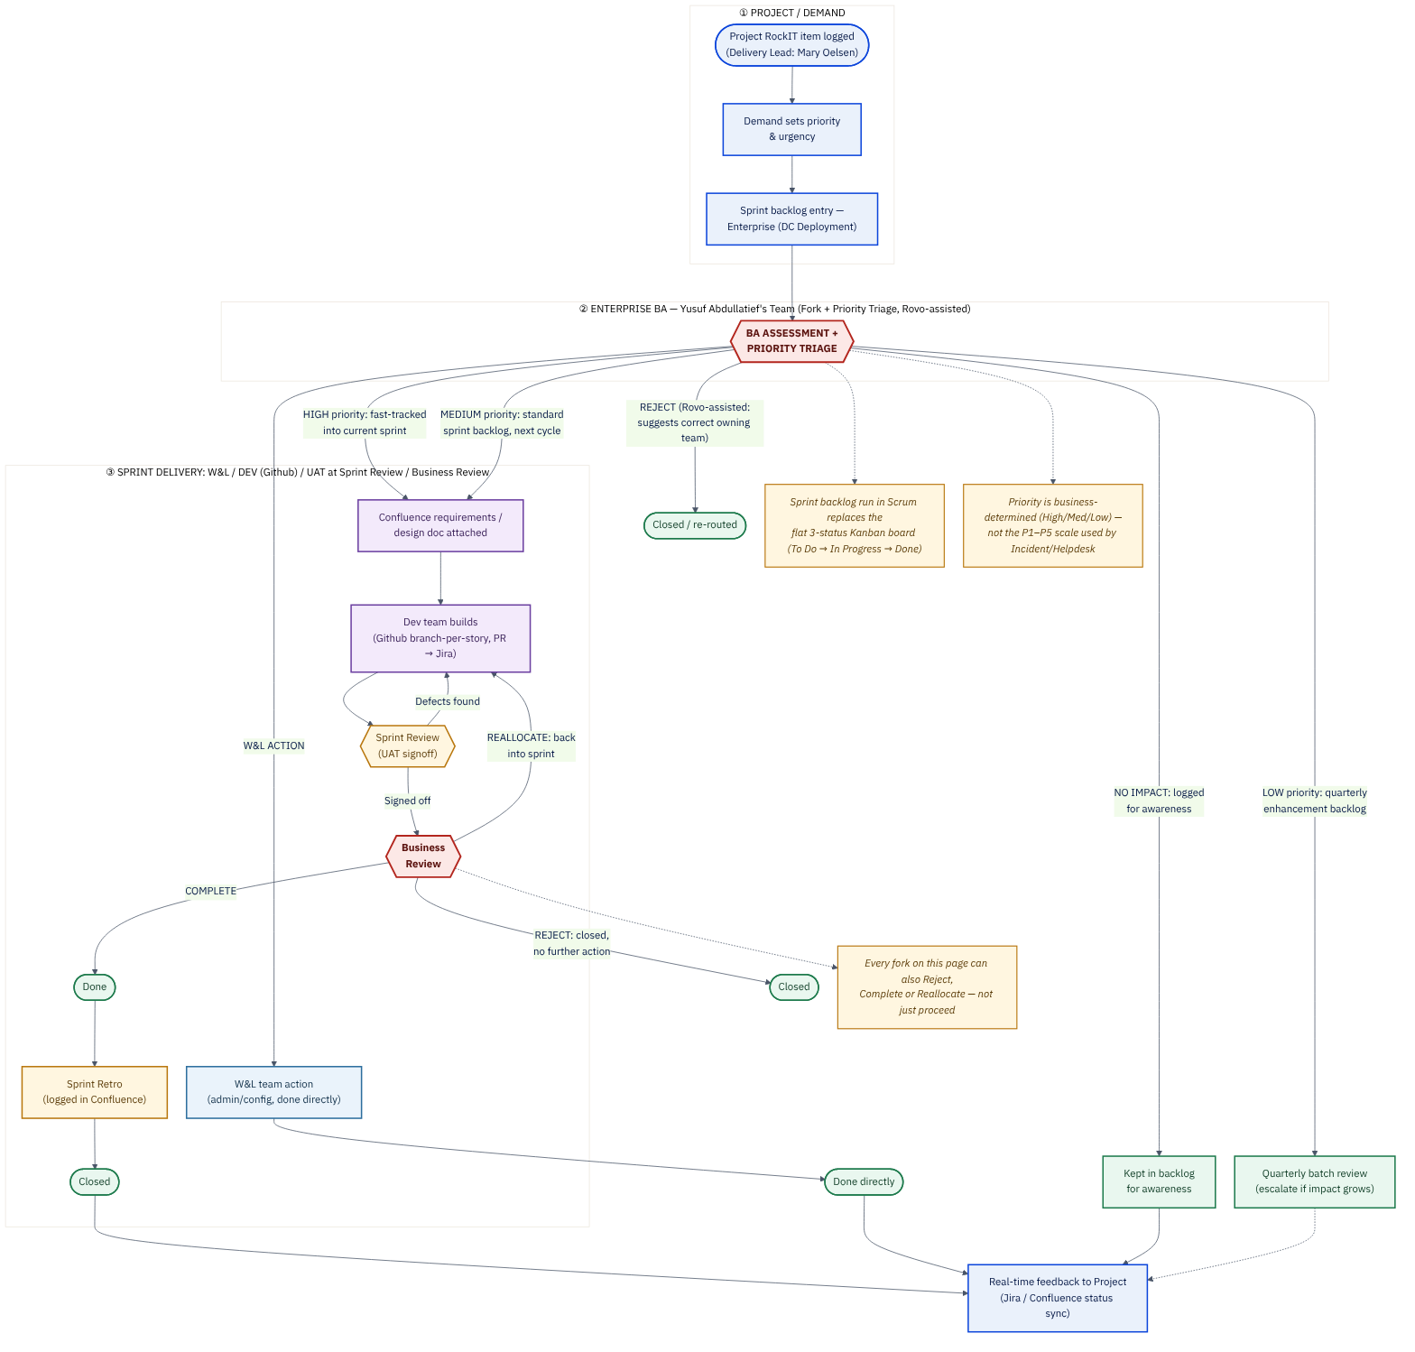
Figure 4 — Project (RockIT): To-Be detailed flow — Sprint cadence.
Summary of the proposed changes:
Area | Proposed change
Working model | Move from a flat 3-status Kanban board (To Do → In Progress → Done) to a Sprint backlog run in Scrum, keeping the same fork-point decision logic.
Intake & priority | BA Assessment becomes BA Assessment + Priority Triage (Rovo-assisted); priority is business-determined (High/Medium/Low), not the P1–P5 scale used by Incident/Helpdesk.
Reject handling | Rovo-assisted suggestion of the correct owning team before closing/re-routing.
Requirements & design | Confluence requirements/design docs attached before Dev picks up the story.
Dev handoff | Formal Github feature-branch-per-story workflow, PRs linked to the Jira ticket.
UAT & sign-off | UAT signoff occurs at Sprint Review, not as a separate ad hoc step.
Low-priority handling | Batched into a quarterly enhancement backlog, reviewed quarterly and escalated if impact grows.
Closure & feedback | Sprint Retro logged in Confluence; real-time status sync back to Project (Jira/Confluence).
Delivery governance | Jira, Github and Confluence activity feeds the Scrums.com platform (platform.scrums.com) for delivery oversight and reporting.

Priority model driving routing in the To-Be process:
Priority | Definition | Routing (To-Be)
High | Business-determined — the item cannot wait for the next planning cycle. | Fast-tracked into the current sprint; Dev notified the same day.
Medium | Business-determined — standard priority, no urgency flag. | Placed in the standard sprint backlog for the next planning cycle.
Low | Business-determined — lowest priority, can wait. | Batched into a quarterly enhancement backlog; escalated only if impact grows.
Reject / W&L | Not Enterprise's remit, or a quick admin/config action. | Rovo-assisted re-route (Reject) or actioned directly within SLA (W&L).

5. Business Process Reengineering Approach

5.1 Current-State Pain Points & Gap Analysis
The table below maps each material pain point in the current Kanban-based process to its business impact and the specific To-Be design element that resolves it.
Current-state pain point | Impact | To-Be resolution
Flat 3-status Kanban board gives no forward visibility into what will land, or when. | Project stakeholders cannot forecast delivery; every ticket looks the same regardless of size or priority. | Weekly Sprint backlog with planning, review and retro ceremonies gives a rolling, forecastable delivery view.
Priority and urgency are set once by Demand and not revisited. | High-impact items can sit behind lower-impact ones with no re-triage mechanism. | BA Assessment + Priority Triage (Rovo-assisted) tiers every item as High/Medium/Low and routes accordingly at intake.
No formal requirements/design documentation before Dev starts. | Rework, misunderstanding of scope, and knowledge loss when people move on. | Confluence requirements/design doc required before a story enters a sprint.
Ad hoc Dev handoff with no branch/PR discipline. | Difficult to trace which commits/PRs delivered which ticket; inconsistent code review. | Formal Github feature-branch-per-story workflow, PR linked to the Jira ticket.
UAT signoff happens as a disconnected, informal step. | Business sign-off timing is unpredictable and hard to plan around. | UAT signoff is folded into the Sprint Review ceremony, on a fixed weekly cadence.
No shared delivery-governance or reporting layer across Project, Demand and Incident work. | Leadership has no single source of truth on delivery health, throughput or quality trend. | The Scrums.com platform ingests Jira, Github and Confluence activity for consolidated delivery governance and reporting.
Dev capacity is fixed to whatever headcount SPAR currently has on the Enterprise BA/Dev pool. | A capacity spike (e.g. a backlog surge) has no release valve — sprint commitments slip. | Delivery pod resourcing model allows capacity to flex via approved delivery partners when needed (Section 7.2), preserving sprint commitments without a structural change to the team.

5.2 Target Operating Model Principles
- One backlog, one cadence: all Project (RockIT) work for Enterprise — DC Deployment flows through a single, weekly-refreshed sprint backlog, replacing the undifferentiated Kanban queue.
- Priority drives routing, not just sequencing: business-determined priority (High/Medium/Low) is captured once, at Priority Triage, and mechanically determines whether an item is fast-tracked, scheduled for the next sprint, or batched quarterly.
- No ticket without a linked document: every story that enters a sprint carries a Confluence requirements/design record, closing the single biggest gap in the current process.
- Every code change is traceable: the Github branch-per-story/PR workflow means every Dev change is traceable to a Jira ticket, and every Jira ticket is traceable to a PR.
- Governance is observed, not chased: the Scrums.com platform ingests Jira, Github and Confluence activity so delivery health is visible without manual status-chasing.
- Capacity is a managed lever, not a fixed constraint: delivery-pod resourcing can flex (Section 7.2) so a capacity spike does not automatically mean slipped sprint commitments.

5.3 Migration & Cutover Plan
The transition from Kanban to Sprints is sequenced over four phases so that the change is validated on a small scale before the whole Project (RockIT) workstream cuts over.
Phase | Duration | Key activities | Exit criteria
Phase 0 — Discovery & Baseline | 2 weeks | Confirm current Kanban baseline against this document; stakeholder walkthroughs with Mary Oelsen, Kogilan Coopasamy, Ashkelon Packery; backlog audit; capacity baseline; technical spike on Jira/Github connectivity into the Scrums.com platform. | Baseline signed off by Project stakeholders; connectivity spike confirms the Scrums.com platform can ingest Jira + Github data.
Phase 1 — Pilot Sprint(s) | 2–3 sprints (4–6 weeks) | Run one delivery pod on weekly sprints in parallel with the existing Kanban board; stand up the Confluence space and page templates; configure the Jira sprint board; pilot Rovo-assisted triage on incoming tickets. | Pilot retro shows ≥80% of sprint commitments met; no critical process gaps raised.
Phase 2 — Full Cutover | 2 weeks | Retire the Kanban board for Project; migrate all open tickets to the sprint backlog; enforce the Github branch-per-story/PR workflow; connect the Scrums.com platform reporting live. | All open tickets migrated; Scrums.com platform dashboard live and reporting on this workstream.
Phase 3 — Stabilize & Optimize | Ongoing (first full quarter) | Velocity/capacity tuning; retro-driven process refinement; first quarterly enhancement-backlog review. | Stable velocity trend across 3+ consecutive sprints; governance cadence operating without close supervision.

5.4 Change Management & Adoption
- Kick-off walkthrough of this document and its companion Process & Flow pack with Mary Oelsen, Kogilan Coopasamy and Ashkelon Packery before Phase 0 begins.
- A short, practical Scrum-ceremonies orientation for anyone new to sprint-based delivery, run ahead of the Phase 1 pilot — not a lengthy Agile-transformation programme.
- A single named point of contact (Delivery Lead: Mary Oelsen) for questions and escalations during the transition, mirroring her existing role.
- Weekly transition-status updates during Phases 0–2, folded into the existing Sprint Review cadence once Phase 1 begins.

5.5 Risk Register
Risk | Likelihood | Impact | Mitigation
Business is unfamiliar with Scrum ceremonies, slowing early sprints. | Medium | Medium | Structured onboarding session; Scrums.com-facilitated first two sprints (Planning, Review, Retro).
Kanban and Sprint models run in parallel too long, causing confusion over where work lives. | Medium | Medium | Hard cutover date at the end of Phase 2, communicated in advance to all stakeholders.
Dev capacity is insufficient to meet weekly sprint commitments during peak load. | Medium | High | Flexible delivery-pod resourcing model (Section 7.2) allows capacity to flex as needed without renegotiating the whole team structure.
Confluence adoption lags and requirements are still tracked ad hoc. | Medium | Medium | Rovo-assisted templates lower the authoring effort; enforce a “no ticket enters a sprint without a linked doc” gate.
Scrums.com platform reporting integration is delayed by tooling or access issues. | Low | Medium | Early technical spike in Phase 0 validates Jira/Github connectivity into the Scrums.com platform before the pilot begins.

6. Sprint Cadence & Scrum Framework

6.1 Weekly Sprint Calendar
Project (RockIT) delivery runs on a fixed, 1-week sprint. The calendar below is the standard weekly rhythm once Phase 2 (full cutover) is complete.
Day | Ceremony | Purpose | Attendees
Monday (AM) | Sprint Planning | Confirm sprint goal; pull committed items from the prioritised backlog (High/Medium items); confirm capacity. | Delivery Lead, Enterprise BA, Dev Team, Product Owner
Daily | Daily Standup (15 min) | What was done, what's next, blockers — keeps the sprint on track without status-chasing. | Dev Team, Enterprise BA (as needed)
Wednesday | Backlog Refinement | Groom the upcoming sprint's candidate items; confirm BA Assessment + Priority Triage outcomes; attach Confluence docs. | Enterprise BA, Product Owner, Dev Team (rotating)
Friday (AM) | Sprint Review (incl. UAT signoff) | Demo completed work; Business Review confirms Complete / Reallocate / Reject; UAT signs off. | Business Review, UAT, Dev Team, Delivery Lead
Friday (PM) | Sprint Retro | What worked, what didn't, one concrete process change for next sprint; logged in Confluence. | Delivery Pod (Dev, BA, Delivery Lead)

6.2 Definition of Ready
- Priority (High/Medium/Low) has been set at BA Assessment + Priority Triage.
- A Confluence requirements/design doc is attached and linked to the Jira ticket.
- Acceptance criteria are stated in a way UAT/Business Review can test against directly.
- Any cross-team dependency (W&L, external teams) is identified and, where possible, already engaged.

6.3 Definition of Done
- Code is merged via a reviewed Github PR linked to the Jira ticket.
- UAT has signed off at Sprint Review against the stated acceptance criteria.
- Business Review has recorded a Complete decision (not Reallocate or Reject).
- The ticket has passed through its 1-week Done hold with no concerns raised, and closure is logged at Sprint Retro.

6.4 Capacity & Velocity Planning
Sprint Planning pulls committed items against measured team capacity for that sprint (accounting for leave, cross-workstream commitments, and any W&L-only capacity). Velocity — the volume of Done work per sprint — is tracked sprint-over-sprint via the Scrums.com platform once Phase 2 is complete, and is the primary signal used in Section 5.3's Phase 3 stabilization activities. Where velocity trends below committed capacity for two consecutive sprints, the flexible delivery-pod resourcing model in Section 7.2 is the first lever considered, ahead of re-scoping the sprint commitment itself.

7. People & Resourcing Model

7.1 Roles & Responsibilities
Role | Responsibility
Business / Project RockIT (Delivery Lead: Mary Oelsen) | Logs the item, engages in Sprint Review as Business Review, receives feedback for implementation once complete.
Head of Enterprise (Kogilan Coopasamy) | Sponsors the Kanban-to-Sprint transition; approves the To-Be model and phased migration plan.
Portfolio Manager (Ashkelon Packery) | Oversees portfolio-level visibility into sprint delivery; a named approver on this document.
Demand | Sets priority and urgency on the item before it is raised to Enterprise.
Enterprise BA — Yusuf Abdullatief's Team | Owns the BA Assessment + Priority Triage fork point; consolidates Reject / No impact / W&L / Dev-required decisions.
Delivery Pod (Dev Team) | Builds the technical solution via the Github branch-per-story/PR workflow; resourcing may flex per Section 7.2.
UAT | Validates the solution at Sprint Review; signs off or sends back for Reallocation.
Business Review | Reviews the completed item at Sprint Review; Completes, Reallocates or Rejects.
Scrums.com Delivery Governance | Operates the Scrums.com platform integration; monitors delivery health, throughput and quality trend across the workstream.

7.2 Delivery Pod Resourcing
The Dev Team functions as a delivery pod resourced against sprint commitments rather than a fixed named headcount. Where internal SPAR capacity is constrained — for example during a backlog surge, a period of leave, or a specialised technical requirement — the pod's capacity can be supplemented by approved delivery partners without changing the sprint cadence, ceremonies, or governance model described in this document.
This is a standard capacity-management option available to any delivery pod operating under this model, not a change to team structure or ownership — Enterprise BA ownership of the BA Assessment + Priority Triage fork point, and Business Review's authority over sign-off, are unaffected regardless of how Dev capacity is resourced in a given sprint.

8. Governance

8.1 RACI — Key Activities
R = Responsible, A = Accountable, C = Consulted, I = Informed.
Activity | Project | Demand | Ent. BA | Dev Pod | UAT | Platform Gov.
Sprint Planning | C | I | A/R | R | C | I
Backlog Refinement | C | C | A/R | R | I | I
BA Assessment + Priority Triage | I | C | A/R | I | I | I
Dev Build (Github branch/PR) | I | I | C | A/R | I | I
UAT / Sprint Review | C | I | C | R | A/R | I
Business Review / Sign-off | A/R | I | C | I | C | I
Sprint Retro | C | I | C | R | C | I
Scrums.com Platform Reporting & Gov. | I | I | I | I | I | A/R

8.2 Escalation Path
- Within-sprint blockers: raised at Daily Standup, owned by the Delivery Lead (Mary Oelsen) same-day.
- Priority disputes (e.g. an item feels mis-tiered at Priority Triage): escalated to Enterprise BA (Yusuf Abdullatief's team) for a re-assessment, not unilaterally re-prioritised by Dev or Project.
- Sprint-commitment risk (velocity trending below capacity): raised at Sprint Review, with the delivery-pod resourcing lever (Section 7.2) as the first response option.
- Governance or reporting discrepancies on the Scrums.com platform: escalated to Scrums.com Delivery Governance for investigation.

8.3 Scrums.com Platform Integration
The Scrums.com platform (platform.scrums.com) is the delivery-governance and reporting layer this workstream connects into once live. Jira (sprint, ticket and priority data), Github (branch/PR/merge activity) and Confluence (requirements, design docs, retro notes) all feed the platform, giving a single, consolidated view of delivery health, throughput and quality trend for Project (RockIT) — without requiring manual status reporting from the delivery pod. Each workstream runs as its own Space on the platform, with an Overview (sprint count, completion-rate trend, automated weekly Steerco report downloads), a Sprint Health view (delivery & throughput by month, sprint-by-sprint review, task-type breakdown, per-member completion rate) and an Engineering Health view (DORA metrics: deployment frequency, lead time for changes, change failure rate, mean time to recovery).

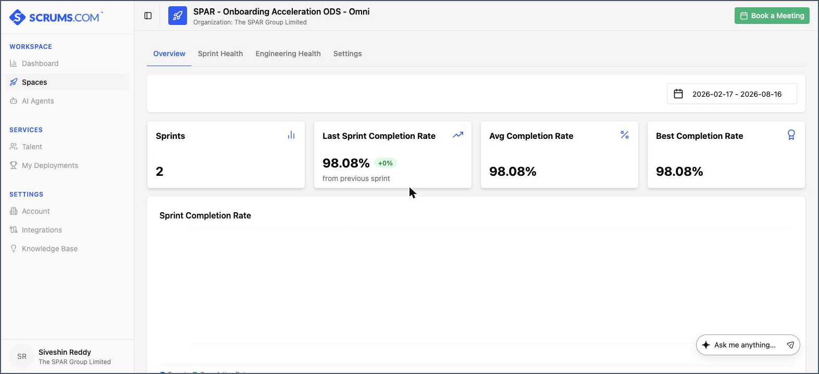
Figure — the Scrums.com platform's Space Overview, shown here for an existing live SPAR workstream on the platform: sprint count, last/average/best sprint completion rate, and automated weekly Steerco report downloads, all populated directly from that workstream's connected Jira data.

This is the same platform SPAR already has access to today — the screenshot above is a real Space in SPAR's own Scrums.com account, not a mockup. Phase 0 (Section 5.3) includes a technical spike to stand up Project (RockIT) as its own Space and confirm its specific Jira/Github connectivity before the pilot begins.

9. Assumptions & Items to Confirm
- This document covers only the Project (RockIT) workstream — Demand Management and Incident/Helpdesk are documented separately within the broader SPAR Enterprise As-Is/To-Be Ideation.
- “No impact” outcomes at BA Assessment are assumed to still be logged for audit/awareness purposes, consistent with the As-Is process.
- The exact criteria distinguishing a W&L action from a Dev-required item has not been independently confirmed beyond “admin/config update” vs. requiring development.
- The migration phase durations in Section 5.3 are planning estimates — actual sprint counts per phase should be confirmed once Phase 0 capacity baseline is complete.
- The delivery-pod resourcing model (Section 7.2) is presented as an available capacity-management option; whether and when it is exercised is a delivery decision made at the point of need, not a default assumption baked into the base sprint plan.
- Scrums.com platform connectivity (Section 8.3) is pending the Phase 0 technical spike and has not yet been validated for this specific workstream.
- The target start date for Phase 0 has not been confirmed and should be scoped as a separate change-management activity with Mary Oelsen, Kogilan Coopasamy and Ashkelon Packery.

10. Approval & Sign-off
This document, together with its companion Process & Flow diagram pack (SPAR_DC_Deployment_Project_SprintTransition_Flows.drawio) and Delivery Playbook & Templates pack, is submitted for review and approval of the proposed Kanban-to-Sprint transition for the Project (RockIT) workstream.
Name | Role | Decision | Date
Mary Oelsen | Delivery Lead, Project (RockIT) | ☐ Approved ☐ Approved with comments ☐ Not approved
Kogilan Coopasamy | Head of Enterprise | ☐ Approved ☐ Approved with comments ☐ Not approved
Ashkelon Packery | Portfolio Manager | ☐ Approved ☐ Approved with comments ☐ Not approved
Yusuf Abdullatief | Enterprise BA (Owner) | ☐ Approved ☐ Approved with comments ☐ Not approved

11. Reference Material
- Source: “Documented SPAR Enterprise As Is and To Be Ideation” (all three workstreams) — Google Drive.
- Live board of record: Jira project DD (“DC Deployment”), board 609 — spar-za.atlassian.net/jira/software/c/projects/DD/boards/609. This is the same board the To-Be Scrum configuration in the companion Delivery Playbook (Section 5) is applied to; no new project or board is created.
- Companion: Process & Flow diagram pack — SPAR_DC_Deployment_Project_SprintTransition_Flows.drawio (4 pages: High-Level As-Is, High-Level To-Be, Detailed As-Is, Detailed To-Be).
- Companion: Delivery Playbook & Templates pack — end-to-end Scrum methodology, Confluence/Jira templates, Scrums.com platform integration detail.
- ClickUp — SPAR Enterprise Workflow Delivery tracking (Epic).

