
SPAR ENTERPRISE — PROJECT (ROCKIT)
Delivery Playbook & Templates
End-to-End Scrum Delivery Methodology, Confluence/Jira Templates & Scrums.com Platform Integration

Document Name | DC Deployment (Project) — Delivery Playbook & Templates
Companion to | DC Deployment (Project) — BRD & Business Process Reengineering (v1.0)
Prepared by | S. Reddy — Scrums.com
Date | 16 August 2026
Version | 1.0 — Draft, for use from Phase 1 (Pilot Sprints) onward
Classification | Confidential — SPAR Enterprise / Scrums.com

1. Purpose
This is the operational companion to the DC Deployment (Project) — BRD & Business Process Reengineering document. Where that document sets out why and what is changing, this playbook sets out how the team runs Project (RockIT) delivery day to day once it is operating on weekly Sprints — the end-to-end Scrum methodology, the Confluence and Jira templates in actual use, board and automation configuration, and how this workstream's data reaches the Scrums.com platform (platform.scrums.com).
This playbook documents templates and configuration for the team to use directly in SPAR's own Jira and Confluence instances. Nothing in this pack changes SPAR's live Atlassian environment on its own — these are the templates and settings to apply when Phase 1 (Pilot Sprints) begins.

2. End-to-End Scrum Delivery Methodology
Delivery under the To-Be model runs through five stages, repeating every sprint. Each stage is described here at the level a new team member would need to actually run it.

2.1 Input
Work enters the system in one of three ways: a Project RockIT item logged by the business, a W&L quick-action request, or a defect raised against previously Done work (a Bug). Every input is captured as a Jira ticket using the Story or Bug template in Section 4.1, and passes through BA Assessment + Priority Triage before it is considered for a sprint.

2.2 Planning
Backlog Refinement (Wednesdays) grooms candidate items for the next sprint — confirming Priority Triage outcomes, attaching Confluence requirements/design docs, and flagging dependencies. Sprint Planning (Monday) then pulls committed items against measured capacity, using the Sprint Planning Notes template (Section 4.3), and sets the sprint goal.

2.3 Execution
Dev builds against the Github branch-per-story workflow (Section 5), with Daily Standup surfacing blockers same-day. W&L actions are executed directly within SLA, bypassing Dev entirely. Every PR references its Jira ticket key so status transitions automatically (Section 5.4).

2.4 Review
Sprint Review (Friday AM) is where UAT signs off and Business Review records Complete, Reallocate or Reject — folding what was previously a disconnected, ad hoc UAT step into a fixed weekly ceremony.

2.5 Outcomes
Sprint Retro (Friday PM) closes the loop: velocity vs. commitment is reviewed, one concrete process improvement is agreed, and completed items that have passed their 1-week Done hold are formally closed with real-time status sync back to the Project board. The Scrums.com platform ingests this entire cycle's Jira/Github/Confluence activity for delivery-governance reporting (Section 6).

3. Weekly Sprint Cadence Calendar
Cadence | Forum | Purpose
Daily | Daily Standup | Within-sprint blockers surfaced and owned same-day (BRD/BPR Section 8.2).
Weekly | Sprint Review + Retro | Business sign-off, UAT, and one concrete process improvement per week.
Quarterly | Enhancement Backlog Review | Low-priority items reassessed; escalate only if impact has grown (Priority Model, BRD/BPR Section 4).
Ongoing | Scrums.com Platform Reporting | Delivery health, throughput and quality trend, visible without manual status-chasing.

4. Confluence Management

4.1 Space Structure
- Space: “Enterprise — Project (RockIT) Delivery” (dedicated space, separate from Demand Management and Incident/Helpdesk spaces).
- Page tree: Home → Requirements & Design Docs (one page per ticket) → Sprint Planning Notes (one per sprint) → Sprint Retros (one per sprint) → Meeting Notes → Reference (this playbook, the BRD/BPR, and the Process & Flow pack, linked for anyone new to the workstream).
- Rovo agent configured against this space to draft new Requirements & Design Docs from the template below, and to answer “where do we stand on ticket X” questions from existing page content.

4.2 Requirements & Design Doc Template
Section | Content
Header block | Title · Jira ticket link · Author · Date · Status (Draft / In Review / Approved).
1. Business Context | Why this is needed — the problem or opportunity, in the requester's own terms.
2. Requirements | Functional requirements (what the system/process must do) and non-functional requirements (performance, access, compliance) as applicable.
3. Proposed Solution / Design | The approach Dev will build against — enough detail that a developer unfamiliar with the request could pick it up.
4. Acceptance Criteria | Mirrors the Jira ticket's acceptance criteria field — the two must stay in sync.
5. Dependencies | Other tickets, teams (W&L, external teams) or systems this depends on, or that depend on it.
6. Rollout / Rollback Plan | How the change reaches production, and how it is reverted if it doesn't work as expected.
7. Sign-off | Business Review name and date, recorded once Complete is confirmed at Sprint Review.

4.3 Sprint Planning Notes Template
Section | Content
Sprint identifier & dates | Sprint number, start/end date (Monday–Friday, 1 week).
Capacity | Available Dev-pod capacity for the sprint (accounting for leave, cross-workstream commitments, and any flexed delivery-pod resourcing per the BRD/BPR Section 7.2).
Sprint goal | One or two sentences — the outcome this sprint is optimising for.
Committed items | Table: Ticket key · Summary · Priority · Owner · Story estimate.
Risks & dependencies | Anything flagged at Backlog Refinement that could affect this sprint's commitment.

4.4 Sprint Retro Template
Section | Content
Velocity vs. commitment | Items committed at Sprint Planning vs. items reaching Done — the core input to BRD/BPR Section 6.4 capacity tuning.
What went well | Bulleted, specific — not general praise.
What didn't go well | Bulleted, specific — framed as process gaps, not individual performance.
Action items | Table: Action · Owner · Due date — one concrete process change per retro is the target, not a long list.
Closure log | Tickets that completed their 1-week Done hold this sprint and were formally closed.

4.5 Meeting Notes Template
Section | Content
Attendees | Name and role.
Agenda | Bulleted, agreed before the meeting starts.
Decisions | What was decided, and by whom (ties to RACI Accountable party where relevant).
Action items | Table: Action · Owner · Due date.

5. Jira Management
Live board of record: SPAR Jira project DD (“DC Deployment”), board 609 — spar-za.atlassian.net/jira/software/c/projects/DD/boards/609. The board today runs on To Do / In Progress / Done style statuses with continuous flow (Kanban); Sections 5.2–5.4 below are the target Scrum configuration to apply to this same board from Phase 1 (Pilot Sprints) onward — no new project or board is being created.

5.1 Issue Templates
Story template (also the base for Task and Bug, with Issue Type changed accordingly):
Field | Guidance / example
Summary | [Component] Short, action-oriented description — e.g. “DC Deployment: add bulk-relabel action to inbound pallets screen”.
Issue Type | Story (feature/change), Task (operational action), or Bug (defect against previously Done work).
Priority | High / Medium / Low — set at BA Assessment + Priority Triage, business-determined.
Sprint | Current sprint (if High), or left in the backlog for Sprint Planning to pull in (Medium), or in the quarterly enhancement backlog (Low).
Epic Link | Parent epic, where the item is part of a larger initiative.
Confluence Doc | Link to the linked Requirements & Design Doc — mandatory before the item can enter a sprint (Definition of Ready).
Acceptance Criteria | Bullet list, written so UAT / Business Review can test against it directly at Sprint Review.
Github Branch | feature/<ticket-key>-<short-description>, created off the default branch; PR title references the ticket key.
Definition of Ready | Checklist — Priority set · Doc linked · Acceptance criteria stated · Dependencies identified.
Definition of Done | Checklist — PR merged · UAT signed off at Sprint Review · Business Review = Complete · 1-week Done hold passed.

5.2 Board & Sprint Configuration
Setting | Configuration
Board type | Scrum board (not Kanban) — reconfigured on the existing Jira project DD (“DC Deployment”), board 609.
Sprint length | 1 week, Monday–Friday, aligned to the Weekly Sprint Calendar.
Workflow states | To Do → In Progress → In Review (PR open) → UAT / Sprint Review → Done → Closed.
Swimlanes | By priority (High / Medium / Low) so fast-tracked items are visually distinct on the board.
Estimation | T-shirt sizing (S/M/L) at Backlog Refinement, used for capacity planning rather than formal story points.
Issue types enabled | Story, Task, Bug — see Section 5.1 templates.

5.3 Workflow States
To Do → In Progress → In Review (PR open) → UAT / Sprint Review → Done → Closed
Every fork described in the BRD/BPR (Reject, No impact, W&L, Reallocate) is modelled as a transition out of this main line, not a separate status — keeping the board itself simple even though the decision logic behind it is not.

5.4 Automation Rules
Trigger | Automated action
Ticket created with Priority = High | Auto-assigned to the current sprint; Dev pod notified the same day.
Github PR opened referencing a ticket key | Ticket transitions to “In Review”; PR link attached to the ticket automatically.
Github PR merged | Ticket transitions to “UAT / Sprint Review” and is added to the next Sprint Review agenda.
Business Review records Complete | Ticket transitions to “Done”; 1-week Done-hold timer starts; the Scrums.com platform is notified for reporting.
1-week Done hold elapses with no reopen | Ticket auto-transitions to “Closed”; real-time status sync fires to the Project board.
Business Review records Reject | Rovo-assisted comment suggests the correct owning team; ticket routed accordingly.
Item tiered Low at Priority Triage | Ticket auto-labelled and moved to the quarterly enhancement backlog view, off the active sprint board.

5.5 Definition of Ready / Definition of Done
See BRD/BPR Sections 6.2 and 6.3 — reproduced on the Jira Story template (Section 5.1) as an in-ticket checklist so it's enforced at the point of use, not just documented separately.

6. Scrums.com Platform Integration
Jira (ticket, sprint and priority data), Github (branch/PR/merge activity) and Confluence (requirements docs, planning notes, retros) all feed the Scrums.com platform (platform.scrums.com) — the same platform SPAR already uses today for its live workstreams. Each workstream runs as its own Space with three views: an Overview (sprint count, completion-rate trend, automated weekly Steerco reports), Sprint Health (delivery & throughput by month, sprint review, task-type breakdown, per-member completion) and Engineering Health (DORA metrics). The example below is a real Space in SPAR's own Scrums.com account, shown to illustrate what Project (RockIT) will look like once it has its own Space from Phase 1 onward:

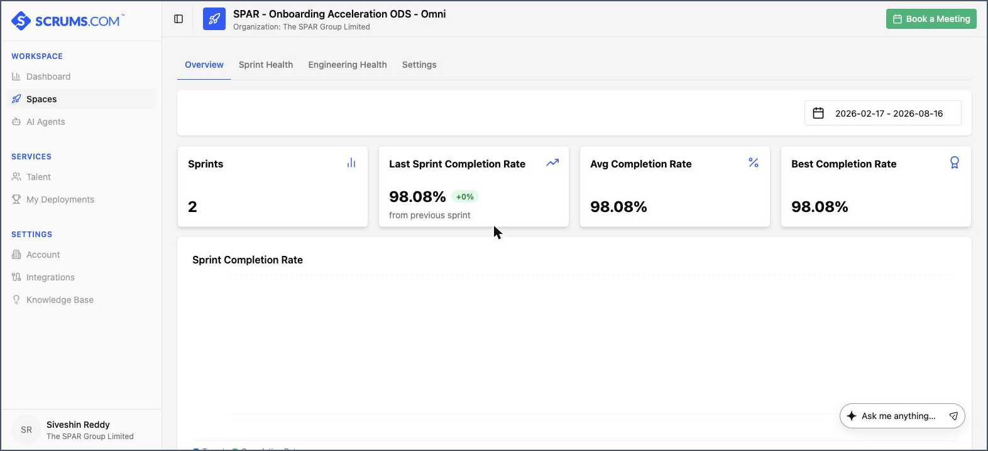
Figure -- Space Overview: sprint count, sprint completion-rate trend, and automated weekly Steerco report downloads, populated directly from that workstream's connected Jira data.

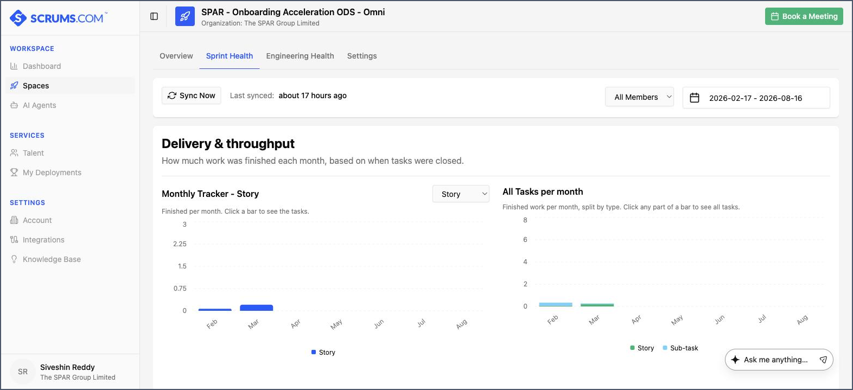
Figure -- Sprint Health view: delivery & throughput by month (Story completions, all task types), synced directly from Jira on a scheduled basis.

The metrics below are what the platform surfaces for this workstream once it is onboarded as its own Space in Phase 2 (full cutover):
Metric | What it tells the workstream
Sprint predictability | Committed vs. Done items per sprint — the primary velocity signal feeding BRD/BPR Section 6.4.
Cycle time (ticket → Done) | How long work actually takes once picked up, by priority tier — flags if High-priority items are truly moving faster.
PR lead time | Time from branch creation to merge — a leading indicator of Dev-pod capacity pressure.
Reject / Reallocate rate | How often items are rejected or sent back at Business Review — a proxy for requirements quality (Definition of Ready compliance).
Backlog age by tier | How long Medium/Low items sit before being picked up — flags if the quarterly-batch mechanism is being used as intended.

Reporting cadence: a sprint-level summary is available immediately after each Sprint Retro; a rolled-up view across sprints is available continuously for anyone with Scrums.com platform access, replacing the need for a manually compiled status report.

7. Governance & Frameworks to Follow
This playbook operates under the governance model set out in the BRD/BPR (Section 8): the Priority Model, the RACI, and the escalation path. The cadence recap in Section 3 above is the operational expression of that governance — nothing here introduces a new decision right or overrides an approval already defined in the BRD/BPR.

8. Templates Appendix

8.1 Statement of Work (SOW) Outline
- Scope — what is and is not covered (mirrors the BRD/BPR Section 1 scope note).
- Effort estimate — by sprint, at T-shirt-size granularity (Section 5.2).
- Dependencies — cross-team or cross-system, called out explicitly.
- Acceptance criteria — how the business will confirm the work is Done.
- Governance — which RACI role signs this SOW off before work is greenlit.

8.2 Ceremony Agenda — Sprint Planning
- Review sprint goal candidates from Backlog Refinement.
- Confirm capacity (leave, cross-workstream commitments, any flexed delivery-pod resourcing).
- Pull committed items; confirm each meets Definition of Ready.
- Agree and record the sprint goal.

8.3 Ceremony Agenda — Sprint Review
- Demo completed items against acceptance criteria.
- UAT signs off, or sends back with defects noted.
- Business Review records Complete / Reallocate / Reject per item.
- Confirm which items enter the 1-week Done hold this week.

8.4 Ceremony Agenda — Sprint Retro
- Review velocity vs. commitment for the sprint just closed.
- What went well / what didn't — specific, not general.
- Agree one concrete action item, with an owner and a due date.
- Confirm closure of any item that has passed its 1-week Done hold.

