Under **configure**:

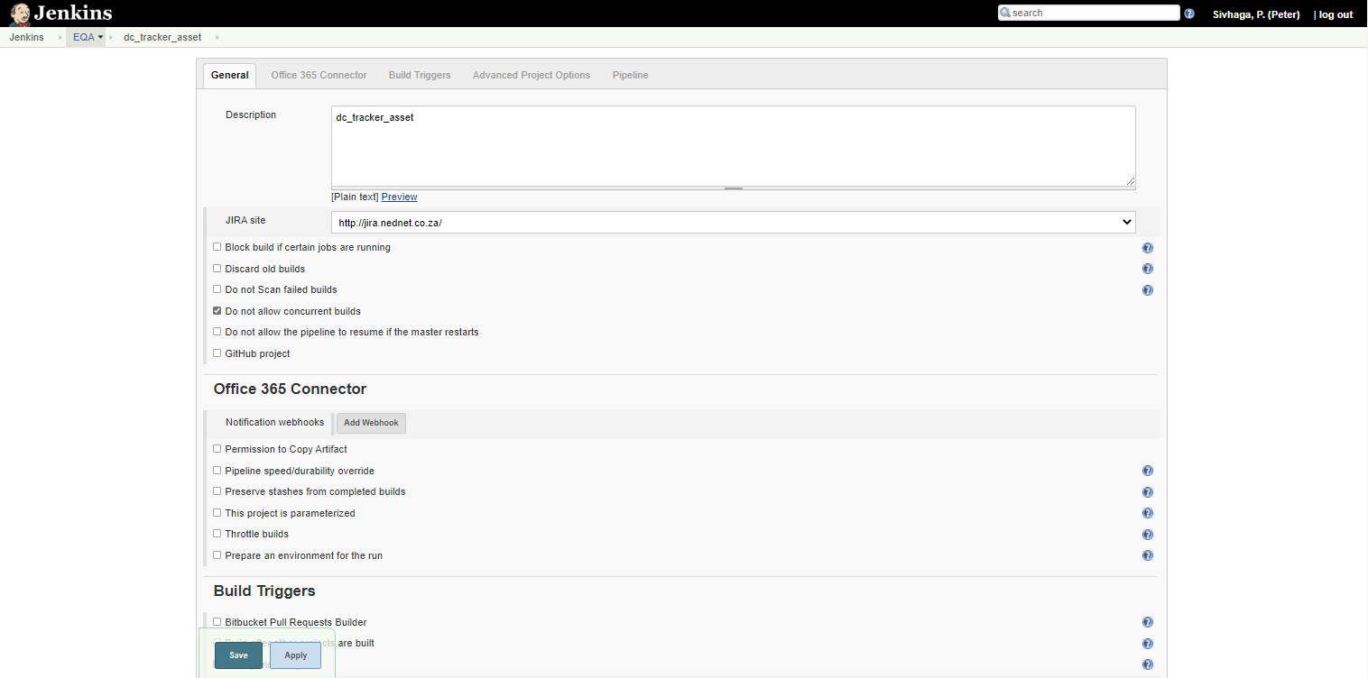

**Triggers**

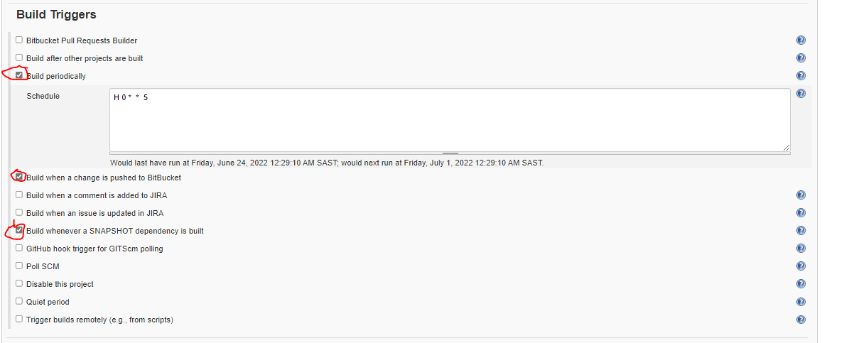

**Pipeline:**

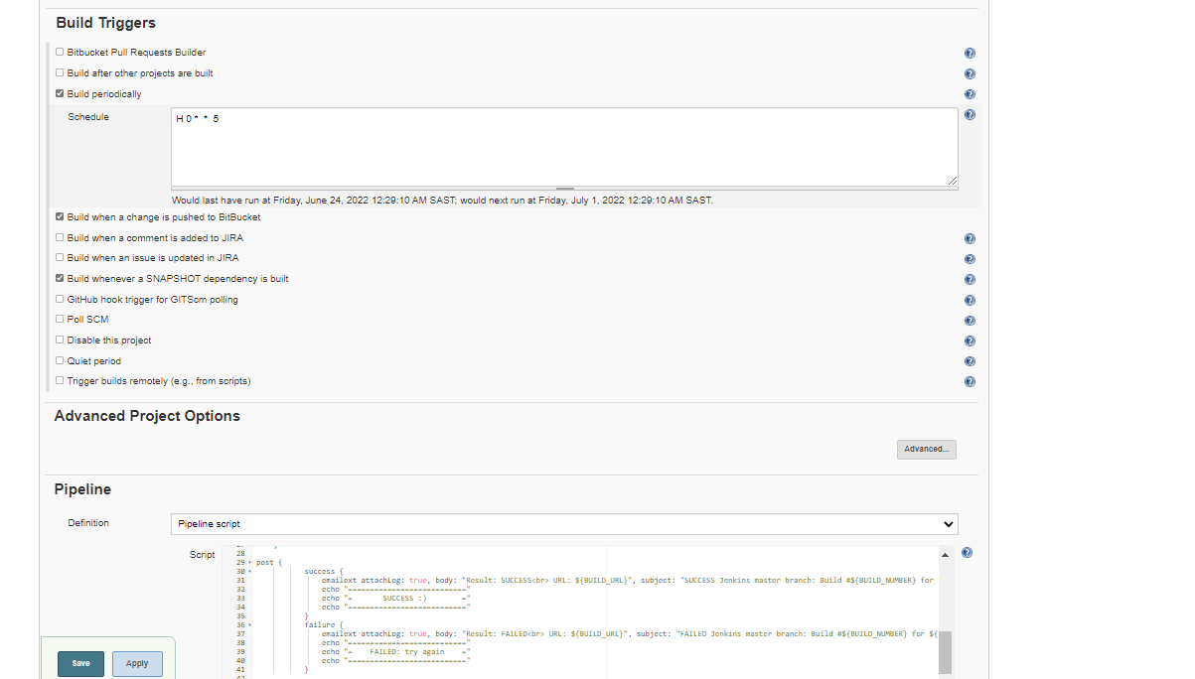

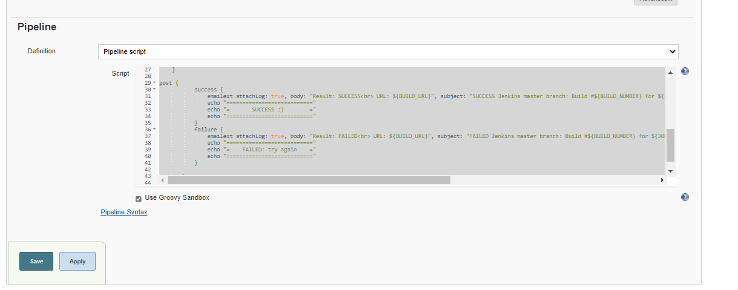

**Pipeline script** :

pipeline {

agent {

label "eqa-windows-agent01"

}

stages {

stage('GIT PULL') {

steps {

git branch: "master", credentialsId: '7bd0ae20-aedc-448c-a86f-6700da7b7e29', url: 'http://bitbucket.nednet.co.za/scm/ioeqatau/dct_consumption.git'

}

}

stage('Quality Analysis') {

steps {

script {

def PROJECT_KEY = "dct_consumption"

echo "ENTER: ENTER: SonarQube"

withSonarQubeEnv('SonarQube') {

sh "mvn sonar:sonar -Dsonar.projectKey=dct-automation -Dsonar.host.url=https://sonarqube.nednet.co.za -Dsonar.login=4ebea6e43c0405ff6e453032787445921b1bbf18"

}

}

}

}

stage('Build') {

steps {

sh 'mvn clean package'

}

}

}

post {

success {

emailext attachLog: true, body: "Result: SUCCESS<br> URL: ${BUILD_URL}", subject: "SUCCESS Jenkins master branch: Build #${BUILD_NUMBER} for ${JOB_NAME} with Test Report", from: "no-reply.jenkins@nedbank.co.za", to: "peters@Nedbank.co.za,tiyanic@Nedbank.co.za"

echo "==========================="

echo "= SUCCESS :) ="

echo "==========================="

}

failure {

emailext attachLog: true, body: "Result: FAILED<br> URL: ${BUILD_URL}", subject: "FAILED Jenkins master branch: Build #${BUILD_NUMBER} for ${JOB_NAME} with Test Report", from: "no-reply.jenkins@nedbank.co.za", to: "peters@Nedbank.co.za,tiyanic@Nedbank.co.za"

echo "==========================="

echo "= FAILED: try again ="

echo "==========================="

}

}

}