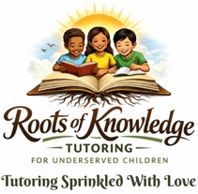

Donation Support Sheet

Mission:
Roots of Knowledge Tutoring Services provides free reading tutoring for underserved children in Los Angeles County, with a focus on helping children from low-income communities build strong literacy skills, confidence, and a love of learning.
Your support helps provide:
📚 Books and learning materials
✏️ Tutoring supplies (paper, writing utensil, reading glasses, etc.)
💻 Virtual tutoring resources
🎓 Free tutoring sessions for children from low-income households

Donor Information
Name: _______________________________________________________
Address: _____________________________________________________
City/State/Zip: ________________________________________________
Phone: _______________________________________________________
Email: ________________________________________________________

One Time Donation Amount
☐ $25
☐ $50
☐ $100
☐ Other Amount: $ __________________

Sponsorship
☐ $30 monthly to sponsor one child
☐ $60 monthly to sponsor two children
☐ Other $ monthly amount to sponsor

Payment Method
☐ Cash
☐ Check (Please make check payable to Roots of Knowledge Tutoring and call 310-597-3810 for mailing instructions)
☐ Digital Payment (Cash App or Zelle) Phone # 310-597-3810 (*Please add Roots of Knowledge Tutoring on the memo line)

Optional
☐ I would like information about volunteering

Thank you for helping children grow strong educational roots.
Together we can help young learners build the literacy skills they need to succeed.

