Finance OS — System Design Document
Version | 0.1 (draft for review)
Date | 2026-10-17
Owner | Sivaram Vangavolu
Status | Design — nothing built yet
Contents
1. Purpose 3
1.1 Goals 3
1.2 Non-goals 3
1.3 What this project honestly cannot show 3
2. Traceability to the target roles 5
2.1 AssemblyAI Finance Engineer 5
2.2 Project Accounting / Billing role 5
3. The fictional company: Echo Labs 7
3.1 Profile 7
3.2 Revenue streams 7
3.3 Products and models 7
3.4 Customers 7
3.5 Projects (6) 7
3.6 Departments and cost centers 8
3.7 Vendors 8
3.8 Personas (for requirements and the agent) 8
4. System context 9
5. Requirements 10
5.1 Functional requirements 10
5.2 Non-functional requirements 15
5.3 AI requirements 16
6. Architecture 17
6.1 Layered view 17
6.2 Technology choices 17
6.3 Repository structure 18
6.4 Environments 19
7. Data design 20
7.1 Source inventory 20
7.2 Core entity relationships 20
7.3 dbt layers and conventions 21
7.4 Dimensional model (marts) 21
7.5 Metric catalog (excerpt) 22
7.6 Allocation rules 23
8. Module design 25
M2 Unit economics 25
M3 Tech spend 25
M4 Burn and KPIs 25
M5 Budget vs. actuals 25
M6 Project accounting 25
M7 Billing operations 26
M8 AR and collections 26
M9 Deal desk 26
M10 Sales comp 27
M12 Reconciliation framework 28
9. AI design 29
9.1 Where AI is used, and where it is not 29
9.2 Agent architecture 29
9.3 Evaluation 30
9.4 Failure handling 30
10. Orchestration design (Dagster) 31
11. Alert design 32
12. Security, privacy and cost 33
13. Testing strategy 34
14. Phase-wise plan 35
Phase 0 — Foundations (1 day) 35
Phase 1 — Synthetic company and data generator (2 days) 35
Phase 2 — Ingestion (1–2 days) 35
Phase 3 — Warehouse modeling (2–3 days) 35
Phase 4 — Reconciliation and orchestration (2 days) 35
Phase 5 — Finance engineering modules (3 days) 36
Phase 6 — Project accounting and billing (3 days) 36
Phase 7 — Apps: deal desk and sales comp (2 days) 36
Phase 8 — AI layer (3 days) 36
Phase 9 — Reporting (2 days) 36
Phase 10 — Process documentation and packaging (1–2 days) 36
15. Risks and mitigations 37
16. Open questions for the owner 38
17. Glossary 39

1. Purpose
Finance OS is a working finance and project-accounting platform for a fictional company, Echo Labs. It is built to show, with running code and reconciled numbers, the work done by two kinds of role:
- Finance Engineer (reference: AssemblyAI). Unit economics, tech spend, burn and KPIs, budget vs. actuals, deal desk, sales comp, finance agents, and the data layer underneath them.
- Project Accounting / Billing Operations (reference: a federal-contracting firm). Contracts, project budgets, purchase orders, vendor invoices, commitments, billing, unbilled work, AR and collections, and process documentation.
The guiding rule comes from the AssemblyAI posting: rebuilt from source data rather than spreadsheets, and every number reconciles or has its variance explained.

1.1 Goals
- G1. One warehouse is the single source of truth. Every dashboard, alert, export and agent answer reads from it.
- G2. Every metric has a written definition: the decision it supports, its formula, its grain and its owner. These are defined before the metric is built.
- G3. Every key number reconciles to an independent source (Stripe ↔ GL, GCP bill ↔ modeled spend, invoices ↔ contract terms), and variances are investigated in writing.
- G4. Manual finance work is automated end to end: daily pipelines, alerts, invoice generation, collection drafts and comp statements.
- G5. AI is used only where it helps (language, summarizing, drafting, explaining) and never to compute money.

1.2 Non-goals
- No real customers, real money or real PII. All business data is synthetic, except the GCP billing export (the owner's own real cloud costs).
- No real ERP (NetSuite, SAP). The general ledger is a modeled, ERP-like structure.
- No GAAP or audit certification. Revenue recognition follows simplified, documented policies.
- No production SLA or multi-tenant SaaS.

1.3 What this project honestly cannot show
Gap | Why
Non-engineers relying on it daily | There are no real users. The system is demo-able, not adopted.
Years of employment in the role | A project can't substitute for tenure
Real federal contract experience | The federal contract is simulated, so the project shows understanding, not experience
Real NetSuite or SAP | Only Stripe (test mode) and GCP are real systems
Finance or accounting degree | Not addressable
Real stakeholder management | Simulated personas only

2. Traceability to the target roles
Every requirement in §5 carries a tag back to the posting line it serves. AAI-n = AssemblyAI, PA-n = project-accounting role.

2.1 AssemblyAI Finance Engineer
ID | Posting line | Modules | Coverage
AAI-1 | Unit economics: cost-to-serve, gross margin, contribution by product, customer, workload | M2 | Full
AAI-2 | Tech-org budgeting: cloud and GPU attribution, vendor and capacity forecasting | M3 | Full (small scale, real GCP data)
AAI-3 | Finance dashboard: burn, runway, margin, KPIs, board-trustworthy | M4, M14 | Full
AAI-4 | Automated budget vs. actuals with overspend alerts | M5, M13 | Full
AAI-5 | Deal desk: guardrails from the margin model, quote generation, routing | M9 | Full
AAI-6 | Sales comp: statements, accelerators, disputes from CRM and billing data | M10 | Simplified
AAI-7 | Finance agents and internal tools | M11 | Full
AAI-8 | Finance data layer from billing, payroll, cloud and accounting | M1 | Full
AAI-9 | Trace discrepancies to source, fixes that hold | M12 | Full
AAI-10 | SQL, Python, warehouse modeling, dbt/Airflow | M1 | Full
AAI-11 | Billing/ERP APIs (NetSuite, Stripe) | M1 (Stripe) | Partial: no NetSuite
AAI-12 | Explain what a number means and doesn't | Metric catalog, M11 | Full

2.2 Project Accounting / Billing role
ID | Posting line | Modules | Coverage
PA-1 | Billing, AR, project accounting, finance ops | M6, M7, M8 | Full (simulated)
PA-2 | Invoice management, collections, documentation | M7, M8 | Full
PA-3 | Project budgets, POs, vendor invoices, commitments, cost tracking | M6 | Full
PA-4 | Turn contract, budget, invoice and payment data into actionable info | M6, M7, M14 | Full
PA-5 | Excel and modern business systems | M14 exports | Full
PA-6 | Federal government contracts | M6, M7 federal contract | Simulated
PA-7 | Project-based accounting or ERP | M6, ERP-like GL | Partial
PA-8 | Documenting processes and improving them | M15 | Full
PA-9 | Contract terms and billing structures | M7 | Full
PA-10 | Automation and AI-enabled tools | M8, M11 | Full
PA-11 | Billing status, unbilled, collections, committed costs, project cash visible | M14 Project view | Full

3. The fictional company: Echo Labs

3.1 Profile
- Voice-AI API company, founded 2024, ~45 employees, US-based.
- Simulation window: 2025-01-01 to 2026-09-30 (21 months), so trends, seasonality and YoY are visible.

3.2 Revenue streams
Stream | Description | Billing | Revenue recognition (simplified policy)
Usage API: batch | Pre-recorded transcription, $/audio hour | Monthly in arrears via Stripe | As consumed
Usage API: streaming | Real-time transcription, higher $/hour | Monthly in arrears via Stripe | As consumed
Committed-use contracts | Annual minimum commit plus overage | Commit billed quarterly in advance; overage monthly | Commit ratably; overage as consumed
Implementation projects | Custom model / integration work | Fixed-fee milestones or T&M | Milestones on acceptance; T&M as hours are delivered

3.3 Products and models
- Models: echo-base, echo-pro, echo-stream. Each has a different GPU cost per audio hour.
- Price list: batch base $0.15/h, batch pro $0.37/h, streaming $0.47/h. Volume tiers: −10% above 10K h/month, −20% above 100K h/month.

3.4 Customers
- ~40 usage customers in 3 segments: self-serve (25), mid-market (11) and enterprise (4, on committed contracts).
- Each customer has a mix of workloads (batch vs. streaming, model choice), so margins differ by customer.

3.5 Projects (6)
Code | Customer | Type | Value | Notes
P-101 | Enterprise A | Fixed-fee, 4 milestones | $180K | On track
P-102 | Enterprise B | T&M with cap | $120K cap | Approaching cap
P-103 | Enterprise C | Fixed-fee, 3 milestones | $95K | Over budget (injected)
P-104 | Mid-market D | T&M | $60K | Slow payer (injected)
P-105 | Federal agency (simulated) | T&M, labor categories, funded ceiling, 2 CLINs | $450K ceiling, $300K funded | Funding hits 75% (alert)
P-106 | Enterprise A | Fixed-fee | $70K | Milestone accepted but not billed (injected unbilled error)

3.6 Departments and cost centers
Engineering (ENG), Infrastructure (INF), Sales (SAL), Professional Services (PS), G&A (GA). Each has an annual budget by GL account and month.

3.7 Vendors
GCP (real export plus synthetic GPU lines), a GPU neocloud (synthetic), Stripe fees, SaaS tools, contractors (subcontractors on projects), payroll provider.

3.8 Personas (for requirements and the agent)
Persona | Needs
VP Finance | Burn, runway, margin, board pack
Controller | Close, reconciliations, GL accuracy, AR
Head of Infra | GPU/cloud spend by team, model and forecast
Sales lead / AE | Deal approval, quote, comp statement
Project Manager | Budget vs. actual, commitments, billing readiness
Billing specialist | Invoice runs, AR aging, collections queue

4. System context
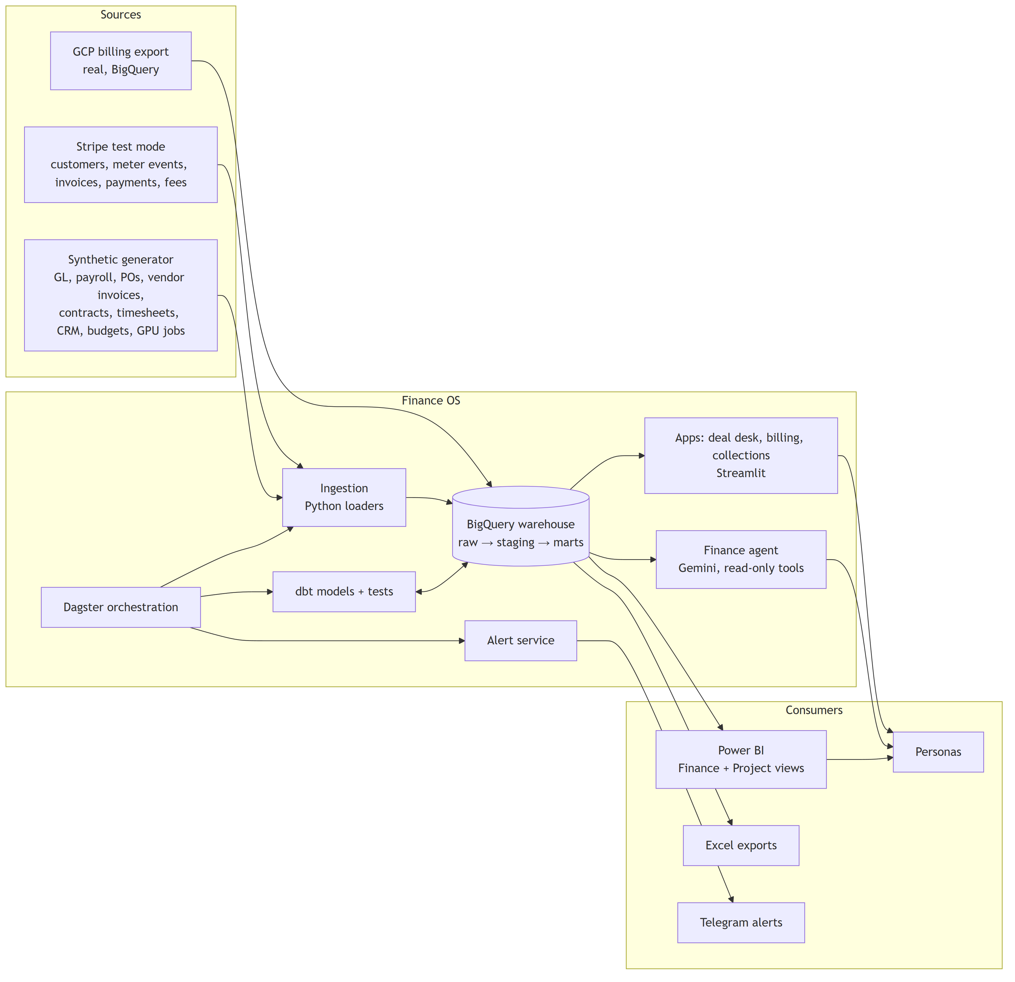
Figure 1

5. Requirements
Priority: M = must, S = should, C = could.

5.1 Functional requirements

M1 — Data layer
ID | Requirement | Pri | Trace
FR-1.1 | Load Stripe test-mode objects (customers, products, prices, meter events, invoices, invoice lines, charges, refunds, balance transactions) incrementally into raw_stripe | M | AAI-8, AAI-11
FR-1.2 | Read the real GCP billing export (standard + detailed) from its BigQuery dataset | M | AAI-2
FR-1.3 | A deterministic synthetic generator (fixed seed) produces GL, payroll, POs, vendor invoices, contracts, timesheets, CRM opportunities, budgets and GPU job logs | M | AAI-8, PA-3
FR-1.4 | The generator writes a manifest of every injected anomaly with its expected detection, so tests can confirm the system finds them | M | AAI-9
FR-1.5 | dbt models in three layers (staging, intermediate, marts) with documented grain | M | AAI-10
FR-1.6 | dbt tests on every model: unique/not-null keys, relationships, accepted values, plus custom reconciliation tests | M | G3
FR-1.7 | Dagster runs the full pipeline daily and supports backfills by month | M | AAI-10
FR-1.8 | Freshness checks per source, alerting when a source is late | S | AAI-9
FR-1.9 | Local development on DuckDB with the same dbt project (dual target) | S | NFR-cost

M2 — Unit economics
ID | Requirement | Pri | Trace
FR-2.1 | Cost to serve per audio hour by model and workload (batch/streaming), from GPU job logs × GPU rates plus allocated cloud overhead | M | AAI-1
FR-2.2 | Gross margin by customer, product and month | M | AAI-1
FR-2.3 | Contribution margin by customer after Stripe fees, support and allocated success costs | M | AAI-1
FR-2.4 | Documented allocation rules (driver-based: GPU-seconds, requests, revenue share), switchable per scenario | M | AAI-12
FR-2.5 | Margin floor per product, feeding the deal desk (M9) | M | AAI-5
FR-2.6 | Customer margin ranking that flags customers below the floor | S | AAI-1

M3 — Tech spend
ID | Requirement | Pri | Trace
FR-3.1 | Attribute cloud and GPU cost to team, model, environment and customer using labels/tags; untagged cost reported as its own line, never hidden | M | AAI-2
FR-3.2 | Tagging coverage KPI (% of spend tagged) | M | AAI-2
FR-3.3 | 3-month forecast of GPU and cloud spend from usage trend × unit cost, with committed vendor contracts | M | AAI-2
FR-3.4 | Capacity view: GPU hours used vs. committed/reserved | S | AAI-2
FR-3.5 | Vendor spend summary with contract end dates and renewal flags | C | AAI-2

M4 — Burn, runway and KPIs
ID | Requirement | Pri | Trace
FR-4.1 | Monthly gross and net burn from the GL cash view | M | AAI-3
FR-4.2 | Runway in months from cash balance ÷ trailing-3-month net burn | M | AAI-3
FR-4.3 | ARR (usage run-rate + committed), NRR, GRR, gross margin %, revenue per employee | M | AAI-3
FR-4.4 | Board pack: one-page KPI summary per month, exportable | S | AAI-3
FR-4.5 | Every KPI is read from the metric catalog; no KPI is defined in a dashboard | M | G1, G2

M5 — Budget vs. actuals
ID | Requirement | Pri | Trace
FR-5.1 | BvA by department × GL account × month, plus YTD and full-year forecast | M | AAI-4
FR-5.2 | Variance in $ and %, with a threshold rule (e.g. >10% and >$5K) | M | AAI-4
FR-5.3 | Overspend alert to the department owner when the threshold is crossed | M | AAI-4
FR-5.4 | Variance commentary field: an AI-drafted explanation from the driving transactions, approved by a human | S | AAI-7

M6 — Project accounting
ID | Requirement | Pri | Trace
FR-6.1 | Contract register: type, value/ceiling, funded amount, billing terms, payment terms, CLINs, labor categories and rates | M | PA-9, PA-6
FR-6.2 | Project budget by cost type (labor, subcontractor, materials, other direct cost) | M | PA-3
FR-6.3 | Commitments: open PO value = PO amount − invoiced against PO | M | PA-3
FR-6.4 | Actuals from timesheets × cost rates, vendor invoices and expenses | M | PA-3
FR-6.5 | Estimate at completion (EAC) = actuals + commitments + estimate to complete; variance at completion vs. budget | M | PA-3, PA-4
FR-6.6 | Percent complete (cost-to-cost) and earned revenue | M | PA-4
FR-6.7 | Unbilled work (WIP) = earned − billed; deferred = billed − earned | M | PA-11
FR-6.8 | Federal funding status: funded vs. ceiling vs. billed, with a 75% funding alert (modeled on the Limitation of Funds notice) | M | PA-6
FR-6.9 | Three-way match of PO ↔ receipt ↔ vendor invoice, with exceptions queued | S | PA-3

M7 — Billing operations
ID | Requirement | Pri | Trace
FR-7.1 | Monthly billing run: build invoice drafts from accepted milestones and approved T&M hours | M | PA-1, PA-2
FR-7.2 | Pre-bill validation against contract terms: rates, caps, funded ceiling, billable labor categories, duplicate lines | M | PA-9
FR-7.3 | Invoice PDF with backup detail (hours by person and labor category for T&M) | M | PA-2
FR-7.4 | Billing status per project: not ready / ready / drafted / sent / paid | M | PA-11
FR-7.5 | Usage invoices come from Stripe; the system reconciles Stripe invoices to metered usage | M | AAI-9
FR-7.6 | Unbilled alert: an accepted milestone or approved hours not billed within N days | M | PA-11

M8 — AR and collections
ID | Requirement | Pri | Trace
FR-8.1 | AR aging buckets (current, 1–30, 31–60, 61–90, 90+) by customer | M | PA-1
FR-8.2 | DSO and collection effectiveness index (CEI) by month | M | PA-1
FR-8.3 | Collections queue ranked by amount × days overdue | M | PA-2
FR-8.4 | AI-drafted collection emails using customer history and contract terms; human approval required; nothing is sent automatically | M | PA-10
FR-8.5 | Dispute log with status and root cause | S | PA-2
FR-8.6 | Cash application: match payments to invoices; unmatched payments queued | S | PA-1

M9 — Deal desk
ID | Requirement | Pri | Trace
FR-9.1 | Deal input: customer, products, expected volume, discount, term, commit | M | AAI-5
FR-9.2 | Projected gross margin using M2 unit costs | M | AAI-5
FR-9.3 | Guardrails: discount bands by volume, margin floor, max term | M | AAI-5
FR-9.4 | Routing: deals inside the guardrails auto-approve; outside them go to Finance with the reason | M | AAI-5
FR-9.5 | Quote and order-form PDF generation | M | AAI-5
FR-9.6 | Approval audit log | S | AAI-5

M10 — Sales comp (simplified)
ID | Requirement | Pri | Trace
FR-10.1 | Comp plan rules: quota, base rate, accelerator above 100%, clawback on churn within 90 days | S | AAI-6
FR-10.2 | Monthly statement per AE from closed-won CRM deals reconciled to billed revenue | S | AAI-6
FR-10.3 | Dispute submission and resolution log | C | AAI-6

M11 — Finance agent
ID | Requirement | Pri | Trace
FR-11.1 | Natural-language Q&A over the marts via read-only, typed tools (no free-form SQL against raw) | M | AAI-7
FR-11.2 | Every answer cites the metric definition and the source rows or query | M | AAI-12
FR-11.3 | The agent refuses to give a number whose reconciliation check is failing, and says why | M | G3
FR-11.4 | The agent never computes money in the model; all figures come from tool results | M | G5
FR-11.5 | An eval set of ≥30 questions with expected answers, run repeatedly; pass rate and consistency recorded | M | AAI-7
FR-11.6 | Variance explainer: given a BvA or margin variance, retrieve the driving transactions and draft an explanation | S | AAI-9

M12 — Reconciliation and data quality
ID | Requirement | Pri | Trace
FR-12.1 | Stripe revenue ↔ GL revenue by month | M | AAI-9
FR-12.2 | Stripe payouts and balance transactions ↔ GL cash | M | AAI-9
FR-12.3 | GCP billing export ↔ modeled GPU and cloud cost | M | AAI-2, AAI-9
FR-12.4 | Invoices ↔ contract terms; billed ↔ earned | M | PA-9
FR-12.5 | Payroll register ↔ GL payroll accounts; timesheet cost ↔ project labor actuals | M | AAI-8
FR-12.6 | Reconciliation status table: check, period, expected, actual, variance, tolerance, status, explanation | M | G3
FR-12.7 | Variance investigation write-ups for each injected anomaly | M | AAI-9

M13 — Alerts
ID | Requirement | Pri | Trace
FR-13.1 | Alert rules: BvA overspend, funding at 75%/90%, T&M cap at 85%, unbilled > N days, AR > 60 days, margin below floor, recon failure, source stale | M | AAI-4, PA-11
FR-13.2 | Delivery to Telegram; de-duplicated; each alert links to its dashboard page | M | AAI-4
FR-13.3 | Alert log table with acknowledgements | S | AAI-4

M14 — Reporting
ID | Requirement | Pri | Trace
FR-14.1 | Power BI Finance view: overview, unit economics, tech spend, BvA, burn/runway, trust (recon status) | M | AAI-3
FR-14.2 | Power BI Project view: portfolio, project detail (budget/commit/actual/EAC), billing status, unbilled, AR aging, funding | M | PA-11
FR-14.3 | Excel exports: AR aging, billing pack, BvA by department | M | PA-5
FR-14.4 | All visuals read marts only; DAX limited to simple aggregations and what-if parameters | M | G1

M15 — Process documentation
ID | Requirement | Pri | Trace
FR-15.1 | Process maps (swim-lane): quote-to-cash, procure-to-pay, project billing, month-end close | M | PA-8
FR-15.2 | SIPOC for each process | M | PA-8
FR-15.3 | Month-end close runbook and checklist | M | PA-8
FR-15.4 | Controls list (who approves what, segregation of duties) | S | PA-8
FR-15.5 | Before/after: manual steps removed by automation, with estimated time saved | S | PA-8

5.2 Non-functional requirements
ID | Requirement
NFR-1 Correctness | All money in NUMERIC (BigQuery) / DECIMAL (DuckDB); no floats. Currency is USD only.
NFR-2 Reproducibility | The generator is deterministic for a given seed; a full rebuild produces identical marts.
NFR-3 Idempotency | Loaders and models can rerun safely; incremental models use merge keys.
NFR-4 Lineage | Every mart column traces to its source via dbt docs; the lineage graph is published.
NFR-5 Cost | Runs inside the GCP free tier (≤1 TB queries, ≤10 GB storage/month) plus Gemini costs under $10/month. A budget alert is set on the project.
NFR-6 Performance | Full daily pipeline < 15 minutes; Power BI pages load < 5 s on imported data.
NFR-7 Security | Secrets in env/Secret Manager, never in git; service account with least privilege; agent tools read-only.
NFR-8 Privacy | No real PII. GCP export holds only the owner's own cost data.
NFR-9 Testability | dbt tests + pytest + agent eval run in CI on every push.
NFR-10 Explainability | Each metric has a catalog entry; each dashboard page states what decision it supports.
NFR-11 Auditability | Approvals (deals, invoices, collection emails) are logged with who, when and what changed.
NFR-12 Portability | DuckDB local target means the whole thing runs offline for a demo.

5.3 AI requirements
ID | Requirement
AIR-1 | AI never produces a money figure. The model selects tools and writes language; numbers come from tool results and are checked against them.
AIR-2 | Every AI output that leaves the system (emails, commentary) requires human approval.
AIR-3 | Prompts, tool schemas and model versions are versioned in git.
AIR-4 | An eval harness runs on every change to prompts or tools; regressions block merge.
AIR-5 | Cost per agent question is recorded from token counts and reconciled monthly to the GCP Vertex AI billing line.
AIR-6 | Failure modes are documented: timeouts, tool errors, refusals, inconsistent answers.

6. Architecture

6.1 Layered view
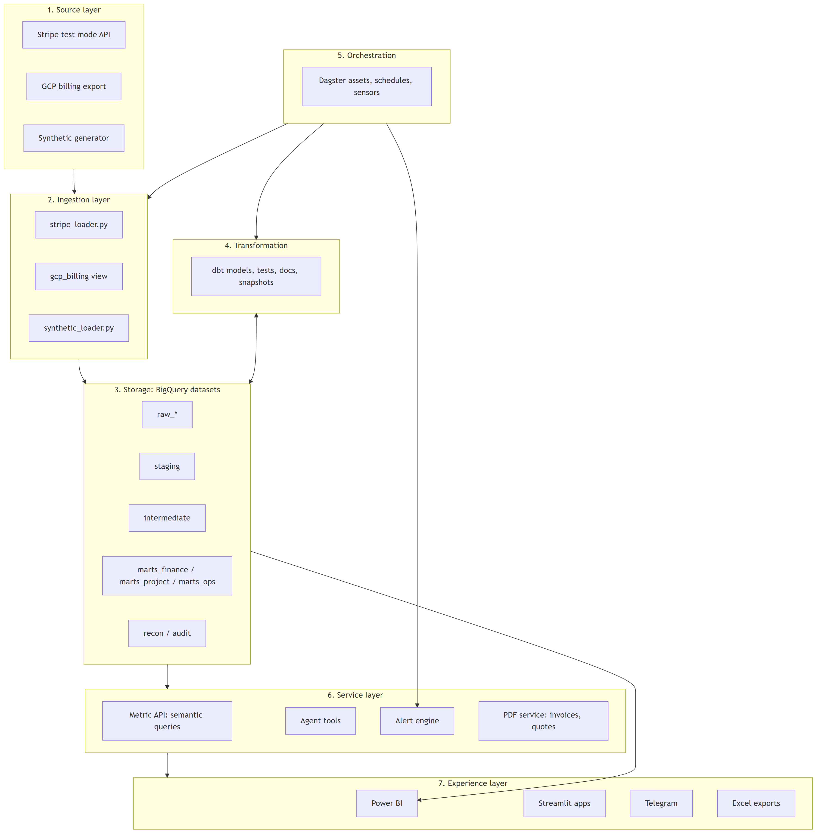
Figure 2

6.2 Technology choices
Concern | Choice | Why | Alternative considered
Warehouse | BigQuery | GCP billing export lands there natively; free tier; Power BI connector | Snowflake (trial expires), Postgres (not a warehouse)
Local dev | DuckDB | Offline, fast, free; same dbt project | —
Transformation | dbt Core | Named in the posting; tests, docs, lineage | SQLMesh
Orchestration | Dagster | Asset-based fits dbt well; local UI; free | Airflow (heavier to run locally; named in the posting, so mention equivalence)
Ingestion | Python (stripe SDK, pandas, google-cloud-bigquery) | Simple, explicit, testable | dlt, Airbyte
Billing system | Stripe test mode | Real API, usage meters, invoices, payments | —
Apps | Streamlit | Fast internal tools in Python | Next.js
BI | Power BI Desktop | Owner's choice; common in finance teams; covers "Excel and business systems" | Looker Studio
LLM | Vertex AI Gemini (flash) | Already used in Lakshyaa; billed in the same GCP project, so cost reconciles | Claude, OpenAI
PDFs | WeasyPrint or ReportLab | Invoice and quote documents | —
Alerts | Telegram Bot API | Already used in JobRadar | Slack
CI | GitHub Actions | dbt build on DuckDB + pytest + agent eval (mocked) | —

6.3 Repository structure
Finance OS/
├── README.md
├── docs/
│ ├── SYSTEM_DESIGN.md # this document
│ ├── METRIC_CATALOG.md # generated from dbt metric YAML
│ ├── DECISIONS.md # ADR log
│ ├── investigations/ # one write-up per variance
│ └── process/ # maps, SIPOC, runbook, controls
├── generator/ # synthetic data (seeded)
│ ├── config.yaml # company size, prices, anomalies
│ ├── entities/ # customers, projects, employees, vendors
│ ├── events/ # usage, gpu jobs, timesheets, invoices, payments
│ └── anomalies.py # injected issues + manifest
├── ingestion/
│ ├── stripe_seed.py # pushes synthetic usage into Stripe test mode
│ ├── stripe_loader.py # pulls Stripe objects into raw_stripe
│ └── synthetic_loader.py
├── warehouse/ # dbt project
│ ├── models/staging/
│ ├── models/intermediate/
│ ├── models/marts/finance/
│ ├── models/marts/project/
│ ├── models/marts/ops/
│ ├── models/recon/
│ ├── snapshots/
│ ├── seeds/ # budgets, price list, comp plans, allocation rules
│ ├── tests/ # custom singular tests
│ └── metrics/ # metric definitions (YAML)
├── orchestration/ # Dagster definitions
├── services/
│ ├── alerts/
│ ├── pdf/
│ └── metric_api/
├── apps/ # Streamlit: deal desk, billing run, collections, comp
├── agent/
│ ├── tools/ # typed, read-only tools
│ ├── prompts/
│ └── evals/ # questions, expected answers, runner
├── powerbi/ # .pbix + theme + screenshots
└── tests/ # pytest

6.4 Environments
Env | Warehouse | Data | Purpose
local | DuckDB file | Synthetic only | Development, CI, offline demo
cloud | BigQuery project finance-os | Synthetic + Stripe test + real GCP export | Full system, Power BI, agent

7. Data design

7.1 Source inventory
Source | Raw dataset | Key objects | Load pattern
Stripe test mode | raw_stripe | customers, products, prices, subscriptions, meter_events, invoices, invoice_lines, charges, refunds, balance_transactions, payouts | Incremental by created cursor
GCP billing | billing_export (native) | gcp_billing_export_v1_*, resource-level detailed export | Read in place via staging view
Generator: finance | raw_erp | gl_accounts, journal_entries, journal_lines, vendors, bills, bill_payments, budgets, cash_accounts | Full refresh per run
Generator: payroll | raw_payroll | employees, pay_runs, pay_lines, departments | Full refresh
Generator: projects | raw_projects | contracts, clins, labor_categories, rates, projects, tasks, timesheets, purchase_orders, po_receipts, milestones, acceptances | Full refresh
Generator: CRM | raw_crm | accounts, opportunities, opportunity_lines, reps, quotas | Full refresh
Generator: infra | raw_infra | gpu_jobs (job id, model, workload, customer, gpu type, seconds, region, labels) | Full refresh
Seeds | seeds | price_list, gpu_rates, allocation_rules, comp_plans, alert_rules, margin_floors | dbt seed

7.2 Core entity relationships
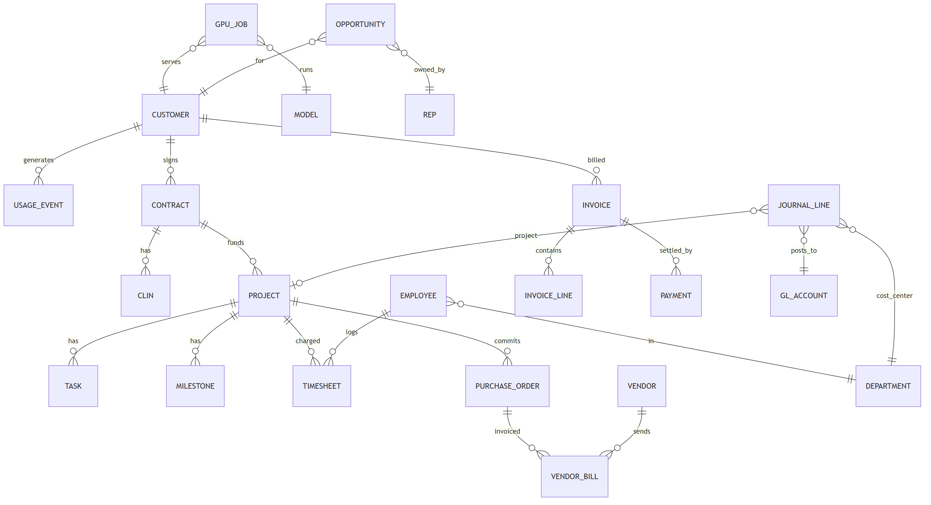
Figure 3

7.3 dbt layers and conventions
Layer | Prefix | Rules
Staging | stg_<source>__<object> | 1:1 with source; rename, cast, cents → dollars, no joins
Intermediate | int_<concept> | Joins and business logic; not exposed to BI
Marts | fct_*, dim_* | Star schema; documented grain; the only layer BI and the agent read
Recon | recon_<check> | One row per check × period, standard columns
Snapshots | snap_* | SCD2 for prices, budgets, contract modifications

7.4 Dimensional model (marts)
Dimensions: dim_date, dim_customer (segment, plan, region), dim_product, dim_model, dim_department, dim_gl_account (type, rollup), dim_project, dim_contract, dim_vendor, dim_employee, dim_rep, dim_labor_category.
Facts:
Fact | Grain | Key measures
fct_usage_daily | customer × model × workload × day | audio hours, requests
fct_gpu_cost_daily | model × workload × customer × day | GPU seconds, GPU cost, allocated overhead
fct_cloud_cost_daily | service × sku × label(team, env) × day | cost, credits, tagged flag
fct_revenue_monthly | customer × product × month | billed, recognized, deferred
fct_unit_economics_monthly | customer × product × workload × month | revenue, COGS, gross margin, contribution
fct_gl_monthly | account × department × project × month | actual
fct_budget_monthly | account × department × month | budget, forecast
fct_bva_monthly | account × department × month | actual, budget, variance $, variance %
fct_project_financials | project × cost type × month | budget, commitments, actuals, ETC, EAC, % complete, earned, billed, unbilled, deferred
fct_contract_funding | contract × CLIN × month | ceiling, funded, billed, remaining, % funded used
fct_invoices | invoice | amount, due date, status, days outstanding
fct_ar_aging_snapshot | customer × invoice × snapshot date | balance, bucket
fct_cash_monthly | month | opening cash, inflows, outflows, net burn, closing cash
fct_deals | opportunity | list value, discount, projected margin, approval route
fct_comp_statements | rep × month | attainment, payout, accelerator, clawback
fct_kpi_monthly | metric × month | value (from metric catalog)

7.5 Metric catalog (excerpt)
Each metric is defined in warehouse/metrics/*.yml with name, purpose (the decision it supports), formula, grain, source models, owner, tolerance, and whether it is MEASURED or ASSUMED.
Metric | Decision it supports | Formula
Cost to serve / audio hour | Pricing floors, model routing | (GPU cost + allocated infra overhead) ÷ audio hours
Gross margin % | Pricing, product mix | (Revenue − COGS) ÷ Revenue
Contribution margin | Account prioritization | Gross margin − Stripe fees − support − success cost
Net burn | Spending pace | Cash out − cash in (operating)
Runway (months) | Fundraising timing | Cash ÷ avg net burn (T3M)
ARR | Growth tracking | Committed annualized + usage run-rate (T3M × 4)
NRR | Expansion health | Revenue from cohort now ÷ same cohort 12 months ago
BvA variance | Spend control | Actual − budget
Tagging coverage | Attribution trust | Tagged cost ÷ total cloud cost
EAC | Project health | Actuals + open commitments + ETC
% complete | Revenue recognition | Actual cost ÷ EAC
Unbilled (WIP) | Billing discipline, cash | Earned − billed (if > 0)
Funding used % | Federal funding notice | Billed + unbilled ÷ funded
DSO | Collections health | AR ÷ revenue × days in period
CEI | Collections effectiveness | (Begin AR + sales − end AR) ÷ (begin AR + sales − current AR)
Deal projected margin | Deal approval | (Net price − cost to serve) ÷ net price at expected volume

7.6 Allocation rules
Pool | Driver | To
GPU cost (tagged by job) | Direct | Customer × model × workload
Shared GPU (idle, warm pools) | GPU-seconds share | Model × workload
Cloud overhead (storage, networking, logging) | Request share | Customer
Untagged cloud | Not allocated; shown as its own line | —
Stripe fees | Direct per charge | Customer
Support & success | Revenue share by segment | Customer

Rules live in seeds/allocation_rules.csv so a scenario can switch drivers without changing code.

8. Module design
Each module lists inputs, logic, outputs, checks and its injected anomaly (the known problem the system must catch).

M2 Unit economics
- Inputs: fct_usage_daily, fct_gpu_cost_daily, fct_cloud_cost_daily, fct_revenue_monthly, allocation seeds.
- Logic: direct GPU cost per job → model-level overhead by GPU-seconds → customer-level overhead by requests → join to recognized revenue → gross and contribution margin.
- Outputs: fct_unit_economics_monthly; Power BI page "Unit economics"; margin floors to M9.
- Checks: sum of allocated cost = total cost pool (allocation must be complete); revenue equals fct_revenue_monthly.
- Injected anomaly: one enterprise customer moves to streaming in month 14 and their margin falls below the floor.

M3 Tech spend
- Inputs: GCP billing export (real), synthetic GPU vendor bills, labels.
- Logic: normalize SKUs → map labels to team/env → untagged line → forecast = usage trend (T3M growth) × unit cost + committed contracts.
- Outputs: fct_cloud_cost_daily, fct_spend_forecast; page "Tech spend".
- Checks: modeled monthly total ↔ invoice total within 1%.
- Injected anomaly: a GPU cluster left running without labels for 9 days (untagged spike).

M4 Burn and KPIs
- Inputs: fct_cash_monthly, fct_revenue_monthly, headcount.
- Outputs: fct_kpi_monthly; page "Overview"; board pack PDF.
- Checks: closing cash ↔ GL cash account balance.

M5 Budget vs. actuals
- Inputs: fct_gl_monthly, fct_budget_monthly, alert rules.
- Logic: variance by dept × account × month; YTD; full-year forecast = YTD actual + remaining budget (or run-rate, selectable).
- Outputs: fct_bva_monthly; page "BvA"; overspend alerts; AI-drafted commentary queue.
- Injected anomaly: Sales T&E 40% over budget in month 17 from a conference.

M6 Project accounting
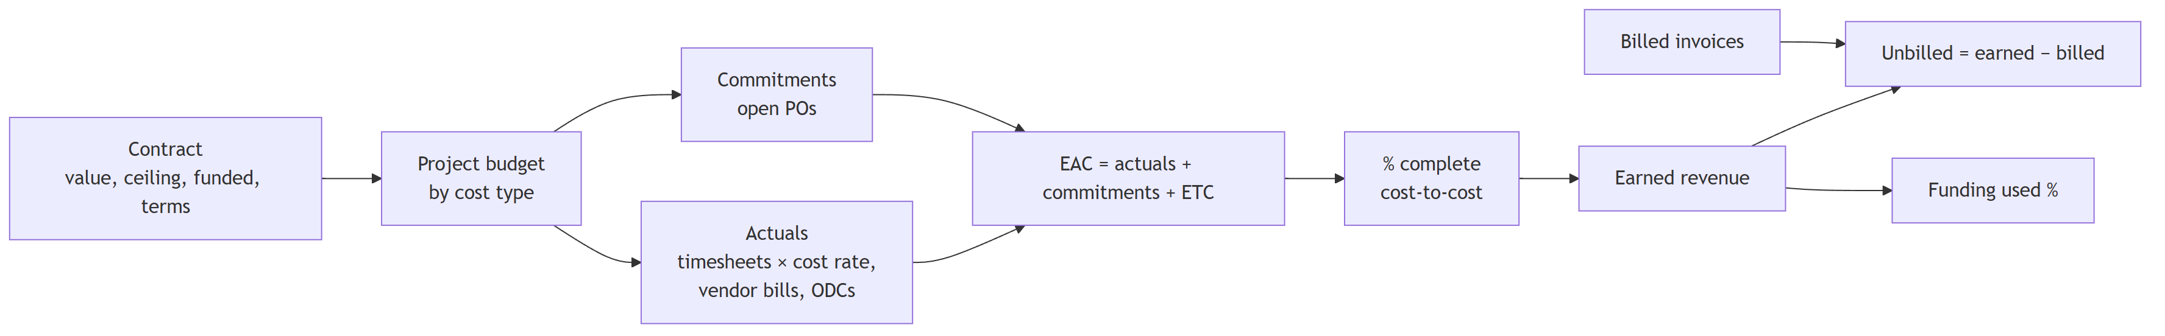
Figure 4
- Outputs: fct_project_financials, fct_contract_funding; Project view pages.
- Checks: project labor actuals ↔ payroll cost of hours; PO invoiced ≤ PO amount.
- Injected anomalies: P-103 over budget (EAC 118% of budget); P-105 funding reaches 75%; P-102 T&M at 88% of cap; a vendor bill with no PO.

M7 Billing operations
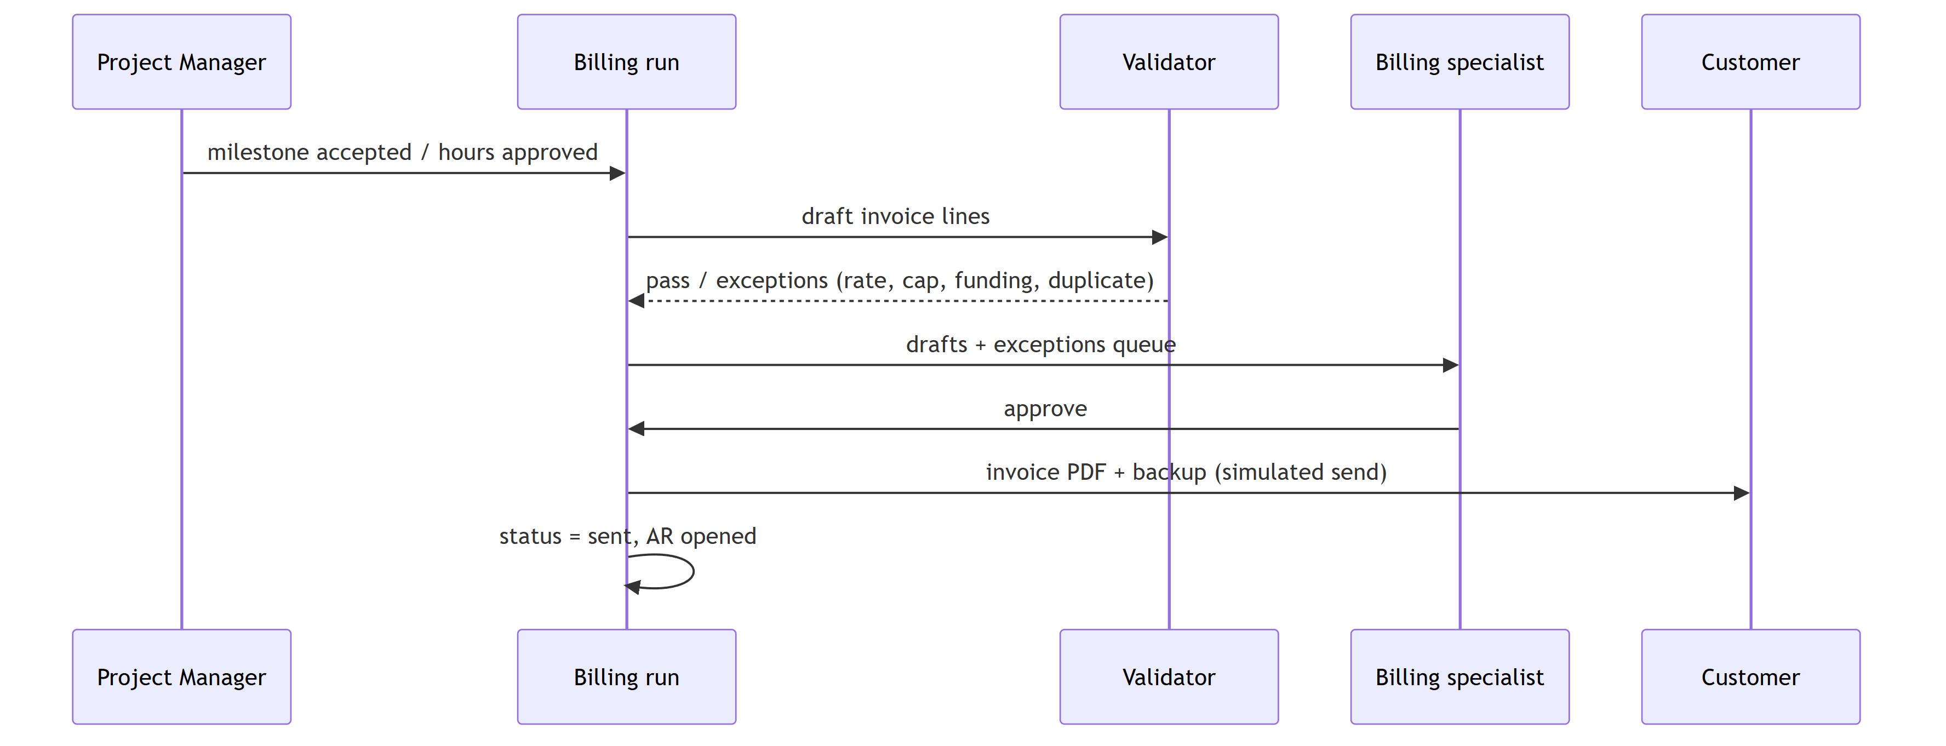
Figure 5
- Validation rules: billed rate = contract rate for labor category; T&M cumulative ≤ cap; federal cumulative ≤ funded; no line billed twice; milestone has acceptance record.
- Injected anomalies: P-106 milestone accepted but not billed for 45 days; one T&M line billed at the wrong labor-category rate.

M8 AR and collections
- Logic: daily aging snapshot; queue score = balance × days overdue × segment weight; AI drafts reminders at 7/30/60 days in increasing firmness, citing the invoice and terms.
- Injected anomalies: P-104 customer pays 70+ days late; one payment applied to the wrong invoice (cash-application exception).

M9 Deal desk
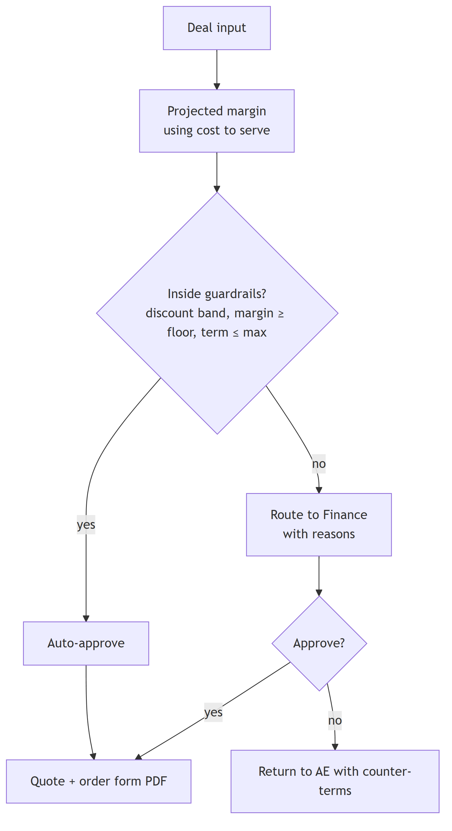
Figure 6

M10 Sales comp
- Attainment = closed-won bookings that have billed (reconciled to fct_invoices) ÷ quota. Payout = base rate × bookings, × 1.5 above 100%. Clawback if churned within 90 days.
- Injected anomaly: a deal marked closed-won in CRM that never billed (must not pay out).

M12 Reconciliation framework
Every recon model outputs the same columns:
column | meaning
check_id | e.g. REC-STRIPE-GL-REV
period | month
expected | value from source A
actual | value from source B
variance | actual − expected
tolerance | absolute or %
status | PASS / FAIL / EXPLAINED
explanation_ref | link to docs/investigations/*.md

A dbt test fails the build on any FAIL that has no explanation. Power BI's "Trust" page shows the latest status of every check. The agent reads this table before answering (FR-11.3).
Check | A | B
REC-STRIPE-GL-REV | Stripe invoices (paid + open) | GL revenue accounts
REC-STRIPE-CASH | Stripe payouts | GL cash deposits
REC-USAGE-BILLED | Metered usage × price | Stripe invoice lines
REC-GCP-MODEL | GCP export total | Modeled cloud cost
REC-PAYROLL-GL | Payroll register | GL payroll accounts
REC-PROJ-LABOR | Timesheet hours × cost rate | Project labor actuals
REC-BILLED-CONTRACT | Invoice lines | Contract rates and caps
REC-ALLOC-COMPLETE | Cost pools | Sum allocated + unallocated

9. AI design

9.1 Where AI is used, and where it is not
Use | AI? | Why
Computing any number (revenue, margin, EAC, burn) | No | Deterministic SQL in dbt; must reconcile
Allocation, recognition, billing validation | No | Rules, auditable
Answering finance questions in plain English | Yes | Language and tool selection
Explaining a variance from its driving transactions | Yes (draft) | Summarizing many rows
Drafting collection emails | Yes (draft, approval required) | Tone and context
Drafting BvA commentary | Yes (draft, approval required) | Saves controller time
Extracting terms from a contract document | Could (phase 8 stretch) | Unstructured input; every field confirmed by a human

9.2 Agent architecture
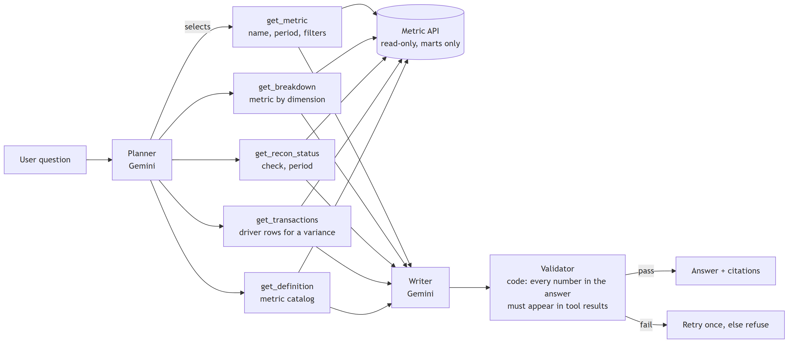
Figure 7
- Tools return typed JSON (Pydantic) with values, the definition, the query used and the recon status.
- Before giving a number, the planner must call get_recon_status. If the relevant check is FAIL, the answer says the number is not trusted and why.
- The validator is code, not a model. It extracts every number from the draft answer and rejects it if any number isn't in the tool results.

9.3 Evaluation
- agent/evals/questions.yaml: ≥30 questions across personas, each with the expected tool calls, expected figure(s) and must-refuse cases.
- Each question runs 3 times. Recorded: correct, consistent across runs, refused correctly, latency, token cost.
- The eval results table is committed per prompt version.

9.4 Failure handling
Failure | Handling
Tool timeout | One retry within the deadline; else "could not retrieve"
Number not in tool results | Validator rejects; one retry; else refuse
Recon failing | Answer flags the number as untrusted
Ambiguous question | Ask one clarifying question
Out of scope (e.g. investment advice) | Refuse

10. Orchestration design (Dagster)
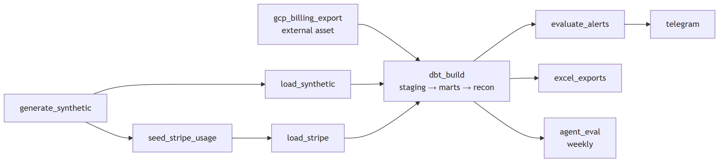
Figure 8
Job | Schedule | Notes
daily_finance | 06:00 daily | Load → dbt build → alerts → exports
monthly_close | 1st business day | Freeze period, snapshot AR, board pack
agent_eval | Weekly + on prompt change | Writes eval results
Freshness sensor | Hourly | Alerts if a source is late
Backfill | Manual, by month partition | Rebuild a period

11. Alert design
Rule | Condition | Recipient persona | Severity
Overspend | Dept × account variance > 10% and > $5K | Dept owner, VP Finance | High
Margin floor | Customer gross margin < floor for 2 months | VP Finance, Sales lead | High
Untagged spend | Untagged > 5% of monthly cloud | Head of Infra | Medium
Funding 75% / 90% | Funding used % crosses threshold | PM, Controller | High
T&M cap 85% | Cumulative billed ÷ cap | PM | Medium
Unbilled aging | Billable item unbilled > 15 days | Billing specialist | High
AR 60+ | Invoice > 60 days past due | Billing specialist, Controller | Medium
Recon fail | Any check FAIL without explanation | Controller | High
Source stale | Source not refreshed in 26 h | Engineer (owner) | Medium

Alerts are de-duplicated by (rule, entity, period) and stored in audit.alert_log.

12. Security, privacy and cost
- Secrets: Stripe test key, GCP service-account key and Telegram token in .env (git-ignored) locally and Secret Manager in cloud. Stripe test mode only; the loader refuses a sk_live_ key.
- Access: service account with BigQuery Data Viewer on the billing dataset, Data Editor on Finance OS datasets only.
- Agent: tools are read-only and limited to marts; no raw SQL; no write tools.
- Privacy: synthetic names via Faker with a fixed seed; no real people. The repo can be public; the GCP export is not committed, only screenshots of aggregates.
- Cost guardrails: GCP budget alert at $10; dbt models partitioned by date and clustered by customer; Gemini calls capped per day.

13. Testing strategy
Level | What | Tool
Unit | Generator rules, allocation functions, validators, PDF builders | pytest
Data | Keys, relationships, accepted values, ranges | dbt tests
Reconciliation | All REC-* checks | dbt singular tests
Anomaly detection | Each anomaly in the manifest is detected by the expected check or alert | pytest reading the manifest + marts
Agent | Eval set: correctness, consistency, refusals | agent/evals/run.py
End to end | Fresh seed → full pipeline → expected KPI values | CI on DuckDB

The anomaly test is central: it proves the system catches problems, rather than just claiming it does.

14. Phase-wise plan
Each phase ends with an exit check. Nothing moves forward until it passes.

Phase 0 — Foundations (1 day)
- Repo, Python env (uv), pre-commit, GitHub Actions skeleton.
- GCP project finance-os, BigQuery datasets, service account, budget alert.
- Enable GCP billing export to BigQuery now. It only collects data going forward, so it needs lead time.
- Stripe test-mode account and key.
- ADR-001 to ADR-005 written (warehouse, orchestration, BI, LLM, money types).
- Exit: dbt debug passes on DuckDB and BigQuery; CI green.

Phase 1 — Synthetic company and data generator (2 days)
- generator/config.yaml: company, customers, projects, employees, vendors, prices, budgets.
- Event generators: usage, GPU jobs, timesheets, POs, vendor bills, payroll, GL journals, CRM deals, payments.
- Double-entry integrity: every journal balances.
- Anomaly injector + anomalies_manifest.json.
- Exit: same seed → identical output; all journals balance; manifest lists ≥12 anomalies.

Phase 2 — Ingestion (1–2 days)
- stripe_seed.py: create customers, products, meters and prices in test mode; push usage meter events; let Stripe generate invoices; simulate payments with test cards.
- stripe_loader.py: incremental pull into raw_stripe.
- Synthetic loader to raw_*; GCP export staging view.
- Exit: row counts match source; rerun produces no duplicates.

Phase 3 — Warehouse modeling (2–3 days)
- Staging models for all sources.
- Dimensions and core facts (§7.4).
- Metric catalog YAML for the first 10 metrics.
- dbt docs and lineage graph.
- Exit: all dbt tests pass; every mart has a documented grain.

Phase 4 — Reconciliation and orchestration (2 days)
- All REC-* models and the standard recon table.
- Dagster assets, schedules, freshness sensor.
- Anomaly detection tests.
- First 2 investigation write-ups.
- Exit: the daily job runs end to end in < 15 min; every injected anomaly is either detected or listed as a known gap.

Phase 5 — Finance engineering modules (3 days)
- M2 Unit economics, M3 Tech spend, M4 Burn and KPIs, M5 BvA.
- Alert engine + Telegram (M13).
- Exit: margin by customer/product/workload reconciles to revenue and cost totals; overspend alert fires for the injected Sales T&E case.

Phase 6 — Project accounting and billing (3 days)
- M6 Project financials and funding, M7 billing run + validator + invoice PDF, M8 AR aging, DSO, CEI, collections queue.
- Exit: P-103 over budget, P-105 funding 75%, P-106 unbilled and the wrong-rate line are all caught; invoice PDF has T&M backup.

Phase 7 — Apps: deal desk and sales comp (2 days)
- M9 deal desk Streamlit app with guardrails, routing and quote PDF.
- M10 comp statements (simplified).
- Exit: an out-of-band deal routes to Finance with reasons; the closed-won-but-unbilled deal does not pay out.

Phase 8 — AI layer (3 days)
- Metric API and typed tools; planner, writer and validator.
- Collections email drafter and BvA commentary drafter with approval queue.
- Eval set (≥30 questions × 3 runs); cost per question reconciled to the Vertex AI billing line.
- Stretch: contract term extraction with human confirmation.
- Exit: eval results recorded honestly (including failures); validator blocks any made-up number in testing.

Phase 9 — Reporting (2 days)
- Mockups first for owner approval, then Power BI Finance view and Project view, theme and tooltips with metric definitions.
- Excel exports.
- Exit: every visual reads a mart; Trust page shows recon status; screenshots captured.

Phase 10 — Process documentation and packaging (1–2 days)
- Swim-lane maps (quote-to-cash, procure-to-pay, project billing, month-end close), SIPOCs, close runbook, controls list.
- Before/after manual-work analysis.
- README with architecture diagram, demo script (5 minutes), and the honest limits from §1.3.
- 3–4 resume bullets sourced from real outputs, each with the query or file behind it.
- Exit: a stranger can clone, run on DuckDB and see the dashboards' numbers.
Total: ~22–25 working days. The minimum version that's enough to apply with is Phases 0–6 plus a basic Power BI (≈ 15 days).

15. Risks and mitigations
Risk | Impact | Mitigation
GCP billing export has little data (small personal spend) | Thin real cost story | Combine with synthetic GPU lines; state clearly which part is real
Stripe test mode rate limits / meter API changes | Ingestion delays | Batch meter events; cache; fall back to synthetic invoices if blocked
Scope creep | Never finishes | Phase exit checks; MVP = Phases 0–6
Synthetic data looks too clean | Weak story | Anomaly injector; realistic noise, late payments, missing tags
AI overstated in interviews | Credibility | AI never computes money; eval results published honestly
Claimed as real company experience | Credibility | README and resume say "simulated company, built end to end"
BigQuery free-tier overrun | Cost | Partitioning, budget alert, DuckDB for dev

16. Open questions for the owner
- Is the GitHub repo public? (Recommended: yes, since it holds no secrets or real PII.)
- Dagster or Airflow? Dagster is recommended; Airflow is named in the posting, so a short note on equivalence goes in the README.
- Which Gemini model and daily cost cap for the agent?
- Include sales comp in the MVP, or leave it as a later phase?
- Should the federal contract go deeper (indirect rates, provisional billing)? Currently it's kept simple.

17. Glossary
Term | Meaning
ARR | Annual recurring revenue
BvA | Budget vs. actuals
CEI | Collection effectiveness index
CLIN | Contract line item number (federal)
COGS | Cost of goods sold (here: cost to serve)
DSO | Days sales outstanding
EAC / ETC | Estimate at completion / estimate to complete
GRR / NRR | Gross / net revenue retention
ODC | Other direct cost
PO | Purchase order
T&M | Time and materials
WIP / unbilled | Revenue earned but not yet invoiced

