Austin Sivret

February 24 2020

IT FDN 100

Assignment 5

Assignment 5

# Introduction

This assignment goes into details on lists and dictionaries, especially 2D dictionaries. I also used more complicated file functions. Finally, I learned about some common script improvements, such as Separation of Concerns, Functions, and templates.

# Module Videos

# Lab 05-A

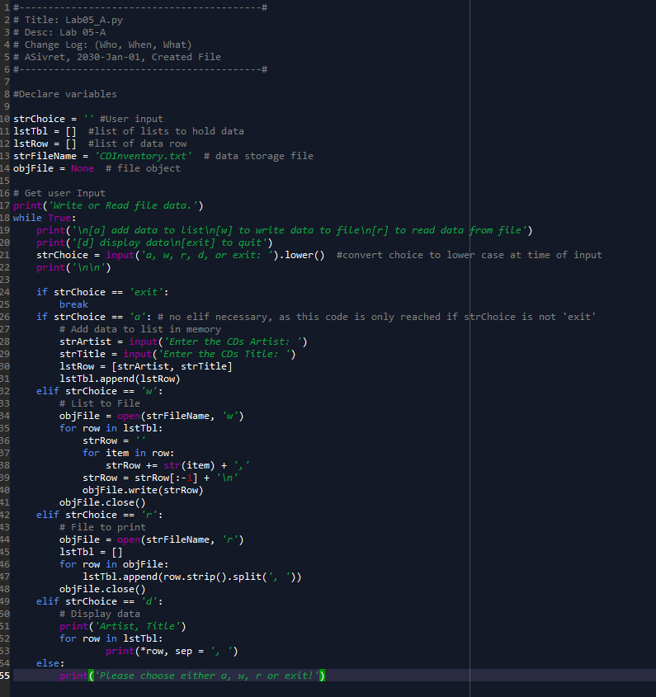

Figure - Lab A

This code will take an input from a user and then iterate them through one of the loops below. Depending on their choices, they can either add to the list, write to the file, read from the file, or display the data in the list. It is very important to be careful where you define your lists; one issue I had was previous lists getting overwritten by newer lists when appending to my table. I’ll have to ask Dirk specifically about that one in class (how to know you won’t have a list from a 2D list overwritten when you change one of the interior lists).

# Lab 05-B

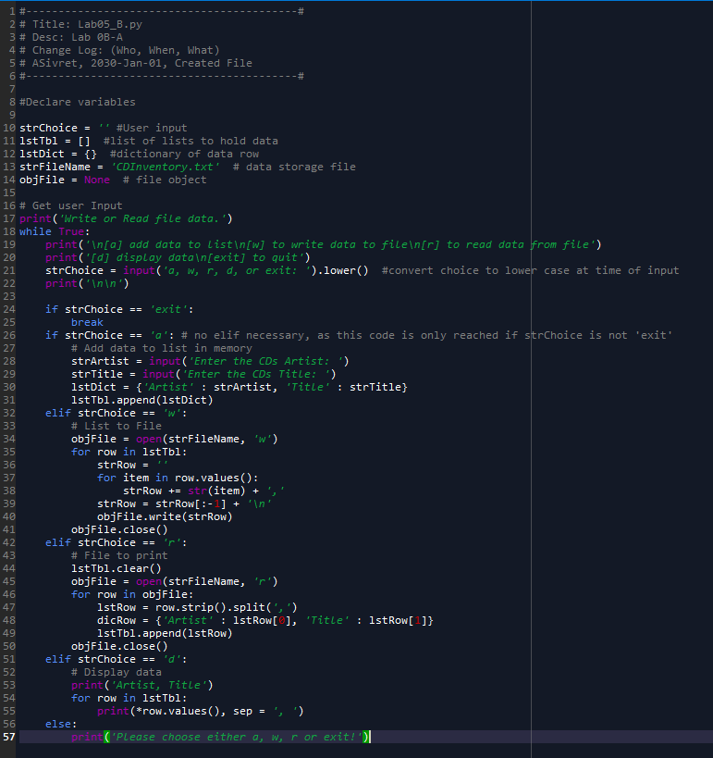

Figure - Lab B

This lab is very similar to the previous, showing how lists and dictionaries are almost interchangeable except the fact that a dictionary links two objects together at each index. The output looks fine to me, I’m not sure what that question is implying.

# Book Chapter

In the book chapter, I learned about lists and dictionaries, as well as the difference between them (mainly immutability). I also learned about shared references, which has been a confusing topic for me in my programming so far.

# Web Pages

I read web pages going over lists and tuples[1], dictionaries[2], and more on reading and writing with files[3]

# Additional Videos

I watched one YouTube video[4] that showed more about reading and writing with files.

# Apply Your Knowledge

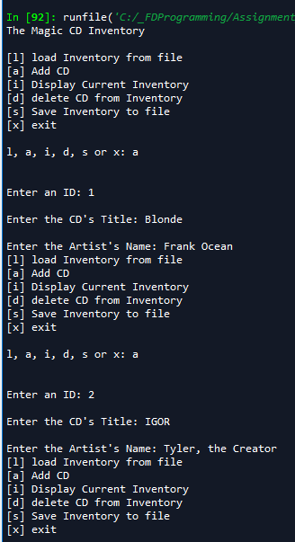

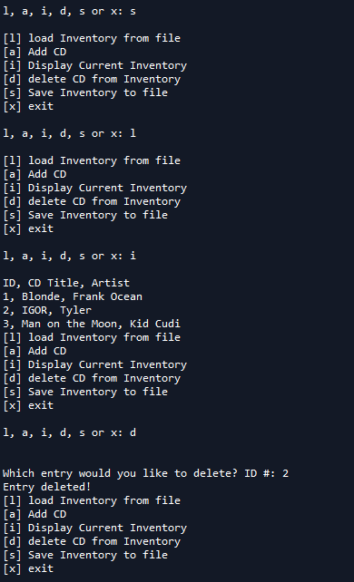

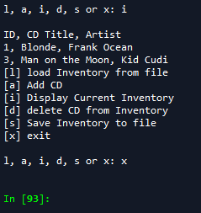

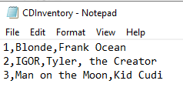

Figure - Output and file for the assignment.

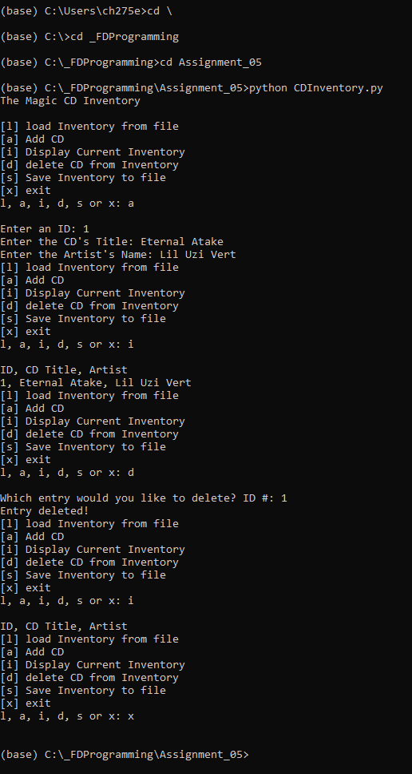

Figure - Terminal output for my assignment.

This assignment gave me a lot of the code to begin with, and I had to make a few modifications. First, I changed the second level of the 2D list to include dictionaries, much like in Lab B. Secondly, I added in the ability to load data. I added an *import os.path* in order to use the *os.path.isfile* function to check if a file existed. If so, then the 2D list is cleared and replaced with the data in the file, and finally the file is closed. I also added functionality to delete an entry. This one was a little tricky, since I wanted to let the user know when the ID they asked for didn’t exist. Normally I would use a simple *if in* statement, but I wasn’t sure how to do that in the second layer of a 2D list. So I created a variable *idInTbl* that starts as *False* and moves to *True* if the ID is found.

# Summary

This was by far the hardest assignment yet, and went in depth on sequences such as lists, tuples, and dictionaries, and even made them 2D. Furthermore, I used a lot more file reading and writing, which required creative use of strings.

1. <https://realpython.com/python-lists-tuples/> Accessed Feb 25 2020
2. <https://realpython.com/python-dicts/> Accessed Feb 25 2020
3. <https://www.geeksforgeeks.org/file-handling-python/> Accessed Feb 25 2020
4. <https://www.youtube.com/watch?v=m0o0CkYsDzI&feature=youtu.be> Accessed Feb 25 2020