Austin Sivret

February 27 2020

IT FDN 100

Assignment 6

Assignment 6

# Introduction

In this assignment, I was introduced to functions and classes, and learned how to use them to make my code more efficient. I learned about the specifics regarding parameters, arguments, and return variables and how to use them more effectively (like using default values). I reviewed reference vs value types and how to use them to improve my code. I also started using docstring to make my functions and classes easier to learn for others and for myself to remember what they do. I learned about variable scope and global variables, as well as the danger of calling global variables within a function. The book chapter explained these concepts through the use of a complex Tic-Tac-Toe game, and I applied my knowledge by editing the CDInventory script to work with functions and classes.

# Module Videos

## Lab 06-A

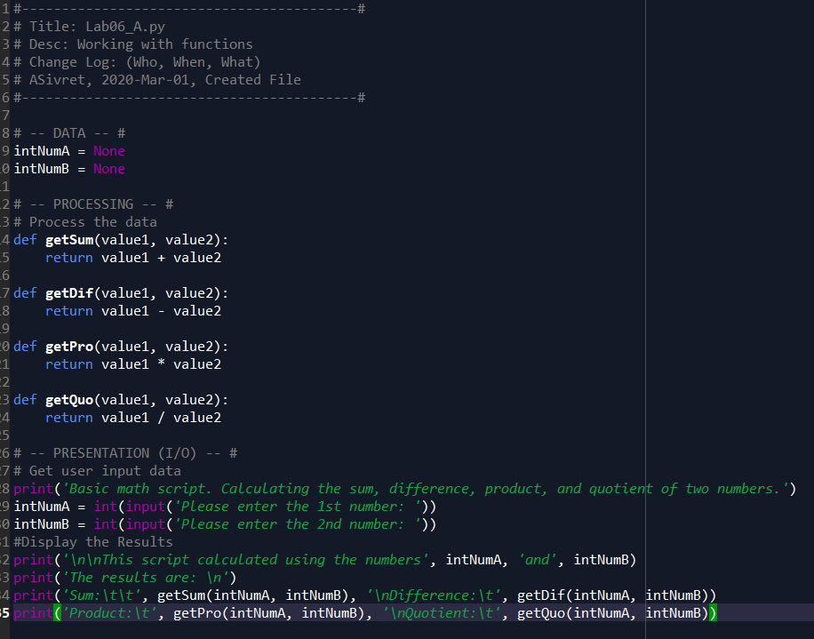

Figure 1 - Lab 06-A

For the first lab I just had to make some slight alterations to existing code to use attributes. Instead of being restricted to IntNumA and intNumB in the functions, I used value1 and value2 as parameters, allowing me to pass whatever I want. In this case, I can still pass in intNumA and intNum2, but I could use other things as well.

## Lab 06-B

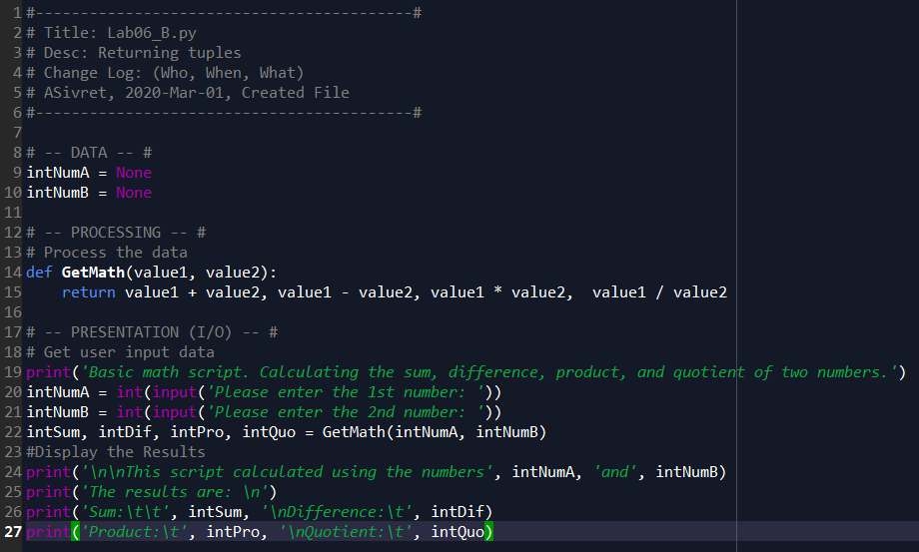

Figure 2 - Lab 06-B

In Lab B, I consolidated all of my functions into one and returned multiple values. These are unpacked and assigned to variables in line 22.

## Lab 06-C

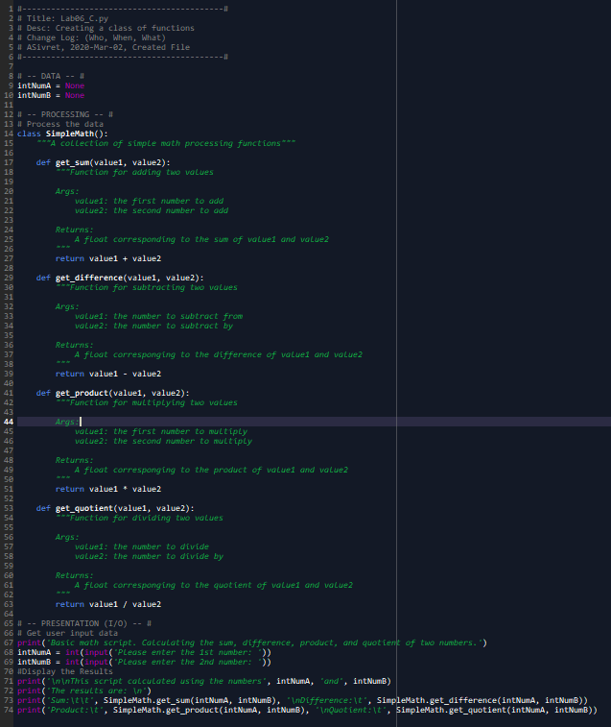

Figure 3 - Lab C

For lab C, I adapted my lab 1 code so that it essentially performs the same function, but also incorporates a class and docstring. I created a SimpleMath class that all of my math functions fall under, and then call later on using *SimpleMath.function_name*. I also added docstring to each Class and function describing what they do.

# Book Chapter

In the book, I learned more about functions as well as parameters, arguments, and return values. I also learned about scope and global variables and how to call them in functions (which generally isn’t a good idea). The rest of the chapter went through how to use functions to program a complicated Tic-Tac-Toe game.

# Web Pages

I read a web page[1] that included a brief review of functions as well as a short exercise with them.

# Additional Videos

I watched a YouTube video[2] that reviewed functions and their uses even further.

# Apply Your Knowledge

For this assignment (output shown below), I used functions and classes to edit a starter *CDInventory* script that resembles the one done last week. More specifically, I moved code from the main function into functions in classes defined beforehand. I moved code to prompt a user for input into the I/O class, code for adding and deleting data to the DataProcessor class, and I moved code to save from memory into a file in the FileProcessor class. For new function, I created docstring explaining what they do, as well as docstring for the FileProcessor class. I had to add parameters and return values to each function in order to achieve the correct variable scope throughout the script.

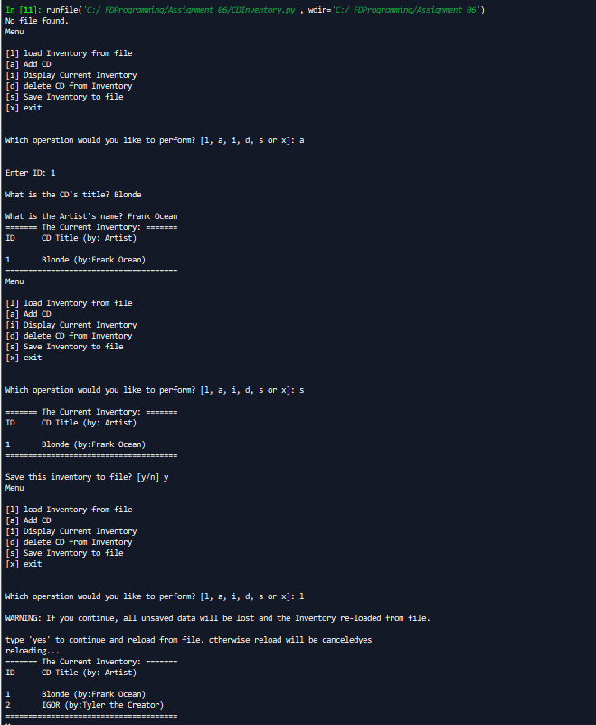

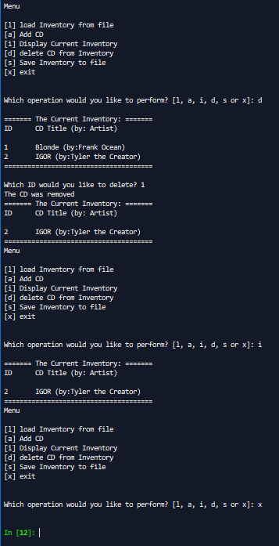

Figure - My assignment script working in Spyder.

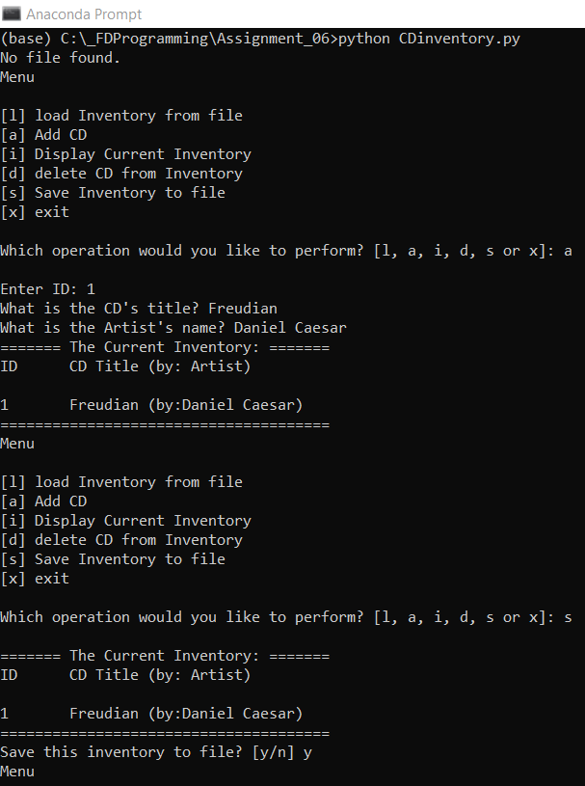

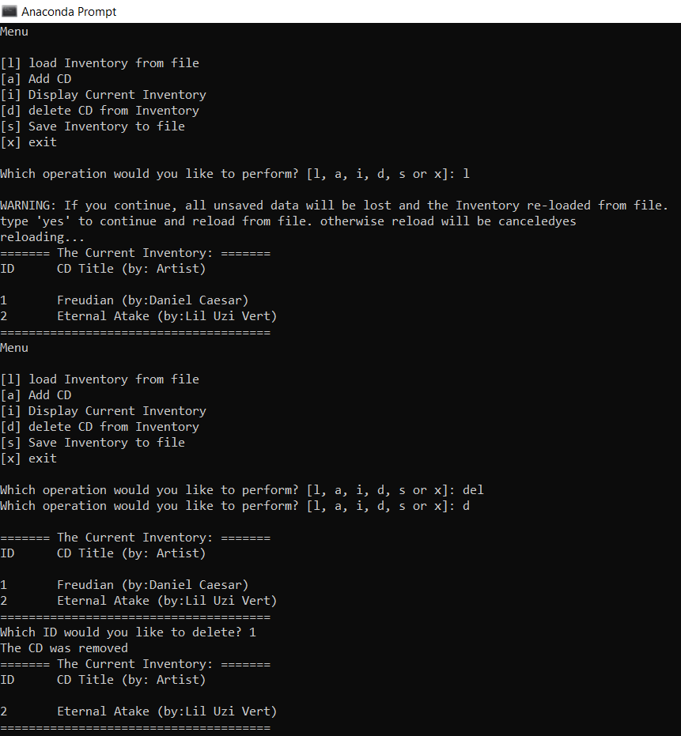

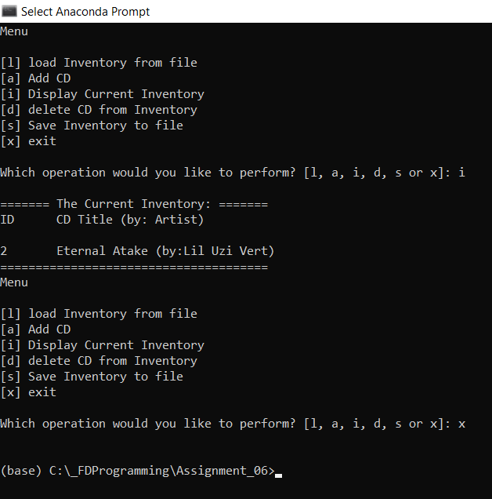

Figure - Script working in command prompt

# Summary

In this module, I learned about functions and classes, and how to use them to shorten my code to be more efficient. I learned about the difference between parameters, arguments, and return variables, and how to use them in my functions and classes. I also learned how to better document my code by using docstring to define my functions and classes.

1. <https://www.learnpython.org/en/Functions> Accessed March 2, 2020
2. <https://www.youtube.com/watch?v=_ypAw_pCOt8&feature=youtu.be> Accessed March 2, 2020