Austin Sivret

March 17 2020

IT FDN 100

Assignment 8

Assignment 8

# Introduction

In this module, I learned about objects and object oriented programming. I learned how to use classes as a blueprint to create objects. I learned about the elements within a class, including constructors, fields, attributes, properties, and methods. I applied my knowledge by introducing some object oriented programming concepts into the CDInventory script.

# Module Videos

## Lab 08-A

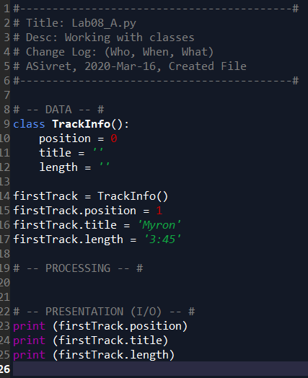

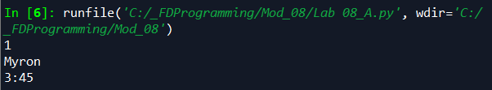

Figure 1 - Working with classes

For Lab A, I created a class called *TrackInfo* and initialized some fields, *position, title*, and *length*. Then I created an object, *FirstTrack*, and assigned some values to the fields. Then, I printed each of these fields to show that the code worked successfully.

## Lab 08-B

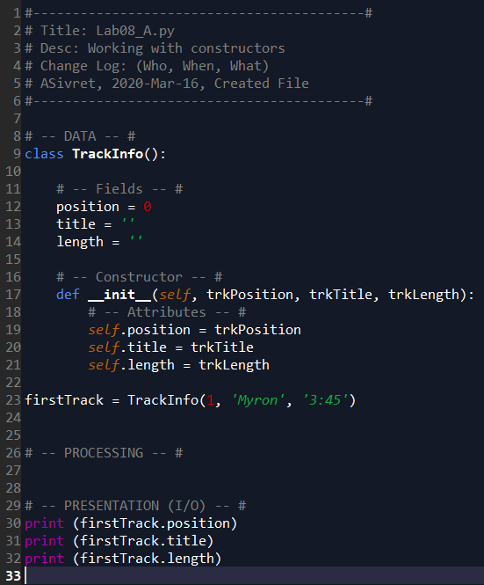

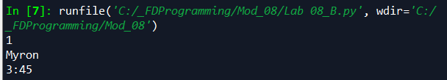

Figure 2 - Working with constructors

I edited my code from Lab A to use a constructor. I created a constructor with *self* and 3 other attributes for *position, title,* and *length*. When the object is first initialized, these 3 arguments are passed to fill the class fields.

## Lab 08-C

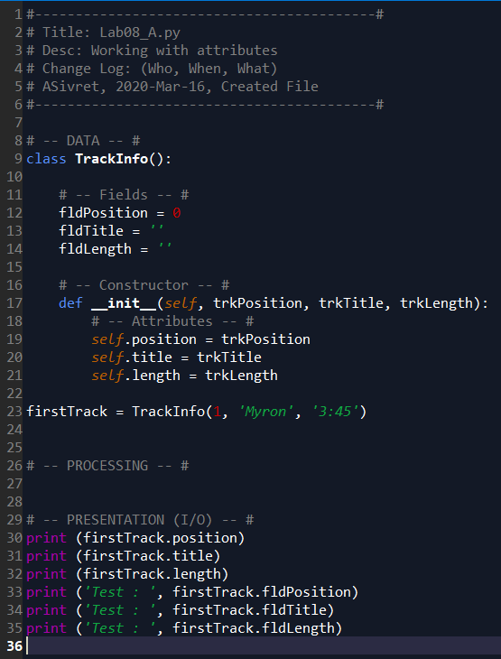

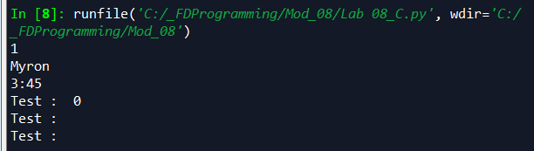

Figure 3 - Working with attributes

In Lab C I learned about attributes. It appears I already used *attributes* in the previous lab without knowing it, so here I demonstrate the difference between *attributes* and *fields* by printing both after running the code.

## Lab 08-D

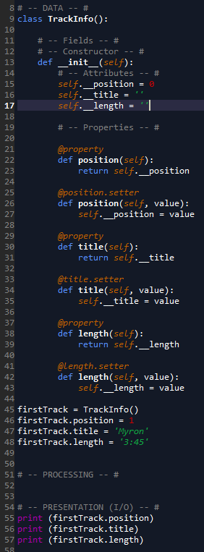

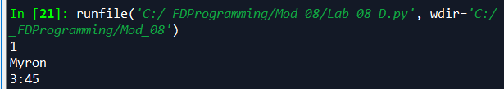

Figure 4 - Working with properties

In this lab, I created properties to handle the attributes of the object. I created a setter and getter method for each of *position*, *title*, and *length*.

# Lab 08-E

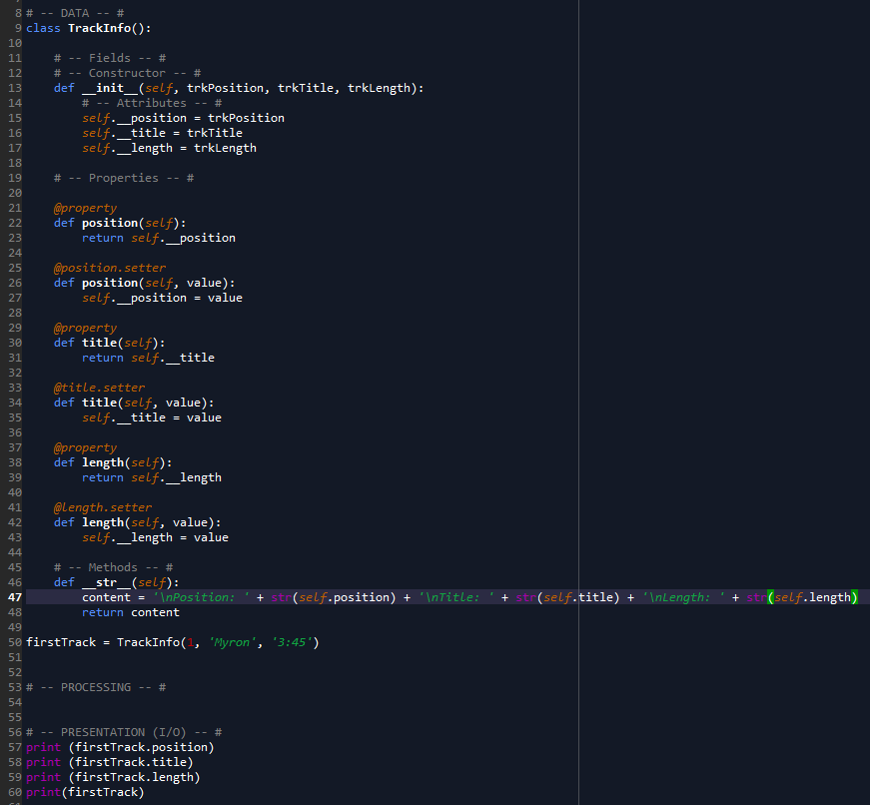

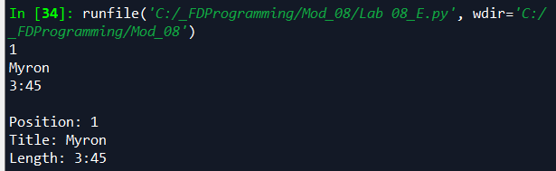

Figure 5 - Working with methods

I added a *__str__* that, when called, returns a formatted list of all of the attributes, with a new line in between them.

# Book Chapter

In the book I got an introduction to object-oriented programming. I learned about methods and attributes of software objects, and how to write classes. I learned about constructors, class attributes, static methods, object encapsulation and private attributes/properties. The chapter used an example of a virtual pet (critter) to bring all the ideas together.

# Web Pages

I read a page[1] reviewing classes, especially parent/child classes and their relationship. I watched a video[2] going over GIT and GitHub.

# Apply Your Knowledge

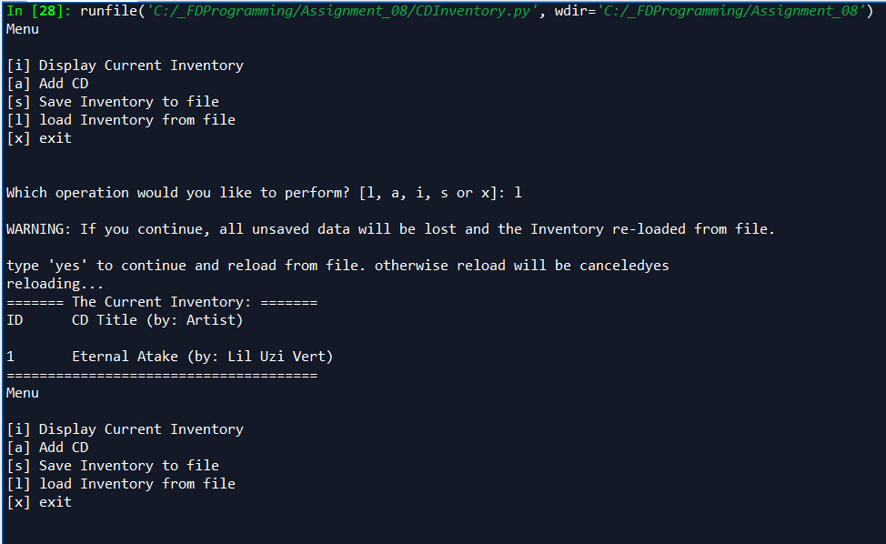

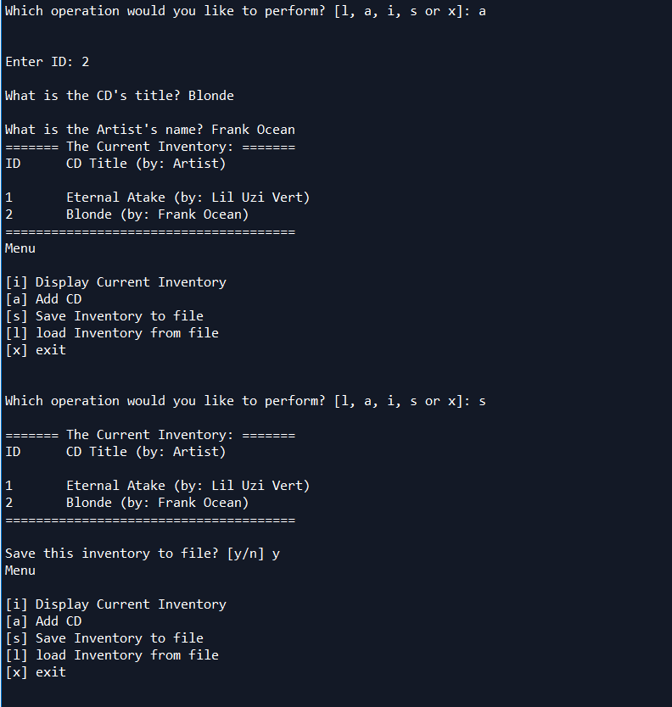

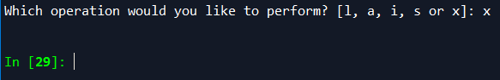

Figure - Script running in Spyder

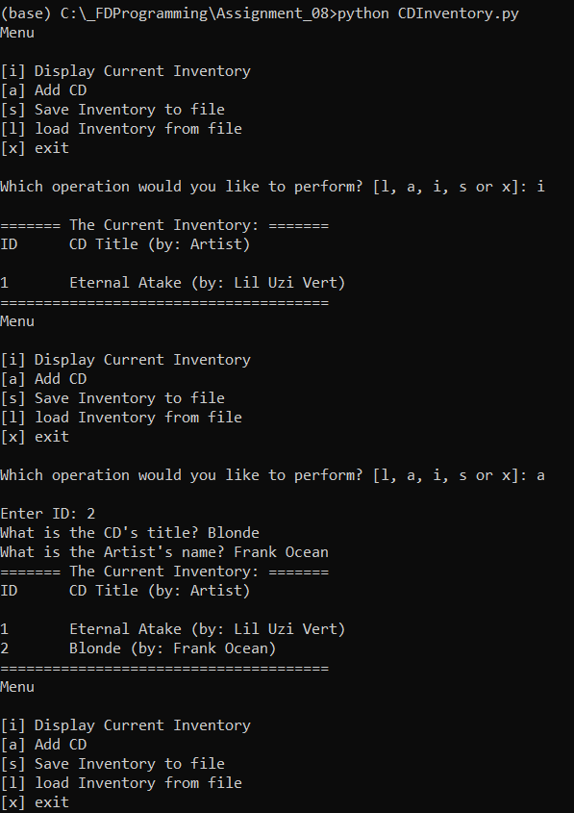

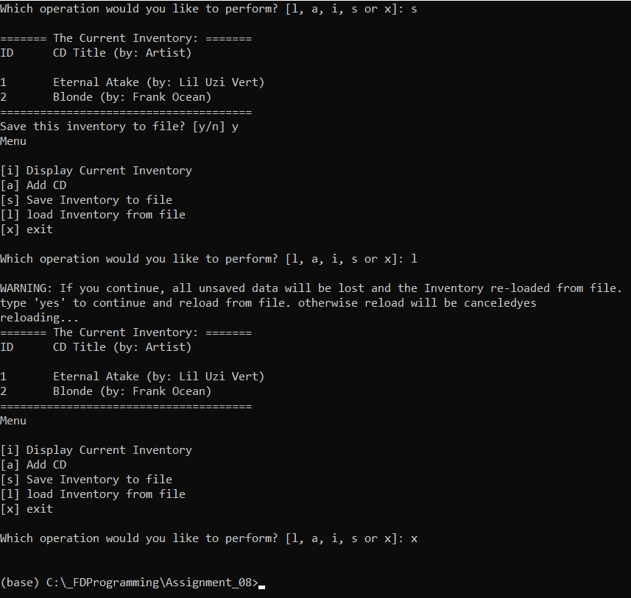

Figure - Script running in command prompt.

For this assignment, I was able to use a lot of code from the Assignment 7 solution. Some major changes included making a class and instances for each CD, requiring properties and methods to be created within the class. I also switched from using dictionaries to CD Objects. I found this particularly difficult, and required some help from Tuesday’s class (hence why it is late) to completely finish.

# Summary

In this section, I learned about object oriented programming, which is a different way of thinking about programming so far. Although I had used classes before, here I used them to instantiate objects with methods and attributes. I also learned more about data encapsulation, and how we use classes to organize elements by privacy.

1. <https://realpython.com/python3-object-oriented-programming/> accessed March 16, 2020
2. <https://www.youtube.com/watch?v=IHaTbJPdB-s&feature=youtu.be> accessed March 16, 2020