Austin Sivret

March 23 2020

IT FDN 100

Assignment 9

Assignment 9

# Introduction

This was the most advanced module yet, diving into more advanced object oriented programming. It included more advanced object definition, communication between objects, making objects from base classes, and overriding methods from base classes. To apply my knowledge, I modified CDInventory.py with these concepts to add track functionality.

# Module Videos

## Lab 09-A

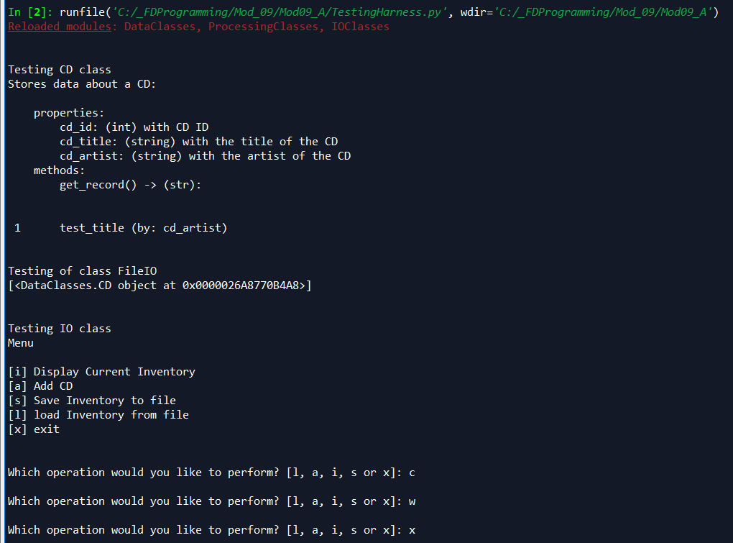

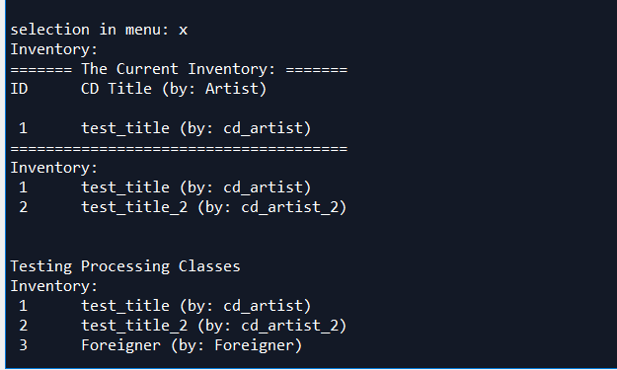

Figure - Lab 09-A

In this lab, I took code from CDInventory and separated it into modules for IOClasses, ProcessingClasses, and DataClasses. I also created a test harness to make sure that each class works. Finally, I repurposed the main script from CDInventory to be able to run the program normally.

## Lab 09-B

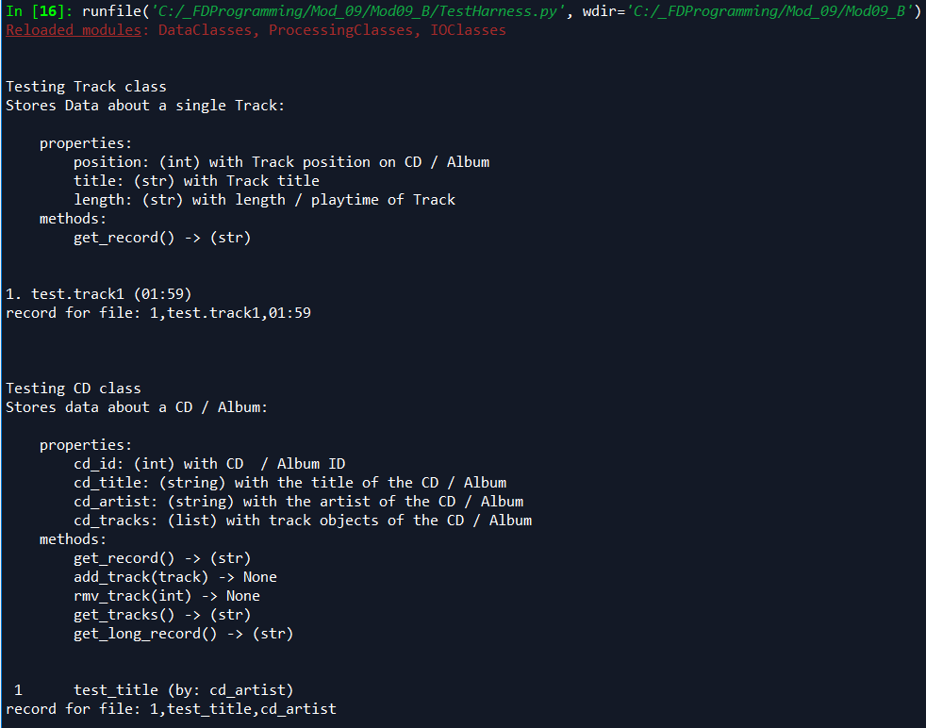

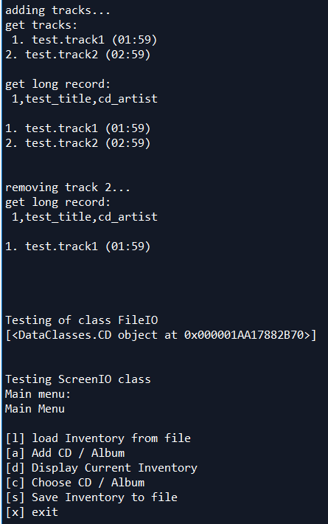

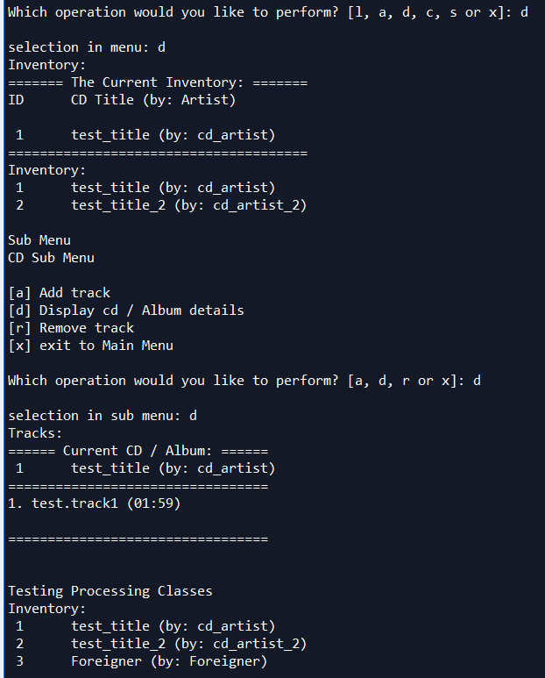

Figure - Lab 09-B output

I found Lab B very difficult, and it involved using more advanced object oriented programming to add track functionality to the CDInventory.py script. I had a lot of trouble with this, and needed to check in with the solution for certain parts. I think I’ll need to relearn object oriented programming from a different perspective.

# Book Chapter

In the book chapter I learned more advanced object oriented programming. I learned about inheritance and base/derived classes. I learned about overwriting new methods, as well as polymorphism. The chapter used a blackjack game to explain the concepts.

# Web Pages

I read a web page[1] going over how to important and use modules, a web page[2] going over the locals() function, and a web page[3] going over modules and packages. I also watched a YouTube video[4] going over Git command line functionality.

# Apply Your Knowledge

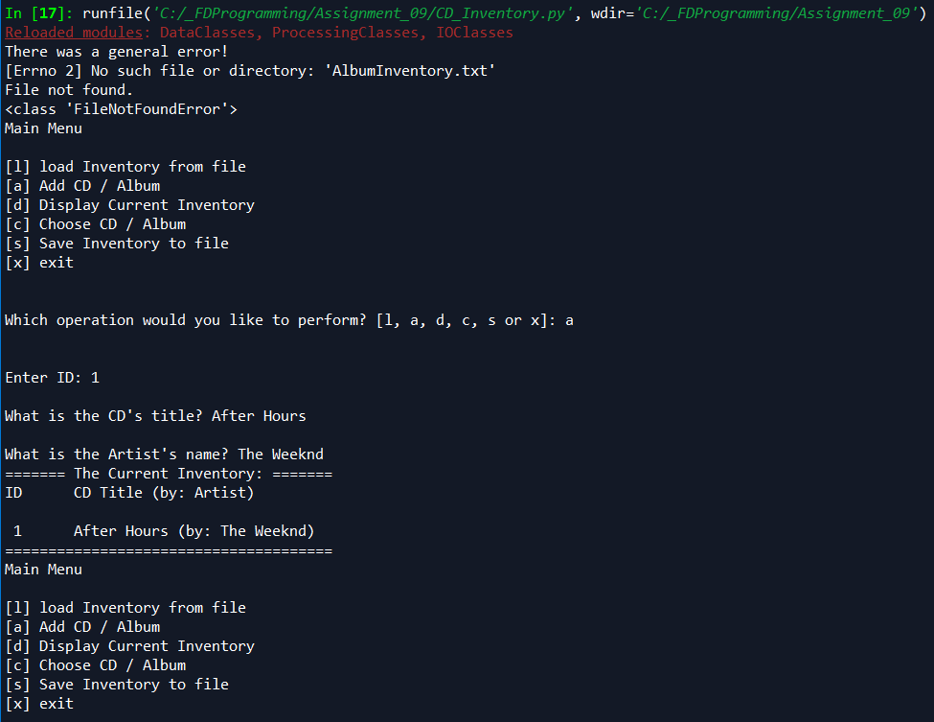

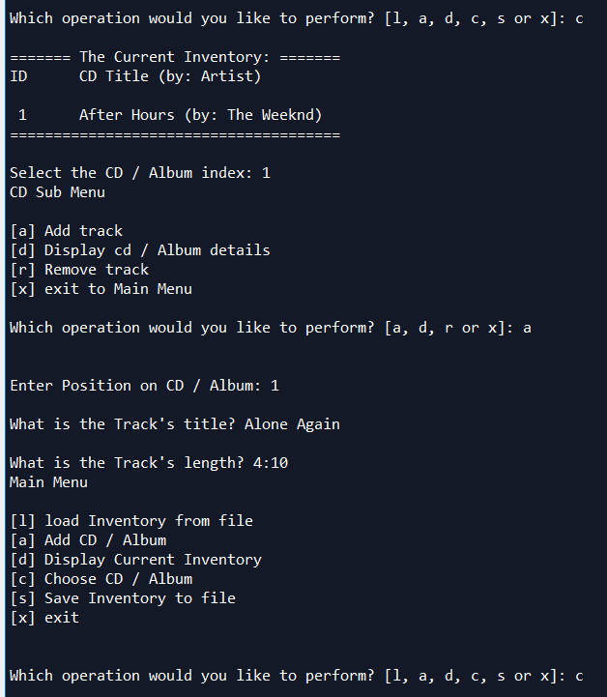

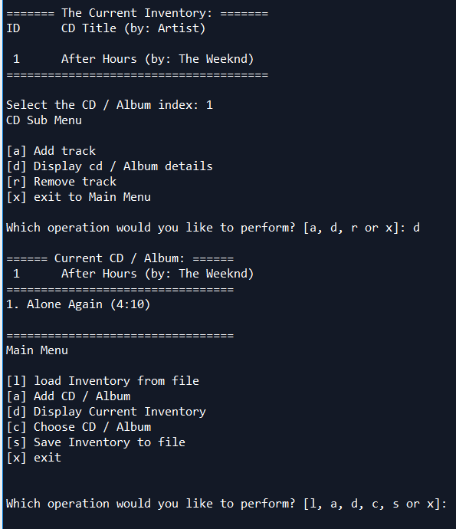

Figure - Output from my assignment.

For the assignment, I tested the code from Lab 09-B. The test harness output is shown in the above Lab 09-B section, while the CDInventory.py output is shown above.

# Summary

In this module I learned about more advanced object oriented programming, like object encapsulation, and creating objects from other objects. I ended the module learning about UML and inheritance.

1. https://www.w3schools.com/python/python_modules.asp Accessed March 23, 2020
2. <https://www.geeksforgeeks.org/python-locals-function/> Accessed March 23, 2020
3. <https://realpython.com/python-modules-packages/> Accessed March 23, 2020
4. <https://www.youtube.com/watch?v=HVsySz-h9r4&feature=youtu.be> Accessed March 23, 2020