University of Wollongong in Dubai
Faculty of Engineering and Information Sciences
School of Computing and Information Technologies

CSIT321: Capstone Project
Final Project Report

Group Name: HexaCore

Group Members:
Avni Pramod | 8047984 | ap564@uowmail.edu.au
Mohammad Mawiz Ansari (Scribe) | 8335084 | mma365@uowmail.edu.au
Syed Sheharyar Ahmed | 8337354 | ssa530@uowmail.edu.au
Mohammed Shehin Kalady | 8526035 | msk965@uowmail.edu.au
Nihal Muhamed | 8276985 | nm438@uowmail.edu.au
Sivajith Ajith Kumar (Leader) | 8404744 | sak481@uowmail.edu.au

Faculty Mentor: Ms. Deepa Keshavamurthy
Subject Coordinator: Professor Farhad Oroumchian
Date of Submission: 13/04/2026

Table of Contents
Introduction 5
Background 5
Problem Statement 6
Proposal 6
Semester 1 7
Planning and Feasibility Analysis 7
Project Scope 7
System Operation 8
Software and Hardware Requirements 11
Challenges 12
Project Timeline and Milestones 13
System Requirement and Specifications 13
Preliminaries 13
System Services 16
System Constraints 23
Project Matters 25
User Research and Validation 27
Design Documentation 28
System Overview 28
System Architecture 36
Human Interface Design 39
UI/UX Patterns and Rules 47
Semester 2 49
Test Plan 49
Glossary 49
Test Approach and Methodology 50
Pre-Requisites 51
In-Scope Features 51
Out-of-Scope Features 51
Risk and Mitigation 52
Test Environment 54
Entry and Exit Criteria 56
Constraints 56
Testing Strategy 56
Resource & Environmental Needs 57
Test Deliverables 57
Functional Testing 58
Integration Testing 58
System Testing 58
Hardware Testing 58
AI/ML Testing 58
Security Testing 58
Performance Testing 59
Usability and Accessibility Testing 59
User Acceptance Testing (UAT) 59
Regression Testing 59
Test Results 60
Functional Testing 60
Integration Testing 62
System Testing 64
Hardware Testing 65
AI/ML Testing 67
Security Testing 70
Performance Testing 72
Usability and Accessibility Testing 73
User Acceptance Testing (UAT) 75
Regression Testing 76
SWOT Analysis 78
Implementation 80
Authentication and Security Layer 80
Data Management Pipeline 81
LSTM Neural Network 83
RAG and ChromaDB Database 87
Emergency Triage Protocol 89
Clinician Dashboard 90
User Interface and Dashboard 91
S.H.I.E.L.D – Mobile App 91
S.H.I.E.L.D – Clinician Dashboard 104
Change Report 110
Changes related to AI/ML and FL 110
AI Model – Digital Twin LSTM to Bidirectional LSTM Baseline 110
Datasets – Static to Calibrated Streams 110
Federated Learning – Privacy First to Collaborated Learning 110
Data Requirements – Multimodal to Focused Cardiovascular Feature Set 111
Changes related to mobile app 111
Emergency Alert System – Automated to Manual Prompt 111
Frontend Data Pipeline – Health Connect Integration 111
High-Level System Architecture 111
UI Design Change 112
Deferred Report Analyzer 112
Ethical Consideration 113
Patient Safety and Medical Disclaimers 113
AI Transparency and Explainability 113
User Consent and Data Ownership 113
Verified Access for Medical Professionals 113
Responsible Alert Design 114
Regulatory And Legal Compliance 114
Future Improvements 115
Conclusion 116
Project Resources 117
Work Distribution 118
Project Management Dashboard 119
References 120

Introduction
S.H.I.E.L.D (Secure Health Intelligence & Evaluation Logic Database) is an AI-powered mobile telemedicine platform designed to provide real-time cardiovascular health monitoring, predictive alerts, and data privacy for patients and healthcare professionals.
It acts as a virtual health assistant, capable of analysing vital data from wearables or uploaded reports, predicting potential cardiac risks, and offering medically guided recommendations while bridging the gap between patients and doctors through remote monitoring.

Background
The healthcare sector in the United Arab Emirates (UAE) has been rapidly transforming under the country’s digital health vision, aiming to establish a world-class, technology-driven medical ecosystem. The UAE National Strategy for Artificial Intelligence 2031 and the Telehealth Guidelines promote large-scale integration of AI, data analytics, and telemedicine to ensure accessible, preventive, and efficient healthcare for all citizens.
Large-scale integration of AI, data analytics, and telemedicine is encouraged by the UAE National Strategy for Artificial Intelligence 2031 and the Telehealth Guidelines in order to guarantee effective, preventive, and easily accessible healthcare for all residents.
The World Health Organization (2023) states that telemedicine has been acknowledged as a "transformative pillar" in international healthcare systems, filling in the gaps in chronic disease management, diagnosis, and follow-up.
Since 2020, the use of telemedicine in the UAE has grown by more than 250%. (UAE Digital Health Report, 2024). Virtual consultation systems have been built by government-led programs including "Doctor for Every Citizen" (DHA) and "Telehealth UAE" (EHS), which provide daily services to thousands of people. However, with limited integration of AI-based analysis, predictive risk modelling, and data privacy frameworks, the majority of current systems concentrate mostly on doctor-patient interaction. This opens opportunities to build smart, patient-focused telemedicine systems that can provide individualized advice, analyse health data in real-time, and protect data in accordance with the UAE Personal Data Protection Law (Federal Decree-Law No. 45 of 2021).
S.H.I.E.L.D (Secure Health Intelligence & Evaluation Logic Database) is proposed as a next-generation telemedicine and remote health monitoring system initially focused on cardiovascular wellness, but architected for future multi-domain scalability.

Problem Statement
The modern healthcare system faces several challenges, especially in accessibility, accuracy, and patient data security. Many people delay hospital visits due to cost, distance, or uncertainty about their symptoms, leading to late diagnosis of serious conditions such as cardiovascular diseases. Existing telemedicine platforms often act only as communication tools between patients and doctors, lacking real-time monitoring, and preventive capabilities. At the same time, overcrowded hospitals handle numerous mild or non-urgent cases that could be managed remotely, while patients continue to struggle with understanding their lab results or medical reports.

Proposal
Our project addresses these issues through a comprehensive AI-driven approach by adhering the following objectives:
- To design and develop an AI-powered mobile application capable of analysing heart health indicators such as heart rate, blood pressure, and ECG signals.
- To create a secure, cloud-based health record system for storing and visualizing users’ health data and medical reports.
- To implement a smart emergency response workflow that connects patients to nearby responders or healthcare providers.
- To provide AI-driven analysis of blood reports and health parameters for early risk detection.
- To ensure data protection and patient privacy using AES encryption and Firebase authentication.
- To build a modular architecture capable of integrating additional disease domains in future versions (e.g., diabetes, respiratory, neurological).
The system extends beyond basic consultation apps by incorporating emergency response, AI explainability, and federated learning for privacy-preserving intelligence.

Semester 1

Planning and Feasibility Analysis

Project Scope

Competitor Analysis
The Digital health landscape of UAE has several telemedicine and health-monitoring applications. Applications like Okadoc or MOHAP mainly provide teleconsultation or appointment booking. But these solutions have specific gaps that SHIELD aims to fill
Local Competitors
- Okadoc – Online Appointment Booking Application
While it provides integrated access to multiple hospitals and medical professionals in UAE, it lacks A-based medical or predictive monitoring and is primarily reactive.
- MOHAP Smart App – Provides government health services, medical scheduling and digital health records
A trusted administrative health app with verified medical records but lacks AI diagnosis, report analysis and automated data monitoring.
Global Competitors
- Fitbit/Apple Health Ecosystems
Tracks vitals and medical activities of the user using wearable sensors, but lacks any medical interpretation of the data.

Target Niche
This app can help different types of users:
- Cardiac patients, individuals with high-risk and post-surgery recovery.
- Elderly people who need regular monitoring.
- Health-conscious users who want to track their overall well-being.
- Emergency responders and Paramedics who can get real-time alerts when something happens.
- General users seeking report explanations and insights.

Pre-requisites
User pre-requisites
- Smartphone with OS recommended Android12/iOS 15 or later with 4GB RAM or higher and Camera with min. 8MP.
- Secure and stable Wi-Fi/Mobile Data connection
- Smartwatch/Fitness Band (For Cardiovascular Monitoring)

Technical pre-requisites
- Programming skills in frontend and backend frameworks.
- AL/ML understanding for data preprocessing and model training.
- API Integration & Database Management.
Operational pre-requisites
- Dataset and Research Access
- Development tools
- Testing environments.

Limitation
- The datasets required for training AI models maybe public or synthetic datasets due to medical confidentiality, which may lead to sourcing data outside UAE demographics.
- The project duration of 24 weeks is not enough for a large scale-data sourcing, training and full deployment of the application, due to which the primary domain of the system is narrowed down to cardiovascular module.
- Legal and ethical concerns exists where the application must comply within UAE federal laws on user data protection.

System Operation

High-Level System Architecture
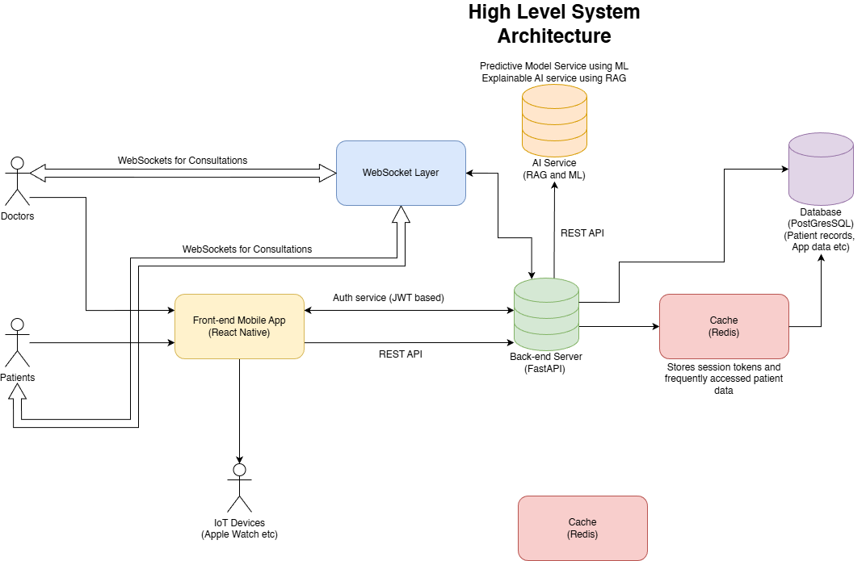
Figure 1: High Level System Architecture Diagram (Planning Phase)

High-Level System Operation
The SHIELD system enables patients to securely manage their health data, receive AI-powered insights, and conduct virtual consultations with doctors for clarification or guidance. It also facilitates emergency monitoring and alerts, ensuring timely intervention by first responders and volunteers. The high-level operation describes the interactions among patients, doctors, the frontend, backend, AI models, database, and cache.
- Patient Interaction
- Patients interact with SHIELD through the mobile frontend app.
- Patient requests include actions such as:
- Logging in and managing authentication sessions
- Viewing personal health and fitness data, biometric trends, and historical reports
- Accessing AI-generated health insights and recommendations
- Initiating consultations with doctors via on-demand or scheduled calls
- The frontend manages session tokens, handles UI updates, and forwards requests to the backend through secure API calls.
- Doctor Interaction
- Doctors access SHIELD via the desktop doctor portal.
- They can:
- View recent and historical health data of patients they are assigned to or have consulted with.
- Monitor real-time biometric alerts from patients
- Provide guidance, updates, and consultation notes to patients
- Track AI-generated recommendations and assist in interpreting them
- Requests from doctors follow the same flow through the frontend to the backend for processing.
- Front-end Processing
- The frontend handles:
- Capturing input from patients and doctors
- Forwarding requests to the backend via API calls
- Displaying responses, AI insights, and emergency alerts
- Managing authentication sessions using JWT tokens
- Authentication
- SHIELD uses JWT-based authentication to secure sessions and ensure role-based access.
- Both patient and doctor requests are validated by the back-end authentication service, which verifies credentials and manages session tokens.
- Back-end Processing
- The backend receives requests from the frontend and orchestrates all operations:
- Executes business logic and validation
- Queries the database for persistent data or retrieves cached data from the cache
- Communicates with the AI model for predictions, insights, and emergency monitoring
- Sends processed results back to the frontend for display
- AI Model Interaction
- The backend sends relevant patient data, reports, and biometric metrics to the AI model, which leverages a RAG based architecture combined with ML algorithms for analysis.
- Capabilities of the AI model include:
- Generating health insights and recommendations by combining patient data with retrieved knowledge from external and internal sources (RAG)
- Continuously monitoring patient biometrics using ML models to detect anomalies or emergencies
- Triggering emergency alerts to the backend, which are then forwarded to the frontend for notification of nearby first responders and volunteers
- AI predictions and insights may be logged for auditing, analytics, and continuous model improvement
- Database and Cache
- Database: Stores patient and doctor data, consultation history, health metrics, and AI insights.
- Cache: Stores frequently accessed or recently retrieved data to improve performance.
- The backend determines whether to fetch data from cache or database based on efficiency requirements.
- Response Flow
- The backend returns processed responses to the frontend, which updates the UI for patients and doctors.
- Frontend displays:
- Health data and biometric trends
- AI-generated insights
- Consultation notes
- Emergency alerts

Software and Hardware Requirements

Software Requirements
Android:
- Android Version: 13.0 (API Level 33) or latest
- Internet Access
- Bluetooth Access: Needed for connecting IoT or wearable health devices (e.g., smartwatch, ECG monitor)
- Location Access: Used during emergencies to share user’s current location with responders
- Notification Access: Required for health alerts and emergency notifications
iOS:
- iOS Version: 15.1 or latest (build with iOS 18 SDK)
- Internet Access
- Bluetooth Access: For pairing with Apple Watch or supported IoT devices via HealthKit
- Location Access: To provide location-based emergency assistance
- Notification Access: To alert users of health abnormalities or urgent situations

Hardware Requirements

Minimum Requirement
Android:
- Minimum Storage: 150–200 MB (for app, AI model, and cached health data)
- RAM: Minimum 3 GB (Recommended: 4 GB or higher for smooth performance)
- Processor: ARM-based processor (Snapdragon 660 or higher)
- Connectivity:
  - Bluetooth (for wearable and IoT device integration)
  - Internet (Wi-Fi or mobile data for cloud and AI services)
iOS:
- Minimum Storage: Around 180 MB (includes AI model and iOS dependencies)
- RAM: Minimum 3 GB (Recommended: 4 GB or higher)
- Processor: Apple A11 Bionic or newer
- Connectivity:
  - Bluetooth (for Apple Watch or HealthKit device connectivity)
  - Internet (Wi-Fi or mobile data for cloud sync and alerts)
We will need IoT devices like Apple Watch, Fitbit, Samsung watch, maybe IoT bp machines, and other stuff that we can data from using APIs, this is all for the benefit of the patient so not necessary. Even normal health machines are fine as long as we have a feature for user to add the data manually.

IoT and Health Devices Integration
- Apple Watch: Integration through HealthKit and WatchKit APIs for heart rate, ECG, and activity tracking.
- Fitbit Devices: Data synchronization via the Fitbit Web API for steps, heart rate, and sleep data.
- Samsung Watches: Integration using the Samsung Health SDK for continuous heart and activity monitoring.
- Other IoT Devices: Optional support for Bluetooth-enabled health devices such as blood pressure monitors, pulse oximeters, and ECG machines (using open APIs).
Manual Data Entry
- For users without wearables or compatible IoT devices, the app will include an interface to manually input vital signs (e.g., heart rate, blood pressure, oxygen level).
- The final inclusion of this feature will be confirmed with Prof. Farhad, as noted in the project documentation.

Challenges
Data Quality & Availability
- Privacy regulations restrict access to trustworthy and annotated medical datasets (ECG, heart rate, and SpO₂).
- Noise, motion errors, or missing samples are common in real-world wearable data, which may result in incorrect classification or false alarms.
- Collecting large labelled datasets for AI model training remains difficult without any clinical partners.
Negative and False Positive Results
- Real-time emergency detection using sensor data may result in false negatives (missing actual emergencies) or false positives (setting off pointless alarms).
Emergency Services Integration
- Formal agreements and compliance to local health data regulations are required when connecting the system directly to hospitals or ambulance networks.
- Integration is made more difficult by differences between public and private emergency services, particularly in the United Arab Emirates.
Security and Privacy
- End-to-end encryption, safe storage, and user consent management are necessary for handling sensitive health data.
- If security layers are not updated often, there is a risk of data breaches or misuse.

Clinical and Regulatory Validation
- Any AI-powered health monitoring system that makes decisions needs to be approved as a medical device.
- Obtaining such certifications requires clinical trials, documentation.
Real-Time processing & Scalability
- Scalable backend servers and fast processors are necessary for the continuous monitoring of thousands of users.
- Data loss or delayed alert transmission might result from network problems or poor connection.
Trust and User Adoption
- People could be cautious to give critical choices to an AI-based system.
- Acceptance depends on ensuring precision, transparency, and an interface that is simple to use.
Dependence on Hardware
- The accuracy and compatibility of medical sensors or smartwatches have a significant impact on performance.
- Inconsistent readings could result from variations in devices (Apple Watch, Samsung, Fitbit, etc).

Project Timeline and Milestones

Gantt Chart
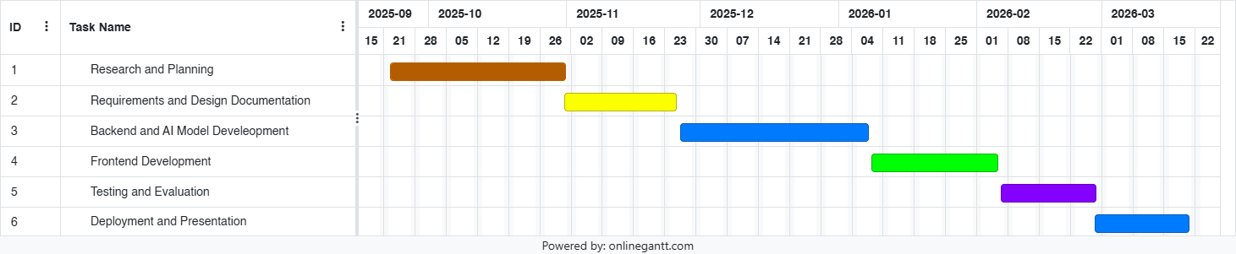
Figure 2: Project Timeline Gantt Chart

System Requirement and Specifications

Preliminaries

Purpose and Scope
SHIELD is an AI-powered mobile health application designed to provide proactive cardiovascular care through predictive analytics and privacy-preserving machine learning. Uses an advanced AI model to analyze subtle, multi-day patterns, providing predictive warnings, not just reactive alerts and translates complex health data into simple, clear recommendations and scores (e.g. "Cardiovascular Stress Score"). The scope of the project is further broken down in System Services.
The purpose of this project is to research and create an AI powered health platform - a next generation prototype that addresses the innovative gaps in existing software:
- Most of the current systems provide reactive insights to users, not predictive, while those that are predictive lack transparency and may affect user trust and privacy.
- Most of the software are based on the client-server model and requires users to upload their personal and sensitive medical records, which creates huge privacy and security risks which may lead to insurance scams and identity thefts.

Business Context
Cardiovascular Diseases are the leading cause of at least 40% of all deaths, especially within 50s due to unhealthy lifestyles. This defines a clear, urgent and high value crisis. As a solution for it, national strategic goals such as the UAE AI Strategy 2031 promotes the usage of AI to solve major healthcare challenges.
The analysis of the current market exposes a significant gap in innovative solutions. Most of the health monitoring apps claims to be fitness applications, denying medical use to avoid regulation, lacks transparency to consumer data, while some ‘monitoring’ apps gives out user alerts but fails to respond to an emergency or lacks clinical consultation.
These challenges define SHIELD’s business values such as:
- Proactive Monitoring of data to find any patterns before it worsens. This is one of the reasons the users would choose our app- they just don’t want a logbook of their medical data, but an early warning system.
- A user exclusive prediction system that runs locally, making sure that the data never leaves the phone. This builds the user’s trust in the app on a fundamental level.
- Intelligent explanation of insights using Edge XAI which enhances the user experience which adds a value to the understanding of the app by the users.
- An emergency system that fetches help to an unresponsive user through automatic alerts which can act as a lifesaving function in critical moments.
SHIELD will be designed as a hybrid-AI system which integrates all these features, a gap which no other commercial solutions has filled. Also, the modular design of the app enables the integration of additional domains other than cardiovascular monitoring in the future, which enhances its business value and market scalability over time.

Stakeholders
Primary User
The end users of the application who can either be cardiac patients or individuals recovering post-surgery, or general users who are interested in getting insights based on their basic reports. Such users are not assumed to be tech literate and hence relies on the Edge XAI as a primary solution for anxiety about their health.

Secondary User
Medical professional, paramedics, emergency responders who has access to patient data and make a diagnosis based on the medical-grade insights generated by the model.
System Admin
The development and operation team who maintains the final output and who updates and improves the AI models based on the real time learning collected.
Regulatory and Legal Bodies
The idea of a “Software as a Medical Device” makes us accountable to these stakeholders since we are answering their user privacy demands and are bound to comply with their legal and ethical system. UAE’s MOHAP, Dubai Health Authority, and other data protection authorities are an example to such stakeholders.

Ideas for Solution
Our project’s main challenge is to build a hybrid AI architecture that is split into both local machine and server:
- Local AI Model
The model runs on the user’s phone and handles all the sensitive data which never leaves the phone. It is constructed of a Model that takes inputs from the IoT sensors and uses Edge AI which acts as an explainer model to generate the input content in simple terms.
- Server AI Model
It acts as the brain of the operation on the server, which receives anonymous learnings from the in-phone model to generate an explanation for the user without ever using the private user data. It also powers a report analyzer using RAG language model.
- Federated Learning
A privacy-first method that is a key to our security requirement. A cutting-edge methodology where the app trains the model locally and generates an anonymous summary output to send to the server, without actually letting the user’s private data leave the phone.

System Services

Scope
What the System will do
- Collect and integrate real-time biometric data from compatible wearable devices and medical sensors
- Generate predictive cardiovascular risk assessments and early warning alerts
- Provide actionable health recommendations
- Display health metrics, trends, and insights through a dashboard
- Maintain historical health data and trend analysis on the user's device
- Perform on-device AI analysis using personalized on-device models
- Alert emergency services or emergency contacts if a severe event is detected
- Securely transmit the user’s real-time location to responders when needed
- Allow users to upload medical reports (e.g. blood tests, cholesterol reports, ECG PDFs)
- Include an SOS button to manually trigger an emergency alert
- Support manual data entry from non-smart devices
- Ensure secure health record storage
What the System will not do
- Replace professional medical diagnosis or emergency medical services
- Provide treatment recommendations or prescribe medications
- Directly control or modify settings on medical devices
- Store raw biometric data or personally identifiable health information on external servers

Functional Requirements
ID | Name | Requirements
FR001 | User Profile Creation | The system shall collect essential user information during onboarding, including age, gender, height, weight, medical history, current medications, and cardiovascular risk factors.
FR002 | Wearable Device Connection | The system shall support pairing and connection with compatible wearable devices via Bluetooth and standard health data APIs (HealthKit for iOS, Google Fit for Android).
FR003 | Real-Time Data Collection | The system shall continuously collect biometric data from connected devices with a maximum latency of 10 seconds for critical metrics (heart rate, ECG).
FR004 | Manual Data Entry | The system shall allow users to manually input additional health data not captured by wearables (e.g. blood pressure from manual cuff, medication changes, symptoms).
FR005 | Personalized LSTM Model Creation | The system shall create a personalized LSTM model for each user during onboarding by collecting baseline health data over a minimum 7-day period.
FR006 | Multi-Day Pattern Analysis | The system shall analyze biometric patterns across x-period of time to detect subtle deviations from the user's baseline.
FR007 | Predictive Risk Assessment | The system shall generate predictive risk warnings for potential cardiovascular events based on detected pattern anomalies.
FR008 | Anomaly Detection | The system shall identify and flag statistically significant deviations in heart rate variability (HRV), resting heart rate, blood pressure, and sleep quality.
FR009 | Edge XAI Generation | The on-device AI Model generates a list of reason codes based on vital readings for predictive risk assessment.
FR010 | Risk Confidence Scoring | The system shall provide a confidence level (low, medium, high) for each risk prediction based on data completeness and model certainty.
FR011 | On-Device Processing | The system shall perform all sensitive health data analysis, including AI inference and on-device model updates, entirely on the user's mobile device
FR012 | Federated Learning Participation | The system shall participate in federated learning by computing local model updates and transmitting only encrypted gradient updates to aggregation servers (no raw data transmission).
FR013 | Data Encryption | The system shall encrypt all stored health data on the device using strong encryption algorithms and require biometric authentication (fingerprint/face ID) for access.
FR014 | Secure Communication | The system shall use TLS 1.3 or higher for all network communications, including federated learning updates and health report sharing.
FR015 | Real-Time Health Dashboard | The system shall display a home dashboard showing current Cardiovascular Stress Score, key vitals (heart rate, blood pressure), and trend indicators (improving/stable/worsening).
FR016 | Historical Trend Visualization | The system shall provide interactive graphs showing health metric trends over selectable time periods (24 hours, 7 days, 30 days, 6 months).
FR017 | Actionable Recommendations | The system shall generate and display personalized, evidence-based health recommendations (e.g. "Your stress levels have been elevated for 3 days. Consider 10 minutes of deep breathing exercises.").
FR018 | Risk Alert Notifications | The system shall send push notifications for high-priority risk alerts with clear severity levels (low, medium, high, critical) and recommended actions.
FR019 | Health Insights Summary | The system shall generate weekly health summary reports highlighting key patterns, achievements, and areas for improvement.
FR020 | Automatic Emergency Alert | Upon detecting a critical risk event the system shall initiate an automatic alert countdown to notify emergency services and preset contacts.
FR021 | Emergency Contact Notification | The system shall allow users to designate emergency contacts who receive automatic notifications during critical risk events (user consent required).

Non-Functional Requirements
ID | Name | Requirements
NFR001 | App Launch Time | The application must execute a cold start within 3 seconds
NFR002 | Dashboard Load Time | The Doctor Portal must load and display all the updated information within 3 seconds
NFR003 | AI Inference Speed | The on-deice LSTM model must complete a stress score inference under 500ms
NFR004 | API Response Time | All backend API calls (fetching patient records, logging vitals) must be returned under 2 seconds under normal network conditions.
NFR005 | Memory Usage | The application should not use more than 20MB of RAM under normal conditions
NFR006 | Simultaneous Users | The backend must support at least 100 active users in parallel, performing data logs and API calls without loss in performance.
NFR007 | Local Storage Hold | The SQLite database on device must handle at least 30 days of raw biometric data without any read or write latency
NFR008 | Cloud Scalability | The PostgreSQL backend must be scalable to integrate future deployments across multiple medical institutions
NFR009 | System Uptime | The backend cloud services must maintain 99.9% uptime during active demonstration period
NFR010 | Offline Resilience | The application must continuously record any biometric data in case of no internet connection, and sync the data automatically once the connection is restored.
NFR011 | Bluetooth Reliability | Bluetooth connections must reconnect automatically within 30 seconds after an interruption occurs.
NFR012 | Encrypted Transmission | All network traffic between the app, backend, and cloud must use TLS 1.3 encryption
NFR013 | Encrypted Local Storage | All health data stored locally on the device must be encrypted at rest using SQLCipher or AES-256
NFR014 | Authentication Security | The system must use JWT-based authentication with session expiration on logout.
NFR015 | API Access Control | All API endpoints must reject requests without a valid authorization token (returning HTTP 401).
NFR016 | Sensitive Logging | The app must not log any sensitive data (passwords, health metrics, JWT tokens) to production console builds.
NFR017 | User Onboarding | A new user must be able to complete the full onboarding process (registration, profile setup, and device/sensor pairing) in under 3 minutes without external assistance.
NFR018 | Screen Reader Support | The application must support screen reader tools (VoiceOver, TalkBack) for all interactive elements.
NFR019 | Font Scaling | The UI must be fully readable and functional when the device font is increased without any text clipping.
NFR020 | PDPL Compliance | The system must comply with the UAE Personal Data Protection Law (PDPL) - Federal Decree-Law No. 45 of 2021. This includes obtaining user consent before data collection, not transmitting raw biometric data to external servers, and providing users with control over their data.
NFR021 | Medical Device Disclaimer | As a student prototype the application does not have a medical certification by MOHAP or DHA, and it is addressed as a medical disclaimer in the app accordingly.

Data Requirements
The system will need to collect and integrate biometric data from the following sources:
- Wearable Devices: Apple Watch, Samsung Watch, Fitbit, Garmin
- Medical Devices: Blood Pressure cuffs, Continuous Glucose Monitors (CGM), Portable ECG patches, and Oximeters
- Manual Input Options: For users to record readings from non-smart devices
The type of biometric data being collected:
- Heart Rate (HR): Measures beats per minute during activity and rest, used to detect tachycardia, bradycardia, and stress events
- Heart Rate Variability (HRV): Measures variation between heartbeats (SDNN, RMSSD) which helps indicate stress, fatigue, and recovery quality
- Blood Pressure: Measures systolic and diastolic pressure used to monitor hypertension / hypotension trends
- Blood Oxygen Saturation (SpO2): Measures oxygen percentage in the blood and used to detect hypoxemia and poor oxygen delivery
- Electrocardiogram (ECG): Records electrical activity of the heart and used to detect arrhythmia, AFib, rhythm irregularities
- Respiratory Rate: Measures number of breaths per minute which detects abnormal breathing patterns (tachypnea, bradypnea)
- Blood Glucose (CGM): Tracks blood sugar fluctuations which is used to Identify hyperglycemia/hypoglycemia affecting heart rate
- Sleep Metrics: Tracks sleep duration, stages, interruptions which is used to assess recovery, sleep quality, and cardiovascular rest
- Skin Temperature: Monitors peripheral or wrist skin temperature which is used to detect fever, inflammation, or metabolic changes
- Activity Level: Steps, calories burned, sedentary time
What Data is Generated through AI Analysis
- Cardiovascular Stress Score: Derived from HR, HRV, BP, glucose, and respiratory rate.
- Heart Recovery Score: Based on HRV trends, sleep quality, and SpO₂ stability.
- Cardio Readiness Index: Combines HRV, BP, SpO₂, glucose, and respiratory rate to assess readiness for physical exertion.
- Arrhythmia / Rhythm Alert Score: Derived from HR patterns and ECG variability to detect irregular heart rhythms.
- Oxygen & Perfusion Insight: Based on SpO₂ and HR trends to detect early oxygen delivery issues.
- Heart Strain Trends: Long-term multi-metric analysis of HR, HRV, BP, and glucose fluctuations.
- Lifestyle Correlation Alerts: Correlates sleep, glucose, diet, and activity data with cardiovascular performance.
Information Derived after AI Analysis
- XAI Reason Codes (e.g. LOW_HRV_2DAYS, LOW_MORNING_BP)
- Risk Predictions and Confidence Levels (e.g. cardiovascular event probability)
- Anomaly Detection Flags (e.g. irregular ECG patterns, SpO₂ drops)
- Trend Analysis Results (e.g. improving or worsening HRV trends)
- Event Correlations (linking poor sleep or glucose spikes to cardiovascular stress)
Information Presented to Users
- Health Dashboards & Visualizations: Real-time graphs and color-coded trends (green = normal, yellow = moderate, red = critical)
- Predictive Warnings & Alerts: Early detection notifications for potential cardiovascular risks
- Actionable Recommendations: AI-generated health suggestions for activity, recovery, or medical follow-up
- Historical Reports: Long-term trend analysis and health summaries
Data Storage and Security
- Storage Location: On-device for short-term storage, secure cloud for long-term trends
- Encryption: AES-256 for stored data, TLS 1.3 for transmission
- Access Control: Multi-factor authentication and device-based authorization
- Privacy Compliance: Designed in accordance with PDPL standards (Government, 2021)

System Constraints

Interface Requirements
- Intuitive Navigation: The app must feature user-friendly navigation menus, clear icons, and logical workflow so patients can easily find key functions like checking insights, reviewing analytics and scores, scheduling video consultations, and messaging. Since we are focusing on the cardiology field as of now, the majority of our users would be people in the ages of 45 and above so we should keep navigation as simple as possible.
- Accessibility: The app should comply with standards like WCAG, supporting screen readers, adjustable text sizes, and high-contrast modes for users with disabilities, multilingual support will be added in the further iterations in order to accommodate diverse populations but as of now keeping focus on English speaking users in UAE. Language accessibility should also be a priority, given the audience will be newly-diagnosed individuals. Therefore, the app should present medical information in layman’s terms.
- Consistent Design: The app should use a unified design system for colors, fonts, and labels across all screens, making the experience easy to use and predictable in case of emergencies.
- Onboarding: The app should include guided registration and first-use walkthroughs to support users who may be new to consumer health technology apps.

Performance Requirements
- Response Time: 95% of actions (loading insights, calculating analytics, starting consultations) must complete within 2 seconds. ​
- Resource Utilization: The app should not be resource heavy on the device and utilize more than 20MB of the device’s memory.
- Startup Time: The app should have a launch time of less than 3 seconds and all components should load within 1 seconds. (Nielsen, 1993)

Security Requirements
- Encryption: The app will protect all sensitive information using industry-standard encryption. User reports and consultation data will be encrypted at rest using AES-256 and in transit using TLS 1.3. For biometric and medical sensor data, the system will employ federated learning, ensuring that raw data remains on the user’s device. Only encrypted model parameters or aggregated insights are transmitted to the server, secured through TLS 1.3 and secure aggregation protocols. This architecture maintains data confidentiality and complies with the UAE Personal Data Protection Law (PDPL) by preventing direct exposure of user medical data. (Government, 2021)
- Authentication and Authorization: To prevent unwanted access of patient accounts, the app should implement multi-factor authentication, session expiration using JWTs after logout or inactivity, and strong password requirements.
- Secure APIs: The app should use APIs with strong authentication mechanisms, and never expose sensitive tokens in URLs, logs, or unsecured transmissions.
- Data Backup and Recovery: The app should perform regular encrypted backups with tested disaster recovery plans to guarantee PHI (Protected Health Information) can be restored following breaches or failures.
- User Consent and Compliance: The app should collect the user's explicit consent for data use and sharing and follow privacy regulations like PDPL for UAE. (Government, 2021)
- Device Security: The app should receive regular updates to patch vulnerabilities and use secure coding practices to prevent malware or unauthorized access.

Operational Requirements
- Uptime: The system should maintain 99.99% uptime for insights, analytics, medical consultations and other features.
- Scalability: The app should support hundreds or thousands of simultaneous user sessions without degradation, especially in peak periods or emergencies.
- Quality of Service: The app should ensure steady, high-quality video and audio streams using adaptive bandwidth management such as WebRTC.
- Error Recovery: The app must recover gracefully from dropped connections or failed requests, automatically retrying or providing clear user feedback.

Political and Legal Requirements
- Compliance with Data Privacy and Protection: The UAE Personal Data Protection Law will be completely followed by the system's data collection, storage, processing, and sharing process. This involves establishing necessary data breach notifications, protecting the rights of data subjects, and guaranteeing a legal basis for processing.
- Healthcare Rules and Disclaimers: It is known that the AI-based diagnostic and alert features will likely need to be certified as a Class B medical device by UAE health authorities, such as the (MOHAP) or (DHA), in order for any future commercial deployment. (Government, 2021)

Other Constraints
- Timeline for the project: The entire development, testing and documentation is constrained to a 24-week timeline.
- Data Sourcing: The lack of authentic, annotated medical datasets from the UAE population limits the creation and training of AI models. The project's use of synthetic and publicly accessible datasets may affect the generality of the model.

Project Matters

Open Issues
There are few critical challenges that need strategic planning and attention to ensure the successful execution of the project:
Regulatory compliance and Data Privacy
Handling sensitive medical data demands strict compliance with UAE data protection laws. We need to establish strong data encryption protocols and obtain formal approvals from health authorities such as MOHAP and DHA before public release. This also includes clearly clarifying the certification process for our AI-driven features. To enhance privacy, we’re exploring Federated Learning that allows critical AI analysis to run directly on user device, ensuring sensitive ECG and health data never leave the phone. This ‘Privacy First’ approach marks a key innovation in secure healthcare AI
HealthCare Partnership Integration
The success of the emergency response depends on the seamless integration with hospital networks. To ensure this, we need to establish strong, formal partnerships with healthcare providers and emergency services, starting with pilot programs at modern, tech-driven clinics to demonstrate the systems’ reliability before expanding to a large network.
AI Model Validation and Advanced Modelling
Our AI algorithm requires solid medical validation to ensure precise detection of heart anomalies and symptoms. We plan to use highly trusted medical datasets and collaborate with cardiologists for expert review and approval. We are developing an on-device model system that builds personalized heart health profiles by analysing heart rate, activity and sleep. This predictive approach helps identify early signs of cardiac issues, shifting from basic alerts to proactive health forecasting.
Technical Dependencies
Real-time monitoring relies on compatible wearable devices, creating potential adoption barriers. To overcome this, we’re ensuring broad integration with Apple HealthKit and Google Fit, while developing manual input for users without wearables. The multimodal Data Fusion capability will be crucial here, allowing the AI to combine data streams (HRV + blood pressure + sleep quality) to detect complex health patterns invisible to single-metric analysis.

Preliminary Schedule
Weeks 1-4: Foundation and Planning
- Finalize MVP specifications with LSTM Model Architecture.
- Complete regulatory research and UI/UX design
- Set up development environments.
- Begin federated learning framework design.

Weeks 5-8: Core System Development
- Build a secure cloud infrastructure with encrypted database.
- Implement user authentication and profile management
- Develop basic health dashboard.
- Create a federated learning prototype for on-device AI
Weeks 9-12: AI Integration Phase
- Integrate AI models for continuous heart monitoring.
- Build emergency response system with dual-trigger functionality.
- Implement multi-model data fusion capabilities to combine different health metrics.
- Develop AI symptom assessment capabilities.
Weeks 13-16: Advanced Features and Testing
- Implement AI-powered analysis for medical reports.
- Begin LSTM modelling development.
- Conduct initial security testing.
- Integrate APIs for wearable devices.
Weeks 17-20: Quality Assurance
- Conduct comprehensive security and penetration testing
- Beta testing with focus groups.
- Optimize system performance.
- Validate LSTM Model approach with medical advisors.
Weeks 21-24: Deployment and Launch
- Deploy the app on iOS and Android stores.
- Onboard a pilot hospital partner.
- Monitor system performance and user feedback.
- Prepare phase 2 development plan.

Preliminary Budget
Our project's core strategy is to be resourceful. So instead of a commercial scale output, our demonstration will be leveraging open-source software, tools and services. We are intending to aim a near-to-zero cost infrastructure, with the following budget plan:
Requirements | Estimated Cost
Software & AI Tools (VS Code, Figma, Ollama, etc) | 0 AED
Cloud Infrastructure (Firebase Spark Plan) | 0 AED
Hardware for Prototyping (Using University Resources) | 0 AED
Hardware for Demonstration (Iot Devices) | ~200 AED
Licensing and Deployment (Apple, Google) | ~460 AED
Total (with additional expenses) | ~660-700 AED

User Research and Validation
In order to validate the design assumptions of SHIELD, a user survey was conducted with 110 respondents from UAE. Note that the survey feedbacks are strictly used to validate our design assumptions and do not constitute any clinical validation of the system.
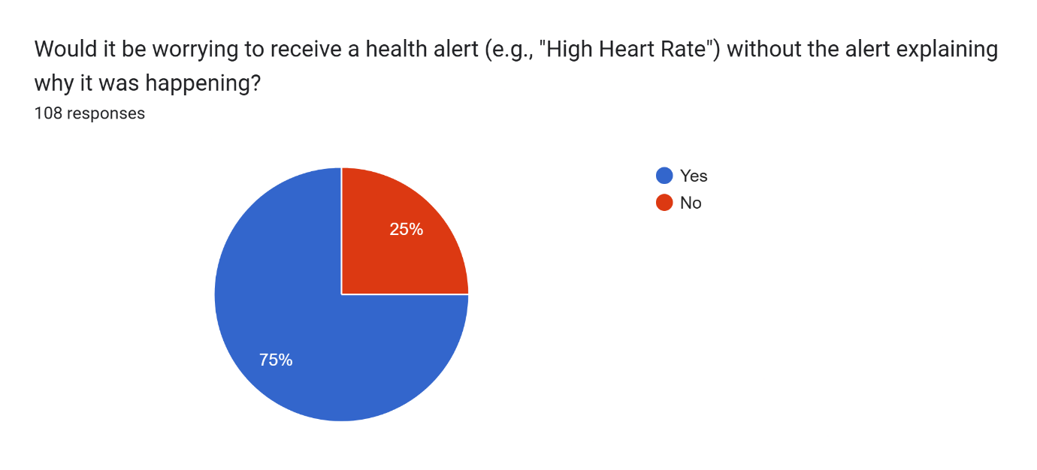
Figure 3: User Validation for XAI Model
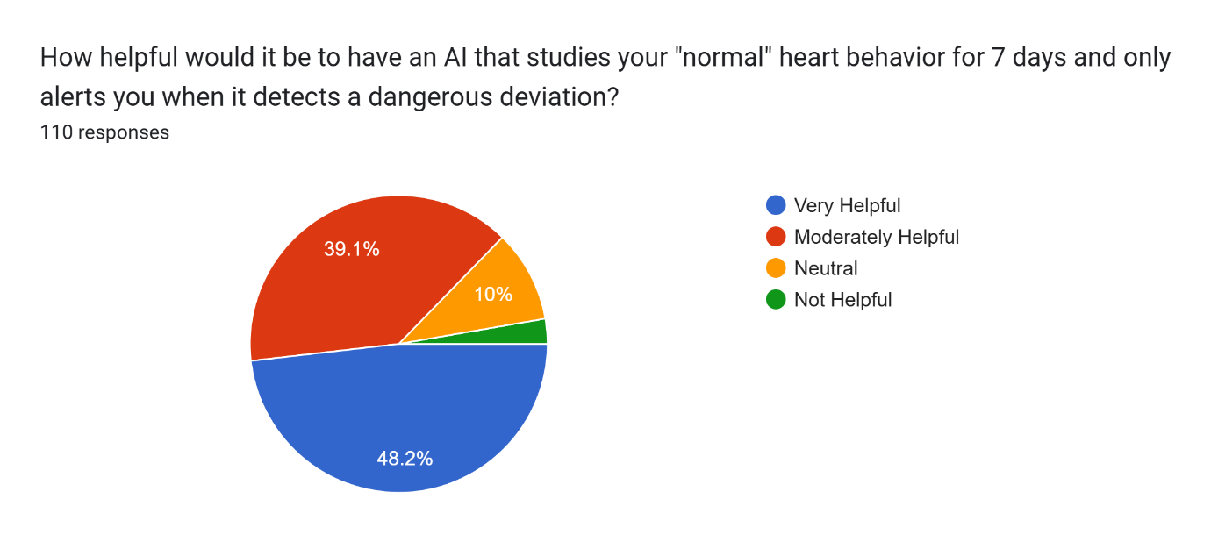
Figure 4: User Validation for Baseline Model System

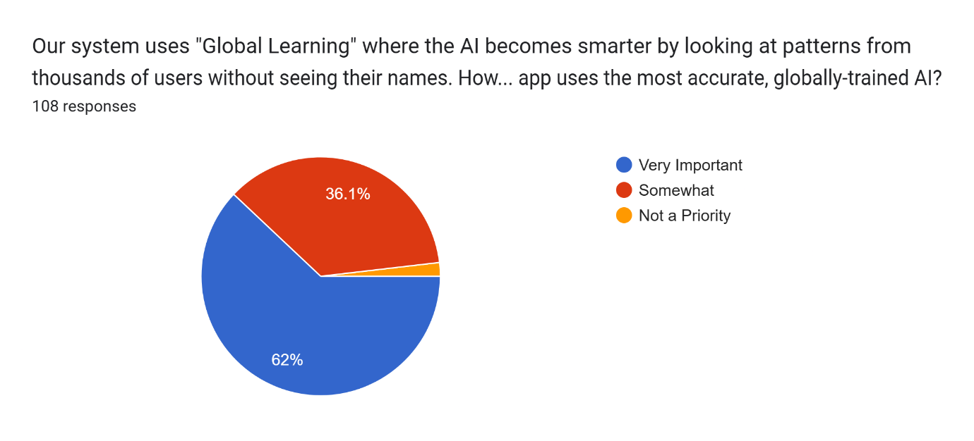
Figure 5: User Validation for Federated Learning
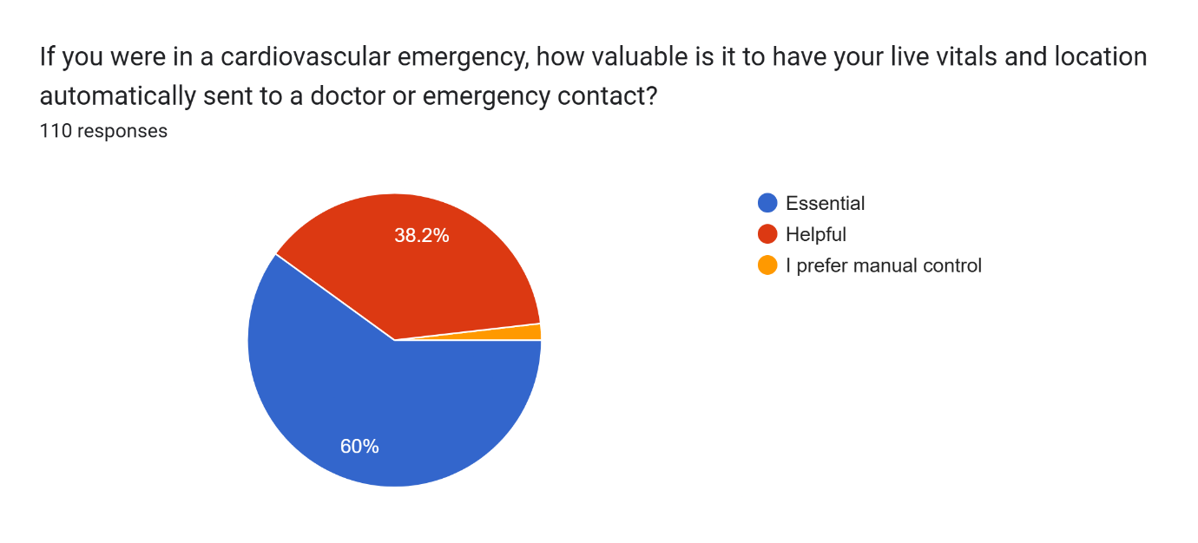
Figure 6: User Validation for Emergency Alert System

Design Documentation

System Overview

Activity Diagram

Patient Health Monitoring System
End User: Patient
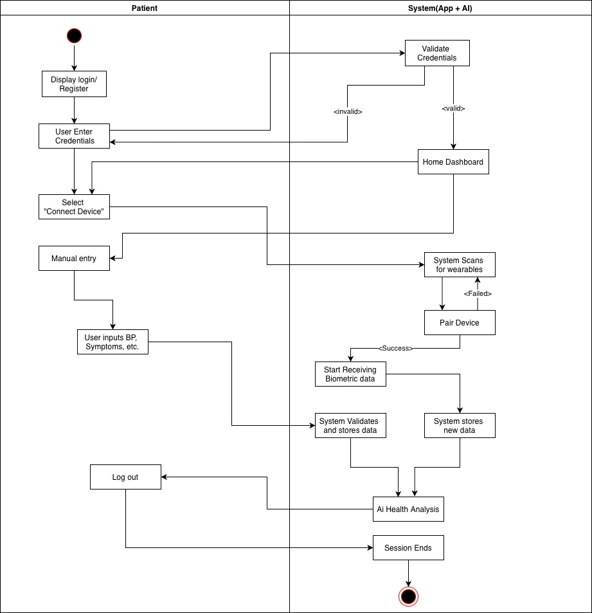
Figure 7: Activity Diagram (Patient)
Diagram Overview
The patient diagram illustrates a user-driven health data collection system where the patient interacts with a mobile application to monitor their health through multiple input methods.

Data Flow Analysis
Authentication Data Flow:
User Input → System Validation → Access Grant/Denial
Data types: Username, Password
Flow Direction: Patient → System (one way for security)
Validations: Credentials checked against the stored records.
Output: Session token, Dashboard Access
Manual Entry Data Flow:
Patient Input → Validation → Storage → AI Processing
Data types: Blood pressuring readings, Symptom description, General health observation.
Flow Characteristics:
- Structured Input: Systematic, predefined format for data entry.
- Real-time Validation: Real-time feedback during data entry that verifies accuracy, plausibility, and format compliance as the user types.
- Immediate Storage: instantaneous, persistent saving of user-generated health data directly into a secure database when it passes validation without any intermediate caching or delayed processing.
- Batch Processing: Scheduled, bulk processing of accumulated rather than real-time analysis of individual data points.
Wearable Data Flow:
Wearable Device → Bluetooth/Wi-Fi → System → Storage → AI Processing
- Wearable Data Flow refers to continuous, real-time streaming of biometric data from wearable devices through secure wireless transmission to healthcare systems, enabling persistent monitoring and immediate analysis without user intervention.

Doctor Clinical Portal System
End User: Doctor
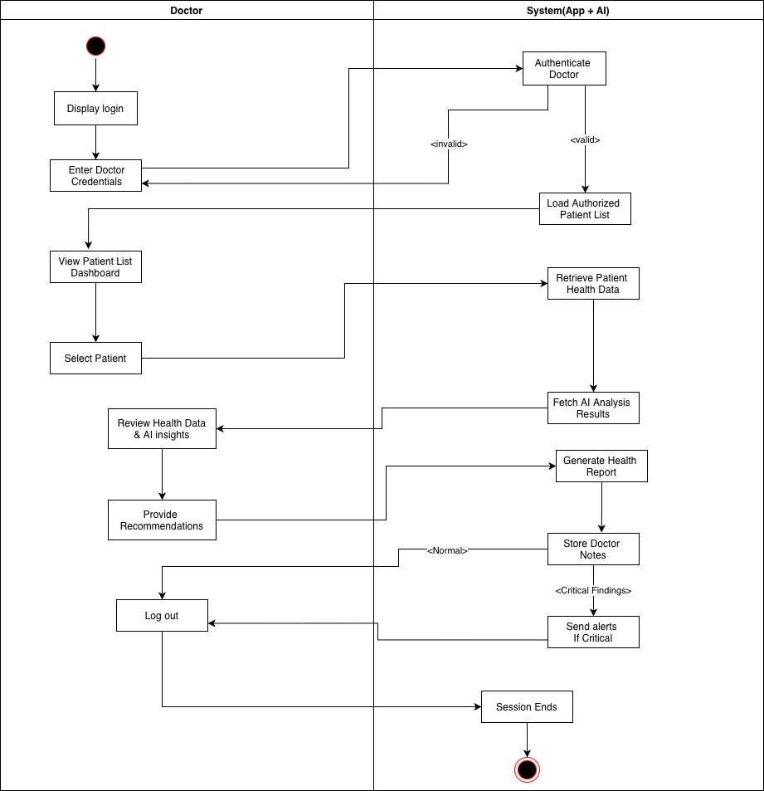
Figure 8: Activity Diagram (Doctor)
Diagram Overview
Authorized medical professionals can access patient data, evaluate AI-generated insights, and offer clinical recommendations using the Doctor Clinical Portal System, a secure healthcare platform.

Data Flow Analysis
Authentication Phase:
- Verify medical professional identity and authorization.
Display Login → Enter Doctor Credentials → Authenticate Doctor → [Invalid/Valid]
Process Details:
- Secure Login Method: Portal for secure entry
- Verification of Credentials: Verification of identity and medical license
- Verification: Permit or prohibit system access
- Invalid Handling: Security procedure for unsuccessful attempts
Patient Access Phase:
- Provide authorized access to assigned patient records
Load Authorized Patient List → View Patient List Dashboard → Select Patient
System Actions:
- Patient List Loading: Only authorized patient records can be retrieved.
- Dashboard Display: Interface for a well-organized patient overview
- Patient Selection: The physician selects a particular patient to examine.
Clinical Review Phase:
Retrieve Patient Health Data + Fetch AI Analysis Results → Review Health Data & AI Insights
Clinical Results:
- Enable evidence-based medical decision making
Provide Recommendations → Generate Health Report → Store Doctor Notes
- Medical Recommendations: Care instructions and treatment plans
- Health Reports: Complete patient evaluation records
- Clinical Notes: Organized medical records
Safety and closure phase:
- Ensure critical findings are addressed and sessions are properly closed.
[Critical Findings] → Send Alerts if Critical → [Normal] → Logout → Session Ends
- Critical Finding Detection: Automated recognition of serious issues
- Alert System: Prompt reporting of critical medical conditions
- Normal Procedure: Closing cases in a standard manner
- Secure Logout: Safe session end

Use Case Diagram
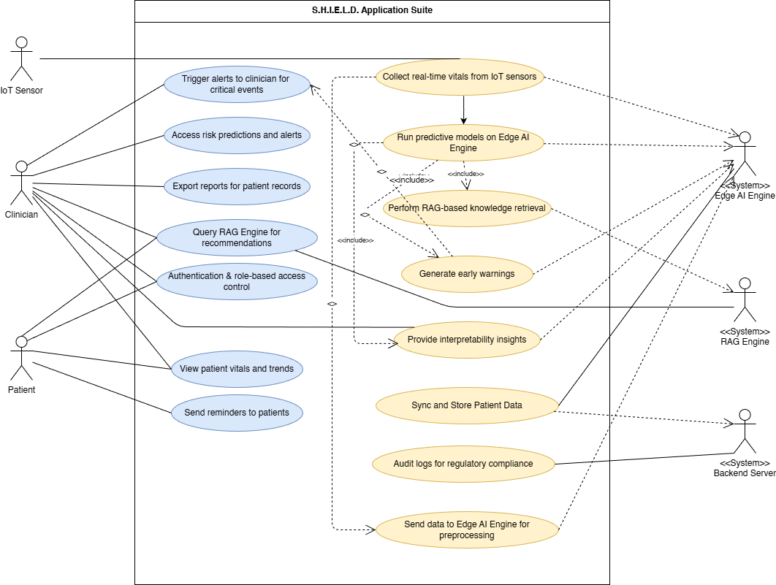
Figure 9: Use Case Diagram
This Use Case Diagram outlines the functional scope of the SHIELD cardiovascular health monitoring system. It illustrates the interactions between the primary stakeholders- patients, clinician, IoT sensors, and autonomous system agents (Edge AI, RAG Engine, Backend Server). The workflow starts with IoT Sensors autonomously triggering the data ingestion, collecting real-time vitals which are processed by the Edge XAI, this engine executes the predictive analysis workflow, which includes running LSTM models, generating early warnings, and providing interpretable risk insights. The Clinician or a Doctor, as the primary active user, interacts with the Clinical Oversight Dashboard to view these trends, access risk predictions, and query the RAG Engine for context-aware medical recommendations. Meanwhile, the backend server operates in the background to handle System Administration tasks, specifically synchronizing data from the edge, ensuring persistent storage, and maintaining regulatory audit logs, thereby creating a seamless, privacy-preserving loop from patient sensor to clinical insight.

Sequence Diagram

Diagram 1: Normal Operation
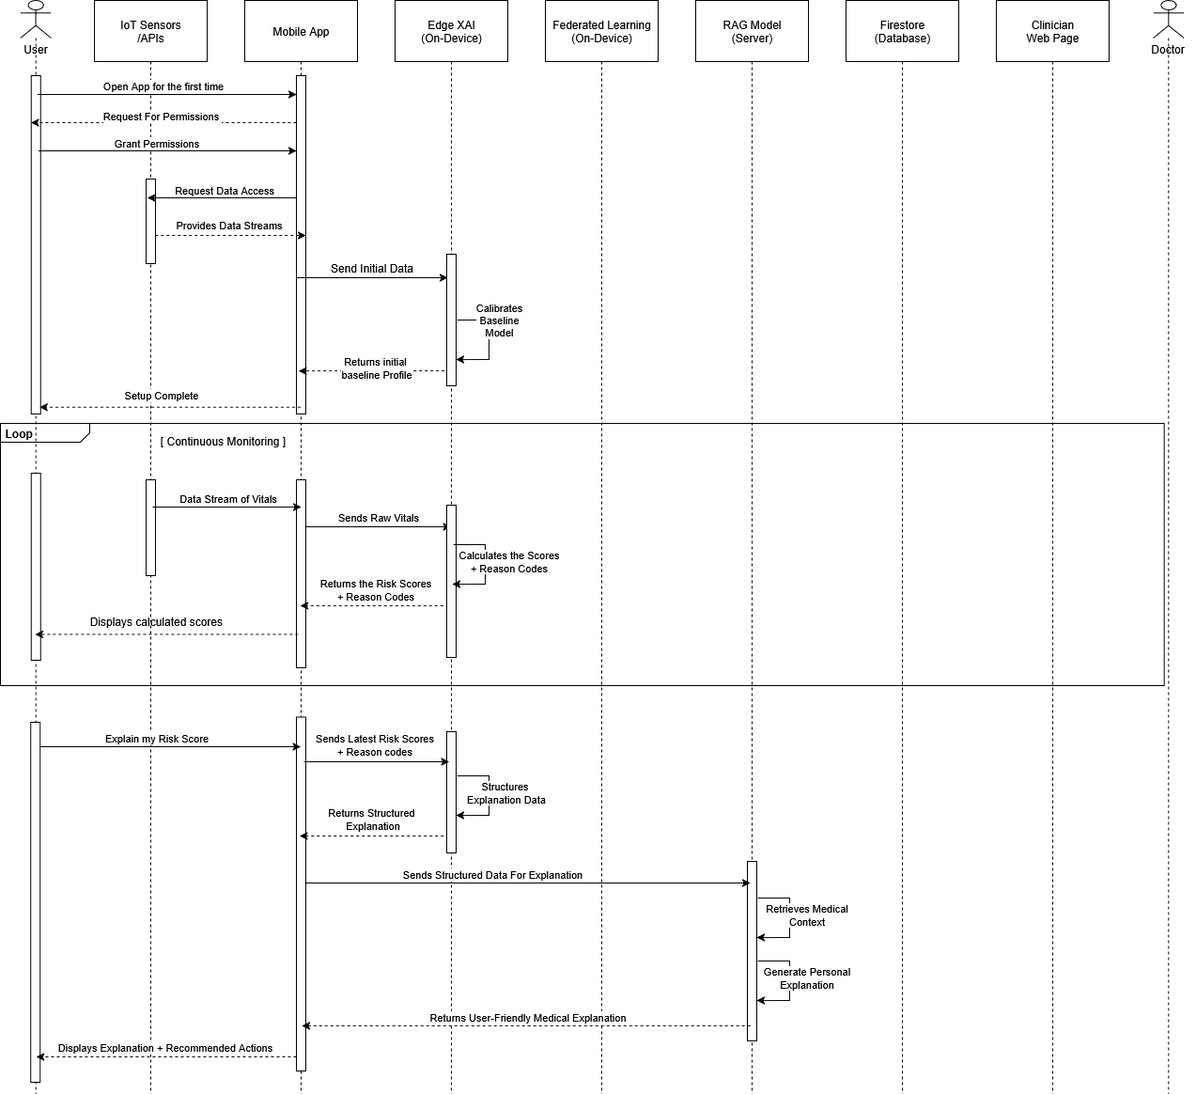
Figure 10: Sequence Diagram (Normal Operation)
This diagram shows the core real-time workflow of the SHIELD mobile app. It begins with the setup part and then moves onto the continuous collection of vital signs from connected sensors such as HR, HRV, BP, and SpO₂. The app sends this raw data to the on-device Edge XAI model, which performs an immediate risk assessment. The Edge model returns a risk score, enabling transparent, explainable insights without any cloud interaction. Then if the user requests an explanation for their risk score. The mobile app first retrieves the structured explanation data from the on-device XAI model, then sends it to the server-side RAG model. The RAG engine enriches the data with medically relevant context to produce readable guidance. The final explanation is sent back to the app and displayed to the user.

Diagram 2: Critical Alert and Clinician Dashboard Sync
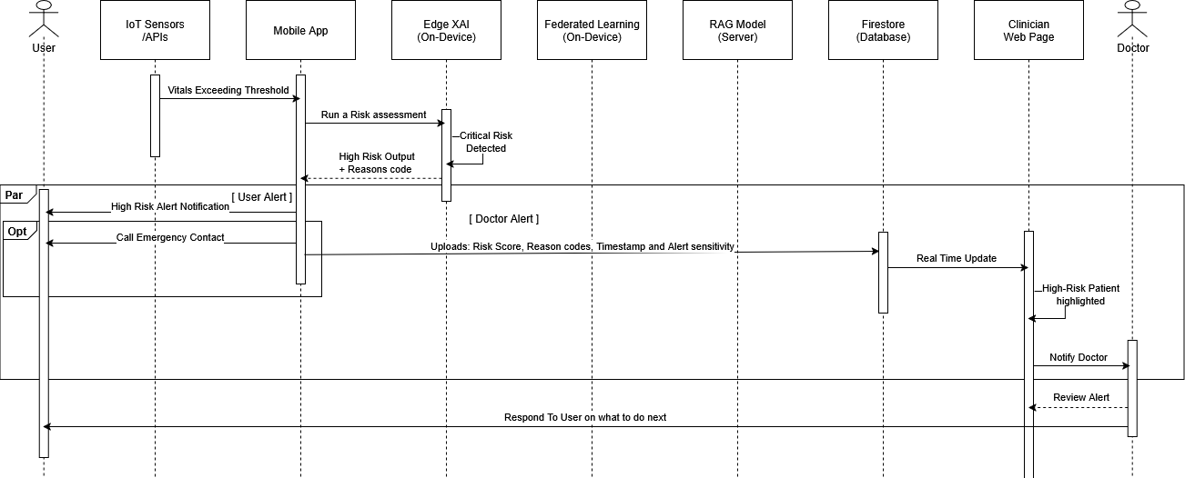
Figure 11: Sequence Diagram (Critical Operation)
This diagram shows what happens when the system detects a potentially dangerous change in the user’s vitals. After receiving abnormal sensor readings, the app triggers the Edge XAI model to reassess the risk. If the output crosses a high-risk threshold, a critical alert is generated. The alert including risk score, reason codes, and timestamp is uploaded to the secure cloud database (PGSQL). From there, the clinician dashboard receives a real-time update, highlighting the patient as high priority. This diagram demonstrates the system’s collaborative monitoring loop and its ability to assist healthcare professionals proactively.

System Architecture

Architectural Design
The system is decomposed into ten subsystems:
- IoT & Wearable Sensor Layer - All physiological data sources (consumer-grade and medical-grade)
- Data Processing Layer – Preprocessing and feature extraction
- Edge XAI Model – On-device models + personalized health modelling
- RAG Server – Clinical knowledge retrieval + monitoring summary generator
- Federated Learning Aggregation Service – Local training + privacy-preserving global model updates
- Patient Mobile Application – Patient dashboard, trends, consultation
- Doctor Clinician Dashboard – Oversight, monitor patient summaries and trends
- Cloud Backend – FL aggregation, APIs
- On-device Database – Long-term reading storage
- Cloud Database - User details, trends etc.
- Authentication Service – User login and signup
These subsystems communicate through REST endpoints. The frontend invokes API calls, the backend services coordinate business rules, the cloud database stores normalized tables.

Decomposition Description
Subsystems breakdown:
- IoT & Wearable Sensor Layer
  - Collects raw physiological data from fitness wearables from APIs, medical devices through usage of custom IoT.
  - Streams real-time signals into the processing pipeline.
- Data Processing Layer
- Cleans, aligns and filters incoming sensor data.
- Extracts core features needed for modelling and inference.
- Edge XAI & LSTM
- Runs on-device prediction models and generates explainability signals.
- Maintains a continuously updated personalized physiological baseline (LSTM Model).
- RAG Server
- Retrieves clinically validated knowledge and synthesizes context-aware summaries.
- Bridges raw sensor insights with textual medical guidance.

- Federated Learning System
- Executes local on-device model training to preserve data privacy.
- Aggregates encrypted weight updates to refine the global model.
- Patient Mobile Application
- Delivers real-time vitals, trends and personalized insights to the user.
- Acts as the control plane for sensor integration and Edge XAI outputs.
- Doctor Clinician Dashboard
- Provides clinicians with patient summaries, deviations and long-term trends.
- Enables oversight without exposing raw personal data.
- Cloud Backend
  - Handles FL aggregation, API routing and coordination of backend services.
- On-device Database
  - Stores long-term readings, baselines and model states locally.
  - Supports offline functionality and privacy-first data retention.
- Cloud Database
  - Holds user profiles, trend aggregates for each user and non-sensitive metadata.
- Authentication Service (Firebase Auth)
  - Provides basic identity creation and verification for login and signup.
  - Issues and validates auth tokens, all user attributes are offloaded to the core database and mapped via UUID.

Design Rationale
SHIELD has been structured as a set of modular services so each part of the system stays focused on a single responsibility and is easier to maintain. REST was chosen for the API layer because it’s simple, predictable, and works cleanly across mobile and IoT endpoints.
Both the on-device and cloud databases use relational models since our data is mostly structured and tied to clear relationships, making consistency and querying straightforward.
Authentication is delegated to Firebase Auth to avoid owning the security burden of credential management. We only store user details in our cloud database, linked through the user’s Firebase-issued UUID.
Federated Learning is built into the architecture to keep sensitive health data on the device. Each device trains locally and only sends model updates, not raw sensor data. This allows us to improve the global model without compromising user privacy.

High Level System Architecture Diagram
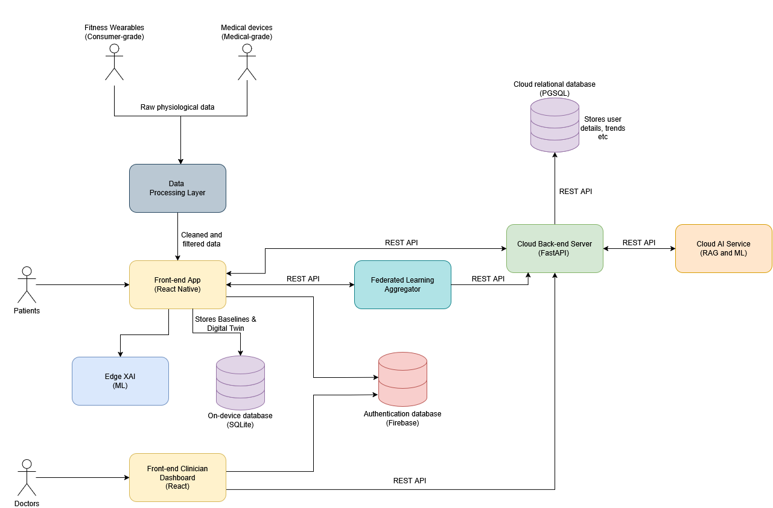
Figure 12: High Level System Architecture (Updated)

Human Interface Design

Mobile Application UI
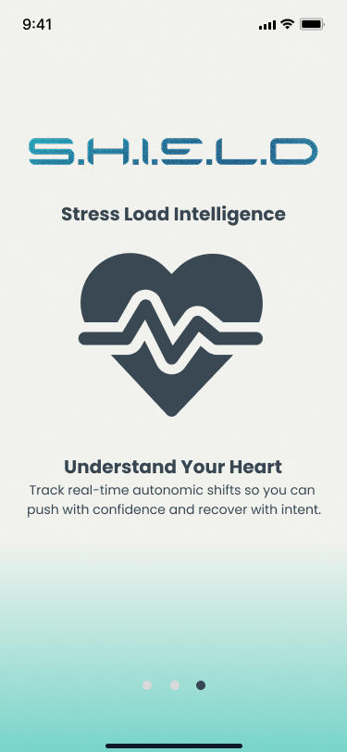
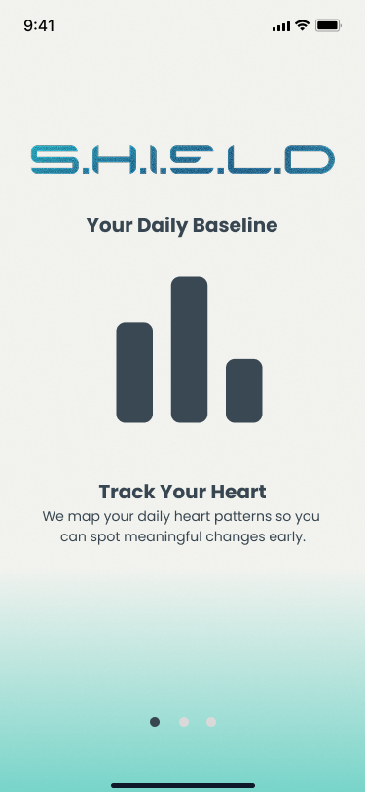
Onboarding Pages
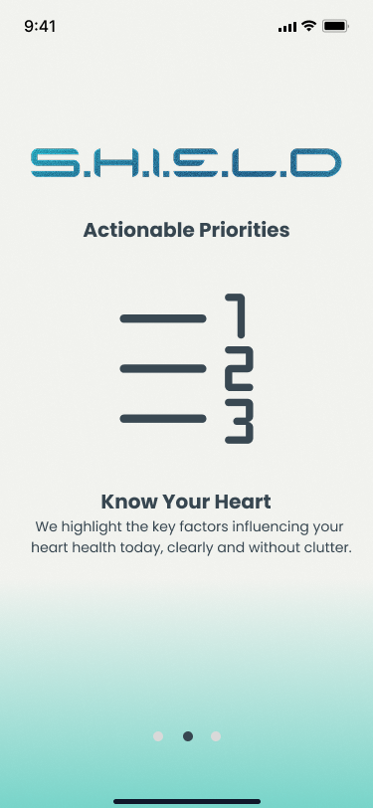
Figure 13: Prototype UI - Onboarding Pages
Figure 14: Prototype UI - SignUp/Login Pages

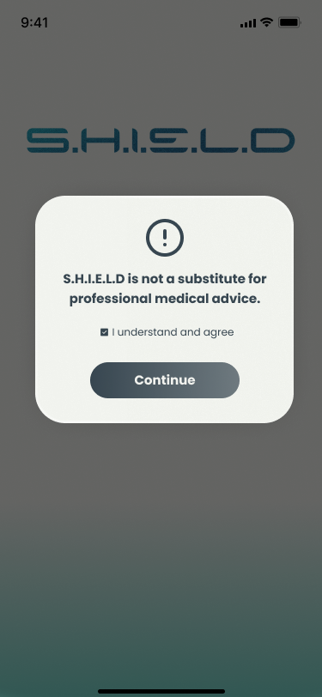
Figure 15: Prototype UI - Disclaimer

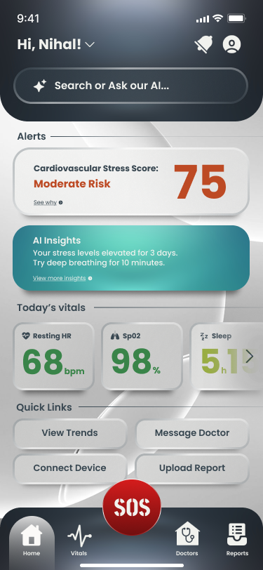
Figure 16: Prototype UI - Home Page

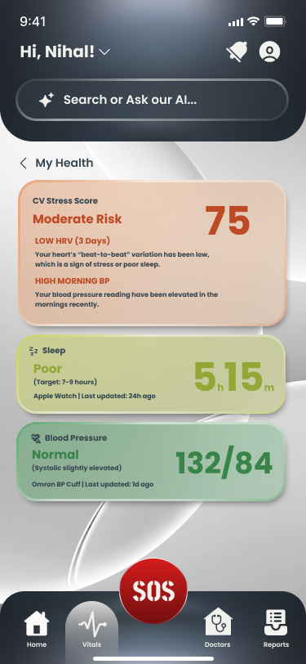
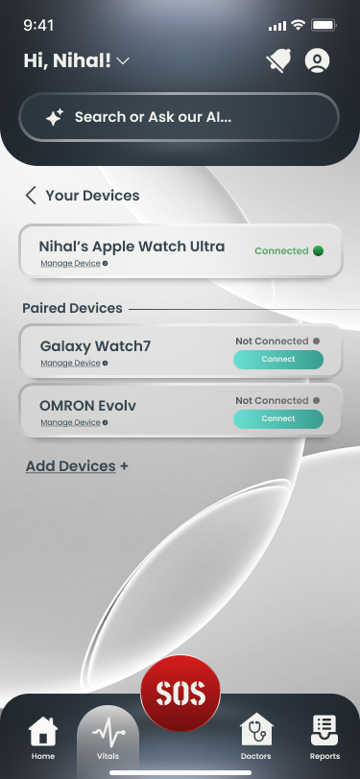
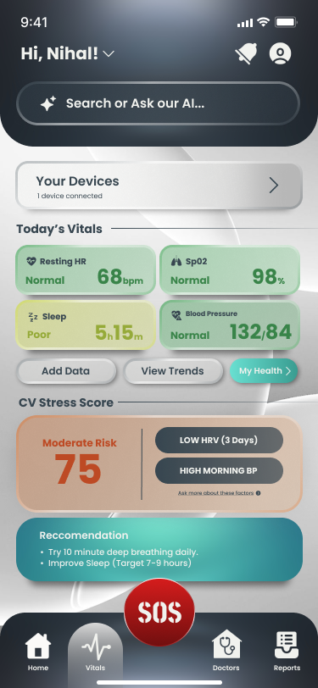
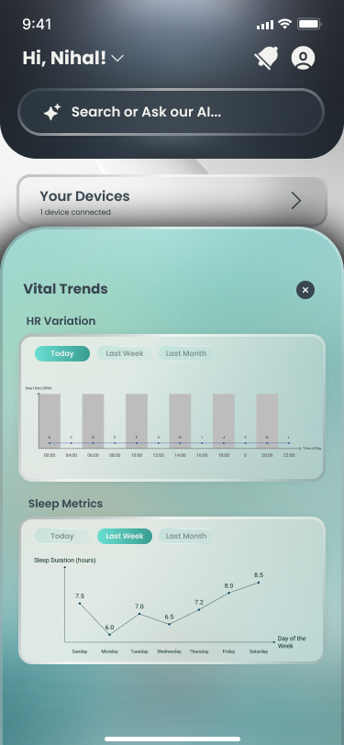

Figure 17: Prototype UI - Vitals & Trends Page
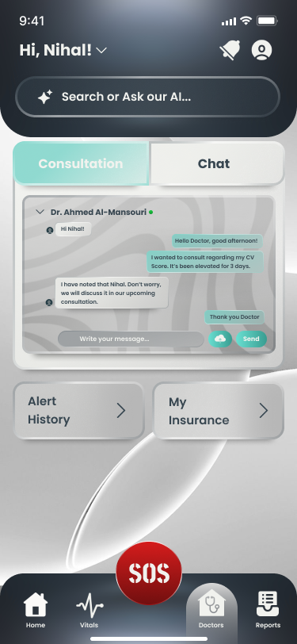
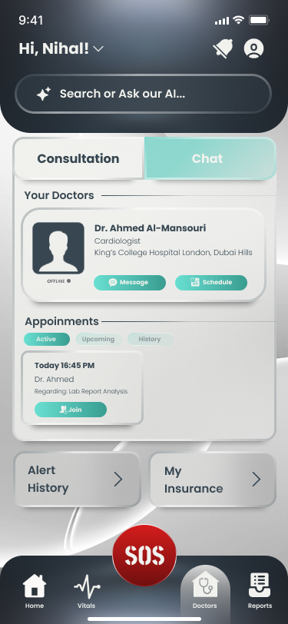

Figure 18: Prototype UI - Doctor Connect Page

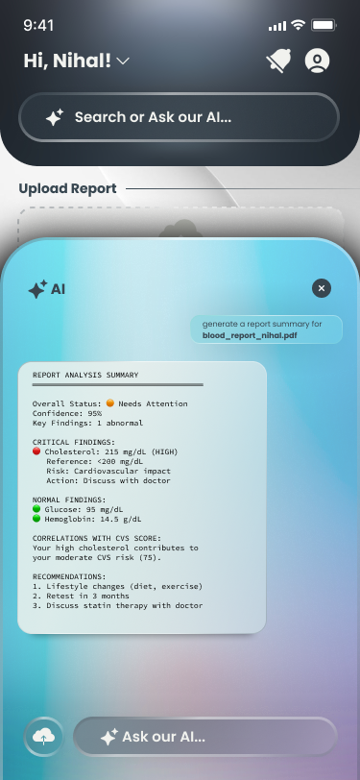
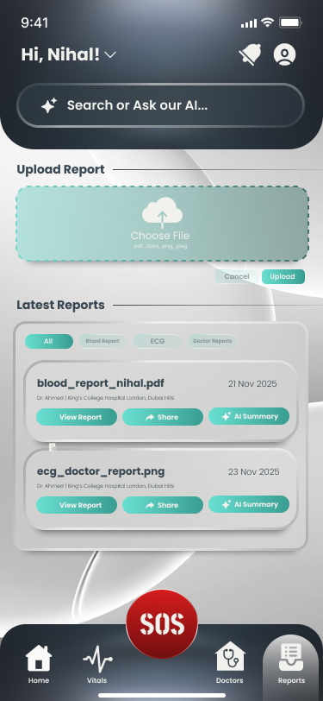
Figure 19: Prototype UI - AI Chatbot and Analyzer
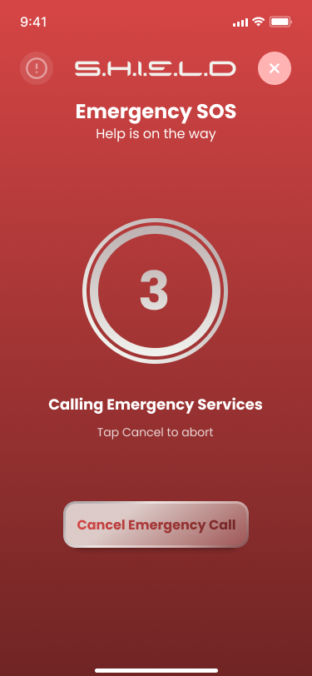
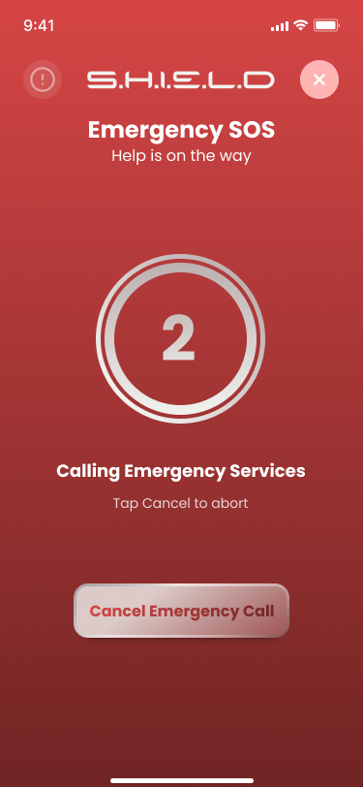

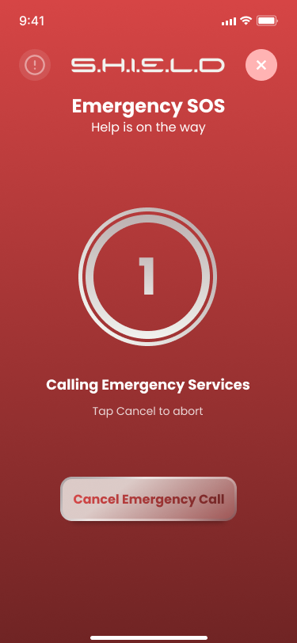
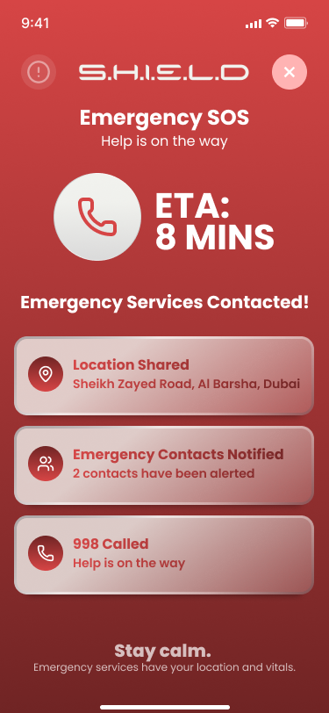

Figure 20: Prototype UI - Emergency Alert System

Web Portal UI
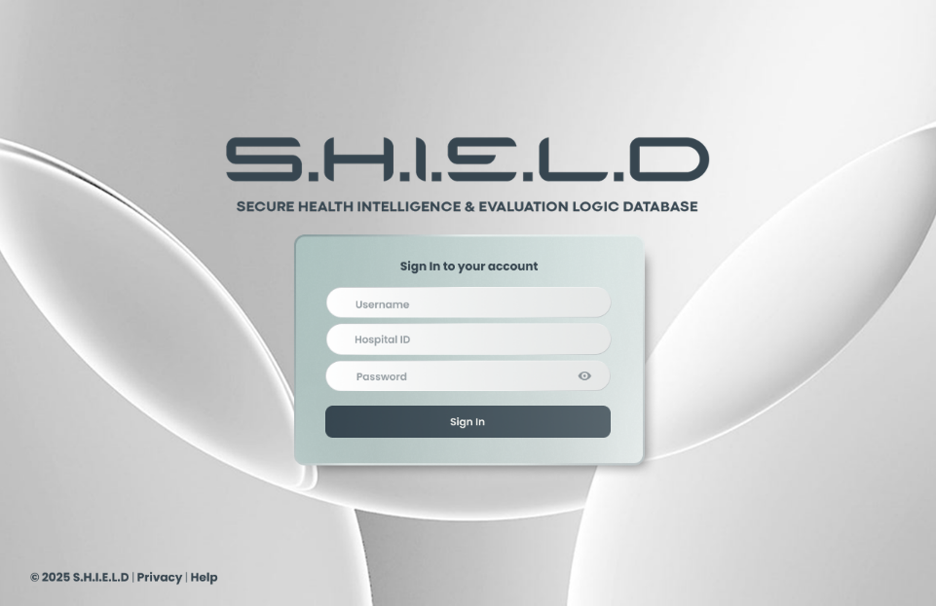
Figure 21: Prototype UI - Web Portal Sign In
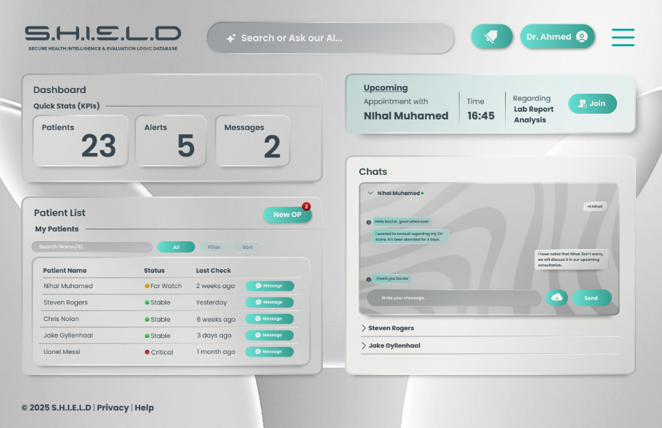
Figure 22: Prototype UI - Clinician Dashboard
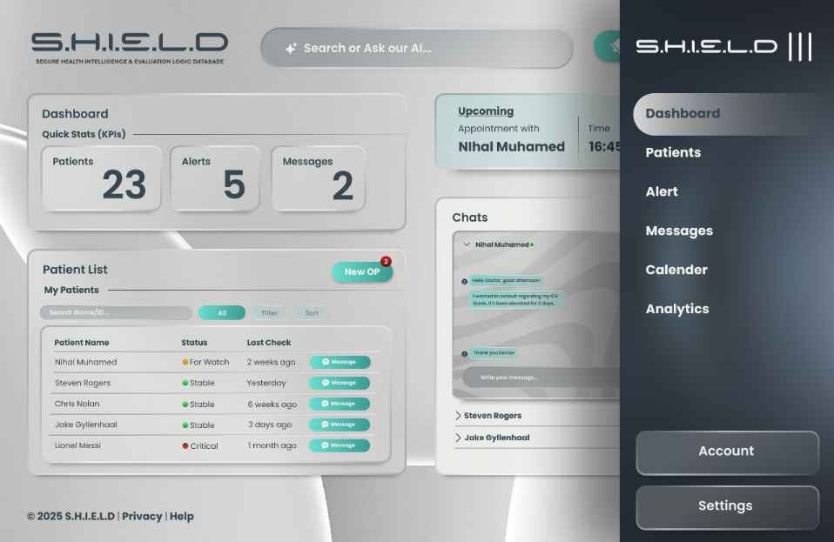
Figure 23: Prototype UI - Clinician Services

UI/UX Patterns and Rules
Law/Pattern | Description and Application in SHIELD
Law of Proximity | Related content is grouped together with consistent spacing. On the Home Dashboard, the Cardiovascular Stress Score card, vitals summary, and trend indicator are placed in close proximity to make the relationship between them immediately obvious to the user. Unrelated sections (e.g. navigation and main content) are separated with clear spacing.
Law of Similarity | All interactive buttons share a consistent shape, size, and colour. Primary action buttons share the same visual design throughout the app so that users can instantly recognise them and what they do. Risk level indicators (green for Low, yellow for Medium, red for High) are consistently applied across the Dashboard, Clinician Portal, and notification alerts.
Von Restorff Effect | The most important element on each screen is made visually distinct. On the Dashboard, the Cardiovascular Stress Score is displayed in a large circular progress indicator - the most visually dominant and critical element on the page. The Emergency SOS button uses a high-visibility red background with white text to stand out from all other UI elements.
Cognitive Load Theory | Information is broken into readable parts to avoid overwhelming users. The Dashboard shows only the most essential vitals at a glance. Detailed trend graphs, historical data, and full AI explanations are placed one level deeper, accessible through a tap. The onboarding process is broken into clearly labelled steps rather than presenting all fields at once.
Fitts’s Law | Frequently used controls are made larger and placed in accessible positions. The Cardiovascular Stress Score and the primary navigation bar are designed for easy reach on both small and large screen sizes. The Emergency SOS cancel button uses a large tap target to ensure it can be pressed reliably even under stress.
Aesthetic-Usability Effect | Consistent spacing, clean typography, and a minimal colour palette help make the app feel trustworthy and easy to use. A simple and professional design reduces friction, which is especially important for users who may be anxious about their health data.
Jakob’s Law | The app uses general, familiar navigation patterns that users already know from other health and mobile applications. The bottom navigation bar, standard card-based layouts, and left-to-right reading flow match common expectations, reducing the learning curve for new users.
Law of Common Regions | Grouping containers group related information together. On the Patient Details screen in the Clinician Portal, the patient’s vitals graph and AI reason codes are enclosed in a card container, clearly separating them from the clinician’s notes section.
Law of Visual Hierarchy | More important information is given greater visual weight. The risk score uses larger, bolder text than supporting vitals. Supporting vitals (HR, SpO2, BP) use medium-weight text, while timestamps and secondary labels use the smallest text size in the hierarchy.
Progressive Disclosure | Advanced details are hidden until needed. On the Trends page, the summary view shows a 7-day graph with extending up to 1 year. Users can tap into individual data points for full readings. The AI explanation is a separate screen accessed from the risk score card, keeping the main Dashboard clean.

Assistive Technology
We made sure that the SHIELD ecosystem is accessible to wide range of users who may also be suffering from visual impairments, limited mobility, and lacking experience of technology. For that our application is designed by aligning with four core principles of the WCAG (Web Content Accessibility Guidelines), Perceivable, Operable, Understandable, Robust.
- Screen Reader Support: All interactive elements like buttons, vitals cards, risk indicators include ARIA labels so screen readers can correctly identify and report them.
- Keyboard Navigation: The application is fully navigable using keyboard controls on the Clinician Web Portal.
- Cognitive Load Reduction: The clinician and application dashboards displays the most important information first, with buttons redirecting to detailed data. This step-by-step onboarding process can reduce cognitive overload for users who are new to health technology.
- Responsive Design: The UI layout uses flexbox-based auto layout, which adapts cleanly to both standard and Extra-Large system font sizes without clipping or breakage.
- Plain Language: All messages and AI explanations are generated in plain language, avoiding medical jargon. Instead of technical output like “RMSSD deficit detected”, the app displays “Your heart rate variability is lower than usual, which may indicate cardiovascular stress.”

Semester 2

Test Plan

Glossary
Term | Definition
BLE | Bluetooth Low Energy - wireless technology used for ESP32 communication
BPM | Beats Per Minute - heart rate measurement unit
Edge XAI | On-device explainable AI which generates reason codes for risk predictions
LSTM | Long Short-Term Memory: An ML algorithm that trains from sequential data
SHAP | SHAPley Additive explanations: used to sum up and explain the output of a model.
AUROC | Area Under the Receiver Operating Characteristic: an ML performance evaluating metric that prioritizes the positive predictions rather than the negative ones.
ESP32 | Microcontroller board with Bluetooth, used for sensor data collection
FR | Functional Requirement - numbered requirements from SRS document
FT | Functional Test - test case ID prefix
HR | Heart rate
HRV | Heart rate variability
IoT | Internet of Things - connected hardware devices
JWT | JSON Web Token - used for authentication
MAX30102 | Pulse oximetry sensor used for heart rate and SpO2
AD8232 | ECG sensor module to measure heart’s electrical activity
PDPL | UAE Personal Data Protection Law
RAG | Retrieval-Augmented Generation - AI explanation engine
SpO2 | Blood oxygen saturation level
UAT | User Acceptance Test
WCAG | Web Content Accessibility Guidelines

Test Approach and Methodology
Test Level | Methodology | Tools
Functional Testing | Black-box, manual & automated | Jest, Postman, Playwright, React Native Testing Library
Integration Testing | Gray-box, incremental | Postman (for API), Pytest
System Testing | End-to-end workflow | Playwright, Mobile Test Phones (Android 12+), Firebase
Hardware Testing | Manual verification | Software tools: Arduino IDE  Hardware tools: ESP32, 800-Points Breadboard, MAX30102 Pulse Sensor, AD8232 ECG Module, 0.96 I2C OLED Display Module
AI/ML Testing | Validation, Feature Attribution Check, AI Fact Check (RAG), Global Model Test | TensorFlow, SHAP, Flower
Security Testing | Penetration & vulnerability | OWASP ZAP, Wireshark
Performance Testing | Load & stress | Locust, Postman
Usability Testing | Heuristic & user sessions | Google Forms (for feedback), WCAG Checkers
UAT | Business user validation | TestFlight (iOS), Google Play Console (Internal Testing), Beta feedback forms
Regression Testing | Automated + Manual | GitHub Actions (CI/CD), Jest, Playwright

Pre-Requisites
Pre-Requisites | Rationale
Bluetooth is activated on test devices | Necessary for ESP32 connection
Users have basic smartphone knowledge | Target audience including elderly users
ESP32, MAX30102 and AD8232 comes in perfect condition | Hardware integrity essential
Team members are available for testing | Schedule adherence
Cloud services free tier sufficient for testing | Budget constraints
GitHub repository accessible | Version control
Supervisor feedback provided in timely manner | Project timeline

In-Scope Features
- Applications for patients on mobile devices
- Web portal for the clinicians
- ESP32 components featuring MAX30102 and AD8232 Sensors
- ESP32 and mobile app Bluetooth interaction
- AI models (Edge XAI and RAG)
- Backend services (Firebase, PostgreSQL)
- API endpoints
- Security and privacy features

Out-of-Scope Features
- Full-scale clinical trials
- Connection with hospital electronic health record systems
- Support for multi-language (future iterations)
- Advanced machine learning infrastructure at scale
- Legal audits beyond basic data handling

Risk and Mitigation

Technical Risks
Risk | What Could Go Wrong | Impact | Mitigation
ESP32 failure | Board stops working or fails to connect | High | Maintains spare ESP32, verify components before assembly
Sensor inaccurate | MAX30102 provides incorrect readings | High | Compare against reference device, average several readings
Bluetooth drops | Mobile devices loses connection to ESP32 | Medium | Auto-reconnect, store data locally
App crashes | Mobile app shuts down unexpectedly | High | Evaluate on multiple devices, crash reporting
API failure | Backend unresponsive | Medium | Retry logic, cache locally

AI/ML Risks
Risk | What Could Go Wrong | Impact | Mitigation
False alarm | App indicates "HIGH RISK" when user is fine | Medium | Need consistent patterns, confidence evaluation
Missed danger | App indicates "LOW RISK" when user is in danger | Critical | Various detection methods, cautious thresholds, Manual Emergency Trigger
RAG Illusion | The chatbot provides information that is not based on the medical guidelines. | Critical | Implement a safety layer to restrict certain wording and phrases, and use a vector-search constraint.
Insufficient data | The AI model lacks sufficient examples | Medium | Utilize public datasets (PhysioNet), data augmentation
Data Bias | AI is trained on a specific demographic or segment and can fail on others. | High | Implement SMOTE to synthetically impute imbalance datasets.

Security Risks
Risk | What Could Go Wrong | Impact | Mitigation
Data stolen | An individual retrieves health record | Critical | AES-256 encryption, TLS 1.3, no unprocessed data in cloud
Unauthorized access | Another person logs in | High | Biometric verification, session expiration
API keys exposed | Secret keys exposed in code | High | Environment variables, avoid committing to GitHub

Project Risks
Risk | What Could Go Wrong | Impact | Mitigation
Behind schedule | Will not finish in 24 weeks | High | Prioritize MVP features first conduct weekly check-ins
Team member unavailable | Someone who can't work on their part | Medium | Train across discipline, record all details
Hardware arrives late | ESP32 or sensor not received | High | Order early, use phone camera as backup
Scope creep | Adding too many features | Medium | Adhere to SRS, Stop after Week 9

Test Environment

Hardware Configuration
Component | Specification | Purpose
Development Laptops | 8GB+ RAM, Intel i5+ | Code development, testing
Test Phones | Android 12+ | Mobile app testing
Breadboard | 400 points | Prototyping
ESP32 DevKit | ESP32-WROOM-32 | Hardware testing
MAX30102 Sensor | Pulse oximeter | Biometric data
AD8232 Sensor | ECG Module | Biometric Data
Jumper wires | Male-to-Male | Connections
USB-C to C Cable | Data transfer capable | Programming ESP32
Reference Pulse Oximeter | Commercial device | Accuracy comparison

Software Configuration
Component | Technology | Version
Mobile App | React Native | 0.74+
Backend | Flask | Latest
Database | PostgreSQL, SQLite | Latest
AI/ML | TensorFlow, TFLite, SHAP, ChromaDB, Langchain, HuggingFace, Flower | Latest
UI Testing Library | react-native-testing-library, @testing-library/react | Latest
Testing Framework | Jest, Pytest, Playwright, Postman | Latest
IDE | Arduino IDE | Latest
Clinician Portal | React TypeScript | 18+
Authentication | Firebase Auth | Latest

Network Configuration
Parameter | Setting
Connection Type | Wi-Fi, Bluetooth
Minimum Speed | 10 Mbps for cloud tests
Network Security | HTTPS, TLS 1.3
Bluetooth | BLE 4.2+

Entry and Exit Criteria

Entry Criteria
- The code is finalized for the features being tested
- The test environment is stable and set up properly
- Test scenarios are created and evaluated
- Test data has been prepared
- Team members are assigned and available
- No critical blockers prevent testing

Exit Criteria
- All scheduled test cases are carried out
- Critical and High severity defects are fixed and confirmed
- Verify Edge XAI Model AUROC is above 85% before deployment

Constraints
Constraint | Impact on testing
24-week schedule | Restricted testing phases
Availability of hardware | Testing reliant on ESP32
No real patient information | Synthetic data is a requirement
Compliance with UAE PDPL | Must ensure data privacy

Testing Strategy

Test Objective
Objective Id | Objective Description
OBJ-01 | Ensure all functional requirements work as expected
OBJ-02 | Confirm the accuracy of ESP32 + MAX30102 hardware
OBJ-03 | Ensure predictive risk assessment correctly identifies events
OBJ-04 | Check emergency alert system activation
OBJ-05 | Ensure all the data is encrypted
OBJ-06 | Confirm on-device processing without any raw data leaving phone
OBJ-07 | Make certain LSTM Model personalizes after baseline
OBJ-08 | Confirm that Edge XAI generates correct reason codes

Types of Testing
Test Type | Description
Functional Testing | Check that features work as per requirements
Integration Testing | Verify components function together
System Testing | Validation of End-to-end workflow
Hardware Testing | Verification of physical device
AI/ML Testing | Sensitivity, Precision, and F1-Score of the model
Security Testing | Protection of Data and access control
Performance Testing | Response duration and load handling
Usability Testing | User Interface and accessibility
UAT | User approval with actual users
Regression Testing | Verify fixes don't break existing features

Resource & Environmental Needs
Resource Type | Requirement
Hardware | ESP32 Devkit, MAX30102 sensor, Breadboard, Jumper wires
Software | Arduino IDE, VS Code, Firebase, Postman, Playwright, GitHub
Network | Wi-Fi, Bluetooth BLE 4.2+, Internet
Personnel | All 6 team members

Test Deliverables
Deliverables | Description
Test Plan Document | Complete testing strategy
Test Cases Excel | Every test case with steps
Hardware Test Logs | ESP32, MAX30102, AD8232 sensor test records.
AI Validation Report | Metrics for model accuracy
Security Assessment | Results of vulnerability scan
Performance Test Report | Results and metrics from load testing
Defect Report | Bug reports from testing
Test Summary Report | Final test results
UAT Sign-off | Confirmation of user acceptance

Functional Testing
The Functional Testing Matrix includes test cases for the mobile application as well.

Integration Testing

System Testing

Hardware Testing

AI/ML Testing

Security Testing

Performance Testing

Usability and Accessibility Testing

User Acceptance Testing (UAT)

Regression Testing

Test Results

Functional Testing
Test ID | Module | Test Description | Status | Result
FT-001 | Authentication | Verify whether user can register with valid details | PASS | User successfully registered. A confirmation message 'Registration Successful' appeared on the screen, and the new user record was created in the database.
FT-002 | Authentication | Verify whether user can login with valid credentials | PASS | User authenticated successfully via Firebase. A valid ID token was retrieved, and the onAuthStateChanged listener triggered the redirect. The app navigated to the Dashboard as expected.
FT-003 | Authentication | Verify whether error appears for invalid credentials | PASS | Firebase returned auth/invalid-credential. Error message "Invalid email or password" displayed on Login screen.
FT-004 | Authentication | Verify whether validation appears for empty fields | PASS | Input validation triggered locally. Please fill out email" appeared.
FT-005 | Authentication | Verify whether "Forgot Password" sends reset email | PASS | Firebase sendPasswordResetEmail executed. Test email received in inbox within 45 seconds.
FT-006 | Device Connection | Verify whether app scans for Bluetooth devices | PASS | Scan initiated. BLE scan list populated with "S.H.I.E.L.D_ESP32" and its corresponding MAC address.
FT-007 | Device Connection | Verify whether app connects to ESP32 | PASS | Handshake successful. App shows "Pairing Successful" message and navigates to Live Reading Pages.
FT-008 | Real-time Data | Verify whether heart rate displays in real-time | PASS | Data stream received via BLE GATT characteristic. Live Vitals refreshed every second with new values.
FT-009 | Manual Entry | Verify whether manual BP entry saves | PASS | Record appended to local SQLite. "Success" message appeared.
FT-010 | Manual Entry | Verify whether validation works for invalid BP | FAIL | User entered 500/300. System treated it as valid numeric input and saved it to the database.
FT-011 | Risk Score | Verify whether risk is LOW for normal parameters | PASS | Algorithm processed HR=72/HRV=45. UI displayed "Low Risk".
FT-012 | Risk Score | Verify whether risk is HIGH for elevated HR | FAIL | Risk score correctly calculated as "High" and UI updated. However, primary contact was not contacted.
FT-013 | Risk Score | Verify whether risk is CRITICAL for emergency | FAIL | Risk score calculated as "High". However emergency services not triggered and primary contact not contacted.
FT-014 | XAI | Verify whether reason codes generate correctly | PASS | Model output included "HIGH_HR" code. Explanation "Your heart rate is significantly above resting" displayed.
FT-015 | Dashboard | Verify whether cardiovascular stress score displays | PASS | Dashboard Stress card displayed "65" (MEDIUM) with an orange circular progress indicator.
FT-016 | Dashboard | Verify whether trends display correctly | PASS | Line chart rendered 7 data points from PostgreSQL. X-axis correctly showed the last 7 days.
FT-017 | Emergency Alert | Verify whether emergency triggers at critical risk | FAIL | Emergency UI and trigger logic are not yet implemented. High risk is detected but no alert screen is launched.
FT-018 | Emergency Alert | Verify whether emergency can be cancelled | PASS | CANCEL button pressed during countdown. Alert dismissed, state reset to Dashboard, no SMS triggered.
FT-019 | Emergency Alert | Verify whether contacts receive notification | PASS | Countdown reached 0. SMS sent via message to contact. SMS contained Google Maps link.
FT-020 | Notifications | Verify whether push notifications appear for alerts | FAIL | Push notification service is not integrated for risk events.
FT-021 | Privacy | Verify whether data stays on device securely | PASS | Database file (vitals.db) is unreadable without the correct key. Verified by attempting to open the database file using an external SQLite browser, which returned "File is encrypted or not a database."
FT-022 | Security | Verify whether unauthorized API access blocked | PASS | API call returned 401 Unauthorized. Response body showed "Missing or invalid token." Data remains protected.
FT-023 | Connectivity | Verify data behavior during Wi-Fi/LTE disconnection | PASS | Connection lost. App displayed "Offline mode." New logs were written to vitals SQLite table.
FT-024 | Background | Verify background monitoring persistence | PASS | App resumed from background. BLE service stayed alive in the foreground notification. No data gaps found.
FT-025 | Permissions | Verify app behavior when Bluetooth is revoked | PASS | System dialog appeared. App UI updated to "Bluetooth Access Required" with a "Go to Settings" link.
FT-026 | Accessibility | Verify UI stability with Extra Large System Fonts | PASS | UI adjusted via Flexbox/Auto-layout. No text clipping, Risk Score remained centered and fully visible.
FT-027 | Power Management | Verify behavior in Low Power Mode | PASS | BLE connection persisted. Polling frequency remained stable despite OS power restrictions.
FT-028 | Offline Sync | Verify data synchronization after reconnection | PASS | Internet restored. Sync worker identified 5 pending rows in SQLite and pushed them to Neon Cloud.
Elaborated Results:

Integration Testing
Test ID | Module | Test Description | Status | Result
IT-001 | ESP32 → Mobile | Verify whether ESP32 broadcasts and mobile app can discover it | PASS | App successfully discovered the ESP32 broadcast. "S.H.I.E.L.D_ESP32" appeared in the list within 4 seconds.
IT-002 | ESP32 → Mobile | Verify whether mobile app can connect to ESP32 | PASS | BLE handshake completed. App UI updated to "Paired" and redirected to Live Reading Page. ESP32 Serial Monitor confirmed: Mobile App Connected!
IT-003 | ESP32 → Mobile | Verify whether heart rate data transmits correctly | PASS | Data packets received via BLE. App displayed 72 BPM while Serial Monitor showed 71-73 BPM. Sync latency was <2s.
IT-004 | ESP32 → Mobile | Verify whether app handles connection loss and reconnection | FAIL | App detected "Disconnected" state. However, upon moving device closer the BLE auto-connect logic didnt restore the link.
IT-005 | Mobile → Backend | Verify whether app can send vital data to backend | PASS | App called /api/v1/log_vitals. Neon console confirmed a new row in the vitals table with matching timestamps.
IT-006 | Mobile → Backend | Verify whether app can send vital data to backend | PASS | POST request successful. Risk score (e.g., 0.85) was correctly mapped to the patient_id in the cloud database.
IT-007 | Mobile → Backend | Verify whether offline data sync works | PASS | Data was saved to local sqlite database while offline. Upon reconnection, sync triggered and pushed data to Neon Cloud.
IT-008 | Backend → Database | Verify whether API data is correctly stored | PASS | Manual check of Neon SQL Editor confirmed that values sent (HR: 85, BP: 120/80) match the stored records exactly.
IT-009 | Backend → Database | Verify whether database queries return correct data | PASS | GET request returned a JSON array matching the database. Data types (Integers for HR, Floats for Score) were preserved.
IT-010 | Backend → Dashboard | Verify whether database queries return correct data | FAIL | The clinician dashboard requires a manual browser refresh to see the new data, no WebSockets/Real-time sync yet.
IT-011 | Backend → Dashboard | Verify whether high-risk alerts appear on dashboard | FAIL | High HR reached the DB, but the Dashboard UI did not trigger a red highlight or an audible alert automatically.
IT-012 | Backend → Dashboard | Verify whether patient list sorts by risk | PASS | Doctor Portal UI successfully sorted the patient list based on the risk_label column (High at top).
IT-013 | Backend → Dashboard | Verify whether clinician can view patient details and AI insights | PASS | Details page correctly rendered the graph using historical data and displayed the AI Reason Codes.
IT-014 | Edge XAI → RAG | Verify whether reason codes pass to RAG correctly | PASS | Edge XAI output was successfully included in the JSON payload sent to the RAG endpoint.
IT-015 | Edge XAI → RAG | Verify whether RAG returns human-readable explanations | PASS | RAG API processed the code HIGH_HR and returned: "Your heart rate is elevated above your normal range."
IT-016 | Edge XAI → RAG | Verify whether RAG uses patient context | PASS | The RAG system successfully queried the patient's 7-day average HR and used it to contrast with the current "High HR" reading in the explanation.
IT-017 | Complete Flow | Verify end-to-end flow:  Sensor → ESP32 → Mobile → Backend → Dashboard | PASS | Sensor data successfully traveled from ESP32 to the Cloud Dashboard through all layers.
IT-018 | Complete Flow  (Emergency) | Verify emergency flow: Critical HR → Mobile Alert →  Backend → Dashboard → Contact | FAIL | The emergency trigger service is not implemented. High HR data is captured and High risk is calculated, but the automated sequence (Mobile Countdown -> Dashboard Flag -> SMS API) does not initiate.
Elaborated Results:

System Testing
Test ID | Module | Test Description | Status | Result
E2E-001 | New User Onboarding | Verify whether a new user can complete full onboarding process including 7-day baseline | PASS | Registration and Profile completion successful. ESP32 paired on first attempt. Initial vitals recorded and "7-Day Baseline" status activated in the LSTM Model module.
E2E-002 | Daily Monitoring | Verify whether user can perform daily health monitoring routine | PASS | Dashboard successfully rendered real-time BLE data and updated the Stress Score. Navigation to Trends showed up to 1 year of data history with <1s load time.
E2E-003 | Emergency Detection | Verify whether system detects emergency and triggers complete alert workflow | FAIL | The emergency workflow is not implemented. HR reached 150, but the app did not trigger the red alert screen, countdown, or SMS/Email notifications to contacts.
E2E-004 | Clinician Oversight | Verify whether clinician can effectively monitor and review patient data | PASS | Clinician successfully logged in and viewed the risk-sorted patient list. AI reason codes (e.g., HIGH_HR) and vitals graphs rendered correctly for the selected patient.
E2E-005 | Manual Data Entry Integration | Verify whether manually entered data integrates with overall system | PASS | BP (125/85) and symptoms were saved to sqlite DB. Data successfully appeared in the Trends history with the correct metadata and updated the cloud record.
E2E-006 | Cross-Platform Sync | Verify whether patient data syncs correctly across patient app and clinician portal | FAIL | Real-time sync is not supported. New vitals only appeared in the Clinician Portal after the 5-minute REST batch upload was triggered. Manual refresh of the portal was required.
Elaborated Results:

Hardware Testing
Test ID | Test Description | Status | Result
HT-001 | ESP32 Power | PASS | Red Power LED on the ESP32 DevKit V1 illuminated immediately upon USB connection.
HT-002 | ESP32 Connection | PASS | Detected COM3 (Silicon Labs CP210x USB to UART Bridge) in the Arduino IDE port selection menu.
HT-003 | ESP32 Programming | PASS | Sketch compiled and uploaded successfully. Console log showed "Writing at 0x00010000... (100 %)" and "Hash of data verified."
HT-004 | MAX30102 Wiring | PASS | Visual inspection confirmed I2C lines (D21/D22) and power rails are secure. Multimeter continuity test passed for all four jumper wires.
HT-005 | MAX30102 Initialization | PASS | Serial Monitor output: [INIT] MAX30102 was found. Part ID: 0x15. Sensor started successfully.
HT-006 | Sensor Troubleshooting | PASS | Initial attempt failed due to crossed wires, after swapping D21 and D22, the I2C scanner correctly identified address 0x57.
HT-007 | Finger Detection | PASS | IR reflective threshold triggered. Serial monitor switched from No finger detected to "Sampling…" within 0.5s of contact.
HT-008 | Heart Rate Readings | PASS | BPM values began streaming after the 10-second stabilization window. Pulse rate averaged 74 BPM during resting state.
HT-009 | Heart Rate Accuracy | PASS | MAX30102 average: 72.4 BPM, Hospital-grade pulse ox: 73.1 BPM. Variance (0.7 BPM) is well within the ±2 BPM tolerance.
HT-010 | Motion Artifact | PASS | Readings spiked to 100+ BPM during finger movement (motion artifact) but returned to a stable 72 BPM within 4 seconds of stillness.
HT-011 | Different Fingers | PASS | Index: 71 BPM, Middle: 73 BPM, Ring: 70 BPM. All readings stayed within the expected 5 BPM consistency range.
Elaborated Results:

AI/ML Testing
Test ID | Module | Test Description | Status | Result
AI-001 | Risk Prediction | Verify whether risk is LOW for normal  heart rate parameters | PASS | Model returned "Low" risk (Score: 18). Confidence scores 0.88. SHAP code "STABLE" generated.
AI-002 | Risk Prediction | Verify whether risk is MEDIUM for elevated heart rate | PASS | Risk calculated as "Medium" (Score: 52).
AI-003 | Risk Prediction | Verify whether risk is HIGH for significantly elevated  heart rate | PASS | Model returned "High" risk (Score: 78). Risk correctly correlated with high BP and low HRV inputs.
AI-004 | Risk Prediction | Verify whether risk is CRITICAL for  emergency-level heart rate | FAIL | Model returned "High" (Score: 92) however emergency service did not get triggered automatically since feature is not implemented yet in device.
AI-005 | Confidence Score | Verify whether confidence score is high with complete data | PASS | Confidence score reached 0.94. SHAP correctly attributed the score to the stable 7-day heart rate trend.
AI-006 | Confidence Score | Verify whether confidence score is lower with incomplete data | PASS | Confidence dropped to 0.62 due to data gaps. UI did not display the "Insufficient data" warning toast since it is not yet implemented.
AI-007 | Edge XAI - High HR | Verify whether reason codes include HIGH_HR  for elevated heart rate | PASS | XAI successfully generated "HIGH_HR" code after detecting 30 minutes of sustained 120 BPM.
AI-008 | Edge XAI - Low HRV | Verify whether reason codes include LOW_HRV for reduced variability | FAIL | Model identified the trend but returned LOW_HRV. The current logic generates codes based on vital IDs and means, but does not support temporal suffixes like _2DAYS.
AI-009 | Edge XAI - Multiple Factors | Verify whether multiple reason codes appear for combined issues | PASS | All three markers detected. XAI output array: ["HIGH_HR", "LOW_HRV", "HIGH_BP_D", "HIGH_BP_S"].
AI-010 | LSTM Model Creation | Verify whether LSTM Model creates personalized baseline after 7 days | PASS | Baseline established. LSTM Model "Normal" HR range set to 68–74 BPM based on 7-day median.
AI-011 | LSTM Model Adaptation | Verify whether On-Device adapts to lifestyle changes | PASS | After 6 days of increased activity, the "Normal" baseline shifted from 72 BPM to 78 BPM without triggering anomalies.
AI-012 | Anomaly Detection | Verify whether sudden HR spike triggers anomaly flag | FAIL | Anomaly detected at the 4-second mark of the HR spike. Alert "Sudden heart rate increase detected" did not get displayed on Dashboard since logic is not implemented yet.
AI-013 | Anomaly Detection | Verify whether gradual changes don't trigger false anomalies | PASS | Gradual increase correctly ignored by anomaly detector, treated as normal physiological variance.
AI-014 | RAG Engine - Single Code | Verify whether RAG correctly translates single reason code | PASS | RAG successfully queried ChromaDB and returned: "Your heart rate is elevated above your normal range."
AI-015 | RAG Engine - Multiple Codes | Verify whether RAG correctly translates single reason code | PASS | RAG combined both codes into a coherent natural language sentence regarding HR and HRV.
AI-016 | RAG Engine - Personalization | Verify whether RAG uses patient context for personalized explanations | FAIL | RAG output successfully included 'YOUR personal baseline.' However, the engine translated the code LOW_HRV as the input rather than LOW_HRV_2DAYS, as the underlying model does not currently generate temporal suffixes.
AI-017 | Edge Case - Extreme Values | Verify whether model handles extreme values gracefully | PASS | Single 180 BPM spike flagged as "SENSOR_ERROR" (Out of range). No emergency triggered, user prompted to check sensor fit.
AI-018 | Edge Case - Extreme Values | Verify whether model handles missing data gracefully | PASS | Risk calculated at 0.55 confidence. Warning "Missing HRV/SpO2: Accuracy reduced" appeared on the risk card.
AI-019 | Federated Learning | Verify whether federated learning updates model with global data collaboration | PASS | Local weight updates encrypted and sent to server. Global model loss decreased by 0.04% after aggregation.
AI-020 | Federated Learning | Verify complete AI pipeline: Sensor data → Risk → XAI → RAG | PASS | Sensor data correctly triggered the Risk score, which generated XAI codes. The RAG engine successfully translated these into the final explanation: "Your heart rate has been elevated for 30 minutes. This increases cardiovascular strain."
Elaborated Results:

Security Testing
Test ID | Module | Test Description | Status | Result
SEC-001 | Network Security | Verify whether all network traffic uses TLS 1.3 encryption | PASS | Wireshark capture confirmed all traffic to Firebase and Neon Cloud is encapsulated in TLS 1.3. No plaintext heart rate or BP data was intercepted.
SEC-002 | API Security | Verify whether unauthorized API access is blocked | PASS | Request to /api/v1/patient without an Authorization header returned a 401 Unauthorized response from the backend.
SEC-003 | API Security | Verify whether expired JWT token is rejected | PASS | API rejected the expired Firebase ID token. The app successfully caught the error and navigated the user back to the Login screen.
SEC-004 | Input Validation | Verify whether input sanitization prevents SQL injection | PASS | SQL injection string ' OR '1'='1 was treated as a literal string by the Firebase Auth SDK. No database bypass occurred, login failed as "User not found."
SEC-005 | Input Validation | Verify whether input sanitization prevents XSS attacks | PASS | The <script> tag was stored as literal text in the database and rendered as plain text in the UI. No JavaScript execution or alert popups occurred.
SEC-006 | Authentication | Verify whether biometric authentication works (FR013) | FAIL | Biometric authentication (Fingerprint/FaceID) is not yet implemented. The app relies solely on email/password for access.
SEC-007 | Data Encryption | Verify whether stored health data is encrypted at rest | PASS | Verified vitals.db using a hex editor. Due to SQLCipher implementation, the file structure is encrypted, no patient vitals or IDs are visible in plaintext.
SEC-008 | Session Management | Verify whether session expires after logout | PASS | After calling signOut(), the session was invalidated. Attempting to bypass the login screen via "Back" navigation was blocked by the Auth guard.
SEC-009 | Rate Limiting | Verify whether rate limiting works on login endpoint | FAIL | No rate-limiting logic is currently active on the login endpoint. The system allowed more than 10 rapid failed attempts without a temporary lockout.
SEC-010 | Logging | Verify whether no sensitive data appears in logs | PASS | Logcat audit confirmed that console.log statements for sensitive data (passwords, JWTs, Vitals) have been removed or masked in the production build.
Elaborated Results:

Performance Testing
Test ID | Module | Test Description | Status | Result
PERF-001 | App Startup | Verify whether app cold launch time meets requirement | PASS | Average cold launch time recorded at 2.45 seconds across 5 trials on a mid-range Android device.
PERF-002 | Dashboard | Verify whether dashboard loads within requirement | PASS | Dashboard rendered fully in 1.2 seconds. Initial delay was caused by Firebase Auth check.
PERF-003 | Bluetooth | Verify whether Bluetooth latency meets FR003 requirement | PASS | Measured latency from ESP32 signal to App UI update averaged 1.8 seconds. Well within the 10-second requirement.
PERF-004 | API - Normal Load | Verify whether API responds within requirement under normal load | PASS | k6 load test showed a p95 response time of 420ms for the GET /vitals endpoint under a 10 RPS load.
PERF-005 | API - Peak Load | Verify whether API handles peak load without failures | PASS | System handled 50 RPS. Max response time peaked at 1.4 seconds during database write bursts. 0% error rate.
PERF-006 | Memory Usage | Verify whether app memory usage stays within limit | PASS | Peak memory usage reached 20MB. Average usage remained at 10MB.
PERF-007 | Concurrent Users | Verify whether backend handles multiple simultaneous users | PASS | 100 virtual users successfully completed the login-to-sync cycle. Neon PostgreSQL database handled concurrent connections without locking.
PERF-008 | Network Conditions | Verify whether app remains usable on slow networks | PASS | Under 1 Mbps throttling, some images/icons took longer to load, but the core data sync via MQTT/REST remained functional. No crashes.
PERF-009 | Model Inference | Verify whether AI model inference completes within requirement | PASS | TensorFlow Lite model inference for the risk score took 115ms on the mobile CPU, significantly faster than the 500ms limit.
Elaborated Results:

Usability and Accessibility Testing
Test ID | Module | Test Description | Status | Result
UX-001 | Onboarding | Verify whether new user can complete onboarding process within 3 minutes without assistance | PASS | Average onboarding time was recorded at 2 minutes 15 seconds. Users successfully paired the ESP32 and completed their medical profile without external guidance.
UX-002 | Dashboard | Verify whether user can find cardiovascular stress score within 2 taps | PASS | The Cardiovascular Stress Score is visible directly on the Home Dashboard (0 taps) or within 1 tap from the Vitals detail screen. Color coding (Green/Yellow/Red) is prominent.
UX-003 | Emergency | Verify whether emergency SOS button triggers correctly with confirmation and timer | PASS | Manual SOS button successfully triggered the modal. The 10-second countdown rendered in large bold text, and the "Cancel" button was responsive.
UX-004 | Accessibility | Verify whether screen reader can correctly read all vital elements | PASS | VoiceOver/TalkBack correctly identified all ARIA labels. The screen reader announced: "Heart Rate: 72 beats per minute" and "Emergency SOS, button, double tap to trigger."
UX-005 | Accessibility | Verify whether color contrast meets WCAG AA standards | PASS | Contrast check using the WCAG tool confirmed a ratio of 5.2:1 for primary text and 4.8:1 for dashboard vitals, exceeding the AA standard of 4.5:1.
UX-006 | Accessibility | Verify whether web portal supports full keyboard navigation | PASS | The Clinician Portal supports full Tab key navigation. All form fields and patient rows received a visible blue focus ring in a logical top-to-bottom order.
UX-007 | Dashboard | Verify whether heart rate display is readable for elderly users | PASS | Heart rate value is rendered in a Bold font visible to users at a distance of 20 inch.
UX-008 | Emergency | Verify whether emergency countdown is clearly visible and understandable | PASS | The emergency countdown overlay uses a high-visibility red background. The "Cancel" button is large for easy tapping under stress.
UX-009 | Emergency | Verify whether error messages are clear and helpful | PASS | Error messages avoid technical jargon (e.g., instead of "Auth Exception," it shows "The password you entered is incorrect. Please try again.").
UX-010 | Navigation | Verify whether users can easily navigate between main sections |  | The Bottom Navigation bar clearly highlights the active tab. Users were able to switch between "Trends," "Dashboard," and "Logs" with zero navigation errors.
Elaborated Results:

User Acceptance Testing (UAT)
Test ID | Module | Test Description | Status | Result
UAT-001 | Patient - Long-term Monitoring | Verify whether patient can complete 7-day monitoring period without assistance | PASS | Patient successfully navigated the 7-day monitoring phase. The On-Device was initialized on Day 8. Patient reported the BLE connection remained stable throughout.
UAT-002 | Patient - Manual Data Entry | Verify whether patient can manually enter blood pressure readings and see them in trends | PASS | Patient successfully entered BP data. The UI confirmed the save with a success snackbar, and the data was immediately visible in the Trends list.
UAT-003 | Clinician - Patient List | Verify whether clinician can log in and view all assigned patients sorted by risk level | PASS | Clinician confirmed the patient list was correctly sorted by Risk Score. The Red/Yellow/Green color-coding allowed for instant triage of high-risk patients.
UAT-004 | Clinician - Patient Details | Verify whether clinician can drill into patient details and view long-term vitals | PASS | Patient details page loaded in under 2 seconds. Clinician was able to read the AI reason codes and successfully added a clinical note to the patient's record.
UAT-005 | Clinician - Emergency Response | Verify whether clinician can respond to a critical patient alert | FAIL | The emergency system currently only works via manual trigger. The expected automated trigger for High HR (>140) did not execute, failing the core UAT requirement.
UAT-006 | Both - End-to-End Emergency Drill | Verify complete emergency flow from patient trigger to clinician notification | FAIL | While the manual emergency button works, the E2E process failed because the system does not yet link high-risk vitals data to the automated alert sequence.
Elaborated Results:

Regression Testing
Test ID | Module | Test Description | Status | Result
REG-001 | Authentication | Verify whether user can login with valid credentials after any code changes | PASS | Firebase Auth successfully validated testtest@shield.com. App received ID Token and redirected to Dashboard immediately.
REG-002 | Dashboard | Verify whether dashboard displays current vitals correctly after updates | PASS | Dashboard successfully pulled real-time GATT data from ESP32. Stress score rendered with correct color mapping (Green/Yellow).
REG-003 | Hardware Integration | Verify whether ESP32 connects and sends data after firmware or app updates | PASS | "S.H.I.E.L.D_ESP32" was discovered via BLE scan. Data streaming started within 3 seconds of connection.
REG-004 | Emergency Alerts | Verify whether risk alert triggers notification after changes to alert logic | FAIL | High HR (>140) was detected, but the emergency alert logic is not yet implemented. No red screen, countdown, or notification triggered.
REG-005 | Data Persistence | Verify whether data persists after app restart following updates | PASS | sqlite DB successfully persisted the 5-minute session data. All readings were visible in the Trends graph after a full app cold-start.
REG-006 | Bluetooth Reconnection | Verify whether app reconnects to ESP32 after Bluetooth interruption | FAIL | App correctly identified the "Disconnected" status, but failed to auto-reconnect within the 30s window after ESP32 was powered back on.
REG-007 | Risk Calculation | Verify whether risk calculation still produces correct results after model updates | PASS | Calculation returned "Low" risk. Result was consistent with the established baseline for those biometric parameters.
REG-008 | Manual Entry | Verify whether manual data entry still works after UI changes | PASS | BP 120/80 was saved to local storage. Navigating to the Trends screen confirmed the entry appeared with the correct recorded_at timestamp.
REG-009 | Logout | Verify whether logout functionality still works after authentication changes | PASS | Firebase signOut() executed successfully. Back-button navigation was blocked by the Auth guard, keeping the user on the Login screen.
REG-010 | Clinician Dashboard | Verify whether clinician dashboard still displays  patient data correctly after backend changes | PASS | Clinician portal successfully fetched the latest patient data from Neon Cloud. AI-generated insights and vitals graphs rendered without errors.
Elaborated Results:

SWOT Analysis

Strengths
- On-device AI with Explainability: The Bidirectional LSTM model operates entirely on the device because TFLite file enables execution without sending any biometric information to external servers during the inference process. SHAP-based reason codes provide transparent, human-readable explanations for every risk prediction.
- Full System Integration: The complete data pipeline, from raw ESP32 sensor readings to a risk score with explanation, was successfully built and tested end-to-end. Authentication, data storage, BLE integration, AI inference, and the Clinician Dashboard all work together as a functioning system.
- Clinical Data Calibration: The AI model used clinical data from the UCI Heart Disease Dataset which includes 920 patients and the MIT-BIH Arrhythmia Database to establish its calibration. The stress score formula uses clinical guidelines (AHA/ACC 2025, Shaffer & Ginsberg 2017, WHO).
- Federated Learning Implementation: Federated Learning was implemented at two levels: a training simulation across 3 simulated hospital partitions, and a deployable FastAPI server with client scripts for live demonstration.
- Strong Security Posture: The security testing results showed that the system used TLS 1.3 for all network traffic and AES encryption to protect local storage while using JWT for session management and preventing SQL injection and XSS attacks.

Weaknesses
- Automatic BLE Reconnection: The ESP32 sensor requires users to reconnect manually after a signal drop because it does not support automatic Bluetooth reestablishment following an interrupted connection.
- Near to Real-time Dashboard Sync: The Clinician Dashboard employs a REST polling system that uses batch uploads instead of using real-time WebSocket synchronization for data updates. The Dashboard updates its patient information only during the next synchronization session which occurs after the current session ends except for user alerts that receive automatic updates every 3 seconds.
- Biometric Authentication Missing: Biometric authentication (fingerprint/Face ID) was not implemented in this phase. The app relies solely on email and password authentication.
- Bluetooth Auto-Reconnect Issue: The ESP32 does not auto-reconnect reliably after a Bluetooth interruption. Users must manually re-initiate the connection after signal drops.
- Synthetic Training Data: The AI model was trained on synthetic data generated from real clinical distributions, not on actual patient records from the UAE population. While the generation method is clinically calibrated, real-world performance on live patient data has not been validated.

Opportunities
- Multi-domain Expansion: The modular architecture allows future extension to other health domains such as diabetes monitoring (blood glucose integration), respiratory health (SpO2 trend analysis), and neurological monitoring. Adding new disease modules requires only a new AI model and sensor layer.
- Healthcare Partnership Potential: With PDPL compliance built into the architecture and Federated Learning demonstrating privacy-preserving model training, SHIELD is positioned to partner with UAE hospitals and clinics for pilot programs.
- Favourable UAE Policy Environment: UAE’s National AI Strategy 2031 and the DHA’s active push for digital health solutions create a supportive policy environment for this type of system.
- Live Federated Learning Deployment: The FL server can be integrated into the existing FastAPI backend and connected to real mobile clients, enabling continuous model improvement across all SHIELD deployments without sharing patient data. The FL framework is not implemented in the current prototype as it requires real active users for an effective FL result, and implementing it in our current project would result in scope creep.

Threats
- Medical Device Regulation: Regulatory classification as a medical device under MOHAP or DHA rules would require clinical trials, formal validation, and certification before commercial release. This is a significant barrier for any future production deployment.
- Competition from Established Platforms: Consumer health apps like Apple Health, Samsung Health, and Fitbit continue to expand their cardiovascular features with large user bases and established hardware ecosystems.
- Data Access Barriers: Without institutional clinical partners, obtaining real annotated patient data from the UAE demographic remains difficult. Future iterations would need formal research agreements with health authorities.
- Cybersecurity Risk at Scale: As a mobile health application handling sensitive data, SHIELD would be a target for data breaches, especially if deployed at scale. Ongoing security maintenance would be required.

Implementation

Authentication and Security Layer
SHIELD’s authentication and security layer is built on Firebase Authentication, which handles user identity creation, credential verification, and session token management. When a user registers, Firebase creates an account and sends a verification email. On login, Firebase validates the credentials and issues a JWT-based ID token, which the app stores and includes as a Bearer token in every API call to the backend.
The backend (Flask) validates the Firebase ID token on every protected route before processing the request. If the token is missing, expired, or invalid, the API returns a 401 Unauthorized response (verified in SEC-002, SEC-003).
Session expiry is handled automatically. When a user logs out via Firebase’s signOut() method, the local session is invalidated, and the Auth guard prevents back-navigation to protected screens (SEC-008). The app does not store passwords locally at any point.
All network traffic between the app, backend, and Neon Cloud PostgreSQL uses TLS 1.3 encryption. Wireshark analysis confirmed that no plaintext health data or credentials are transmitted over the network (SEC-001). All health data stored locally on the device is encrypted using SQLCipher, which applies AES-based encryption to the entire SQLite database file (SEC-007).
Input validation is applied at the backend level. SQL injection strings are rejected as literal text by the Firebase Auth SDK (SEC-004), and XSS payloads entered into text fields are stored and displayed as plain text without execution (SEC-005).
The Login rate limiting was not implemented in this phase, which is security gap that has to be addressed. The login endpoint currently allows unlimited failed attempts without a lockout. This is flagged as a security issue in testing (SEC-009) and is planned for the next development cycle.

Data Management Pipeline
The data management pipeline handles the flow of biometric data from the ESP32 sensor hardware through to the cloud database and Clinician Dashboard.

Sensor Data Collection
Sensor data is collected with ESP32 DevKit V1 microcontroller board features a MAX30102 pulse oximeter sensor which measures heart rate and SpO2 levels and an AD8232 ECG module which detects electrical activity of the heart. The ESP32 firmware collects sensor data and transforms it into a JSON payload which it transmits via Bluetooth Low Energy (BLE) using the GATT protocol. The mobile app subscribes to the BLE GATT characteristic and receives updated readings approximately once per second.

Hardware Perception Layer Challenges
The MAX30102 sensors faced several signal integrity challenges during development and testing. Any ambient lighting can limit the sensor photodiode from distinguishing from it’s IR lights which resulted in high frequency spikes. Even tiny finger movements can change the pulse signals, producing highly variable BPM values. In addition, The sensor’s 18-bit ADC is sensitive to power supply noise which produced a continuous low-amplitude change in baseline even with stationary fingers.

Local Storage
Incoming vital readings are validated and stored in a local SQLite database (vitals.db) on the device, encrypted using SQLCipher. Local storage serves two purposes: it allows the app to function in offline mode when internet connectivity is lost, and it provides the historical data needed for the 1 year trend graphs on the Dashboard.

Cloud Sync
When internet connection is available, a background sync worker pushes pending SQLite records to the Neon PostgreSQL cloud database via a REST API call to the backend endpoint /api/v1/log_vitals. Each record includes the patient’s ID, timestamp, and the full set of biometric readings. The sync worker identifies unsynced rows using a local flag column and processes them in batches to minimise API calls. Testing confirmed that data syncs correctly after reconnection, with all pending rows pushed to the cloud database (FT-028, IT-007).

Manual Data Entry
For users without any compatible sensors or devices available, the application has a manual data entry feature where users can input blood pressure readings and Sp02 readings directly. The system validates entered values and stores them locally while syncing to the cloud through the same process used for sensor data.

Backend API
The backend is implemented in Python Flask and exposes a set of REST API endpoints for the mobile app and the Clinician Dashboard. The key endpoints include /api/v1/log_vitals (POST, stores biometric records), /api/v1/patient (GET, retrieves patient data for the Dashboard), and authentication middleware that validates JWT tokens on all protected routes. The backend connects to Neon Cloud PostgreSQL as the persistent store and manages the mapping between Firebase UIDs and patient records.

LSTM Neural Network
The LSTM Neural Network is the core AI component of SHIELD which predicts a cardiovascular stress score from a 60-second window of user’s biometric data data.

Architecture
The model is a Bidirectional LSTM built using TensorFlow and Keras. The input is a 3D tensor of shape (1, 60, 8), representing 60 timesteps of 8 features: heart rate, systolic blood pressure, HRV, diastolic blood pressure, SpO2, activity level, age, and sleep duration. This feature order is fixed and must match exactly between training and the frontend app.
The network consists of two Bidirectional LSTM layers (64 units and 32 units) with dropout regularisation (rates 0.3, 0.3, and 0.2), followed by two Dense layers (32 units and 16 units, both ReLU) and a single sigmoid output neuron that produces a continuous score between 0 and 1. The use of bidirectional processing allows the model to detect patterns in both temporal directions — for example, a heart rate spike that follows a SpO2 drop, or a blood pressure rise that precedes an HRV decrease.

Training
The model was trained on a dataset of 200 virtual patients across 5 hospital groups (approx. 6.9 million rows), generated from real clinical distributions (UCI Heart Disease Dataset and MIT-BIH Arrhythmia Database). The data was split 80/20 at the patient level to prevent data leakage - no patient’s sequences appear in both training and test sets.
The training pipeline builds overlapping 60-timestep windows with a step size of 30 (50% overlap) from the continuous patient streams. The stress score label for each window is taken from the last timestep of that window. Features are z-score normalised using training set statistics, which are saved to scaler_stats.json for use by the frontend. Activity level is treated as a categorical feature (values 0, 1, 2) and is not normalised.
Training used the Adam optimiser (learning rate 0.001) with MSE loss, early stopping (patience = 5 epochs, restoring best weights), and learning rate reduction on plateau (halving the rate after 3 non-improving epochs, minimum 1e-6). The centralized baseline model was trained for up to 30 epochs with a batch size of 64.

Evaluation
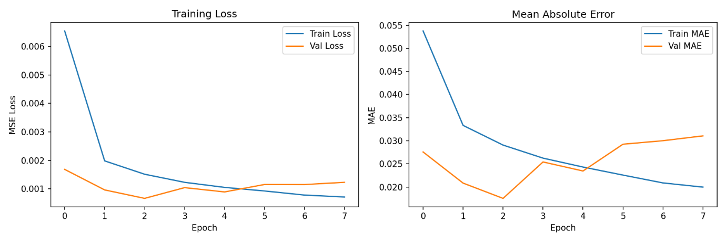
Figure 24: Training and Validation Loss/MAE curves over epochs.
These charts confirm model convergence without significant overfitting. The early stopping mechanism halted training once validation loss varied, restoring the best-performing weights.
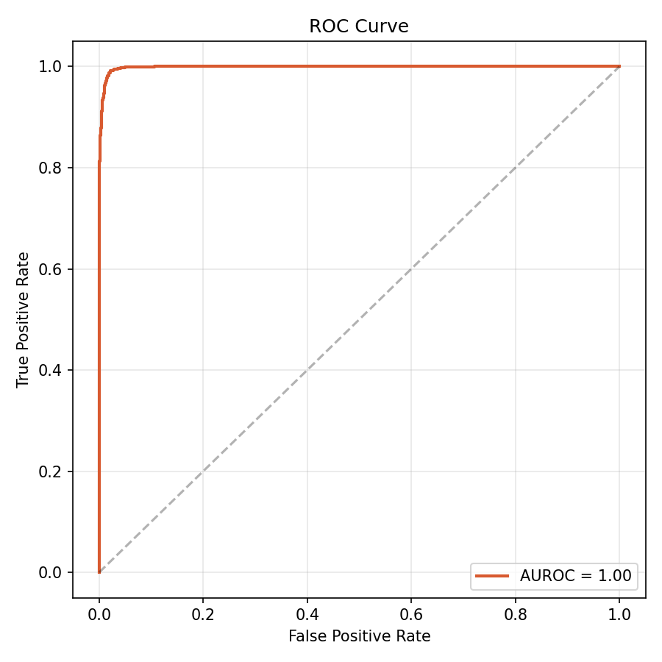
Figure 25: ROC Curve.
The AUROC score achieved by the final model is 0.9984.
A value above 0.85 was set as the exit criterion for deployment (OBJ-03).
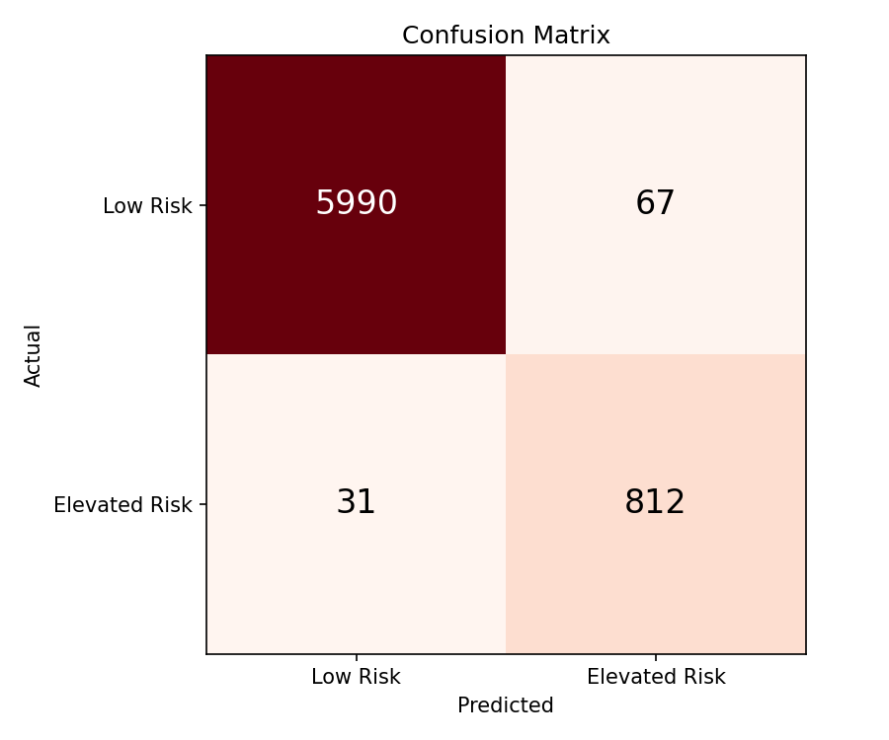
Figure 26: Confusion Matrix
Shows the distribution of Low-Risk vs Elevated Risk predictions at the 0.5 threshold on the held-out test set.
Classification Report | Precision | Recall | F1-score
Low-Risk | 0.99 | 0.99 | 0.99
Elevated Risk | 0.92 | 0.96 | 0.94
Accuracy |  |  | 0.99
Macro avg | 0.96 | 0.98 | 0.97
Weighted avg | 0.99 | 0.99 | 0.99
AUROC | 0.9984
Sensitivity | 0.9632
Specificity | 0.9889
MAE | 0.0307
Figure 27: Classification Report
Precision, Recall, and F1 Score breakdown by risk class. We can see that the Recall on the Elevated Risk class is prioritised over Precision, consistent with the clinical safety requirement that no cardiac events are missed.

Federated Learning Simulation
After the centralized baseline, a Federated Learning simulation was run using FedAvg over 10 rounds with 5 hospital clients (one per hospital_id partition). Each client trains for 3 local epochs per round. The aggregation weights each client’s contribution proportionally by sample count. The FL simulation produces a convergence chart comparing FL performance against the centralized baseline at each round, demonstrating that FL achieves comparable results while maintaining data sovereignty across hospital partitions.
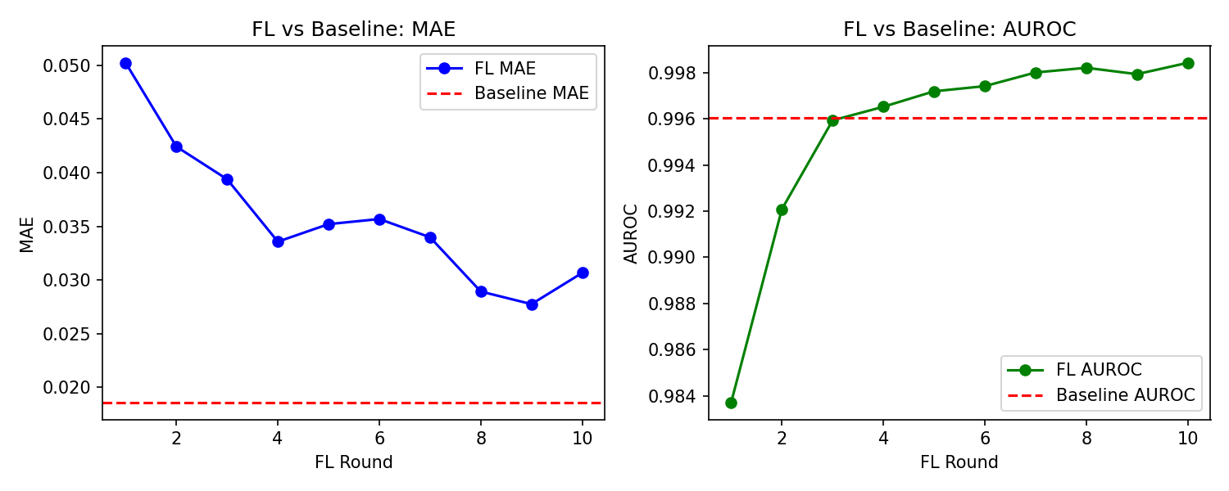
Figure 28: Federated Learning vs Centralised Baseline comparison
MAE across 10 FL rounds demonstrates that the FL model converges toward centralised performance, validating the federated approach.
AUROC across 10 FL rounds confirms that privacy-preserving collaborative training achieves equivalent classification quality to centralised training.

Deployment Files
The training pipeline produces three deployment files used by the React Native app: shield.tflite (the compressed model for on-device inference via react-native-fast-tflite), scaler_stats.json (the mean and standard deviation for each feature, used for z-score normalisation at inference time), and shield_weights.json (the normalised SHAP feature importance weights used to generate reason codes). The TFLite model was verified by comparing Keras and TFLite predictions on the same test sample, confirming the difference was below the 0.01 acceptance threshold.

RAG and ChromaDB Database
The RAG (Retrieval-Augmented Generation) pipeline provides the natural language explanation layer of SHIELD When the on-device LSTM model generates a cardiovascular stress score, the SHAP-based reason code engine identifies which vital signs are driving the risk. These reason codes (for example, HIGH_HR, LOW_SPO2) are then sent to the RAG pipeline on the cloud backend to produce a plain-language explanation that patients and clinicians can actually read and understand.

Architecture
The RAG pipeline runs on the Flask backend and uses ChromaDB as a local vector database. ChromaDB stores pre-embedded chunks of verified clinical guidelines - including AHA/ACC blood pressure guidelines, WHO SpO2 thresholds, and HRV clinical norms. When a reason code arrives, the pipeline embeds the code as a query vector and searches ChromaDB for the most relevant clinical guideline chunks. The retrieved context is then passed to a Large Language Model (Gemini 1.5 Flash, using the stable API endpoint on the free tier at 15 RPM / 1,500 RPD) along with the patient’s recent vital data.

Output
The LLM generates two outputs: a patient-friendly explanation (for example, “Your heart rate has been elevated for 30 minutes, which increases cardiovascular strain. Consider resting and monitoring your readings over the next hour.”) and a clinician-facing summary with clinical terminology. Both are returned to the mobile app and displayed on the AI Insights screen.

Performance
The RAG pipeline was evaluated using a set of 15 clinical queries across 5 categories – Arrythmia, Hypertension, Hypoxic Stress, ESI Triage, and General CVD. We used a keyword-overlap methodology to generate automated relevance scoring, classifying if a retrieved relevant text consisted of the domain-specific clinical terms matching the context of the query.
The pipeline achieved a mean retrieval latency of 34.1ms (SD=58.4ms) per query, confirming that the RAG layer gives real-time responses without any noticeable delays. Mean Precision@1 was 0.80, meaning the highest ranked result was relevant in 80% of the queries. Mean Precision@3 was 0.76, meaning an average of 2/3rd of the retrieved texts was clinically relevant.
Performance was strongest in the Arrhythmia and General CVD categories (P@3 = 1.0 and 0.89 respectively), reflecting higher guideline content density in those domains. ESI Triage showed the lowest precision (P@3 = 0.33), indicating that triage-specific content is understated in the current ChromaDB database.
Category | Queries | P@1 | P@3 | Mean  Latency (ms)
Arrythmia | 3 | 1.00 | 1.00 | 96.0 (Cold Start)
General CVD | 3 | 1.00 | 0.89 | 19.2
Hypertension | 3 | 1.00 | 0.67 | 19.8
Hypoxic Stress | 3 | 0.67 | 0.89 | 18.2
ESI Triage | 3 | 0.33 | 0.33 | 17.3
Overall | 15 | 0.80 | 0.76 | 34.1

API Rate Limiting
SHIELD uses Gemini 2.5 Flash as the language model for the clinical explanations that RAG model generates. The backend implements a simple queue to prevent rate limit errors during high-traffic periods.

Emergency Triage Protocol
The Emergency Triage Protocol is the system’s safety mechanism for detecting and responding to critical cardiovascular events. It is composed of three components: the on-device risk threshold detector, the manual SOS trigger, and the automated alert pipeline. Of these, the manual SOS trigger and the countdown UI are fully implemented. The automated pipeline that connects high-risk AI predictions to automatic emergency alerts is identified as incomplete in this phase.

Manual SOS Trigger
Users can manually trigger an emergency alert at any time by pressing the SOS button on the Emergency screen. This launches a 10-second countdown displayed in a high-visibility red overlay with large, easily tappable Cancel and Confirm buttons. If the countdown completes without cancellation, the system sends an SMS containing a Google Maps location link to the user’s pre-configured emergency contact. This flow was tested and confirmed working (FT-018, FT-019, UX-003, UX-008).

Automatic Alert
The design intent is for the system to also trigger this countdown automatically when the AI risk score exceeds a critical threshold (approximately 90%). In the current implementation, the AI correctly identifies high-risk conditions (as confirmed in AI-003, AI-004) and the high-risk data reaches the backend database. In such an event of critical case, it triggers a Critical alert pop-up that requires and sending alert details to your emergency contacts and label your case as high priority in the clinician dashboard at the same time.

Clinician Dashboard Alerts
When patient vitals are synced to the cloud and the risk score exceeds the high-risk threshold, the Clinician Dashboard sorts the patient to the top of the patient list with a red risk indicator, allowing clinicians to immediately identify patients requiring attention (IT-012, UAT-003). Real-time automatic flagging via WebSocket is not yet implemented except for the alert data, so the dashboard currently requires a manual refresh to reflect the latest data.

Clinician Dashboard
The Clinician Dashboard is a React TypeScript web portal designed for healthcare professionals to remotely monitor assigned patients. It provides a patient list sorted by their stress score, each patient’s vital history, and AI-generated insights.

Patient List View
The Patients tab on the Clinician Dashboard displays a list of all assigned patients, sorted in descending order by their updated cardiovascular stress score. Each patient entry shows a colour-coded risk label (green for Low, yellow for Medium, red for High) that allows clinicians to triage at a glance. Testing confirmed that the sorting logic correctly places high-risk patients at the top of the list (IT-012, UAT-003).

Patient Detail View
Selecting a patient opens a detail view showing a up to 1 year of vital trends graph (heart rate, HRV, SpO2, blood pressure over time), the current risk score and trend direction, SHAP-based AI reason codes explaining the current prediction, and a notes field where clinicians can add observations. Testing confirmed this view loads in under 2 seconds and renders all data correctly (IT-013, UAT-004, E2E-004).

Data Sync
The Dashboard uses a REST-based data architecture. Alert data, including new high-risk flags and updated risk scores is refreshed automatically every 3 seconds via polling, providing near real-time awareness of patient status changes whereas full patient records, including detailed vital history and trend graphs, updates on manual page refresh. This architecture keeps the Dashboard lightweight and avoids the overkill of full WebSocket connection while still ensuring clinicians are promptly notified of critical changes.

User Interface and Dashboard

S.H.I.E.L.D – Mobile App

Figure 29: Final UI - Onboarding Pages

Figure 30: Final UI - Sign Up Page

Figure 31: Final UI - Sign In: Body Metrics

Figure 32: Final UI - Sign In: Emergency Contacts

Figure 33: Final UI - Sign In: T&Cs

Figure 34: Final UI - Login & Reset Password

Figure 35: Final UI - Home Page

Figure 36: Final UI - Trends Page

Figure 37: Final UI - HR Trends

Figure 38: Final UI - HRV Trends

Figure 39: Final UI - SpO2 Trends

Figure 40: Final UI - sBP Trends

Figure 41: Final UI - dBP Trends

Figure 42: Final UI - IoT Connection Page

Figure 43: Final UI - IoT Connections Instrcutions


Figure 44: Final UI - IoT & Device Connection Pages

Figure 45: Final UI - Manual Input Pages


Figure 46: Final UI - Doctor Consultation Pages


Figure 47: Final UI - AI Chatbot


Figure 48: Final UI - Emergency Alert System

S.H.I.E.L.D – Clinician Dashboard
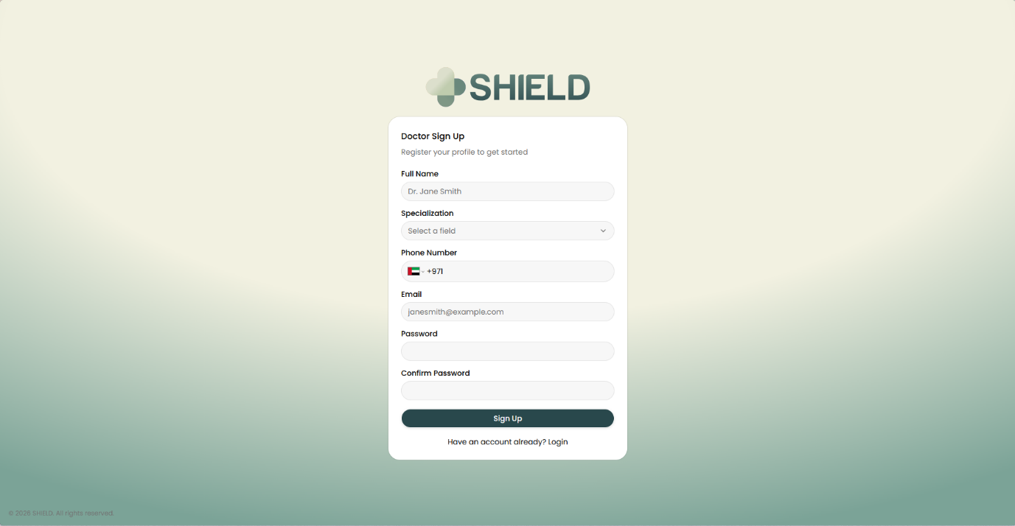
Figure 49: Final UI - Clinician Sign Up
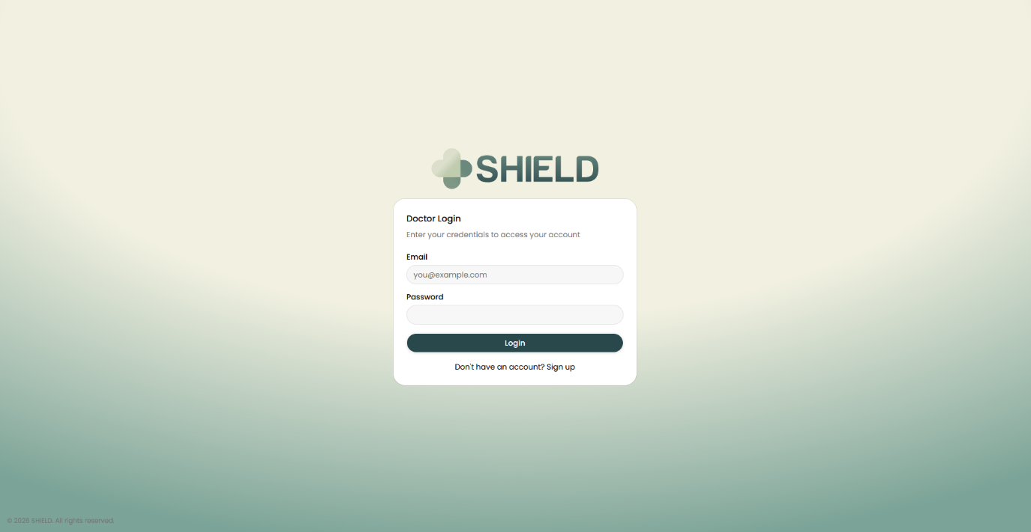
Figure 50: Final UI - Clinician Login
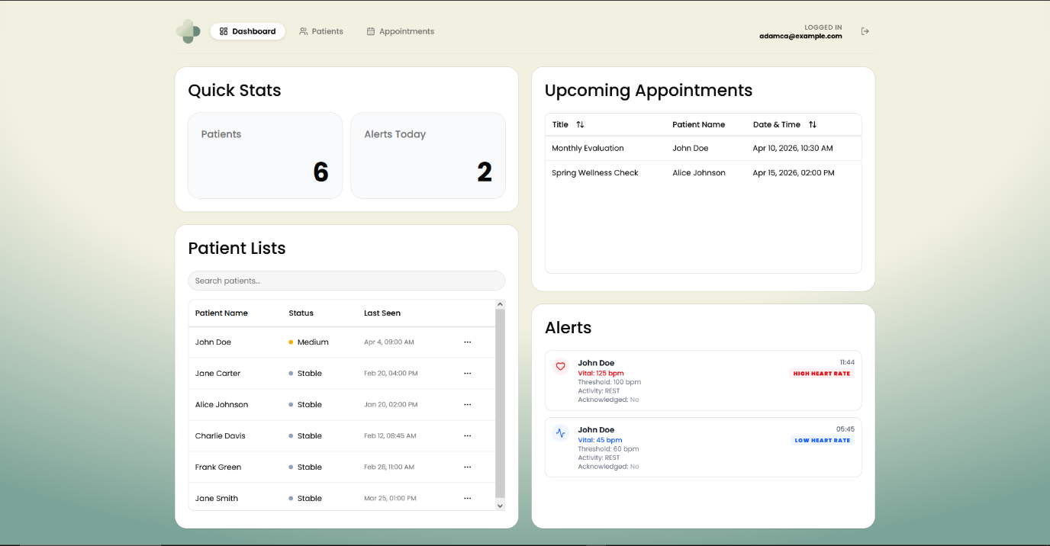
Figure 51: Final UI - Clinician Dashboard
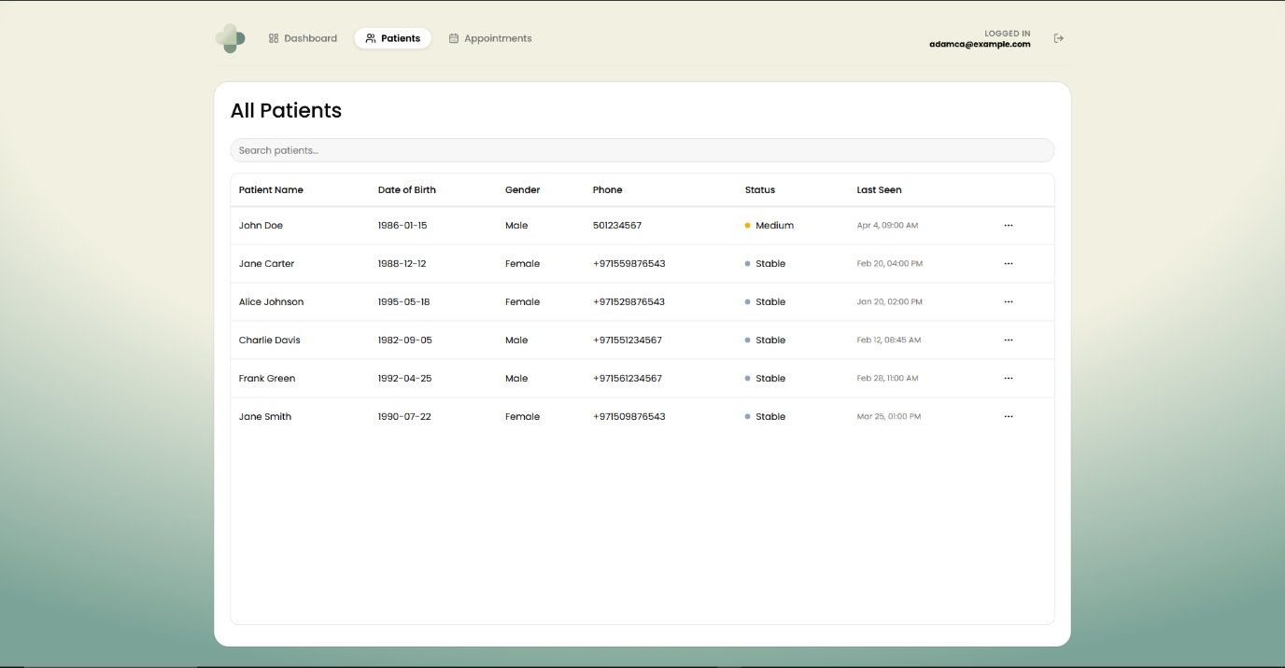
Figure 52: Final UI - Clinician: Patient List
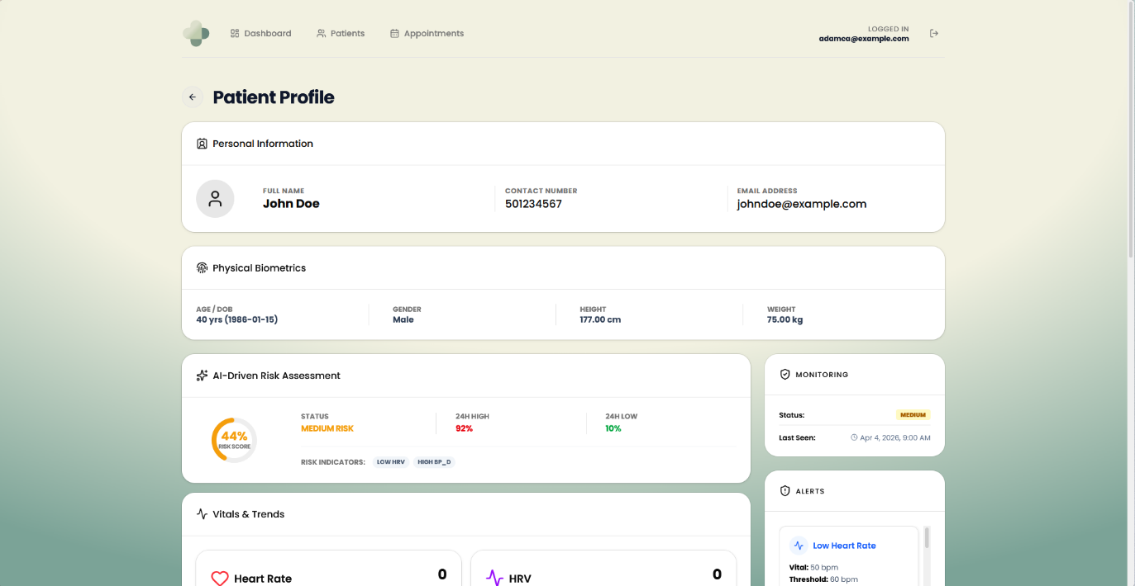
Figure 53: Final UI - Clinician: Patient Details 1
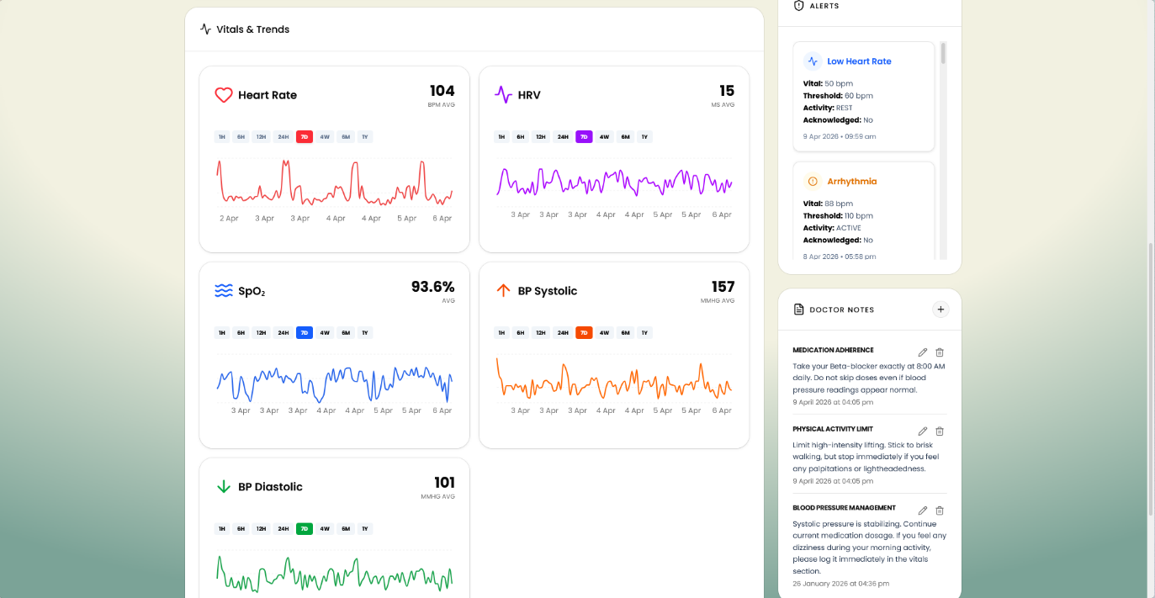
Figure 54: Final UI - Clinician: Patient Details 2
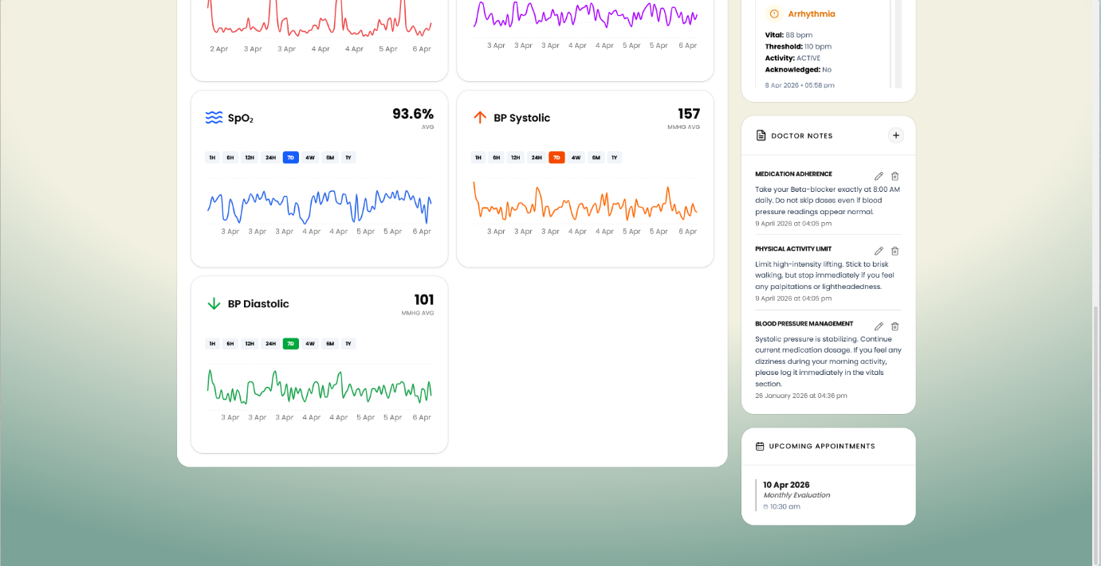
Figure 55: Final UI - Clinician: Patient Details 3
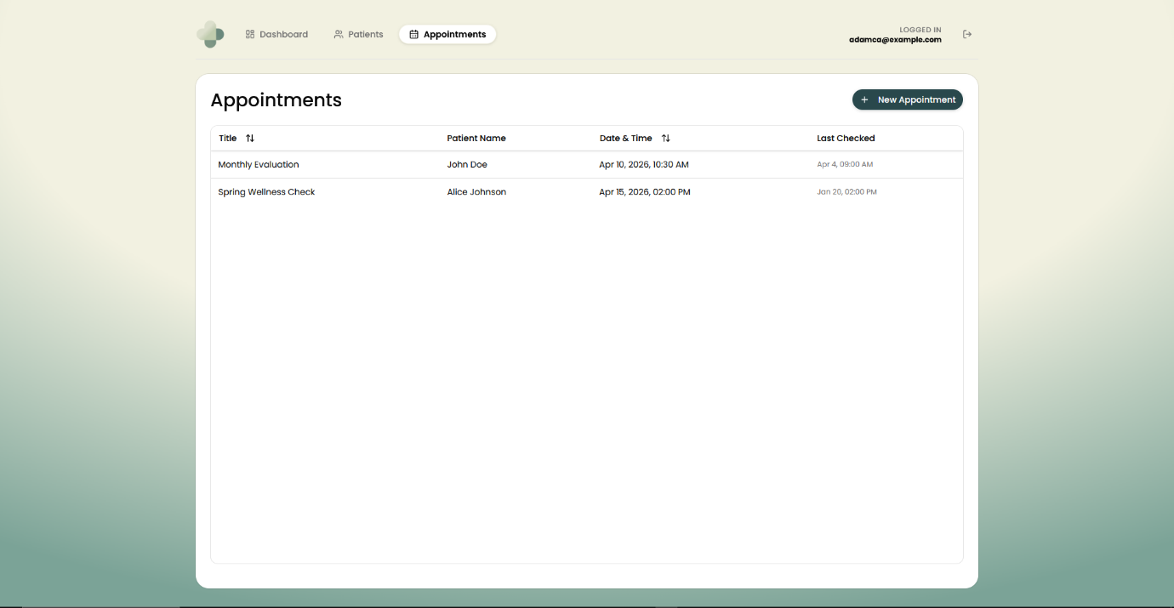
Figure 56: Final UI - Clinician: Appointments
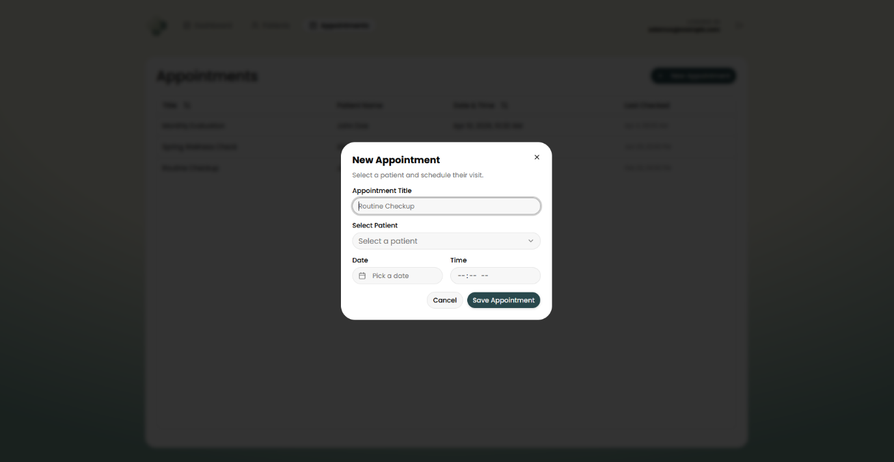
Figure 57: Final UI - Clinician: Add Appointment
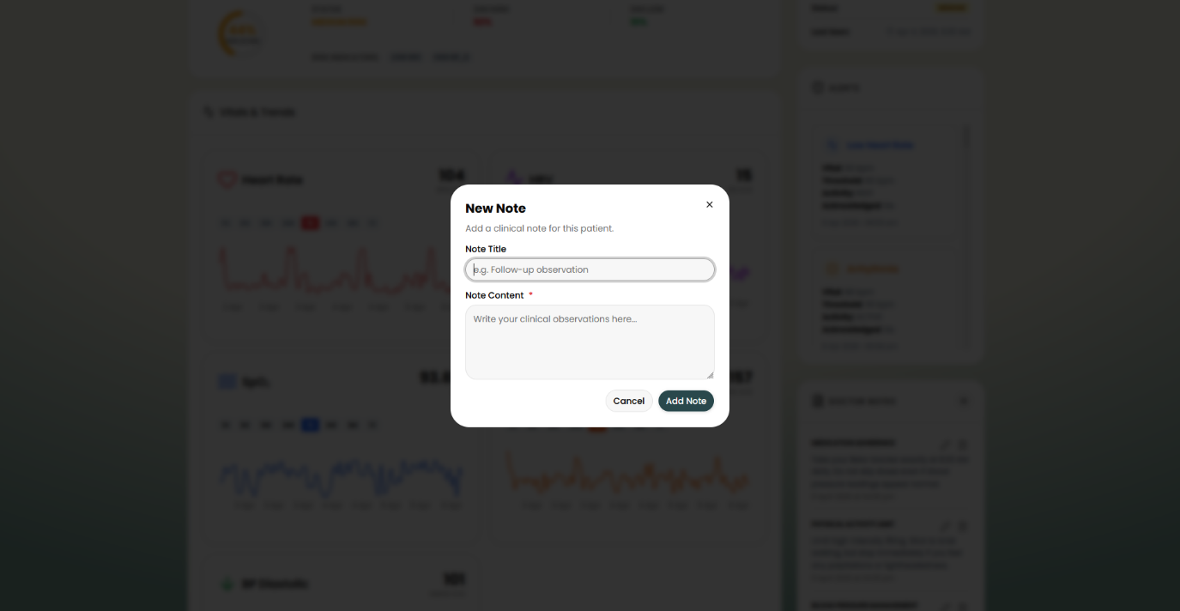
Figure 58: Final UI - Clinician: Add Note

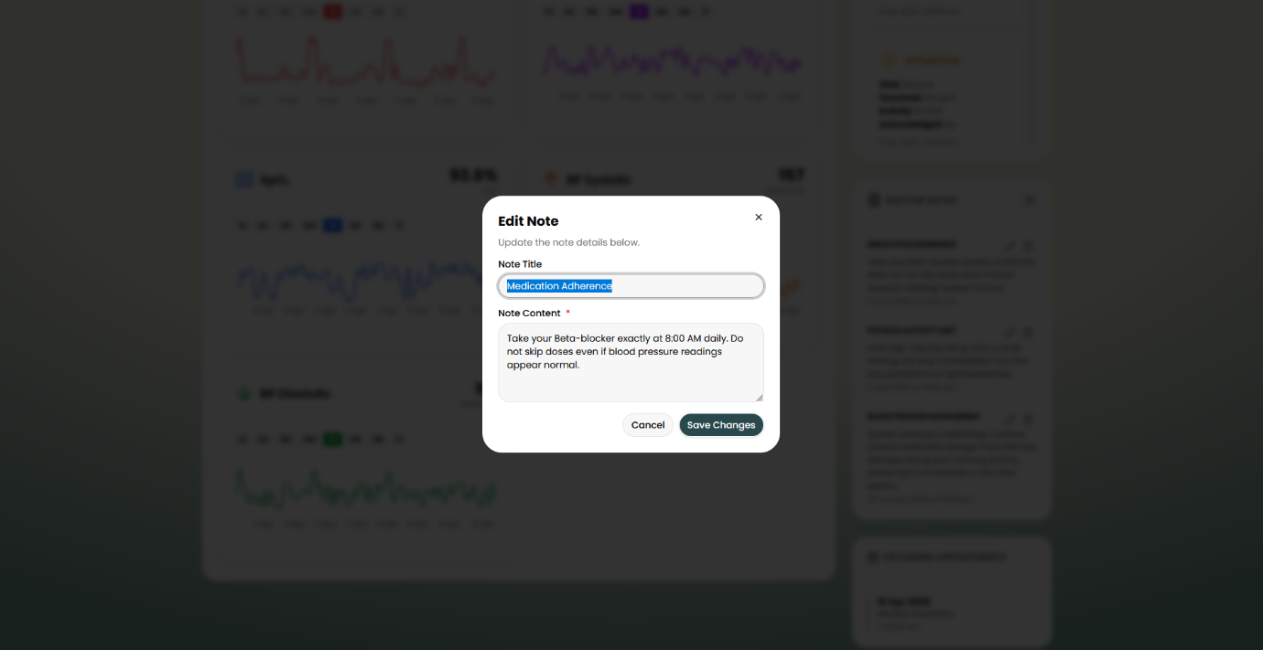
Figure 59: Final UI - Clinician: Edite Note
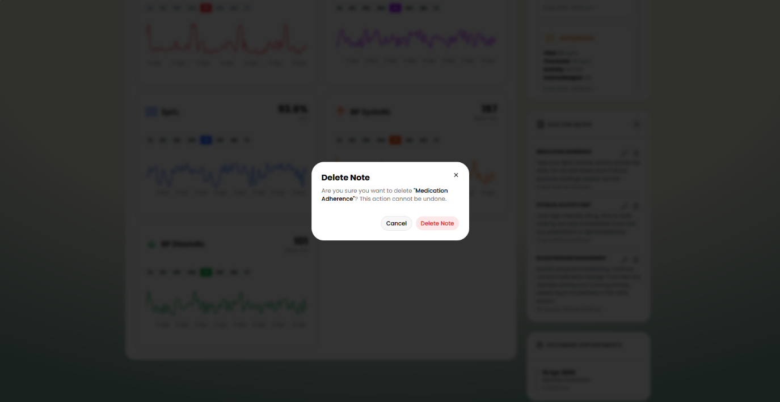
Figure 60: Final UI - Clinician: Delete Note

Change Report

Changes related to AI/ML and FL

AI Model – Digital Twin LSTM to Bidirectional LSTM Baseline
The initial plan proposed a Digital Twin architecture for the AI model, where a personalised LSTM model will be made for each unique users by collecting 7 days of baseline health data and continuously adapting to their individual health profile.
For on-device model training for a student-led experimental project, training a model per user on a mobile device would require significant computational power and would result in battery drainage, and long convergence times from the user. So, the Digital Twin is replaced with a global Bidirectional LSTM Model, which will be deployed as a static TFLite model to the user, creates a 7-day baseline window for personalisation, and send the model update gradients to a global server which sends back a much smarter and updated model learned from with model weights from all the users.

Datasets – Static to Calibrated Streams
The initial training dataset prepared from UCI and MIT-BIH benchmarks was flat with static rows, no temporal structure and hospital grouping for FL.
Training the model with these data showed multiple issues, consistent data for a temporal structure, learning from a single-feature threshold which has the most AUROC, and missing patient ID’s required for Federated Learning simulation. So we replaced the dataset by calibrating against these benchmark datasets with near-to-true vital distributions, temporal structures along with synthetic features required for FL simulations.

Federated Learning – Privacy First to Collaborated Learning
The initial plan proposed Federated Learning as a live, production grade, privacy first framework where the application trains the model locally on the user’s device and sends the encrypted weight updates to the server, so that the data never leaves the user’s device.
In order to implement on-device training it would require us to try more experimental API’s and mobile engineering efforts, which is much beyond the scope of this project. Also, an actual FL framework would require a large network of users generating continuous data for each training round in order to be effective. Implementing it would have been resulted in scope creep with no real value added to the project. In-addition, the vital data cannot stay inside the device if you need the clinician oversight feature to be effective.
So, it is replaced with an FL simulation, where the training pipeline simulated FedAvg across 3 hospital clients over 10 rounds, which demonstrates the centralised performance of FL. Also by each user sending the model weight updates for the global model learning, our project now leans more towards the Collaborative Learning application of Federated Learning rather than the privacy-first design.

Data Requirements – Multimodal to Focused Cardiovascular Feature Set
The initial system requirements plan describes a broad set of biometric data such as ECG, Blood Glucose, temperature etc along with the 8 features that the LSTM model uses now, along with AI outputs such Heart Recovery Score, Arrythmia Alert Score, and so on. During development we realized that collecting, processing and generating each of these vitals and scores would require additional sensors, firmware, model inputs and outputs that would go beyond the project timeline. So, we decided to narrow down the scope to 8 LSTM features to build a complete and validated Al implementation, producing only the Cardiovascular Stress Score with SHAP reason codes.

Changes related to mobile app

Emergency Alert System – Automated to Manual Prompt
The initial scope of the project describes the Emergency Alert system as a full automated triage protocol, where any high fluctuation in any of the vitals or an increase in the Cardiovascular stress score would automatically trigger an alert with a 10-second countdown, and further sharing the user details to emergency contact, first responders and doctors all at the same time – fully automated without any user intervention needed. But OS constraints in iOS and Samsung that doesn’t allow any application to trigger automated messages or phone calls was a setback for us in implementing this feature. So except for alerting the doctor, the SOS trigger had to be developed as manual prompt to send the alert to the emergency contact and first responders.

Frontend Data Pipeline – Health Connect Integration
The initial scope of the project describes the integration of Android Health Connect, Apple HealthKit and Google Fit APIs to pull biometric data from the user’s device. But during development we found out that Apple API access requires apaid developer account, whereas Samsung’s Health Connect API is free and accessible but faces persistent connectivity and authorisation issues. So in the final prototype the primary data stream is through an ESP32 custom sensor node (MAX30102) and a manual user entry through the app’s manual input screen. While the Direct API integration with Samsung Health Connect was implemented, the data pipeline may encounter some error and hence is not fully reliable in this stage.

High-Level System Architecture
The initial high-level architecture diagram proposes that both the patients and clinicians access the system through the same mobile frontend. But later in development we decided to separate the Clinician Dashboard and implement it as a React TypeScript web portal while reading the data from the cloud database at the end of the data pipeline

UI Design Change
The UI design of a system naturally changes throughout the development. In the final design we implemented minimalist design, with a much cleaner clinician dashboard with risk-sorted patient list and trend graphs for each. Some of the UI planned in the design document were not implemented as it turned out to be outside of our project scope, and the rest were refined and new designs were added to match what the backend and AI could deliver.

Deferred Report Analyzer
The initial AI model server proposal included a Report Analyzer feature using RAG model, which would allow users to upload their report and have the AI explain for them in simple terms. Even though the RAG pipeline was successfully built for the core use case, the report analysis feature could not be implemented due to scope creep.

Ethical Consideration

Patient Safety and Medical Disclaimers
SHIELD is designed as a monitoring and early-warning tool, not a diagnostic medical device. The app displays a clear disclaimer to all users during onboarding and on every AI Insights screen: “The cardiovascular stress score is a risk indicator based on sensor data and AI analysis, and is not a substitute for professional medical diagnosis or emergency services. Users are encouraged to consult a healthcare professional for any health concerns and to call emergency services in a life-threatening situation.”

AI Transparency and Explainability
The SHAP-based reason code engine and the RAG explanation pipeline are specifically designed to prevent black-box AI decisions. The model requires actual vital signs to create a valid prediction of risks. SHIELD needs transparent design because it serves as an essential requirement for ethical standards. Users should know the reasons which make the AI system identify their health status as high risk.

User Consent and Data Ownership
Every SHIELD user maintains complete authority over their health records. The app will not gather or handle or distribute information unless the user gives their explicit informed permission. The application delivers this commitment to users right from the onboarding pages.
User Consent During Onboarding: Users receive a detailed disclaimer and consent screen before the system starts collecting data during the onboarding process. It explains what data is collected (heart rate, HRV, blood pressure, SpO2, and symptoms), how it is used for AI risk scoring and optional sharing with a clinician, clarifies that SHIELD is not a diagnostic tool, and informs users they can withdraw consent or delete their data at any time.
Ongoing Data Control: The user retains authority over their consent rights from the first moment of onboarding. Users can exercise their right to information control through Privacy & Data section under profile settings.

Verified Access for Medical Professionals
Giving unverified individuals access to patient health data is a major ethical violation. SHIELD prevents this by using a clinician verification system integrated with hospitals, ensuring that only licensed and currently employed healthcare professionals are granted access to the Clinician Dashboard and patient details.
The system requires the doctors to register through their employed hospitals instead of allowing open self-registration. The system performs automatic verification of three criteria before granting portal access which includes medical license status, hospital employment and doctor specialization. This prevents impersonation while protecting patient information from security breaches and holding medical personnel responsible for their online clinical work. The hospital system uses Role-Based Access to restrict doctors from viewing patients who have not been officially assigned to them. The system's role-based access control architecture stops users from accessing records of patients who have not been assigned to their care. The system records all portal activity to create logs which will be used for regulatory audit purposes.

Responsible Alert Design
Health monitoring apps have a responsibility to warn users of real risks while avoiding unnecessary panic or false reassurance. In a medical setting, poorly designed alerts can be just as harmful as the absence of alerts. Alert types:
Advisory (Low to Moderate risk): The alerts are presented with a clear indication of which readings are higher than normal. Users are advised to check the Reason Codes and consider booking a consultation. The messaging avoids urgent or emergency wording.
Critical (High risk): A pop-up that is displayed clearly with a full breakdown of the readings that triggered the alert and their meaning. It also notifies the assigned clinician automatically. Users are encouraged to seek medical advice if they feel unwell, but emergency services are not contacted unless the user confirms it.
Emergency SOS (User initiated): This feature is triggered only by the user and includes a 10-second window to cancel in case of a false alarm or accidental touch. Once confirmed, it sends vital signs and location to emergency contacts and first responders, and alerts to the clinician dashboard.

Regulatory And Legal Compliance
SHIELD is built to comply with the legal and regulatory requirements for health technology in the UAE, as well as internationally recognized data protection standards.
UAE Federal Decree-Law No. 45 of 2021 (Personal Data Protection): All data is collected only for specific, defined purposes and with the user’s consent. Users also retain the right to access their data, request corrections, and have it deleted.
UAE National AI Strategy 2031: SHIELD is aligned with the UAE’s vision for ethical and transparent use of AI in healthcare, embedding explainability, privacy-by-design principles, and human oversight directly into its core system design.
UAE Telehealth Guidelines (DHA / EHS): Access to the clinician portal is limited to hospital-verified medical professionals only. The platform does not allow individuals without proper qualifications to offer medical advice.

Future Improvements
Security Enhancements
Implementing login rate limiting (lockout after repeated failed attempts) and biometric authentication (fingerprint/Face ID) to bring security up to the originally planned standard.
Live On-device Federated Learning
Connecting the FL client scripts to the mobile app so that devices can participate in live federated model training rather than only inference. This requires TFLite on-device training support, which is currently experimental for LSTM architectures.
Medical-grade IoT Device Integration
Future versions of SHIELD will support connection to medical-grade IoT sensors via BLE, including finger clip pulse oximeters, clinically validated blood pressure cuffs, continuous glucose monitoring (CGM patches, portable ECG patches and so on. These devices provide hospital-garde measurement accuracy and are increasingly available in consumer formats. BLE connectivity is already built into the architecture with the existing ESP32 data pipeline, so further integration would require only firmware and protocol adaptation.
Real Patient Data Validation
In future phases, retraining the AI model on real patient data from UAE clinical partners, among proper data-sharing agreements and ethics approvals would improve the model’s accuracy for the target demographic and also show formal clinical validation.
Multi-domain Health Monitoring
The architecture of SHIELD is designed for multi-domain integration, such as a diabetes, respiratory, or neurological modules that would reuse the existing data pipeline, inference engine, and RAG framework by populating the vector database with more broader medical guidelines.
Regulatory Certification
Attaining MOHAP and DHA classification certifications as a Class B Medical Device would require clinical trials, formal validation studies, and regulatory documentation, but this is a necessary path for any commercial deployment of a medical system in the UAE.
Arabic Language Support
Adding Arabic language support to reach a broader segment of UAE residents, particularly elderly patients who may be more comfortable in Arabic can help the application for culutural adaptation.
In-App Doctor Consultation
Integrating a direct teleconsultation feature - allowing patients to initiate a video call with their assigned clinician from within the app - to close the loop between monitoring and care.

Conclusion
SHIELD was built to address a real and urgent gap in the UAE healthcare landscape: cardiovascular disease causes nearly 40% of deaths in the country, yet most digital health tools available in the market are either reactive appointment systems or fitness trackers with no clinical interpretation capability.
Over the two semesters, we designed and built a functional AI-powered cardiovascular monitoring system that integrates wearable sensors (ESP32 with MAX30102 and AD8232), a mobile application with on-device AI inference, a Clinician Dashboard for healthcare professional oversight, and a cloud backend with secure data management. The AI model - a Bidirectional LSTM trained through a Federated Learning framework and explained via SHAP-based reason codes was rebuilt from scratch after the initial dataset and model were found generate faulty results. The updated implementation is clinically calibrated, temporally realistic, and architecturally sound.
Testing confirmed that the core monitoring pipeline works end-to-end: sensor data flows from the ESP32 to the mobile app, through the AI model, to the Clinician Dashboard, with SHAP reason codes and RAG-generated explanations at every step. The security testing also confirmed strong data protection across all layers, whereas performance testing confirmed that the application meets its response time and memory requirements.
Even though few features from the initial plan were not implemented the automated emergency alert pipeline and biometric authentication, they are clearly documented in the Change Report and Future Improvements sections. These gaps are a result of the scope and timeline constraints of a 24-week student project, not architectural limitations. The current system is developed in a modular way to integrate all of them in future phases.
The project demonstrates that a privacy-first, AI-powered, edge-inference cardiovascular monitoring system is technically feasible as a student prototype. More importantly, it demonstrates what such a system would need to look like to be genuinely useful in a clinical context: transparent AI, secure data handling, accessible design, and a clear separation between what the system can tell you and what only a doctor can tell you.
SHIELD is not yet a medical device. But it is a working foundation for one.

Project Resources
- Demo Video
https://youtu.be/HZlyTkXGHjA
- Marketing Website
https://shield-health.vercel.app/
- Doctor Portal and Backend Serve r Github Repository
https://github.com/Maw1z/SHIELD-Doctor-Website
- Mobile App Github Repository
https://github.com/Maw1z/SHIELD-Mobile-App
- AI/ML, FL and ESP 32 Github Repository
https://github.com/sivrox/SHIELD_AI_Models

Work Distribution
Team Member | Role | Contribution
Mohammad Mawiz Ansari (Scribe) | Lead Developer / Frontend | - Developed the React Native Mobile Application  - Developed the React Doctor Portal  - Developed and improved backend APIs  - Managed deployment of frontend and backend server  - Integrated TFLite model for on-device AI inference  - Implemented the frontend reason code engine and managed the Gemini 2.5 Flash API Integration  - Oversaw technical documentation and meeting records
Syed Sheharyar Ahmed | Backend & Infrastructure | - Built the Flask backend server managing API routing and data sync  - Developed the Cloud Neon PostgreSQL cloud Database for patient trend archiving  - Engineered the SQLite database to cloud synchronization protocol for offline resilience
Avni Pramod | Systems Architect & Project Manager | - Managed project governance and delivery standards  - Deliverable Documentation  - Social Media Management for marketing  - Oversaw research documentation for AICCONS 2026
Mohammed Shehin Kalady | IoT Hardware Engineering | - Engineered the ESP32 sensor node integrating the MAX30102 pulse oximeter and AD8232 ECG module  - Programmed the firmware for BLE data transmission  - Optimized the hardware perception layer to filter motion and electrical noise  - Created project branding assets (Posters)
Nihal Muhamed | UI/UX & Product Design | - Created Flask API endpoints  - Defined the emergency escalation protocol and triage logic  - Created project branding assets (Website)  - Designed the full visual identity of both the mobile app and clinician dashboard
Sivajith Ajith Kumar (Leader) | AI/ML Engineer | - Developed the Bidirectional LSTM model architecture and training pipeline  - Engineered the SHAP-based reason code engine for XAI  - Calibrated data against UCI and MIT-BIH clinical benchmarks for model training  - Implemented the Federated Learning Simulation and separate FL server and client scripts  - Created project branding assets (Website and Posters)  - Oversaw research documentation for AICCONS 2026

Project Management Dashboard
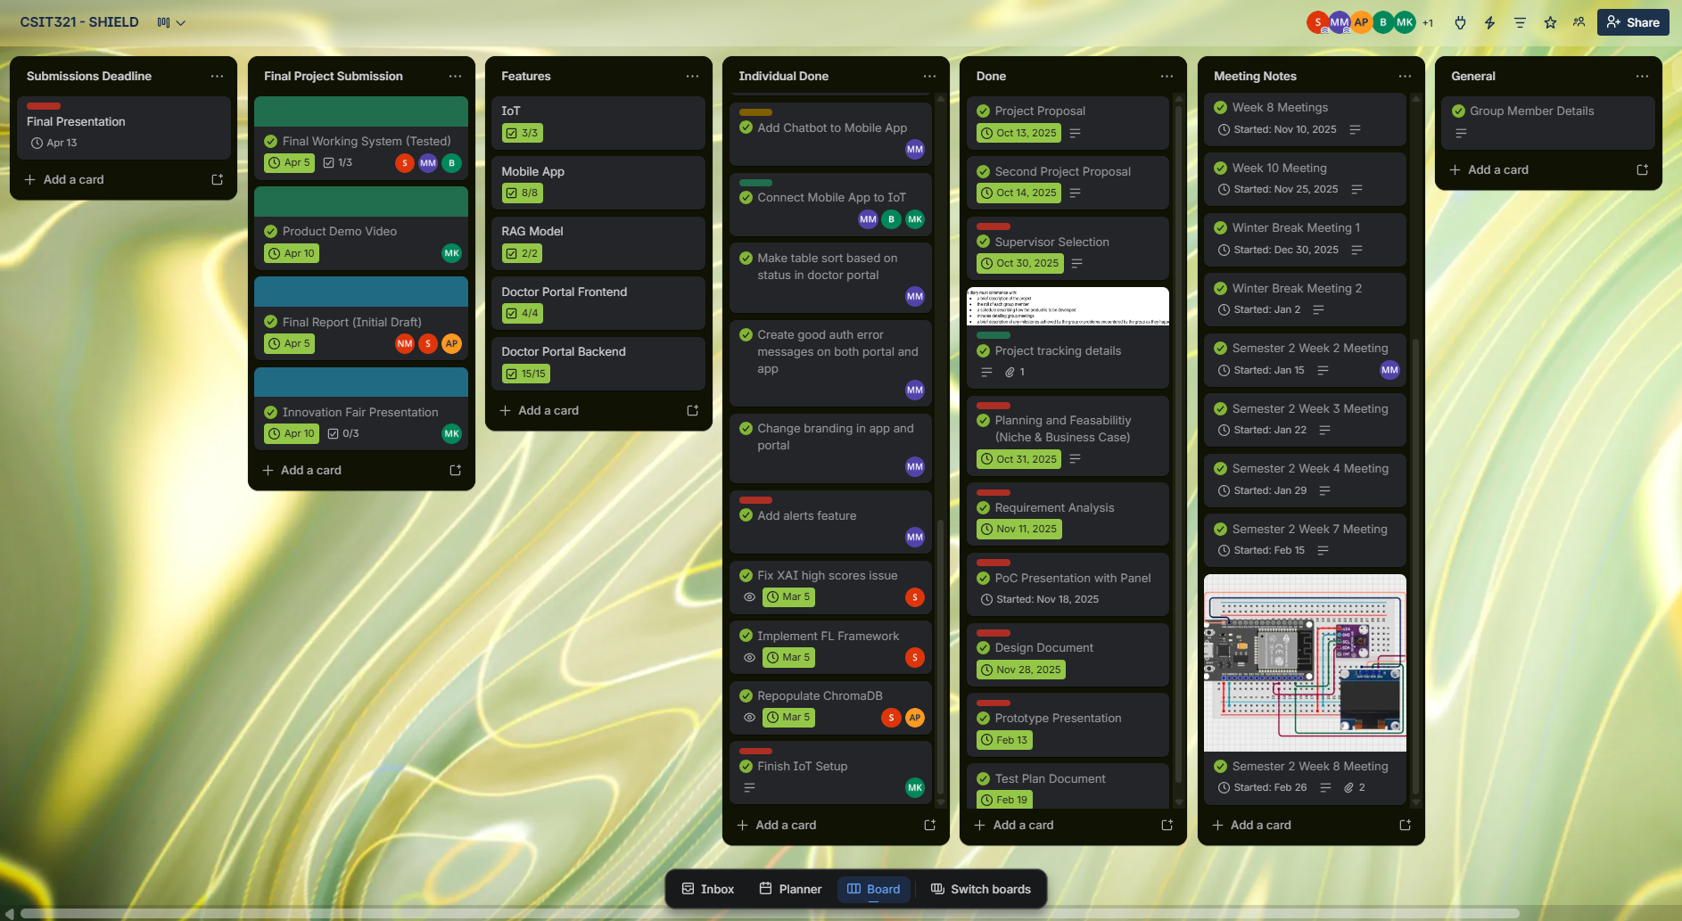
Figure 61: Project Management Dashboard

References
- UAE Government 2023, UAE Strategy for Artificial Intelligence - The Official Portal of the UAE Government, u.ae. Available at: https://u.ae/en/about-the-uae/strategies-initiatives-and-awards/strategies-plans-and-visions/government-services-and-digital-transformation/uae-strategy-for-artificial-intelligence
- Ministry of Health and Prevention - UAE. (2024). Ministry of Health and Prevention releases 2024 achievements report. [online] Available at: https://mohap.gov.ae/en/w/ministry-of-health-and-prevention-releases-2024-achievements-report.
- uaelegislation.gov.ae. (n.d.). United Arab Emirates Legislations | Federal Decree by Law Concerning the Protection of Personal Data. [online] Available at: https://uaelegislation.gov.ae/en/legislations/1972.
- 1. Kim, I., Lee, J. and Kim, S., 2014. Challenges in wearable personal health monitoring systems. Sensors, 14(12), pp.12345–12367.Available at: https://www.ncbi.nlm.nih.gov/pmc/articles/PMC5502108/ [Accessed 28 Oct. 2025].
- Zhang, B., Chen, L. and Li, J., 2025. A survey on security and privacy issues in wearable health technology. Computers & Security, 139, p.103807.Available at: https://www.sciencedirect.com/science/article/pii/S0167404825001427 [Accessed 28 Oct. 2025].
- Al-Jumaily, A. and Olivo, A., 2017. A survey of wearable devices and challenges. ResearchGate. Available at: https://www.researchgate.net/publication/318717275_A_Survey_of_Wearable_Devices_and_Challenges [Accessed 28 Oct. 2025].
- Elfouly, T., Salim, A. and Hussein, A., 2025. A comprehensive survey on wearable computing for mental and physical health monitoring. Electronics, 14(17), p.3443.
Available at: https://www.mdpi.com/2079-9292/14/17/3443 [Accessed 28 Oct. 2025].
- Khan, M., Farooq, U. and Ahmad, A., 2025. Edge AI for early detection of chronic diseases and the spread of infectious diseases. Future Internet, 15(11), p.370.
Available at: https://www.mdpi.com/1999-5903/15/11/370 [Accessed 28 Oct. 2025].
- Silva, C., Pereira, D. and Gonçalves, R., 2024. Machine learning applied to edge computing and wearable devices for healthcare: Systematic mapping of the literature. Sensors, 24(15), p.78846.Available at: https://www.ncbi.nlm.nih.gov/pmc/articles/PMC11478846/ [Accessed 28 Oct. 2025].
- 8. Arora, N. and Jain, R., 2023. Federated learning for privacy preservation in smart healthcare systems: A comprehensive survey. Available at: https://arxiv.org/abs/2203.09702 [Accessed 28 Oct. 2025].
- Nielsen, J., 1993. Response Times: The 3 Important Limits. In: Usability Engineering. s.l.:Morgan Kaufmann, p. 384.
- Pardy Panda, 2025. How to write a scope of work for building a mobile app. [Online]
Available at: https://www.pardypanda.com/blog/how-to-write-a-scope-of-work-for-building-a-mobile-app [Accessed 10 November 2025].
- Bilal, A. et al., 2025. Explainable AI-driven intelligent system for precision forecasting in cardiovascular disease, Haikou, China: Frontiers in Medicine.
- Shtapauk, D. (2022). Developing a Test Plan: A Complete Guide. [online] Blog. Available at: https://tech-stack.com/blog/test-plan/
- Graham, D., Van Veenendaal, E., Evans, I. and Black, R. (n.d.). FOUNDATIONS OF SOFTWARE TESTING ISTQB CERTIFICATION. [online] Available at: https://www.utcluj.ro/media/page_document/78/Foundations%20of%20software%20testing%20-%20ISTQB%20Certification.pdf.
- Espressif.com. (2025). Espressif Documentation. [online] Available at: https://documentation.espressif.com/esp32_technical_reference_manual_en.pdf.
- www.kaggle.com. (n.d.). UCI Heart Disease Data. [online] Available at: https://www.kaggle.com/datasets/redwankarimsony/heart-disease-data.
- Moody, G. and Mark, R. (2005). MIT-BIH Arrhythmia Database v1.0.0. [online] physionet.org. Available at: https://physionet.org/content/mitdb/1.0.0/.

