S.H.I.E.L.D. (Secure Health Intelligence & Evaluation Logic Database)
Updated Project Report
The Problem Landscape
Cardiovascular Disease (CVD) remains the world's leading cause of death. In the United Arab Emirates (UAE), this crisis is particularly acute, with CVD responsible for approximately 40% of all deaths. Most alarmingly, recent data indicates a sharp rise in heart attacks among younger demographics (people under 50), driven by lifestyle factors such as stress and diet.
Despite the urgency of this crisis, current consumer health technologies are inadequate. Existing health apps suffer from two critical failures:
- Reactivity: They act as "rear-view mirrors," showing users data only after it has been recorded, failing to predict events before they happen.
- Insecurity: They operate on a centralized model that requires users to upload their sensitive, private medical data to the cloud, creating significant privacy and security risks.
This gap leaves the population without a trustworthy, proactive early-warning system for their most critical health threat.
Why This Solution?
S.H.I.E.L.D. is not merely another health tracker; it is a strategic response to a specific national and technological need.
- Addressing a Growing Crisis: By focusing on the rising trend of CVD in younger populations, the project targets a high-impact area where early intervention can save lives.
- Alignment with National Strategy: The project is directly aligned with the UAE AI Strategy 2031, utilizing cutting-edge artificial intelligence to solve major national health challenges.
- Technological Innovation: We are applying Federated Learning—a privacy-first AI methodology—to consumer heart health. This approach allows us to build powerful predictive models without ever compromising user privacy, a novel application in the mobile health space.

Project Objective
Our objective is precise: To design, prototype, and validate a privacy-first, AI-powered cardiovascular monitoring platform that bridges the gap between patient self-care and clinical oversight.
The system is designed to be an "AI-powered Health Guardian." Its core function is to move beyond simple tracking to provide predictive warnings for cardiovascular risks. Uniquely, it achieves this while maintaining a "Golden Rule" of privacy: all sensitive user data remains securely on the user's own device and is never uploaded to a central server.
The Solution: S.H.I.E.L.D. Ecosystem
S.H.I.E.L.D. fills this gap with a comprehensive "Feature Ecosystem":
- IoT Integration: Seamlessly collecting data from both consumer wearables (Apple Watch) and medical-grade devices (BP cuffs).
- Edge XAI: Creating a personalized, on-device model of the user's heart health.
- Privacy-First Architecture: Utilizing Federated Learning to ensure data sovereignty.
- Predictive Analysis: Forecasting risks based on multi-day trends, not just current vitals.
- Medical Advice (RAG): Providing actionable, AI-generated health recommendations.
- Clinical Oversight (Updated): A secure "Clinician Dashboard" that allows authorized doctors to remotely monitor high-risk patients, view real-time alerts, and access explainable AI insights ("Reason Codes") to support diagnosis.
High-Level Architecture
The system utilizes a Hybrid AI Architecture to balance the conflicting needs of privacy and power.
- On-Device (The "Edge"): Handles data collection, the Digital Twin model, and Edge-XAI generation. This ensures privacy and low latency.
- On-Server (The "Cloud"): Handles heavy computational tasks like the RAG (Retrieval-Augmented Generation) model for language translation and the Federated Learning Aggregator.

- Secure Cloud Sync (Updated): A secure, real-time database (Firebase Firestore) that syncs only the processed insights (Risk Scores, Reason Codes, Critical Alerts) from the patient's phone to the doctor's web dashboard.
Core Technologies
Our innovation is built on four pillars:
- IoT Sensor Network: A fusion of consumer and medical sensors to capture a holistic view of heart health (HR, HRV, BP, SpO2).
- Edge XAI: A lightweight, on-device model that generates instant risk scores and "Reason Codes," ensuring transparency without server dependency.
- Federated Learning: A distributed training method where the "model travels to the data." Phones train the global model locally and share only anonymous learnings, preserving privacy.
- RAG Engine: A server-side "translator" that converts the Edge XAI's numerical outputs into clear, human-readable explanations.
- Clinician Web Portal (Updated): A secure, React-based web application for doctors which features a Patient Triage View and Real-time Dashboard.
6.3 Methodology
We employ a Parallel Prototyping methodology.
- Research: Validating the gap and technology (Complete).
- Prototype (Pi-Lab): Building the AI engines on Raspberry Pi hardware to prove the Federated Learning network works in a controlled environment.
- Develop: Building the mobile app (React Native) and backend (FastAPI) in parallel.
- Integrate: Porting the proven AI models into the final mobile application.

Update based on Panel Feedback
Based on the feedback from the panel to include clinician collaboration into our architecture, we are shifting the project goal from Self-Monitoring to Collaborative Monitoring. The AI model doesn't just warn the patient, but also their doctor/professional medical team.
We are planning to build a secure and responsive web portal for the dashboard for registered Doctors, Nurses, Cardiologists, where they have access to:
- Patient roster
- Live dashboard
- AI Insight Panel
- Alert History
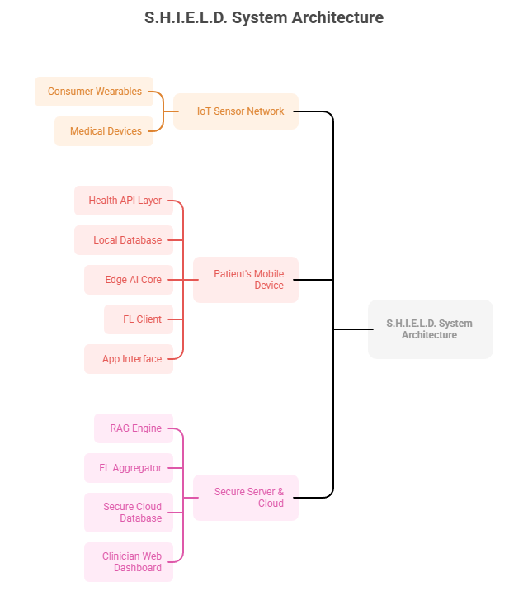
Conclusion
The insights aren't just for patients. Our Clinician Dashboard lets doctors see the exact same AI insights. It sorts patients by risk, allowing doctors to focus on who needs help right now, transforming their workflow from reactive to proactive.

