**Living Computing Project (LCP)**

[**www.programmingbiology.org**](http://www.programmingbiology.org)

Projects Summary – UROP Summer 2016

Prof. Douglas Densmore; dougd@bu.edu

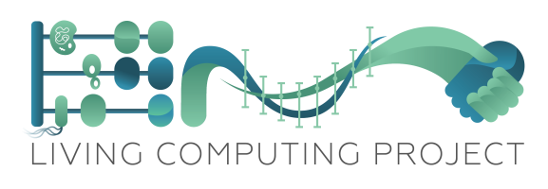

The Living Computing Project ([www.programmingbiology.org](http://www.programmingbiology.org)) investigates computing paradigms in living organisms. Specifically, it explores if digital, analog, memory, and communication concepts can be implemented in cellular environments. Understanding if quantitative approaches and standardized metrics can broadly be applied to these systems will help us develop the formalized mechanisms we can use to specify, design, and verify these systems. Solutions in medicine, materials, sensing, and manufacturing will be able to be more easily created, efficiently implemented, and broadly distributed if computing paradigms are found to be applicable.

The collection of **10 UROP students for the summer of 2016** will be aiding in this research. Specifically they will be involved in **one of four efforts**:

**2016 Boston University Wet Lab iGEM Team** – *Four Students* – These students will take basic DNA building blocks and assemble them into genetic circuits. These circuits will act as either digital or memory based computing elements. The students will then characterize these circuits to extract quantitative metrics related to their performance. This data will be archived physically and electronically along with the biological DNA information to begin to curate a library of computational components for the LCP. These components will be housed in the LCP Inventory of Composable Elements (ICE), the Synthetic Biology Open Language (SBOL) Stack, and BTSync (for flow cytometer data). This collection of information will be used to augment existing design software to predict the performance of future circuits and search for optimized designs. This project will require molecular biology skills and bioinformatics analysis. These students will be supervised by BME graduate student Divya Israni.

**2016 Boston University Hardware iGEM Team** – *Three Students* - These students will be creating a microfluidic design environment to automate the testing of genetic logic circuits. The fabrication, control, and data extraction for this platform will be automated with the use of software tools. The team will be creating a genetic system that interfaces with off the shelf sensors and hardware so that it can be quickly reconfigured for numerous environments and designs. It will consist of a set of input locations, intermediate locations, switch fabric, and output locations. This will allow for a generic device that is differentiated experiment by experiment. This project will involve embedded systems design, CNC milling, 3D printing, and software programming. These students will be supervised by ECE graduate student Ryan Silva.

**Phagebook and CIDAR Software** – *Two Students* – Synthetic biology software includes tools for specification, design, assembly, verification, and data management activities. CIDAR lab ([www.cidarlab.org](http://www.cidarlab.org)) has numerous software packages that need to be made either more robust, user friendly, or more widely tested. These include a design environment for functional specification and assembly of genetic circuits (Phoenix) as well as a social media platform for synthetic biology (Phagebook). This project will require web design, Java/Javascript, cloud computing, and database skills. These students will be supervised by ECE graduate student Prashant Vaidyanathan.

**Living Computing Project Research Intern** – *One Student* – This student will work on fundamental research questions related to models of computation in synthetic biology (e.g. state machines, data flow networks) and how they can be formalized and assigned to biological elements. This project will require computational interests, programming skills, and some computer science exposure. This student will be supervised by ECE Research Assistant Professor Dr. Swapnil Bhatia.