Task 1 LeetCode 383:

from collections import Counter

class Solution:

    def canConstruct(self, ransomNote: str, magazine: str) -> bool:

        randict=dict(Counter(ransomNote))

        magadict=dict(Counter(magazine))

        for key in randict:

        # Check if key exists in dict2 and if the value in dict2 is greater than or equal

            if key not in magadict or randict[key] > magadict[key]:

                return False

        return True  # All checks passed

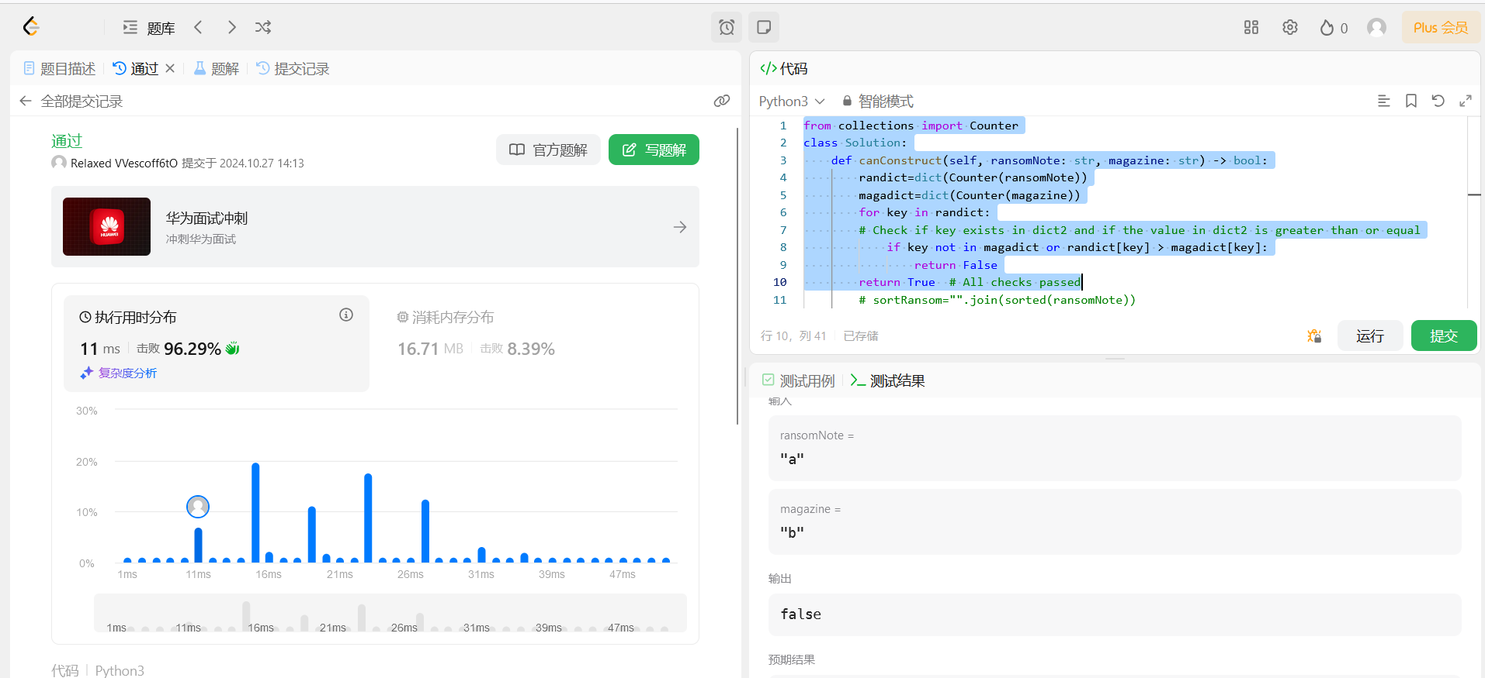

Idea for code:

Create a dictionary for ransomNote and magazine. We first need to make sure all keys in the ransomNote dict appears in magazine, then if this condition passes, we need to make sure the number of times which each key appears in ransomNote must be less or equal to the number of appearances in the magazine dict. If both conditions are true, return true.

Task 2

第二个task没有用到debug tool, 我比较了一下tutorial里面用到的code (Fig.1)发现

res_json = json.loads(res) 是多余的，加上报错信息也在第30行 (Fig.2). comment之后无报错，结果如图三所示，InternLM成功回答了prompt的内容

Fig 1.

Fig 2

Fig 3