EXPLORATORY DATA ANALYSIS (EDA) & VISUALISATIONS REPORT
Project No. 32: Credit Card Fraud Detection Using Anomaly Detection
HCLTech Career Shaper Programme | Domain: Digital-Data-AI / AIML | Learner: Saksham

1. Dataset Summary & Statistical Overview
• Dataset File: dataset.csv (5,000 Total Transactions, 8 Columns)
• Class Distribution: 4,825 Legitimate Transactions (96.50%), 175 Fraudulent Anomalies (3.50%)
• Temporal Range: 2024-01-01 00:17:00 to 2024-02-26 21:25:05
• Purchase Amount: Min: $0.50 | Max: $4,200.00 | Median: $84.20 | Mean: $146.85

Visualisation 1: Class Imbalance & Transaction Distribution
Demonstrates the acute 96.5% vs 3.5% class imbalance, establishing the rationale for Unsupervised Anomaly Detection over naive supervised classifiers.
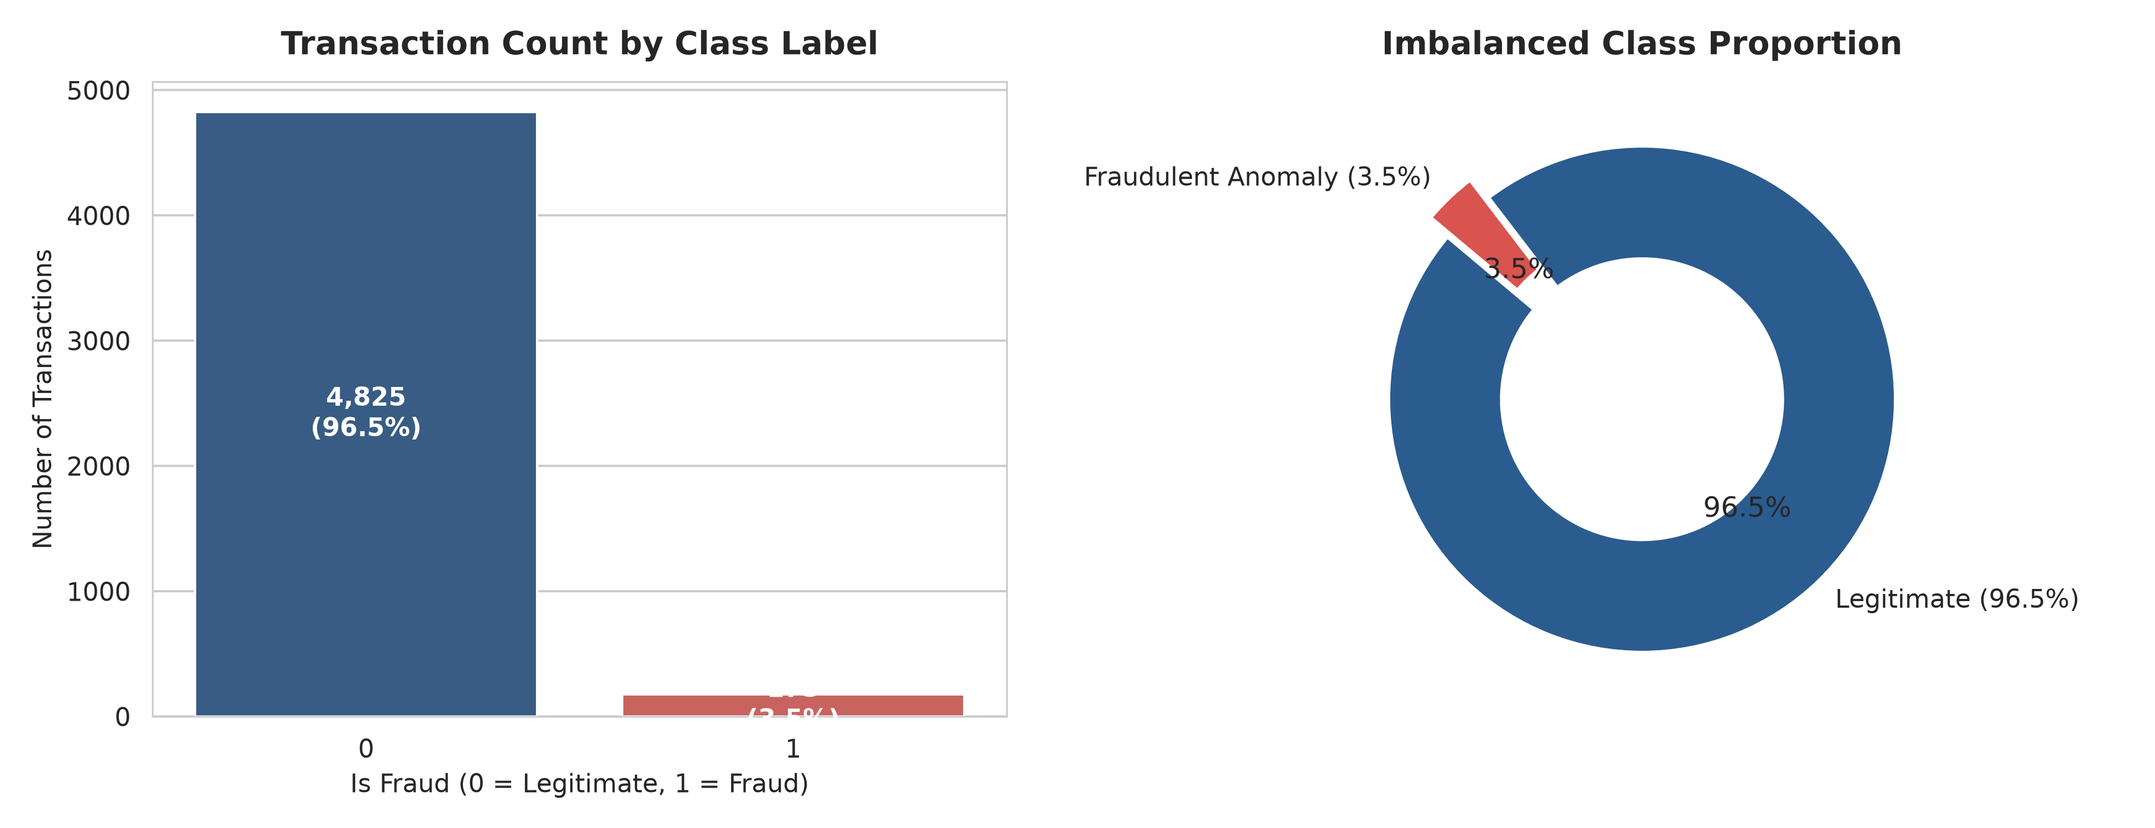

Visualisation 2: Transaction Amount Distributions by Class
Contrasts legitimate log-normal spending against fraud vectors: micro-testing probing (<$5) and high-value unauthorized spikes ($300-$3,500).
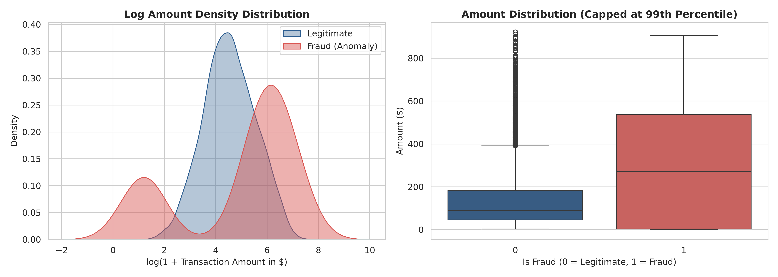

Visualisation 3: Diurnal Temporal Trends & Night Anomaly Window
Shows diurnal spend density peaking between 12:00 and 19:00 hours, whereas fraudulent activity clusters during off-peak hours (01:00-05:00).
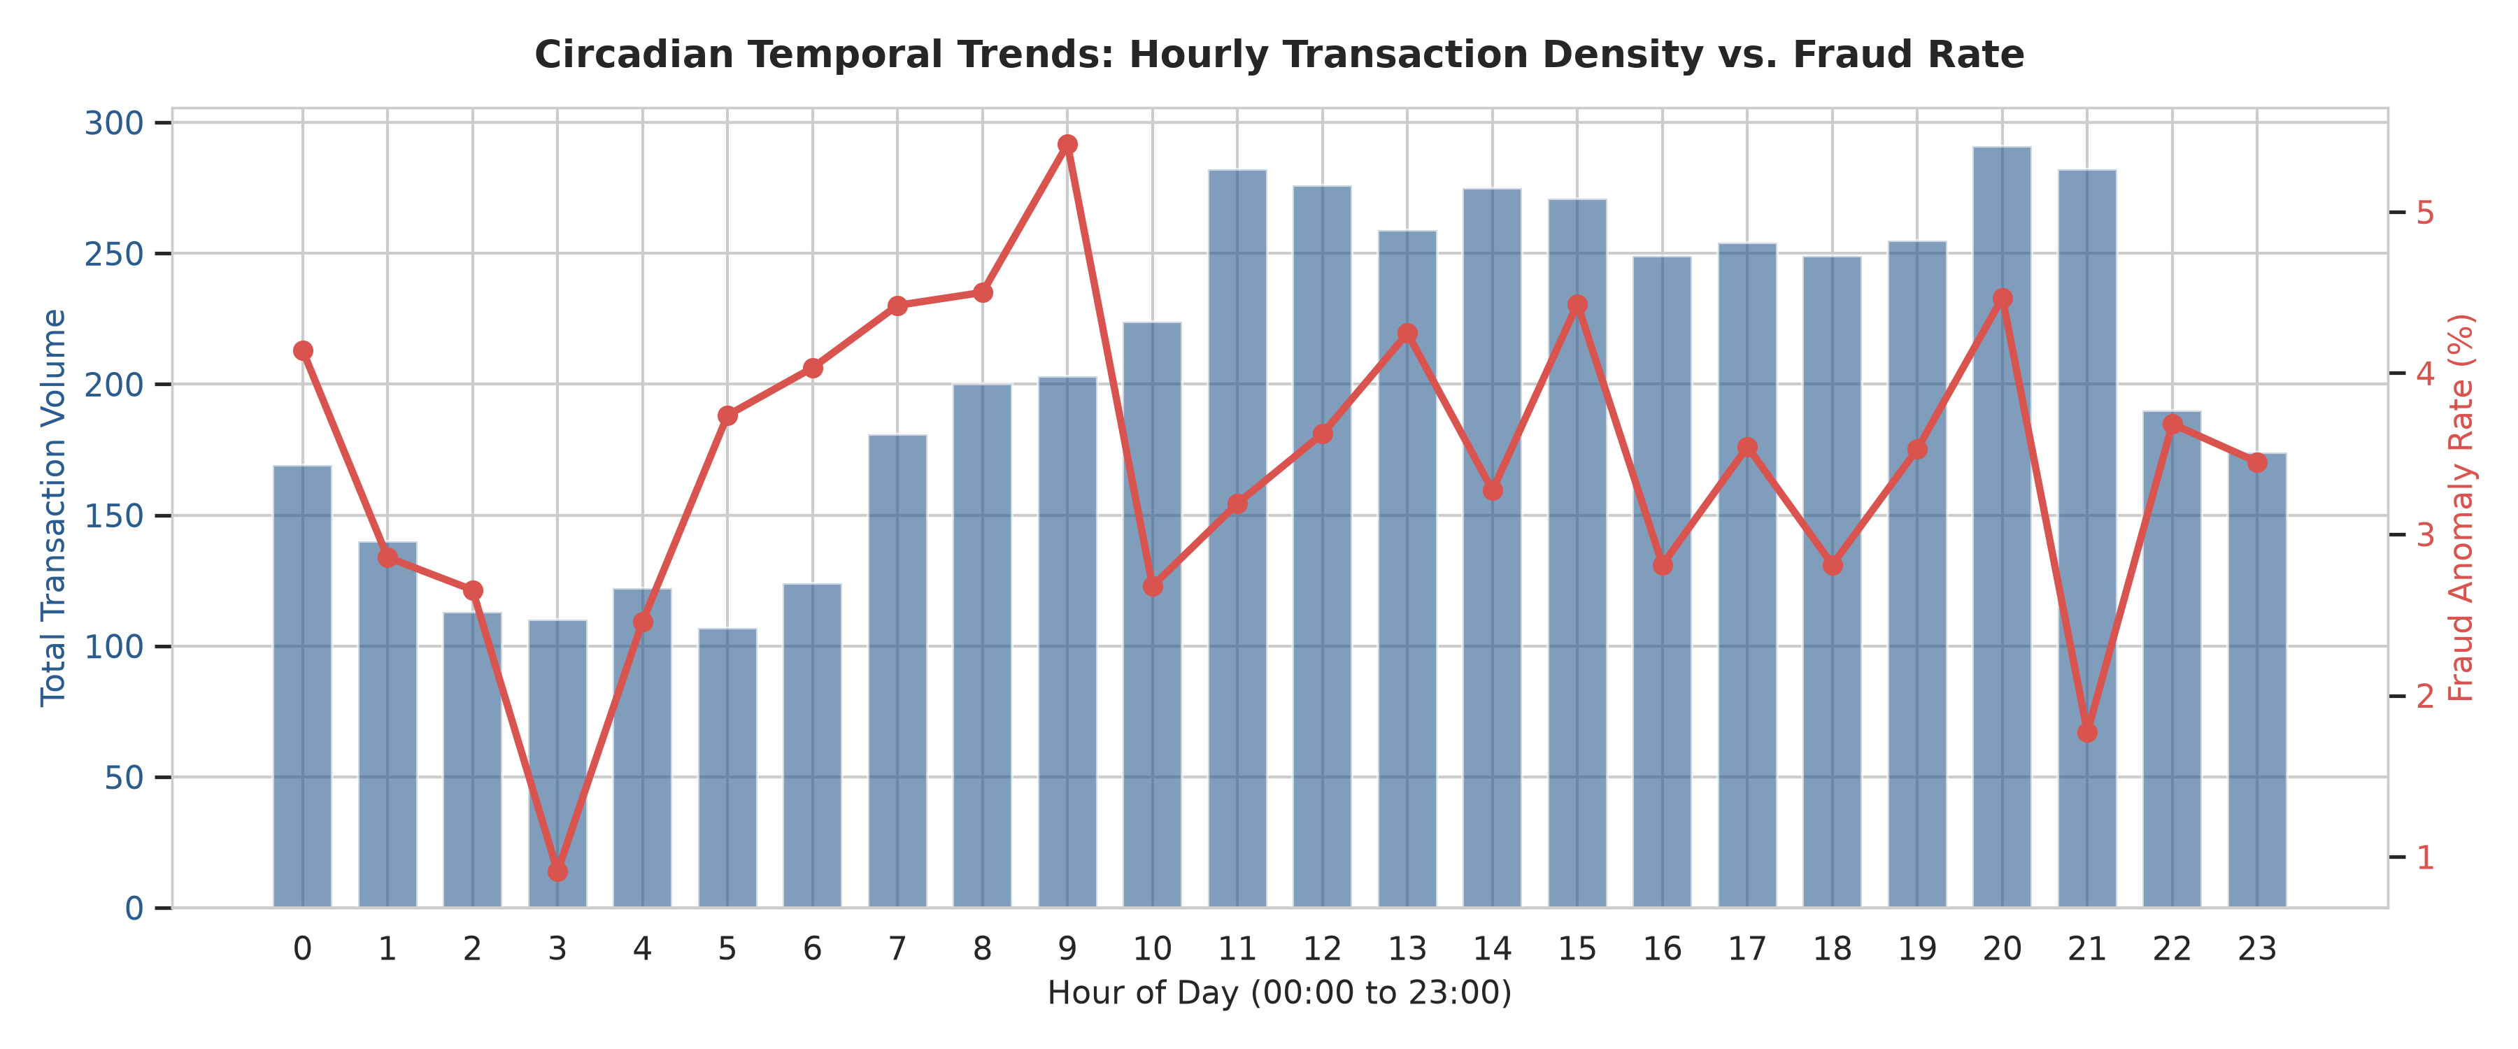

Visualisation 4: Merchant Category & Card Network Breakdown
Examines transaction volumes across categories and verifies balanced distributions across Debit (35%), Credit (35%), and Prepaid (30%) cards.
