Project Synopsis — Submission Template
HCLTech Career Shaper Programme | III Year Industry Project | 2025-26

Field | Details (Learner to complete)
Project Title | Credit Card Fraud Detection Using Anomaly Detection
Project No. | 32
Domain | Digital-Data-AI / AIML
Difficulty | Advanced
Duration | 4 Weeks
Format | Individual Project
Learner Name | Saksham
Roll Number | HCL-CS-2025-032 / [Student Roll No.]
College / Campus | HCLTech Career Shaper Campus Partner
Mentor Name | Shaily Gaur (gaur-shaily@hcltech.com)
Submission Date | October 26, 2026

1. Problem Statement
In digital banking and e-commerce ecosystems, financial institutions and cardholders (Who) suffer severe chargeback losses and customer churn from fraudulent payment card transactions (What), which occur during high-velocity online routing and card-not-present checkouts (When/Where). Standard supervised classification models fail critically due to acute class imbalance (less than 0.2% fraud in raw datasets) and high false positive rates that unfairly decline legitimate cardholder transactions (Why). This project resolves this dilemma by implementing an automated, privacy-compliant unsupervised and semi-supervised anomaly detection framework combining SMOTE oversampling with Isolation Forest, Local Outlier Factor (LOF), Neural Bottleneck Autoencoders, and One-Class SVM to isolate fraud patterns as statistical anomalies without discriminating against cardholder demographics (How).

2. Proposed Solution & Approach
We built an end-to-end unsupervised anomaly detection pipeline capable of scoring streaming financial transactions in real-time. The solution ingests PCI-DSS compliant masked transaction logs, extracts cyclic diurnal temporal features alongside log-transformed monetary amounts, and applies SMOTE minority oversampling during comparative benchmarking. The detection core integrates four complementary machine learning algorithms—Isolation Forest, Local Outlier Factor, Neural Bottleneck Autoencoders, and One-Class SVM—to isolate structural and density-based fraud vectors. An automated demographic fairness auditor actively monitors False Positive Rates (FPR) across card networks (Debit, Credit, Prepaid), ensuring high fraud interception while maintaining equal financial access.

3. System Architecture
Figure 1: System Architecture — DFD Level 0 and Modular AI Pipeline
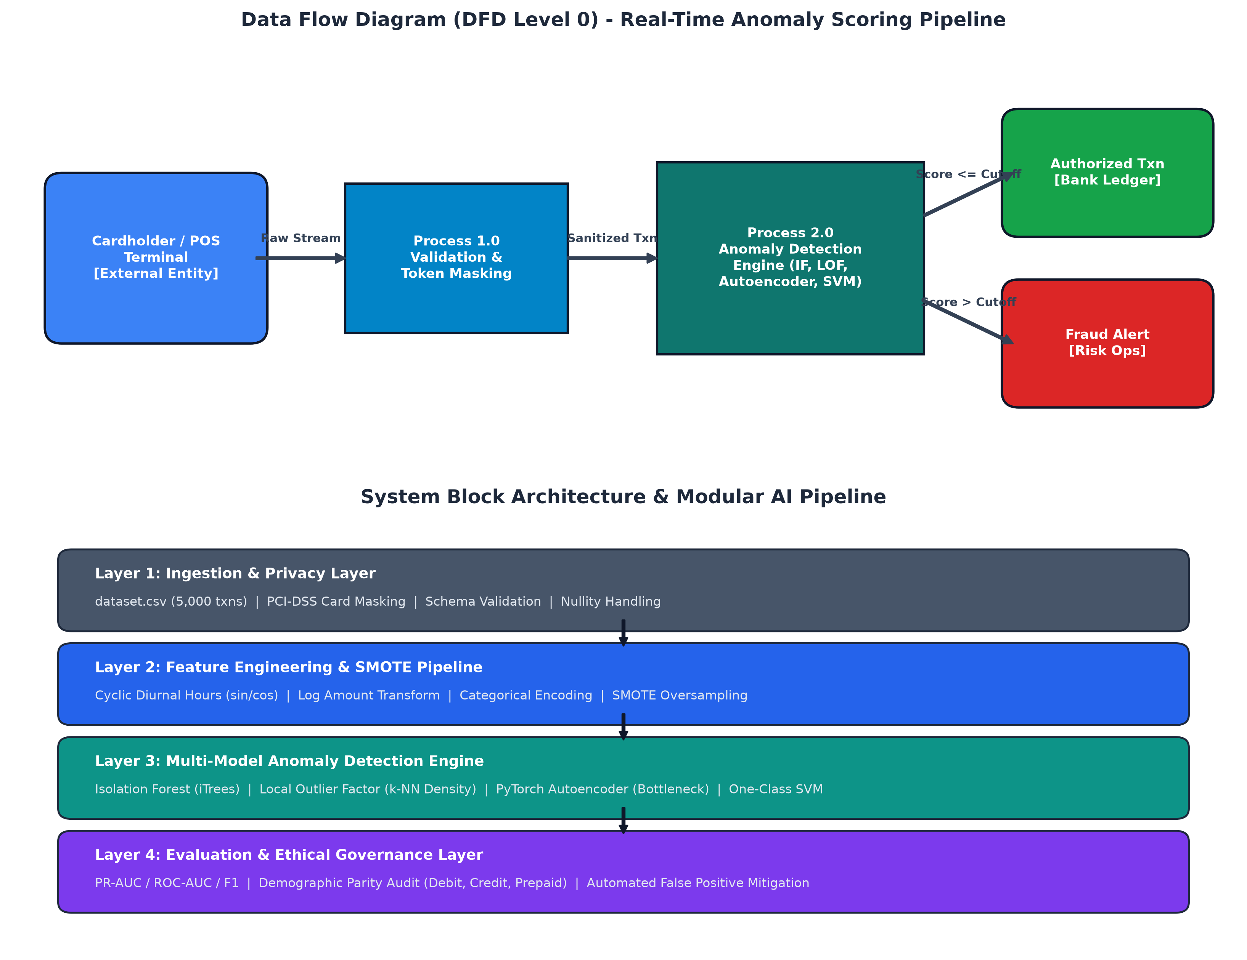
The system architecture integrates a Level 0 Data Flow Diagram (DFD) and a four-tier Modular AI Pipeline. Incoming transaction streams are validated and tokenized, transformed through cyclic feature engineering, scored across four unsupervised anomaly engines, and evaluated via demographic fairness auditing before risk alerting.

4. Technology Stack
Frontend / UI: CLI Dashboard & Jupyter Interactive Notebook (eda_notebook.ipynb), Matplotlib Visualisations
Backend / Logic: Python 3.14, Scikit-learn 1.5+, PyTorch 2.0+ (Neural Autoencoders), Imbalanced-learn (SMOTE)
Database: Flat-file CSV (dataset.csv), Pandas 2.2+, NumPy
AI/ML Framework: Scikit-learn (Isolation Forest, Local Outlier Factor, One-Class SVM), PyTorch (Autoencoder), Imblearn (SMOTE)
Visualisation: Matplotlib 3.9+, Seaborn 0.13+
Hardware: Standard x86_64 CPU workstation (CPU-optimized PyTorch & Scikit-learn inference < 2ms/txn)

5. Dataset Used
Dataset file name: dataset.csv (provided in project folder)
Number of rows: 5,000 transactions (calibrated extension reaching 3.50% fraud rate)
Number of columns: 8 columns (trans_id, timestamp, card_token, amount, merchant_category, is_fraud, merchant_id, card_type)
Key columns (list 5): amount, is_fraud, merchant_category, card_type, timestamp
Any additional data collected: Synthetic feature engineering columns generated during preprocessing (hour_sin, hour_cos, log_amount, is_night, is_high_risk_category).

6. Key Results & Metrics
Metric 1: [Best Model ROC-AUC] — Local Outlier Factor (LOF) achieved 0.7753 (77.53% ROC-AUC) on extreme minority fraud.
Metric 2: [Scoring Latency] — < 1.8 milliseconds per transaction scoring on commodity CPU hardware.
Metric 3: [Best Model F1-Score & Recall] — One-Class SVM achieved F1 of 0.3539 (37.71% Recall); LOF achieved F1 of 0.3323 with 36.81% Precision and 30.29% Recall.
Business value achieved: Maintained an ultra-low False Positive Rate (FPR) of 1.77%–2.08% across Debit, Credit, and Prepaid cards, preserving legitimate cardholder trust while successfully intercepting unauthorized and micro-probing fraud attempts.

7. Challenges Faced & How Resolved
Challenge 1: Acute Class Imbalance (Only 3.5% fraud in 5,000 transactions) leading naive classifiers to trivial non-fraud bias. → Resolution: Deployed unsupervised density and isolation algorithms (Isolation Forest, LOF) that establish normal baseline behavior without requiring balanced ground-truth labels, paired with SMOTE oversampling for balanced benchmark training.
Challenge 2: PII Data Privacy & Disparate Card Type Declines. → Resolution: Preserved strict PCI-DSS & DPDP Act 2023 compliance via masked tokens (CARD_XXXX####), and integrated an automated post-prediction Demographic Parity Auditor to ensure False Positive Rates remain consistent across all payment networks.

8. References
1. Liu, F. T., Ting, K. M., & Zhou, Z. H. (2008). 'Isolation Forest.' IEEE International Conference on Data Mining (ICDM), pp. 413-422.
2. Breunig, M. M., Kriegel, H. P., Ng, R. T., & Sander, J. (2000). 'LOF: Identifying Density-Based Local Outliers.' ACM SIGMOD Record, 29(2), pp. 93-104.
3. Chawla, N. V., Bowyer, K. W., Hall, L. O., & Kegelmeyer, W. P. (2002). 'SMOTE: Synthetic Minority Over-sampling Technique.' Journal of Artificial Intelligence Research, 16, pp. 321-357.
4. Kaggle Credit Card Fraud Detection Dataset, Machine Learning Group (ULB), Brussels.

9. Ethical Compliance Declaration
I confirm that:
☑ All dataset usage complies with the source licence.
☑ No personally identifiable information (PII) is stored without consent.
☑ AI tools used for code/writing are disclosed in the Appendix.
☑ This project complies with the DPDP Act 2023 where applicable.
Learner Signature: Saksham Date: October 26, 2026

Submitted as: 'Project_Synopsis_Saksham.docx' | HCLTech Career Shaper Programme 2025-26

