Heat-Assisted Expansion for Collagen-Selective Extraction from Collagen-Rich Tissue for Proteomics

Introduction
The extracellular matrix (ECM) is an intricate network of large, heavily crosslinked proteins that provide tissue mechanical support and regulate cellular migration, adhesion, polarization, differentiation, and apoptosis. The ECM contains highly insoluble core components such as fibrillar collagens and elastin, as well as basement-membrane proteins that form sheet-like structures for support. Alterations in ECM composition and architecture are strongly implicated in cancer metastasis and disease pathogenesis. Therefore, accurate characterization of the ECM is crucial for understanding disease mechanisms and for identifying therapeutic targets and strategies, and bottom-up proteomics has developed as an attractive tool to probe and quantify the ECM [1,2].
Because of the extensive covalent crosslinking and rigid triple-helical structure of collagens, which are a dominant component of the ECM, the ECM is notoriously difficult to solubilize and digest for bottom-up proteomics. Specialized extraction strategies are often required to access ECM proteins (dubbed the "Matrisome"), and most protocols utilize harsh chemical extractions and detergents. Common protocols include sequential depletion of cellular proteins using buffers of varying salt concentration, detergent composition, and pH to enrich for the ECM (decellularization), the usage of photocleavable surfactants (e.g., Azo), extraction with strong denaturants such as urea, sodium dodecyl sulfate (SDS) or guanidine hydrochloride (Gnd-HCl) followed by hydroxylamine (HA), and chemical cleavage approaches such as CNBr [3-5].
An underexplored approach for improving collagen accessibility is expansion of dried collagen-rich tissues through heat and rapid steam generation to hypothetically increase enzymatic access and solubility. It has been previously demonstrated that short-term boiling as a pre-treatment for enzymatic hydrolysis of collagen-rich tissue increases protein yield noticeably, but long-term heating at higher temperatures remains understudied [6]. Microthermal studies on mouse-derived tail tendons show that residual, strongly hydrogen-bonded water in dry collagen rapidly evaporates during brief exposure to high temperatures at 150 ± 10 °C [7]. Rapid vaporization under exposure to these high temperatures generates internal pressure that expands the porous architecture and internal surface area of certain dried collagen-rich foods in some culinary practices (e.g. fish maw, pork rinds).
This technique can be leveraged in sample preparation steps to make collagen more accessible to subsequent thermal denaturation and enzymatic digestion. Subsequent, extensive hot-water incubation at 80 °C, which is above the denaturation temperature of hydrated collagen I of 65 +/- 10 °C and is the temperature at which water absorption was determined to reach its maximum for hydrated collagen [8], further disrupts intramolecular hydrogen bonding and crosslinking in the triple helix, yielding lower-molecular-weight collagen fragments that are more easily solubilized, digested, and identified by mass spectrometry [7,9].

Here, we evaluate a heat-based workflow for collagen-selective extraction and Matrisome enrichment from collagen-rich tissue. The approach combines brief high-temperature expansion of dried chicken-foot tendon at 180 °C with subsequent incubation in hot water at 80 °C or collagenase I treatment. Solubilized proteins were processed using standard bottom-up proteomics and analyzed by LC-MS/MS. Performance was benchmarked against a commonly used ECM decellularization workflow based on sequential depletion of cellular and soluble protein fractions.

Rather than serving as a universal replacement for decellularization, the heat-based workflow is evaluated here as a collagen-focused preparation strategy for highly insoluble, collagen-rich samples. We show that heat-treated samples achieve high Matrisome selectivity by peptide-spectrum match (PSM) composition and collagen sequence coverage comparable to the benchmark, while the benchmark retains broader coverage of non-collagen and Matrisome-associated proteins. Together, these results suggest that heat-assisted extraction provides a simple, low-chemical workflow for selectively extracting collagens from collagen-rich tissue.

Results

Tissue expansion and solubilization
Chicken-feet-derived tendons were dissected and washed with ice-cold PBS to remove contaminants and then dried in a lab oven to allow for rapid steam generation in subsequent heating in canola oil. The average mass of the dried tendons was 9.7 ± 1.9 mg, and they were briefly submerged in canola oil at 180 °C on a hot plate with a magnetic stir bar for 5-10 seconds until there was rapid expansion of tissue. The temperature of 180 °C was decided empirically after preliminary testing of puffing efficiency at different temperatures of 140 °C, 160 °C, and 180 °C. Heating at 180 °C achieved the most rapid and obvious expansion with minimal browning (Figure 1). Samples were removed immediately after expansion with metal tongs to minimize instances of Maillard reactions and sample browning, which would promote crosslinking and aggregation.
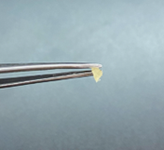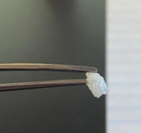
Figure 1. Photograph of dried tendons (left) before and (right) after heating in canola oil at 180 °C, demonstrating successful expansion with minimal browning.
Heat-treated tendons were then incubated in 1.5 mL chloroform under mild agitation for 45 minutes at room temperature to delipidate the sample and remove the bulk of surface oil. The tendons were then removed from the chloroform wash and incubated in water at either room temperature or 80 °C for 1 hour or 48 hours, according to their assigned conditions (Table 1). Collagenase-treated samples were incubated with 500 uL of 2 mg/mL (0.2% w/v) collagenase type I, to allocate approximately 1 mg of collagenase for ~10 mg of tissue for 1 hour at 45 °C [10, 11]. The PBS buffer was also supplemented with 0.9 mM CaCl₂ to stabilize collagenase activity. Samples were then centrifuged after treatment and protein precipitation using chloroform and methanol was performed. Cold-water controls were included as exploratory negative controls and were excluded from formal statistical comparisons.

Table 1. Experimental conditions (n=3, except for cold water controls)
Condition | Pre-heat (180 °C) | Solvent / Enzyme | Incubation Temp | Duration
Short heat | No | Water | 80 °C | 1 h
High heat / Short heat | Yes | Water | 80 °C | 1 h
Long heat | No | Water | 80 °C | 48 h
High heat / Long heat | Yes | Water | 80 °C | 48 h
Collagenase | No | Collagenase I | 45 °C | 1 h
High heat / Collagenase | Yes | Collagenase I | 45 °C | 1 h
Cold water Control | No | Water | 4 °C | 48 h
High heat / Cold water Control | Yes | Water | 4 °C | 48 h
Benchmark | No | Reference decellularization protocol | -- | --

A clear correlation was observed between the intensity of the heat treatment and the degree of tissue solubilization. Samples subject to heat treatment at 180 °C prior to incubation swelled significantly upon rehydration in their respective solvents. Samples subjected to extended incubation (48 h at 80 °C) exhibited complete gelatinization of the supernatant, whereas shorter incubations (1 h at 80 °C) showed only localized gelatinization immediately surrounding the tendon. The most dramatic difference in size reduction after incubation between the heated and non-heated samples occurred for the collagenase-treated samples. Samples that were heat-treated prior to collagenase treatment notably decreased in size compared to collagenase-treated samples that did not undergo heat treatment. This suggests that the combination of high-temperature expansion may have increased accessibility of collagenase, leading to more efficient digestion in the 1-hour incubation period.
The mass of the remaining insoluble pellet, containing cell debris and insoluble ECM proteins that did not solubilize during treatment, was compared to the original starting dry mass of the sample to calculate the average decrease in sample size using the following formula:
$\% Solubilization =100* (1- \frac{Mass of remaining insoluble pellet}{Mass of starting dry material}$)

The largest degree of solubilization was achieved by the heat-treated, collagenase-treated samples, with about 89.6% of the original dry mass getting solubilized. The least efficient solubilization was achieved by the non-heat-treated, 1-hour 80 °C incubated samples, with an average of 30.3% solubilization of the original dry mass.
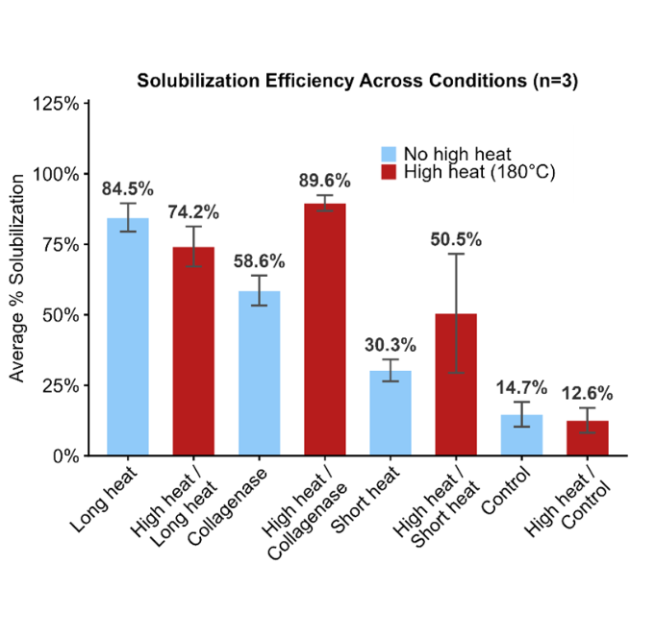
Figure 2. Solubility comparison depicting percentage of original dry mass solubilized for each treatment. Pre-heat treatments are shown in red; treatments without the pre-heat step are in blue.

Matrisome enrichment by PSM composition

The benchmark condition yielded the highest absolute number of Matrisome PSMs, indicating greater overall sampling depth of Matrisome proteins. However, the heat-treated water conditions, particularly those receiving the 180 °C pre-heating step, produced the highest fraction of total PSMs assigned to Matrisome proteins. This indicates that the heat-based workflow did not necessarily recover the broadest Matrisome profile, but it produced a more compositionally selective soluble fraction enriched for Matrisome-derived identifications. In contrast, collagenase-treated samples showed lower Matrisome enrichment and greater variability across replicates, suggesting that enzymatic treatment of intact, heterogeneous tendon pieces introduced less reproducible extraction behavior under the tested conditions.
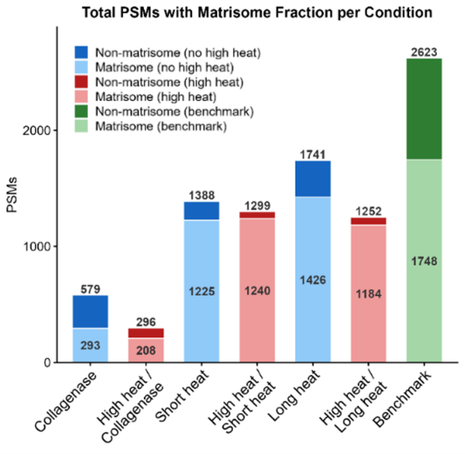 | 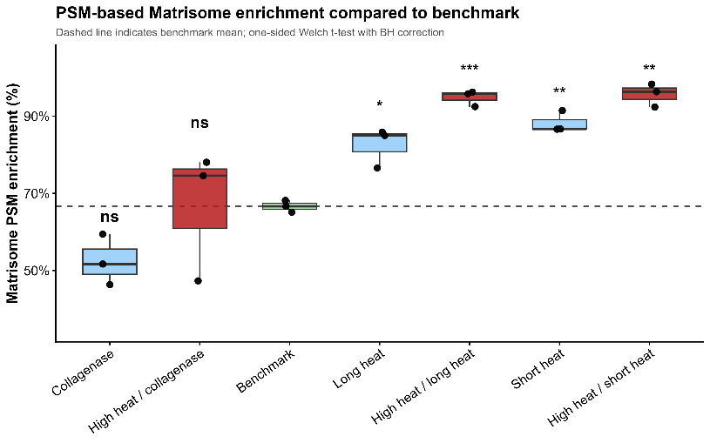
Figure 3. (a) Stacked bar chart showing total and Matrisome PSMs per condition. Lighter shading indicates Matrisome PSMs; labels show Matrisome (inside) and total (above) counts. (b) Statistical analysis of PSM enrichment, showing heat-based workflows performing significantly better in most cases compared to the benchmark

Matrisome enrichment by protein intensity
Matrisome enrichment was also assessed using normalized Razor protein intensity (Supp. Table 1 shows protein intensity enrichment from DIA-NN intensity values). In contrast to the PSM-based analysis, heat-treated samples and the benchmark all showed similarly high Matrisome enrichment by intensity. This likely reflects the dominance of collagen proteins in the total protein signal. Because collagens are large, abundant structural proteins that generate strong peptide intensity, intensity-based enrichment can be driven disproportionately by collagen signal, even when the breadth of Matrisome identification differs across methods. Therefore, PSM-based and intensity-based enrichment provide complementary but distinct information, with PSM enrichment reflecting the composition of identified spectra and intensity enrichment reflecting the distribution of protein signal across abundant detected proteins.
Table 2. Matrisome Enrichment by Protein Intensity
Condition | % Enrichment by intensity | S.D.
Long heat | 99.5 | 0.1
High heat/long heat | 99.8 | 0.1
Collagenase | 76.4 | 4.5
High heat/collagenase | 71.1 | 22.4
Short heat | 99.6 | 0.1
High heat/short heat | 99.9 | 0.03
Decellularization | 98.1 | 0.2

Sequence coverage across matrisome subsets
Sequence coverage was used to assess the depth of protein characterization across Matrisome categories. Sequence coverage represents the percentage of a protein’s amino acid sequence detected by mass spectrometry and is especially important for distinguishing related ECM proteins, isoforms, and proteoforms. Across broad Matrisome categories, the benchmark generally provided higher or more comprehensive sequence coverage than the heat-based workflows, particularly for non-core and Matrisome-associated proteins.
This indicates that the benchmark remains better suited for broad Matrisome profiling. However, when the analysis was restricted to collagens, several heat-based water treatments achieved collagen sequence coverage comparable to the benchmark. The short heat treatments reached median collagen coverage values of approximately 26.5–29.1%, approaching the benchmark median of 30.9%. The long heat treatments also produced substantial collagen coverage, although broader non-collagen Matrisome coverage remained lower than the benchmark. These results further emphasize that the heat-based workflow is strongly biased toward collagen recovery. This collagen selectivity may be advantageous for studies focused on fibrillar collagen-rich tissues, but it also limits the method’s ability to capture the broader Matrisome compared with conventional decellularization-based enrichment.
- 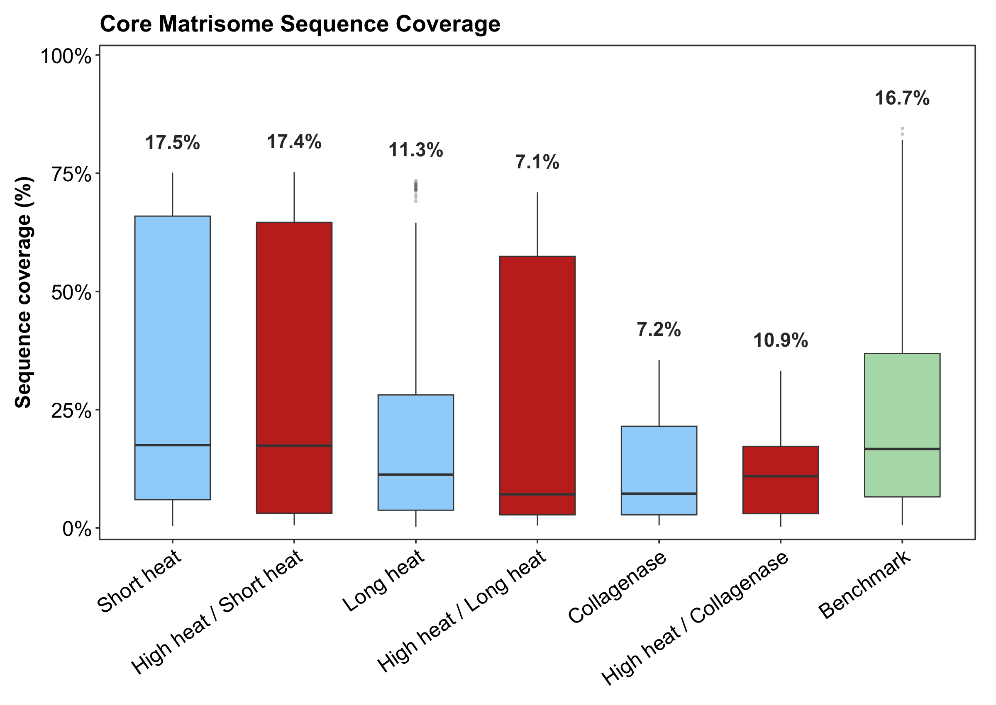 | - 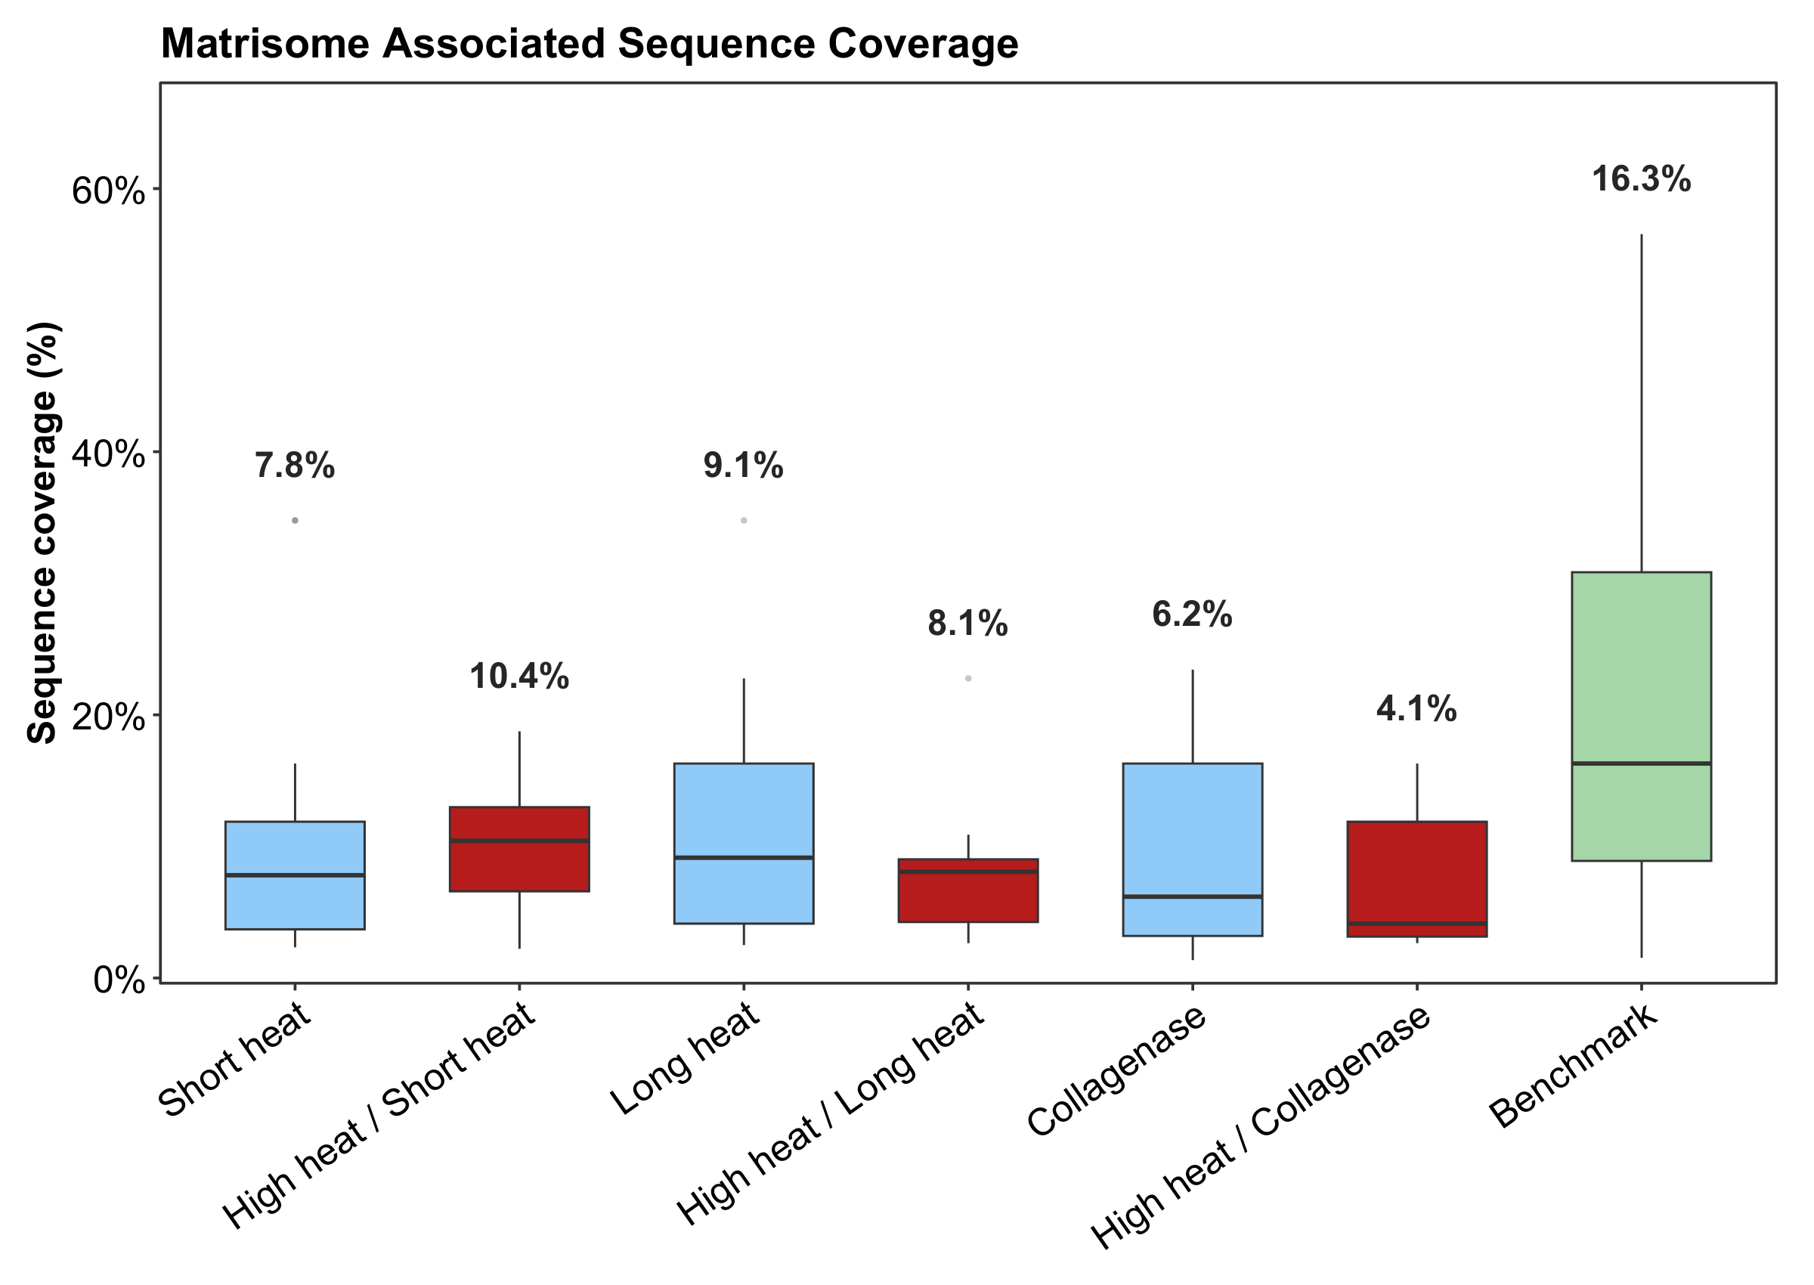
- 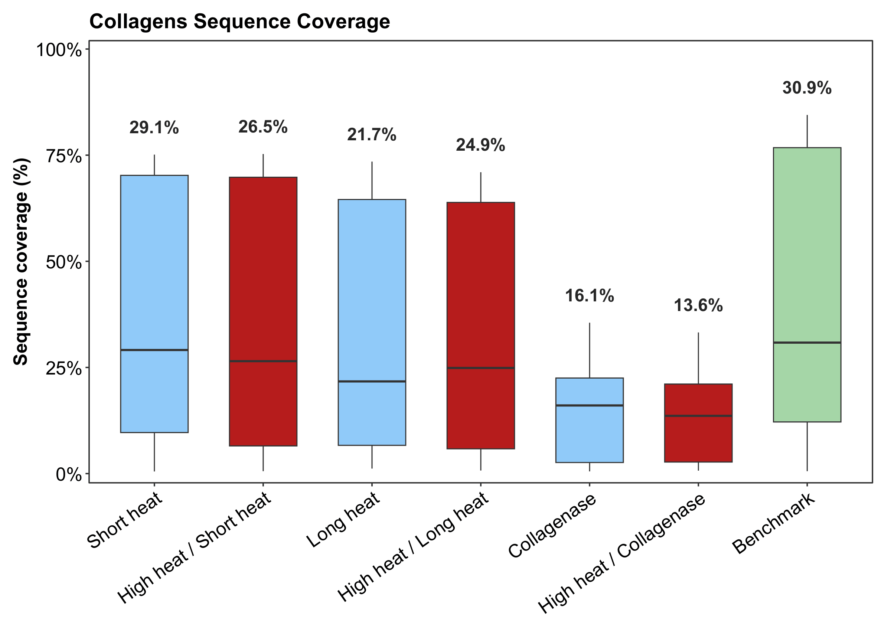
Figure 4. Sequence coverage distributions for (a) core matrisome, (b) matrisome-associated proteins, and (c) collagens across extraction conditions. Benchmark samples showed broader matrisome coverage overall, whereas heat-treated water conditions achieved collagen sequence coverage approaching the benchmark.

Shared and unique matrisome proteins
Protein overlap analysis was used to compare the breadth of Matrisome recovery across extraction strategies. Across conditions, many of the detected Matrisome proteins were shared, indicating that the heat-based workflows recovered a core set of abundant tendon Matrisome proteins. However, the benchmark condition identified the largest number of unique Matrisome proteins, particularly among non-collagen ECM and Matrisome-associated categories. This supports the conclusion that the benchmark provides broader Matrisome coverage, whereas the heat-based methods preferentially recover a collagen-dominated subset of the ECM.
- 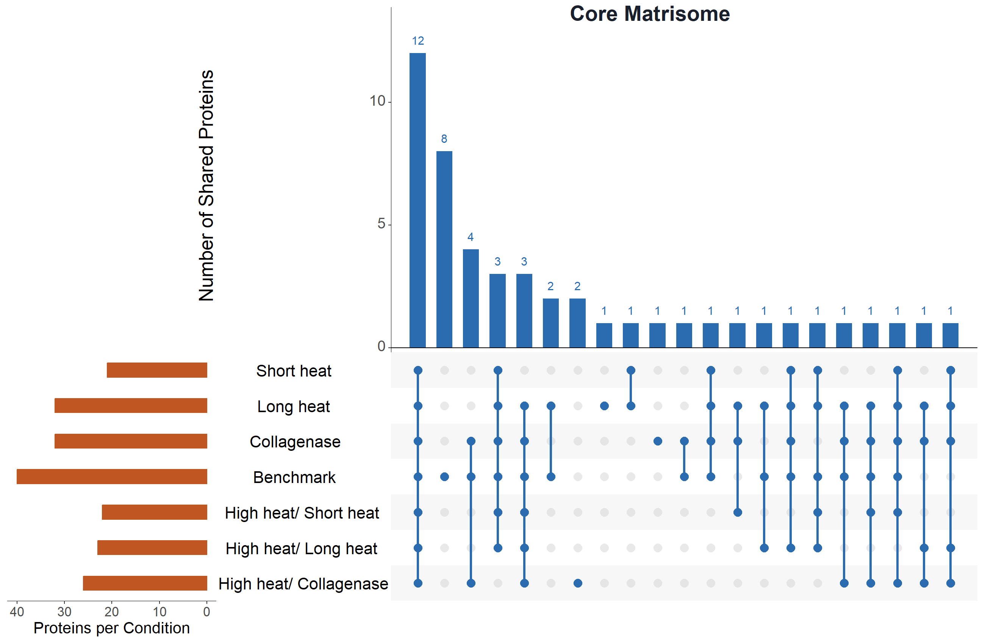 | - 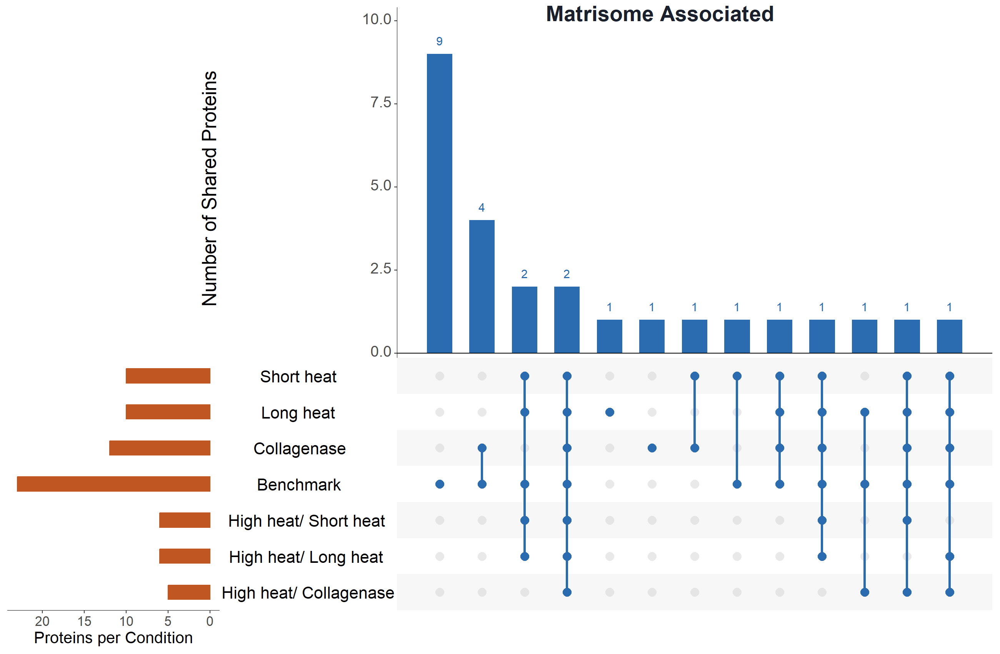
Figure 5. UpSet plots with unique and shared (a) all Matrisome and (b) Matrisome-associated proteins across conditions. Most Matrisome proteins are shared across conditions, with the most unique proteins being identified by the benchmark.

STRING analysis of proteins uniquely identified in the benchmark indicated enrichment for ECM organization and ECM post-translational modification processes. These results further suggest that chemical-based sequential extraction may improve access to lower-abundance or less collagen-dominant Matrisome components that are not as efficiently recovered by the heat-based workflow alone.

Replicate consistency
Replicate consistency was assessed to evaluate the reproducibility of each extraction strategy across independent tendon samples. Heatmaps of replicate similarity showed that most water-based heat treatments produced consistent replicate profiles, comparable to the benchmark condition. This suggests that the heat-assisted water extraction workflow can reproducibly recover a collagen-rich protein fraction from tendon tissue.
In contrast, collagenase-treated samples exhibited greater variability across replicates. This variability may reflect differences in enzyme accessibility within intact tendon pieces, local differences in tissue structure, pH, calcium availability, or incomplete and heterogeneous cleavage of insoluble collagen fibers. Attempts to account for non-tryptic collagenase-generated peptides by modifying database-search parameters substantially increased the search space and did not produce interpretable improvements. These observations suggest that collagenase treatment, under the conditions tested here, introduced more technical variability than the water-based heat treatments.
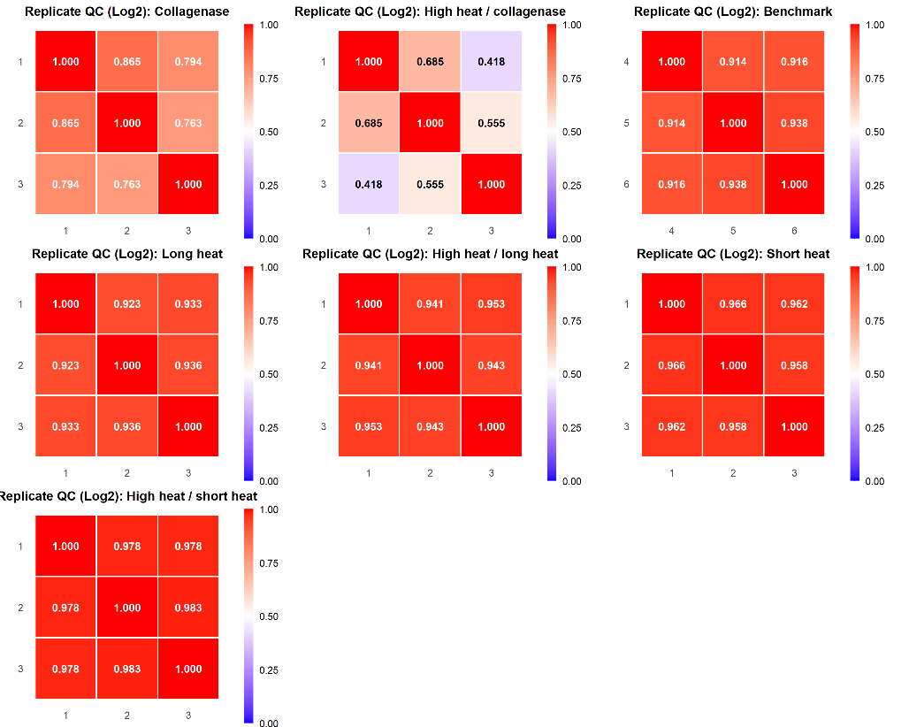
Figure 6. Heat maps showing replicate similarity across the different conditions, with heat-based conditions achieving high reproducibility across replicates.

Discussion
Here, we explore the effects of physical puffing of dried collagen-rich tissue via rapid exposure to high heat at 180 °C paired with incubation in hot water at 80 °C for an extended time over 1 hour and 48 hours. We demonstrated that high heat exposure and the physical reconfiguration of the extracellular matrix in collagen-rich tissue, such as tendon, during sample preparation steps can heavily bias protein identification and coverage towards collagen.
The major finding of this study is that brief high-temperature expansion followed by hot-water incubation produces a collagen-selective Matrisome extraction from tendon tissue. Compared with the decellularization benchmark, heat-treated water samples showed a higher fraction of Matrisome-assigned PSMs, indicating greater compositional selectivity in the soluble fraction. However, the benchmark produced broader Matrisome coverage, particularly among non-collagen and Matrisome-associated proteins. This may be due to the heat-induced degradation of non-collagen or non-core Matrisome proteins through the usage of high heat (e.g. 80 °C and 180 °C) and the physical expansion of collagenous networks “releasing” more soluble proteins for degradation by heat. Nevertheless, the heat-based workflow is best interpreted as a collagen-focused extraction strategy rather than a general replacement for established ECM enrichment protocols.

The difference between PSM-based enrichment and intensity-based enrichment further supports this interpretation. Heat-treated samples showed higher Matrisome enrichment by PSM composition than the benchmark, suggesting reduced representation of non-Matrisome protein identifications. However, enrichment by Razor intensity was high for both heat-treated and benchmark samples. This likely reflects the dominance of collagen proteins in total protein signal, since abundant fibrillar collagens can contribute disproportionately to intensity-based measurements. Thus, PSM composition and intensity enrichment describe different aspects of method performance, where the heat-based workflow improves the selectivity of identified spectra toward Matrisome proteins, and both heat-based and benchmark methods remain dominated by collagen signal at the intensity level.

Sequence coverage analysis showed that this selectivity is primarily collagen-focused. The benchmark achieved broader coverage across most Matrisome categories, consistent with its intended purpose as a more comprehensive ECM enrichment workflow. In contrast, the heat-treated water conditions achieved collagen sequence coverage comparable to the benchmark while showing reduced coverage of non-collagen Matrisome categories. These findings suggest that heat-based extraction may be particularly useful when the experimental goal is to recover and characterize collagens from highly insoluble, collagen-rich tissues.

Several limitations should be considered. First, this workflow was evaluated using chicken-foot tendon, a highly collagen-rich tissue, so its performance in softer tissues or less collagen-dominated matrices remains to be determined. Second, the method is strongly collagen-selective and should not be interpreted as a comprehensive Matrisome enrichment strategy. While this selectivity may be useful for collagen-focused applications, it limits recovery of broader non-collagen ECM and Matrisome-associated proteins compared with the benchmark. Third, although the method reduces reliance on harsh extraction buffers, the use of chloroform washing for delipidating the sample may introduce variability or concerns regarding whether collagen bias is completely heat-dependent, and alternative approaches for delipidation can be explored. Finally, the potential effects of high temperature on collagen post-translational modifications were not directly assessed in this study. Future work should evaluate whether heat-assisted extraction preserves, alters, or biases detection of disease-relevant collagen modifications in comparison to chemical-based extraction methods.

Conclusion

In summary, we developed and benchmarked a heat-based extraction workflow for collagen-rich tissue that combines brief high-temperature expansion with hot-water incubation. The method produced highly Matrisome-enriched soluble fractions by PSM composition and achieved collagen sequence coverage comparable to a conventional decellularization benchmark. However, the benchmark provided broader recovery of non-collagen and Matrisome-associated proteins, indicating that the heat-based workflow is not a universal replacement for comprehensive ECM enrichment.

Instead, this method is best suited as a collagen-selective, low-chemical preparation strategy for highly insoluble, collagen-rich samples. Its simplicity and strong collagen bias may make it useful for studies focused on tendon, fibrosis, collagen-rich clinical specimens, or biomaterial applications where collagen recovery is the primary goal. Future work should test the workflow across additional tissue types, evaluate compatibility with collagen post-translational modification analysis, and determine whether heat-assisted extraction can be combined with existing decellularization strategies to improve access to both collagenous and non-collagenous Matrisome components.

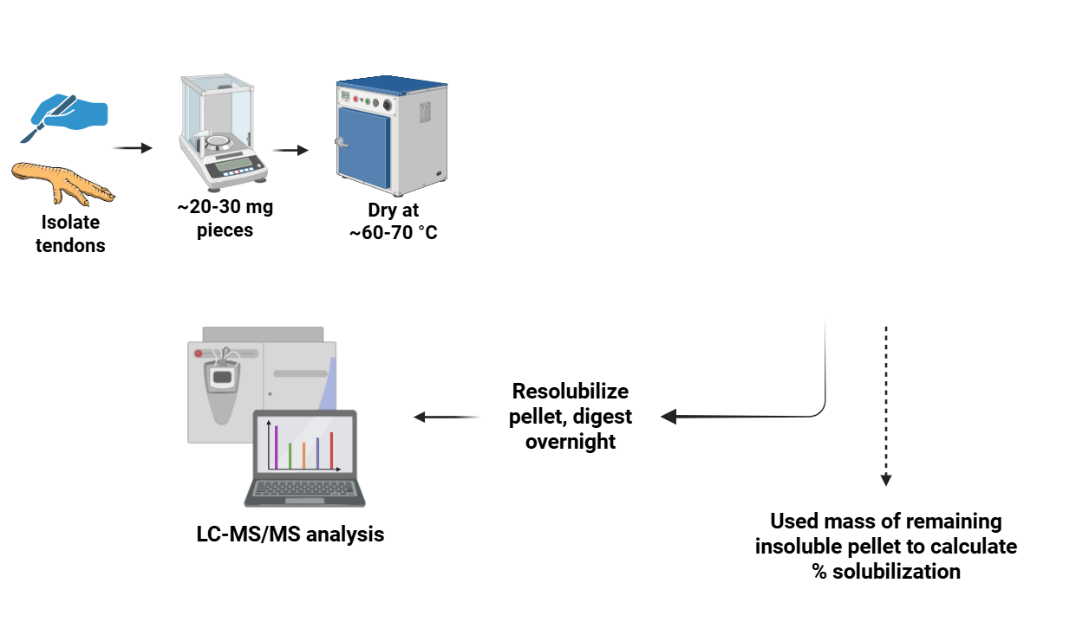
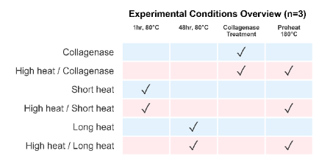
Methods

Figure 8: Schematic of heat-based workflow
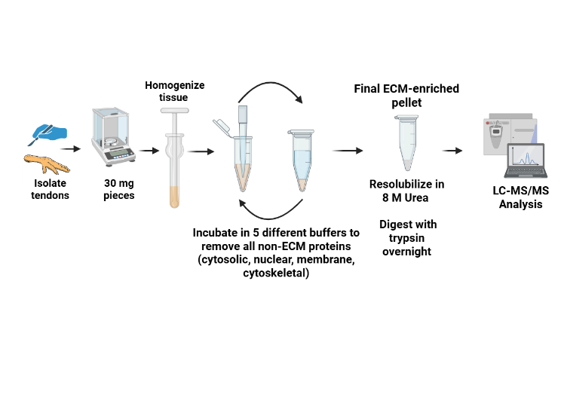
Figure 9. Schematic of decellularization benchmark workflow.

Tissue procurement
Chicken-foot tendons were dissected and rinsed on ice with ice-cold PBS (1x), 70% ethanol (1x), and PBS (1x) to remove surface contaminants. Tissues were cut into 20-30 mg pieces with sterile surgical scissors, and individual weights were recorded. Samples were stored in pre-weighed low-bind 1.5 mL tubes.

Tissue drying and preparation
Samples were dried in a laboratory oven at ~60 °C with tube caps open and tubes spaced equally apart on a metal tube holder. Each tube was weighed hourly, and when mass stabilized across two consecutive hourly measurements, the samples were removed from the oven and the final dry mass recorded.

Tissue heat treatment (high-temperature expansion / "puffing")
After drying, half of the samples were stored at 4 °C in closed tubes, while the other half were processed by heating in oil. Approximately 150 mL of canola oil was heated in a glass beaker on a heating plate inside a fume hood. The temperature of the oil was carefully monitored during the entire duration of heating in oil using a thermocouple, and a magnetic stir bar was used to distribute heat equally. When the oil reached 180 °C, dried tendon pieces were briefly immersed (5-10 s) one at a time using metal tongs, removed immediately after rapid expansion, and blotted on lint-free paper to remove excess oil. Samples were allowed to cool to room temperature, photographed, and returned to their tubes. Cold-water controls were included as exploratory negative controls but were not used for formal statistical comparisons because replicate structure was limited and one sample showed evidence of incomplete digestion. These controls were therefore used only to assess whether passive cold-water extraction produced substantial Matrisome signal, rather than to support quantitative conclusions.

Chloroform wash and heat treatment
Before treatment in water and collagenase solution, each heated tendon was placed in 1 mL 100% chloroform in glass vials and incubated under mild agitation for 45 minutes to remove the bulk of surface oil. The tendons were then carefully removed from the glass vials, and each tendon (except for collagenase-treated samples) was then soaked in 500 uL deionized water in low-bind 1.5 mL tubes. For collagenase-treated samples, tendons were incubated with 1 mg of collagenase type I (0.2% w/v) dissolved in 500 uL PBS supplemented with 0.9 mM CaCl2 (pH 7.4). Samples were incubated according to their assigned conditions (Table 1).

Transferring soluble fractions
After treatment, samples were centrifuged at 18,000 x g for 20 min at 4 °C. Supernatants were carefully transferred to pre-weighed, pre-labeled low-bind tubes and designated as the soluble fraction. Remaining pellets (insoluble fraction) were air-dried on a metal rack at 60 °C, and after drying, insoluble pellets were weighed and the mass recorded.

Note: Since some samples had a thicker gelatin layer upon cooling, they were briefly re-heated at 37 °C after centrifugation until the gelatin was warmed and liquified for transfer by pipetting into their designated tubes.

Lipid cleanup and protein precipitation
A 150 uL aliquot of each soluble fraction was transferred to a new, pre-weighed 1.5 mL low-bind tube for protein precipitation. Methanol/chloroform precipitation and two acetone washes were performed as follows:
- Add 4x sample volume of ice-cold methanol (600 uL). Vortex 10 s.
- Add 1x sample volume of cold chloroform (150 uL). Vortex 10 s.
- Add 3x sample volume of water (450 uL). Vortex 10 s, then centrifuge 1 min at 14,000 x g. A protein wafer will appear at the interphase.
- Carefully remove and discard the upper aqueous phase without disturbing the wafer.
- Add 4x sample volume of cold methanol (600 uL). Vortex and centrifuge 2 min at 14,000 x g to pellet proteins. Discard supernatant.
- Air-dry pellet briefly and avoid over-drying.

Urea solubilization
Dried protein pellets were weighed and the mass recorded. To each pellet, 50 uL of 8 M urea (in 100 mM Tris, pH 8.5) was added. Samples were vortexed and sonicated until pellets were solubilized. Larger or more stubborn pellets were incubated at 37 °C for up to 2 h under gentle agitation, or more 8 M urea was added to them.

Protein digestion (reduction, alkylation, trypsinization)
Samples were diluted to 2 M urea by adding 100 mM Tris. TCEP was added to a final concentration of 5 mM as a reduction step, and samples were incubated at room temperature in the dark for 20 min. CAA was then added to a final concentration of 10 mM as an alkylation step and incubated at room temperature in the dark for 15 min. CaCl2 was added to a final concentration of 1 mM. Trypsin was added at a 1:50 w/w enzyme:protein ratio, using the dried pellet mass to estimate protein amount, and samples were incubated overnight (~14-18 h) at 37 °C. The digestions were quenched by adding 96% formic acid to a final concentration of 1%, and samples were loaded onto Evotips.

LC-MS/MS and data processing

After quenching the digestion reactions, samples were loaded onto Evotips (Evosep) following the manufacturer’s instructions. Sample analyses were performed on a Q Exactive HF Orbitrap mass spectrometer (Thermo Fisher Scientific) operated in data-independent acquisition (DIA) mode. Samples were analyzed in randomized order to minimize potential batch effects.

DIA raw files were converted to mzML and searched directly using MSFragger-DIA within FragPipe v 23.0. Spectra were searched against the Gallus gallus UniProt reference proteome (UP000000539; downloaded 2026-02-16) with common contaminants and reversed decoy sequences included. Trypsin was specified as a fully tryptic enzyme (cleavage C-terminal to K/R, not before P) with up to two missed cleavages. Precursor and fragment mass tolerances were set to 10 ppm and 20 ppm, respectively, with mass calibration and parameter optimization enabled. Carbamidomethylation of cysteine (+57.02146 Da) was set as a fixed modification. Variable modifications were oxidation of methionine, protein N-terminal acetylation, and hydroxylation of lysine and proline (+15.9949 Da), with a maximum of three variable modifications per peptide. Peptides were restricted to 7-50 residues and 500-5000 Da. Search results were processed through MSBooster, Percolator, and ProteinProphet, and filtered to 1% false discovery rate (FDR) at the PSM, peptide, and protein levels with Philosopher. Razor protein intensity values from sample protein.tsv files were used for intensity enrichment analysis, and psm.tsv files were used for PSM enrichment analysis. Protein group intensities were used from the report.pg_matrix.tsv file for intensity enrichment analysis (see Supplementary).

For label-free quantification, a spectral library was generated in FragPipe and values were extracted with DIA-NN (v1.8.2 beta 8). Output was filtered at 1% FDR at both the precursor and protein-group levels, and precursor- and protein-group-level abundance matrices were generated using fixed-width peak-center quantification. Contaminant protein groups (keratins, trypsin, and albumin) and unannotated groups were excluded prior to calculating enrichment.

Solubilized protein measurement
The remaining insoluble pellets were washed with 1 mL of ice-cold acetone (-20 °C), spun down, and the acetone carefully removed. The pellets were air-dried and weighed. Using the mass of the insoluble pellets, the solubilization efficiency was calculated using the following equation:
$\% Solubilization =100* (1- \frac{Mass of remaining insoluble pellet}{Mass of starting dry material}$)

Comparison to decellularization protocol
As a benchmark comparison, separate tendon samples were decellularized using a protocol that depletes intracellular, non-ECM proteins using buffers of varying salt concentrations and pH to achieve a final ECM-enriched pellet. The starting material was 30 mg of fresh chicken foot tendon tissue washed with ice-cold PBS in the same manner as above.

Benchmark extraction buffers
Buffer | Composition
Buffer C (Cytosolic) | 10 mM HEPES (pH 7.9); 10 mM KCl; 1.5 mM MgCl2; 0.34 M sucrose; 10% glycerol
Buffer W (Wash) | 10 mM HEPES (pH 7.9); 10 mM KCl; 1.5 mM MgCl2; 0.34 M sucrose; 10% glycerol
Buffer N (Nuclear) | 20 mM HEPES (pH 7.9); 420 mM NaCl; 1.5 mM MgCl2; 0.2 mM EDTA; 20% glycerol; benzonase
Buffer M (Membrane) | 10 mM HEPES (pH 7.9); 10 mM KCl; 1.5 mM MgCl2; 0.34 M sucrose; 10% glycerol; 1% NP-40
Buffer CS (Cytoskeletal) | 10 mM HEPES (pH 6.8); 100 mM NaCl; 1 mM MgCl2; 0.3 M sucrose; 1% SDS

Tissue homogenization
Three tendons weighing ~30 mg each were first cut into small pieces using sterile surgical scissors on an ice-cold plate. The tendon fragments were then further homogenized using a manual homogenizer with 150 uL of ice-cold Buffer C. Homogenization was performed on ice and until a homogeneous solution was obtained for all three samples.

Compartment protein extraction
For the extraction of cytosolic proteins, samples with the added Buffer C were placed on a tube rotator for 20 min at 4 °C. Samples were then centrifuged at 16,000 x g for 20 min at 4 °C. After centrifuging, the supernatant was discarded. The following extraction steps were then carried out:
- The pellet was resuspended in 120 uL of Buffer W, placed on a tube rotator for 20 min at 4 °C, and then centrifuged for 20 min at 4 °C. The supernatant was discarded.
- The pellet was resuspended in 45 uL of Buffer N supplemented with benzonase for nuclear protein extraction. Samples were placed on a tube rotator for 30 min at 4 °C, then centrifuged for 30 min at 4 °C. The centrifugation step was repeated once more, and the supernatants were discarded.
- The pellet was resuspended in 30 uL of Buffer M for membrane protein extraction. Samples were placed on a tube rotator for 30 min at 4 °C, then centrifuged for 30 min at 4 °C. The supernatant was discarded.
- The pellet was resuspended in 60 uL of Buffer CS for cytoskeletal protein extraction. Samples were placed on a tube rotator for 30 min at 4 °C, then centrifuged for 30 min at 4 °C. The supernatant was removed, and the pellet was resuspended in 45 uL of Buffer C, rotated for 20 min at 4 °C, centrifuged for 20 min at 4 °C, and the supernatant removed.
- To wash off detergents, the pellet was washed in ice-cold PBS 4 times (~1 mL each, 5 min at 16,000 x g).

Protein solubilization and digestion
The pellets were left to air dry, and the dry mass was recorded. The pellets were solubilized in 25-50 uL 8 M urea (depending on dry pellet size) at 37 °C with agitation until the pellet was no longer dissolving (no longer than 5 minutes). The concentration of urea was brought down to 2 M using 100 mM Tris prior to digestion. The equivalent of 10 μg was taken from each sample for protein digestion in the manner described above, and the digestion conditions were identical for both the benchmark and heat-dependent methods.

Data Analysis
Three biological replicates per condition were used. Sequence coverage values were obtained directly from FragPipe protein output files, and proteins annotated as decoys or contaminants were excluded before analysis. Proteins were mapped to genes and matched to ECM subsets using reference Matrisome gene set annotations from the NABA gene sets available through GSEA. Sequence coverage was summarized within each condition and ECM subset, and median sequence coverage was used as the primary summary statistic for visualization.
Matrisome enrichment was calculated using both intensity-based and PSM-based approaches. For intensity-based enrichment, Razor protein intensities were normalized within each sample by total protein signal, and enrichment was calculated as the percentage of total intensity attributable to reference-defined Matrisome proteins. Condition-level means and standard deviations were then calculated across biological replicates. For PSM-based enrichment, Matrisome PSMs were summed within each sample and divided by total PSMs, with decoys and contaminants excluded. Replicate values were averaged within each condition and visualized as stacked bar plots showing the Matrisome and non-Matrisome fractions. For DIA-NN intensity valculations, protein-group intensities were normalized within each sample to total intensity after excluding contaminants (keratin/trypsin/albumin) and unannotated groups. Matrisome fractions were computed per sample and then averaged across replicates.
Protein-level overlap across experimental conditions was assessed using UpSet analysis. Replicate samples were pooled at the condition level by taking the union of detected genes, such that a gene was considered present if it was identified in at least one replicate. Presence/absence matrices were constructed for each condition and used to compare shared and unique Matrisome proteins. Proteins uniquely identified in the benchmark condition were submitted to STRING for functional enrichment analysis using default settings, and enriched biological process terms were summarized.
Replicate consistency was evaluated using pairwise Pearson correlations of log2-transformed protein intensities within each condition. Protein intensity values were matched across samples by gene name. For each condition, only genes detected in all biological replicates were retained, and missing or zero intensity values were treated as missing rather than true quantitative zeros. Intensities were transformed as log2(intensity + 1), and Pearson correlation coefficients were calculated between replicate intensity profiles. Correlation matrices were visualized as heatmaps to assess within-condition reproducibility.

Statistical Analysis
Statistical analyses were performed to compare sequence coverage and PSM-based Matrisome enrichment across extraction conditions. Differences in sequence coverage across conditions were evaluated using Kruskal–Wallis tests, followed by pairwise Wilcoxon rank-sum tests with Benjamini–Hochberg correction for multiple comparisons. These analyses were performed within each ECM subset.
For PSM-based Matrisome enrichment, the percentage of total PSMs assigned to Matrisome proteins was calculated for each biological replicate. Each extraction condition was compared against the benchmark using one-sided Welch’s t-tests to determine whether Matrisome PSM enrichment was significantly higher than the benchmark. Resulting p-values were adjusted using the Benjamini–Hochberg method. Summary statistics, including means, medians, standard deviations, and replicate-level percentages, were calculated per condition.

References
1. Yue B. Biology of the extracellular matrix: an overview. J Glaucoma. 2014;23(8 Suppl 1):S20-S23.
2. Naba A. Ten Years of Extracellular Matrix Proteomics: Accomplishments, Challenges, and Future Perspectives. Mol Cell Proteomics. 2023;22(4):100528.
3. Towler AG, Perciaccante AJ, Aballo TJ, Zhu Y, Wang F, Lloyd S, Kadoya K, He Y, Tian Y, Ge Y. A Single-Step Protein Extraction for Lung Extracellular Matrix Proteomics Enabled by the Photocleavable Surfactant Azo and timsTOF Pro. Mol Cell Proteomics. 2025 Aug;24(8):100950. doi: 10.1016/j.mcpro.2025.100950. Epub 2025 Mar 17. PMID: 40107422; PMCID: PMC12535824.
4. Naba A, Clauser KR, Hynes RO. Enrichment of Extracellular Matrix Proteins from Tissues and Digestion into Peptides for Mass Spectrometry Analysis. J Vis Exp. 2015;(101):e53057.
5. Sato et al. Proteomic Analysis of Human Tendon and Ligament: Solubilization and Analysis of Insoluble Extracellular Matrix in Connective Tissues. J Proteome Res. 2016;15(12):4709-4721.
6. Zhang Y, Olsen K, Grossi A, Otte J. Effect of pretreatment on enzymatic hydrolysis of bovine collagen and formation of ACE-inhibitory peptides. Food Chem. 2013;141(3):2343-2354.
7. Bozec L, Odlyha M. Thermal denaturation studies of collagen by microthermal analysis and atomic force microscopy. Biophys J. 2011;101(1):228-236.
8. Suwa Y, Nam K, Ozeki K, Kimura T, Kishida A, Masuzawa T. Thermal denaturation behavior of collagen fibrils in wet and dry environment. J Biomed Mater Res B Appl Biomater. 2016;104(3):538-545.
9. Mirza SP, Halligan BD, Greene AS, Olivier M. Improved method for the analysis of membrane proteins by mass spectrometry. Physiol Genomics. 2007;30(1):89-94.
10. Sinthusamran S, Benjakul S. Effect of drying and frying conditions on physical and chemical characteristics of fish maw from swim bladder of seabass (Lates calcarifer). J Sci Food Agric. 2015;95(15):3195-3203.
11. Wu Q, Li C, Li C, Chen H, Shuliang L. Purification and characterization of a novel collagenase from Bacillus pumilus Col-J. Appl Biochem Biotechnol. 2010;160(1):129-139.

Supplementary

Supplementary Table 1. DIA-NN Quantification Enrichment Results

(Note: need to explain the discrepancy between these values and the ones from razor protein intensity, how the two differ, and that the collagenase enrichment increased significantly upon removal of contaminants)
Condition | % Enrichment by intensity | S.D.
Long heat | 96.4 | 0.4
High heat/long heat | 96.2 | 0.2
Collagenase | 53.7 | 4.8
High heat/collagenase | 44.1 | 23.3
Short heat | 95.8 | 1.1
High heat/short heat | 95.6 | 0.5
Decellularization | 95.0 | 0.12

NABA Reference subset gene matching summary

Supplementary Table 2. Genes matched per NABA Reference Matrisome subset (across all conditions)
Subset | Matched Genes | Matched Proteins | Genes in Subset | Match Rate (%)
Matrisome | 81 | 92 | 1,026 | 7.9
Core Matrisome | 49 | 59 | 275 | 17.8
Matrisome Associated | 32 | 33 | 751 | 4.3
Basement Membranes | 8 | 9 | 40 | 20.0
Collagens | 14 | 23 | 44 | 31.8
ECM Glycoproteins | 26 | 27 | 196 | 13.3
Proteoglycans | 9 | 9 | 35 | 25.7
ECM Affiliated | 8 | 8 | 170 | 4.7
ECM Regulators | 19 | 20 | 238 | 8.0

Supplementary Table 3. Total and Matrisome PSMs by condition
Condition | Total PSMs | Matrisome PSMs | Enrichment (%)
Collagenase | 579 | 293 | 50.6
High heat / Collagenase | 296 | 208 | 70.3
Short heat | 1,388 | 1,225 | 88.3
High heat / Short heat | 1,299 | 1,240 | 95.5
Long heat | 1,741 | 1,426 | 81.9
High heat / Long heat | 1,252 | 1,184 | 94.6
Benchmark | 2,623 | 1,748 | 66.6

Supplementary Table 4. Median sequence coverage (%) by Matrisome subset and condition
Subset | Short heat | HH / Short heat | Long heat | HH / Long heat | Collagenase | HH / Collagenase | Bench-mark | Cold water Control | HH / Cold water Control
Core Matrisome | 17.5 | 17.4 | 11.3 | 7.1 | 7.2 | 10.9 | 16.7 | 8.2 | 10.9
Matrisome Associated | 7.8 | 10.4 | 9.1 | 8.1 | 6.2 | 4.1 | 16.3 | 17.2 | --
Collagens | 29.1 | 26.5 | 21.7 | 24.9 | 16.1 | 13.6 | 30.9 | 7.7 | 10.9
Proteoglycans | 8.8 | 9.2 | 7.1 | 8.4 | 4.2 | 10.3 | 19.8 | 24.5 | --
ECM Glycoproteins | 6.2 | 1.4 | 5.9 | 2.8 | 5.5 | 6.7 | 9.0 | 12.2 | --
Basement Membranes | 0.7 | 1.4 | 2.9 | 3.8 | 3.5 | 4.1 | 4.7 | 5.6 | --
ECM Affiliated | 3.7 | 9.0 | 7.4 | 9.0 | 4.3 | 3.4 | 23.4 | 30.1 | --
ECM Regulators | 5.7 | 5.8 | 9.1 | 5.8 | 3.1 | 3.1 | 12.4 | 9.9 | --

HH = High heat (pre-heating at 180 °C). "--" indicates no proteins detected in that subset for that condition.

