Features
- Controls TinyBMS distributed cell modules
  - Utilizes all functions: voltage and temperature measurement, balancing.
- Small footprint: only 50 x 47 x 12 mm
- Easy-to-use screw terminals for electrical connections
- Flexible and capable for the size and price. Example applications:
  - E-bikes
  - Larger electric vehicles
  - Small to medium UPS or solar storage installations
- Recommended pack size: 8–100 series cells (29–360V), 5–500Ah.
- 1 communication chain, maximum of 250 series cells
  - For >100 cells, or packs segmented in physically separated locations, a larger master device with multiple communication chains is recommended.
- Current sensor input
  - +/- 2% accuracy once user-calibrated
  - 10-bit resolution, configurable unit step
  - Single-ended measurement
  - Automatic, continuous offset calibration (sensors with reference output)
  - State-of-Charge integration (accurate ”fuel gauge”)
- Programmable inputs & outputs
  - Flexible control of chargers, loads, gauges, buzzers, control switches etc.
  - Configurable for many different needs
  - 10 configurable user pins:
    - 4 power switch output channels for 12V relays, contactors, indicator lights etc.
    - 1 power PWM channel to power a fan or an analog gauge
    - 1 digital logic level input pin. Example: a control switch or pushbutton
    - 4 bi-directional digital logic level GPIO pins
      - 1 pin supports PWM – for analog charger control, for example
      - 3 pins support digital communication via SPI bus for extension modules
- Configuration from PC via serial port
- Basic data logging functionality for cell health diagnosis
  - Indication of increased leakage, increased DC resistance and decreased capacity.
  - Data aquisition via serial port

Connection diagram
# | Type | Function | Description
1 | Power input | Power Supply + | 12V power supply input, 9 to 18V. Can and often should be isolated from the managed battery pack.
2 | Power input | Power Supply -
3 | Power GPO | PWM Output 1 - | Programmable PWM output, for analog gauges, fans, etc. Max 0.5A continous, 1A peak. This is the switching side.
4 | Power GPO | PWM Output 1 + | +12V side (filtered & fused from pin#1) for PWM Output 1.
5 | GPIO | GPO/PWM Output 2 | Programmable general purpose digital or PWM output, for external 5V low-current circuitry. Push-pull output switches between 0V and 5V. Max. 20 mA.
6 | GPIO | GND for #5 and #7 | Signal ground for pin#5 and pin#7.
7 | GPIO | General purpose / button input | Programmable input pin. Push-button or switch can be connected between pin#7 and pin#6. 0V/5V logic level input with limited bandwidth.
8 | BMS chain START | BMS start +V | To BMS chain START module pin ”IN+”
9 | BMS chain START | BMS start data | To BMS chain START module ”IN–”
10 | BMS chain END | BMS end GND | To BMS chain END module ”GND”
11 | BMS chain END | BMS end data | To BMS chain END module ”DO”
12 | BMS chain END | BMS end +V | To BMS chain END module ”+V”
13 | Extension or GPIO | Ground for extension modules | Ground and power for extension modules, or ground and logic power reference when using pins#15-17 as GPIO.  +5V can supply max 100mA. Proper supply bypass caps must be used at the load.
14 | Extension or GPIO | +5V for extension modules
15 | Extension or GPIO | Extension MOSI / GPIO | Pins can be configured separately for general purpose input or output purposes, or used as a group (SPI bus) for supported extension modules such as digital gauges.  As GPIO, they exhibit 0V/5V logic levels and max 20mA output current.
16 | Extension or GPIO | Extension MISO / GPIO
17 | Extension or GPIO | Extension SCK / GPIO
18 | Current sensor | GND | Hall-type or other isolated analog current sensor (optional). Current sensor must draw less than 100mA from the +5V line. Proper supply bypass caps must be used at the sensor. For bidirectional sensing, Reference voltage indicates the zero point (usually at 2.5V). Signal ranges between 0..5V. When using sensors without the reference pin, tie unused pin to ground or +5V.
19 | Current sensor | Signal
20 | Current sensor | Reference
21 | Current sensor | Power +5V
22 | Power GPO | GND | These four programmable high-side switching outputs can be used to drive relays, contactors, indicator lights etc. directly. For example, a contactor can switch off AC power from the charger when the BMS detects full battery, or a large DC contactor can isolate the battery in fault situations. Each output switches the (filtered and protected) input power on and off. Each output can supply 2A, but total consumption (including PWM output in pin#3) must be kept below 3A.
23 | Power GPO | Power Output 1 +
24 | Power GPO | GND
25 | Power GPO | Power Output 2 +
26 | Power GPO | GND
27 | Power GPO | Power Output 3 +
28 | Power GPO | GND
29 | Power GPO | Power Output 4 +

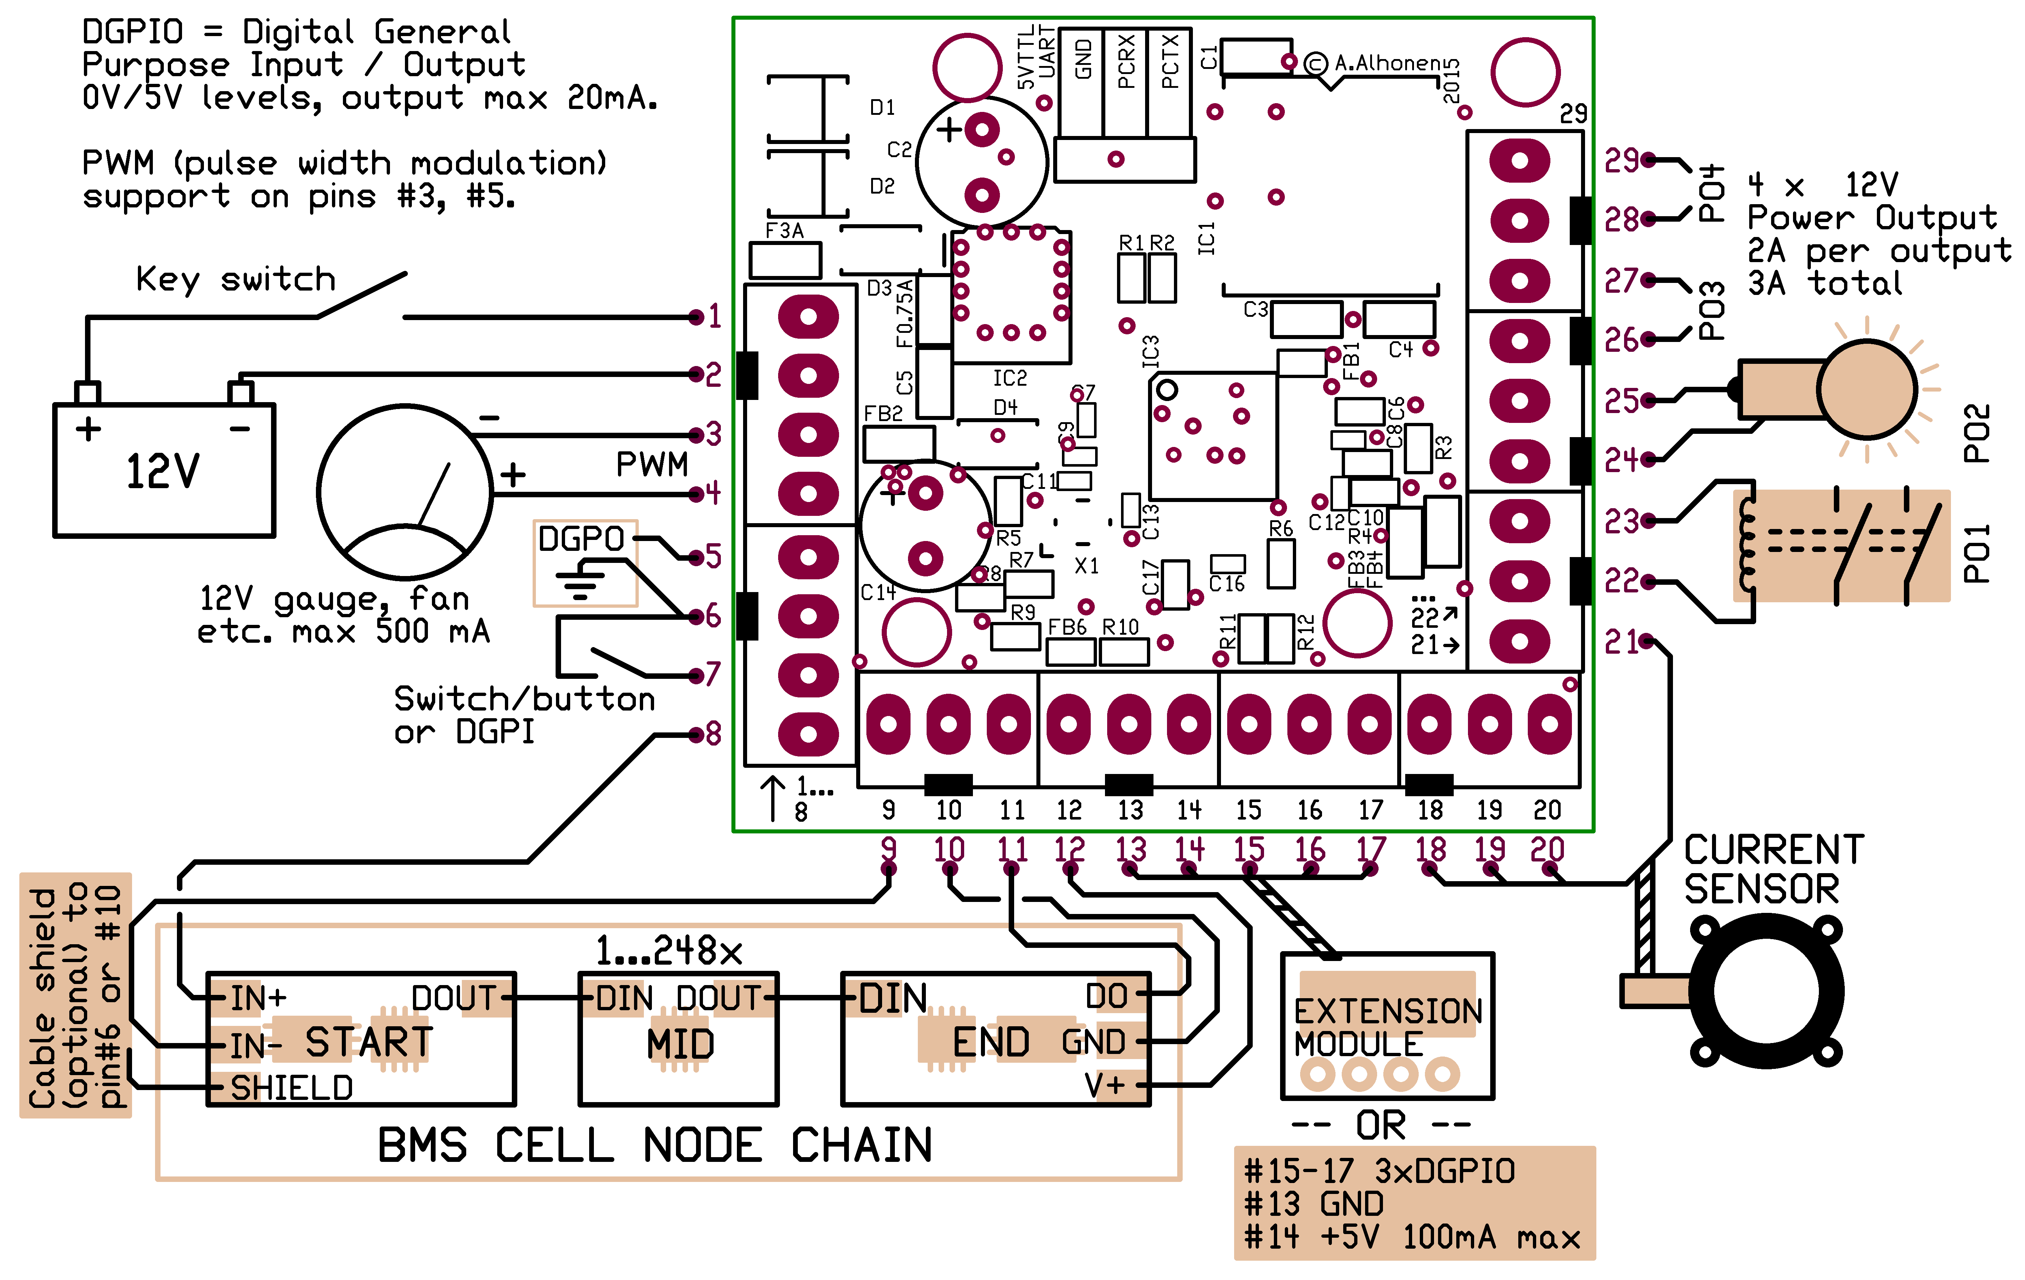

Electrical ratings

Power Outputs
Power Outputs PO1–PO4 switch the 12V input power on/off on their outputs. The voltage is approx. 0.5V lower than the input supply due to protection diodes.
Power Outputs can supply 2A each. Please note that the 12V power side is protected with a 3A SMD fuse which can blow if the total output current in Power Outputs and PWM Power Output exceeds 3A for several seconds, or xxx A for xxx seconds.

PWM Power Output
PWM Power Output switches the 12V input on/off. It can be used as an extra power switch, or in PWM mode. In PWM mode, output is switched at xxx kHz. This provides smooth, stepless analog-like control for gauges, fans etc.
Watch out for maximum peak load of 3A for xxx µs, or 1A for 100 ms. Continuous load must be < 0.5A. This output is fused from the same 3A SMD fuse with the Power Outputs.

Digital GPIO
Digital GPIOs are weakly protected against voltage transients, overcurrent and ESD. You must maintain the voltage at these pins between -0.3 and +5.3V all the time and beware of electrostatic discharge events. If there is a risk that external voltage would be injected to these pins while the Master is unpowered from the 12V input line, it is recommended that you add an extra series resistor of at least 470 ohms to prevent erroneous behavior and damage.
Digital outputs are 5V push-pull sources equipped with a 120 ohm series resistor and can withstand short circuit (35..40 mA) for 1 second. The outputs can be loaded with max. 25 mA; an LED can be connected directly.

Configuration – understanding the values
XXXBMS offers flexible configuration to suit many different uses. The downside is that there are numerous configuration parameters you need to be aware of. You also need to understand the limiting datasheet values for the battery cell technology – this is true when configuring any BMS.
The foremost task of any BMS is to individually measure the voltage and temperature of all series battery cells. The ”worst” cell always defines the state of the battery pack; if any cell is going out of its limiting values, charging or discharging is stopped.
The secondary (but still extremely important) function is to provide the user with information, most importantly, state-of-charge (SoC), the percentage of usable charge (or energy) left in the battery pack.
It is important to understand that the measurement of SoC is never trivial. Looking at the cell voltage gives usable approximations only under zero load, and only with some battery chemistries. Another method, current integration (aka Coulomb counting), can give accurate reading of energy used so far, but can estimate energy left only if battery is completely discharged once in a while (i.e., a few times per year) so that the system can keep up with the actual battery capacity which diminishes when the battery ages.
XXXBMS utilizes two different setting for what is considered "empty" – a so-called 0% point, and the cutoff point. The 0% point is set to a point in the cell discharge curve which is steep enough to be clearly identified. In practice, it means that the BMS instructs the user to take immediate action to stop the discharge, e.g., to safely stop the vehicle. 0% point resets the Coulomb counting, giving the BMS the opportunity to measure the actual battery capacity.
If the cutoff point is ever reached, the BMS takes immediate action to shut down the discharge. System designer must design so that the BMS can take the action; the easiest way is to use a power contactor inside the battery pack and configure the BMS to shut it down, removing power from all loads.
Cutoff point is specified in the cell datasheet. Difference between the 0% point and the cutoff point cannot be too large, because the 0% point must be in the steep section of the cell voltage curve to be identified reliably. Otherwise, temperature and load conditions may give false 0% status too early. Still, setting the 0% point and cutoff point slighly apart has the advantage that there still is a percent or two usable charge left, which can, for example, enable driving the vehicle to the nearest power outlet in urban environment (possibly within 1 kilometer).
Because both 0% point and cutoff point are voltage-based, load and temperature conditions affect them due to the internal DC resistance of the cell (i.e. voltage drop or sag). XXXBMS can compensate for this voltage sag, but caution must be taken not to overcompensate, especially if the cell datasheet does not provide enough information.
For example, typical cell datasheet may specify that the cutoff voltage at room temperature and C/5 load is 2.5V. To be on the safe side, use this as the final cutoff voltage. However, it usually is acceptable to go slightly below 2.5V during short current pulses which greatly exceed the specified C/5 test current. But every cell technology is different; when in doubt, obey the datasheet limits.

