PuluTOF1 Development Kit of Four Sensors
Typical applications

- Simultaneous Localization and Mapping
- Autonomous Mobile Robot Obstacle Avoidance and Route Planning
- 360° Environmental Scanning
- Gesture Recognition & People Counting
- Object Counting & Volume Measurement
- Generic 3D Point Cloud Generation
- Modeling of Moving Targets and Environments
- Real-time Applications
- Low-Cost Applications
- Technology Evaluation
- Academic Research

Pulu Robotics Oy, Tampere, Finland

Datasheet & Manual v. 0.11

Features & specifications
(on stock firmware)

- Sensor Technology: Real-time 3D Time-of-Flight
- Sensors: 4 modules 9600 pixels each, connected to the master board with flat flex cables
- Distance measurements: 160x60 pixels / sensor, total 28.4 kDistances / frame
- Instantaneous Field of View (FOV): 110°x46° / sensor
- Peak optical power: 8 W 850 nm NIR
- Minimum distance: 100 mm
- Maximum distance: typically 4-5 meters depending on external light and material reflectivity
- Accuracy & noise: Typically +/- 50 mm or +/- 5%
- Ambient light: works in direct sunlight with reduced accuracy and range
- 3-level HDR (High Dynamic Range) imaging
- Error detection and correction:
  - Dealiasing
  - Interference removal
  - "Mid-lier" (flying pixel) removal
  - Temperature compensation
  - Offset calibration
  - Modulated stray light estimation & compensation
  - Producing fault-free point cloud, especially designed for mobile robot obstacle mapping
- 10 Frames Per Second (kit), 2.5 FPS (per sensor)
- Interface: SPI. Compatible w/ most single-board computers
- Raspberry Pi 3 compatibility: Specifically designed to work as a HAT (hardware attachment)
- Supplied example software saves .xyz point cloud files
- Most specifications can be extended within physical design limitations by modifying the stock firmware

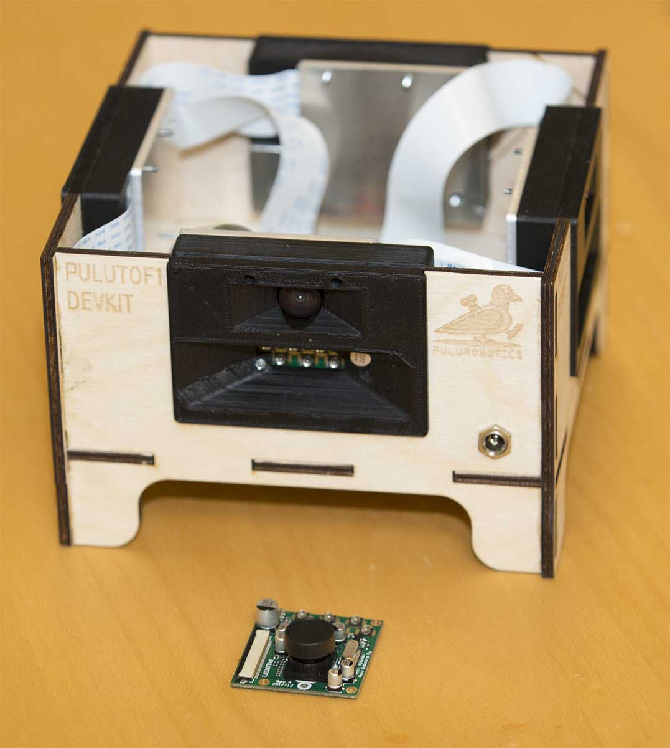

Licensing

- Open Source GPL2 low-level firmware allows working around application-specific requirements, formerly very difficult to deal with
- Open Source GPL2 linux example software (written in C) is delivered as is for development purposes
- RESTRICTION: An internal firmware piece of the imager chip (called "sequencer program") is Copyright Espros Photonics Corporation, licensed to be distributed to our direct customers only, and is non-redistributable.

Document revision history

2018-06-20 A.A. Added document revision history. Internal release.
2018-07-?? M.O. Added pictures
2018-08-02 A.A. Updated maximum operating voltage
Hardware information

Power supply

Main power supply: 18V to 20V, at least 1.3A.
Suggested AC adaptor: MEANWELL GST25A18-P1J, supplied in standard package
Power consumption: 5W (20W peak)

(Raspberry Pi 3: 5V, at least 1.5A recommended. Please refer to Raspberry Pi documentation.
Suggested AC adaptor: Official Raspberry Pi power supply)

Most of the kits sold have been modified to include a 5V DC-DC supply for the Raspberry Pi - in this case, only the 18V-20V power supply is needed.

3.3V Logic Power Supply (optional)

Your PuluTOF1 Master comes factory-connected to utilize the Raspberry Pi 3’s internal 3.3V supply through the HAT connection – approx. 100 mA is consumed. If you want to use another 3.3V supply, remove the jumper cable and supply 3.3V through connector P3 pin #4. See the PuluTOF1 Master schematic for more detail.

Additional IO connector on PuluTOF1 Master (optional)

PuluTOF1 has an additional 8-pin IO connector (designator P3), which can be freely used in your own firmware modifications. The pinout is:
#1: SPI MOSI
#2: Not Connected
#3: SPI MISO
#4: +3V3 supply for PuluTOF1 – approx. 100mA usage
#5: SPI SCK
#6: GND
#7: SPI nCS
#8: Not Connected

Example uses of this connector include:
1) Triggering the acquisition
2) Providing external time-sensitive information such as real-time robot position, which can be augmented in the distance data packet

Stock firmware implements the following default functionality for this connector:
1) PuluTOF1 Master works as SPI slave on this connector, and expects standard SPI communication initiated by the other device.
2) Expected SPI datagram is delimited by the nCS signal, with continuous transfer of 12 bytes, with inter-frame gap of at least 10µs.
3) When nCS goes high to signify end-of-transfer, these 12 bytes are stored and copied as is to the next distance measurement data structure (pulutof.h: pulutof_frame_t.robot_pos).
4) This data can be used for a free-running timestamp, robot pose, or similar purposes, for real-time moving camera applications, to avoid skews caused by data processing delays.

Pulu Robotics’ RobotBoard Rev1B supplies 3.3V and outputs the robot pose at 1kHz update rate through this connector.

Thermal considerations of the sensor modules (optional)

The supplied aluminum heatsinks on the back of the sensors are good for the stock firmware and operating ambient temperatures up to +45 deg C, when proper air flow is allowed (i.e., they are not covered).

If you modify the firmware for higher framerate, longer integration time, or otherwise change the imaging pattern, or use the sensors in higher ambient temperature, you should perform your own thermal evaluation. Excessive temperatures (over 50 degree C measured on the heatsinks) may cause measurement drifts due to imperfectly tuned temperature compensation, and reduce the lifetime of the devices. In all cases, higher temperatures reduce the peak optical power, shortening the maximum measured range slightly.

When mounting the sensors in your own application, make sure you leave the supplied aluminum plates uncovered for air to move around them. Avoid accidental thermal insulation caused by thermally non-conductive materials such as closed plastic structures, etc.

For increased cooling in conditions where the supplied heatsinks would get blocked, we recommend that you mount additional metal heatsinks directly on the existing aluminum backplate, using thermally conductive paste, tape, glue or pad material. Use materials designed for good thermal conductivity.

With the stock firmware, average power dissipation of a single sensor is approx. 1.2W, which is fairly easy to dissipate giving the area of the backplate.

WARNING: Opening the four small screws that fix the lens hood, the circuit board, and the aluminum backplate together, poses a high risk of accidentally breaking something, or not being able to put the sensor back together correctly. The warranty is void in this case. For this reason, please do not try to attempt increasing cooling by completely replacing the aluminum backplate; instead, mount extra cooling to the existing backplate. If you absolutely need to replace the backplate with your own, please contact us for more information (and replacement sensor modules if required).

Mechanical
* Mounting on standard tripod screw 1/4"-20
* Mounting on standard M4 screws
* Can be mounted in two ways (90 degree rotation)
Maximum recommended cable length 500mm.
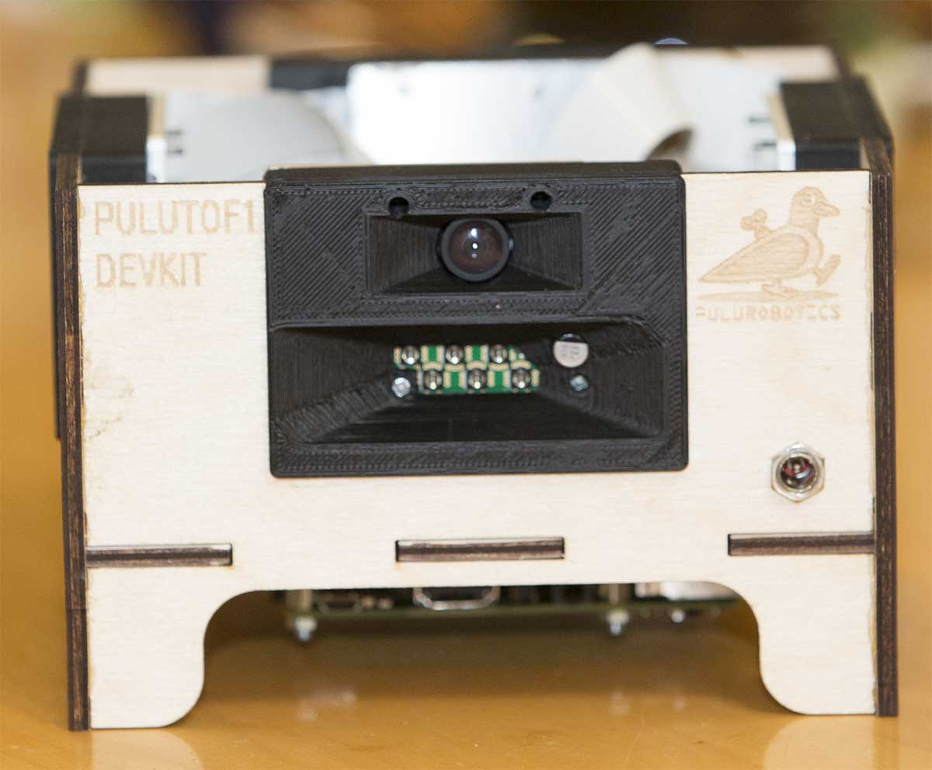
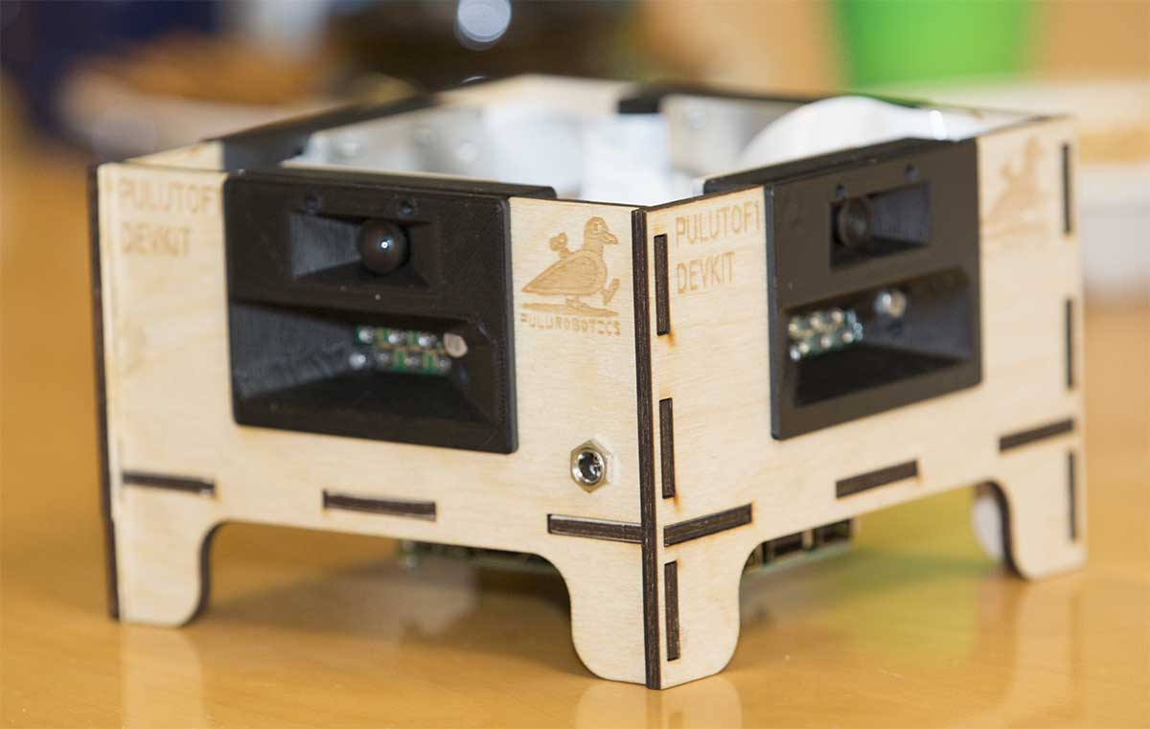

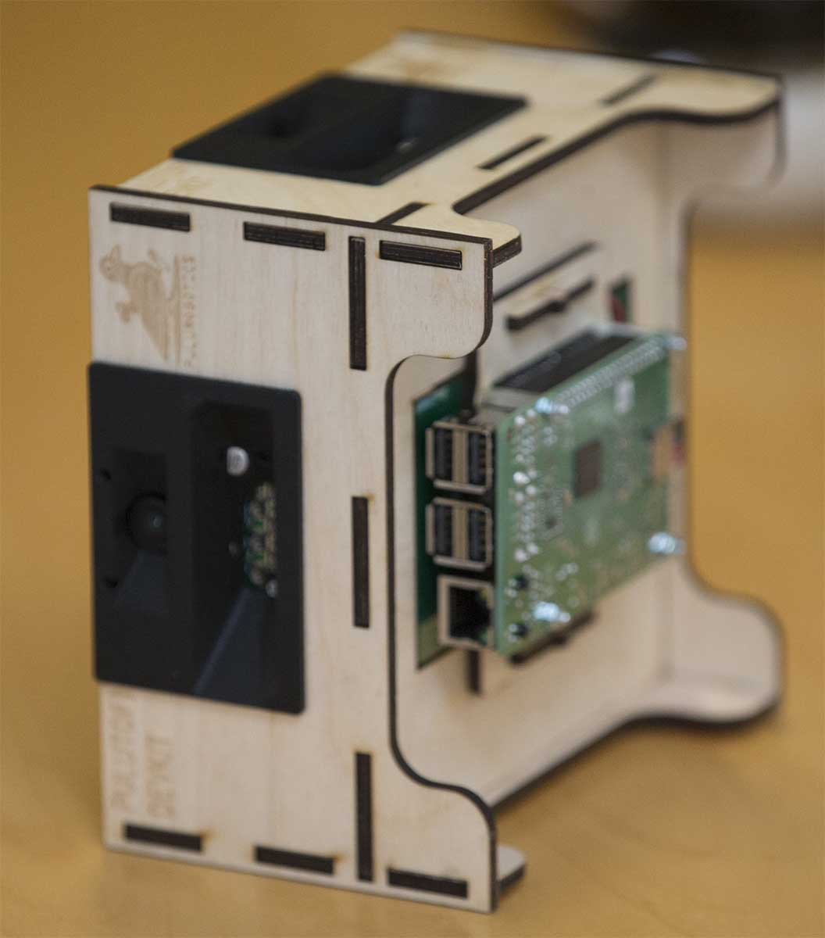
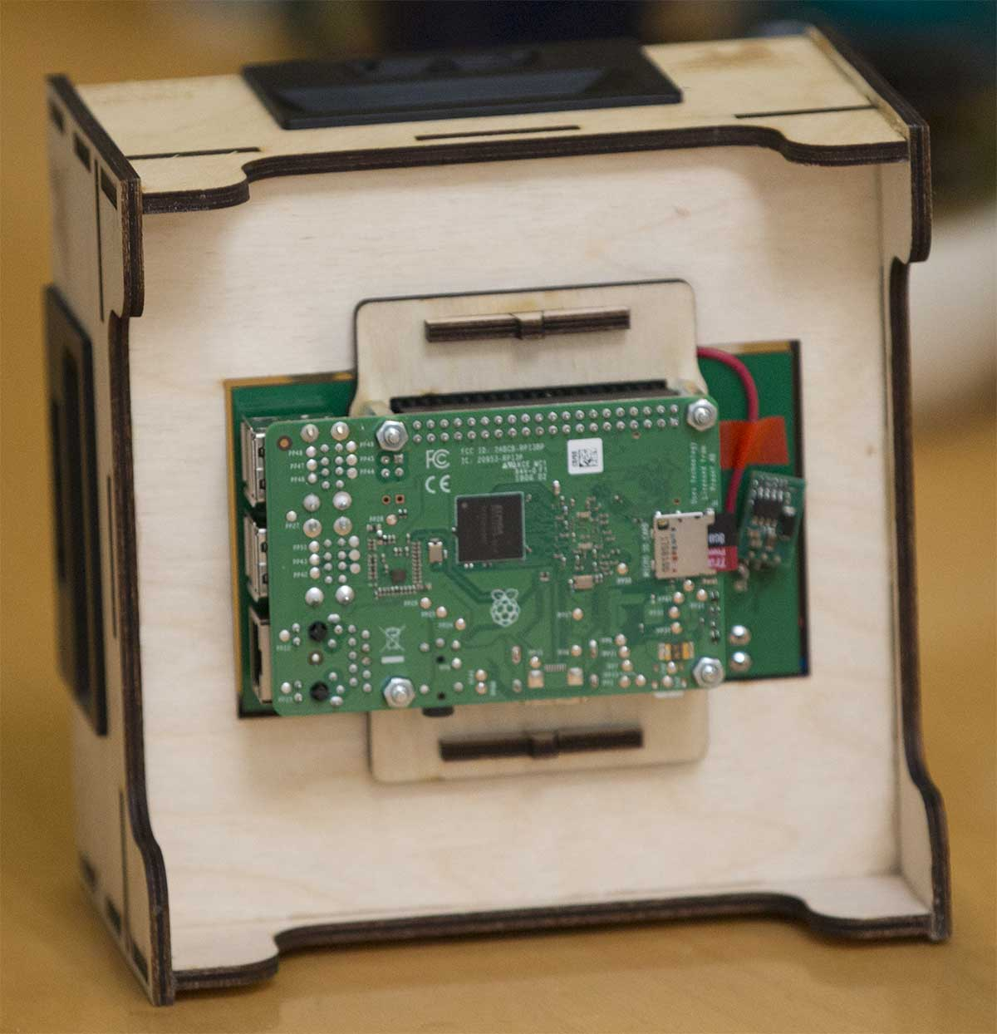

Software

Logging in with pre-installed Raspberry Pi

If you bought your PuluTOF1 with a pre-installed Raspberry Pi, please follow this step.

To access the Raspberry, create a wifi hotspot/access point with
SSID = pulu
PASSWORD = pulupulu

The Raspberry will connect to this network automatically. Join the same network, and investigate the Raspberry’s IP address:
A) by looking at your Wifi hotspot’s connected device list, or
B) by using network spying tool – for example, if your own computer got an IP address of 192.168.55.123, use:
nmap -sn 192.168.55.0/24

The default user installed is pulu, with password pulupulu. Once logged in, for security, please change the password.

Software is already installed in /home/pulu/pulutof1-devkit. You can do
git pull
make

to update to the newest software from our Github repository.

Installation

If you bought your PuluTOF1 with a pre-installed Raspberry Pi, you are good to skip this step. Otherwise, please read on!

Log in on your Raspberry Pi. The examples below assume you log in as user pi.

We recommend that you install git:
sudo apt-get install git

Then, you can fetch the newest software:
git clone https://github.com/siwastaja/pulutof1-devkit.git

Go to the directory created:
cd pulutof1-devkit

Then compile the devkit software:
make

You are good to go.

Reset, stopping and starting up again

Reseting the PuluTOF1 is not normally necessary. If you need to do it, run:
./spiprog r

When powered up, PuluTOF1 normally starts to acquire depth images. You can always keep it running while powered, that’s OK.

If you still want to shut it down while keeping the Raspberry Pi powered, for example, to save power consumption, run:
./spiprog d

This command shuts down the sensor modules, stopping their LED power supply as well as their analog power supplies, while keeping the digital power supply enabled.

To restart the board after this, run
./spiprog R

Getting your first point cloud

When you see the IR LEDs on the modules blink (it’s visible to the naked eye as dark red), your PuluTOF1 already generates data, and is just waiting for you to read it out.

To start saving continuous point cloud, run
./main -p > pointcloud.xyz

To stop, type q and enter.

Currently implemented interactive commands
Run
./main

The following keyboard commands are available. Pressing enter after the letter is required.

v Toggle verbose mode: prints technical details of the received data packets.
p Toggle point cloud file output mode between: 1) no output, 2) output with local zero coordinates, 3) output in unified coordinates
0 Do offset calibration for sensor 0
1 Do offset calibration for sensor 1
2 Do offset calibration for sensor 2
3 Do offset calibration for sensor 3

Offset calibration is normally not needed by the user. If the flash memory is corrupted for any reason, the offset calibration is performed as follows:
1) turn the verbose mode on
2) Put a dark or black target, at least 6x6 cm in size, middle in the front of the sensor being calibrated, 7.5 cm away from the sensor
3) Run the calibration command until you see the verbose data stopping for a while (typically 5 seconds), then check the dbg[7] value in the verbose print for status code: 0 = success, others = failure.
4) Repeat for all four sensors

Programming custom mounting patterns

The PuluTOF1 software automatically joins the four sensor images together, to a single point cloud with unified coordinates. For this to work, you need to tell the software where the sensors are actually located and in which directions they are looking at. Everything is preconfigured to work out of the box, but most likely, at some point, you’ll get rid of our factory mount and want your own arrangement.

With the stock example software, dynamic (moving) configuration of the sensors is not currently supported. Static mounting points are configured by modifying pulutof1.c. Find this line:
static const sensor_mount_t sensor_mounts[NUM_PULUTOFS] =

The four sensor configurations follow, the first one is indexed by “0” as printed in big silkscreen font next to the relevant connector on the PuluTOF1 Master.

The parameters to configure, in this order, are:
mountmode: Rotation of the sensor. Please look at the sensors directly from the front side. You’ll see the camera lens, which is:
- On the left – mountmode = 1. Vertical FOV is 110°
- On the right – mountmode = 2. Vertical FOV is 110°
- On the bottom – mountmode = 3. Vertical FOV is 46°
- On the top – mountmode = 4. Vertical FOV is 46°

x_rel_robot: the camera module x coordinate in your point cloud coordinate system.
y_rel_robot: the camera module y coordinate in your point cloud coordinate system.
ang_rel_robot: the camera module’s horizontal rotation angle, 0 = the direction of positive x coordinate, typically East. Increasing values turn counter-clockwise. For example, DEGTORAD(45) means that when viewed directly from the sky, the camera looks North-East.
vert_ang_rel_robot: the camera module’s vertical rotation angle. Zero looks directly sideways, looking towards the horizon. Positive values look up. For example, DEGTORAD(90) would look directly to the sky.
z_rel_ground: The z coordinate of the camera module from your zero level.

After you modify this table, you need to recompile the software. Run:
make

Firmware update

- Look at the Pulu Robotics website for a new firmware. See if it
- Download the new binary (if available) from the Pulu Robotics’ website
- Run: md5sum new_firmware.bin
- Compare the md5sum hash against the one posted on the download page, to make sure your download is non-corrupted. The hashes need to match.
- Run the firmware update:
./spiprog r new_firmware.bin

Firmware is transferred to the PuluTOF1 Master through the SPI interface. The data is checksummed during transfer. Firmware update code verifies there are no transfer errors before actually erasing and writing the microcontroller flash memory, so the process is robust against errors.

Do not power off the device during firmware update – this may corrupt the device. If this happens for any reason, the master can always be recovered using a simple USB-TTL Serial interface cable. For more information, please contact us.

Firmware development

WARNING: Firmware development for such embedded device always requires experience and understanding of microcontroller development. Pulu Robotics Oy cannot assume any responsibility or liability of broken hardware, or any damages, material or personal, resulting from modifying the stock firmware, or writing your own. Our resources to support customer’s own firmware development are limited. This means that using custom firmware will officially void the warranty.

REMARK: When looking at studies (academic, corporate or hobbyist) on existing 3DTOF cameras, it became apparent there is frustration about hardware limitations which would be extremely straightforward to solve on the 3DTOF camera firmware level, but are complex or impossible to solve with post-processing. Since 3DTOF is never 100% perfect, different applications require different optimizations. We developed PuluTOF1 for robot mapping and navigation planning, but some applications can be quite different. This lead us to provide the open-source firmware. We are always interested in hearing about your specific use case and its peculiar constraints.

NOTE: For firmware development, to avoid frustrating delays, it’s highly recommended that you buy a 3.3V-compatible USB-TTL Serial interface cable beforehand. If there is any such mistake in compilation flow, or modification of relevant code, that would result in a non-working reflasher code (including the application code to enter the reflasher), our normal firmware update mechanism will not work anymore. In this case, the chip can be only reprogrammed through the non-eraseable ST’s factory bootloader through 3.3V UART.

For your own firmware development, experience in ARM Cortex-M and STM32 embedded development is assumed. We prefer a simple, universal & standard environment only based on gcc-arm-none-eabi and make, but you could import the code to the IDE of your choice. To compile our stock firmware:

Download and install the gcc-arm-embedded toolchain from
https://launchpad.net/gcc-arm-embedded

Download our firmware sources:
git clone https://github.com/siwastaja/pulutof1-fw

Compile it:
make

main.bin is generated and can be upgraded using the standard firmware update procedure.

