Deploying WebApp in IIS Default WebSite:

1. Activate the IIS Feature on your Server.

* We aim to support IIS 7.0/7.5/8.0

2. Install .NET 4.5

Download from <http://www.microsoft.com/en-gb/download/details.aspx?id=30653>

* Run as Admin
* By installing .NET 4.5 *after* activating IIS, .NET 4.5 should add itself to IIS
* After install, Microsoft .NET 4.5 should appear in “Control Panel\All Control Panel Items\Programs and Features”

3. Add IIS 7.0/7.5 fix for WebApp URL Routing

* Download from <http://support.microsoft.com/kb/980368>

4. Configure Application Pool

* DefaultAppPool should use .NET Framework **v4.0**, **Integrated** Managed Pipeline.
  + DefaultAppPool is over interest, because it is the Application Pool used for scripts executed in the Default Web Site
* If .NET Framework is not v4.0, right click on the pool, and select Basic Settings from the context menu.
  + Set the .NET Framework to v4.0, and the Managed Pipeline to Integrated.

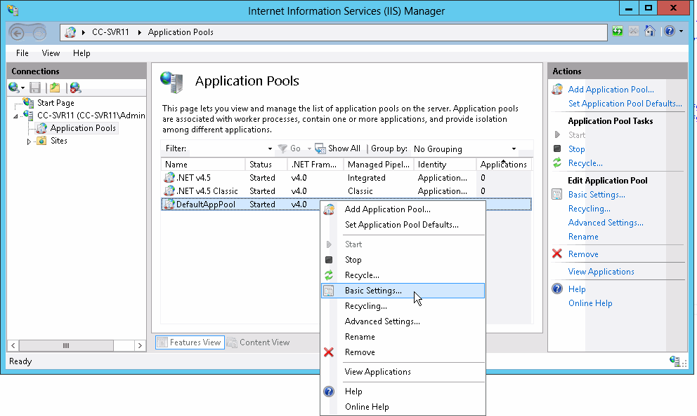

* If v4.0 is not available as option, look at the additional advice under the heading “Setting the Default Application Pool to .NET 4” at <http://www.asp.net/web-forms/tutorials/deployment/deployment-to-a-hosting-provider/deployment-to-a-hosting-provider-deploying-to-iis-as-a-test-environment-5-of-12>

5. Add Application

* If the WebApp binaries are not already on your machine, unzip them into a folder under the Default WebSite
  + E.g. C:\inetpub\wwwroot\ssd
* In the IIS Manager, right click on the “Default Web Site” and select the Add Application option from the context menu
  + Under the context menu, use the alias ‘ssd’, and select the folder with the WebApp binaries

