***Lab #1 Programming Techniques In Java (CENG 212)***

# Lab reports are due at the end of the second weekly lab session. Submission consists of the hard copy print out of this completed handout AND an online submission of all of your uncompressed FirstnameLastname_*.java source code files in a single submission attempt. Please do not leave attempts in progress for an extended period of time.

|  |  |
| --- | --- |
| **Student Number:** | |
|  | |
| **First Name :** | **Last Name:** |
|  | |
| **Lab day /date :**  **Lab Time:** | **Lab section:** |

**Before completing this lab handout:**

1. Ensure that you have a computing account and know your password.

# Purpose:

Introduction to Java. This assignment displays the list of even numbers and odd numbers from a starting number to ending number. Both the starting number and ending number are provided by the user.

# During the lab:

**PART I:**

# Run through <https://github.com/six0four/ceng212#lab-01-session> - complete incomplete

# Show the professor, then continue to do the below.

**PART II:**

When the application is executed, it displays ***your full name*** and ***your student number*** on the top right hand corner of the display as given below:

Name: Muhammad Khan

Student Number: N01234567

The application then asks the user to “Enter starting number:”

User enters this number.

The application then asks the user to “Enter the ending number:”

User enters this ending number.

If starting number is greater than the ending number, the application prints a message, “Starting number must be smaller than the ending number” and the application then ends (System.exit(0) ends the application). **2 Marks - complete  incomplete**

If the range is valid, i.e., starting number is smaller than the ending number, then the application displays: **1 Mark - complete  incomplete**

Printing even numbers:

Even number is: #

Even number is: # ….

Count of even numbers is: # 3 **Marks - complete  incomplete**

Printing odd numbers:

Odd number is: #

Odd number is: # ……

Count of odd numbers: # **3 Marks - complete  incomplete**

Overall application with documentation **1 Mark - complete  incomplete**

**Samples given below:**

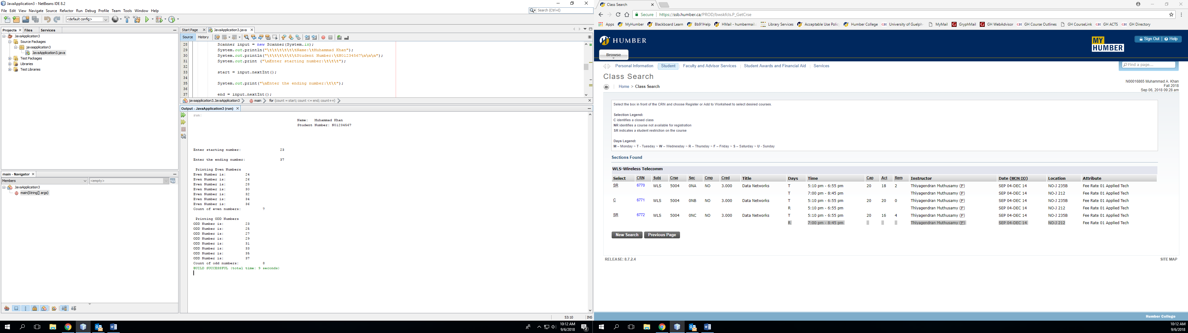

**Sample for Invalid range:**

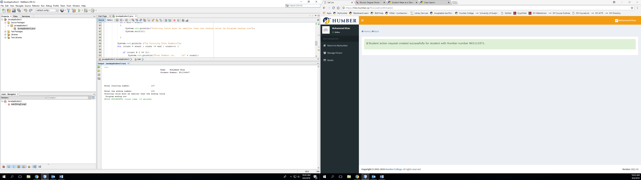

**Sample with valid Negative range of numbers:**

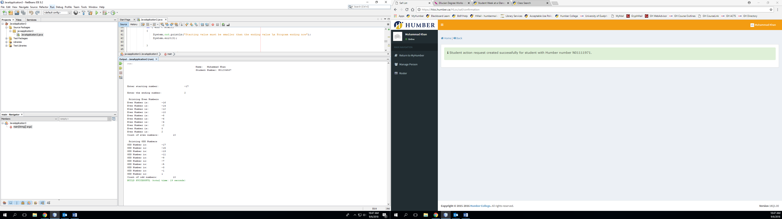

**Coding:** (Copy and Paste Source Code here)

**Testing:** (Describe how you test this program)

Completed lab submission must include ***copy of source code***, execution of valid range of numbers, execution of invalid range of numbers. ***Copy source code*** and ***copy display from executed codes***, in word document and upload it as assignment 1 on blackboard. Blackboard accepts only WORD document as other document format (e.g. Java file etc.) may not be displayed for marking.

# Submit the following items:

1. Compile, Run, and Submit (you must submit the programs regardless whether they are complete or incomplete, correct or incorrect) – please mark the appropriate boxes for complete/incomplete. Submit all of your uncompressed e.g. FirstnameLastname_PartI.java, FirstnameLastname_PartII.java source code files in a single blackboard submission attempt. Please do not leave attempts in progress for an extended period of time; AND,
2. Print this Word file and submit the completed hard copy to me at the end of the lab session on your second lab day.