How blade entry (catch) and exit (release) points are calculated
PadViz7 CatchEvents engine + the Phase-9 feasibility study — 21 Jul 2026

Scope and provenance
This note explains how the visualiser decides when each paddle blade enters and leaves the water, and where (in the boat's frame) that happens. It embeds the PNG images that sit next to it in visualisation/.
Those images were NOT produced for this note — they were generated earlier by visualisation/stroke_catch_explore.py (the Phase-9 feasibility study, first run on the 16 Jul 2026 field data). They are included as the evidence the method is sound; you can regenerate any of them yourself:
python visualisation/stroke_catch_explore.py <segment>
# <segment> is one of: right1 left right2 zero (default right1)
Two closely related things are described:
- A. The feasibility study (Python, stroke_catch_explore.py) — proves the physical signals exist and are repeatable. This is what the images show.
- B. The live detector (Processing, PadViz7/CatchEvents.pde) — the code that actually places the entry/exit dots in the left-hand Entry/Exit panel during playback. Same physics, production-friendly filters.
B is a faithful port of the method A validated, so they agree by construction.

1. The core idea — two independent questions
A stroke's catch/release is found by combining two things that come from different sensor channels, so they cross-check each other:
- Where is the blade? — from ORIENTATION (the quaternion). The paddle shaft is the sensor's body +X axis. Rotating that axis into the world tells us which blade is low (near/under the water) and which is high (in the air). A blade is 'in the water' for the run of frames where its tip sits below the shaft centre.
- When does it hit / leave the water? — from the ACCELEROMETER. Water entry and exit are little impacts: a short burst of 8-30 Hz vibration ('thud'), far above the slow ~0.5-1 Hz rocking of the stroke. The loudest burst in the descending part of an in-water run is the ENTRY; the loudest in the rising part is the EXIT.
Orientation gives the coarse window and which blade; the high-frequency impact envelope gives the sharp timestamp inside that window.
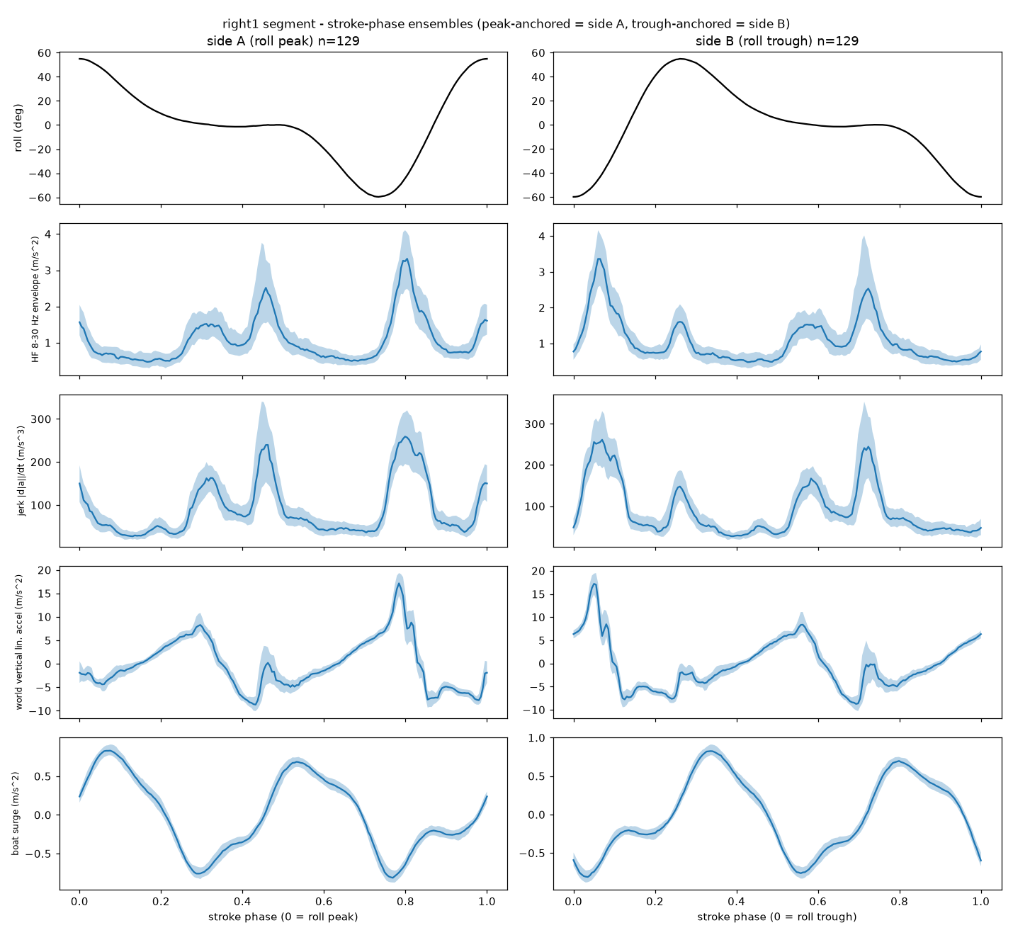
Figure 1 — catch_ensemble.png (right1 segment). Every cycle is time-normalised to a 0->1 phase and averaged. Row 2 (HF 8-30 Hz envelope) shows FOUR sharp bumps per full cycle = 2 entries + 2 exits (right in, right out, left in, left out). That the same four bumps line up with tip-height crossings and boat surge is the proof they are real catch/release impacts.

2. Per-frame signals (CatchEvents.pde, compute())
For every frame i:
- amag[i] = |accel| = sqrt(ax^2+ay^2+az^2) — accelerometer magnitude. Orientation-independent, so the impact 'thud' survives however the paddle is held.
Shaft direction in the world = first column of the rotation matrix R(q):
ux = 1 - 2(qy^2 + qz^2)
uy = 2(qx*qy + qw*qz)
uz = 2(qx*qz - qw*qy)
- uzRaw[i] = uz — vertical component of the shaft. +X tip height above the shaft centre = +uz*1.05 m; -X tip height = -uz*1.05 m.
- phi[i] = atan2(uy, ux) — compass heading of the shaft in the world.
- hMag[i] = sqrt(ux^2+uy^2) — how much of the shaft lies in the horizontal plane (scales the blade's XY reach).
- Which quaternion? GRV (magnetometer-free) when the CSV has it (v8.13+), because the fused yaw carries a cycle-periodic magnetic artefact that GRV does not (firmware spec 16.11). Older files fall back to the fused quaternion (status 'approx').
- Impact envelope: hf = bandpass(amag, 8..30 Hz) (2nd-order Butterworth, forward then backward for zero phase), then env = 50 ms RMS of hf — the 'loudness of impact' curve. Its peaks are the events.
- Tip-height driver: uzLp = lowpass(uzRaw, 3 Hz, zero-phase) — de-noised blade up/down signal used to find in-water runs.

3. Finding an in-water run, then splitting it into entry + exit
For each blade (right +X then left -X; sgn = +1 / -1):
A frame is IN WATER when the tip is below the centre by more than LOW_T:
sgn * uzLp[i] * BLADE_L < LOW_T (LOW_T = -0.05 m, BLADE_L = 1.05 m)
Consecutive in-water frames form a RUN [runStart .. runEnd], kept only if its length is between MIN_RUN_S = 0.20 s (shortest credible immersion) and MAX_RUN_S = 4.0 s (longer => the boat is at rest, not a stroke).
Inside a kept run, minIdx is the deepest-tip frame. That splits the run into:
- descending [runStart .. minIdx] -> contains the ENTRY
- rising [minIdx .. runEnd] -> contains the EXIT
The event time in each part is the frame with the loudest impact envelope, accepted only if it clears the impact gate:
best = argmax(env) over that part
accept if env[best] >= envGate, envGate = max(ENV_RATIO*median(env), ENV_FLOOR)
(ENV_RATIO = 1.3, ENV_FLOOR = 0.8 m/s^2)
i.e. the burst must be at least 1.3x the typical background AND above an absolute floor. A gentle dip with no real impact produces no event. This is the whole entry/exit decision; everything else is placing the point in space.
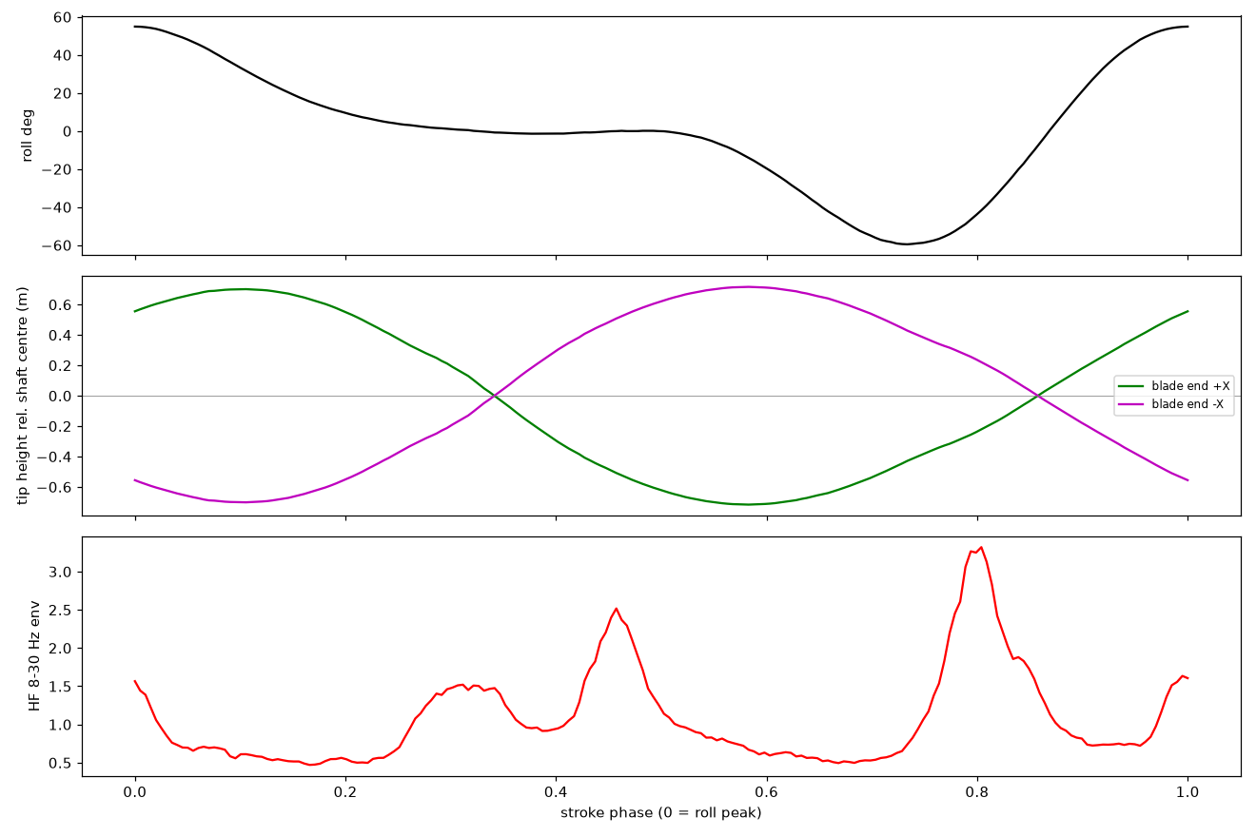
Figure 2 — tip_height.png (right1). Middle panel: tip height of both blade ends (+X green, -X magenta) vs stroke phase; where a curve dips below 0 the blade is under the shaft centre (the in-water window). Bottom: the HF impact envelope. The bumps line up with the start (entry) and end (exit) of each dip.

4. Where the event is drawn (boat-frame XY)
Each accepted event becomes a position in the BOAT frame (+X = starboard, +Y = bow) for the top-down Entry/Exit scatter:
a = phi[best] - psiRef[best] - datumEff (shaft heading rel. to boat, minus datum)
r = BLADE_L * hMag[best] * sgn (horizontal reach of the blade)
xB = r * cos(a)
yB = r * sin(a) + PADDLE_BOW_OFFSET_M (+0.45 m: shaft centre is forward of boat)
- psiRef = the boat's heading at the synced frame (boat GRV yaw preferred; with no boat CSV, a +/-15 s rolling circular mean of the shaft heading — flagged 'approx').
- datumEff = yaw datum = the constant rotation that makes 'shaft +X' read as 'boat +X (starboard)' at rest. Circular mean of (phi - psiRef) over the sidecar rest window (or the whole file if no sidecar), PLUS any manual nudge (yawManualAdjustDeg, the n/N keys). The override exists because the automatic datum was tens of degrees off on some sessions (spec 13.7).
- Side / colour: sensor +X = shaft toward the RIGHT blade (spec 2), so +X events are the right blade, -X the left. If a session's paddle was mounted reversed the colours swap — a physical mount fact, not a software correction (memory project_paddle_mount_diagnosis).

5. The images in this folder
All produced by stroke_catch_explore.py on PadLog20260716.csv / BoatLog20260716.csv. The filename SUFFIX is the data segment:
suffix | segment
(none) | right1 — first steady right-handed stretch
_left | left-handed stretch
_right2 | second right-handed stretch
_zero | zero-feather stretch (anchored on PITCH, not roll, because roll is half-period ambiguous at zero feather — spec 16.10)

catch_ensemble* — the key evidence (Figure 1). 5 rows x 2 columns: left = 'side A' (cycles anchored on the roll/pitch peak), right = 'side B' (anchored on the trough). Rows: 1 anchor angle, 2 HF 8-30 Hz impact envelope (the entry/exit signal), 3 jerk, 4 world-frame vertical accel, 5 boat surge (synced via rx_ms). Look for four bumps per cycle in row 2.
catch_strip* — raw sanity check: a raw, un-averaged 12-second slice — roll (top), HF impact envelope (middle), boat surge (bottom). Confirms the averaged bumps correspond to genuine per-stroke events in the raw data.
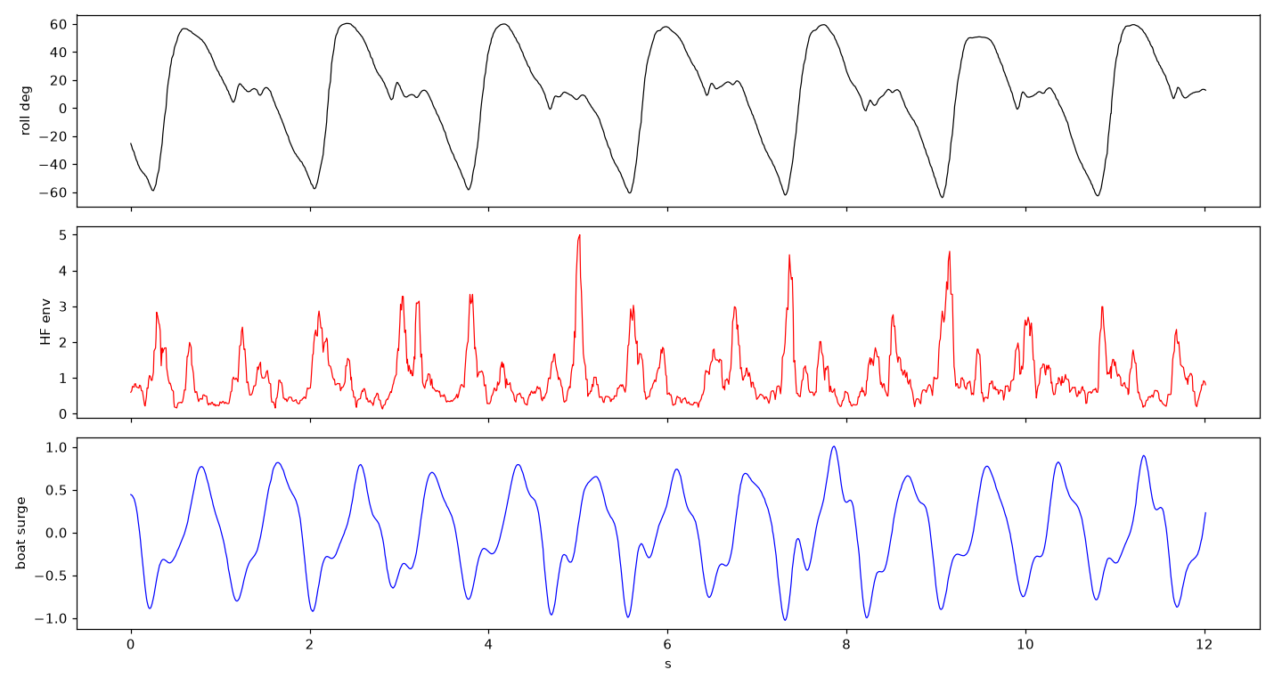
Figure 3 — catch_strip.png (right1).
tip_height* — geometry vs impact alignment (Figure 2).
Zero-feather segment — detection is unchanged; only the cycle anchoring switches to pitch.
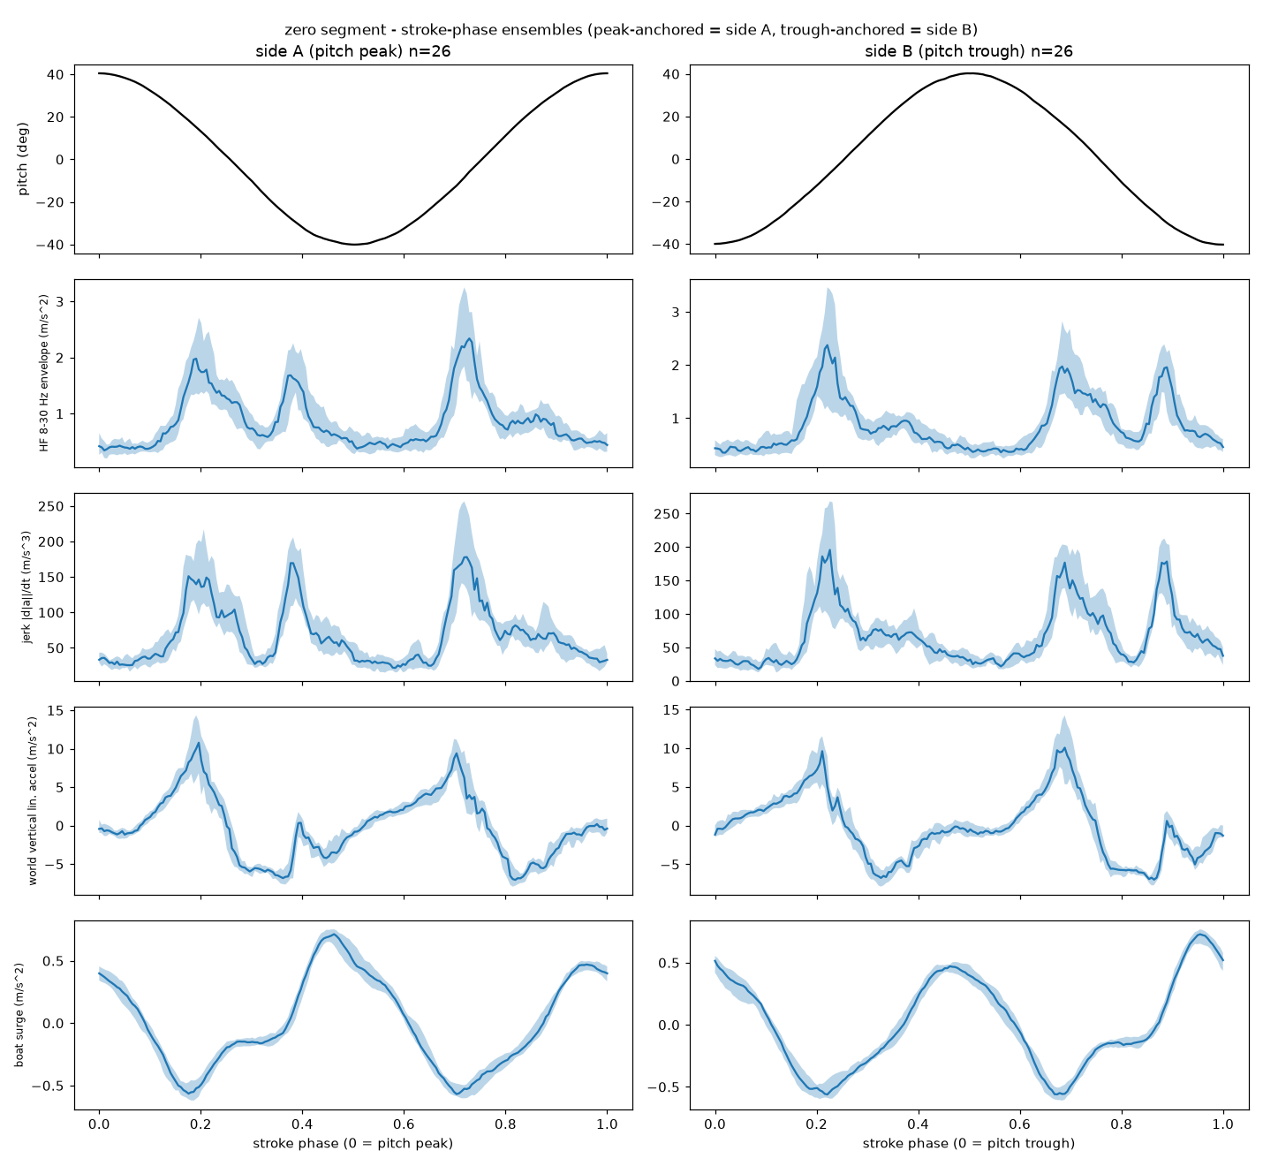
Figure 4 — catch_ensemble_zero.png. The zero-feather stretch, anchored on pitch. The HF impact structure (row 2) is still present per cycle even though the roll waveform is symmetric.
Reported timing sharpness (printed by the script, right1 segment): the HF bumps are phase-locked with a per-cycle jitter of roughly +/-33 to +/-96 ms — tight enough to timestamp a catch to a fraction of a stroke.

Not about entry/exit — don't be misled:
- stroke_compare.png — padnormal vs padbad ROLL waveforms/spectra, from the 11 Jul two-piece-paddle CPM over-count investigation (stroke_compare.py). Nothing to do with catch/release.
- stroke_hifreq.png — high-frequency ROLL content for that same CPM bug (stroke_hifreq.py). Also unrelated to entry/exit.
They live in the folder because they came from a different study; listed only so you know they are not part of this explanation.

6. Feasibility script vs live detector — the small differences
Same physics, different mechanics chosen to suit each environment:
 | Feasibility study (stroke_catch_explore.py) | Live detector (CatchEvents.pde)
Impact band-pass | brick-wall FFT band-pass (offline) | 2nd-order Butterworth, forward+backward (zero phase)
Cycle handling | segments by roll/pitch peaks, ensemble-averages to SHOW structure | detects each in-water run directly; timestamps a single event so dots appear live
Heading / datum | fixed per-segment, exploratory | per-file/per-sidecar datum + saved manual nudge

The images explain and justify the method; CatchEvents.pde is the production implementation of it.

7. Known limits / things that can look wrong
- Yaw-datum error: if the automatic datum is off, ALL entry/exit dots rotate together about the origin. Fix with the n/N nudge keys (saved in the sidecar). A calibration, not a detection bug.
- No boat CSV: heading falls back to a rolling mean of the paddle's own heading — fine for 'which side / how far out', weaker for absolute bearing.
- Pre-GRV files (older than v8.13): fused yaw is used and the status line says 'approx'; expect a little more scatter from the magnetic artefact.
- Zero feather: detection works, but cycle anchoring uses PITCH, not roll (roll is half-period ambiguous) — hence the _zero images anchor on pitch. The entry/exit logic itself (tip height + HF impact) is unchanged.
- Very gentle strokes with no real splash may not clear envGate and so produce no event — by design, to avoid false positives.

Code: visualisation/PadViz7/CatchEvents.pde (live detector), visualisation/stroke_catch_explore.py (feasibility study + images). Spec: visualisation/specs/padviz6_spec.md 13.3 (engine), 13.5 (feasibility), 13.7 (yaw datum override); firmware spec 16.11 (GRV vs fused yaw).

