Paddle instrumentation · dynamic modelling
Where is the paddle?
Estimating where the paddle actually sits — through the whole stroke — from orientation alone, and knowing exactly how far that can go.
Session 30 Aug 2026 · jig-calibrated forward paddling Data 105,522 frames over four turn-free runs · ~18 min · 36–38 CPM Ref functional_spec §8.1.1
The problem, in one breath
You have two motion sensors: one on the paddle shaft, one on the boat. Each reports its orientation beautifully. Neither reports its position.
Knowing which way the paddle points is easy — that is what a quaternion gives you, and the visualiser already uses it. Knowing where the middle of the paddle is relative to the boat, moment by moment, is the hard part, and it matters: it is what tells you whether you plant the blade further forward on the left than the right, how long the blade is really in the water, and where along the hull the work happens.
The obvious idea — take the accelerometers and add up the motion — does not work. Acceleration has to be integrated twice to get position, and every tiny error grows quadratically: a half-degree tilt leaks a slice of gravity into the sum, and within a second or two the estimate has drifted metres away. Two inertial sensors simply cannot measure the changing gap between them by integration. So we need a different route in.
The idea: let the body do the constraining
The paddle centre is not free to be anywhere. It is held in two hands, on the ends of two arms, hanging off two shoulders that sit in a fixed seat. Your reach, your grip, how far you twist and lean — each has a limit. That is a kinematic chain: a linkage anchored at the body that turns the paddle's measured orientation into a position, without any integrating.
The simplest version — and the one examined here — collapses the whole chain to a single pivot. Picture the paddle centre riding on the surface of a sphere centred on your shoulders. The sphere's radius is your reach. As the shaft swings through the stroke, the point rides around the sphere.
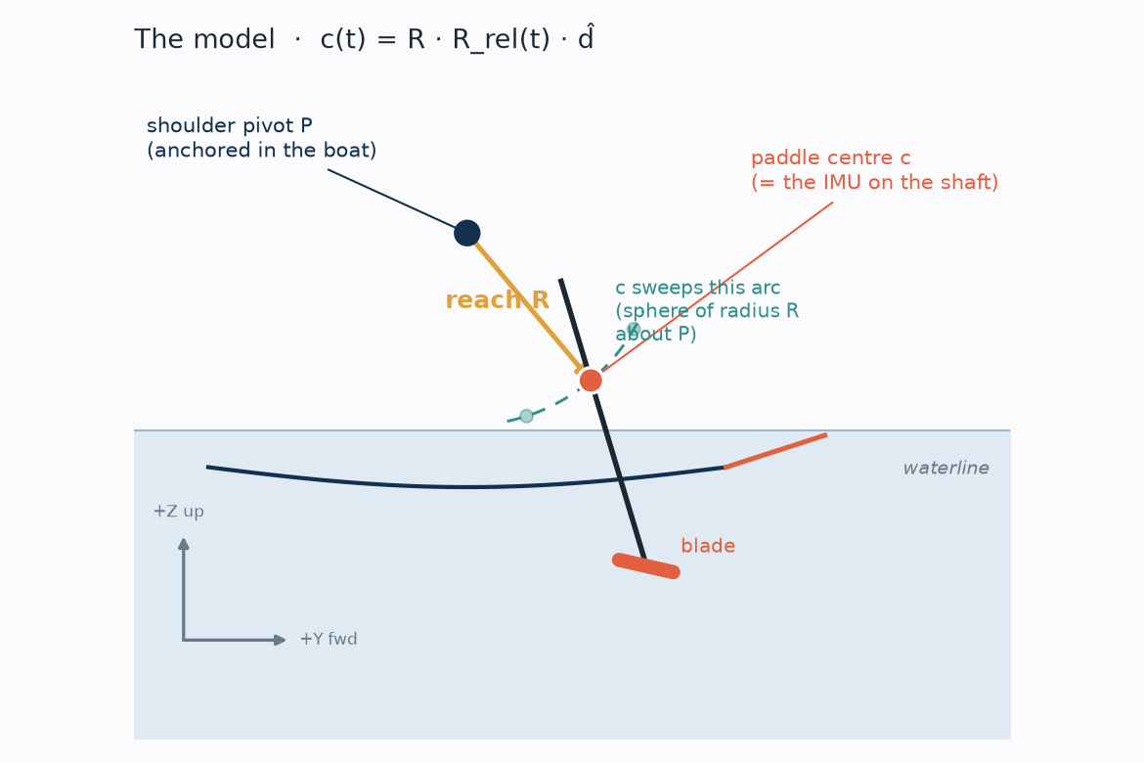The one-pivot arm-swing model. The paddle centre c (the sensor) sits at a fixed reach R from a shoulder pivot P that is anchored in the boat. Its direction is handed straight over from the measured paddle-vs-boat orientation, so as the paddle rotates, c travels the dashed arc. No free knobs, no integration.
Reading the one line of maths
The whole model is a single expression. It looks compact but every piece is something physical:
c(t) = R · R_{rel}(t) · d̂
- c(t)the position of the paddle centre in the boat's frame, at time t — the thing we want.
- Ryour reach: the fixed distance from shoulders to the middle of the paddle (measured, 0.67 m).
- R_{rel}(t)the measured orientation of the paddle relative to the boat — boat sensor and paddle sensor combined, the one quantity both IMUs give us cleanly.
- d̂a fixed direction "out to the paddle" in the paddle's own frame — forward and a little down when at rest.
Read left to right: take the fixed reach-direction d̂, rotate it by whatever the paddle is currently doing R_{rel}(t), scale by the arm length R. Out comes a position — driven entirely by orientation you have actually measured, with just two constants set once from your body.
What it can see, and what it can't
This is the honest heart of it. Because the pivot is fixed, the model can only move the paddle centre by rotating it. When you swing the shaft, orientation changes, and the model follows — that motion is fully observable.
But you also lean and twist your torso. When you do, both hands move together: the paddle translates across the water without changing which way it points. Orientation doesn't budge — so the model, driven only by orientation, stays blind to it. That lean/twist component is the one thing this approach can never recover.
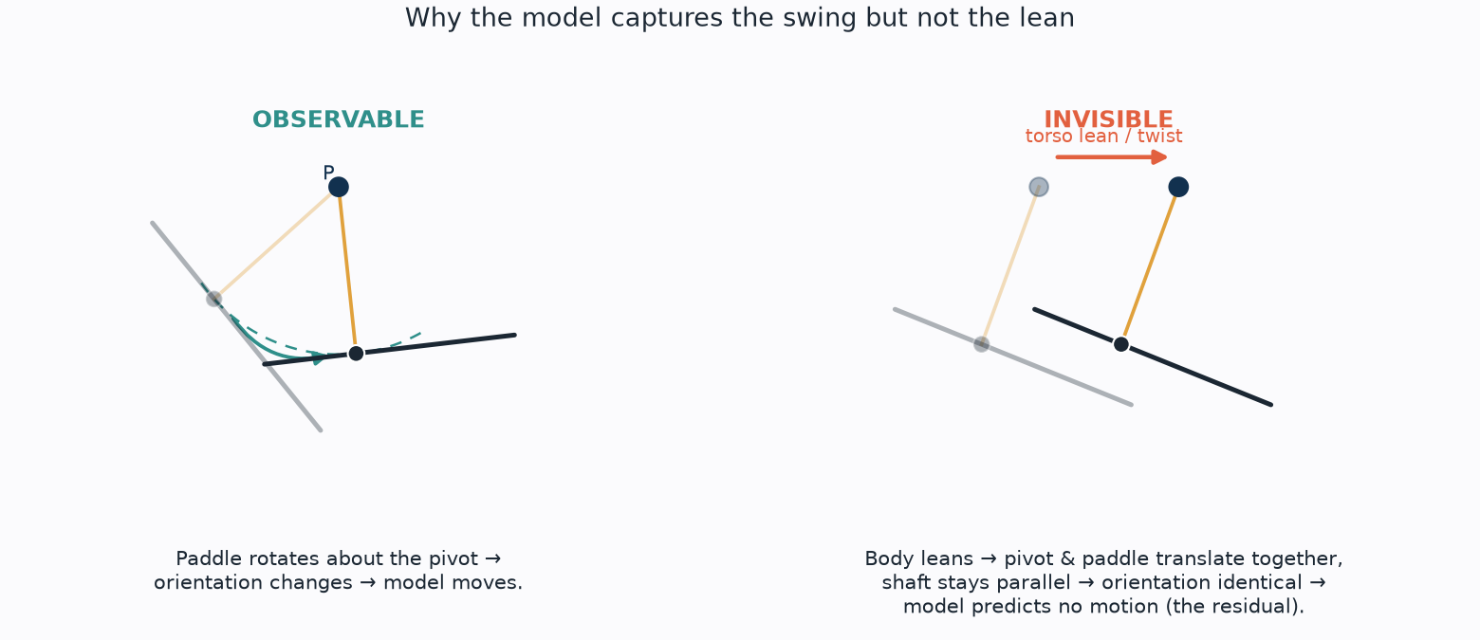The line the model cannot cross. Left — rotating the paddle about a fixed pivot moves the centre along its arc; orientation changes, so the model sees it. Right — a torso lean slides the pivot and paddle forward together with the shaft parallel; orientation is identical, so the model predicts nothing. This is exactly the residual we expect to be left over.
Testing it honestly — without ever knowing the true position
We have no ground-truth track of the paddle centre, so we cannot just compare. But the paddle carries its own accelerometer, and that gives us a way to grade the model that never integrates anything:
- Check the frames first. Rotate the paddle's accelerometer into world coordinates and take the average. It should be pure gravity — [0, 0, 9.8]. It came out [−0.13, −0.28, 9.76], so the orientation maths and the sensor frames are trustworthy before we lean on them.
- Compare in acceleration, not position. Differentiate the model's position twice to get the acceleration it predicts. Separately, take the real accelerometer and strip gravity off — that is the true acceleration of the paddle centre. Both are accelerations; nothing is integrated, so nothing drifts. Ask: how much of the real stroke-rhythm acceleration does the model reproduce?
- Cross-check against the water. While the blade is buried and pulling, the planted tip is nearly still in the world — so in the boat's frame it must sweep backwards at roughly boat speed. GPS gives boat speed independently. Does the model's blade agree?
What came out
The model, fed nothing but measured orientation and two body constants, reproduces well over half of the real paddle-centre motion — and the independent water check backs it up.
54%
of stroke-band paddle-centre acceleration reproduced (overall)
61%
on the forward axis — the direction that matters most
3.50 m/s
modelled planted-blade sweep vs 2.53 m/s GPS boat speed
~40%
left unexplained — the lean/twist the method can't see
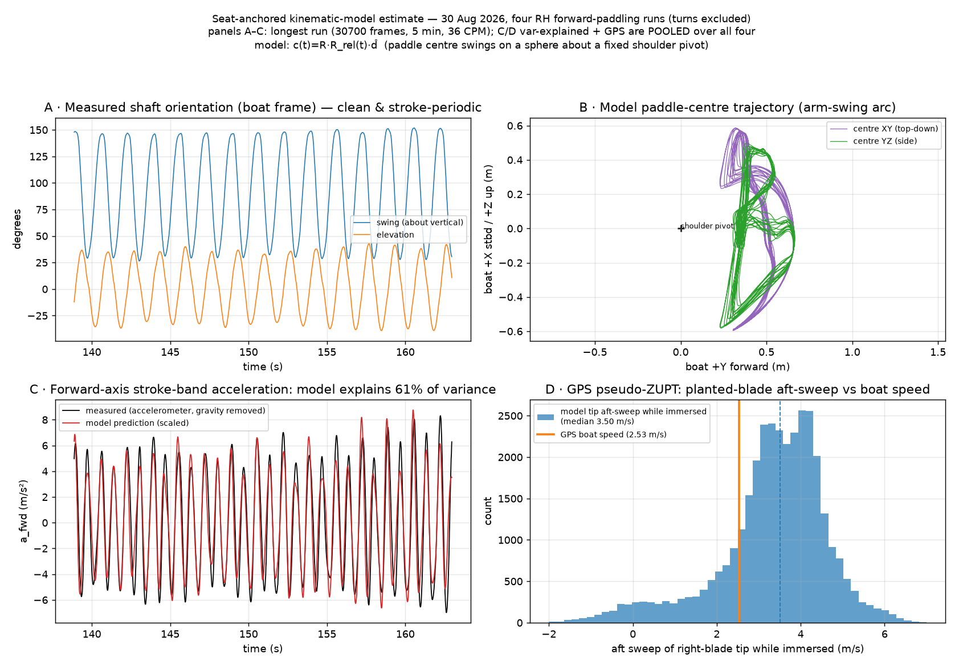The four checks, on the real session. A the measured shaft orientation is large and cleanly stroke-periodic — a solid signal to build on. B the model traces a consistent arm-swing arc in front of the body. C the model's predicted forward acceleration (red) tracks the real accelerometer (black) stroke for stroke — 61% of the variance. D the modelled planted-blade sweep sits just above the GPS boat speed — the rigid straight-arm model slightly over-swings.
A useful side result
The same test re-run with the mag-free (GRV) orientation source scored worse — 0.40 versus 0.54 — confirming, from a completely different angle, the earlier finding that fused orientation is the cleaner source for this well-calibrated session.
What it means
From orientation alone, the arm-swing is recoverable: a two-constant geometric model with nothing tuned per frame gets you most of the way, and its blade kinematics are physically consistent with the GPS. That is genuinely useful — it means much of "where the paddle is" is not lost after all.
The remaining ~40% is not model sloppiness; it is a wall. Torso lean and twist move the paddle without rotating it, and no amount of orientation data can see that. So this is close to the ceiling for anything built from two inertial sensors. It also sharpens an earlier caution: an apparent left-vs-right difference in how far forward the blade enters lives partly in exactly this unobservable zone, so treat it as indicative, not measured, until it can be pinned down.
Two clean ways forward if this line is worth pursuing: calibrate the body dimensions from the clip-on jig pose (replacing the assumed reach and direction with your real ones), and fold the GPS water-check in as an active per-stroke correction rather than only a consistency test. Beyond that, truly tracking the paddle through the lean needs a ranging sensor — UWB or a short camera baseline — on the next hardware unit.

Calibrating the body from the jig pose
The first pass used assumed constants (reach 0.55 m, a guessed rest-direction, sensor frames taken as perfectly aligned). The session opened with the paddle held in a clip-on jig at a known pose relative to the hull, so those guesses can be replaced with measurements. The jig shows the two sensor frames are 10.9 deg out of alignment even there; referencing the relative orientation to the jig pose removes that skew and is the single biggest improvement (0.54 -> 0.58). Fitting the reach direction from the data adds a little more (-> 0.59). The reach magnitude R, though, never comes out of the motion - the blade-tip velocity is dominated by the measured blade rotation and the score is scale-free, so R stays anthropometric or tape-measured. The jig calibrates what is observable (the orientation reference, and with data the reach direction); it cannot give the reach magnitude or absolute translation.

Update - four turn-free runs, measured reach (31 Aug 2026)
This session was re-classified into four separate right-handed forward-paddling runs with the three turns left in the gaps between them, and the measured reach R = 0.67 m applied. Each run is scored independently (no seam where runs join) and the results pooled. The four runs agree closely - 0.52, 0.55, 0.57, 0.52 - pooling to 0.54 (0.61 forward), essentially the same as the single range with the turns left in, so the turns were never biasing the result. R is scale-free, so 0.67 m changed no variance number; it only corrected the trajectory scale and pushed the GPS planted-blade sweep to 3.50 m/s against 2.53 m/s boat speed - the rigid straight-arm model over-swings by ~1 m/s, which is exactly the compliance a bent elbow or torso lean would absorb. A torso IMU between the shoulder blades is the highest-value single sensor to add next: it measures the lean/twist that is the dominant residual, un-fixing the pivot the model has to assume.
Provenance. Analysis and the four-panel results figure produced by visualisation/stroke_kinematic_model.py; the two schematics by a throwaway plotting script; this report written by Claude Opus 4.8 (Claude Code session), 30 Aug 2026; re-run over four turn-free runs at the measured reach (0.67 m), 31 Aug 2026. Full findings in visualisation/kinematic_model_30aug_findings.md; logged in PROVENANCE.md.

