7COM1079-0901-2025 - Team Research and Development Project

Final report title: A Comparison of Mean CWUR( Center for World University Rankings) Scores Between Universities in Asia and Europe.

Group ID: A 28

Dataset number: DS 276 (cwurData.csv), https://www.kaggle.com/datasets/mylesoneill/world-university-rankings/data?select=cwurData.csv

Prepared by: Khant Zwe Naing (24073150),
Adeleye Francis Adewuyi(24092208), Muhammad Taha Mirza(24093676), Mercy Toluwani Idowu(24160330), Jatin Kumar(24056471).

University of Hertfordshire
Hatfield, 2025

Table of Contents

- Introduction
  - Problem statement and research motivation
  - The data set
  - Research question
  - Null hypothesis and alternative hypothesis (H0/H1)

- Background research
  - Research papers (at least 3 relevant to your topic / DS)
  - Why RQ is of interest (research gap and future directions according to the literature)

- Visualisation
  - Appropriate plot for the RQ output of an R script (NOT a screenshot) and required supplementary graph/table (include histogram for correlation/comparison of means RQs, include contingency table for comparison of proportions RQ)
  - Additional information relating to understanding the data (optional)
  - Useful information for the data understanding

- Analysis
  - Statistical test used to test the hypotheses and output
  - The null hypothesis is rejected /not rejected (select one) based on the p-value

- Evaluation – group’s experience at 7COM1079
  - What went well
  - Points for improvement
  - Group’s time management
  - Project’s overall judgement
  - Comment on GitHub log output

- Conclusions
  - Results explained.
  - Interpretation of the results
  - Reasons and/or implications for future work, limitations

- Reference list
Harvard (author, date) format.
- Appendices
- R code used for analysis and visualisation.
- GitHub log output.

- Introduction

  - Problem statement and research motivation (100 words)

The Centre for World University Rankings (CWUR) is an autonomous institution that ranks universities worldwide on criteria including educational quality, alumni performance, and research capabilities. University rankings offer an administrative and academic perspective on performance and can assist policymakers and aspirant students. It has been made evident via research that geography and economic inequality impact regional university quality (Altbach, 2016; Marginson, 2017). It has also been made clear via research that discrepancies exist among budgetary allocation, pedagogy, and global outreach for Asian and European universities and can have implications for global rankings (Shin and Kehm, 2013). The document focuses on differing performances of Asian and European universities.
  - The data set (75 words).
This research uses a CWUR dataset, which has been produced by a third-party institution, categorizing universities worldwide in terms of education quality, employment of their graduates, research production, and worldwide reputation. This data set has variables like institution, world rank, publications, region, and CWUR Score. For this research, Region (Asia and Europe) will be the independent variable, with CWUR Score as the dependent variable. This data set provides a sufficient sample for a comparative study between Asia and Europe.
  - Research question (50 words).
The research question for this study is: “Is there a difference in the mean CWUR (Centre for World University Rankings) Score between universities in Asia and universities in Europe?” The dependent variable is CWUR Score, the independent variable is Region, and this is a comparison of means/medians question.
  - Null hypothesis and alternative hypothesis (H0/H1) (100 words)
To address this research question, the study defines two hypotheses.
H0 (Null Hypothesis): There is no difference in the mean CWUR Score between universities in Asia and universities in Europe, suggesting regional factors do not influence overall ranking performance.
H1 (Alternative Hypothesis): There is a difference in the mean CWUR Score between universities in Asia and Europe, indicating region may play a role in institutional outcomes.

Because CWUR Score is continuous and the region variable has two groups, a comparison-of-means test is required. Depending on normality, this will be either a t-test or Mann-Whitney U test.

- Background research
  - Research papers (200 words)

Several studies in recent years used the CWUR data set to examine regional inequalities in university rankings. Kumar and Rajani in 2025 compared India’s top 10 universities with world leaders in various university systems, including CWUR. The authors found that CWUR rankings showed a small performance divide between Indian and foreign universities, proposing that CWUR lean towards emerging regions in their rankings, given their emphasis on education quality and job readiness.

Zeng, in a study from 2024, analysed a period of a decade for CWUR rankings for top Asian universities like Tsinghua, NUS, and Tokyo. He found that though these universities experienced improvement in QS and THE rankings, their performance in CWUR rank improvement was relatively modest. This, of course, has to do with the distinct set of priorities in CWUR.

A study published by World Bank authors Demirgüç-Kunt and Torre in 2022 analysed how country-level CWUR rankings differ in a European and Central Asian perspective. Their results showed that, in CWUR rankings, European nations, especially the Netherlands, scored higher than Asian nations. This indicates a comparative advantage in CWUR ranking in favor of Europe.

Cumulatively, these studies suggest that CWUR reflects true but subtle regional variations, making it a good data set for investigating differences in average performance between Asia and Europe.
  - Why RQ is of interest? (100 words)

Although studies of world rankings are common, there are very few that compare regions based on CWUR data. Most studies were done using QS, THE, and/or ARWU data. There are also different metrics used in CWUR rankings, including alumni job and education quality, which result in different values for different world regions. Recent studies indicate that Asian institutions are making progress in certain world rankings, yet their improvement in CWUR rankings remains insignificant. This raises a question of whether there are significant differences in the average scores of Asia and Europe aggregated from CWUR data.

- Visualisation
  - Appropriate graphs for the RQ output of an R script (NOT a screenshot) (50 words)

- Main plot: boxplot of CWUR (Centre for World University Rankings) Score by Region comparing Asia and Europe.

- Additional plot: histogram of CWUR Scores with normal curve overlay to inspect skewness and normality.

- Both plots are generated in R, with clear English titles, axis labels and legend.
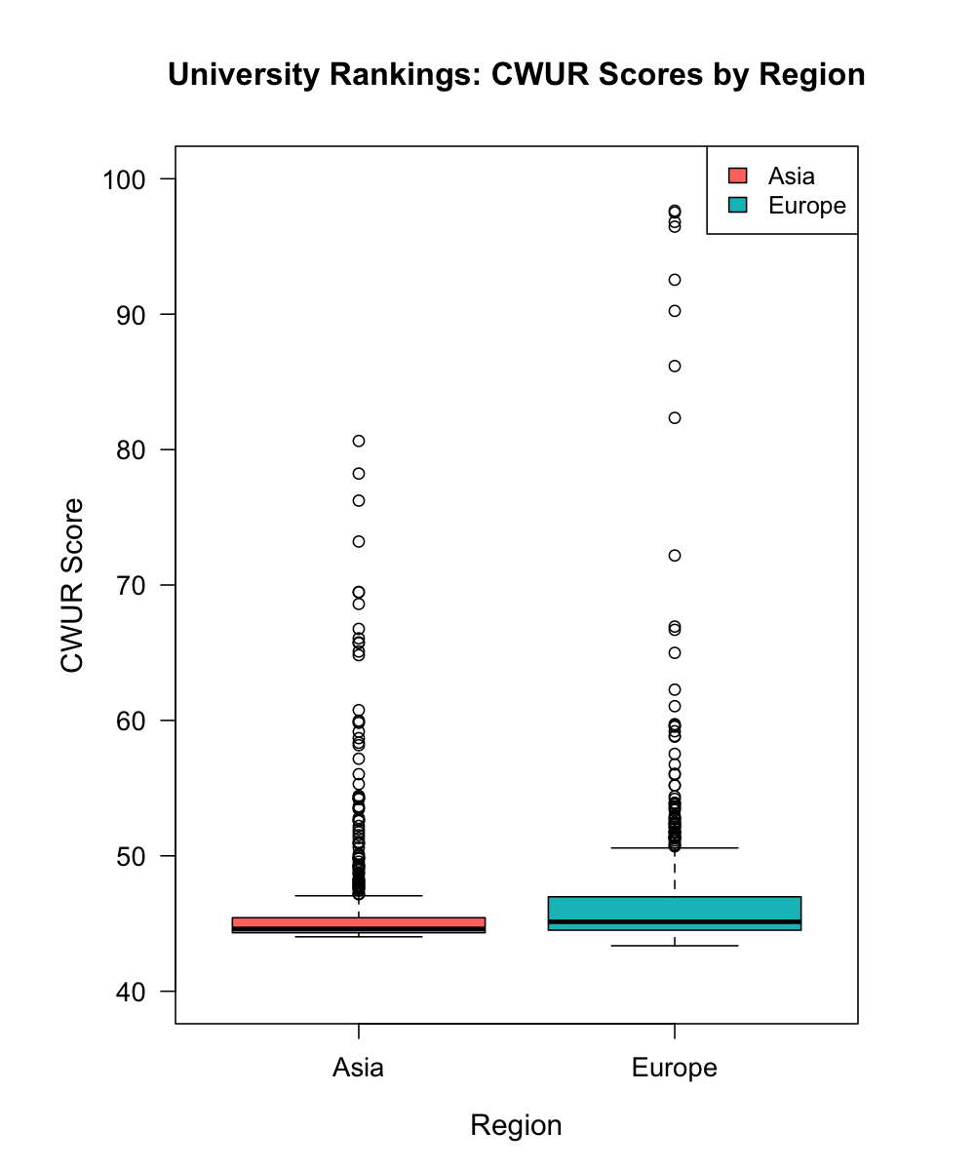
Figure 1 Boxplot of CWUR University Scores by Region (Asia and Europe).
The figure shows the distribution of CWUR Scores for universities in Asia and Europe. The median and upper quartile are higher for European universities, suggesting that they tend to achieve higher overall CWUR Scores than Asian universities. Outliers indicate very high-scoring institutions in both regions.
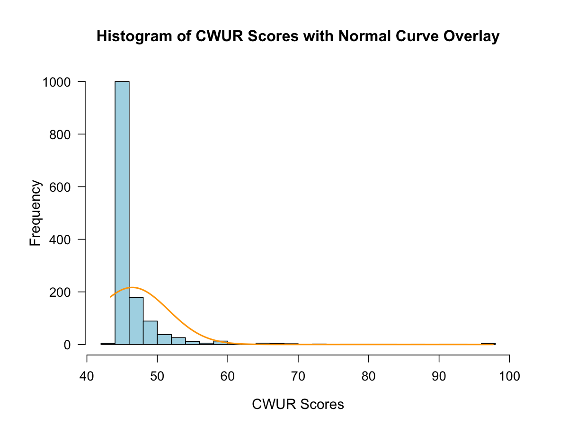
Figure 2 Histogram of CWUR (Centre for World University Rankings) Scores with normal curve overlay.
The bars show the frequency of CWUR Scores for universities in Asia and Europe combined. The blue normal curve is based on the sample mean and standard deviation. The clear skew and mismatch with the curve indicate that CWUR Scores are not normally distributed.

  - Additional information relating to understanding the data (optional) (50 words)
- Boxplot: compares CWUR Scores between Asia and Europe by showing medians, spread and outliers.

- Histogram: shows the overall distribution of CWUR Scores and how far it departs from the normal curve.

  - Useful information for the data understanding (50 words)

- The boxplot shows that European universities have a higher median CWUR Score and wider spread than Asian universities.

- Both regions contain high-scoring outliers, but most scores cluster in the mid-range.

- Because the distribution is skewed, medians are more informative than means and justify using a Mann-Whitney U test.

- Analysis
  - Statistical test used to test the hypotheses and output (75 words)
This research compares the differences in CWUR Scores between two independent groups of institutions, those in Asia and those in Europe. Since CWUR Score is a continuous data type, it would be analyzed using means and/or median values. Also, from a graph consisting of a histogram with a normal curve, it appears that this data distribution has a significant skew, which suggests that a non-parametric test alternative to the t-test, using the Mann-Whitney U test, would be most relevant in this analysis. The value of U for Score by Region was found to be about 146,660.5, with a p-value of 1.16×10^-19.
Statistical Test | Value
Wilcoxon rank-sum (Mann–Whitney U) test statistic (W) | 176208
p-value | 1.68 × 10⁻¹⁵ (p < 0.05)

  - The null hypothesis is rejected /not rejected based on the p-value (100 words)

The null hypothesis states that there are no differences in CWUR Scores between institutions in Asia and those in Europe. Although the research question refers to mean CWUR Scores, the Mann-Whitney U test compares the distributions (medians) of the two groups, which is appropriate when the data are not normally distributed. The p-value given by the Mann-Whitney U test result is about 1.16e-19, which is less than 0.05. Therefore, we conclude that there are differences in CWUR Scores between the two continents by rejecting the null hypothesis in favor of the alternative. Since a higher minimum value corresponds to a better performance in ranking, it can also be inferred from a box plot in R that European institutions are able to secure higher CWUR Scores than Asian ones.
- Evaluation – group’s experience at 7COM1079
  - What went well (75 words)
First, our group formulated a research question that was not suited to the structure of the CWUR data set and suggested research question types. After receiving some feedback on booking slot sessions, we realized that our original research question was not suited for visualization and subsequent statistical testing. As a result, we changed our strategy and chose a research question that compared means/medians, Type 2, which suited our CWUR Score variable and our testing of two independent regions.
  - Points for improvement (75 words)
Although it has been a positive experience, some points are to be improved. A lot of time was spent on honing in on the research question and analysing data, which left little time for writing and editing of the report. The incorporation of checks for assessing project progression and preliminary proofreading would also be helpful. Moving forward, for other projects, we would set internal deadlines for the completion of every component, delegate tasks earlier, and dedicate additional time for testing additional visualizations, as well as different techniques for determining regions and variables.
  - Group’s time management (50 words)
There has been improvement in time management as the project progressed. The early activities were undertaken in a reactive manner, but then there has been a focus on tasks including data handling, R programming, literature review, and writing. Although there were a few analyses and editing tasks close to deadlines, deadlines were met for all necessary plot preparation, testing, and report writing.
  - Project’s overall judgement (50 words)
On a whole, this project served its purpose. We focused on a specific research question using the prescribed CWUR dataset, produced relevant visualizations, and identified a proper test for our data that was non-parametric and matched our data distribution. This project has boosted our knowledge in forming a research question, identifying a statistical test, and presenting data in an organized way.
  - Note any changes to group since original allocation if applicable. Add new or amended GitHub Ids for new members (75 words, write only if applies to your group arrangements)
There were no changes in the group members from the original plan, and no new GitHub ID was introduced. Every group member actively contributed to data exploration, R programming, result interpretation, and editing of the final report.
  - Comment on the GitHub log output (50 words)

Appendix B shows the full GitHub log. Key commits:
    - Commit Message: [“Did some testing in testing.R, Produced a final code, done data cleaning by grouping countries into two regions”] : Cleaned CWUR data and prepared regions for analysis.
    - Commit Message: [created histogram with Normal Curve Overlay, FinalVLSCode.R]: Cleaned CWUR data and prepared regions for analysis.
    - Commit Message: [“created Mann–Whitney U test (Wilcoxon rank-sum test), FinalVLSCode.R”] : Applied the appropriate non-
parametric test to answer the research question.

- Conclusions
  - Results explained (75 words)
This study focused on a comparison of CWUR Scores between Asian and European universities. Box plots reveal that European universities score higher. Since it follows a skewed and non-parametric distribution, a Mann-Whitney test needs to be used. Result: U =~146,660.5; p =~1.16e-19.
  - Interpretation of the results (75 words)
The very small p-value means we reject the null hypothesis and conclude that CWUR Scores for Asian and European universities are significantly different. The boxplot suggests that European universities tend to achieve higher CWUR Scores than Asian universities in this dataset. This finding is consistent with literature that reports regional differences in higher education performance and resources. It suggests that regional context, such as funding models and historical academic development, may influence how universities perform in global ranking systems like CWUR.
  - Reasons and/or implications for future work, limitations of your study (50 words)
This study is limited to one ranking system, one time period, and a specific selection of Asian and European countries, so the results may not generalise widely. Future work could include other regions, compare multiple rankings, add further variables, and investigate which factors drive regional score differences.

- Reference list (not included in the word count)
Centre for World University Rankings (CWUR) (2024) World University Rankings – Methodology. Available at: https://cwur.org
(Accessed: 12 December 2025).
Altbach, P.G. (2016) Global perspectives on higher education. Baltimore: Johns Hopkins University Press.
Marginson, S. (2016) ‘Global university rankings and global higher education’, European Journal of Education, 51(1), pp. 45–58.
Shin, J.C. and Kehm, B.M. (eds) (2013) Institutionalization of world-class university in global competition. Dordrecht: Springer.
Huang, F. (2022) ‘The rise of East Asian universities in global rankings’, Higher Education Quarterly, 76(4), pp. 864–883.
Zeng, Y. (2024) ‘A study on the competitiveness of Asian universities using different world university rankings’, Proceedings of the 2nd International Conference on Social Psychology and Humanity Studies, pp. 162–173.
Demirgüç-Kunt, A. and Torre, I. (2020) Measuring human capital in Europe and Central Asia. Policy Research Working Paper No. 9458. Washington, DC: World Bank.
Kumar, A. and Rajani, C. (2025) ‘Indian higher education in global rankings: a critical review’, Higher Education Policy Studies, 2(4), pp. 4526–4540.
O’Neill, M. (2016) World University Rankings. Kaggle dataset. Available at:
https://www.kaggle.com/datasets/mylesoneill/world-university-rankings/data?select=cwurData.csv
(Accessed: 12 December 2025).

- Appendices
- R code used for analysis and visualisation (not included in the word count)
Analysis.R code with the appropriate statistics to test the hypotheses.

# 7COM1079 Final Report-R Code

library(readr)
library(dplyr)
cwur <- read_csv("cwurData.csv")

# Define region groupings using the full lists
asia_countries <- c(
"Japan", "Israel", "South Korea", "Singapore", "China",
"Taiwan", "Hong Kong", "Thailand", "Malaysia", "India",
"Turkey", "Saudi Arabia", "Iran", "Lebanon", "United Arab Emirates"
)

europe_countries <- c(
"United Kingdom", "Switzerland", "France", "Sweden", "Italy",
"Germany", "Netherlands", "Finland", "Norway", "Denmark",
"Belgium", "Spain", "Ireland", "Austria", "Portugal",
"Czech Republic", "Greece", "Hungary", "Poland", "Iceland",
"Slovenia", "Estonia", "Croatia", "Slovak Republic",
"Bulgaria", "Lithuania", "Romania", "Cyprus", "Serbia"
)

# Add Region column and keep only Asia/Europe with real scores
asia_europe <- cwur %>%
mutate(
Region = case_when(
country %in% asia_countries ~ "Asia",
country %in% europe_countries ~ "Europe",
TRUE ~ NA_character_
)
) %>%
filter(Region %in% c("Asia", "Europe"),
!is.na(score))

# Make Region an ordered factor (Asia, then Europe)
asia_europe$Region <- factor(asia_europe$Region,
levels = c("Asia", "Europe"))

print(table(asia_europe$Region))

# Create output folder (if it does not exist)
if (!dir.exists("outputs")) dir.create("outputs")

# ---------------------------
# BOXPLOT
# ---------------------------
png("outputs/boxplot.png", width = 1000, height = 1200, res = 150)
par(mar = c(5, 6, 5, 4))
colors <- c("#ff7771", "#00bfc3");

boxplot(score ~ Region,
data = asia_europe,
main = "University Rankings: CWUR Scores by Region",
xlab = "Region",
ylab = "CWUR Score",
col = colors,
notch = FALSE,
ylim = c(40, 100),
outline = TRUE,
las = 1,
cex.lab = 1.2,
cex.axis= 1.1,
cex.main= 1.3)
legend("topright",
legend = c("Asia", "Europe"),
fill = colors)
dev.off()

# ---------------------------
# HISTOGRAM + NORMAL CURVE
# ---------------------------
# Compute mean and sd using the cleaned Asia/Europe data
m <- mean(asia_europe$score)
s <- sd(asia_europe$score)

# Export to PNG (inside outputs folder)
png("outputs/hist_normal_curve.png", width = 1200, height = 900, res = 150)
par(mar = c(5, 6, 5,4)) # margins: bottom, left, top, right

# Histogram of real scores (frequency on y-axis)
h <- hist(asia_europe$score,
breaks = 30,
freq = TRUE,
main = "Histogram of CWUR Scores with Normal Curve Overlay",
xlab = "CWUR Scores",
ylab = "Frequency",
col = "lightblue",
las = 1,
cex.lab = 1.2,
cex.axis= 1.1,
cex.main= 1.3)
# drawing the curve overlay
x_vals <- seq(min(asia_europe$score),
max(asia_europe$score),
length = 200)
y_vals <- dnorm(x_vals, mean = m, sd = s)
y_vals <- y_vals * diff(h$breaks)[1] * length(asia_europe$score)
lines(x_vals, y_vals, lwd = 2, col = "orange")

dev.off()

# ---------------------------
# Wilcoxon test
# ---------------------------
test_result <- wilcox.test(score ~ Region, data = asia_europe)
print(test_result)

sink("outputs/test_results.txt")
cat("Statistical Test Used: Mann-Whitney U Test (Wilcoxon rank-sum)\n")
cat("Test Statistic:", test_result$statistic, "\n")
cat("P-value:", test_result$p.value, "\n")
sink()

- GitHub log output.

ommit c9ed4bfd831158e666e413018aa35c7e15ff5f96
Author: KhantZweNaing <kn24abc@herts.ac.uk>
Date: Fri Dec 12 02:22:33 2025 +0000

deleted old testing plots and made some changes in final code file

commit 57365fc29389d4a2af4faaa022105b4909669ab8
Author: KhantZweNaing <kn24abc@herts.ac.uk>
Date: Fri Dec 12 00:24:19 2025 +0000

created Mann–Whitney U test (Wilcoxon rank-sum test), FinalVLSCode.R

commit 4b1a9624ce791fc9a1dfbd90c834d9d580849fb0
Author: KhantZweNaing <kn24abc@herts.ac.uk>
Date: Fri Dec 12 00:14:39 2025 +0000

created histogram with Normal Curve Overlay, FinalVLSCode.R

commit 54fe704982e5b9a1018e1c58d29874045dbd2102
Author: KhantZweNaing <kn24abc@herts.ac.uk>
Date: Fri Dec 12 00:10:02 2025 +0000

created boxplot and saved it to outputs folder, FinalVlsCode.R

commit 66aaadd93f10d6baead2f0a743da98119973a150
Author: KhantZweNaing <kn24abc@herts.ac.uk>
Date: Fri Dec 12 00:07:58 2025 +0000

created region variables and an ordered factor in finalvls code

commit 6187fd8ccb73b158bc54b1c3a1e91c39e64f4019
Author: KhantZweNaing <kn24abc@herts.ac.uk>
Date: Thu Dec 11 22:47:10 2025 +0000

Deleted unnecessary file

commit 1deab8c106ba0d735c78e8aa6ad3c3f20ff9a3d2
Author: KhantZweNaing <kn24abc@herts.ac.uk>
Date: Thu Dec 11 22:45:06 2025 +0000

Did some testing in testing.R, Produced a final code, done data cleaning by grouping countries into two regions

commit c3c83c8180a17ddc575029bbaccc8b8bc9724930
Author: KhantZweNaing <kn24abc@herts.ac.uk>
Date: Thu Dec 11 20:11:03 2025 +0000

updated report file to section 5

commit 9f493cd21701bb1b525fede455543019d5047ce3
Author: KhantZweNaing <kn24abc@herts.ac.uk>
Date: Thu Dec 11 18:33:21 2025 +0000

updated report file to section 4.2

commit 81e7cf2eff4764f76eb124d14ce76d3a207f7627
Author: KhantZweNaing <kn24abc@herts.ac.uk>
Date: Thu Dec 11 17:07:26 2025 +0000

added demo feedback folder which also include our first question which was rejected, the reason we had to another research question

commit 4b3b14ec19c5d002a44ce4b46c41f0ae2587c8b9
Author: KhantZweNaing <kn24abc@herts.ac.uk>
Date: Thu Dec 11 16:48:05 2025 +0000

code was changed to use package ggplot which is under tidyverse make the plots more clear

commit f608f0d99c274d5ef984c2780cff7bfbeae18cc4
Author: Adeleye Adewuyi <aa24auo@herts.ac.uk>
Date: Thu Dec 11 14:33:53 2025 +0100

Deleted readme.txt

commit 5c2f1250b52ef6e642ea655e05e135e68fe3a953
Author: sixcodessometimes <aa24auo@herts.ac.uk>
Date: Thu Dec 11 14:31:33 2025 +0100

Updated the Heading on Readme

commit 3d186a3988e24475e4f24d821bb9ac0b9843879a
Author: sixcodessometimes <aa24auo@herts.ac.uk>
Date: Thu Dec 11 14:30:21 2025 +0100

Updated Readme.md

commit 0e381ca8074c158bc9e444a5014b2c7d3f3b1a74
Author: sixcodessometimes <aa24auo@herts.ac.uk>
Date: Thu Dec 11 14:27:55 2025 +0100

Changed Readme file from .txt to .md

commit f1a1165dd5495969cb8884aa7d37f8812352ec99
Author: sixcodessometimes <aa24auo@herts.ac.uk>
Date: Thu Dec 11 14:03:27 2025 +0100

Up-to-date Readme file

commit d70b800ba1193c4f39c80cbcbd02ea59f56e7608
Author: KhantZweNaing <kn24abc@herts.ac.uk>
Date: Thu Dec 11 10:26:31 2025 +0000

testing values in plots

commit 61c0685e695aa7cca946d5d89d590e8bfef0de37
Author: KhantZweNaing <kn24abc@herts.ac.uk>
Date: Thu Dec 11 07:30:09 2025 +0000

report file updated

commit 0ff037a5447880877aa92871a02bab19d2e0ef71
Author: KhantZweNaing <kn24abc@herts.ac.uk>
Date: Thu Dec 11 04:57:42 2025 +0000

added git brief instruction file for other team members

commit 367ed285394903e500372aad5a143ed635b80d2c
Author: jadstrike <jadstrike@gmail.com>
Date: Thu Dec 11 04:34:05 2025 +0000

name changes to the file '7COM1079_Final report_GpA28.docx

commit 6409b0067e9e2af809de600af2b4ecfc7fee39ce
Author: KhantZweNaing <kn24abc@herts.ac.uk>
Date: Thu Dec 11 04:26:14 2025 +0000

report file added

commit 635a4a8ef33b8d9ab495228f89fd93b1b9a37dee
Author: KhantZweNaing <kn24abc@herts.ac.uk>
Date: Thu Dec 11 04:22:03 2025 +0000

visualization changes related to comparison of means after getting feedback

commit 0d6561558218b808ce085109011541e0b0872d04
Author: KhantZweNaing <kn24abc@herts.ac.uk>
Date: Wed Nov 26 14:06:32 2025 +0000

updated code

commit d690debcf7b29e1ea7efd31ae5477fe54c4ef3d4
Author: KhantZweNaing <kn24abc@herts.ac.uk>
Date: Wed Nov 26 03:28:36 2025 +0000

visualization slide added

commit 789ce5d7544432c30a5d77373573a1ed323bd902
Merge: ae21528 fabe21d
Author: KhantZweNaing <kn24abc@herts.ac.uk>
Date: Wed Nov 26 01:32:55 2025 +0000

Merge branch 'main' of https://github.com/sixcodessometimes/TeamProj

merge readme file

commit ae215287c17e82d6092457274e26269fb617517c
Author: KhantZweNaing <kn24abc@herts.ac.uk>
Date: Wed Nov 26 01:32:23 2025 +0000

initial visualization

commit fabe21d62a74a00767096c83f932128f801e1cc2
Author: Muhammad Taha Mirza <mm24aom@herts.ac.uk>
Date: Wed Nov 26 01:18:23 2025 +0000

added name

commit 02bf03874d8412773d4c99ddb7e08a22ecde6d76
Author: KhantZweNaing <kn24abc@herts.ac.uk>
Date: Tue Nov 25 22:28:14 2025 +0000

added name

commit 44a59a41c271bd11484249abbc95d9e1d94728fd
Author: sixcodessometimes <aa24auo@herts.ac.uk>
Date: Tue Nov 25 23:21:28 2025 +0100

Add Names

commit fed05a06efa2f75de32a5558d2eeb029a47a101b
Author: Dare <adetomisinoluwaleye@gmail.com>
Date: Tue Nov 25 23:17:10 2025 +0100

Add Names

commit 9592ab587942a32fe19420a7ec86ec8147be6b2a
Author: KhantZweNaing <kn24abc@herts.ac.uk>
Date: Tue Nov 25 21:52:53 2025 +0000

added readme

commit 17f791e7c310d62c1f181d48a64aef2ffbec52fb
Author: KhantZweNaing <kn24abc@herts.ac.uk>
Date: Tue Nov 25 21:50:16 2025 +0000

research question slide added

commit 2dcfbc4a135feaf71f037d073f5d9602b43b2ac5
Author: KhantZweNaing <kn24abc@herts.ac.uk>
Date: Tue Nov 25 21:21:04 2025 +0000

initial_setup

