Connectivity, Research Capacity, and Access to Orbit
A cross-national correlational analysis of internet penetration, researcher density, and space-launch activity
Data source: Our World in Data — Analysis dated 11 June 2026

Abstract
Three independently compiled global datasets—the share of the population using the internet, the density of researchers engaged in research and development (R&D) per million inhabitants, and the annual number of objects launched into outer space—were merged at the country level to examine pairwise associations between national digital connectivity, scientific labour capacity, and access to orbit. After normalising cumulative launch counts by 2024 population to obtain a per-capita launch-intensity measure, all three constructs were found to be strongly and positively inter-correlated (Spearman ρ = 0.76–0.85; all p < 10⁻¹⁹). Partial-correlation analysis indicated that internet penetration functions as the central marker of a shared latent dimension of national development: the associations of internet penetration with each of the other two variables remained robust when the third was held constant (partial r ≈ 0.53), whereas the association between researcher density and launch intensity attenuated to near-significance (partial r = 0.20, p = 0.049) once internet penetration was controlled. A multiple regression of log launch intensity on the two predictors explained 62% of cross-national variance, with internet penetration the dominant term. The findings are interpreted as reflecting a common developmental substrate rather than direct causal linkage, and several methodological caveats—cross-sectional design, fixed population denominators, and attribution of launches by operator nationality—are discussed.

Contents

1. Introduction
The diffusion of digital connectivity, the accumulation of scientific human capital, and the capability to place objects in orbit are each commonly invoked as indicators of national technological advancement. Whether these three phenomena move together across nations—and, if so, whether any pair is linked beyond their shared dependence on general development—is an empirical question amenable to correlational analysis of open cross-national data.
This report addresses three specific questions posed at the outset of the investigation: (i) whether the proportion of a population using the internet covaries with the density of researchers in a country; (ii) whether internet usage covaries with space-launch activity; and (iii) whether researcher density covaries with space-launch activity. A secondary, exploratory objective was to surface salient temporal and country-level patterns within the constituent datasets.
All analysis was conducted on datasets published by Our World in Data (OWID), which aggregate primary statistics from the International Telecommunication Union, the UNESCO Institute for Statistics, and the United Nations Office for Outer Space Affairs (UNOOSA) respectively. The three source archives were supplied as compressed CSV exports.

2. Data and Methods

2.1 Datasets
Three datasets were analysed:
- Share of the population using the internet (% of individuals), 6,330 country–year observations spanning 1990–2024 (ITU, via OWID).
- Researchers in R&D per million people, 2,075 country–year observations spanning 1996–2023 (UNESCO Institute for Statistics, via OWID).
- Annual number of objects launched into outer space, 1,273 country–year observations spanning 1957–2025, attributed to the nationality of the launching operator or owner (UNOOSA, via OWID).

2.2 Pre-processing
Records lacking a standard ISO-3166 country code, together with the aggregate “World” entity and supranational regional groupings, were removed so that the unit of analysis was the sovereign state. Two analytical frames were constructed. The first, a contemporaneous panel, merged the internet and researcher series on exact country–year keys, preserving the full temporal resolution (1,977 matched observations). The second, a cross-sectional frame, collapsed each indicator to a single value per country—the mean across all available years for the two rate measures, and the cumulative all-time total for launches—to permit three-way comparison and the construction of a per-capita launch measure.

2.3 Per-capita normalisation of launches
The launch series is an absolute annual count, whereas internet penetration and researcher density are intensive (per-population) quantities. Direct correlation of an extensive count with intensive rates conflates national scale with national intensity; a small number of populous states therefore dominate the raw totals. To place all three variables on a comparable intensive footing, cumulative launches were divided by national population to yield a launch-intensity measure expressed as launches per million residents.
Because the source archives do not include population, a complete population table for all 102 launching nations was assembled from United Nations and World Bank mid-2024 estimates and applied as the denominator. This is an explicit approximation: a single contemporary population is used to deflate a launch stock that accumulated over decades. The resulting intensity is best read as launches per million present-day residents rather than a time-matched per-capita rate. The approximation is least accurate for states whose population changed markedly over the launch era, and the limitation is revisited in Section 5.

2.4 Statistical procedures
Owing to the heavy right-skew of the launch-intensity measure (spanning more than three orders of magnitude), launch intensity was log₁₀-transformed before any product-moment (Pearson) correlation or regression. Rank-based Spearman coefficients, which are invariant to monotone transformation and robust to the remaining skew, are reported alongside as the more conservative estimate. Ninety-five-percent confidence intervals for Pearson coefficients were obtained by the Fisher z-transformation.
To test whether any bivariate association reflects a direct link as opposed to shared dependence on a common factor, first-order partial correlations were computed on the subset of 93 countries with complete data on all three variables, and an ordinary-least-squares regression of log launch intensity on internet penetration and researcher density was estimated. Analyses were performed in Python 3 using pandas, SciPy, and statsmodels.

3. Results

3.1 Pairwise associations
All three pairwise relationships are positive and highly statistically significant (Table 1). The association between internet penetration and researcher density is the most consistent: in the contemporaneous panel of 1,977 country–year observations it returns a Pearson coefficient of 0.602, and at the cross-sectional country level the rank correlation rises to 0.853. Once launches are expressed per capita, the two space relationships—weak and partly non-significant in raw count form—strengthen markedly, reaching Spearman coefficients of 0.76 and 0.78 respectively.
Table 1. Pairwise correlations between the three indicators. Pearson coefficients for launch intensity are computed on the log₁₀ scale.
Relationship | n | Pearson r | 95% CI | Spearman ρ
Internet × Researchers (panel, contemporaneous) | 1,977 | 0.602 | — | 0.639
Internet × Researchers (cross-sectional) | 153 | 0.669 | 0.57–0.75 | 0.853
Internet × Launch intensity (log) | 101 | 0.739 | 0.64–0.82 | 0.761
Researchers × Launch intensity (log) | 93 | 0.685 | 0.56–0.78 | 0.777

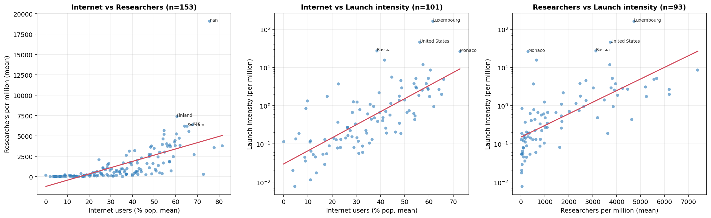
Figure 1. Country-level scatter relationships. Left: internet penetration versus researcher density (linear axes). Centre and right: internet penetration and researcher density versus launch intensity (logarithmic vertical axis). Red lines are ordinary-least-squares fits.

3.2 Partial correlations and regression
The raw pairwise coefficients cannot, on their own, distinguish a direct association from one mediated by a shared developmental dimension. The partial-correlation analysis (Table 2) is therefore decisive. Internet penetration retains a substantial association with researcher density when launch intensity is held constant (partial r = 0.542), and with launch intensity when researcher density is held constant (partial r = 0.526). By contrast, the association between researcher density and launch intensity collapses from a zero-order Spearman of 0.78 to a partial coefficient of 0.204 (p = 0.049) once internet penetration is controlled.
Table 2. First-order partial correlations on the common set of 93 countries. *** p < 0.001; * p ≈ 0.05.
Partial correlation (n = 93) | Variable held constant | Partial r
Internet × Researchers | Launch intensity | 0.542 ***
Internet × Launch intensity | Researcher density | 0.526 ***
Researchers × Launch intensity | Internet penetration | 0.204 *

The regression corroborates this structure. A model of the form log₁₀(launch intensity) = β₀ + β₁·internet + β₂·researchers explains 62% of cross-national variance (R² = 0.616, adjusted R² = 0.607, n = 93). Internet penetration is a strong and unambiguous predictor (β₁ = 0.029 per percentage point, p < 0.001), whereas researcher density contributes only marginally once connectivity is in the model (β₂, p = 0.051). Taken together, internet penetration behaves as the hub variable: it is the strongest single proxy for the latent factor that the three indicators jointly express, and the apparent researcher–launch link is largely accounted for by the fact that research-intensive countries are also highly connected.

3.3 Temporal structure
The two time series differ fundamentally in shape (Figure 2). Mean internet penetration across countries follows the classic logistic diffusion curve, rising from near zero in the early 1990s to roughly three-quarters of the population by the mid-2020s; the apparent late downturn is an artefact of reduced country coverage in the most recent years rather than a genuine decline. Annual launch activity, by contrast, was effectively flat at 100–150 objects per year for five decades before an abrupt super-exponential rise beginning around 2017, reaching approximately 4,500 objects in 2025.
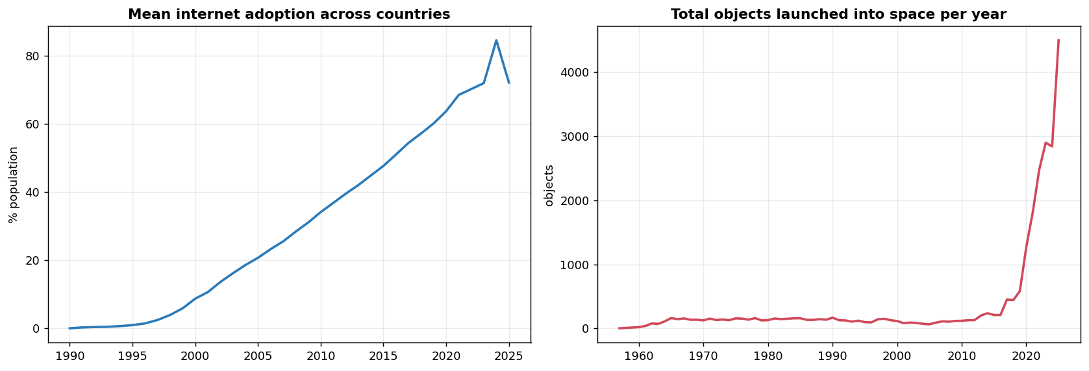
Figure 2. Left: mean internet penetration across countries, 1990–2025. Right: total objects launched globally per year, 1957–2025.
This recent surge is overwhelmingly attributable to a single national operator base. United States launch counts rose from 191 in 2018 to 3,708 in 2025, driven by commercial low-Earth-orbit satellite constellations; over the same interval China grew more modestly (95 to 374) and the Russian Federation remained approximately constant. The global “explosion” in launch activity is thus, in the main, a commercial-American phenomenon rather than a broadly distributed one.

3.4 Launch intensity and notable country-level patterns
Ranking countries by launch intensity rather than absolute count substantially re-orders the leaderboard (Table 3). Luxembourg tops the table at 163 launches per million residents—more than three times the United States rate—reflecting deliberate national space-economy policy (it hosts major satellite operators and enacted space-resource legislation) rather than population scale. Uruguay and Monaco are similar small-state outliers; conversely the United States and Russia, which dominate absolute counts, occupy more moderate intensity positions.
Table 3. Highest launch intensity (cumulative launches per million 2024 residents).
Country | Cumulative launches | Population (M, 2024) | Launches / million
Luxembourg | 109 | 0.67 | 162.7
United States | 15,677 | 341 | 46.0
Russia | 3,914 | 144 | 27.2
Monaco | 1 | 0.04 | 26.3
Uruguay | 53 | 3.4 | 15.6
United Kingdom | 807 | 68.3 | 11.8
Finland | 48 | 5.6 | 8.6
Israel | 55 | 9.8 | 5.6

Three further exploratory findings are noted:
- Democratisation of orbit. The number of nations achieving their first-ever launch is accelerating—16 in the 1990s, 34 in the 2010s, and 20 already in the first half of the 2020s. Recent entrants are disproportionately lower-income states (Rwanda, Ethiopia, Uganda, Zimbabwe, Kenya, Nepal, Bhutan), consistent with the falling cost of small-satellite access. Several of these have very low internet penetration, which weakens the launch relationships at the margins.
- Connectivity leapfrogging. The time taken to progress from 5% to 50% internet penetration ranges from as little as three years (South Korea, Kazakhstan) to nearly two decades (Belize, São Tomé and Príncipe, Tuvalu). The contemporary laggards—Central African Republic, South Sudan, Burundi, Chad, Yemen—are predominantly conflict-affected economies.
- Erosion of research capacity. While most countries expanded their researcher workforce substantially (South Korea recorded the largest gain, from roughly 2,200 to 9,400 per million), a minority contracted. The declines—led by the Russian Federation and Ukraine—track political and economic disruption, suggesting that a shrinking research workforce is a reasonably reliable correlate of national instability.

4. Discussion
The central empirical result is that digital connectivity, scientific labour capacity, and per-capita access to orbit are strongly and positively inter-correlated across nations, but that this mutual association is most parsimoniously understood as the expression of a single underlying developmental dimension rather than as a web of direct causal links. The partial-correlation structure is the key evidence: internet penetration—a cheap, near-universally measured indicator—absorbs most of the explanatory work, and the residual researcher–launch association is barely distinguishable from zero once connectivity is controlled.
This pattern is theoretically unsurprising. Internet penetration, researcher density, and space activity are each downstream of national income, institutional capacity, education systems, and infrastructure investment. That internet penetration emerges as the strongest single marker likely reflects its position as the most finely measured and least lumpy of the three: it varies smoothly across the full development range, whereas launch activity is concentrated in a handful of operators and is increasingly distorted by a single commercial actor, and researcher density saturates among high-income states.
The small-state outliers reinforce the interpretation that the headline correlations describe a general tendency rather than a deterministic law. Luxembourg and Monaco achieve extreme launch intensities through policy and accounting domicile effects unrelated to their domestic research base, while several recent lower-income entrants to orbit demonstrate that symbolic or capacity-building launches can occur well below the connectivity levels the trend would predict.

5. Limitations
Several constraints qualify the findings and should temper any causal reading:
- Correlation, not causation. The analysis is observational and cross-sectional. No temporal precedence or instrumental strategy is employed, and the dominant interpretation—shared dependence on national development—is itself inferential.
- Fixed population denominator. Launch intensity divides a multi-decade launch stock by a single 2024 population. For countries whose population changed substantially across the launch era this introduces denominator error; a fully rigorous treatment would deflate each launch by the population of its specific year.
- Attribution and scale of launches. UNOOSA attributes objects to operator or owner nationality, which can diverge from the launching state and concentrates recent activity in commercial constellations; a single corporate programme can therefore dominate a national figure. The 2025 count is also partial.
- Coverage and missingness. The indicators differ in temporal and national coverage, and the cross-sectional means are computed over non-identical year windows. Ecological correlations among country aggregates need not hold at the level of individuals or institutions.

6. Conclusion
Across nations, internet penetration, researcher density, and per-capita space-launch activity rise together, and once launch counts are placed on a per-capita footing the three form a tightly coupled triad. The coupling, however, is best explained by a common developmental substrate rather than by direct linkage between any specific pair: internet penetration serves as the most informative single index of that substrate, and the relationship between research capacity and launch activity is largely mediated through it. The original three questions can therefore be answered as follows—internet usage and researcher density are strongly associated; internet usage and space activity are strongly associated once normalised; and researcher density and space activity are associated chiefly because both track connectivity, with little direct relationship remaining when connectivity is held constant.

Data sources
Our World in Data — Share of the population using the Internet (International Telecommunication Union). https://ourworldindata.org/grapher/share-of-individuals-using-the-internet
Our World in Data — Researchers in R&D (per million people) (UNESCO Institute for Statistics). https://ourworldindata.org/grapher/researchers-in-rd-per-million-people
Our World in Data — Annual number of objects launched into outer space (UN Office for Outer Space Affairs). https://ourworldindata.org/grapher/yearly-number-of-objects-launched-into-outer-space
Population denominators: United Nations World Population Prospects and World Bank, mid-2024 estimates.

