First create new repository without add readmi file

*In react project terminal-------*

git init

npm install gh-pages --save-dev

git add .

git status

*git commit -m "first commit"*

*git branch -M main*

*git remote add origin* [*https://github.com/BIMAL3726/My-Portfolio.git*](https://github.com/BIMAL3726/My-Portfolio.git)

*{* *error: remote origin already exists*

**git remote**

**git remote remove origin**

**git remote**

*}*

*git push -u origin main*

we get these 4 line code when we create new repository

**deploy on github**

then package.json befor name

https://your-username.github.io/your-repo-name

"homepage"**:**"https://BIMAL3726.github.io/portfolio"**,**

Then script section add in last

"predeploy"**:**"npm run build"**,**

"deploy"**:**"gh-pages -d build"

npm run deploy

git remote add origin https://github.com/BIMAL3726/Portfolio.git

git branch -M main

git push -u origin main

***update code***

git status

git add .

git status

git commit -m "next version"

git status

git push

------------------------

if this problem visible

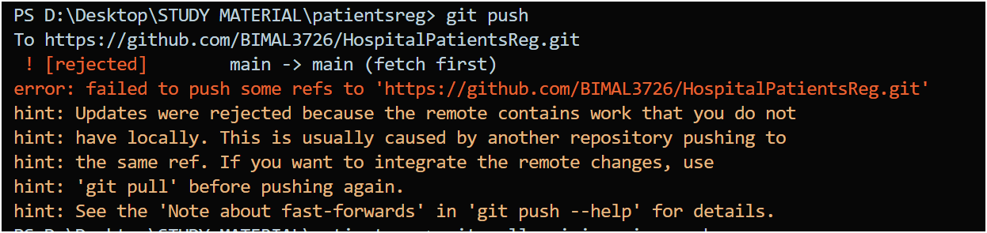

Solution :

git pull origin main --rebase

git push origin main

git push

(**for backend**)

--------------------

1. npm run deploy(for react only)

then refresh the page of github project page

Render **deploy process—**

<https://chatgpt.com/share/685d87e6-3bb0-8002-9b7b-83907a76e08b>  
  
<https://youtu.be/cVEOhgPziO8?si=aoVL30eGcbeue9pw>  
  
start command for backend : node server/Server.js

for backend – web services

|  |  |
| --- | --- |
| **Environment** | Node |
| **Root directory -** | empty |
|  |  |

start command---- node server/Server.js

web services- backend

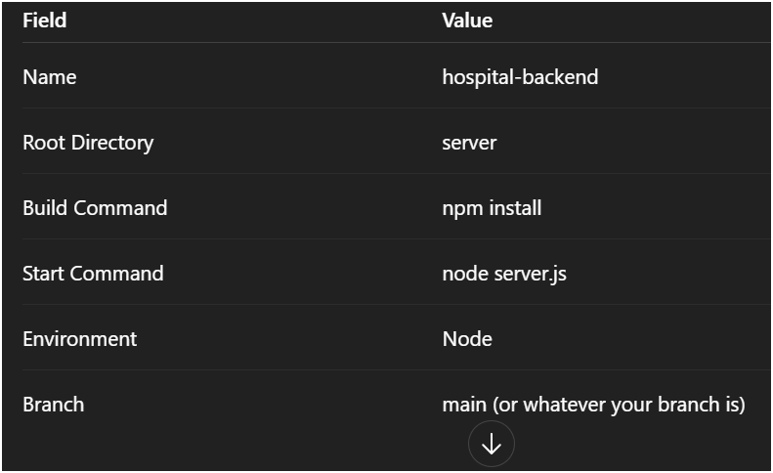

After deploying backend , url – change the all local host front end,and backend to deploying url

static site- frontend

folder structure create  
open terminal->tree -a -I 'node_modules' > structure.txt

***Desktop 2,3,4------***1. login github account

* 2.open project repository – goto repo- click code—copy https url—
* Open vs code with proper file path where take the project – open terminal of VS code—git clone https://................ –enter  
  4. cd project folder name
* **git pull**  
  once setup every time when it push the main project it pull the other desktop to work the same project ……………