Kurt Vonnegut
In the mid-1960s, Vonnegut was offered a teaching position at the prestigious Iowa Writers’ Workshop at the University of Iowa. His role as long-distance father and husband was propelled by voluminous correspondence with his family, who remained in their Cape Cod residence.


In a letter to his wife, Jane, dated September 28, 1965, he outlines his daily routine:
I awake at 5:30, work until 8:00, eat breakfast at home, work until 10:00, walk a few blocks into town, do errands, go to the nearby municipal swimming pool, which I have all to myself, and swim for half an hour, return home at 11:45, read the mail, eat lunch at noon. In the afternoon I do schoolwork, either teach or prepare. When I get home from school at about 5:30, I numb my twanging intellect with several belts of Scotch and water ($5.00/fifth at the State Liquor store, the only liquor store in town. There are loads of bars, though.), cook supper, read and listen to jazz (lots of good music on the radio here), slip off to sleep at ten. I do pushups and sit ups all the time, and feel as though I am getting lean and sinewy, but maybe not.
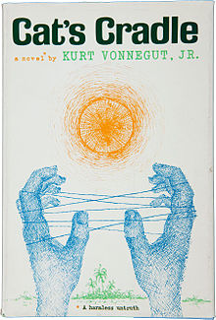

Science is magic that works.

Truth was the enemy of the people, because the truth was so terrible, so Bokonon made it his business to provide the people with better and better lies.

Perhaps, when we remember wars, we should take off our clothes and paint ourselves blue and go on all fours all day long and grunt like pigs. That would surely be more appropriate than noble oratory and shows of flags and well-oiled guns.

"Everything must have a purpose?" asked God. "Certainly," said man. "Then I leave it to you to think of one for all this," said God. And He went away."

Anything a scientist worked on was sure to wind up as a weapon, one way or another.

Tiger got to hunt, bird got to fly;
Man got to sit and wonder 'why, why, why?'
Tiger got to sleep, bird got to land;
Man got to tell himself he understand.

Cat's Cradle is the fourth novel by American writer Kurt Vonnegut, first published in 1963. It explores issues of science, technology, and religion, satirizing the arms race and many other targets along the way.

