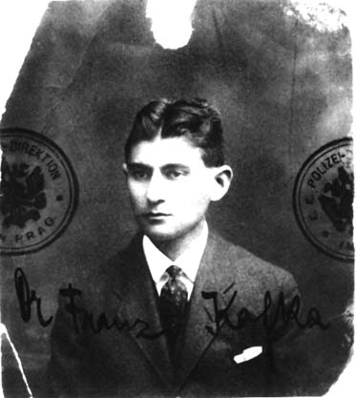

Franz Kafka

(3 July 1883 – 3 June 1924)

Writing habits

[T]wo years later, promoted to the position of chief clerk at the Workers’ Accident Insurance Institute, he was now on the one-shift system, 8:30 AM until 2:30 PM. And then what? Lunch until 3:30, then sleep until 7:30, then exercises, then a family dinner. After which he started work around 11 PM (as Begley points out, the letter- and diary-writing took up at least an hour a day, and more usually two), and then “depending on my strength, inclination, and luck, until one, two, or three o’clock, once even till six in the morning.” Then “every imaginable effort to go to sleep,” as he fitfully rested before leaving to go to the office once more. This routine left him permanently on the verge of collapse.

Writing purpose
Kafka had poor health; he needed to conserve all his energy and attention for writing. Writing did not give him vitality; it certainly did not give him money or fame in his lifetime. It was a compulsion, a habit, a refuge. It made life possible and purposeful; it sometimes, not always, gave him peace of mind.
…
“One advantage in keeping a diary is that you become aware with reassuring clarity of the changes which you constantly suffer and which in a general way are naturally believed, surmised and admitted by you, but which you'll unconsciously deny when it comes to the point of gaining hope or peace from such an admission.”

“In the diary you find proof that in situations which today would seem unbearable, you lived, looked around and wrote down observations, that this right hand moved then as it does today, when we may be wiser because we are able to look back upon our former condition, and for that very reason have got to admit the courage of our earlier striving in which we persisted even in sheer ignorance.”

Kafka believed his diary kept him honest; he could not pretend that now was worse than then or that he was as he remembered and not as his diary revealed him to be.
(http://www.whistlingshade.com/0601/kafka.html)

Writing
“… when in this frame of mind you go striding down the long streets - then for that evening you have completely got away from your family, which fades into insubstantiality, while you yourself, a firm, boldly drawn black figure, slapping yourself on the thigh, grow to your true stature.”

When you go striding down the long streets and have gotten away from your family for that evening, then you grow to your true stature.
(http://franzkafkastories.com/shortStories.php?story_id=kafka_the_sudden_walk)

