Culture in the lab: development of song culture in the zebra finch

http://ofer.sci.ccny.cuny.edu/
Zebra finch raised in isolation develop abnormal songs. We designed an experiment to determine whether wild-type song culture might emerge over multiple generations in an isolated colony founded by isolates. In tutoring lineages starting from isolate founders, we quantified alterations in song across tutoring generations. We found that juveniles imitated
the isolate tutors but changed certain characteristics of the songs. These alterations accumulated over learning generations. Consequently, songs evolved towards the wild-type in three to four generations. Thus, species-typical song culture can appear de novo.
Abnormal 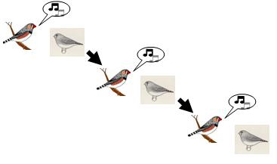 Wild type

