Bloom's Taxonomy

Bloom's Taxonomy divides educational objectives into three "domains": cognitive, affective, and psychomotor. A goal of Bloom's taxonomy is to motivate educators to focus on all three domains, creating a more holistic form of education.
1) What are the 3 domains that Blooms taxonomy?

Cognitive
There are six levels in the taxonomy, moving through the lowest order processes to the highest:

Bloom's Taxonomy Verb Chart
Knowledge (Recalling learned material) | recall, underline, list. name, record, label, cluster, match, memorize, define, arrange
Comprehension (Understanding the material) | understand, show, summarize, explain, describe, demonstrate, review, cite, restate, locate
Application (Using the material) | apply, select, model, organize, illustrate, utilize, choose, imitate, demonstrate, use
Analysis (Breaking material down to increase understanding) | analyze, compare, contrast, classify, map, characterize, divide, break down, choose, examine
Synthesis (Reshaping material into a new form) | construct, speculate, design, compose, create, develop, invent, blend, propose, formulate
Evaluation (Judging the worth of material) | evaluate, convince, argue, judge, criticize, rate, measure, persuade, assess, recommend

2) Write the six categories and list 3 verbs for each category.
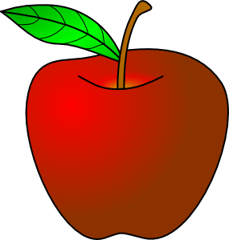

Knowledge

Questions like: What are the health benefits of eating apples?

Comprehension

Questions like: Compare the health benefits of eating apples vs. oranges.

Application

Questions like: Which kinds of apples are best for baking a pie, and why?

Analysis

Questions like: List four ways of serving foods made with apples and explain which ones have the highest health benefits. Provide references to support your statements.

Synthesis

Questions like: Convert an "unhealthy" recipe for apple pie to a "healthy" recipe by replacing your choice of ingredients. Explain the health benefits of using the ingredients you chose vs. the original ones.

Evaluation

Questions like: Do you feel that serving apple pie for an after school snack for children is healthy? Why or why not?
3) Think about the six questions above – how would you answer them? (You do not have to write this on the homework )

