Design, prototype and construction and ID in Practice

# Task 1

The model will be for a mobile phone since majority of people can use a phone and it is easily accessible to almost anyone. The Lecturers, student assistants, and staff must be able to choose a room that they want to change the temperature of that room, to provide a good user experience, the system has to inform the user if the room is being occupied by another person when they are trying to set the temperature. The user can change the temperature by pressing the plus or minus icon to increase or decrease it, the current temperature of the room will be displayed on top, with a big font to ensure that all type of users can see the current temperature. **Interface metaphors** like the plus and minus sign will be used because they are intuitive and give the user the idea that plus means adding or increasing and the minus sign correlate with decreasing, a temperature icon will be placed in between the plus and minus sign to portray that these systems related to the temperature. **Interaction type** used for this system will be an instructing interaction type where the users will instruct the system to change the temperature of the room to their liking. Another interaction type is the responding where the systems need to alert the user of any person who might be currently using a particular room, also alert the user when the temperature is no longer suitable for the room. **Interface type,** the system will use the shareable interface since they will all be doing the same task, nothing much is different since each user will be able to change only one room temperature a time, only the Janitor can update temperature for multiple rooms. **Function to be performed**, all users must be able to change the temperature of the lab or room or office, users can also report if there are any issues when setting the temperature. **Related functions** the user can change the temperature until they have login with their university credentials. After they are logged in, they can change the temperature, submit a report if there are any issues. **Information required** A user needs know or have their university credential information, the room or lab they are trying to change the temperature of.

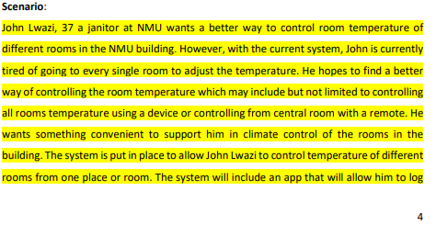

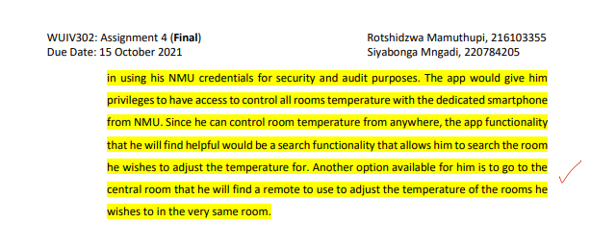**Additional information on the scenario**: For more security measures, Lecturer, Staff, or Staff will only be able to control temperature by using a QR scanner to identify the current room they in instead of searching the room.

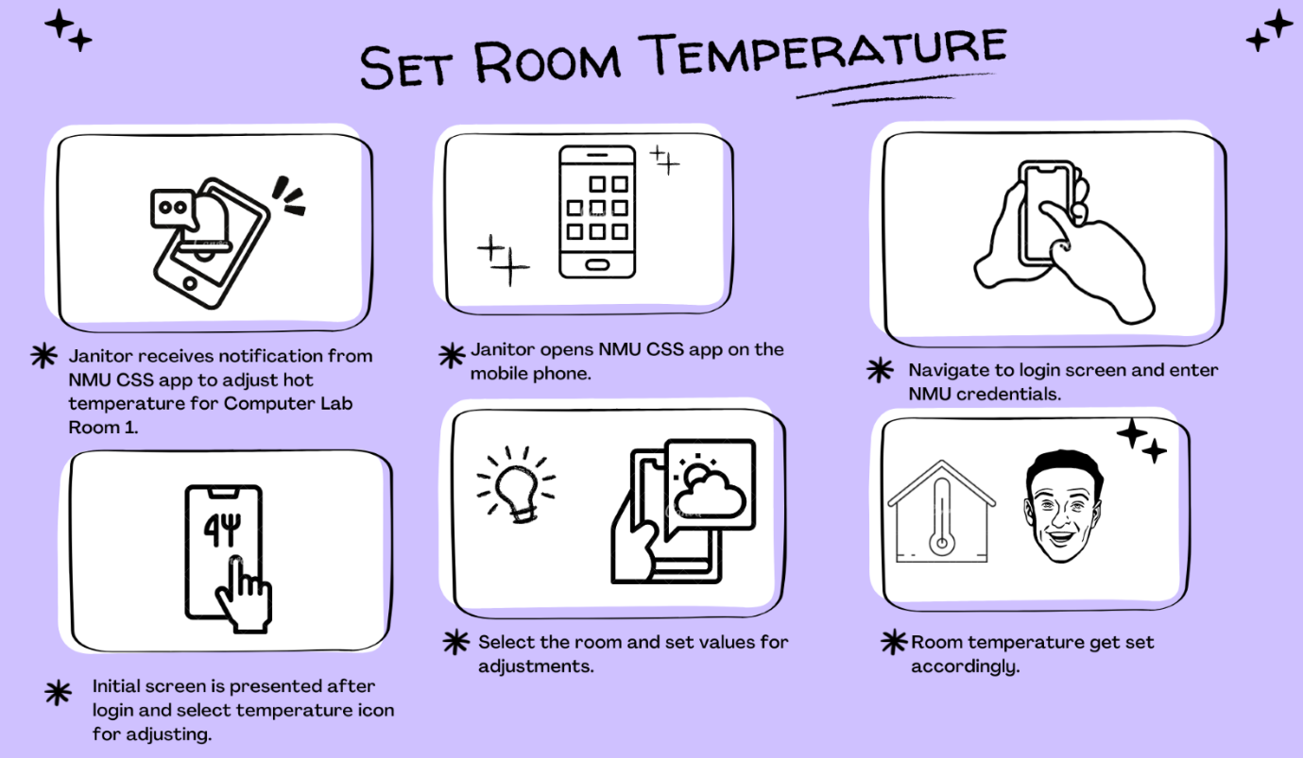**Storyboard: NMU CSS App**

1. 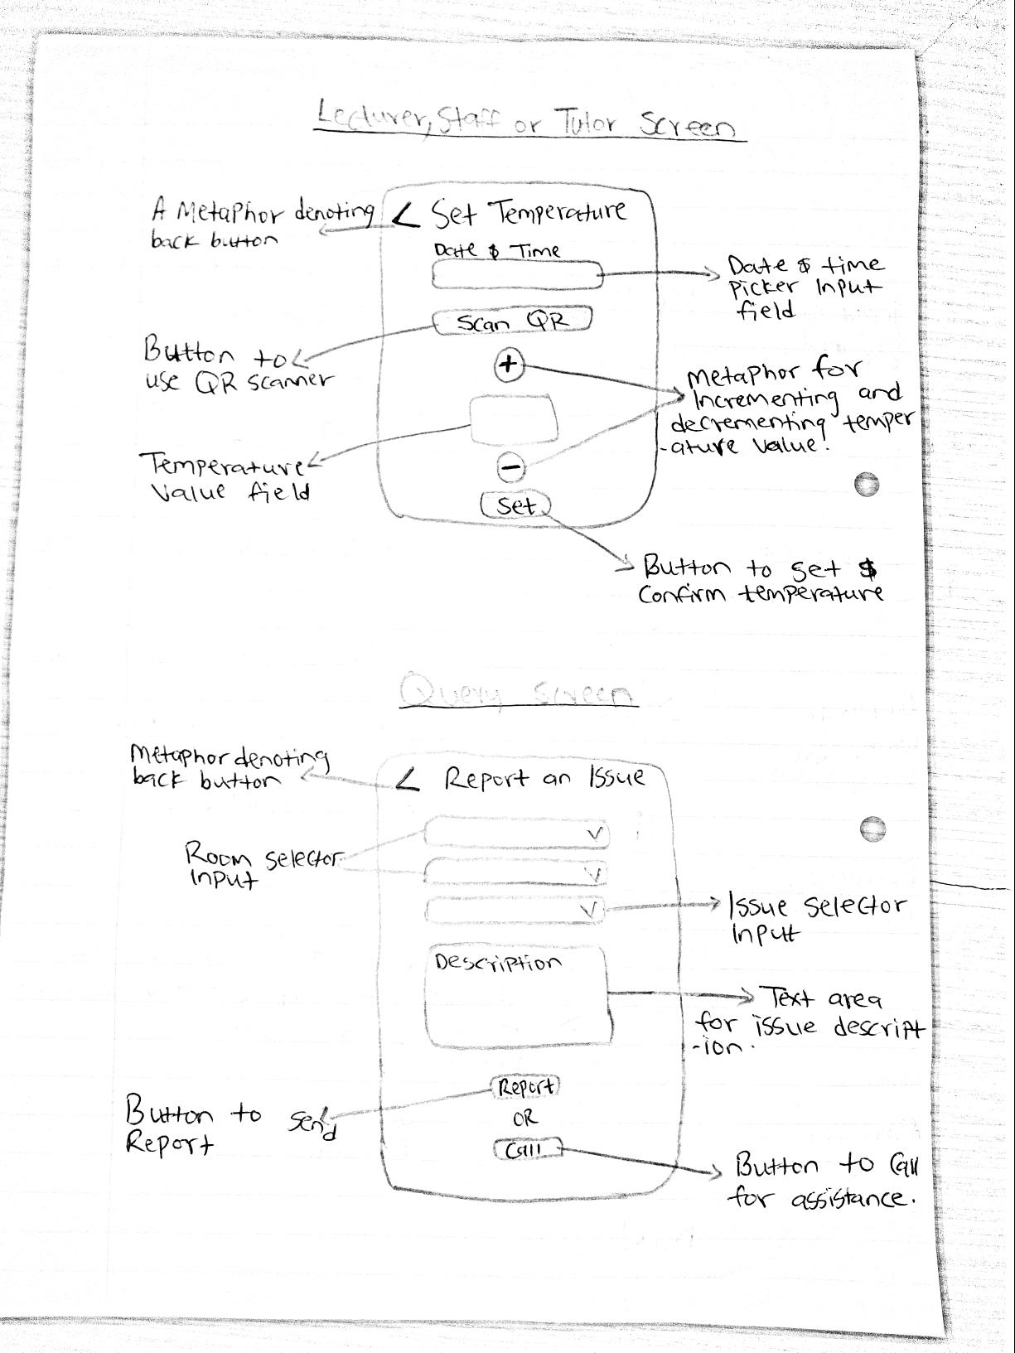

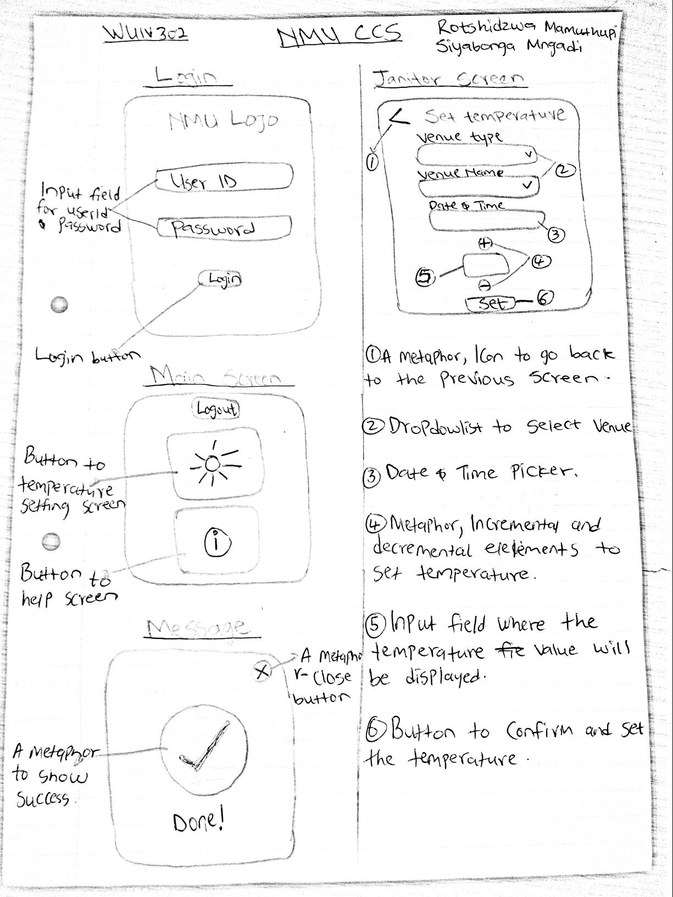

# Task 2

Prototype tool use: **Justinmind**

Website: <https://www.justinmind.com/>

**Instructions**: Please download the software from the website above and it is free. It requires an email for free download, after installation all is set, you will need to open the file and it will load the project. The file will be via email.

|  |  |
| --- | --- |
| Login Screen | Main Screen |
| Set Temperature Janitor | Set Temperature Lecturer, Staff or Tutor    **Back** or **Cancel** button |
| Confirmation screen: Query Screen: Confirmation Screen:  **Set Temperature Send Query/Report** **Send Query** | |

# Task 3

**Interface Design Pattern**: Data input/output

Any system might ask visitors to input data. The designer's job is to make data entry as quick, easy, and error-free as possible. The goal is to not frustrate users when they are using the system, making sure that errors are kept to a minimum as possible. A date picker shows a calendar and allows users to select a date with a few clicks instead of manually inputting them. It is critical to offer feedback to users once they submit data.  Both failures and successes should be communicated to your users. Alerts keep your users up to date and increase their trust in the system.