Assignment No. 11

Neo4j Graph Database

Consider the “Research Papers Database” scenario as follows:
The research papers have authors (often more than one). Most papers have a classification (what the paper is about). The classifications form a hierarchy in several levels (for example, the classification “Databases” has the sub- classifications “Relational” and “Object-Oriented”). A paper usually has a list of references, which are other papers. These are called citations.

Design/model the graph database using Neo4j for above scenario.

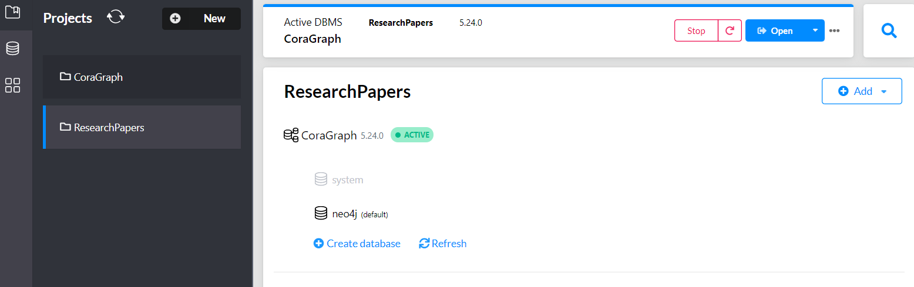

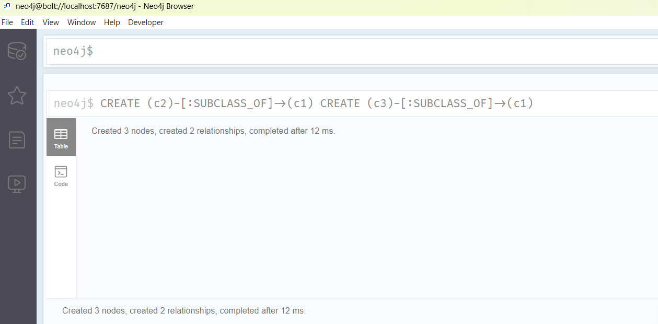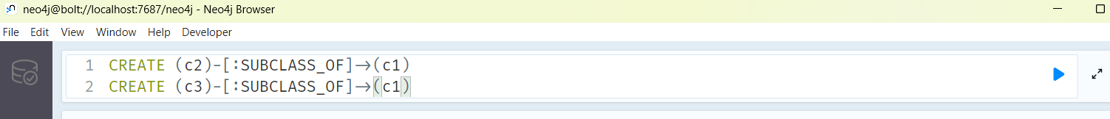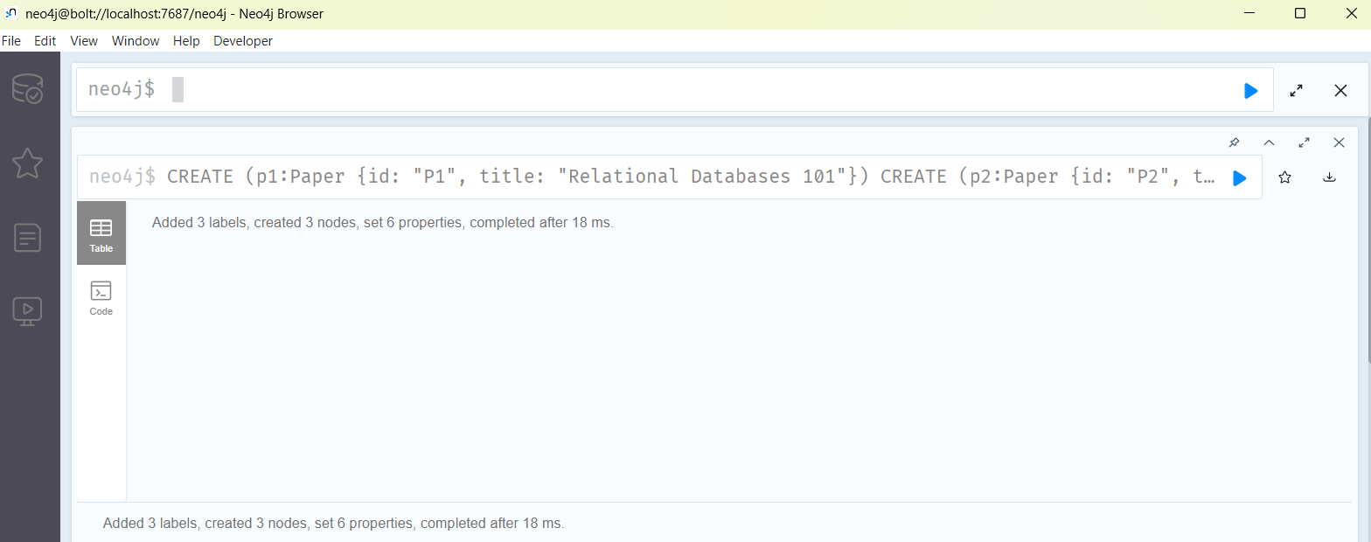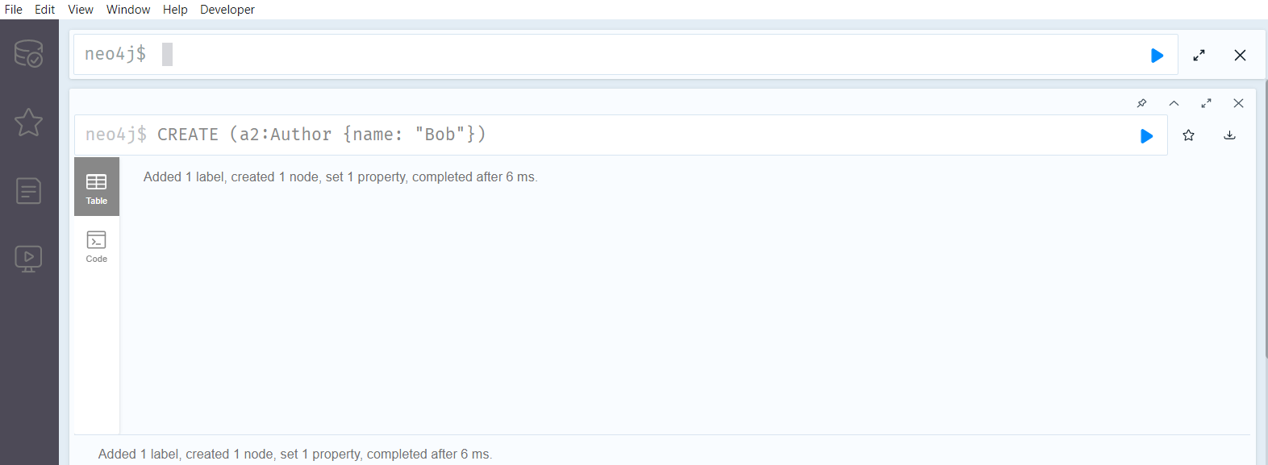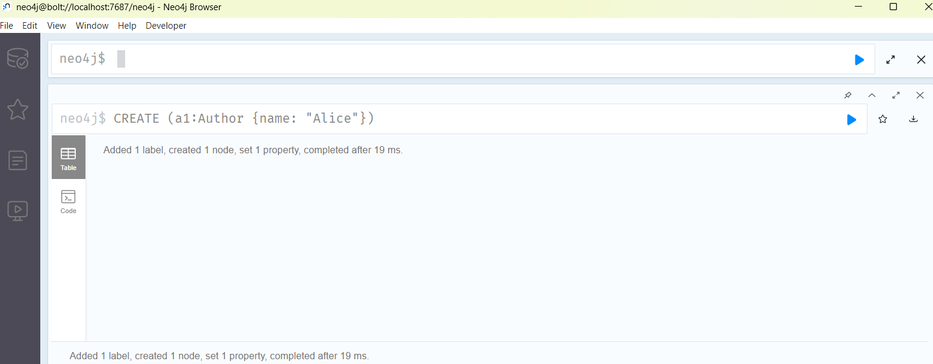

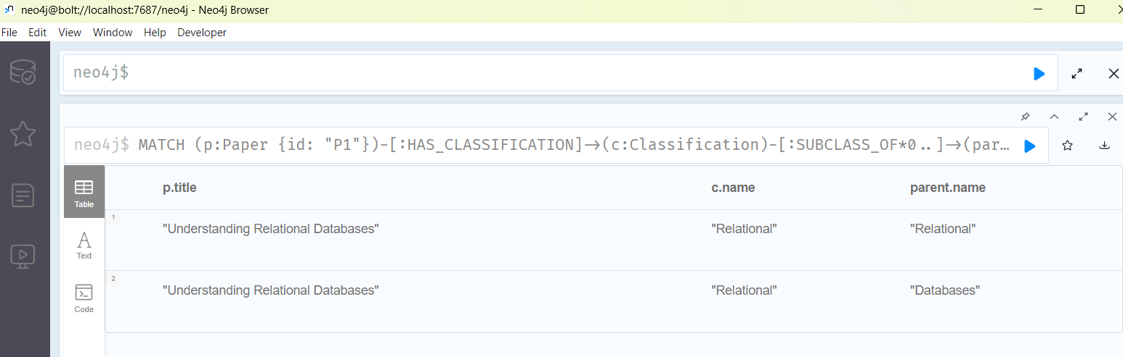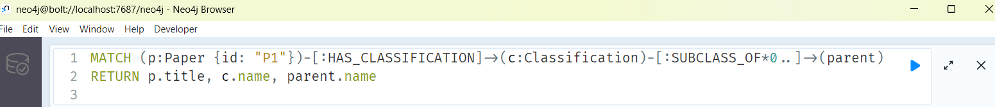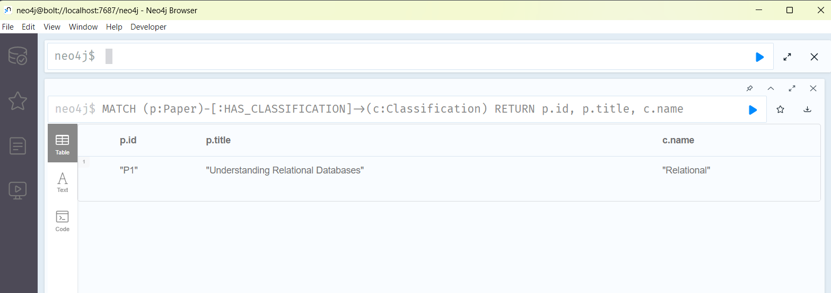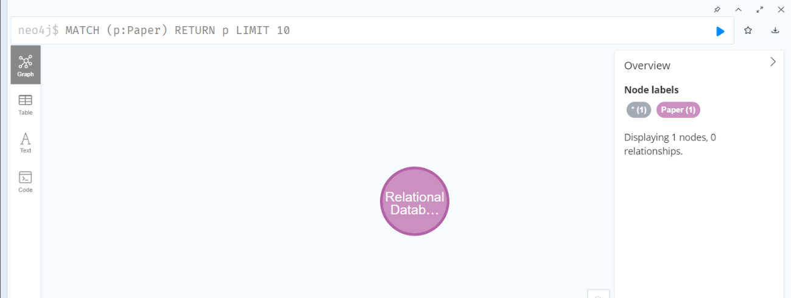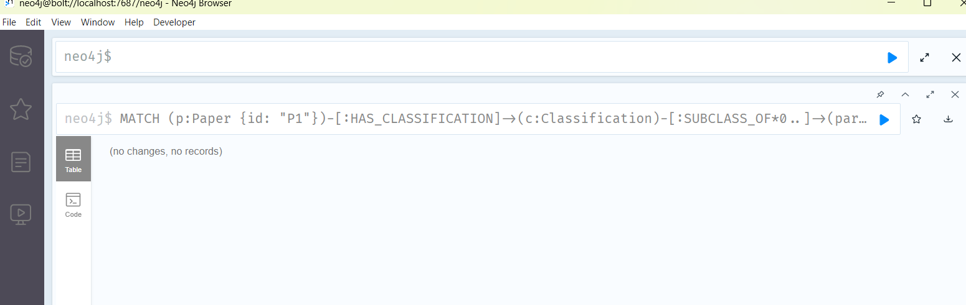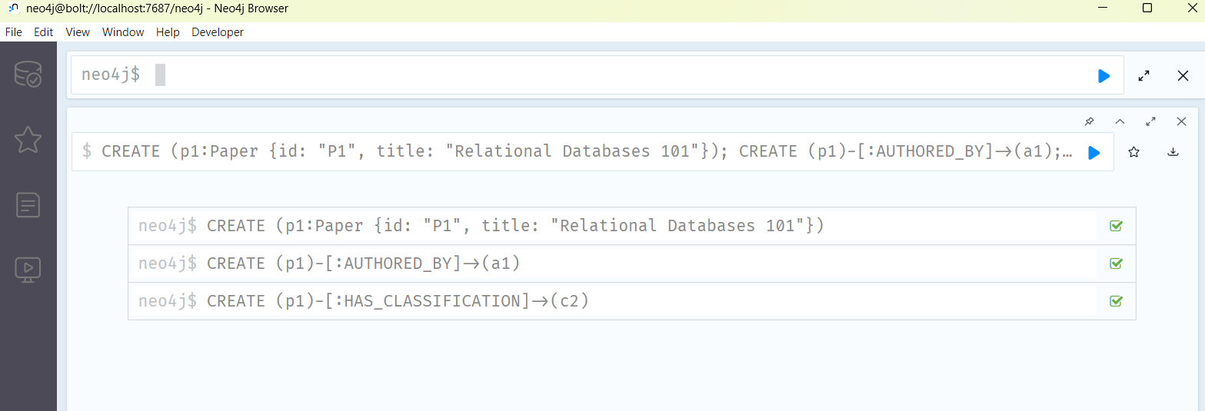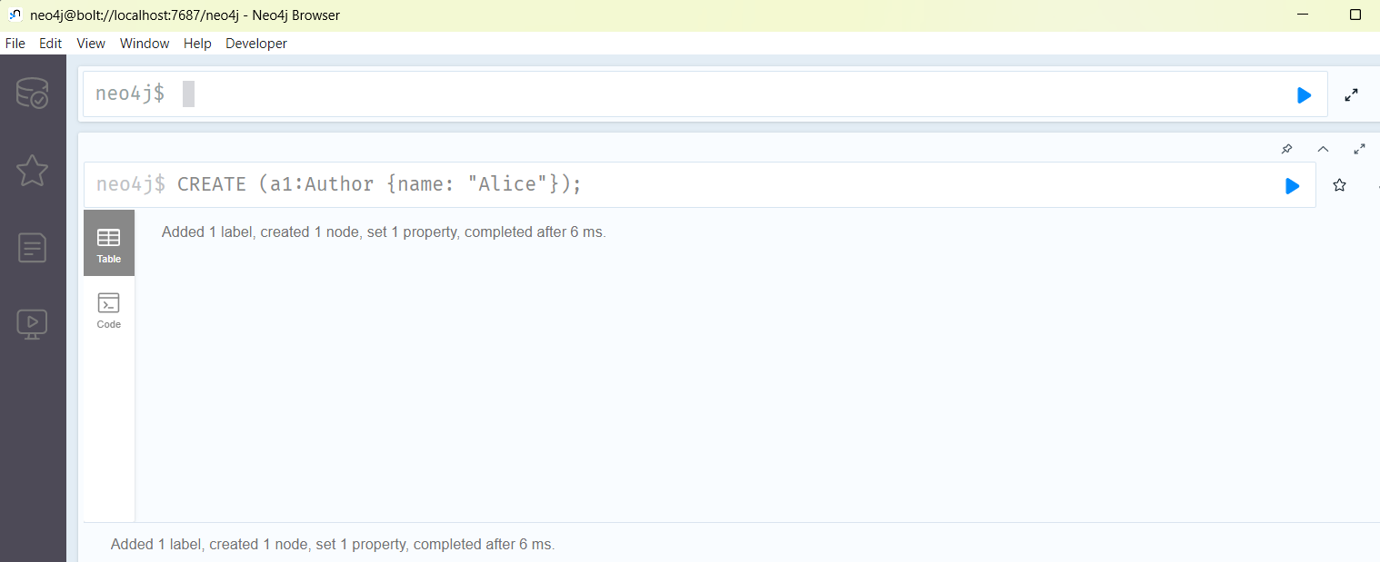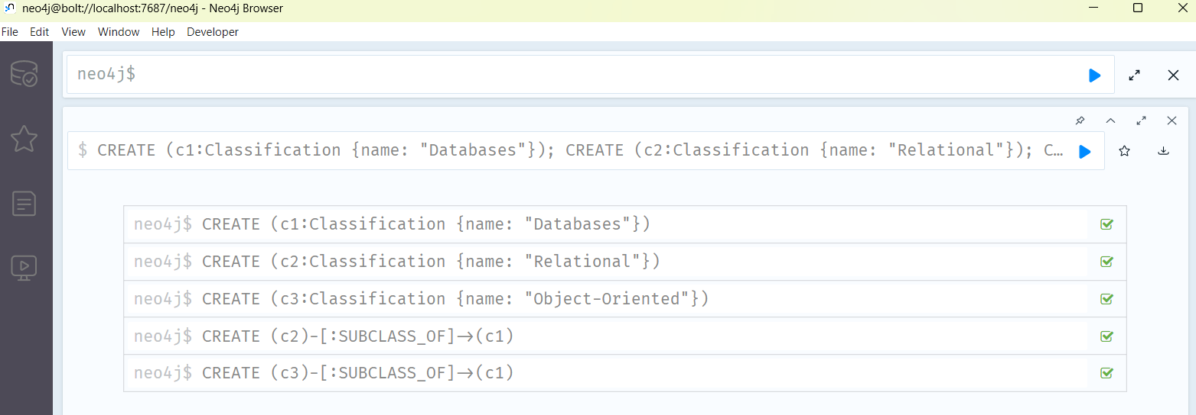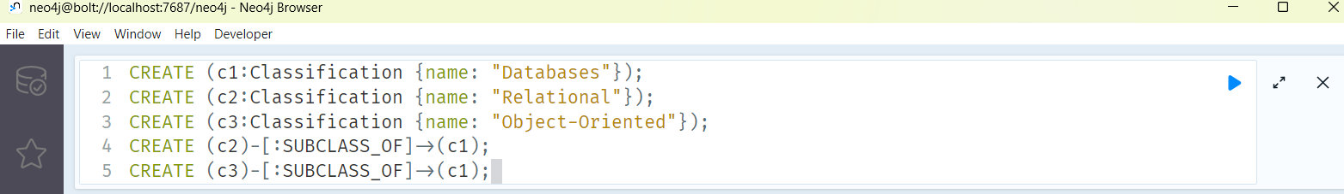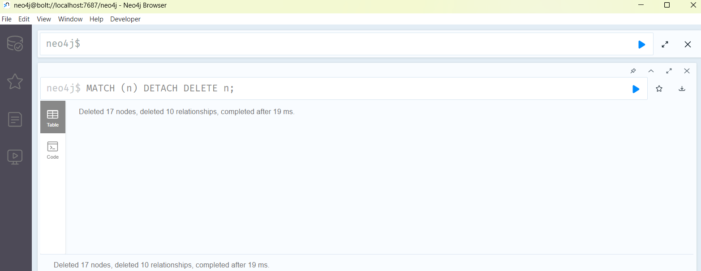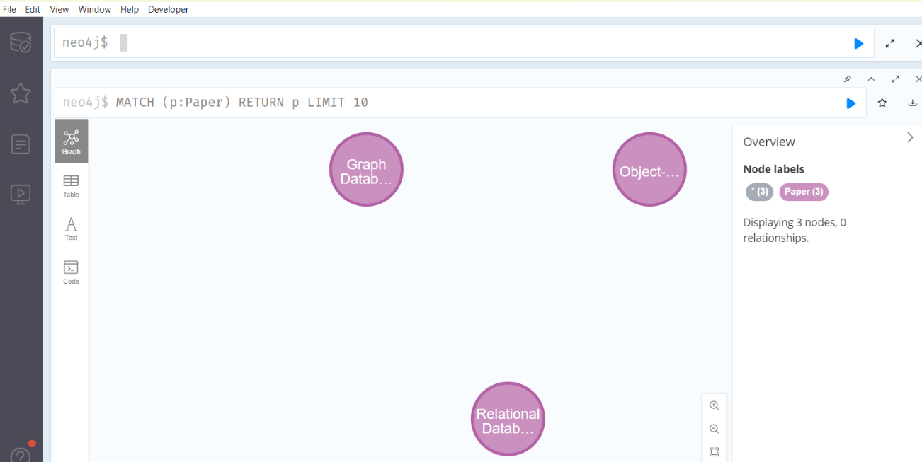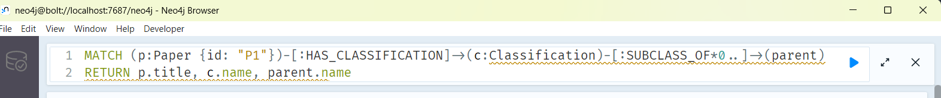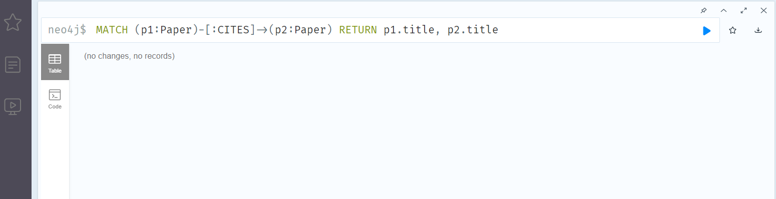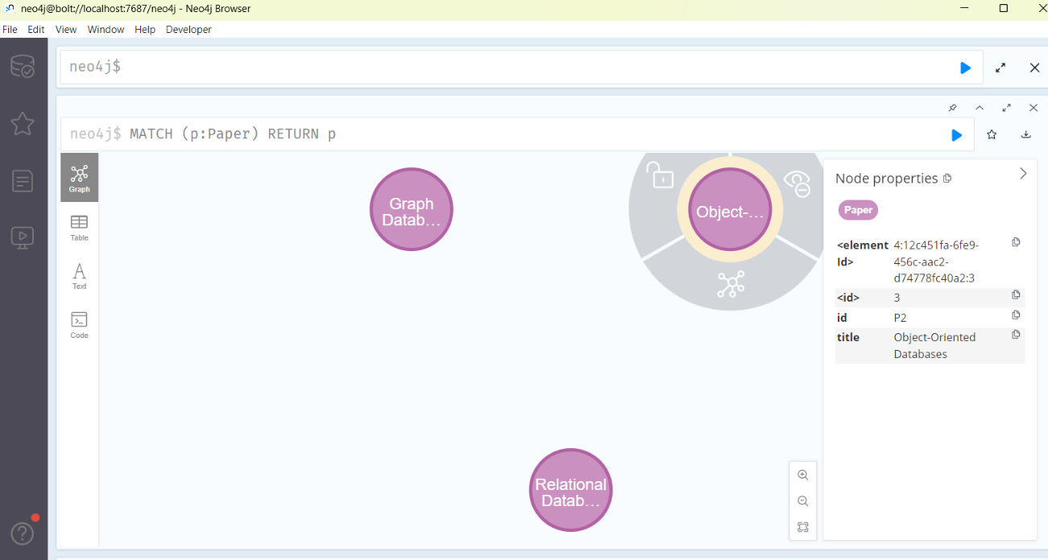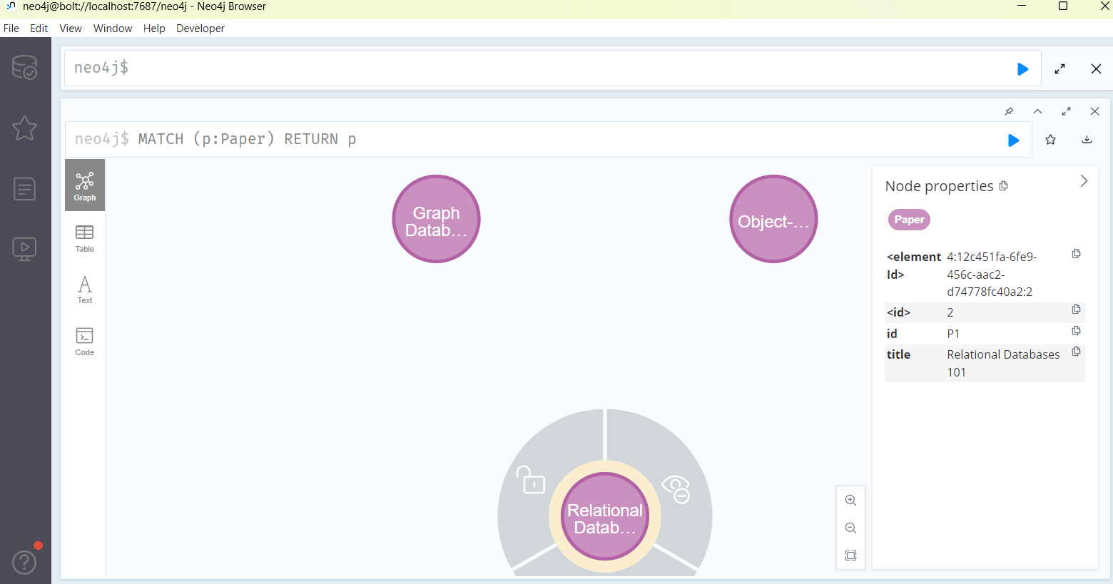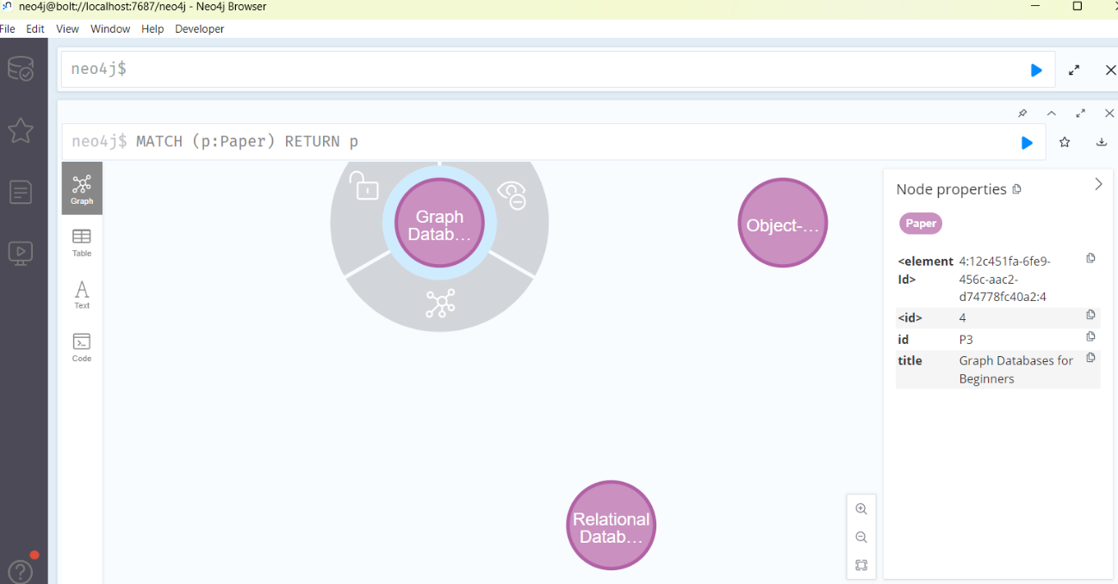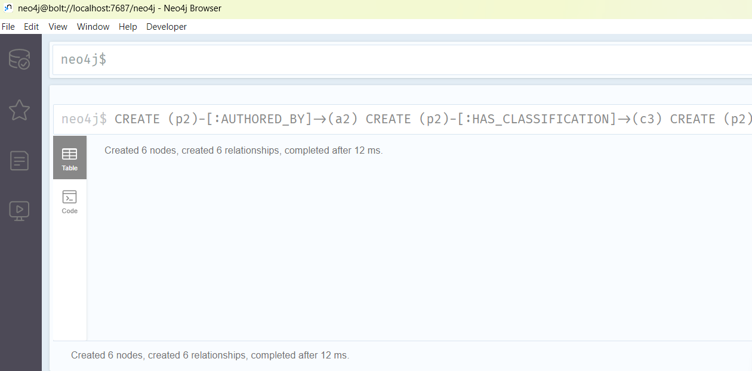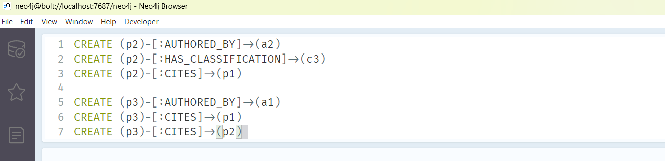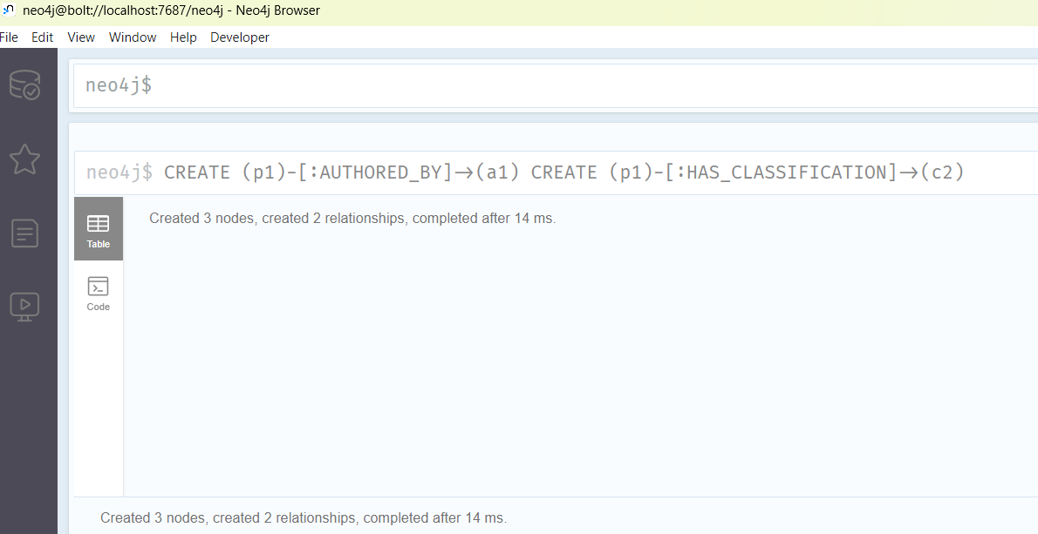

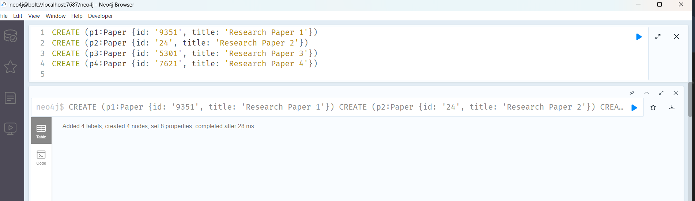

- Download the raw data from Cora Research Paper Classification Project : http://people.cs.umass.edu/~mccallum/data.html The database contains approximately 25,000 authors, 37,000 papers and 220,000 relationships.

Load this data using Neo4j Data Browser

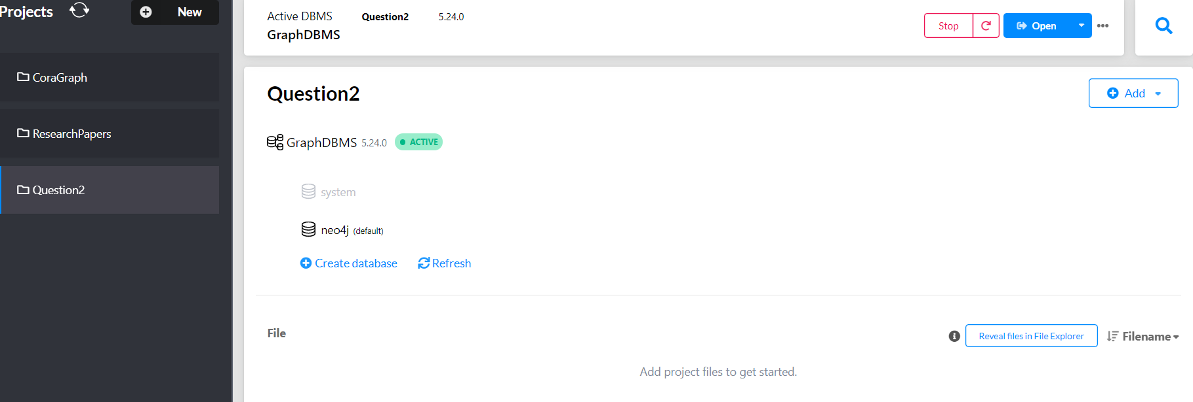

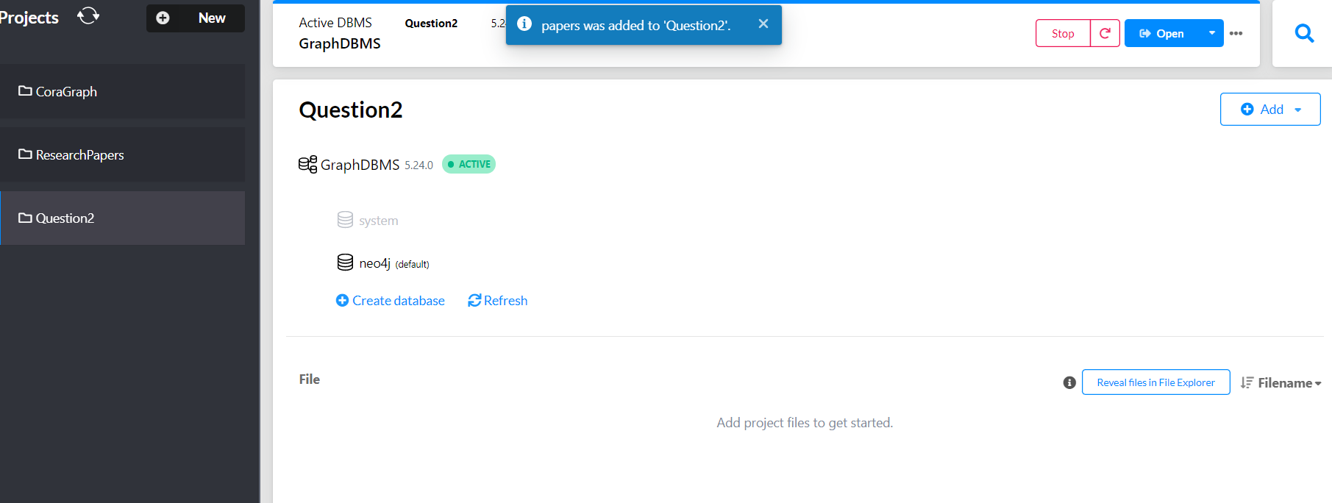

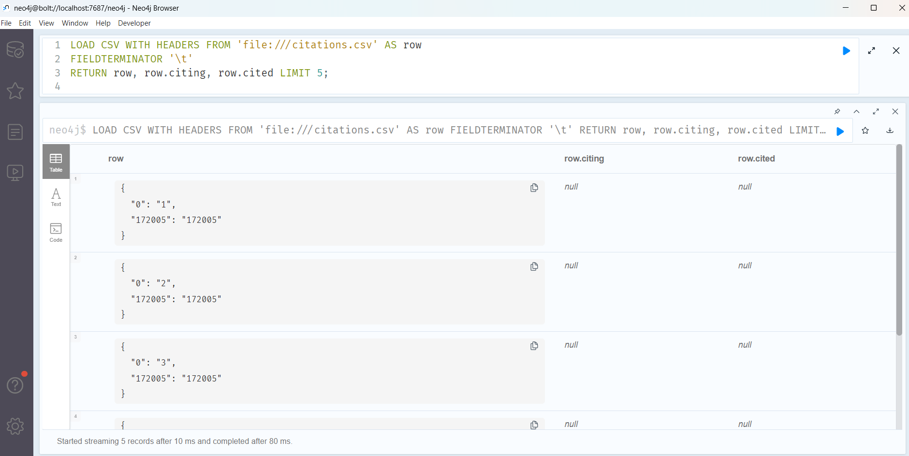

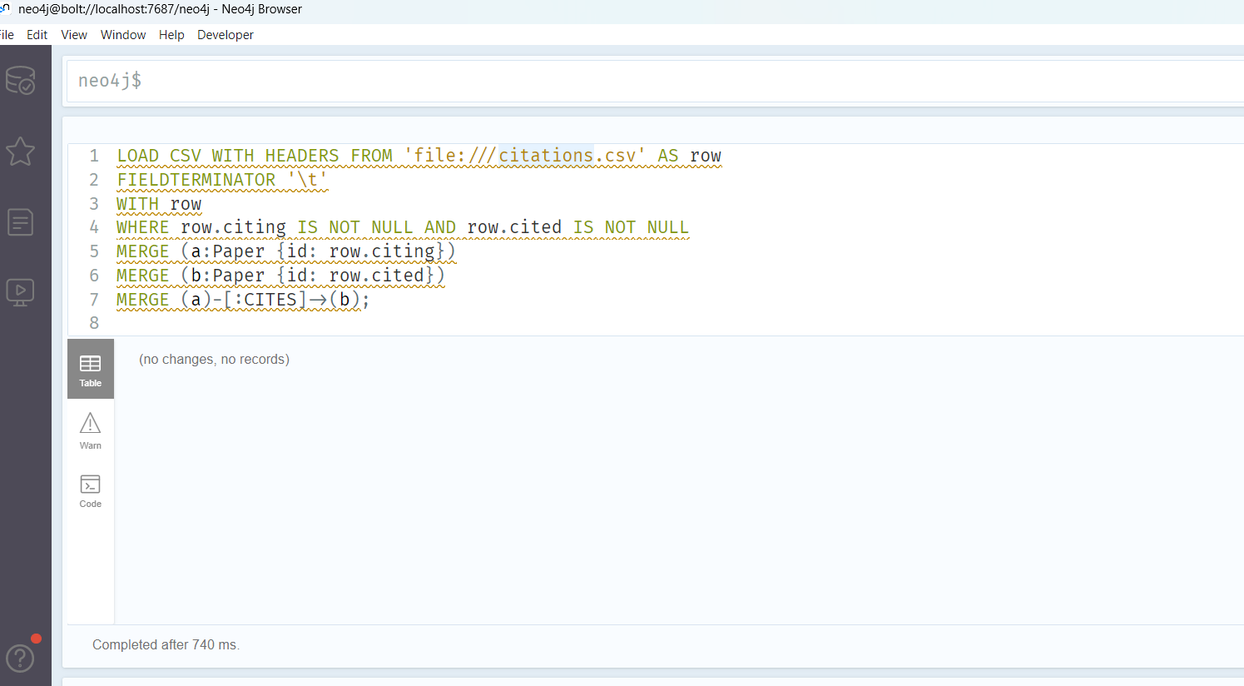

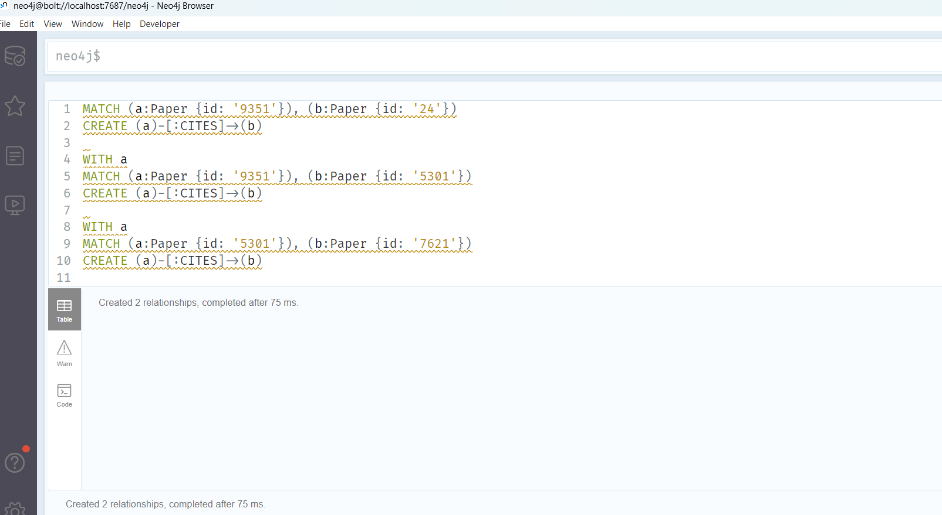

- Design the Angular form for any kind of search on above database. The form should able to answer queries like
  - Does paper A cite paper B? If not directly, does paper A cite a paper which in its turn cites paper B? And so on, in several levels.

  - Show the full classification of a paper (for example, Databases / Relational)

  - Any miscellaneous / user defined queries.

