**Abstract**

The development and implementation of a QR based attendance system, which can be used in school and colleges for tracking attendance records efficiently by scanning the QR codes through the webcam. The projects aims to provide an efficient solution to reduce manual efforts in maintaining attendance records by providing accurate results and smooth functioning with feasibility.

The QR Code Attendance System is a modern approach to automate the attendance management in various places. This report presents an abstract overview of the attendance system using QR. QR are two-dimensional barcodes that can store and made of a required data of each student. Each student have their own separate QR code. QR codes acts as unique identifiers for each student and can be easily scanned using smartphones or dedicated scanning devices or webcam. The main objective of QR code attendance system is to replace the traditional method of manual attendance in college and make it easy for teachers to take attendance and maintain record of it.

QR code attendance system increases accuracy of attendance because sometimes there must be some mistakes in manual attendance marking but in this each student have their own separate QR code which ensures accurate tracking record.

QR code attendance system is a time efficient attendance system

Which is quick process. It can be implemented across various colleges and institutions and in different organizations. Though it is modern and efficient solution for attendance.

.

### 

### **ACKNOWLEDGEMENT**

WE are highly grateful to the Dr. R K Jain , Director, Rajarshi Shahu College of Engineering (RSCOE), Pune, for providing this opportunity to carry out the major project work. The constant guidance and encouragement received from Dr. Kavita P. Moholkar H.O.D. CSBS Department, RSCOE Pune has been of great help in carrying out the project work and is acknowledged with reverential thanks. WE would like to express a deep sense of gratitude and thanks profusely to Prof. Seema Verma , without her wise counsel and able guidance, it would have been impossible to complete the project in this manner. WE express gratitude to other faculty members of Computer Science and Business Systems department of RSCOE for their intellectual support throughout the course of this work. Finally, WE are indebted to all whosoever have contributed in this report work.

Almas Shaikh

Sakshi Takbhate

Vedanti Koyande

Rucha Shastri



## 

## 

**LIST OF FIGURES**

|  |  |  |
| --- | --- | --- |
| **Fig. No.** | **Figure Description** | **Page No** |

3.3.1 Use case Diagram 11

3.3.2 Class Diagram 12

3.3.3 Activity Diagram 13

3.3.4 Sequence Diagram 14

3.3.5 Component Diagram 15

3.4.1 E-R Model 16

**TABLE OF CONTENTS**

### **Contents PageNo.**

***Abstract i***

***Acknowledgment ii***

***List of Figures iii***

***Table of Contents iv***

**Chapter 1: Introduction**  **6**

1.1) Introduction to Project 6

1.2) Project Category 6

1.3) Objectives 6

1.4) Problem formulation 6

1.5) Identification/Reorganization of Need/Motivation 6

1.6) Existing System 6

1.7)Proposed System 6

1.8) Unique Features of the System 7

**Chapter 2: Requirement Analysis and System Specification 8**

2.1) Feasibility study (Technical, Economical, Operational) 8

2.2) Software Requirement Specification Document 8

2.3) Validation 9

2.4 )Expected hurdles/Limitations 9

2.5) SDLC model to be used 9

**Chapter 3: System Design**   **10**

3.1) Design Approach 10

3.2 )Detail Design 10

3.3) System Design using various Structured analysis and design tools 10

3.4) User Interface Design(External interface requirement) 16

3.5 ) Database Design 16

3.6 ) Methodology 17

**Chapter 4: Implementation, Testing and Maintenance**   **18**

4.1) Introduction to Languages, IDE’s, Tools and

Technologies used for Implementation 18

4.2) Coding standards of Language used 18

4.3) Testing Techniques and Test Plans 18

**Chapter 5: Results and Discussions**   **19**

5.1) User Interface Representation (of Respective Project) 19

5.2 )Snapshots of system with brief detail of each 19

5.3 )Back Ends Representation (Database tobe used ) 19

5.4 )Testing Strategy and Approach 19

**Chapter 6: Conclusion 21**

6.1) Summary of project 21

**Chapter 7: Future Scope 22**

7.1) Improvements and Enhancements 22

**Chapter 8: References**  **23**

**Chapter 1: Introduction**

**1.1) Introduction to Project :-**

**Introduction:**

A system that keeps a record of students attendance using QR code. Students have to scan their QR cards in front of webcam and the system scans and verifies attendance notes down their attendance on excel sheet. Each Qr code contains a specific information and data of students. The system will store the students attendance records. It also generates report in excel sheet for the teachers reference . Such system is very useful in school as well as in college for daily attendance.

**1.2) Project Category** **:-**Lab Automation (Research based).

**1.3) Objectives** :- To mark daily attendance of the students correctly. To reduce paperwork attendance, and making it convenient for the faculty and user.This system allows for real time marking of attendance along with date.

**1.4) Problem Formulation** :- To develop a useful and efficient QR based attendance system to generate accurate records and manage students attendance properly.

**1.5) Identification/Reorganization of Need/Motivation:-** To decrease the workload of the teachers of managing the attendance every single time, this system would manage the records of student attendance by using the QR.

**1.6) Existing System** :- Such systems are already present in different areas and fields.

**1.7) Proposed System :-** A system that keeps a record of students attendance by using QR . Students have to scan their QR in front of webcam and the system note down their attendance through scanning and verifying by webcam. Each Qr code contains a specific information of students. The system will store the students attendance record. It also forms excel sheet of attendance.

**1.8) Unique Features of the System:-** Such systems are already present in many places but the main difference and uniqueness in this system is that it is not mandatory to use the scanner to scan QR codes instead we have used webcam. Hence this system reduces time taken/required for attendance and webcam can be used instead of scanner as well.

**Chapter 2: Requirements Analysis**

**2.1) Feasibility study(Technical, Economical, Operational) :-**

* Technical feasibility :- When we talk about the technical feasibility of this system , such QR code scanning technology can be easily used in mobile applications or other web-based systems. The software interfaces required for this project such as VS code , MS excel are easily available. To ensure this software can be accessed by many devices .
* Economical feasibility :- The economical cost of implementing QR based attendance system can vary depending upon software and hardware used and its maintenance. However this system can give a long term cost savings by reducing manual attendance and efforts and providing accurate data analysis.
* Operational feasibility :- The operational feasibility of this project also depends on the availability of the hardware such as tablets , smartphones, PC’s, webcam and the network connectivity to make sure the easy usage of this system.

**2.2) Software Requirement Specification Document:-**

* Data Requirement:- The system stores the following data:

User information such as name, ID, roll number, address, mobile number, email id . Attendance records such as date, time, user ID on the attendance sheet.

* Functional Requirements:-The student shall scan the OR code marking his/her attendance.
* QR Code Generation:- The system shall generate a unique QR code for each user/student. The QR code will contain the necessary information such as name and its roll number .Attendance
* Tracking and management:-The system shall provide a QR code scanning to record the attendance. The system will give analysis based on attendance data provided and captured.
* Performance Requirements:- The system shall be able to handle a limited number of users and attendance records. The QR code scanning process shall be fast, efficient and responsive to ensure smooth attendance marking.
* Dependability Requirements:-The system shall maintain accurate attendance records.
* Maintainability Requirement:-The system code as well as documentation of the system shall be well-documented for ease of maintenance and reducing efforts.
* Security Requirements:-The system will implement proper security measures to protect user data and attendance records. The system’s user interface is user-friendly and easy to understand.

**2.3) Validation** :-

The validation activities we can consider like , we can validate the QR code generation by generating QR codes for different users and we can verify if the encoded information is correct or not under unit testing.To test the interaction between QR code scanning and the attendance record process to ensure accurate data.

**2.4) Expected hurdles/Limitations:-**

While implementing such QR based attendance system, several hurdles can be encountered such as technology limitations, device similarity, user adoption and training, user familiarity and user resistance , data accuracy and integrity, network and connectivity issues ,and finding out what are the needs of users.

**2.5) SDLC model to be used:**-

Agile methodology can be considered in the case of a QR based system , therefore a Scrum SDLC model can be considered which includes requirement gathering , sprint planning,sprint execution, and repeat sprints.

**Chapter 3: System Design**

**3.1) Design Approach :-**

For implementing project we used python programming language. So the design approach of the system is both function oriented and object oriented.

**3.2)** **Detail Design:-**

1.QR generate module

2.QR scanning module

3.Attendance tracking module

4. Attendance sheet module

**3.3) System Design using various tools: DFD’s** : Data flow diagram (DFD) is a graphical representation of the flow of data within a project or system. In our system, the DFD explains how data flows or transfers between different steps.

**Fig: DFD for QR based attendance system.**

**UML DIAGRAMS :-**

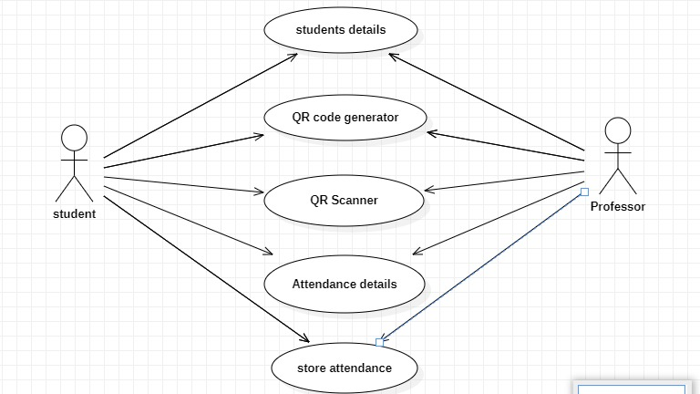

**Fig 3.3.1:- Use Case diagram**

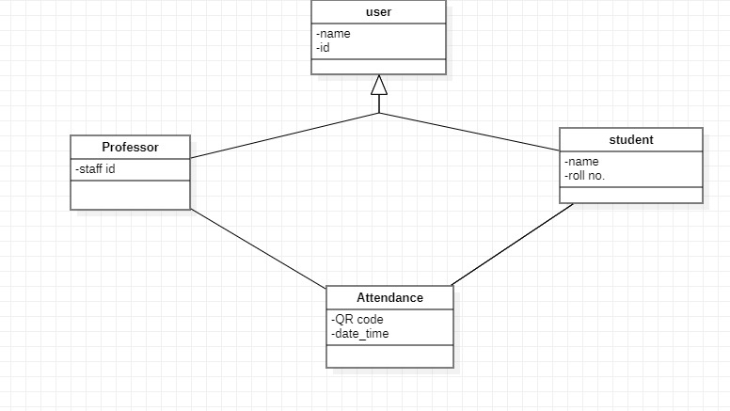

**Fig 3.3.2:-Class diagram**

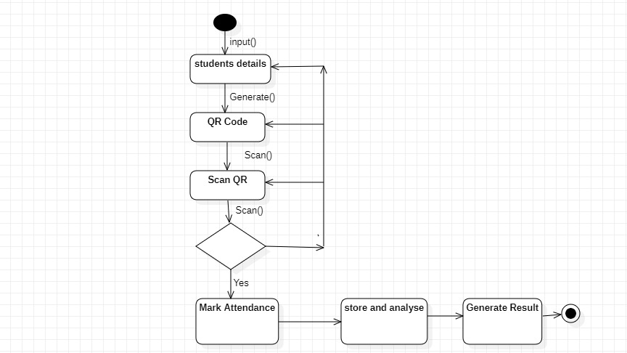

**Fig 3.3.3 :- Activity diagram**

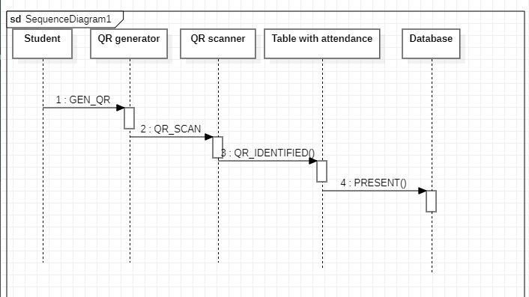

**Fig 3.3.4:- Sequence diagram**

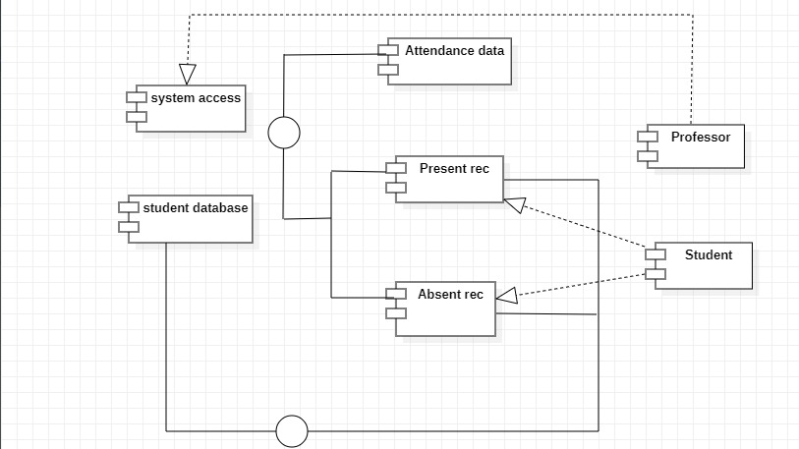

**Fig 3.3.5:-Component diagram**

**Data Dictionary**:

Data dictionary gives a simple understanding of the data components used in the system. It

defines the names, different data types, and additional information for data element. Providing effective understanding of a system.

**3.4) User Interface Design**

* QR CODE
* QR code scanner
* Attendance record
* Excel sheet
* Database Design

**3.5) Database Design:-**

**3.5.1 ER Diagrams**

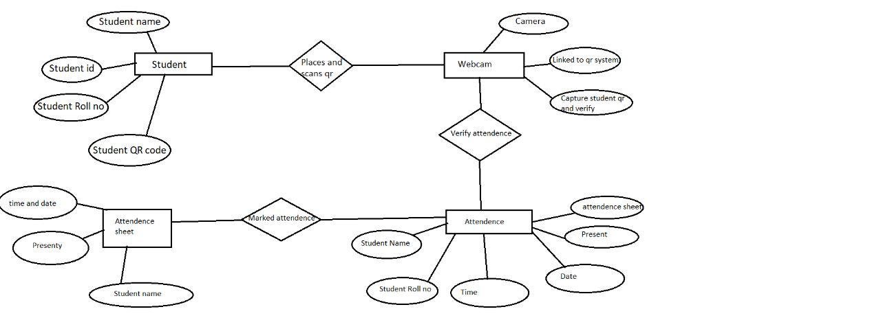

**Fig:- ER Diagram for QR based attendance system.**

**3.6) Methodology:**

1.Develop a QR code by python programming language using the data of student such as student name, student roll no.

2.Generate a code that take the attendance with the help of web cam and generate the student attendance sheet as per attendance details.

**Chapter 4. Implementation, Testing, and Maintenance**

**4.1) Introduction to Languages, IDE’s, Tools and Technologies used for Implementation:-**

The languages used to generate the QR based attendance system includes python .The IDE’s used visual studio code and the tools and technologies used are QR code generation libraries.

**4.2) Coding standards of Language used:-**

It is mandatory to follow the coding properly to ensure the stability and readability of the code. The python coding used include naming convections i.e. using lowercase letters with underscores to separate words for variables .Also indentations are used to avoid mixing tabs and spaces and reduce confusion .Line length and comments are used to explain the purpose and logics of the code.

**4.3 Testing Techniques and Test Plans:-**

Testing is an important part of the software development process including its implementation. The testing techniques and the test plans can be unit testing, integration testing, functional testing, performance testing, security testing . The test plan contemplation can be test objectives , test scope, test data, bug reporting, test documentation.

**Chapter 5. Results and Discussions**

**5.1) User Interface Representation:-**

The user interface of QR based attendance usually consists of different screens and constituents to allow the users to communicate with the system.

Mark attendance screen which includes camera(webcam) to scan the QR codes.

**5.2) Snapshots of system with brief detail of each:-**

The snapshots of the systems contains dashboard and excel sheet snapshot which will provide an overview of attendance related information.

The marked attendance screen snapshot will be used to mark the attendance using QR codes.

**5.3) Back Ends Representation (Database to be used ):-**

The databases that can be used for the back end of a QR based attendance system depends on the python programming language and contains different libraries. And the data file of student information.

**5.4 )Testing Strategy and Approach:-**

* Test QR Code Generation:

Scenario: Generate a QR code for a single user.

Expected Result: The QR code should contain the user's ID and session information. Actual Result: The QR code is successfully generated and contains the expected data.

* Test QR Code Scanning:

Scenario: Scan a valid QR code.

Expected Result: The system should recognize and process the QR code, marking the user as present.

Actual Result: The QR code is scanned successfully, and the user's attendance is recorded accurately.

* Test Attendance Recording:

Scenario: Scan

* **QR attendance system Snapshot:**

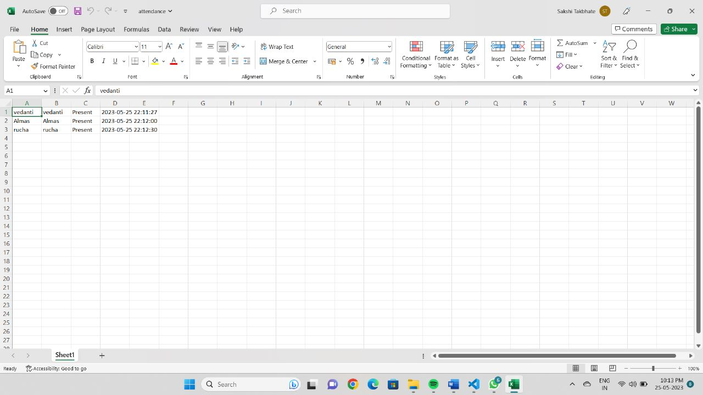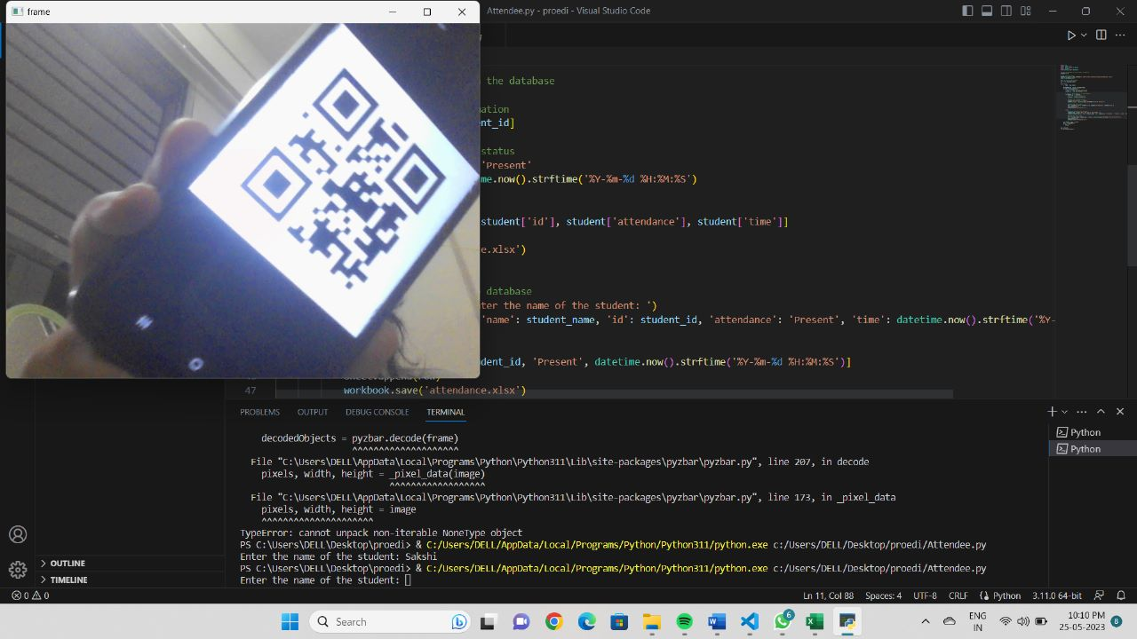

**Chapter 6. Conclusion**

**6.1) Summary of project:**

In conclusion, the generation of a QR-based attendance software system offers several benefits for efficient and automated attendance tracking. Through scanning of QR codes, the system simplifies the attendance procedure , reduces the errors, and enhances data accuracy. The software system will allow the users to mark attendance easily without any error using their respective devices , and the users can easily manage and track the attendance records.

User interface and representation can also be considered in terms of results and discussion. Throughout this software system generation process, various aspects were considered which included data requirements, functional requirements, performance requirements, dependability requirements, maintainability requirements, security requirements.

A suitable SDLC model according to the system can be chosen, and coding standards can be followed to ensure a high-quality software. Testing techniques and test plans were also implemented to verify the software's functionality, performance, security. Future scope of this QR based attendance system will be on a great demand as well as it will be useful as it offers several benefits as well as works as an efficient attendance management tracking system.

The potential areas of future scope are mobile app enhancements, biometrics integeration, attendance analytics, analytics and reporting , scalability and cloud development.

**Chapter 7: Future Scope**

**7.1) Improvements and Enhancements:**

Our future work will focus on providing missed class topics and notes available to students. Full control to professor with more secured and enhanced options. Finally we conclude, if we integrates this attendance monitoring system with face identification tool then system will solve the real world attendance problem.

**Chapter 8: References/Bibliography**

1. https://developer.android.com/training/index.html

2. https://www.tutorialspoint.com/android/

3. https://github.com/zxing/zxing

4. http://files.microscan.com/whitepap ers/barcode_basics.pdf

5."ISS QR Code AIM Store: Historical Archive". Available: Aimglobal.org

6. http://androidhive.com