Game Design Document

Fill up the following document

1. Write the title of your project.

Time Machine game

1. What is the goal of the game?

Facing challenges in order to survive and returning to the present age

1. Write a brief story of your game.

The game is about a 13-14 year old boy who is a geniuse when it comes to robotics. He designs a time machine but when goes to test it, it’s remote breaks down and goes to the stone age.

There he has to face 2 main challenges. He has to survive in the stone age for 3-4 days. There he has to find food, water and shelter to live in. He also has to protect himself from the wild animals.

The second challenge is to find back his remote, find some resources to fix his remote and timemachine. He also has to come baqck to the present time. We also want to give the players an option to write btheir feedback and keep it displayed in the app.

1. Which are the playing characters of this game?

* Playing characters are the ones who respond to the user based on the input from the user.
* Cars, monkeys, dinos, wizards, etc., are the playing characters in the game.

|  |  |  |
| --- | --- | --- |
| Number | Character Name | What can this character do? |
| 1 | Player(Name optional) | Player of the game |
| 2 | Dinosours | Obstacles |
| 3 | Wild Animals | Obstacles |
| 4 | Wild plants | Obstacles |
| 5 |  |  |
| 6 |  |  |
| 7 |  |  |
| 8 |  |  |

1. Which are the Non-Playing Characters of this game?

* Non-Playing characters are the ones that don't have an action or behavior when the user interacts with the game.
* Hurdles, stones, bananas, coins, etc., are non-playing characters in the game.

|  |  |  |
| --- | --- | --- |
| Number | Character Name | What can this character do? |
| 1 | Cave | Shelter |
| 2 | Stone | Obstacle |
| 3 | Wodden rocks | Obstacle |
| 4 | River bodies | Points |
| 5 | Food | Points |
| 6 |  |  |
| 7 |  |  |
| 8 |  |  |

Draw your imagination of this game. What does this game look like?

* Draw the game either on your computer or on paper.
* Add images of the game scenes to show each of the playing and non-playing characters at least once.

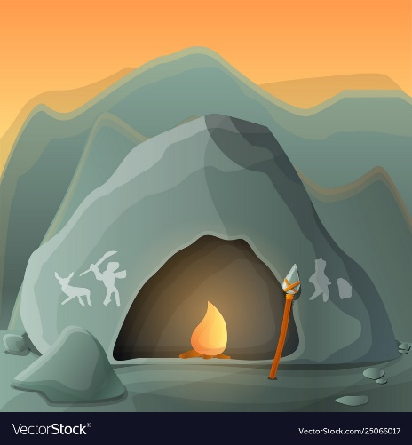

How do you plan to make your game engaging?

We plan to make the game engaging by adding good images and animations. The game is engaging as it has many levels and it is something new for the players as they must have heard very less about it and will be a new experience for them.