Anonymous Feedback Tool — Technical Design Document

Version: 1.0
Date: April 28, 2026
Status: Current

1. System Overview

The Anonymous Feedback Tool is a web application that enables employees to submit workplace concerns anonymously and allows HR staff to manage, investigate, and close those cases. The system is designed to operate in two deployment modes:

Mode | Purpose
public | Internet-facing server — employee portal only (no HR console or HR APIs)
full | Intranet server — all features including HR console, HR APIs, dashboard, and admin management

2. Technology Stack

Layer | Technology
Language | PHP 8.1+ (strict types throughout)
Database | MySQL 8.0+ / MariaDB (InnoDB, utf8mb4)
Frontend | HTML5, Bootstrap 5, Vanilla JavaScript (ES6+)
Authentication | JWT (HS256, custom implementation — no external library)
LDAP / AD Integration | PHP ldap_* extension
Email | Custom SMTP mailer over PHP stream sockets — no external library
Web Server | Apache / Nginx with URL rewriting to index.php
CSS | Custom app.css built on Bootstrap
No framework | Custom MVC — no Composer, no third-party packages

3. Application Architecture

The application follows a lightweight custom MVC pattern without any framework or package manager.

index.php ← Front controller: bootstraps, registers routes, dispatches
app/
bootstrap.php ← Autoloader, .env loader, security headers, DI container setup
Core/
Router.php ← HTTP method + path matching, named parameter extraction
Request.php ← Input abstraction (JSON body, POST, query string, method)
Response.php ← JSON response helper
Container.php ← Simple service locator / dependency injection container
Database.php ← PDO factory — creates database if not exists, returns PDO
Migration.php ← Idempotent schema migration runner (runs on every request)
JwtService.php ← JWT encode/decode/verify (HS256, HMAC-SHA256)
Authorization.php ← Bearer token extraction and role-based access
SmtpMailer.php ← Native SMTP over stream sockets (STARTTLS + SMTPS)
Controllers/
Api/ ← Stateless JSON API controllers
Web/ ← Page controllers (render HTML views)
Models/ ← Plain value objects with fromRow()/toArray()
Repositories/ ← All SQL queries, PDO interactions
Services/ ← Business logic (FeedbackService, NotificationService, LdapAuthService)
Views/
layouts/main.php ← Shared HTML shell, Bootstrap, navigation
pages/ ← Page-level PHP view templates
emails/ ← HTML email templates
config/
app.php ← All application config (reads from environment variables)
database.php ← Database connection config (reads from environment variables)
database/
schema.sql ← Full DDL — CREATE TABLE IF NOT EXISTS for all tables
users.sql ← Default HR user seed data and default category seed data
scripts/
process_notifications.php ← CLI script run by cron for scheduled notifications
public/
assets/css/app.css ← Stylesheet
assets/js/app.js ← All frontend JavaScript
api-docs/openapi.json ← OpenAPI 3.0 specification
uploads/ ← Uploaded attachment files (not web-accessible directly)

4. Request Lifecycle

Flowchart

Figure: Request Lifecycle Flowchart
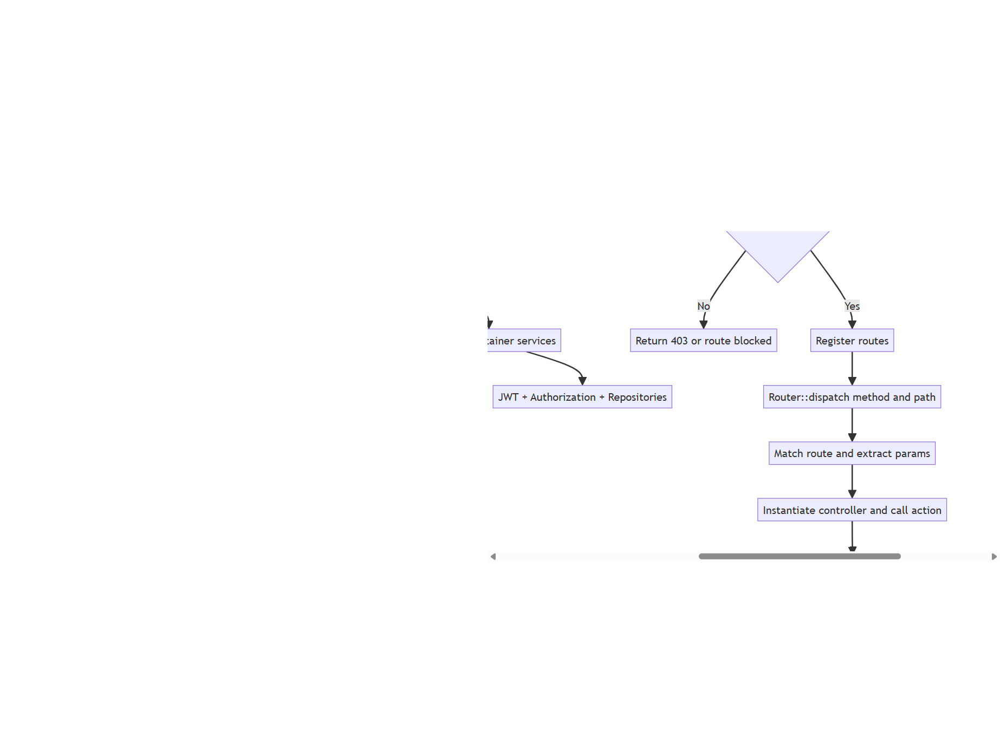

Browser Request
│
▼
index.php (front controller)
│
├── require bootstrap.php
│ ├── Register PSR-4-style autoloader (App\ → app/)
│ ├── Load .env file into getenv / $_ENV / $_SERVER
│ ├── Set security headers (X-Frame-Options, X-Content-Type-Options, Referrer-Policy)
│ ├── Load config/app.php and config/database.php
│ ├── Container::set('db') — PDO connection
│ ├── Migration::run() — idempotent schema migration
│ ├── Container::set('jwt') — JwtService
│ ├── Container::set('auth') — Authorization
│ └── Container::set('feedbackRepository', 'categoryRepository', etc.)
│
│ NOTE: processScheduledNotifications() is NOT called here.
│ It runs only via scripts/process_notifications.php (cron/Task Scheduler).
├── Check APP_MODE — block /hr and /api/hr in public mode
│
├── Register routes on Router instance
│
└── Router::dispatch(method, path)
│
├── Match route pattern using regex
├── Extract named URL parameters
└── Instantiate controller class → call method(params)
│
├── API Controller → Response::json(array, statusCode)
└── Web Controller → include view template → HTML output

5. Database Schema

Entity Relationship Summary

categories ──────────────────────────┐
│ FK category_id
statuses ────────────────────────────┤
│ FK status_id
stages ──────────────────────────────┤
│ FK stage_id
feedbacks (id, reference_no, category_id,
category_other, description,
status_id, stage_id, priority,
anonymized_summary, action_taken,
outcome_comments, internal_notes,
acknowledged_at, created_at, updated_at)
│
┌───────────────────────┼────────────────────────────┐
│ │ │
report_updates attachments notifications
(FK report_id CASCADE) (FK report_id CASCADE, (FK report_id CASCADE)
FK report_update_id CASCADE)

login_attempts
(rate-limiting — no FK)

audit_logs
(FK report_id SET NULL — preserves history on delete)

users
(HR/Ethics officer accounts)

Table Definitions

stages
Column | Type | Notes
id | INT UNSIGNED PK | Auto-increment
name | VARCHAR(120) UNIQUE | Display name (e.g. Logged, Under Review, Escalated)
is_active | TINYINT(1) | 1 = available for use by HR
sort_order | INT UNSIGNED | Controls display order
created_at | DATETIME
updated_at | DATETIME

Default stages seeded on install: Logged, Under Review, Awaiting Response, Escalated, Resolved, Closed.

categories
Column | Type | Notes
id | INT UNSIGNED PK | Auto-increment
name | VARCHAR(120) UNIQUE | Display name
is_active | TINYINT(1) | 1 = shown to employees
sort_order | INT UNSIGNED | Controls display order
created_at | DATETIME
updated_at | DATETIME

statuses
Column | Type | Notes
id | INT UNSIGNED PK | Auto-increment
name | VARCHAR(120) UNIQUE | Display name
is_active | TINYINT(1) | 1 = usable by HR
sort_order | INT UNSIGNED | Controls display order
created_at | DATETIME
updated_at | DATETIME

feedbacks
Column | Type | Notes
id | BIGINT UNSIGNED PK | Auto-increment
reference_no | VARCHAR(40) UNIQUE | Format: AF-YYYYMMDD-XXXXXX
category_id | INT UNSIGNED NOT NULL | FK → categories(id)
category_other | VARCHAR(255) NULL | Populated only when category = "Other"
description | TEXT NOT NULL | Employee-submitted detail
status_id | INT UNSIGNED NOT NULL | FK → statuses(id)
stage_id | INT UNSIGNED NOT NULL | FK → stages(id)
priority | ENUM('Low','Normal','High','Critical') | Default: Normal — fixed ENUM (not a table)
anonymized_summary | TEXT NULL | HR-authored; visible to employee via lookup
action_taken | TEXT NULL | HR internal
outcome_comments | TEXT NULL | Required when status = "Investigation completed"
internal_notes | TEXT NULL | HR internal; never exposed to employee
acknowledged_at | DATETIME NULL | Timestamped on first HR acknowledgement
created_at | DATETIME NOT NULL
updated_at | DATETIME NOT NULL

Design note — Stage vs Priority:
- stage_id is a FK to the stages table (like status_id and category_id) so HR can manage the set of defined workflow stages from the console.
- priority remains an ENUM (Low, Normal, High, Critical). These four values are semantically ordered and universally understood; storing them in a table would allow renaming that destroys that meaning.

report_updates
Column | Type | Notes
id | BIGINT UNSIGNED PK
report_id | BIGINT UNSIGNED NOT NULL | FK → feedbacks(id) ON DELETE CASCADE
update_reference_no | VARCHAR(40) UNIQUE | Format: UPD-YYYYMMDD-XXXXXX
update_text | TEXT NOT NULL | Employee follow-up content
created_at | DATETIME NOT NULL

attachments
Column | Type | Notes
id | BIGINT UNSIGNED PK
report_id | BIGINT UNSIGNED NULL | FK → feedbacks(id) ON DELETE CASCADE
report_update_id | BIGINT UNSIGNED NULL | FK → report_updates(id) ON DELETE CASCADE
original_name | VARCHAR(255) | Original filename
stored_name | VARCHAR(255) | Randomised filename on disk
mime_type | VARCHAR(150)
size_bytes | INT UNSIGNED
created_at | DATETIME NOT NULL

audit_logs
Column | Type | Notes
id | BIGINT UNSIGNED PK
report_id | BIGINT UNSIGNED NULL | FK → feedbacks(id) ON DELETE SET NULL
actor_user_id | INT NULL | FK → users(id) ON DELETE SET NULL (nullable for anonymous actions)
actor | VARCHAR(80) | anonymous or HR username
action | VARCHAR(200) | Machine-readable action label
reference_no | VARCHAR(40) | Retained even if report is deleted
details | TEXT | Human-readable detail
created_at | DATETIME NOT NULL

Design note:
- report_id is a legacy column name kept for backward compatibility after the historical table rename from reports to feedbacks.
- Semantically it references feedbacks(id).

notifications
Column | Type | Notes
id | BIGINT UNSIGNED PK
report_id | BIGINT UNSIGNED NOT NULL | FK → feedbacks(id) ON DELETE CASCADE
kind | VARCHAR(20) | new_feedback, followup_notif, reminder_48h, escalation_72h
recipient | VARCHAR(100) | Email address sent to
sent_at | DATETIME NOT NULL

users
Column | Type | Notes
id | INT PK
name | VARCHAR(255)
email | VARCHAR(255) UNIQUE
password_hash | VARCHAR(255) | bcrypt
role | ENUM('hr','ethics')
is_active | BOOLEAN
created_at / updated_at | TIMESTAMP

login_attempts
Column | Type | Notes
id | INT UNSIGNED PK
ip | VARCHAR(45) | IPv4 or IPv6
success | TINYINT(1)
attempted_at | DATETIME

6. API Endpoints

Public Endpoints (available in both modes)

Method | Path | Description
GET | / | Employee feedback portal (HTML)
POST | /api/feedback | Submit new anonymous feedback
POST | /api/feedback/update | Submit follow-up to existing case
GET | /api/feedback/{reference} | Retrieve own case status and updates
GET | /api/reports | Public anonymized reports (filterable)
GET | /api/attachments/{id} | Download an attachment by ID
GET | /api/categories | List active categories (for dropdown)
GET | /api/categories/{id} | Get a single category
GET | /api/statuses | List active statuses
GET | /api/statuses/{id} | Get a single status
GET | /api/stages | List active workflow stages
GET | /api/stages/{id} | Get a single stage

HR Endpoints (full mode only — JWT required except login)

Method | Path | Description
GET | /hr | HR Management Console (HTML)
GET | /hr/cases/{reference} | Case update screen (HTML)
GET | /hr/dashboard | Analytics dashboard (HTML)
GET | /hr/categories | Manage categories (HTML)
GET | /hr/statuses | Manage statuses (HTML)
POST | /api/hr/login | Authenticate HR user, returns JWT
POST | /api/hr/logout | Invalidate session
GET | /api/hr/me | Current authenticated user profile
GET | /api/hr/cases | List all feedback cases (filterable, paged)
GET | /api/hr/cases/{reference} | Full case detail
POST | /api/hr/cases/{reference} | Update case (status, priority, notes, etc.)
GET | /api/hr/dashboard/trends | Quarterly category trends + frequency summary
GET/POST/PUT/DELETE | /api/hr/categories | CRUD for feedback categories
GET/POST/PUT/DELETE | /api/hr/statuses | CRUD for workflow statuses
GET/POST/PUT/DELETE | /api/hr/stages | CRUD for workflow stages
GET | /api/docs | API documentation page (HTML)
GET | /api/openapi.json | OpenAPI 3.0 specification (JSON)

7. Authentication & Authorisation

HR Login Flow

POST /api/hr/login
│
├── 1. Rate-limit check — max 5 failed attempts per IP per 15 minutes
│
├── 2. Hybrid authentication (controlled by HR_AUTH_MODE env var):
│ ├── "ldap" — LDAP/AD only
│ ├── "local" — database users table only
│ └── "hybrid" — try LDAP first, fall back to database
│
├── 3. On success:
│ ├── Issue JWT (HS256, 24-hour expiry)
│ │ Payload: { user_id, email, name, role, iat, exp }
│ └── Return token to client
│
└── 4. Client stores JWT in localStorage
└── All subsequent HR API calls include:
Authorization: Bearer <token>

LDAP Authentication Detail

The LdapAuthService supports two bind strategies:
- Service account bind — Binds with a service account, searches the user DN in the subtree, then verifies credentials with a second bind as that user.
- Direct bind — Attempts to bind directly using LDAP_BIND_PATTERN (e.g., %s@domain.com).

Role assignment from LDAP is determined by group membership (LDAP_HR_GROUPS, LDAP_IS_GROUPS), OU (LDAP_HR_OUS, LDAP_IS_OUS), or department (LDAP_HR_DEPARTMENTS, LDAP_IS_DEPARTMENTS).

TLS (STARTTLS) is supported and configured via LDAP_USE_TLS=true.

JWT Verification

Every HR API controller calls Authorization::authenticate() which:
- Extracts the Bearer token from the Authorization header
- Verifies the HMAC-SHA256 signature using the configured JWT_SECRET
- Checks the exp claim against the current time
- Populates the Authorization service with the decoded user payload

8. Anonymity Mechanism

Anonymity is enforced at the application layer:

- No session, cookie, IP address, user agent, or browser fingerprint is stored against a submission
- The feedbacks table has no user identifier column
- The only link back to a submission is the reference number, which is randomly generated (bin2hex(random_bytes(3))) and only shown once to the submitter
- internal_notes are never returned by any public API endpoint
- File downloads via /api/attachments/{id} serve by ID only — no path traversal is possible as stored_name is used with basename()

9. File Upload Handling

- Accepted MIME types are validated server-side (PDF, Word documents, images)
- Files are stored in the /uploads/ directory using a randomised stored_name
- The /uploads/ path is blocked at the front controller level (HTTP 403) — files can only be downloaded via /api/attachments/{id}
- Attachment records are linked to either a report_id or a report_update_id (not both)

10. Email Notification System

Immediate Notifications (triggered on submit)

Event | Recipients
New feedback submitted | All active HR users (role = hr); falls back to HR_NOTIFICATION_EMAIL env var
Employee follow-up submitted | All active HR users

Scheduled Notifications (triggered by cron / Task Scheduler)

The script scripts/process_notifications.php must be run by an external scheduler (Linux cron or Windows Task Scheduler — recommended: every hour). It is not called on web requests. It identifies reports that:
- Have not been acknowledged after a configurable number of hours
- Have not already received a notification of that kind (deduplication via notifications table)

Threshold | Kind | Recipients
48 hours unacknowledged | reminder_48h | HR users (role = hr)
72 hours unacknowledged | escalation_72h | Ethics users (role = ethics)

Dev override: Set DEV_NOTIFICATION_EMAIL in .env to redirect all notification emails to a single address during development.

Email Transport

SmtpMailer uses native PHP stream_socket_client() — no external libraries. It supports:
- STARTTLS — port 587 (negotiated upgrade)
- SMTPS — port 465 (implicit SSL)
- Multipart MIME messages with HTML + plain-text fallback

11. Security Controls

Control | Implementation
SQL Injection | All queries use PDO prepared statements with bound parameters
XSS | Output in views uses htmlspecialchars() / escHtml() in JS; CSP not yet implemented
CSRF | Not applicable — all state-changing operations require JWT authentication
Clickjacking | X-Frame-Options: DENY header set on all responses
MIME sniffing | X-Content-Type-Options: nosniff header
Path traversal | Attachment downloads use basename() on stored filename; uploads directory blocked at front controller
Brute force | login_attempts table tracks per-IP failures; lockout after 5 failures in 15 minutes
JWT secret | Must be set via JWT_SECRET environment variable; application warns if default value is used
Direct uploads access | str_starts_with(path, '/uploads') check in index.php returns HTTP 403
LDAP injection | Credentials passed directly to ldap_bind() — not used in LDAP search filter strings

12. Environment Configuration

All configuration is driven by environment variables loaded from a .env file. No credentials are stored in source code.

Variable | Description | Default
APP_NAME | Application display name | Anonymous Feedback Tool
APP_MODE | public or full | full
APP_BASE_URL | Base URL (required for cron email links) | http://localhost:8000
JWT_SECRET | HMAC signing key — must be changed in production | insecure default
DB_HOST | MySQL host | 127.0.0.1
DB_PORT | MySQL port | 3306
DB_DATABASE | Database name | anonymous_feedback_tool
DB_USERNAME | Database user | _(empty)_
DB_PASSWORD | Database password | _(empty)_
HR_AUTH_MODE | hybrid, ldap, or local | hybrid
LDAP_HOST | Active Directory / LDAP server | localhost
LDAP_PORT | LDAP port | 389
LDAP_BASE_DN | Base DN for user searches | _(empty)_
LDAP_DOMAIN | AD domain for UPN suffix | _(empty)_
LDAP_USE_TLS | Enable STARTTLS | false
LDAP_SERVICE_USER | Service account DN for bind | _(empty)_
LDAP_SERVICE_PASSWORD | Service account password | _(empty)_
LDAP_HR_GROUPS | Comma-separated AD groups for HR role | _(empty)_
LDAP_IS_GROUPS | Comma-separated AD groups for Ethics role | _(empty)_
SMTP_HOST | SMTP server hostname | localhost
SMTP_PORT | SMTP port (587 = STARTTLS, 465 = SMTPS) | 587
SMTP_USERNAME | SMTP auth username | _(empty)_
SMTP_PASSWORD | SMTP auth password | _(empty)_
MAIL_FROM | Sender email address | noreply@localhost
MAIL_FROM_NAME | Sender display name | Voice Without Fear
HR_NOTIFICATION_EMAIL | Fallback HR notification recipient | _(empty)_
ETHICS_NOTIFICATION_EMAIL | Ethics officer notification recipient | _(empty)_
DEV_NOTIFICATION_EMAIL | Dev only — when set, all notifications are redirected to this address regardless of DB recipients | _(empty)_

13. Database Migration Strategy

Migration::run(PDO $pdo) is called on every request from bootstrap.php. All DDL statements use IF NOT EXISTS and are wrapped in try/catch blocks so they are idempotent — running them on an already-migrated database has no effect.

The migration handles both:
- Fresh installs — creates all tables from schema.sql and seeds default data from users.sql
- Legacy upgrades — detects and migrates old schema versions:
- status (text column) → status_id (FK to statuses table)
- category (text column) → category_id (FK to categories table) + category_other
- audit_logs.report_id FK addition

14. Frontend Architecture

All frontend logic is in a single file: public/assets/js/app.js.

The page is a Single HTML Shell — layouts/main.php loads once and app.js calls the REST API to populate all dynamic content without full page reloads.

Key patterns used:
- api(url, options) — central fetch wrapper that automatically attaches the JWT Authorization header if a token is present in localStorage
- TokenManager — localStorage-based JWT read/write/clear helper
- escHtml(str) — client-side HTML escaping to prevent XSS from API data rendered into the DOM
- All form submissions are intercepted with addEventListener('submit', ...) — no native form posts
- The "Other" category selection dynamically shows/hides a free-text field without a page reload

15. Deployment Topology (Recommended)

Internet
│
▼
[Public Server] APP_MODE=public
├── Employee submission portal (/)
├── Public feedback API (/api/feedback/*, /api/categories, /api/statuses)
└── No HR routes registered

(Internal network only)
│
▼
[Intranet Server] APP_MODE=full
├── HR Management Console (/hr/*)
├── HR API (JWT protected) (/api/hr/*)
└── Shares same MySQL database as public server

[MySQL Server]
└── anonymous_feedback_tool database

[Cron Job — Intranet Server]
└── php scripts/process_notifications.php (every 30–60 minutes)

Both servers share the same codebase and the same database. The APP_MODE environment variable controls which routes are registered.

16. Reference Number Format

Prefix | Format | Example | Used For
AF | AF-YYYYMMDD-XXXXXX | AF-20260428-3F9A12 | New feedback reports
UPD | UPD-YYYYMMDD-XXXXXX | UPD-20260428-B8C441 | Follow-up updates

The six-character suffix is generated using strtoupper(bin2hex(random_bytes(3))) — 16.7 million possible values per day, collision probability negligible for typical usage volumes.

