LTMLE Project Outputs
Laura Aleksonis, Siyaa Bhargava, Xhemka Elezi
2026-04-18
#install.packages('ggplot2')
library(ggplot2)
cat('Packages retrieved!')
## Packages retrieved!

Retrieval of Data and Results
The working directory should be set to a folder containing all relevant items, including a folder named “Datasets” where the dataset of interest resides.
## Data retrieved!

Dataset Statistics
The threshold value used to categorize yards gained was the median of Yards gained per season in both t1 and t2.
## Summary of Yards Gained in t1:
## Min. 1st Qu. Median Mean 3rd Qu. Max.
## -11.0 65.0 197.0 266.2 368.0 2094.0
##
## Summary of Yards Gained in t2:
## Min. 1st Qu. Median Mean 3rd Qu. Max.
## -9.00 93.75 226.00 319.50 440.00 1948.00
##
## - - -
##
## Summary of Yard Categorizations:
## t2
## t1 At or above median Below median
## At or above median 263 251
## Below median 169 689
## Sample size: 1372 football players
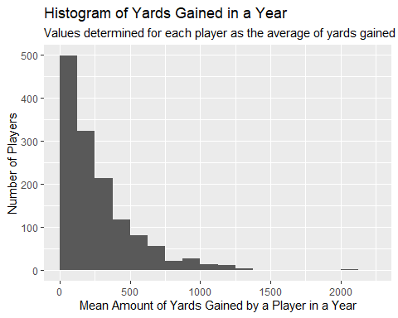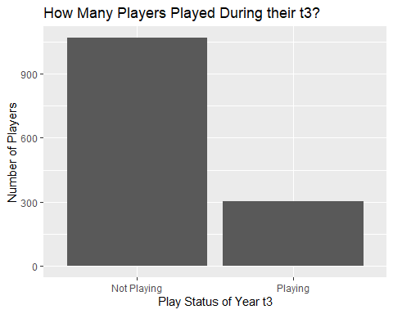
## Correlations between all variables included in maximal model:
## Years_Played_Before_t1 Passes_Completed_t1
## Years_Played_Before_t1 1.00000000 0.22588328
## Passes_Completed_t1 0.22588328 1.00000000
## Passes_Attempted_t1 0.21673401 0.98423703
## Touchdowns_t1 0.17946614 0.79740102
## Interceptions_t1 0.13494367 0.60749495
## Yards_Category_t1 0.19595507 0.61875918
## Passes_Completed_t2 0.19659314 0.43357376
## Passes_Attempted_t2 0.18259565 0.42347298
## Touchdowns_t2 0.15566246 0.37027957
## Interceptions_t2 0.07372086 0.23173247
## Yards_Category_t2 0.12254547 0.29801333
## Played_in_t3 -0.08722860 0.01080638
## Passes_Attempted_t1 Touchdowns_t1 Interceptions_t1
## Years_Played_Before_t1 0.21673401 1.794661e-01 0.134943667
## Passes_Completed_t1 0.98423703 7.974010e-01 0.607494954
## Passes_Attempted_t1 1.00000000 7.710420e-01 0.645177893
## Touchdowns_t1 0.77104199 1.000000e+00 0.413907185
## Interceptions_t1 0.64517789 4.139072e-01 1.000000000
## Yards_Category_t1 0.62460371 5.203051e-01 0.428241903
## Passes_Completed_t2 0.41040532 3.861187e-01 0.208367495
## Passes_Attempted_t2 0.40639518 3.772598e-01 0.208638580
## Touchdowns_t2 0.34525074 3.495640e-01 0.157476443
## Interceptions_t2 0.23159389 1.942443e-01 0.149093789
## Yards_Category_t2 0.29042063 2.697283e-01 0.158269586
## Played_in_t3 0.01340713 -7.260844e-05 -0.008892665
## Yards_Category_t1 Passes_Completed_t2
## Years_Played_Before_t1 0.195955070 0.1965931
## Passes_Completed_t1 0.618759179 0.4335738
## Passes_Attempted_t1 0.624603707 0.4104053
## Touchdowns_t1 0.520305118 0.3861187
## Interceptions_t1 0.428241903 0.2083675
## Yards_Category_t1 1.000000000 0.3206193
## Passes_Completed_t2 0.320619256 1.0000000
## Passes_Attempted_t2 0.317526190 0.9851140
## Touchdowns_t2 0.255925383 0.8359285
## Interceptions_t2 0.184139756 0.5945439
## Yards_Category_t2 0.327960027 0.5704917
## Played_in_t3 0.005498069 0.1138246
## Passes_Attempted_t2 Touchdowns_t2 Interceptions_t2
## Years_Played_Before_t1 0.1825957 0.1556625 0.07372086
## Passes_Completed_t1 0.4234730 0.3702796 0.23173247
## Passes_Attempted_t1 0.4063952 0.3452507 0.23159389
## Touchdowns_t1 0.3772598 0.3495640 0.19424428
## Interceptions_t1 0.2086386 0.1574764 0.14909379
## Yards_Category_t1 0.3175262 0.2559254 0.18413976
## Passes_Completed_t2 0.9851140 0.8359285 0.59454389
## Passes_Attempted_t2 1.0000000 0.8079923 0.64050748
## Touchdowns_t2 0.8079923 1.0000000 0.42448733
## Interceptions_t2 0.6405075 0.4244873 1.00000000
## Yards_Category_t2 0.5745603 0.4879373 0.39109478
## Played_in_t3 0.1177342 0.1135409 0.05927440
## Yards_Category_t2 Played_in_t3
## Years_Played_Before_t1 0.1225455 -8.722860e-02
## Passes_Completed_t1 0.2980133 1.080638e-02
## Passes_Attempted_t1 0.2904206 1.340713e-02
## Touchdowns_t1 0.2697283 -7.260844e-05
## Interceptions_t1 0.1582696 -8.892665e-03
## Yards_Category_t1 0.3279600 5.498069e-03
## Passes_Completed_t2 0.5704917 1.138246e-01
## Passes_Attempted_t2 0.5745603 1.177342e-01
## Touchdowns_t2 0.4879373 1.135409e-01
## Interceptions_t2 0.3910948 5.927440e-02
## Yards_Category_t2 1.0000000 1.188065e-01
## Played_in_t3 0.1188065 1.000000e+00
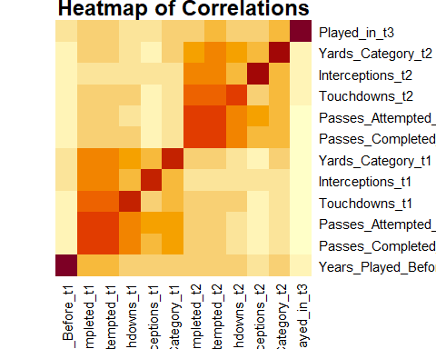

Comparison Statistics

Summary Statistics
## OUTPUT: Maximal Model Statistics
## Statistics
## Value_of_abar ATE_Estimate ATE_P_Value RR_Estimate RR_P_Value
## list(c(1, 1), c(0, 0)) 0.06808748 0.5230688 1.407614 0.5622164
## list(c(1, 0), c(0, 0)) 0.09103050 0.5294350 1.544965 0.5308068
## list(c(0, 1), c(0, 0)) 0.18384651 0.1456500 2.100620 0.2102432
## Statistics
## Value_of_abar OR_Estimate OR_P_Value
## list(c(1, 1), c(0, 0)) 1.532917 0.5527577
## list(c(1, 0), c(0, 0)) 1.734523 0.5294833
## list(c(0, 1), c(0, 0)) 2.695571 0.1874924
##
## - - -
##
## OUTPUT: Minimal Model Statistics
## Statistics
## Value_of_abar ATE_Estimate ATE_P_Value RR_Estimate RR_P_Value
## list(c(1, 1), c(0, 0)) 0.15182652 0.074391218 2.558279 0.22081663
## list(c(1, 0), c(0, 0)) 0.04462753 0.679897552 1.458037 0.68681823
## list(c(0, 1), c(0, 0)) 0.34968331 0.003625251 4.588992 0.04960263
## Statistics
## Value_of_abar OR_Estimate OR_P_Value
## list(c(1, 1), c(0, 0)) 3.075654 0.19144624
## list(c(1, 0), c(0, 0)) 1.533880 0.68543693
## list(c(0, 1), c(0, 0)) 7.491395 0.02731934

Complete Statistics: Maximal Model
##
## OUTPUT: Maximal Model
## (abar = list(c(1, 1), c(0, 0)) )
##
## Estimator: tmle
## Call:
## ltmle(data = data, Anodes = c(paste0(treats, "_t1"), paste0(treats,
## "_t2")), Lnodes = c("Passes_Completed_t1", "Passes_Attempted_t1",
## "Touchdowns_t1", "Interceptions_t1", "Passes_Completed_t2",
## "Passes_Attempted_t2", "Touchdowns_t2", "Interceptions_t2"),
## Ynodes = "Played_in_t3", abar = abar)
##
## Treatment Estimate:
## Parameter Estimate: 0.23513
## Estimated Std Err: 0.057832
## p-value: 4.7899e-05
## 95% Conf Interval: (0.12178, 0.34848)
##
## Control Estimate:
## Parameter Estimate: 0.16704
## Estimated Std Err: 0.089568
## p-value: 0.06219
## 95% Conf Interval: (0, 0.34259)
##
## Additive Treatment Effect:
## Parameter Estimate: 0.068087
## Estimated Std Err: 0.10662
## p-value: 0.52307
## 95% Conf Interval: (-0.14088, 0.27705)
##
## Relative Risk:
## Parameter Estimate: 1.4076
## Est Std Err log(RR): 0.58993
## p-value: 0.56222
## 95% Conf Interval: (0.44293, 4.4734)
##
## Odds Ratio:
## Parameter Estimate: 1.5329
## Est Std Err log(OR): 0.71959
## p-value: 0.55276
## 95% Conf Interval: (0.37411, 6.2811)
##
## - - -
##
## OUTPUT: Maximal Model
## (abar = list(c(1, 0), c(0, 0)) )
##
## Estimator: tmle
## Call:
## ltmle(data = data, Anodes = c(paste0(treats, "_t1"), paste0(treats,
## "_t2")), Lnodes = c("Passes_Completed_t1", "Passes_Attempted_t1",
## "Touchdowns_t1", "Interceptions_t1", "Passes_Completed_t2",
## "Passes_Attempted_t2", "Touchdowns_t2", "Interceptions_t2"),
## Ynodes = "Played_in_t3", abar = abar)
##
## Treatment Estimate:
## Parameter Estimate: 0.25807
## Estimated Std Err: 0.11371
## p-value: 0.023241
## 95% Conf Interval: (0.035194, 0.48095)
##
## Control Estimate:
## Parameter Estimate: 0.16704
## Estimated Std Err: 0.089568
## p-value: 0.06219
## 95% Conf Interval: (0, 0.34259)
##
## Additive Treatment Effect:
## Parameter Estimate: 0.091031
## Estimated Std Err: 0.14475
## p-value: 0.52943
## 95% Conf Interval: (-0.19268, 0.37474)
##
## Relative Risk:
## Parameter Estimate: 1.545
## Est Std Err log(RR): 0.69403
## p-value: 0.53081
## 95% Conf Interval: (0.39642, 6.0211)
##
## Odds Ratio:
## Parameter Estimate: 1.7345
## Est Std Err log(OR): 0.87585
## p-value: 0.52948
## 95% Conf Interval: (0.31164, 9.654)
##
## - - -
##
## OUTPUT: Maximal Model
## (abar = list(c(0, 1), c(0, 0)) )
##
## Estimator: tmle
## Call:
## ltmle(data = data, Anodes = c(paste0(treats, "_t1"), paste0(treats,
## "_t2")), Lnodes = c("Passes_Completed_t1", "Passes_Attempted_t1",
## "Touchdowns_t1", "Interceptions_t1", "Passes_Completed_t2",
## "Passes_Attempted_t2", "Touchdowns_t2", "Interceptions_t2"),
## Ynodes = "Played_in_t3", abar = abar)
##
## Treatment Estimate:
## Parameter Estimate: 0.35089
## Estimated Std Err: 0.089785
## p-value: 9.3043e-05
## 95% Conf Interval: (0.17491, 0.52686)
##
## Control Estimate:
## Parameter Estimate: 0.16704
## Estimated Std Err: 0.089568
## p-value: 0.06219
## 95% Conf Interval: (0, 0.34259)
##
## Additive Treatment Effect:
## Parameter Estimate: 0.18385
## Estimated Std Err: 0.12635
## p-value: 0.14565
## 95% Conf Interval: (-0.063793, 0.43149)
##
## Relative Risk:
## Parameter Estimate: 2.1006
## Est Std Err log(RR): 0.59241
## p-value: 0.21024
## 95% Conf Interval: (0.65779, 6.7083)
##
## Odds Ratio:
## Parameter Estimate: 2.6956
## Est Std Err log(OR): 0.75234
## p-value: 0.18749
## 95% Conf Interval: (0.61696, 11.777)

Complete Statistics: Minimal Model
## OUTPUT: Minimal Model
## (abar = list(c(1, 1), c(0, 0)) )
##
## Estimator: tmle
## Call:
## ltmle(data = data[, c("Years_Played_Before_t1", "Passes_Attempted_t1",
## "Yards_Category_t1", "Passes_Attempted_t2", "Yards_Category_t2",
## "Played_in_t3")], Anodes = c("Yards_Category_t1", "Yards_Category_t2"),
## Lnodes = c("Passes_Attempted_t1", "Passes_Attempted_t2"),
## Ynodes = "Played_in_t3", abar = abar)
##
## Treatment Estimate:
## Parameter Estimate: 0.24926
## Estimated Std Err: 0.044179
## p-value: 1.6801e-08
## 95% Conf Interval: (0.16267, 0.33585)
##
## Control Estimate:
## Parameter Estimate: 0.097432
## Estimated Std Err: 0.072728
## p-value: 0.18035
## 95% Conf Interval: (0, 0.23998)
##
## Additive Treatment Effect:
## Parameter Estimate: 0.15183
## Estimated Std Err: 0.085095
## p-value: 0.074391
## 95% Conf Interval: (-0.014957, 0.31861)
##
## Relative Risk:
## Parameter Estimate: 2.5583
## Est Std Err log(RR): 0.7672
## p-value: 0.22082
## 95% Conf Interval: (0.56872, 11.508)
##
## Odds Ratio:
## Parameter Estimate: 3.0757
## Est Std Err log(OR): 0.86007
## p-value: 0.19145
## 95% Conf Interval: (0.56996, 16.597)
##
## - - -
## OUTPUT: Minimal Model
## (abar = list(c(1, 0), c(0, 0)) )
##
## Estimator: tmle
## Call:
## ltmle(data = data[, c("Years_Played_Before_t1", "Passes_Attempted_t1",
## "Yards_Category_t1", "Passes_Attempted_t2", "Yards_Category_t2",
## "Played_in_t3")], Anodes = c("Yards_Category_t1", "Yards_Category_t2"),
## Lnodes = c("Passes_Attempted_t1", "Passes_Attempted_t2"),
## Ynodes = "Played_in_t3", abar = abar)
##
## Treatment Estimate:
## Parameter Estimate: 0.14206
## Estimated Std Err: 0.080059
## p-value: 0.075989
## 95% Conf Interval: (0, 0.29897)
##
## Control Estimate:
## Parameter Estimate: 0.097432
## Estimated Std Err: 0.072728
## p-value: 0.18035
## 95% Conf Interval: (0, 0.23998)
##
## Additive Treatment Effect:
## Parameter Estimate: 0.044628
## Estimated Std Err: 0.10816
## p-value: 0.6799
## 95% Conf Interval: (-0.16736, 0.25662)
##
## Relative Risk:
## Parameter Estimate: 1.458
## Est Std Err log(RR): 0.9353
## p-value: 0.68682
## 95% Conf Interval: (0.23315, 9.1179)
##
## Odds Ratio:
## Parameter Estimate: 1.5339
## Est Std Err log(OR): 1.0562
## p-value: 0.68544
## 95% Conf Interval: (0.19355, 12.156)
##
## - - -
## OUTPUT: Minimal Model
## (abar = list(c(0, 1), c(0, 0)) )
##
## Estimator: tmle
## Call:
## ltmle(data = data[, c("Years_Played_Before_t1", "Passes_Attempted_t1",
## "Yards_Category_t1", "Passes_Attempted_t2", "Yards_Category_t2",
## "Played_in_t3")], Anodes = c("Yards_Category_t1", "Yards_Category_t2"),
## Lnodes = c("Passes_Attempted_t1", "Passes_Attempted_t2"),
## Ynodes = "Played_in_t3", abar = abar)
##
## Treatment Estimate:
## Parameter Estimate: 0.44712
## Estimated Std Err: 0.095931
## p-value: 3.1495e-06
## 95% Conf Interval: (0.25909, 0.63514)
##
## Control Estimate:
## Parameter Estimate: 0.097432
## Estimated Std Err: 0.072728
## p-value: 0.18035
## 95% Conf Interval: (0, 0.23998)
##
## Additive Treatment Effect:
## Parameter Estimate: 0.34968
## Estimated Std Err: 0.12021
## p-value: 0.0036253
## 95% Conf Interval: (0.11409, 0.58528)
##
## Relative Risk:
## Parameter Estimate: 4.589
## Est Std Err log(RR): 0.77604
## p-value: 0.049603
## 95% Conf Interval: (1.0027, 21.003)
##
## Odds Ratio:
## Parameter Estimate: 7.4914
## Est Std Err log(OR): 0.91247
## p-value: 0.027319
## 95% Conf Interval: (1.2528, 44.798)

