Diabetes Prediction MLOps Project Report
Generated on: 07 April 2026
Capstone Topic: DevOps for AI (Unit V)

1. Project Overview
This project predicts whether a patient is diabetic and shows how to deploy an AI model using DevOps practices. The goal is to make the model easy to train, test, deploy, monitor, and maintain.

2. Open-Source Tools Used
- Scikit-learn for model training
- FastAPI for model serving
- Pytest for automated testing
- Docker for containerization
- Kubernetes (Kind) for orchestration
- GitHub Actions for CI/CD
- Prometheus metrics for monitoring

3. Architecture Diagram
The diagram below shows the complete MLOps workflow from data and training to deployment, monitoring, and automation.
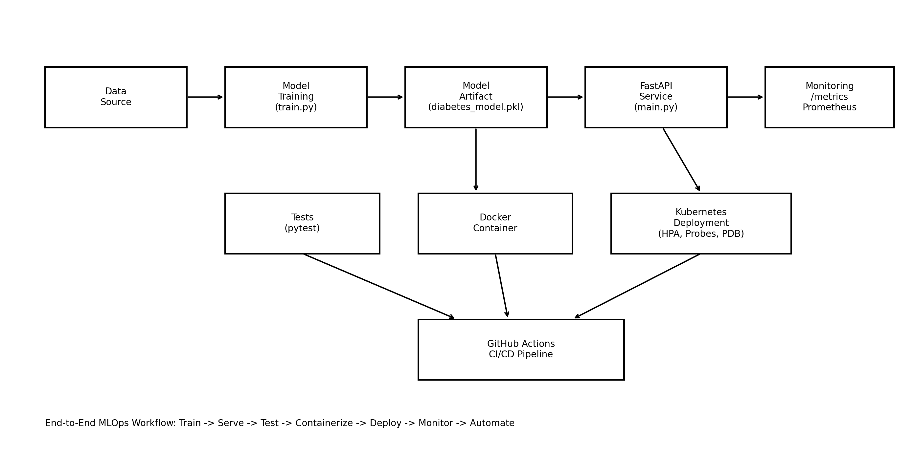
Figure: End-to-end MLOps architecture

4. Implementation in Simple Steps
1. Train model using train.py and save it as diabetes_model.pkl.
2. Load the model in FastAPI (main.py) and expose prediction endpoint /predict.
3. Add health endpoints (/health and /ready) for deployment checks.
4. Add monitoring endpoint (/metrics) with Prometheus metrics.
5. Write test cases in test_main.py and enforce coverage with pytest.ini.
6. Build container image using Dockerfile and run app in a non-root user.
7. Deploy app on Kubernetes using k8s-deploy.yml with probes, HPA, and PDB.
8. Automate checks and builds in .github/workflows/ci-cd.yml.

5. Key DevOps Features Implemented
- Automated tests with coverage threshold
- Code quality checks (Black and Flake8)
- Security scan using Bandit
- Container healthcheck and secure runtime
- Kubernetes readiness/liveness/startup probes
- Auto-scaling using Horizontal Pod Autoscaler
- Availability protection using PodDisruptionBudget
- Operational metrics for traffic, latency, errors, and model readiness

6. How to Demonstrate to Professor
- Run python train.py
- Run uvicorn main:app --reload --host 0.0.0.0 --port 8000
- Show /docs, /health, /ready, /metrics endpoints
- Run pytest and show all tests passing with coverage
- Build and run Docker image
- Deploy to Kind/Kubernetes and show kubectl get deploy,po,svc,hpa,pdb
- Show successful GitHub Actions pipeline run

7. Conclusion
This project successfully demonstrates DevOps for AI using an open-source stack. It includes model lifecycle, API deployment, testing, CI/CD, containerization, orchestration, and monitoring.

