DIP-Gfit

Background:

At high altitude, decreased performance of soldiers is observed due to reduced atmospheric partial pressure. Rapid acclimatization under such conditions is a big challenge. DIP-Gfit, a natural performance enhancer, promotes rapid acclimatization and prevents loss of physical and cognitive performance. DIP-Gfit is well standardized and characterized single herb product. DIP-Gfit improves cardio respiratory function at high altitudes. The product is rich in bioactive phytochemicals such as nucleobases (provide energy and enhance mitochondrial activity), ascorbic acid, flavonoids like rutin, kaempferol, quercetin, isorhamnetin, hesperidin (anti-stress), coumarin (anti-inflammatory) etc.

Potential Benefits of DIP-Gfit:
  - Overall performance (physical and cognitive) enhancer
  - Adaptogenic potential helps in rapid acclimatization under adverse environmental conditions
- Prevents fatigue
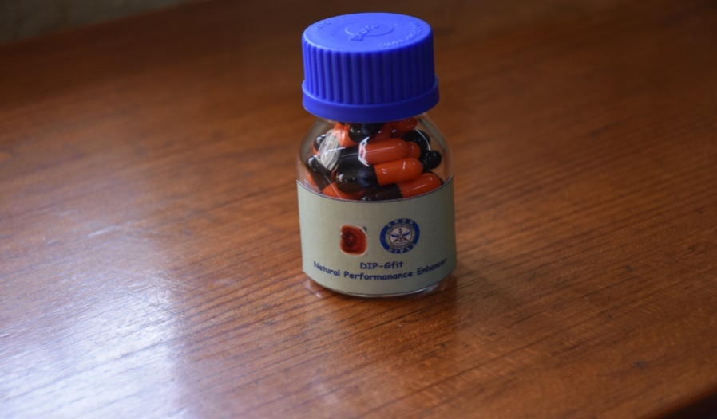
  - Multiple modes of action acts via activation of anti-oxidative, anti-inflammatory and cyto-protective pathways in parallel under stressful environment
- DIP-Gfit is safe and has good shelf life up to 2 years

Applications:

- Potent Performance Enhancer
- Anti-stress Daily Health Supplement
- Sports Supplement
- Energy Supplement

Very useful for mountaineers, sport persons, soldiers posted at high altitude and civilians as it works as anti-fatigue and anti stress.

Patent: Indian patent filed

