## Front End Engineering-II /Artificial

## Intelligence and Machine Learning

Project Report

Semester-IV (Batch-2022)

Task Management App

**Supervised By: Submitted By:**

Mr.Saqlain Koser Siya Bansal(2210992386)

Shruti Sharma(2210992358)

Sudhanshi(2210992413)

Sneha Jindal(2210992390)

**Department of Computer Science and Engineering**

## Chitkara University Institute of Engineering & Technology,

## Chitkara University, Punjab

**Introduction:**

**Background:**

Task management has evolved significantly over the years, transitioning from traditional pen-and-paper methods to digital platforms. While physical to-do lists and planners served their purpose, they often lacked flexibility and accessibility, hindering users from effectively managing their tasks. With the advent of technology, task management tools have become increasingly sophisticated, offering features such as customizable task lists, reminders, collaboration capabilities, and integration with other productivity applications.

Despite the abundance of task management tools available, many users still struggle to find a solution that meets their specific needs. Existing platforms often suffer from usability issues, lack of integration with other tools, and limited customization options. Moreover, the sheer variety of options can be overwhelming for users, making it challenging to identify the most suitable tool for their requirements.

**Objectives:**

The primary objective of this project is to develop a task manager website that addresses the shortcomings of existing solutions while providing a seamless and intuitive user experience. Specifically, the website aims to achieve the following objectives:

Enhanced Usability: Designing an intuitive user interface that facilitates easy navigation and task management, catering to users with varying levels of technical proficiency.

Comprehensive Features: Incorporating a wide range of features to support diverse task management needs, including task categorization, priority setting, due date reminders, collaboration tools, and integration with popular productivity applications.

Customization Options: Providing users with the flexibility to customize their task management workflow according to their preferences, including customizable task lists, tags, labels, and sorting options.

Accessibility: Ensuring accessibility for users across different devices and platforms, including desktop computers, tablets, and smartphones, through responsive design and cross-platform compatibility.

Performance and Reliability: Building a robust and scalable infrastructure to ensure optimal performance and reliability, even under high usage loads, to minimize downtime and disruptions..

**Significance:**

The significance of developing a task manager website lies in its potential to revolutionize the way individuals and organizations manage their tasks and enhance productivity. By offering a user-friendly and feature-rich platform, the website aims to empower users to prioritize, organize, and track their tasks more effectively, leading to reduced stress, improved time management, and enhanced efficiency.

Furthermore, the website's ability to integrate seamlessly with other productivity tools and applications enhances its utility, providing users with a centralized hub for managing all aspects of their work and personal life. This integration streamlines workflows, eliminates the need to switch between multiple applications, and ensures data consistency across different platforms.

Additionally, the accessibility of the website across various devices and platforms ensures that users can stay productive regardless of their location or preferred device. This flexibility enables users to manage their tasks on the go, whether they're in the office, at home, or traveling.

In conclusion, the development of a task manager website represents a significant step towards meeting the evolving needs of modern-day task management. By combining advanced features with user-centric design principles, the website seeks to redefine the task management experience and empower users to achieve their goals with greater ease and efficiency.

**2. Problem Definition and Requirements:**

**Problem Statement:**

In today's digital age, individuals and organizations face increasingly complex challenges in managing their tasks effectively. While there is a plethora of task management tools available, many users still struggle to find a solution that meets their specific needs and seamlessly integrates into their workflows. Current task management platforms often suffer from a lack of user-friendly interfaces, limited customization options, and inadequate integration capabilities, leading to frustration and inefficiency.

One of the primary issues users encounter is the complexity of existing task management tools. Many platforms offer a wide array of features, but navigating through these features can be overwhelming and time-consuming. Users often find themselves spending more time learning how to use the tool than actually completing their tasks. Furthermore, the lack of intuitive design and cumbersome user interfaces hinder productivity rather than enhancing it.

Another common challenge is the lack of flexibility and customization options. Users have diverse preferences and workflows when it comes to managing tasks, and existing platforms often fail to accommodate these variations. Users may require specific features or functionalities tailored to their unique needs, such as customizable task categories, priority levels, and sorting options. Without these customization options, users are forced to adapt their workflows to fit the limitations of the tool, resulting in suboptimal task management experiences.

Integration with other productivity tools and applications is another critical aspect that is often overlooked. In today's interconnected digital ecosystem, users rely on a variety of tools and platforms to manage different aspects of their work and personal lives. However, many task management tools lack seamless integration with these external applications, forcing users to switch between multiple tools and duplicate their efforts. This fragmentation of workflows not only reduces efficiency but also increases the likelihood of errors and oversights.

Furthermore, data security and privacy concerns are paramount in task management, especially for users handling sensitive or confidential information. Many existing task management platforms may lack robust security measures, putting user data at risk of unauthorized access or data breaches. Without adequate security safeguards in place, users may hesitate to entrust their task management workflows to these platforms, further exacerbating the problem.

Overall, the problem of ineffective task management tools stems from a combination of usability issues, limited customization options, inadequate integration capabilities, and security concerns. Addressing these challenges requires the development of a task manager website that prioritizes user-centric design, offers comprehensive customization options, seamlessly integrates with other productivity tools, and ensures robust security measures to safeguard user data. By providing users with a user-friendly, flexible, and secure task management solution, the website aims to enhance productivity, streamline workflows, and empower users to achieve their goals more effectively in the digital age.

**Software Requirements:**

Frontend Development: The task manager website will be built using HTML, CSS, and JavaScript for frontend development. These technologies will be used to create the user interface, design layout, and add interactivity to the website.

Framework or Library Usage: While HTML, CSS, and JavaScript form the core technologies, additional frameworks or libraries may be utilized to enhance development efficiency and user experience. For instance, front-end frameworks like Bootstrap or Materialize can be used for responsive design and pre-built UI components. JavaScript libraries such as jQuery or React may also be employed for simplifying DOM manipulation and building interactive features.

Browser Compatibility: The website should be compatible with major web browsers, including Google Chrome, Mozilla Firefox, Safari, Microsoft Edge, and Opera. Compatibility testing should be conducted to ensure consistent performance and appearance across different browsers and versions.

Responsive Design: Implementing responsive design principles is crucial to ensure that the website is accessible and functional across various devices and screen sizes, including desktops, laptops, tablets, and smartphones. CSS media queries and flexible layout techniques should be utilized to adapt the website's layout and content dynamically based on the viewport size.

Accessibility: The website should adhere to accessibility standards to ensure that it is usable by individuals with disabilities. This involves using semantic HTML markup, providing alternative text for images, ensuring keyboard navigation support, and implementing ARIA (Accessible Rich Internet Applications) attributes where necessary.

Performance Optimization: Optimizing the performance of the website is essential to provide a fast and responsive user experience. This includes minimizing file sizes, optimizing image assets, leveraging browser caching, and reducing the number of HTTP requests. Techniques such as lazy loading and code splitting may also be employed to improve loading times.

Version Control: Utilizing version control systems like Git for tracking changes to the codebase, collaborating with other developers, and managing code revisions. Platforms such as GitHub or GitLab can be used for hosting the repository and facilitating collaborative development workflows.

Testing Frameworks: Implementing testing frameworks such as Jest or Mocha for automated testing of frontend components, ensuring code reliability, and detecting potential issues early in the development process.

By leveraging HTML, CSS, and JavaScript, along with associated frameworks and best practices, the task manager website can be developed to provide a responsive, accessible, and feature-rich user experience tailored to meet the needs of modern task management.

**Hardware Requirements:**

The hardware requirements for the TaskeEase App are relatively minimal and include:

Standard computing devices such as desktop computers, laptops.

Internet connectivity for accessing online resources, downloading updates, and synchronizing user data across devices.

**Data Sets:**

Sample Task Data: A dataset containing sample task data is essential for testing and demonstrating the functionality of the task manager website. This dataset should include a diverse range of tasks representing various categories, priorities, due dates, and statuses (such as completed or pending). Each task entry should include relevant information such as title, description, due date, and any associated tags or labels. Additionally, the dataset may include recurring tasks to test the website's handling of repetitive tasks and reminders.

User Data: User-related data is required for user management and authentication purposes. This dataset should include user profiles, login credentials (such as usernames and encrypted passwords), email addresses, and any other relevant user information. User data may also include user preferences, such as default task categories, notification settings, and customization options. Additionally, the dataset should include sample user interactions, such as task creation, updates, and completion, to simulate real-world usage scenarios and test the website's functionality thoroughly.

Integration Data: If the task manager website integrates with external applications or services, sample integration data may be needed for testing and validation purposes. This dataset should include sample data from the integrated platforms, such as calendar events, project tasks, or communication threads. For example, if the website integrates with Google Calendar, the dataset may include sample calendar events with various attributes like title, description, start/end times, and attendees. Similarly, if the website integrates with project management tools like Trello or Asana, the dataset may include sample project tasks with details such as title, description, assignees, due dates, and project board associations. Testing with integration data helps ensure seamless interoperability and functionality across different platforms and services.

Historical Data: Historical task data may be useful for analyzing user behavior, trends, and patterns over time. This dataset can include past task records, user activity logs, and performance metrics. Analyzing historical data can provide valuable insights into user engagement, task completion rates, common workflow patterns, and areas for improvement. Additionally, historical data can be used to train machine learning models for predictive analytics and personalized task recommendations, enhancing the website's functionality and user experience.

Security and Privacy Data: Given the importance of data security and privacy in task management, a dataset containing sample security and privacy scenarios may be necessary for testing and evaluating the website's security measures. This dataset should include simulated security threats, such as unauthorized access attempts, data breaches, and malicious attacks. Testing with security and privacy data helps identify vulnerabilities and weaknesses in the website's security architecture, allowing for proactive mitigation measures to be implemented.

Overall, access to relevant datasets for testing and validation is essential to ensure the functionality, reliability, and security of the task manager website. By leveraging diverse datasets representing different usage scenarios and integration requirements, developers can thoroughly test the website's features and performance, ultimately delivering a robust and user-friendly task management solution.

**3. Proposed Design / Methodology**

Html code:

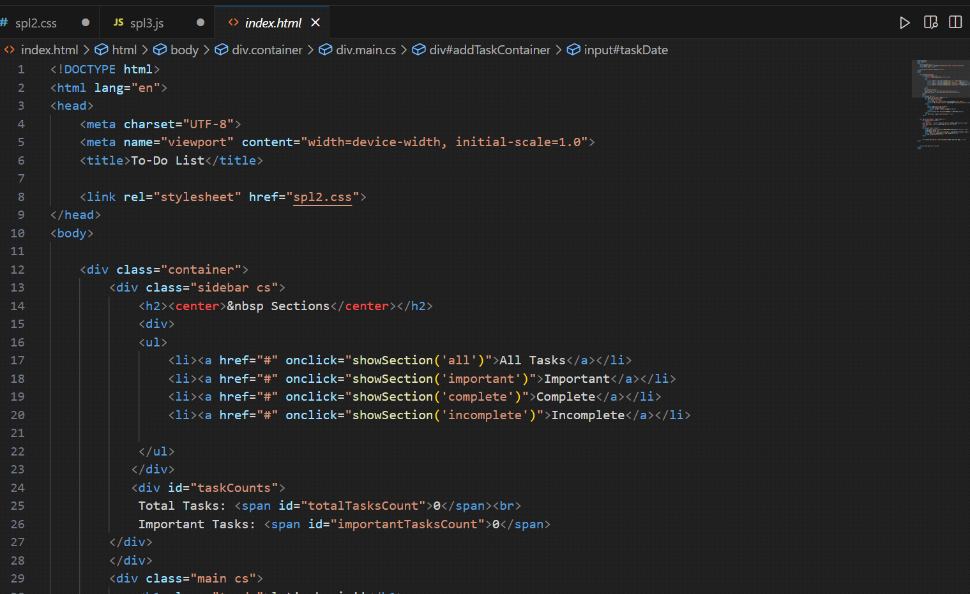

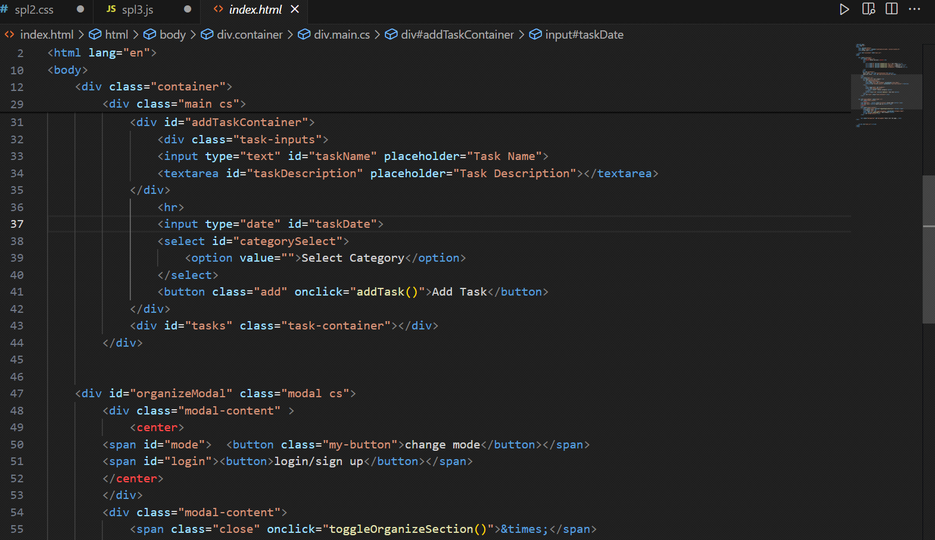

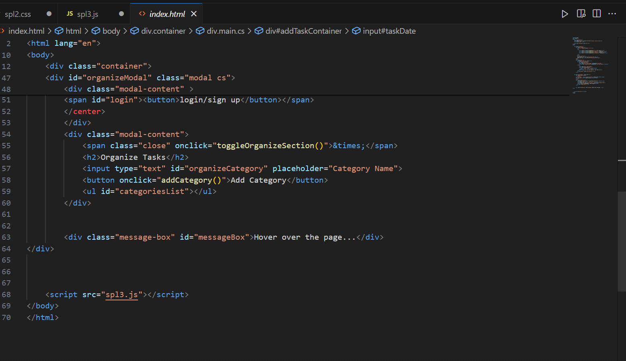

CSS code:

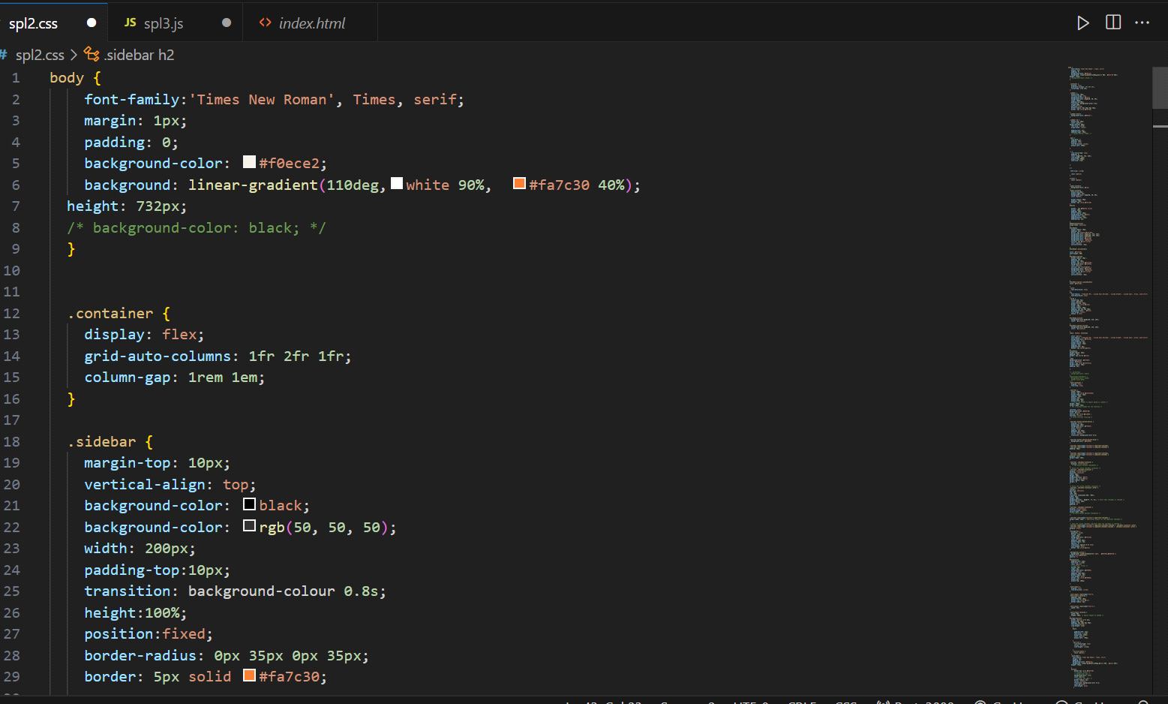

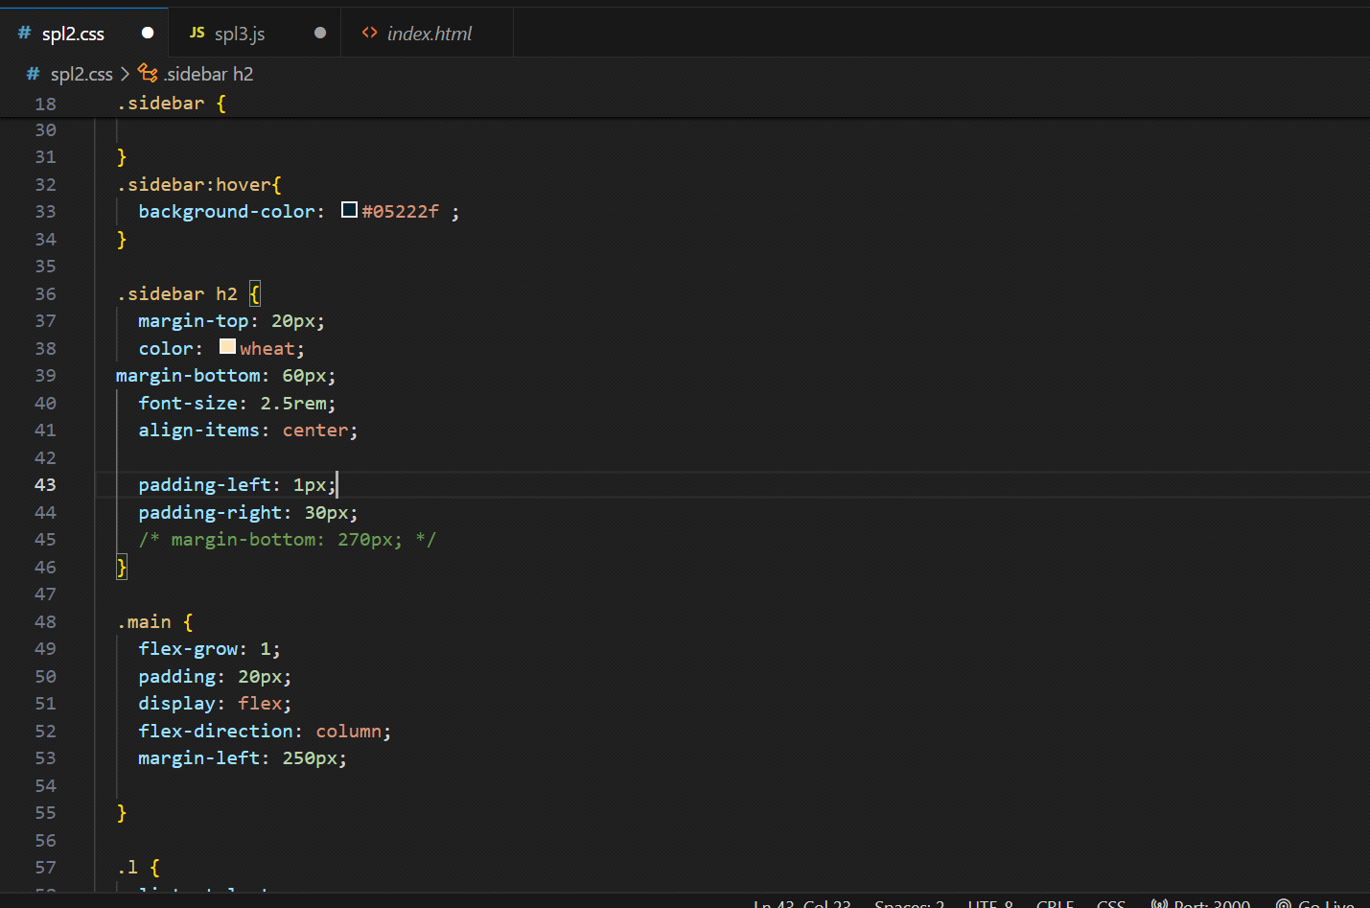

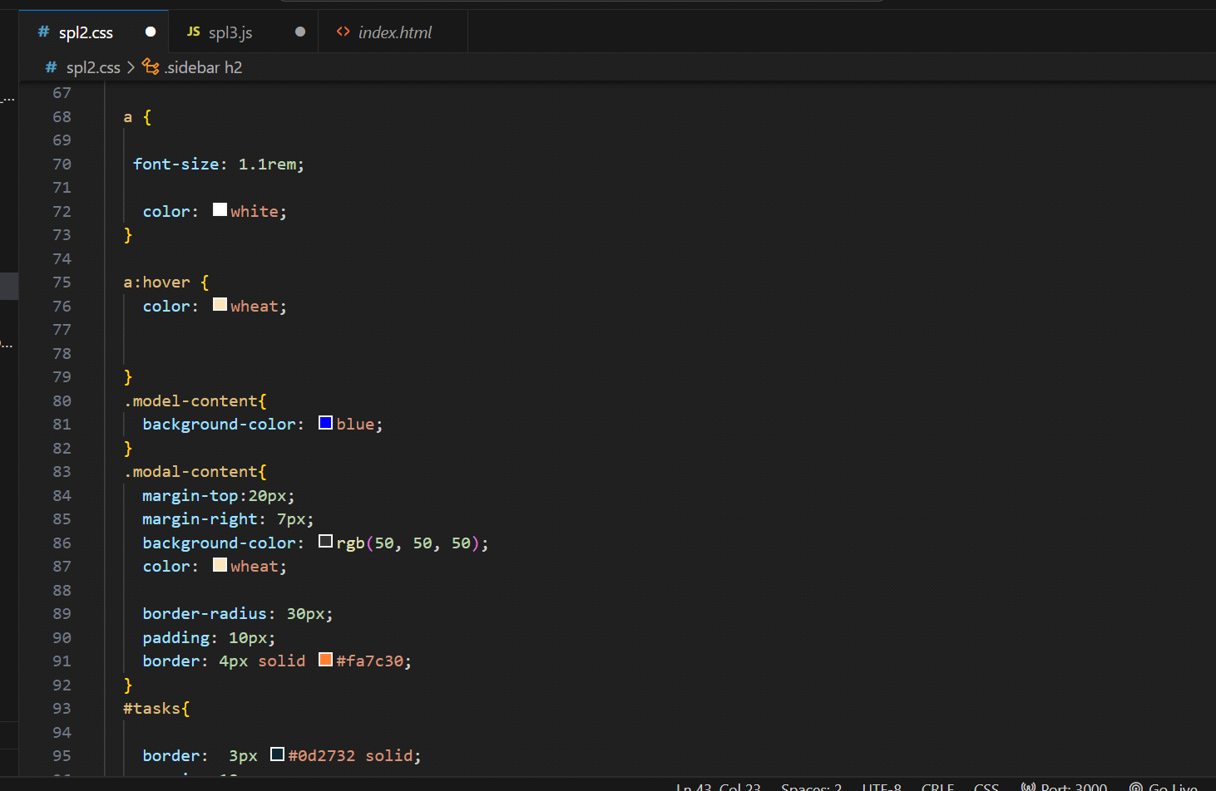

JavaScript code:

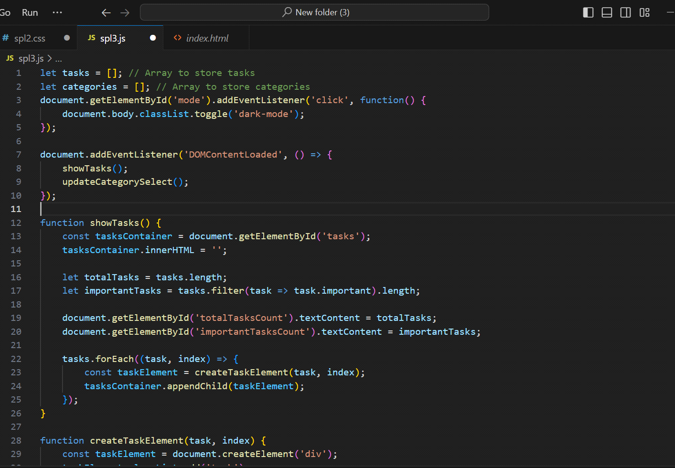



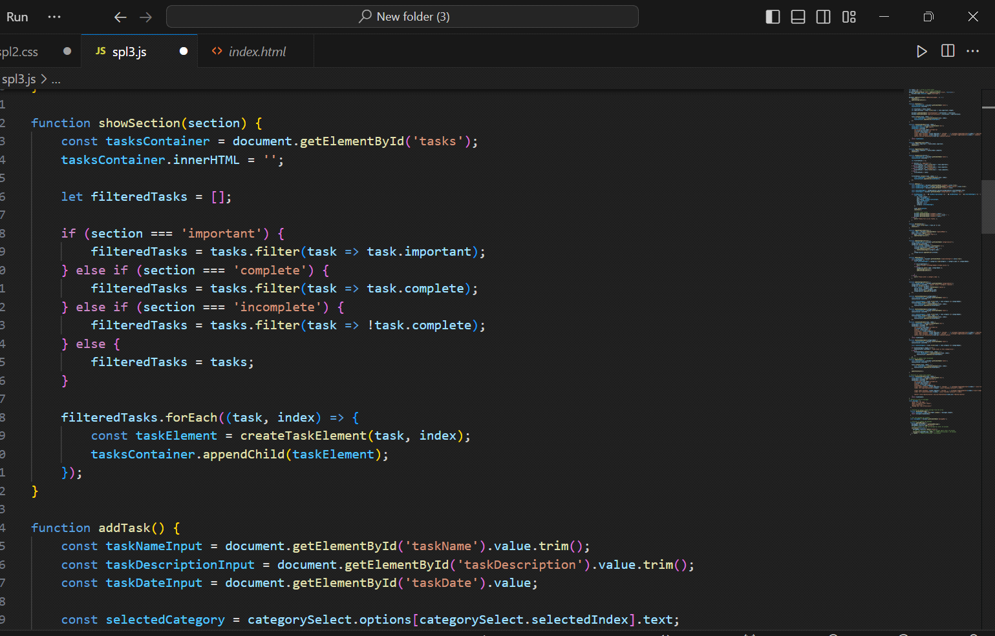

**Result:**

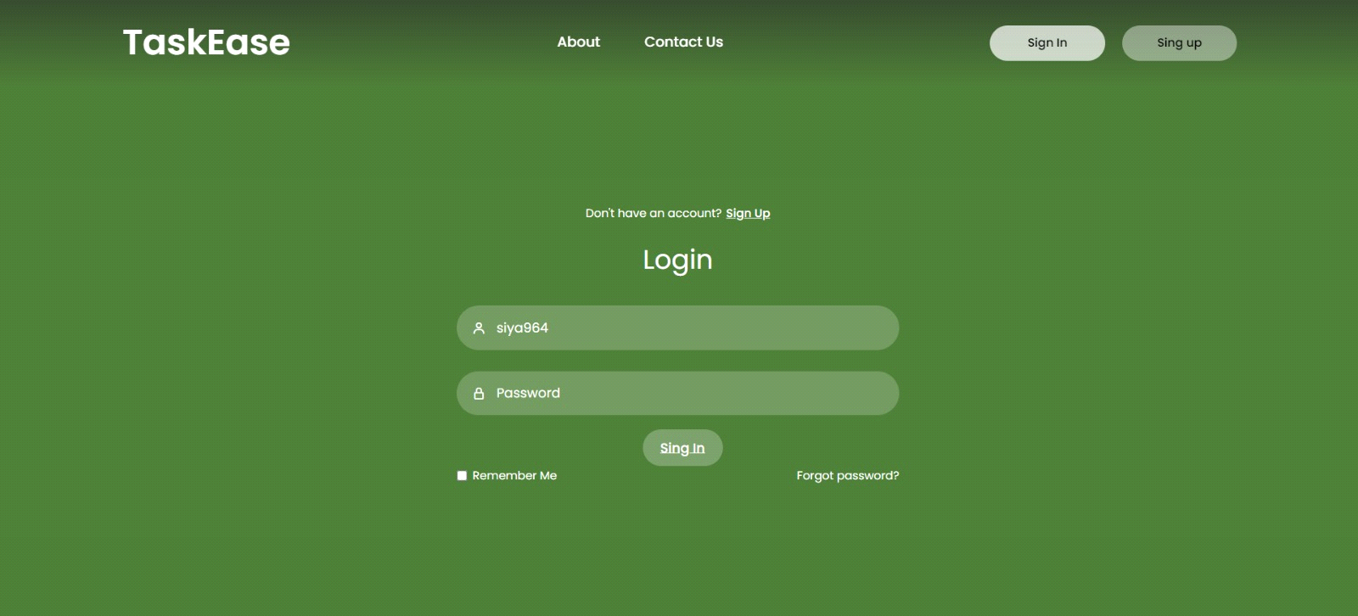

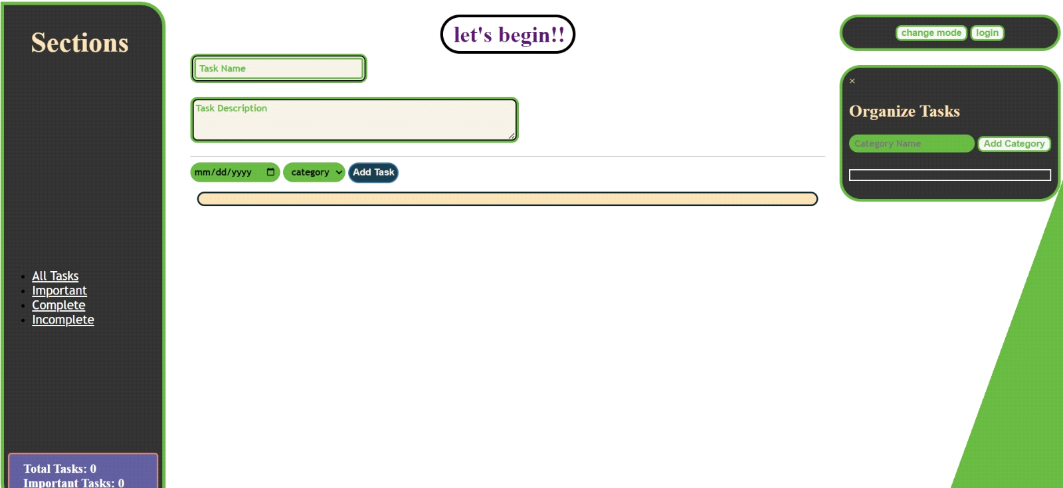

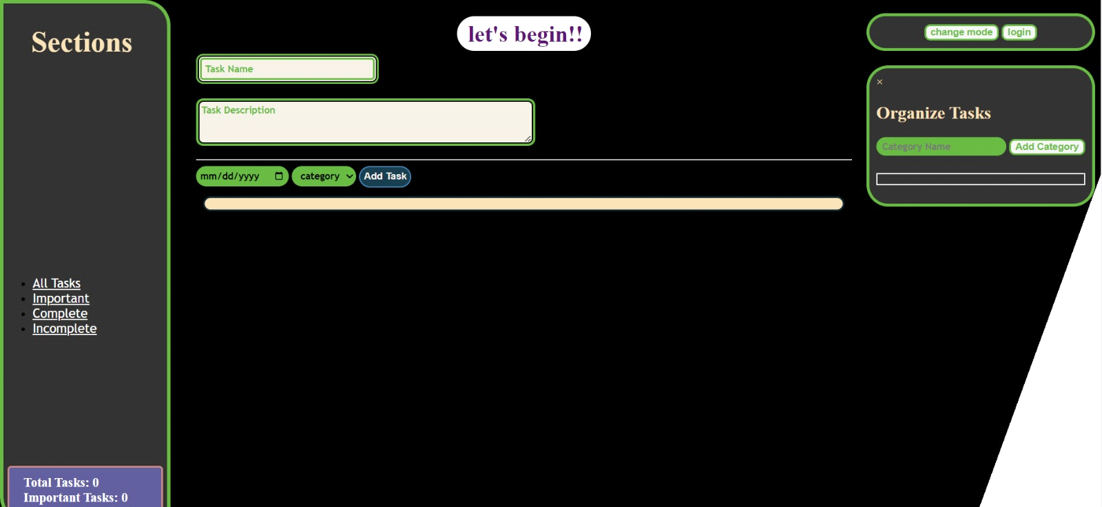

**Reference:**

Youtube, w3schools