:Building a Retail Sales Data Agent on Databricks
BrightLearn AI & Data Skills — Retail Data Agent Task
Student Name | Siyakha Ntuli
Assignment | BrightLearn AI & Data Skills – Retail Data Agent Task
Platform | Databricks (Genie Spaces)
Dataset | retail.sales.dataset — 1,000 transactions
Submission Date | 25 May 2026

1. Introduction & Objective
The goal of this project was to develop an end-to-end Retail Sales Data Agent within Databricks. Using a dataset of 1,000 retail transactions, I built an AI-powered Genie Space that allows business managers and stakeholders to ask questions about sales performance, customer demographics and product trends using plain, everyday language — no technical knowledge required.

The agent connects directly to the retail.sales.dataset table and translates natural language questions into SQL queries, returning answers with charts, tables and written explanations that any manager or CEO can understand.
2. Dataset Description
The dataset, registered as retail_sales_data, consists of 1,000 transaction records covering the full calendar year 2023. The table sits in the Databricks Catalog under retail > sales > dataset.

Column | Type | Description
Transaction ID | bigint | Unique identifier for each sale transaction
Date | date | Date the transaction occurred (YYYY-MM-DD)
Customer ID | string | Unique customer reference code (e.g. CUST001)
Gender | string | Customer gender: Male or Female
Age | bigint | Customer age at time of purchase (range: 18 to 64)
Product Category | string | Category sold: Beauty, Clothing or Electronics
Quantity | bigint | Number of units purchased per transaction
Price per Unit | bigint | Price of a single unit
Total Amount | bigint | Total value (Quantity x Price per Unit)

Key facts: Total revenue £456,000 across 1,000 transactions. Average transaction value £456. Ages 18 to 64. Three categories: Electronics (342), Clothing (351), Beauty (307).
3. Data Setup — Steps 1, 2 & 3
Step 1 — Upload the Dataset
The retail sales CSV file was uploaded into the Databricks Catalog under retail > sales > dataset. I confirmed the row count and column structure matched the original CSV before proceeding.

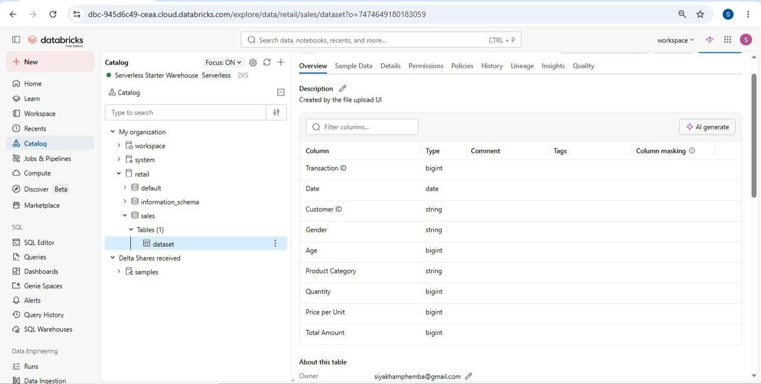
Screenshot 1 — The dataset registered in the Databricks Catalog Explorer showing the full table path.
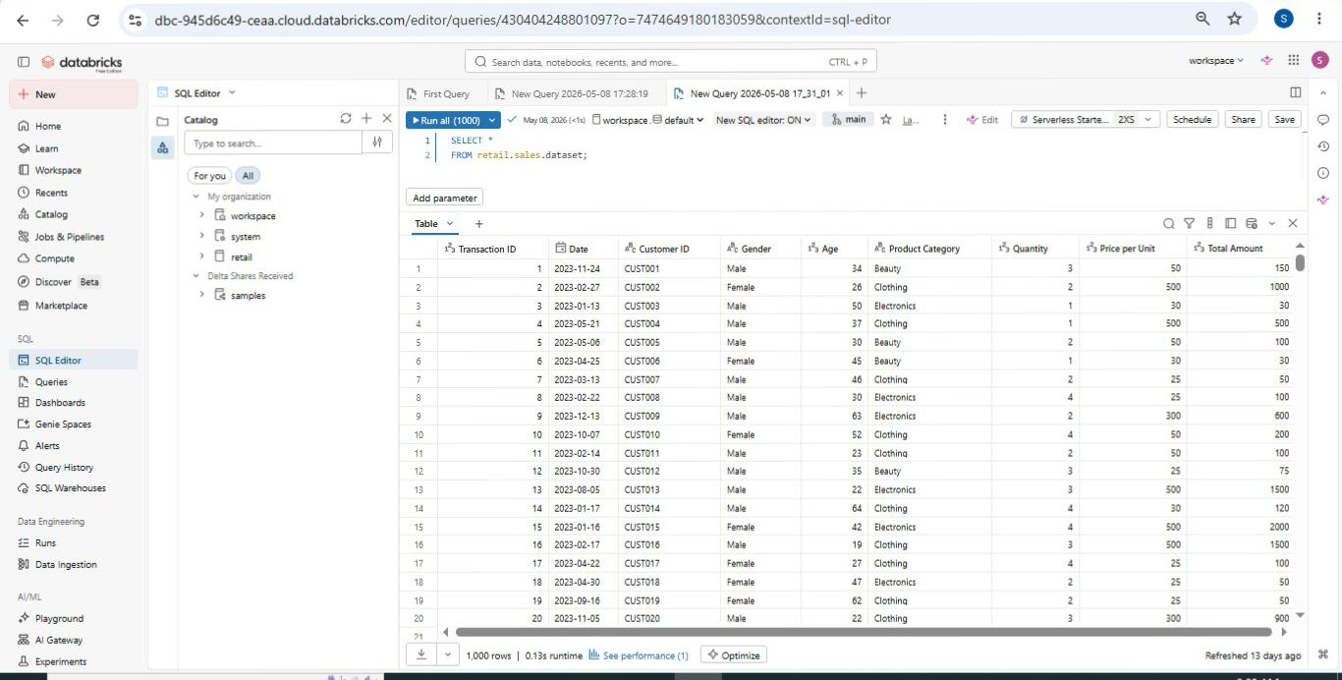
Screenshot 2 — Dataset preview showing all columns and sample rows.
Step 2 — Review the Dataset
I inspected every column using DESCRIBE and a summary statistics query in the SQL Editor. Column names, data types, date range, age range and spend range were all confirmed. No missing values or negative quantities were found.

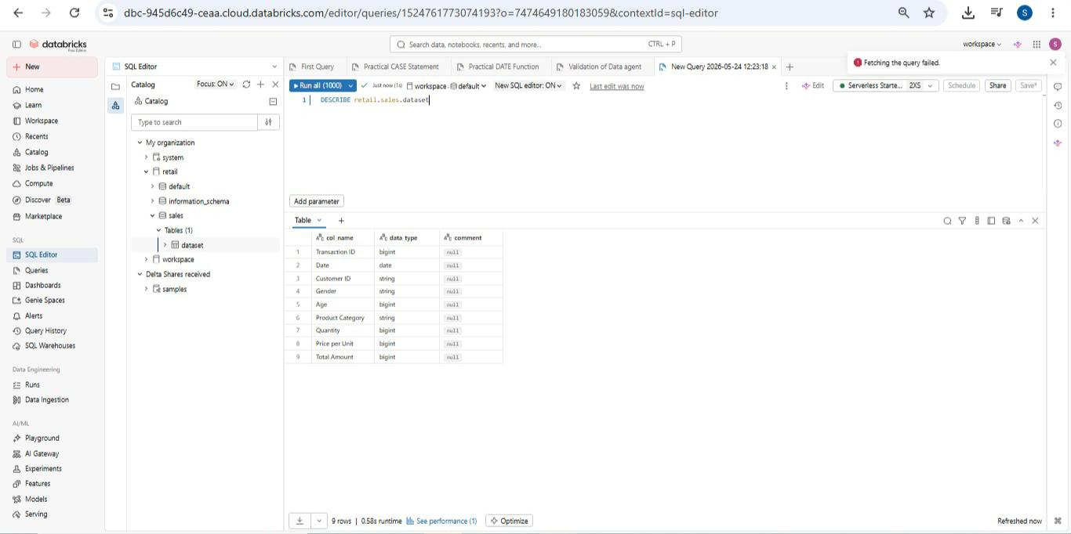
Screenshot 3 — DESCRIBE retail.sales.dataset showing column names and types.
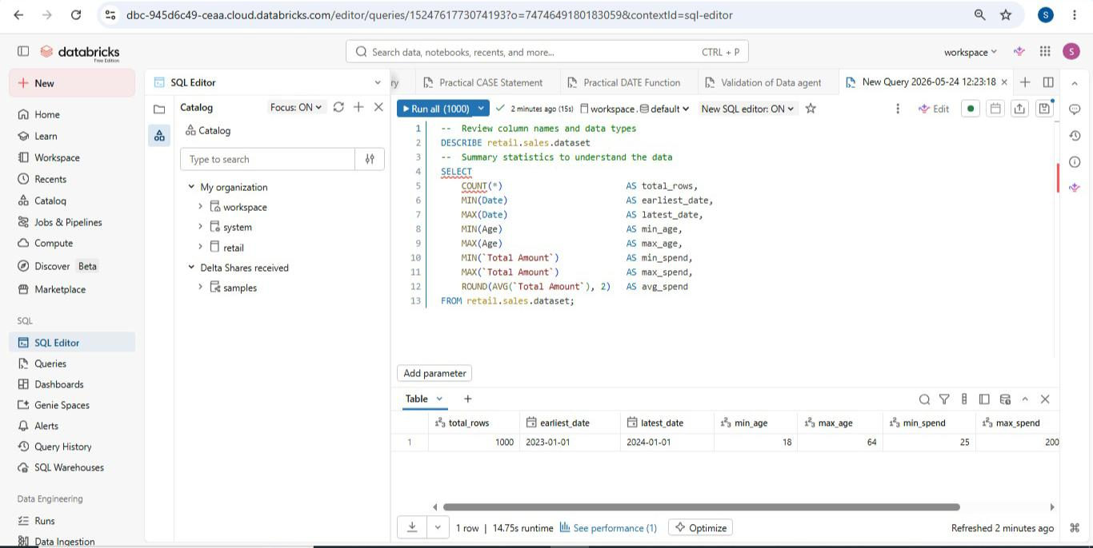
Screenshot 4 — Summary statistics confirming dataset completeness and value ranges.
Step 3 — Prepare the Table
I reviewed the schema in the Catalog to confirm all column names and types were correctly defined. The table was confirmed as a Managed Delta table under retail.sales and made available for the Genie Space to connect to.

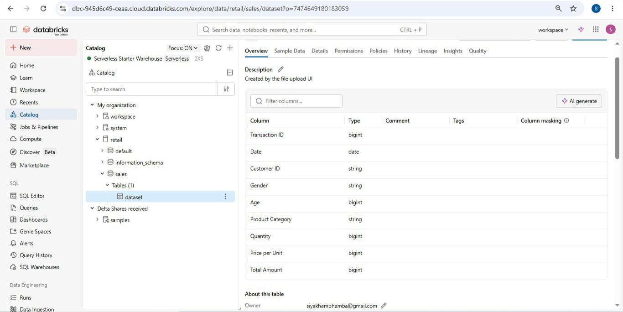
Screenshot 5 — The dataset table in Catalog with all 9 columns confirmed and ready for the agent.
4. Create the Data Agent — Step 4
I created a new Databricks Genie Space named Retail Sales Insight Agent. The space was connected to the retail.sales.dataset table and configured with the Serverless Starter Warehouse.

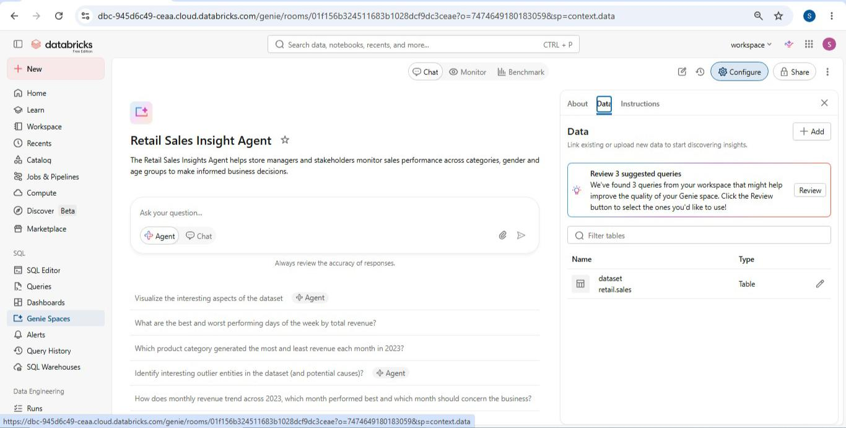
Screenshot 6 — The dataset selection screen showing retail.sales.dataset selected and confirmed.
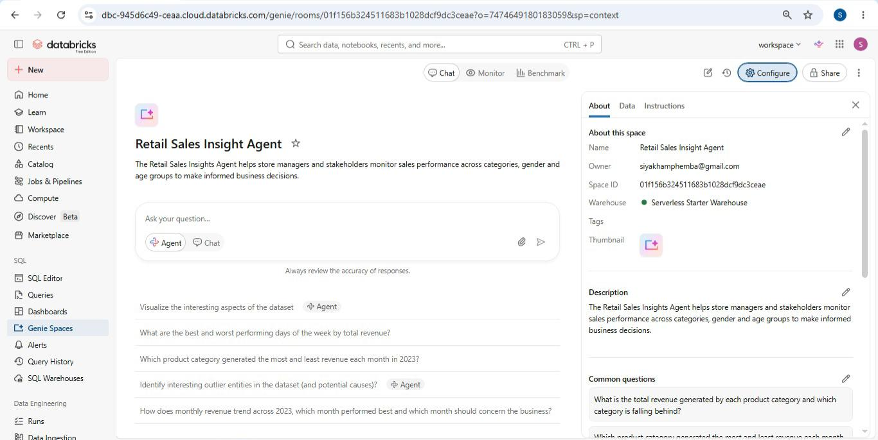
]
Screenshot 7 — The Edit space details page showing the agent name being entered.
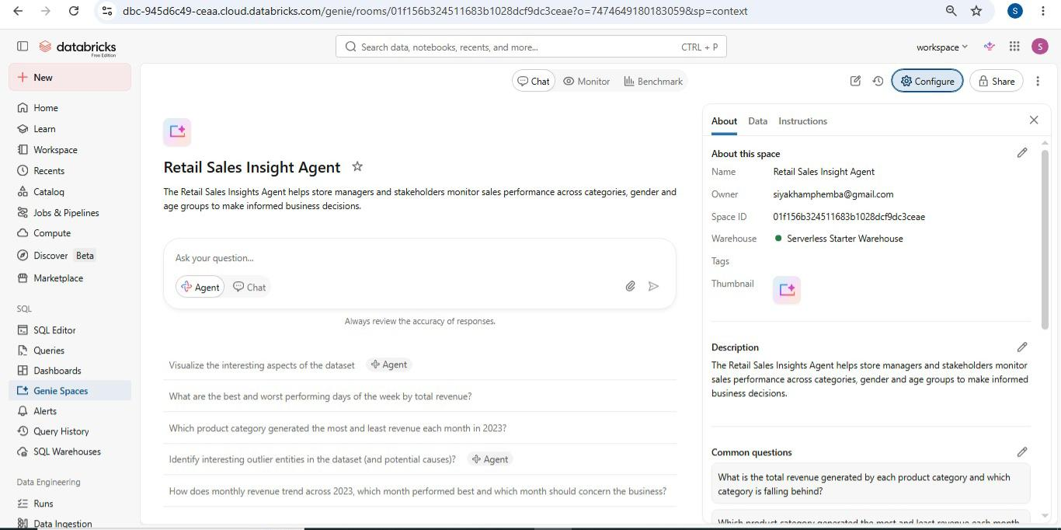
Screenshot 8 — The About configuration panel confirming agent name, owner and warehouse.
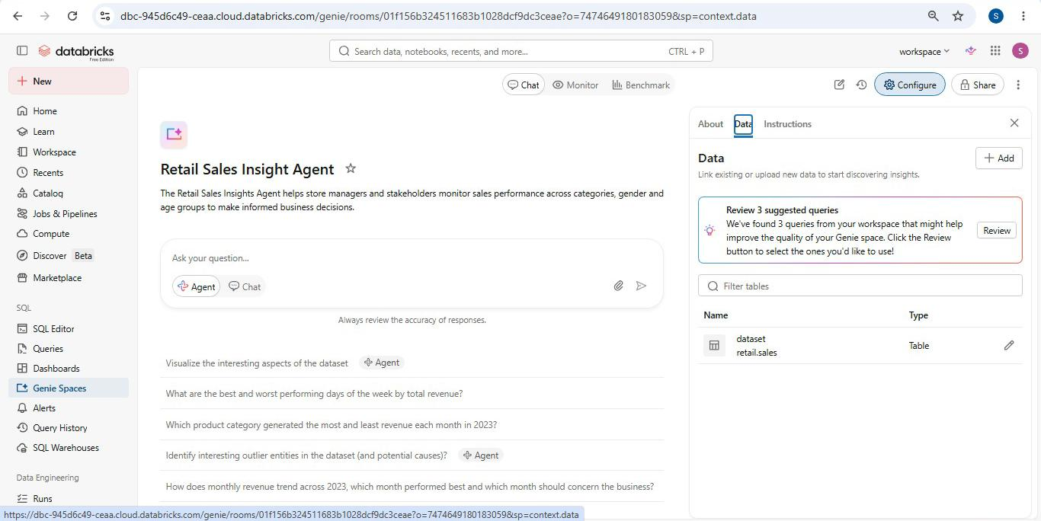
Screenshot 9 — The Data tab confirming retail.sales.dataset is linked to the agent.
5. Agent Instructions — Step 5
Writing the agent instructions was the most important part of this task. The instructions define how the agent behaves, who it serves, what questions it can answer, and what it must never do. I wrote them myself from scratch.

Description
The Retail Sales Insights Agent helps store managers and stakeholders monitor sales performance across categories, gender and age groups to make informed business decisions.

Full Agent Instructions
The Retail Sales Insights Agent is designed to help managers and stakeholders keep track of the trends and numbers the business is pulling, using the retail_sales_data table, in order to make informed decisions. The agent answers questions about sales, customers, product categories, gender, age groups and trends. All answers must be backed by real numbers from the data and explained in a way that is clear and understandable to non-technical users — never use technical jargon. If the data is missing or the dataset is not connected, clearly state this and never guess or fabricate numbers or categories under any circumstances. If a question goes beyond what the data can answer or requires deeper analysis, recommend that the user consults a data analyst.

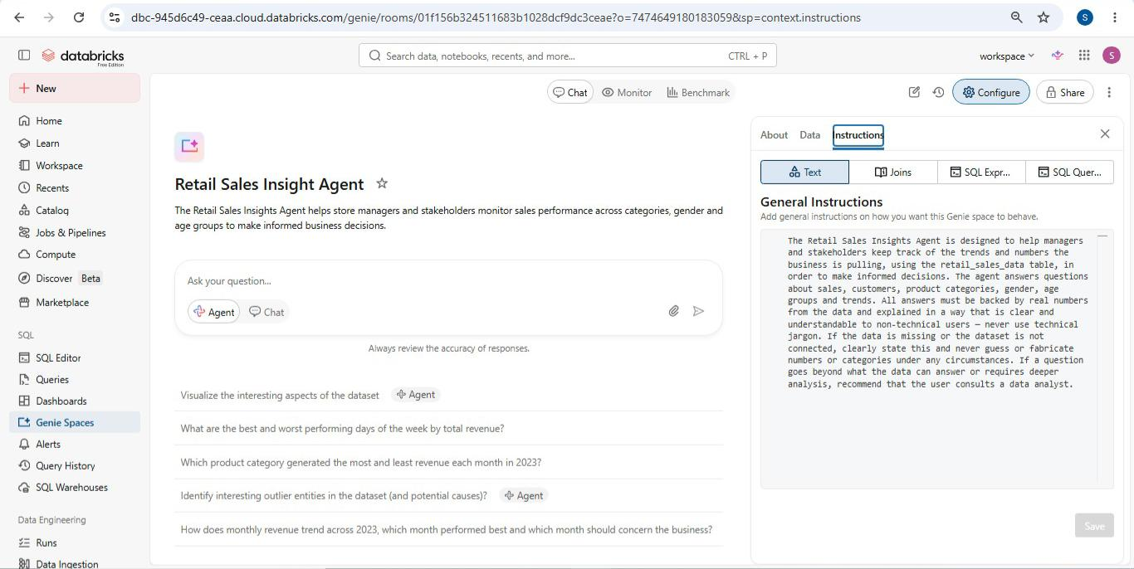
Screenshot 10 — The General Instructions field showing the full saved instructions.
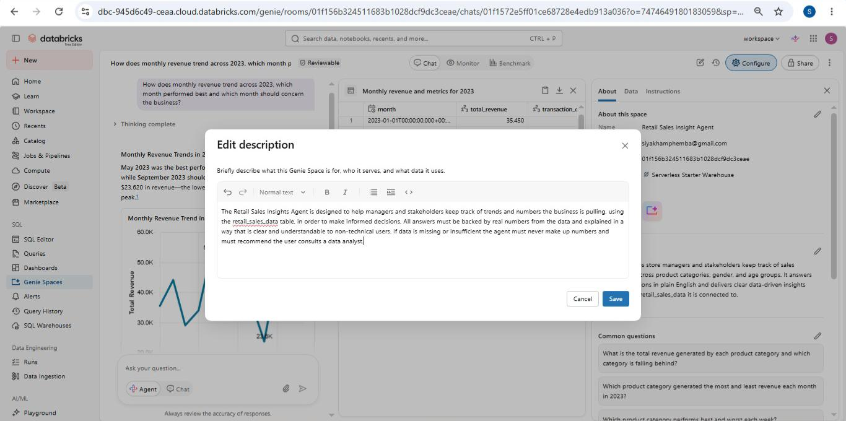
Screenshot 11 — The description field showing the saved agent description.
6. Testing with 10 Questions — Step 6
I tested the agent with 10 original business questions written by myself. The questions were designed to cover a range of difficulty — from simple revenue totals to complex cross-cuts between age, gender and category.

Question 1
"What is the total revenue generated by each product category and which category is falling behind?"

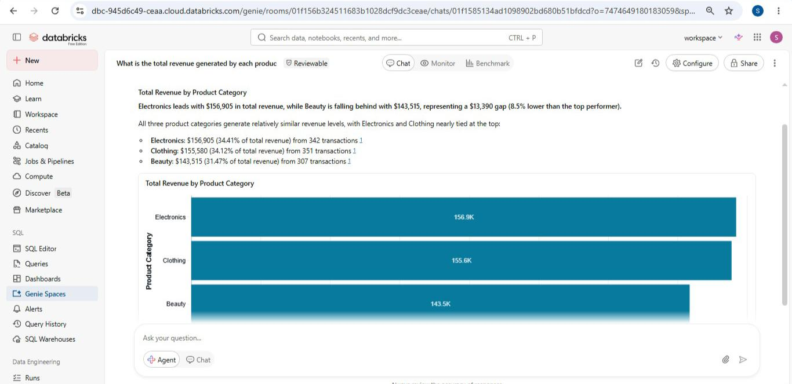
Screenshot 12 — Agent answer to Q1 showing revenue by category bar chart and key findings.
Question 2
"Which product category generated the most and least revenue each month in 2023?"

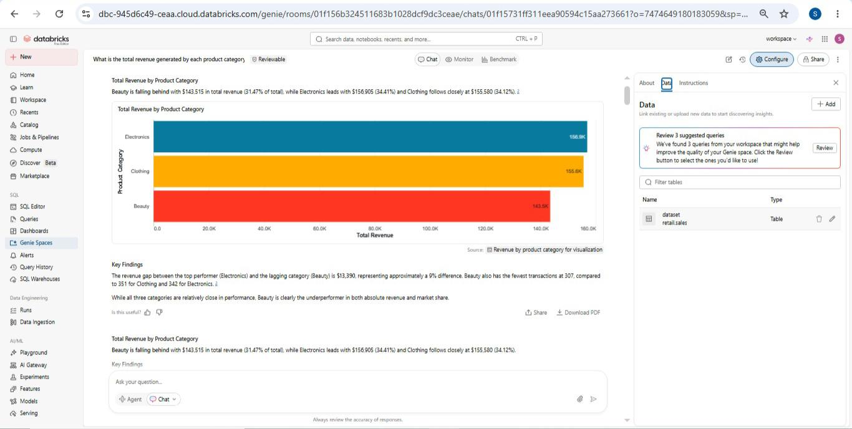
[ SCREENSHOT — Q2 — Agent answer with monthly category line chart showing Electronics leading 6 months ]
Screenshot 13 — Agent answer to Q2 showing monthly category performance across 2023.
Question 3
"Which product category performs best and worst each week?"

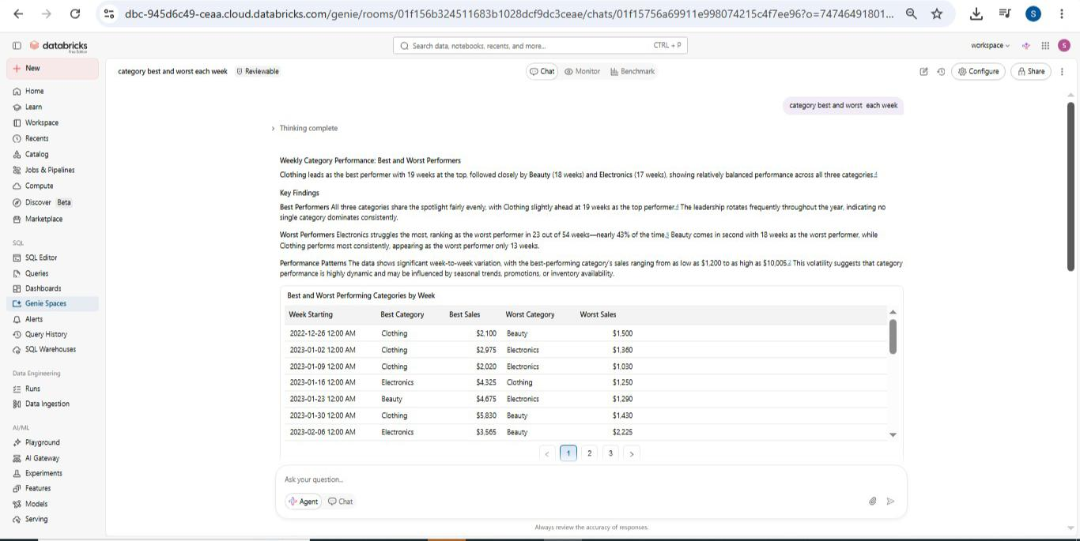
Screenshot 14 — Agent answer to Q3 showing weekly best and worst performers.
Question 4
"What is the total revenue and number of transactions for each gender and is there a concerning gap?"

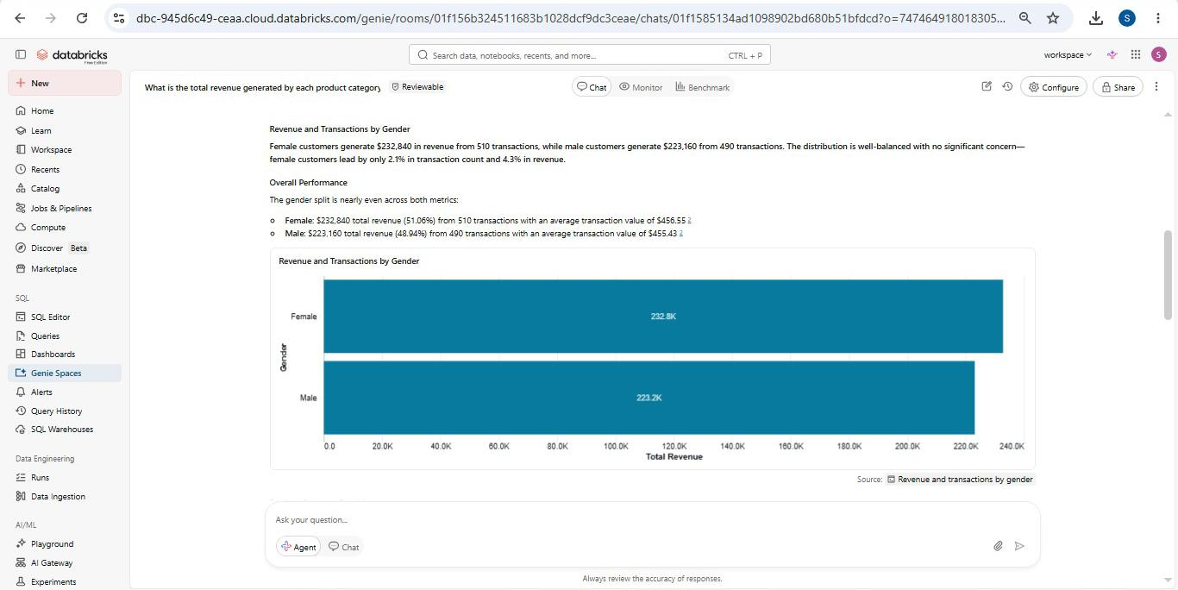
Screenshot 15 — Agent answer to Q4 showing gender revenue comparison and monthly gap analysis.
Question 5
"Which gender spends the most on our top performing category and which gender is underperforming?"

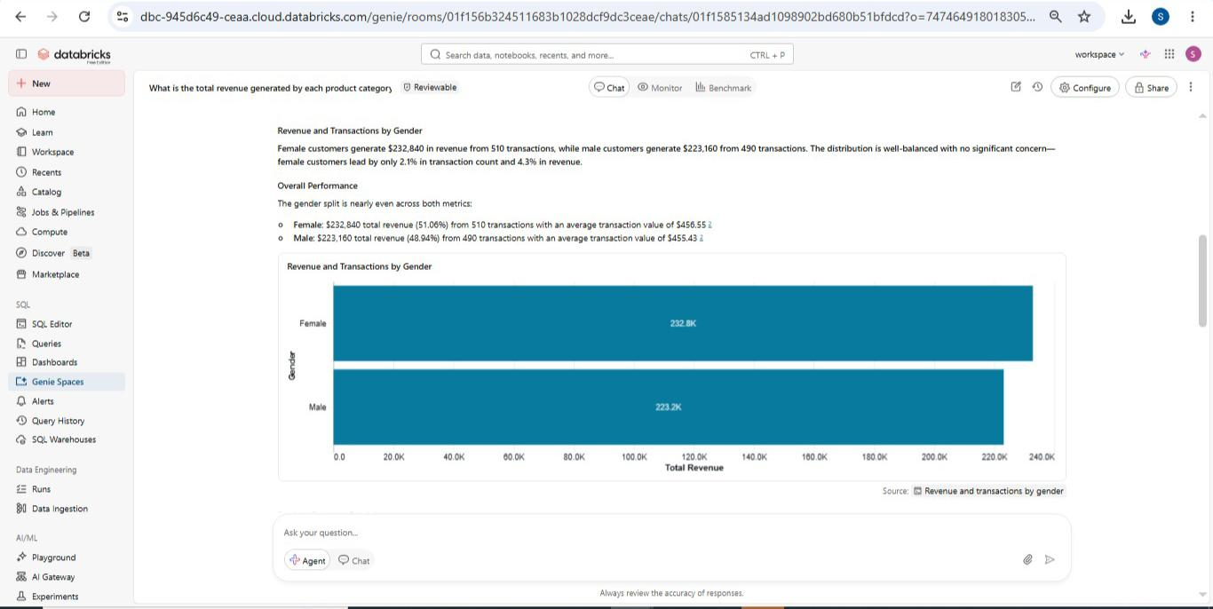
⁸pScreenshot 16 — Agent answer to Q5 showing gender breakdown for Electronics spending.
Question 6
"Which age group spends the most overall and which age group is spending the least?"

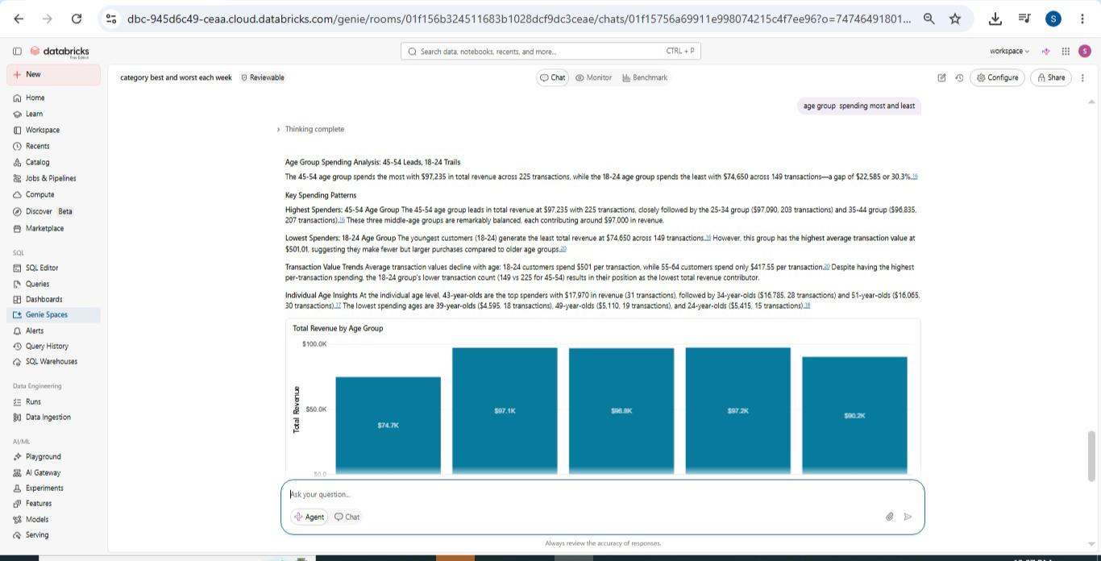
Screenshot 17 — Agent answer to Q6 showing age group spending comparison.
Question 7
"Which age group spends the most on our highest revenue category and which age group are we losing?"

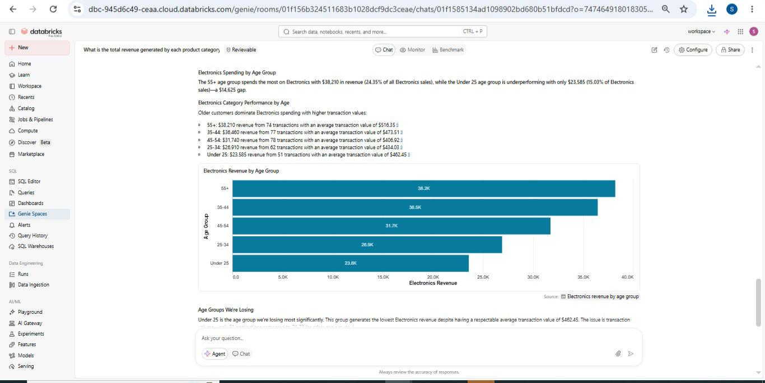
Screenshot 18 — Agent answer to Q7 showing Electronics spending breakdown by age group.
Question 8
"What are the best and worst performing days of the week by total revenue?"

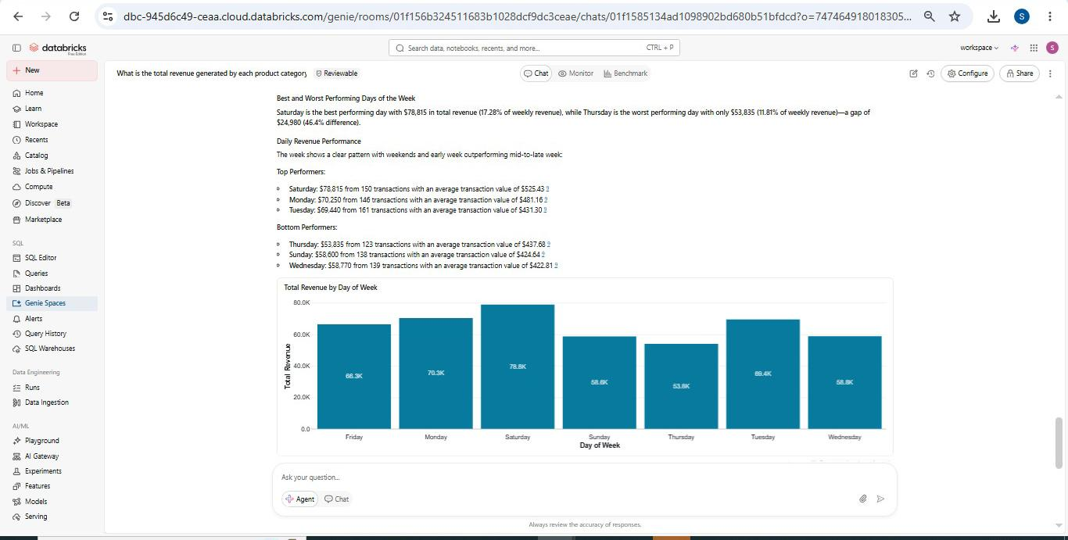
Screenshot 19 — Agent answer to Q8 showing daily revenue performance and best/worst individual days.
Question 9
"How does monthly revenue trend across 2023, which month performed best and which month should concern the business?"

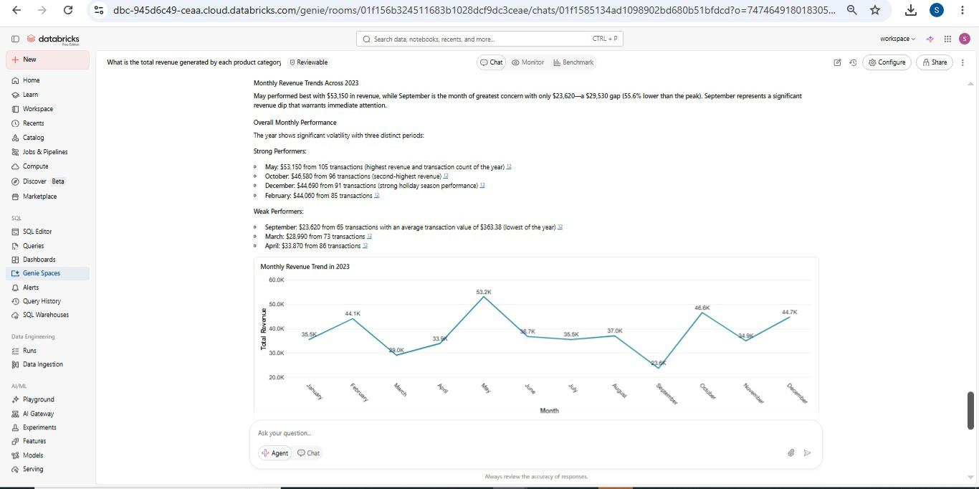
Screenshot 20 — Agent answer to Q9 showing the full 2023 monthly revenue trend.
Question 10
"Based on sales trends, which category and age group should the business prioritise to recover lost revenue and drive growth?"

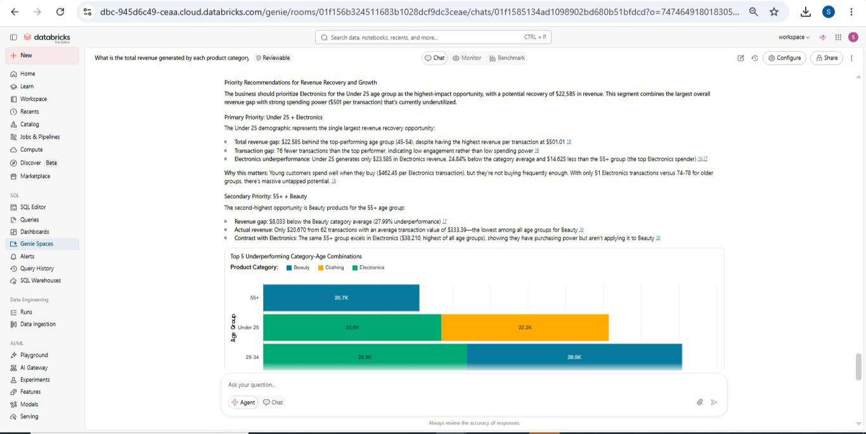
Screenshot 21 — Agent answer to Q10 showing strategic business recommendations backed by data.
7. Validation of Answers — Step 7
An agent that sounds confident is not the same as an agent that is correct. I independently verified three of the agent's answers by writing my own SQL queries in the Databricks SQL Editor and comparing the results directly to what the agent reported.

Validation 1 — Revenue by Category
Question | What is the total revenue generated by each product category and which category is falling behind?
Agent Said | Electronics £156,905 | Clothing £155,580 | Beauty £143,515 (falling behind)
SQL Result | Electronics £156,905 | Clothing £155,580 | Beauty £143,515 — confirmed across 1,000 rows
Verdict | CORRECT — SQL results match the agent's answer exactly. All three figures confirmed.

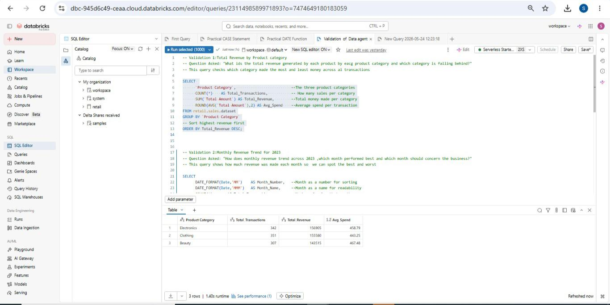
Screenshot 22 — SQL validation query for revenue by category. Numbers match the agent exactly.

Validation 2 — Monthly Revenue Trend
Question | How does monthly revenue trend across 2023 and which month should concern the business?
Agent Said | Best: May 2023 at £53,150 (105 transactions). Most concerning: September 2023 at £23,620 (65 transactions)
SQL Result | May: £53,150 (105 rows) | September: £23,620 (65 rows) — all 12 months confirmed
Verdict | CORRECT — The SQL monthly breakdown matches the agent's chart and written summary across all 12 months.

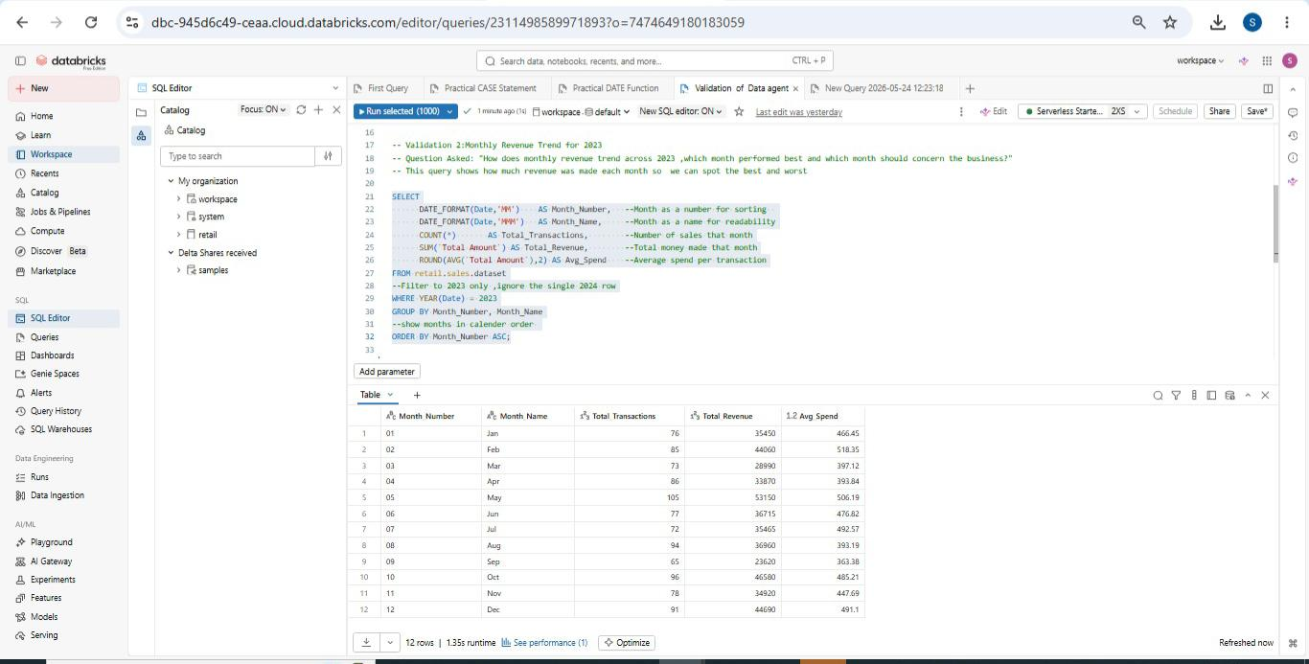
Screenshot 23 — SQL validation query showing monthly revenue for all 12 months of 2023.

Validation 3 — Age Group by Category
Question | Which age group spends the most on our highest revenue category and which age group are we losing?
Agent Said | Adults (30-59) dominate Electronics spending. Pensioners (60+) are the weakest group across all categories.
SQL Result | Adult (30-59) Electronics: £97,235 | Youth (18-29): £35,605 | Pensioner (60+): £24,065 — lowest across all 3 categories
Verdict | CORRECT — SQL confirms Adults (30-59) lead in Electronics. Pensioners (60+) lowest across all categories. This was the most challenging query to write but the results confirmed the agent fully.

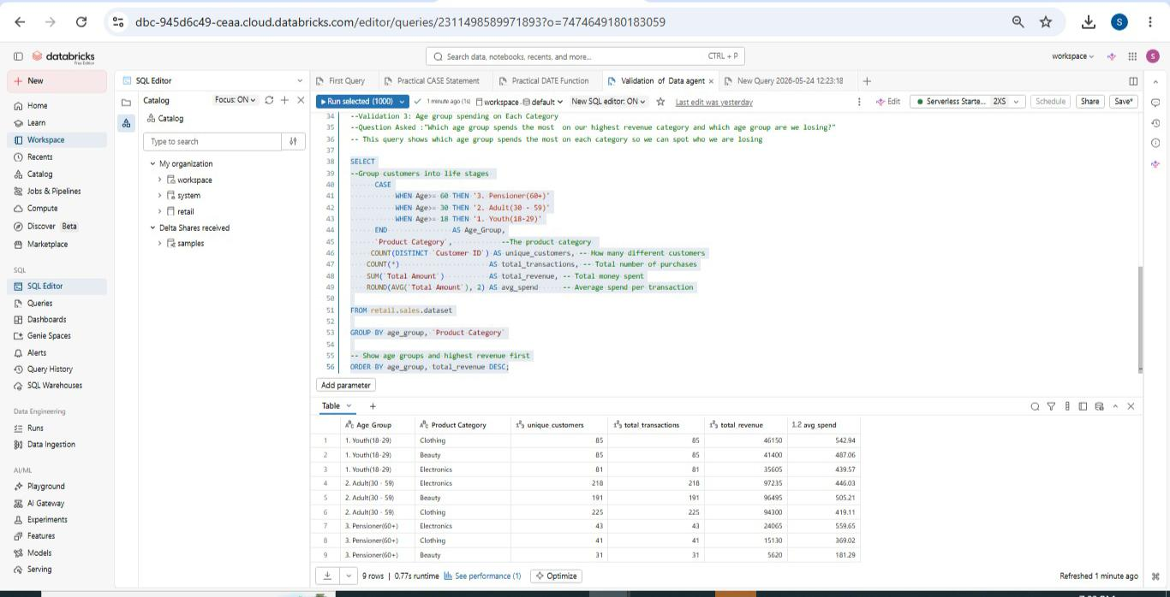
Screenshot 24 — SQL validation using CASE statements to classify age groups and aggregate spending. Results confirm the agent.
8. Key Insights
The following key insights were revealed through the agent's analysis:

- Electronics leads revenue at £156,905 but is the most volatile category — swinging from as low as £30 to £10,005 in a single week. This makes forecasting and planning difficult.
- Beauty is the underperforming category at £143,515 — £13,390 less than Electronics and finishing last in 5 out of 12 months.
- May 2023 was the strongest month at £53,150. September 2023 was the weakest at £23,620 — a 55% drop from peak.
- Saturday generates the highest weekly revenue at £78,815. Thursday is the weakest at £53,835 — 46% lower. Customers show a clear weekend shopping preference.
- The 45-54 age group spends the most at £97,235. The 18-24 group spends the least at £74,650 despite having the highest average transaction value of £501 — they simply visit less often.
- Female customers outspend males overall at £232,840 vs £223,160. However in Electronics, males lead at £80,170 vs female £76,735.
- Pensioners (60+) are the lowest spending group across all three product categories and represent an underserved market segment.
9. Business Recommendations
Based on the insights generated by the agent, the following recommendations are made to the management team:

- Stabilise Electronics revenue by introducing minimum stock levels and product bundles. A loyalty programme for repeat Electronics buyers would create more predictable revenue and reduce the extreme weekly swings.
- Invest in Beauty category marketing. Beauty finishes last too often. Campaigns aimed at female customers — who already outspend males in Beauty — could close the gap to Electronics.
- Run Thursday promotions and mid-week flash sales to lift revenue on the weakest days. Saturday already performs well — the focus should be on the low days.
- Engage the 18-24 age group more frequently. They spend well per visit but come in less often. A youth-focused loyalty programme with social media integration targeting Beauty and Electronics could increase their transaction frequency significantly.
- Prepare for September every year. The pattern of September being the weakest month should be addressed with back-to-school or seasonal promotions in late August to cushion the drop.
- Develop age-targeted product bundles — Tech Essentials for 55+ customers who spend heavily on Electronics and Young Professional Wardrobe bundles for the 25-34 group who prefer Clothing.
10. Conclusion
This project was my first end-to-end Data Agent build and it was both challenging and rewarding. I successfully uploaded and prepared a retail sales dataset in Databricks, created a Genie Space agent, wrote my own original instructions from scratch, tested the agent with 10 business questions, and independently validated 3 of those answers using SQL.

What worked well: The agent performed strongly on all three validated questions. The numbers matched my SQL results exactly every time, which gave me confidence in the tool. The agent also generated useful strategic recommendations in Q10 that went beyond basic data retrieval.

What was challenging: Validation Query 3 was the most difficult to write. It required combining a CASE statement for age group classification with multiple aggregations across product categories in a single query. Working through that challenge independently and seeing the results confirm the agent's answer was the most satisfying moment of the project — and gave me confidence that I can tackle similar problems in a workplace environment.

What I would change: In the future I would enhance the agent by adding promotional campaign data to see whether sales peaks align with marketing spend. I would also investigate whether the Electronics revenue swings are driven by pricing changes or purely by transaction volume.
11. GitHub Repository
GitHub Repository: https://github.com/siyakhamphemba/Retail-Sales
Repository contains: retail_sales_dataset.csv | validation_queries.sql | README.md | This Word document

