BrightLearn
AI & DATA SKILLS
STUDENT EXERCISE · SQL JOINS
SQL Joins Submission
INNER JOIN · LEFT JOIN · FULL OUTER JOIN
TOPIC: SQL Joins QUESTIONS: 15 + 5 bonus
LEVEL: Beginner ENVIRONMENT: Databricks SQL

PART A — INNER JOIN
Returns only rows where the join condition is true on BOTH sides. Unmatched rows are dropped.
Q01 Show every user who has a subscription. Match users to subscriptions.
TABLES: users · subscriptions
COLUMNS: user_id, user_name, subscription_id, start_date
SQL:
SELECT u.user_id, u.user_name, s.subscription_id, s.start_date FROM users u INNER JOIN subscriptions s ON u.user_id = s.user_id;
SCREENSHOT / OUTPUT:
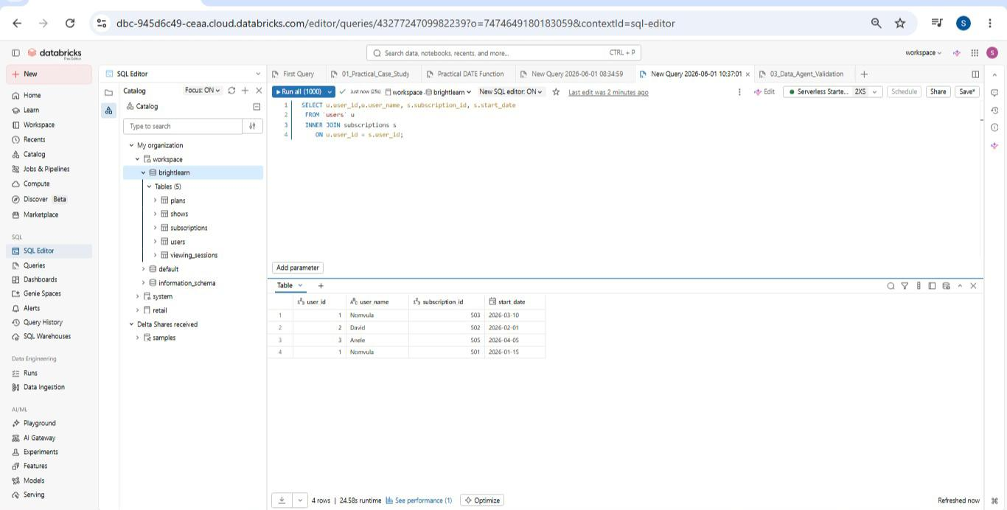

Q02 Show every subscription with its matching plan name and monthly price.
TABLES: subscriptions · plans
COLUMNS: subscription_id, user_id, plan_name, monthly_price
SQL:
SELECT subscription_id, user_id, plan_name, monthly_price FROM subscriptions s INNER JOIN plans p ON s.plan_id = p.plan_id;
SCREENSHOT / OUTPUT:
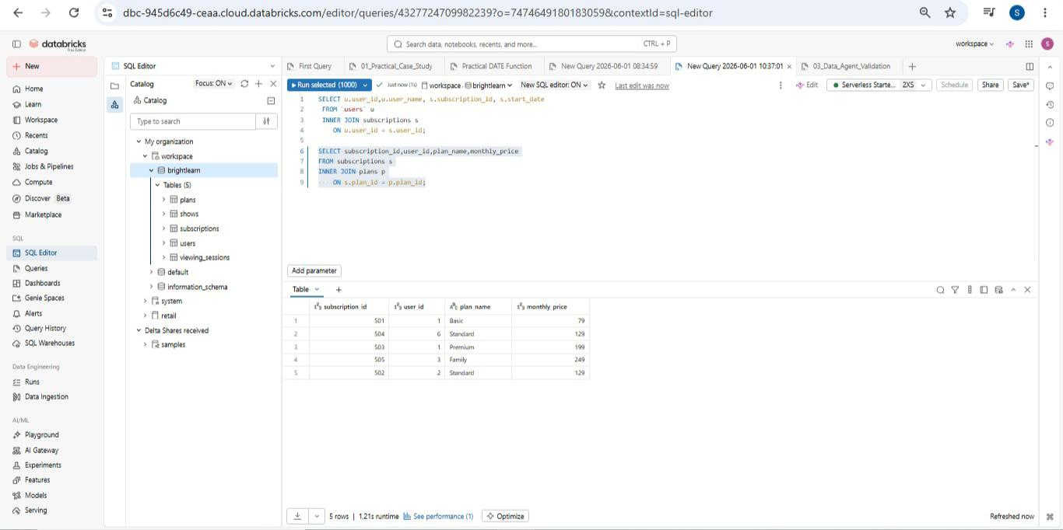

Q03 Show every viewing session that has a matching show. Include the show title and genre.
TABLES: viewing_sessions · shows
COLUMNS: session_id, user_id, show_title, genre, watch_minutes
SQL:
SELECT session_id, user_id, show_title, genre, watch_minutes FROM viewing_sessions v INNER JOIN shows s ON v.show_id = s.show_id;
SCREENSHOT / OUTPUT:
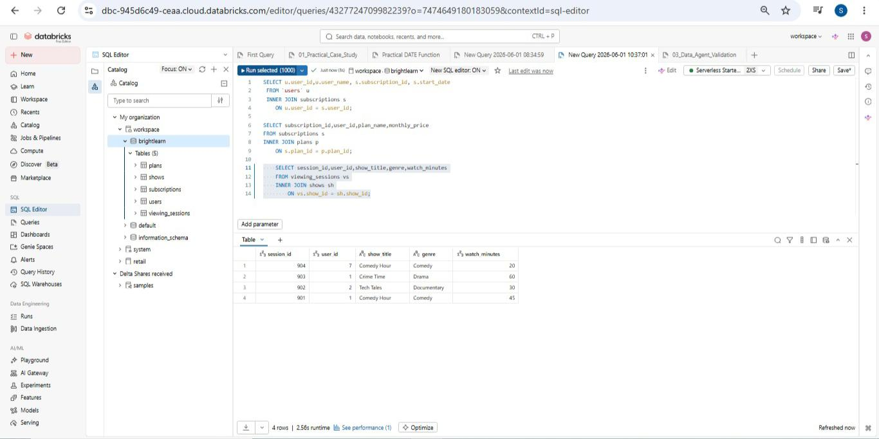

Q04 Show every viewing session with the user who watched it. Only show sessions with a matching user.
TABLES: users · viewing_sessions
COLUMNS: user_name, country, session_id, show_id, watch_minutes
SQL:
SELECT user_name, country, session_id, show_id, watch_minutes FROM users u INNER JOIN viewing_sessions v ON u.user_id = v.user_id;
SCREENSHOT / OUTPUT:
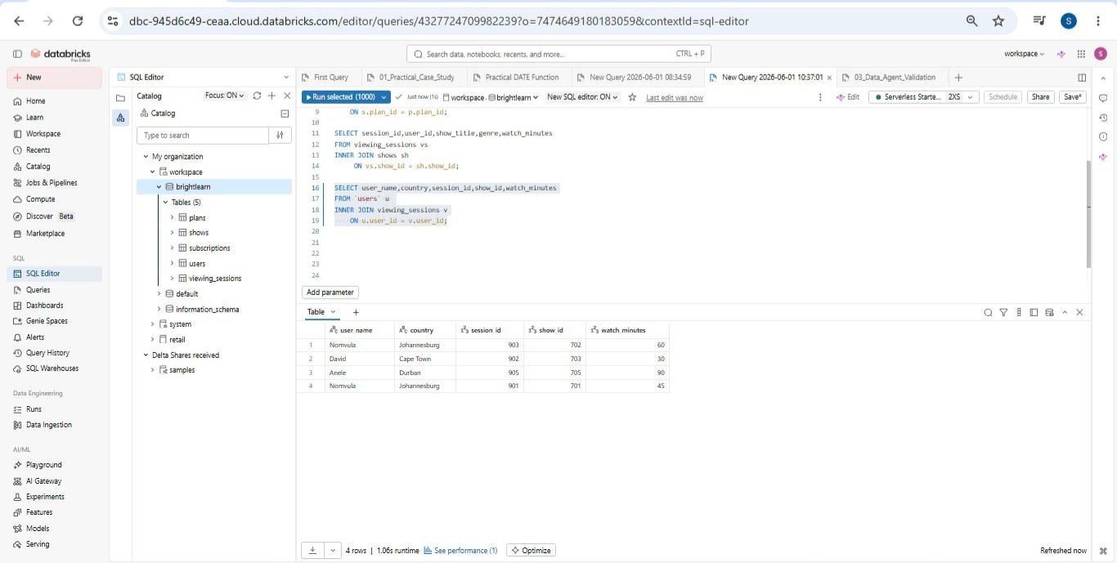

Q05 Show users with their subscriptions, plan name, and price. Only users with both a subscription and a valid plan.
TABLES: users · subscriptions · plans
COLUMNS: user_name, country, plan_name, monthly_price, start_date
SQL:
SELECT user_name, country, plan_name, monthly_price, start_date FROM users u INNER JOIN subscriptions s ON u.user_id = s.user_id INNER JOIN plans p ON s.plan_id = p.plan_id;
SCREENSHOT / OUTPUT:
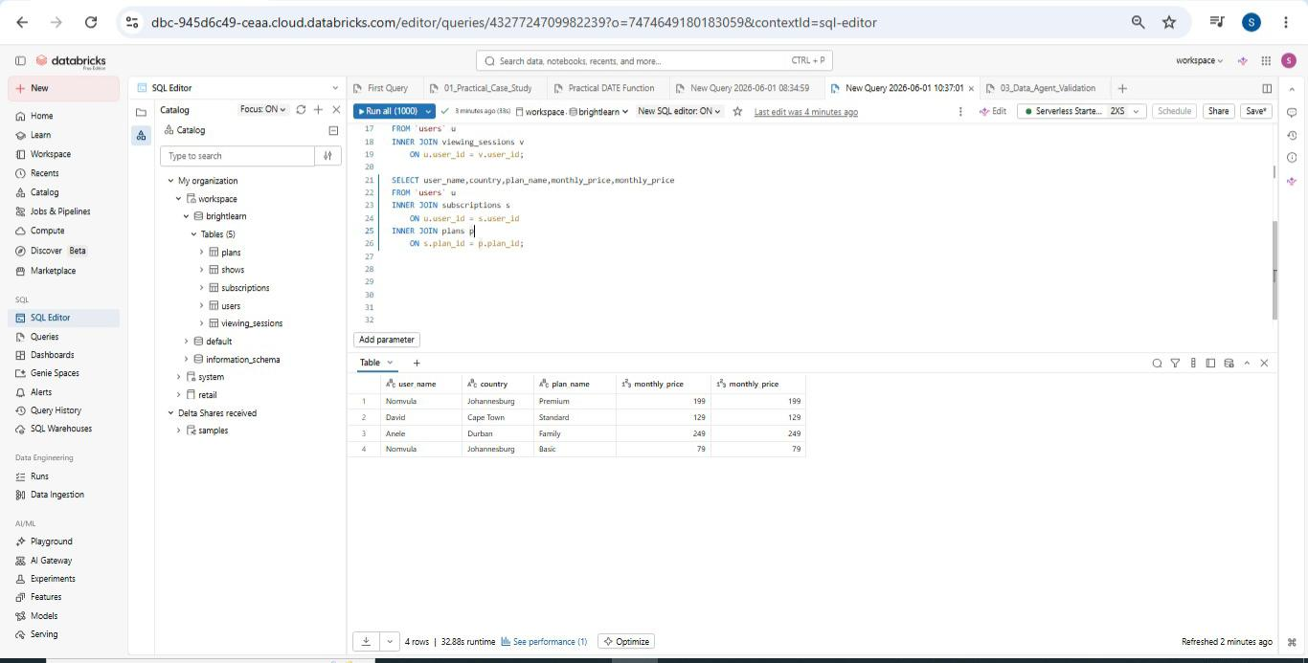

PART B — LEFT JOIN
Returns every row from the LEFT table. Unmatched rows on the right become NULL.
Q06 Show every user and any subscriptions they have. Users without subscriptions must still appear.
TABLES: users · subscriptions
COLUMNS: user_id, user_name, subscription_id, start_date
SQL:
SELECT u.user_id, u.user_name, s.subscription_id, s.start_date FROM users u LEFT JOIN subscriptions s ON u.user_id = s.user_id;
SCREENSHOT / OUTPUT:
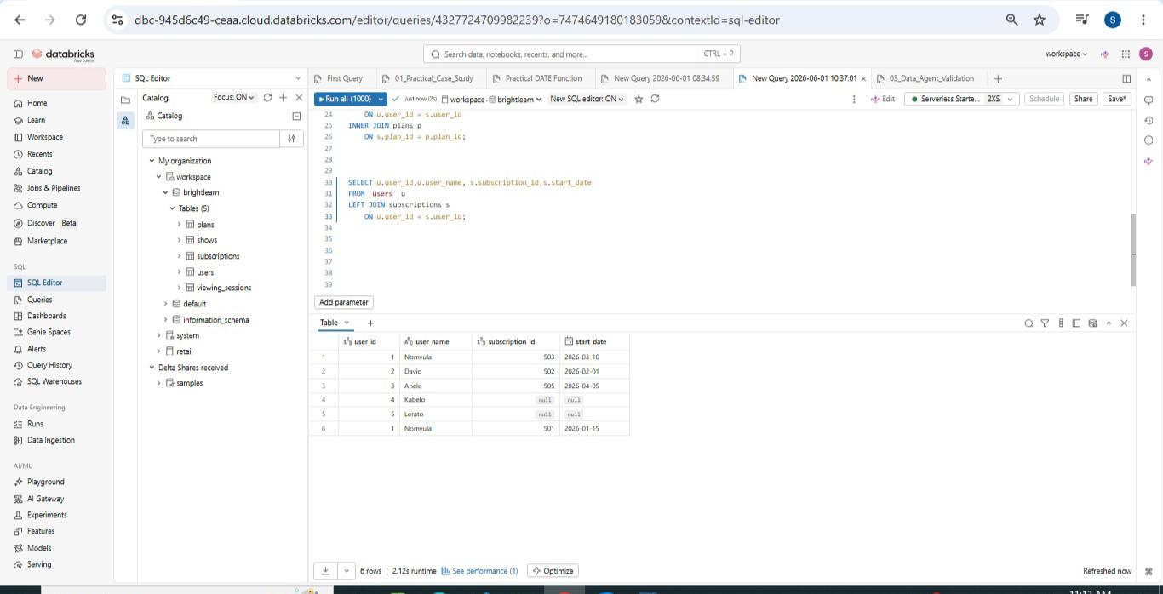

Q07 Show every plan and the subscriptions on it. Plans with no subscribers must still appear.
TABLES: plans · subscriptions
COLUMNS: plan_id, plan_name, subscription_id, user_id
SQL:
SELECT p.plan_id, p.plan_name, s.subscription_id, s.user_id FROM plans p LEFT JOIN subscriptions s ON p.plan_id = s.plan_id;
SCREENSHOT / OUTPUT:
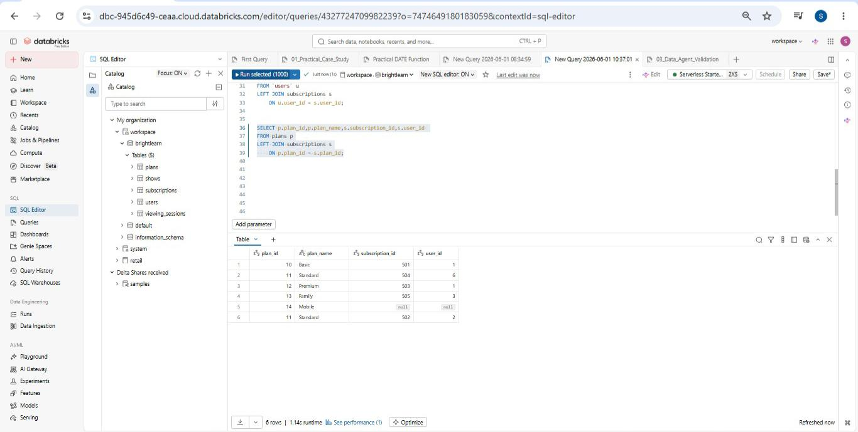

Q08 Show every show and any viewing sessions on it. Shows that were never watched must still appear.
TABLES: shows · viewing_sessions
COLUMNS: show_id, show_title, session_id, watch_minutes
SQL:
SELECT s.show_id, s.show_title, v.session_id, v.watch_minutes FROM shows s LEFT JOIN viewing_sessions v ON s.show_id = v.show_id;
SCREENSHOT / OUTPUT:
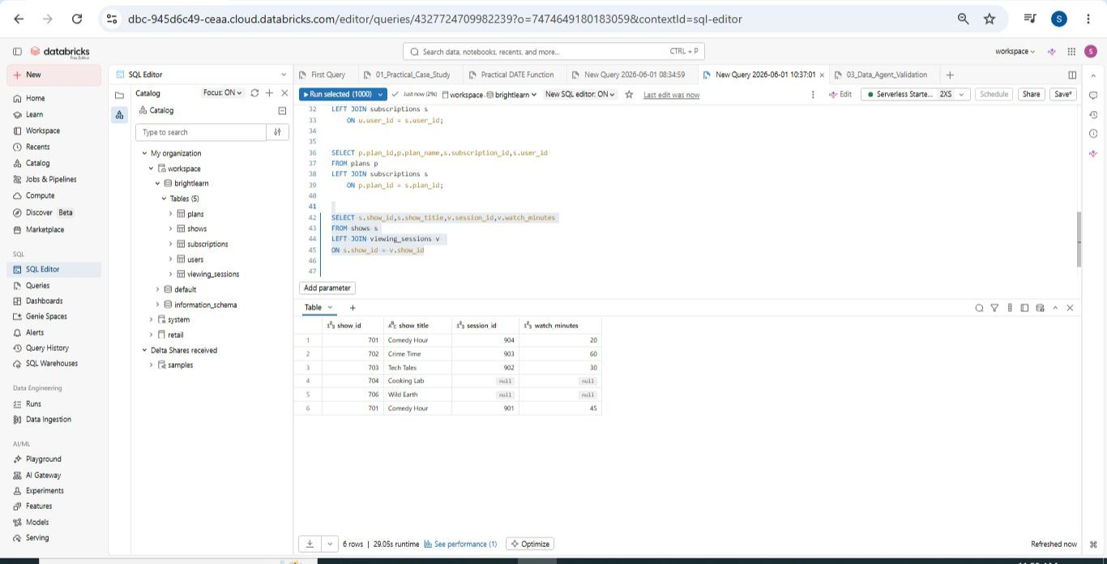

Q09 Show every viewing session and the user who watched it. Sessions with missing users must still appear.
TABLES: viewing_sessions · users
COLUMNS: session_id, show_id, watch_minutes, user_id, user_name
SQL:
SELECT v.session_id, v.show_id, v.watch_minutes, v.user_id, u.user_name FROM viewing_sessions v LEFT JOIN users u ON v.user_id = u.user_id;
SCREENSHOT / OUTPUT:
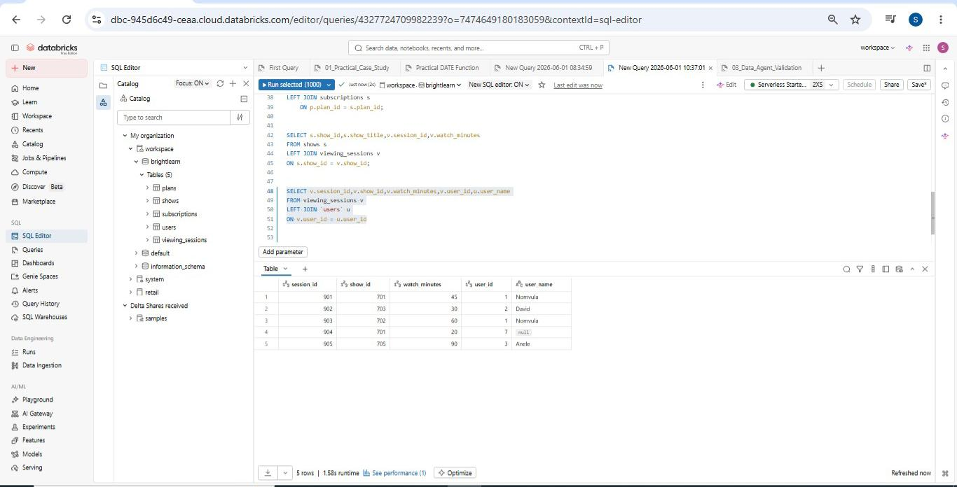

Q10 Show every user, the plan they are on (if any), and the monthly price. Users without subscriptions must still appear.
TABLES: users · subscriptions · plans
COLUMNS: user_name, country, plan_name, monthly_price
SQL:
SELECT user_name, country, plan_name, monthly_price FROM users u LEFT JOIN subscriptions s ON u.user_id = s.user_id LEFT JOIN plans p ON p.plan_id = s.plan_id;
SCREENSHOT / OUTPUT:
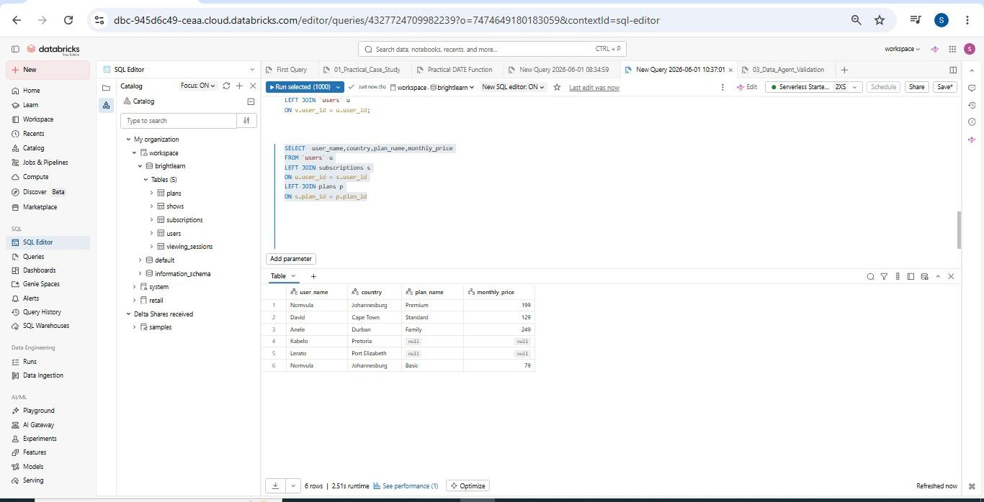

PART C — FULL OUTER JOIN
Returns every row from BOTH tables. Unmatched rows on either side become NULL. SQL environment: Databricks (supports FULL OUTER JOIN natively).
Q11 Show every user and every subscription, including users without subscriptions AND subscriptions referencing users that do not exist.
TABLES: users · subscriptions
COLUMNS: user_id, user_name, subscription_id, start_date
SQL:
SELECT u.user_id, u.user_name, s.subscription_id, s.start_date FROM users u FULL OUTER JOIN subscriptions s ON u.user_id = s.user_id;
SCREENSHOT / OUTPUT:
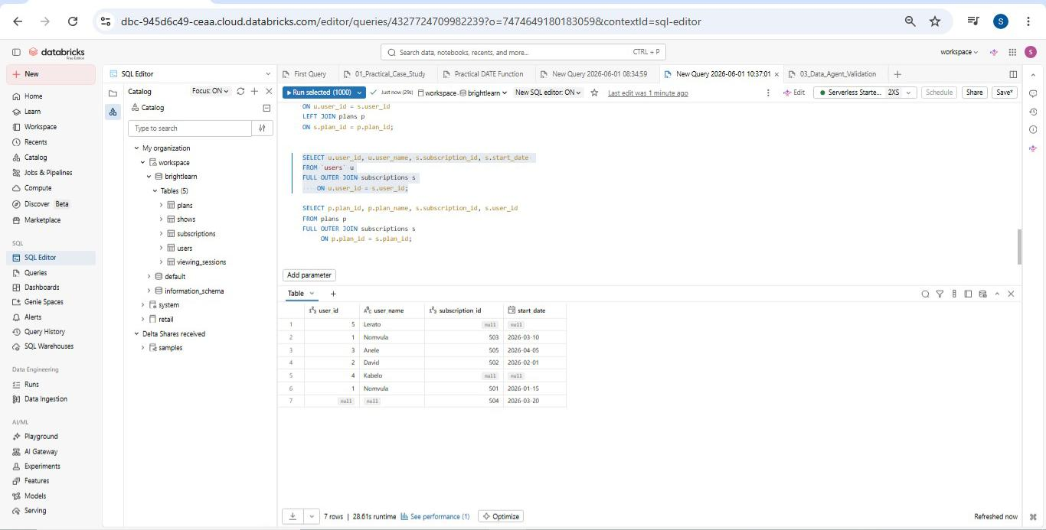

Q12 Show every plan and every subscription, including plans without subscribers AND subscriptions referencing non-existent plans.
TABLES: plans · subscriptions
COLUMNS: plan_id, plan_name, subscription_id, user_id
SQL:
SELECT p.plan_id, p.plan_name, s.subscription_id, s.user_id FROM plans p FULL OUTER JOIN subscriptions s ON p.plan_id = s.plan_id;
SCREENSHOT / OUTPUT:
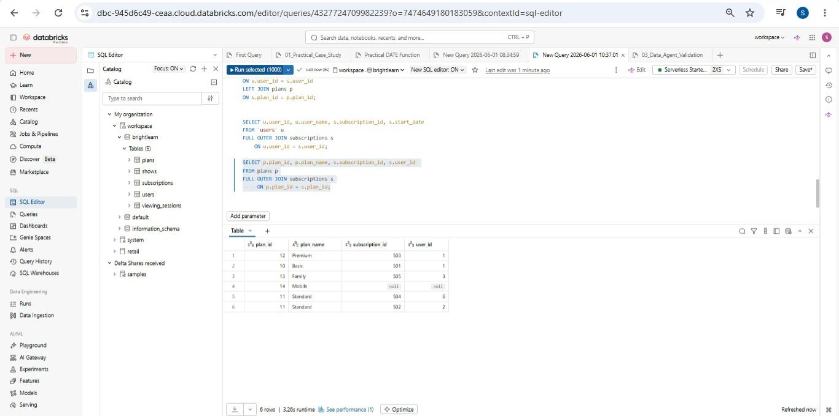

Q13 Show every show and every viewing session, including shows never watched AND sessions referencing shows that do not exist.
TABLES: shows · viewing_sessions
COLUMNS: show_id, show_title, session_id, watch_minutes
SQL:
SELECT s.show_id, s.show_title, v.session_id, v.watch_minutes FROM shows s FULL OUTER JOIN viewing_sessions v ON s.show_id = v.show_id;
SCREENSHOT / OUTPUT:
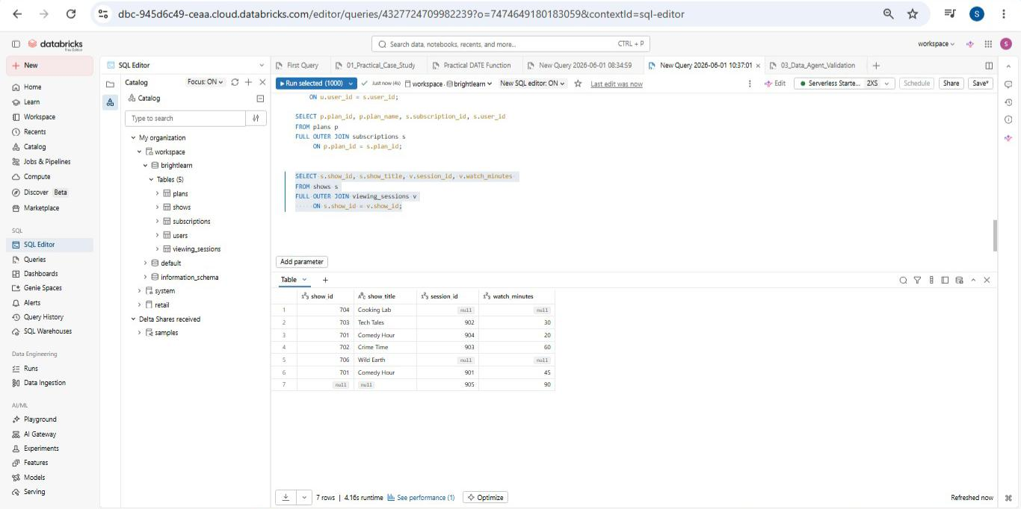

Q14 Show every user and every viewing session, including users with no sessions AND sessions referencing users who do not exist.
TABLES: users · viewing_sessions
COLUMNS: user_id, user_name, session_id, show_id, watch_minutes
SQL:
SELECT u.user_id, u.user_name, v.session_id, v.show_id, v.watch_minutes FROM users u FULL OUTER JOIN viewing_sessions v ON u.user_id = v.user_id;
SCREENSHOT / OUTPUT:
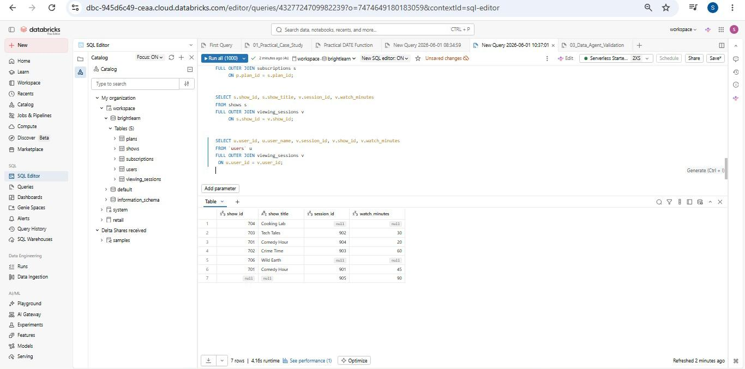

Q15 Show every user, every subscription, and every plan in one query using FULL OUTER JOIN throughout.
TABLES: users · subscriptions · plans
COLUMNS: user_id, user_name, subscription_id, plan_id, plan_name
SQL:
SELECT COALESCE(u.user_id, s.user_id) AS user_id, u.user_name, s.subscription_id, p.plan_id, p.plan_name FROM users u FULL OUTER JOIN subscriptions s ON u.user_id = s.user_id FULL OUTER JOIN plans p ON s.plan_id = p.plan_id;
SCREENSHOT / OUTPUT:
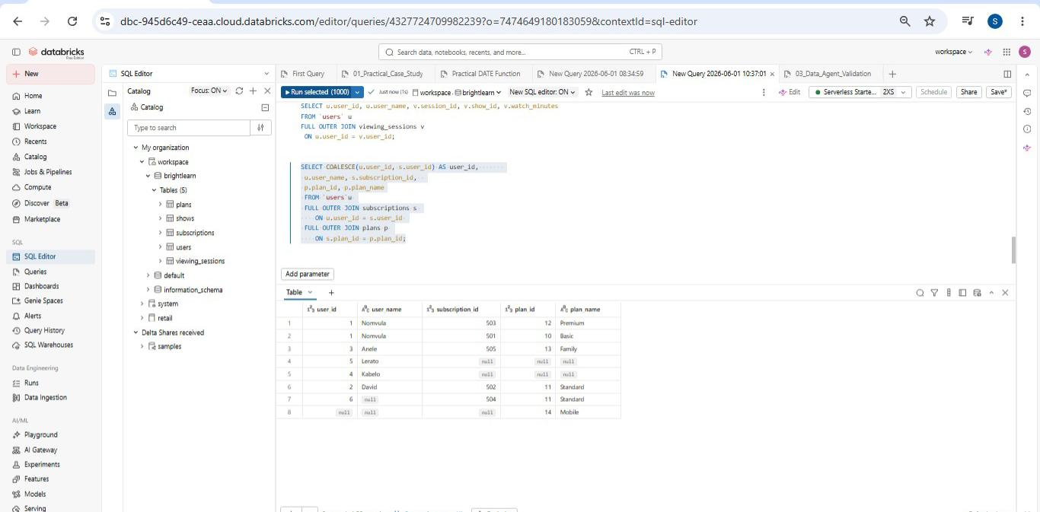

BONUS CHALLENGE — Reasoning About Data
Answered by reading the tables directly, without writing additional SQL.
BONUS 01 Which users have not subscribed to any plan?
Users 4 (Kabelo) and 5 (Lerato) — they exist in the users table but have no matching rows in subscriptions.
BONUS 02 Which subscriptions reference users that do not exist in the users table?
Subscription 504 — it references user_id 6, which does not exist in the users table.
BONUS 03 Which shows have never been watched?
Show 704 (Cooking Lab) and show 706 (Wild Earth) — no rows in viewing_sessions reference these show_ids.
BONUS 04 Which viewing sessions reference shows that do not exist?
Session 905 — it references show_id 705, which does not exist in the shows table.
BONUS 05 Which plans have no subscribers?
Plan 14 (Mobile) — no row in subscriptions has plan_id 14.
STUDENT REFLECTION
I completed this exercise using Databricks SQL. The queries were straightforward to run as Databricks supports FULL OUTER JOIN natively, requiring no workarounds for Part C.
While these types of JOIN queries are important to know and understand, I found the exercise not particularly challenging at the beginner level. The five-table dataset was small and clean, which made it easy to predict results before running each query.
I initially intended to use MySQL for this exercise, as I am currently working on a MySQL project. Had I done so, Part C would have required the LEFT JOIN UNION RIGHT JOIN workaround since MySQL does not support FULL OUTER JOIN natively — which would have added more complexity. I ultimately chose Databricks for its native support and cleaner syntax.
BrightLearn · SQL Joins Exercise · Databricks SQL

