Investment Committee Memorandum
Return Forecasting Model Comparison - Target Corporation (TGT)
To: Investment Committee
From: Team Hemisphere
Date: 20th June 2026
Subject: ARIMA vs. LSTM forecasting of TGT daily stock returns

1. Executive Summary
We compared a classical ARIMA benchmark against a deep-learning LSTM network for forecasting Target Corporation’s (TGT) daily log returns over January 2020 to December 2024. Evaluated on the same untouched out-of-sample test window, the two models performed comparably, with a test RMSE of 0.0257 for ARIMA versus 0.0254 for LSTM. We recommend ARIMA (1,0,3) as the working forecasting model: it matches the LSTM on accuracy and is clearly stronger at predicting direction, while remaining simpler, faster, and easier to explain and audit. Daily-return forecasts at this horizon are inherently noisy and should inform positioning, not drive it mechanically.

2. Data and Forecasting Setup
Source. Daily TGT prices were retrieved from Yahoo Finance via the yfinance library with split- and dividend-adjusted closing prices (auto-adjust enabled), reproducing the Project 2 data workflow.
Period and field. 03 Jan 2020 – 31 Dec 2024 (1,257 trading days), using the adjusted close as the price field.
Return definition. Daily log return r_{t} = ln (P_{t} / P_{t−1}), which is time-additive and approximately stationary.
Train / validation / test split. The series was split chronologically into 879 training, 188 validation, and 190 test days with no shuffling and no leakage. The validation window was used for model selection; the test window was scored once, for the final comparison. An ADF test on the return series strongly rejected the unit-root null (statistic ≈ −36.4, p < 0.001), confirming stationarity and supporting an integration order of d = 0.

3. ARIMA vs. LSTM Results
All metrics below are computed on the identical out-of-sample test window so the comparison is like-for-like.
Model | Forecast target | Test MAE | Test RMSE | Directional accuracy
ARIMA(1,0,3) | Daily log return | 0.0145 | 0.0257 | 54.7%
LSTM (10→50→1) | Daily log return | 0.0144 | 0.0254 | 45.8%
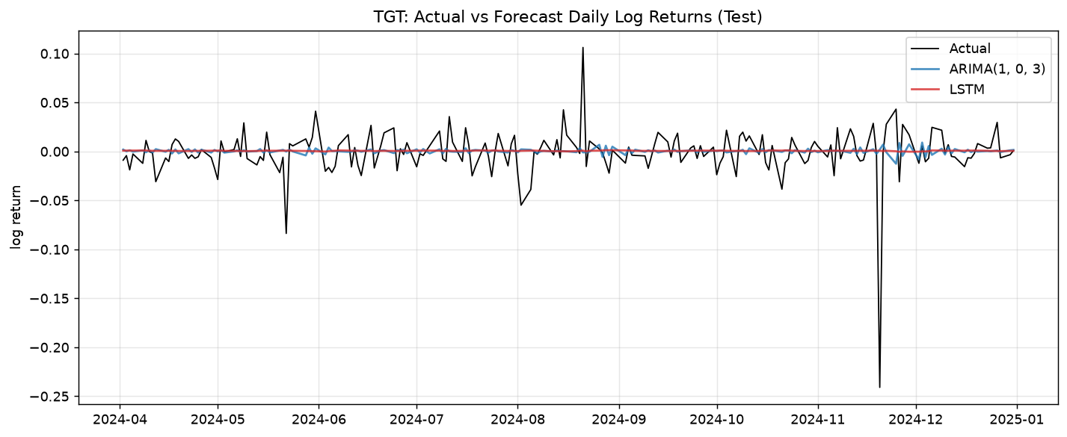
Figure 1. Actual vs. forecast TGT daily log returns over the test window.

4. Model Selection and Interpretation
We use test RMSE as the primary criterion because it penalizes large forecast errors most heavily, with MAE as a stability check and directional accuracy as a secondary business signal. On these criteria the LSTM does not materially improve on the ARIMA benchmark: its test RMSE is lower by only about 1.2% well within the noise and below the threshold we set for adopting a more complex model and its directional accuracy of 45.8% is in fact lower than ARIMA’s 54.7% and below the 50% coin-flip line. This is the expected result: daily equity returns are close to white noise, so a parsimonious linear model captures essentially all the weak linear structure, and a higher-capacity LSTM tends to match rather than beat it out-of-sample while costing more time and transparency. We therefore select ARIMA (1,0,3), in line with the decision rule favoring the simpler model when the complex model offers no clear, stable advantage.

5. Next 30-Trading-Day Return Outlook and Caveats
Re-fit on the full sample, the selected ARIMA (1,0,3) model projects a cumulative log return of approximately +0.0041 over the next 30 trading days (≈ +0.4% implied price move), i.e. a mildly positive central tendency that decays quickly toward the series mean. This figure should be read as a low confidence point estimate surrounded by wide uncertainty. Return forecasts at the daily horizon are dominated by noise, are sensitive to single-day shocks (e.g., earnings), and are not standalone trading signals. The analysis is fully reproducible from the saved dataset, fixed random seeds, and the recorded package versions; results should be refreshed as new data arrives.

