

**Assignment 2**

Course title: Database Management System Lab

Course code: CSE 312

Summitted to:

Mst. Eshita Khatun

Lecturer

Department of CSE

Daffodil International University

Submitted by:

A

Md. Siyamul Islam Siyam

ID: 171-15-8865

Section: “O”

Department of CSE

Daffodil International University

**Date of Submission:** 12/02/2019

Database & Table Create:

Create Database Assignment_2

Create Table Student(

SID int IDENTITY(1,1) Primary Key not null,

FName varchar(30) not null,

LName varchar(30) not null,

Age int not null,

Grade float null,

Phone_Number int null,

)

Insert into Student(FName,LName,Age,Grade,Phone_Number)

Values('Ovi', 'Majumdar', 22, 1.25, 0123)

Insert into Student(FName,LName,Age,Grade,Phone_Number)

Values('Akash', 'Pathan', 21, 2.22, 6441), ('Raja', 'Tushar', 24, null ,6548),

('Ovi', 'Majumdar', 26, 1.21, 01324),

('Rubaiaya', 'HAfiz', 24, 0.88, 9546),

('Sazzad', 'Pinku', 28, 4.00, 3598),

('Sazzad', 'Pinku', 30, 0.25, null)

select * from Student

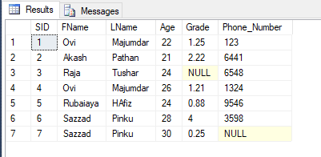

1. Select all FName but similar names cannot be shown twice

[Hints: use ‘select’ command to view table with distinct keyword.]

**Solution:**

select distinct FName from Student

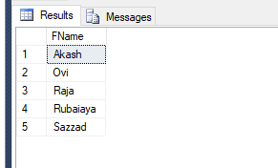

1. Select all SID, FName and Grade of those people who is older than 25 years and phone number ends with 8.

**Solution:**

select SID, FName, Grade from Student where age>25 and Phone_Number like '%8'

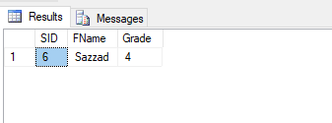

1. Select all the FName and Age. But show according to their age starting from younger to older.

**Solution:**

select FName, Age from Student order by Age

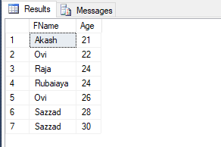

1. Select all the FName and Age. But show according to their age starting from older to younger.

**Solution:**

select FName, Age from Student order by Age desc

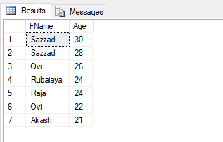

1. Delete Ovi from the table. Describe what happened.

**Solution:**

delete from Student where FName= 'Ovi'

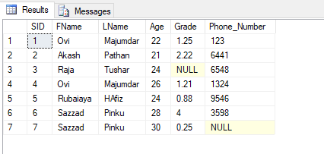

**Before Delete**

**‘Ovi’**

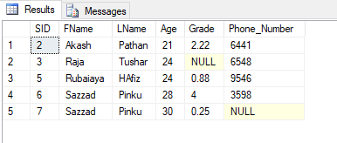

**After Delete**

**‘Ovi’**

**What’s happen:** The Delete command is used to remove **some or all** rows from a table.

A WHERE clause can be used to only remove some rows.

After performing a DELETE operation, I can Rollback or to undo this row.

1. Select all FName whose age is between 23 to 30.

**Solution:**

select FName from Student where age >= 23 and age <=30

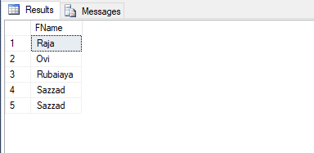

***“The End”***